  - DIGITAL TASK DS2
  - Module Code LCLM4002
  - Student name : Viorica Raducan
  - Student ID 2543250

Scenario RIVER FITNESS

Instructions :
You are helping a local gym called River Fitness . They collected customer feedback and want a simple , clear summary.
You are given results from short survery (Satisfed , Neutral , Not Satisfed ).
Create a digital artefact showing :
- The number of responses in each category
- One simple chart (bar or pie)
You may use Excel or PowerPoint

What you received from the manager :
TO:Junior Assistant
From : Hassan Murad , Manager , River Fitness
Subject : Customer Feedback Please Make a Simple Summary

Hi ,
Last month we collected customer feedback about our gym service. Please create a simple digital summary that shows :
How many responses were Satisfed , Neutral or Not Satisfed
One clear chart
Customer feedback survery results
Satisfed 46
Neutral 18
Not Satisfed 11

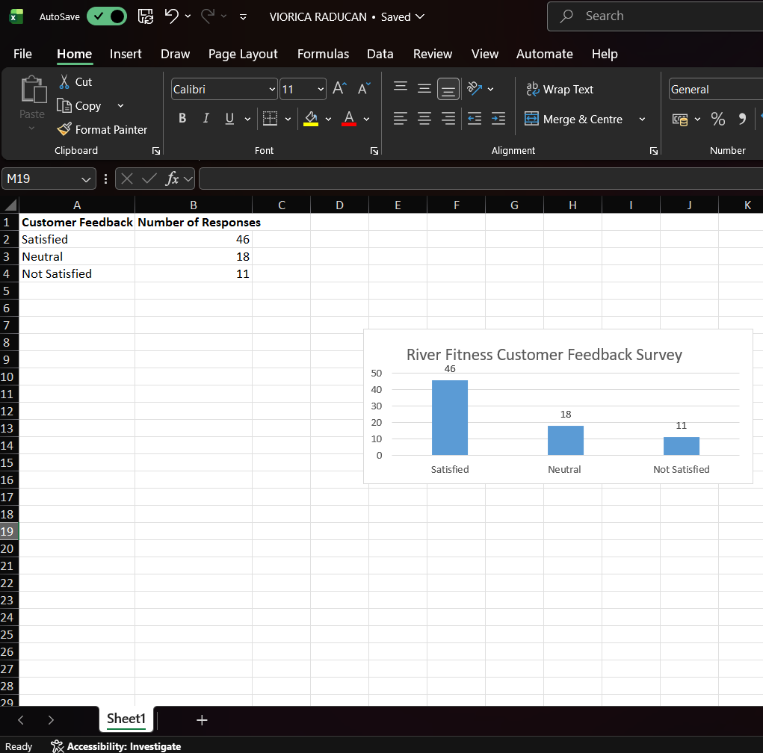

DS2 Decision & Iteration Log
Scenario 2 – River Fitness Customer Feedback Summary
1. Why I chose the tool?
For this task, I chose Microsoft Excel because it is an effective tool for organising numerical data and creating charts. The scenario required me to produce a simple digital summary showing customer feedback results and one clear chart. Excel is designed for this type of work because it allows users to enter data into tables, calculate information if needed, and create professional charts quickly.
I also selected Excel because it is one of the most commonly used programs in businesses. Managers often use Excel to analyse survey results, monitor performance and present information clearly. Using Excel helped me create a professional digital artefact that is easy to understand and suitable for a business environment.
Another reason I chose Excel is that I already have basic knowledge of the software. I felt confident using it to complete the task, and it allowed me to organise the data efficiently. Overall, Excel was the most suitable choice because it met all the requirements of the assignment.

2. What information I used
The information used in this task came directly from the River Fitness customer survey provided in the scenario. The survey results showed three categories of customer satisfaction:
* Satisfied – 46 responses
* Neutral – 18 responses
* Not satisfied – 11 responses
I entered these figures into an Excel spreadsheet using two columns. The first column contained the customer feedback categories, while the second column contained the number of responses. After entering the data, I checked that all the figures matched the information provided in the scenario to ensure accuracy.
Once the data had been entered correctly, I selected the table and used Excel to create a clustered column chart. The chart provides a visual summary of the survey results, making it much easier to compare the responses. The results clearly show that the majority of customers were satisfied with River Fitness, while fewer customers selected Neutral or Not satisfied.

3. What changes I made
After entering the data into Excel, I made several improvements to create a professional digital summary.
First, I added the title “River Fitness Customer Feedback Survey” so that anyone reading the document could immediately understand what the information was about.
Next, I organised the survey results into a clear table with headings. I formatted the headings in bold and added borders around the table to improve readability.
I then created a clustered column chart from the data. I added data labels to each column so that the exact number of responses could be seen without referring back to the table. I also adjusted the chart size and layout to make it easy to read.
Finally, I checked the spelling, formatting and layout to ensure that the document looked neat, professional and suitable for a business manager.

4. How I improved my work
I improved my work by checking the accuracy of both the data and the presentation before completing the task. I carefully compared every figure with the original survey results to make sure there were no mistakes.
I also improved the overall appearance by using a clean and simple layout. Rather than adding unnecessary colours or graphics, I focused on presenting the information clearly. This is important because business reports should be easy to read and understand.
Adding the chart was another important improvement because it allows the manager to identify patterns quickly. Instead of reading only numbers in a table, the chart provides a visual comparison between the three categories of customer feedback.
I also reviewed the formatting to ensure consistency throughout the spreadsheet. The headings, table and chart were aligned correctly, making the document more organised and professional.
If I completed this task again, I would improve it further by adding the River Fitness logo, using the company’s brand colours and including a short recommendation based on the survey results. For example, I could suggest maintaining the high level of customer satisfaction while investigating the reasons why some customers were not satisfied.
Overall, I believe my final digital artefact meets the requirements of the assignment. It presents the survey results accurately, uses an appropriate digital tool and communicates the information clearly. The table and chart make the results easy to understand, and the document is suitable for a business manager who needs a quick summary of customer feedback.

