Financial Management for the Hotel Industry
M5X01922

Student Name: Sanie ismailova
Lecturer Name: Dale Clarke
Student number:1816359

Table of Contents
Introduction 3
Task 1 3
Task 2 7
Recommendations 9
Conclusion 9
References 10

Introduction
This report has been focused on the budgeting of the organisation which need to be prepare on the basis of the estimated figures of the profit and the cash position within the company. The budgeting process will be showing the exact idea about the company’s revenue margin, estimated cost and the budgetary profit which need to be determined previously on the basis of the survey. This process will be assisted in decision making by the management team within the organisation on the several points like production scale, cost margin and the profit margin within the organisation.
Within the budgeting process, the cash budget is the most important estimation which need to be done by the management to achieve the accurate allocation of the limited resources in the required departments. The profit budget needs to be prepared to find out the expected profit by controlling the other factors within the organisation. The proper budgeting process will be associated with the controlling and planning within the organisation in several departments to control the wastages within the organisation and controlling in every sector inside the firm.
This report has been segregated into two different parts including the cash budget preparation and estimated profit budget determination will help in perceive the firm’s current position in accurate manner.

Task 1
The preparation of the cash budget has been allied with the expected cash inflows and the cash outflows and the cash disbursements during the year. The cash budget will be the estimation of the projection of cash position within the company which includes all the expenditures and the incomes and the loans receipts and payments (Robinson, 2017). The cash budget need to be prepared on the basis of the future cash position that the company can retain through several performance and it is necessary for the firm to determine the future cash position through which the company can perform its operations as well as meet all the dues arise within the firm (Reitano et al., 2019). This cash budget has been allied with the sufficient cash position through which the firm can operate its activities in the long term.
The firm has been estimated the revenue margin and the production scale to prepare the cash budget along with the firm’s spending and the accounts collections portion adjusted. If the firm does not have sufficient liquid funds that is cash funds then the firm need to raise its funds through issue shares or issue debentures in the capital market (Peters, Gudergan and Booth, 2019). The cash budget will be prepared on the basis of the monthly cash incomings and cash outgoings and with the opening cash balance and the closing cash balance adjusted (Saarinen, 2017). The cash budget will be prepared in the monthly basis to see in which sector the firm need to contribute more liquid funds and from which sector the firm can collect large amount of liquid funds (Otieno, 2019). The cash budget system has been prepared on the basis of the all the cash receipts from the debtors which need to be added with the opening cash balance within the firm. The cash payments need to be segregated in different ways and non- cash items should be excluded from these payments sectors (Schabus, Kross and Verbeeten, 2018). All the payments required to be deducted from the aggregated receipts portion that is the opening cash balance and the all cash receipts, which will be determined the closing balance of the selected month (Nishimura, 2019). This process will be allowed the firm to forecast the future cash and liquid funds needs throughout the months.
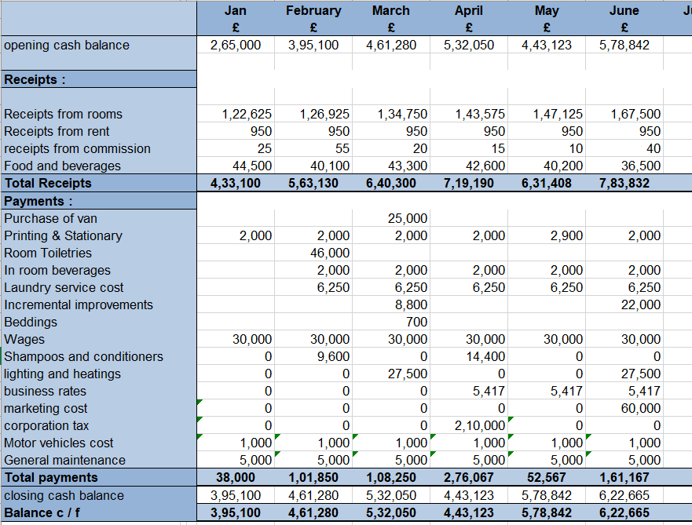
Cash projection for January To June 2020
(Source: Created by author)
The cash budget can be stated as the circular flow of the cash position within the firm in the formal presentation and this process will shows the cash disbursement in the divergent purposes and the cash collections from the different sources will be associated with the cash budget procedure (Schmidgall and DeFranco, 2019). When the future will be uncertain then the projection and the estimation of the budget will promote the clear idea about the cash requirements for the organisation in the future after considering the specific revenue level and production level (Narayan and Prasad, 2019). When the cash flow will remain stable then the management of the company can construct the cash budget on the monthly basis for the six months duration or 12 months duration. On the contrary, when the cash position is under the uncertain situation, then cash budget needs to be prepared for the quarterly time duration.
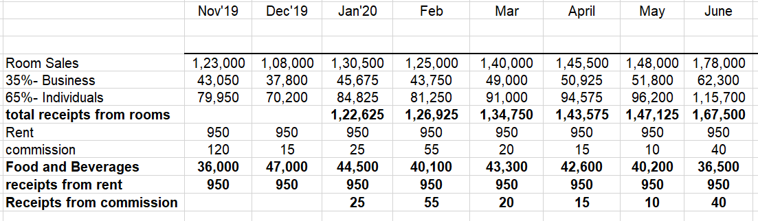
Workings for receipts part
(Source: created by author)
The cash budget is not same as the income statement as under the income statement all accounts have been mentioned and taken into account at the time of the income statement projection whereas the cash budget will be associated with the only cash incomings within the specific time period (Myint, 2019). The projected income statement will project all types and all classes of incomes and the expenditures within the firm to find out the profit or the losses of the firm. On the opposing, the projection of cash budget will be allied with the determination of the opening cash balance and the closing cash balance instead of profit margin. As stated by Kroos, Schabus and Verbeeten (2018), the cash budget will be consisted with all types of income and non- income that is the proceeds from the sale of stocks and assets and the repayments of the loans and debentures will be taken under the payments side as it has been affected the cash position of the firm. The sources of non- income will not appear under the income statement as the income from the sale of assets and stocks will not appear under the income statement (Shahlo, 2019).
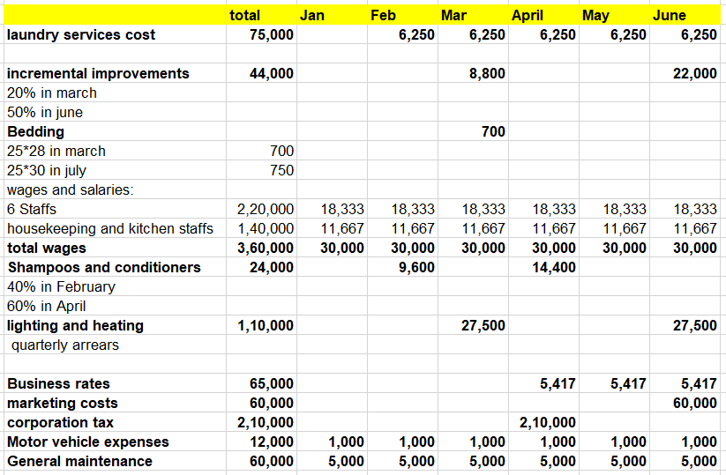
Workings for expenditure portion for January to June 20’
(Source: Created by author)
The cash budget has been associated with the all expenses that may be related with the accrued expenses or the advanced payments of costs that need to be adjusted under the cash budget (Kassahun, 2019). Whtheer the income statement has been showing the cash basis expenses and the incomes that indicated all the accrued and outstanding and advance payments and receipts need to be deducted from the current specific accounts to produce the accurate profit margin as well (Kamena and Renaud, 2019). The disbursement of the cash in terms with the dividend payments and purchase of the assets will not show in the income statement to define the profit margin but it has been counted under the cash budget as it will be related with the cash payments and the cash receipts.
Again, portrayed by Ittner and Michels (2017), the apportionment and the distribution of the several factors have been included under the income statement but that has not been included in the cash budget. The depreciation and the amortisation will not be considered under the cash budget process though these have been included under the income statement as well. As opined by Hovland (2019), the cash budget has been concerned with the timing of the cash payments and cash receipts whereas the other budgets have been associated with the time span of the transaction occurred within the organisation. The three parts within the cash budget has been identified like determination of the cash inflows and the identification of the cash outflows and the determination of the cash closing balances (Henttu-Aho, 2018). The cash budget has been oriented with the forecasting of the cash position in the future time span and the cash budget will also focus on the cash surplus or the cash deficiencies within the firm that may be occur in the future time (Voznyak et al., 2019). The cash surplus and the cash deficiencies have been associated with the positive cash balance or negative cash balances which the firm has been maintained after adjusting all the cash incomings and cash outgoings (Felicia, 2019).
The cash budget will also be prepared to assist the management team to perceive whtheer the firm needs the bank loan or not and the sector of the organisation in which the cash requirements will be the most. To plan for the advanced financing option, the firm need to prepare the cash budget and the management should also focus on the accurate financing option by considering the amount of cash requirements within the several departments (Devi and Devaki, 2019). The management can also plan for the cash requirements and on the basis of the type of requirements, the optimum option for financing can be selected by the management which will have the minimum portion of costs or charges on the profit margin. Through accurate cash budget, the management can find out whtheer there are idle cash within the organisation and the selection of the proper way to utilise the idle cash in optimum manner that will help in producing the better benefits to the organisation (Culhane, 2019). The accurate maintenance of the balance among the cash and the working capital, investments and the borrowings will be possible through the effectual preparation of the cash budget.

Task 2
Under this task, the profit budget has been focused on the basis of the time related factors that is it can be observed that in the many organisation, the time has been treated as the valuable factors in comparison with the money. The estimated profit budget has been associated with the better decision making by the management on the proper financial performance verification (Birt et al., 2020).
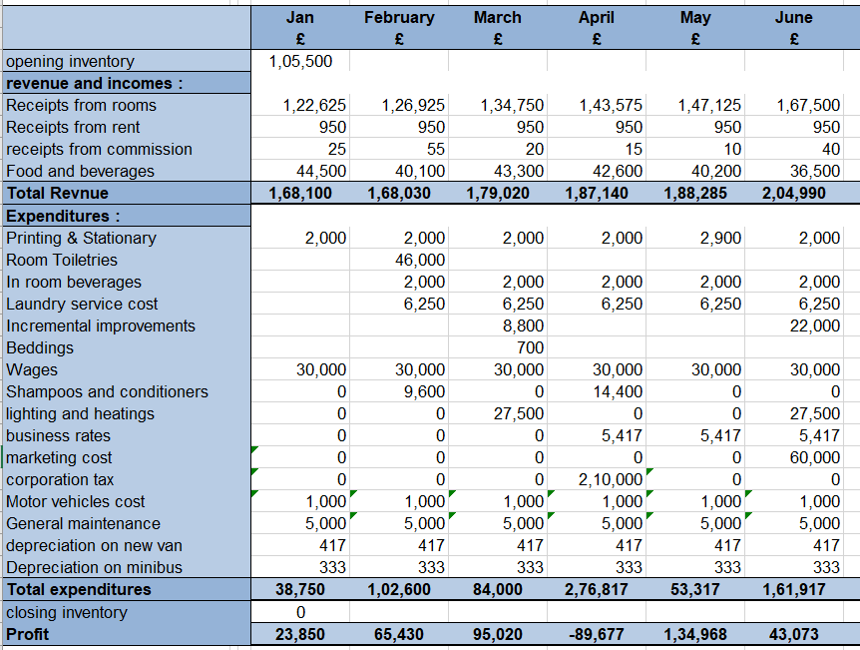
Estimated profit projection for January to June 2020.
(Source: Author)
It can be observed that the profit can be determined with the aggregated results of revenue with the closing inventory and the total expenditures and opening stock should be deducted from that (Bhar, 2019). In the month of April, 89677 losses have been observed but in the next month, the company has covered up the profit margin as well.
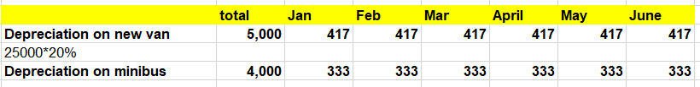
Workings for depreciation in monthly basis
(Source: Created by author)
At the beginning of the fiscal year, the management need to be focus on the projection of the revenue and the production costs which will be helpful for determination of the projected profit margin within the organisation. In this case, the cash budget has been prepared through considering the provided information and the profit estimated budget has also been prepared (Al Kaabi, Karim and Hossain, 2019). It can be observed that, there are two assets of the company, motor van and minibus which has been depreciated per annum on the straight- line mtheod which will be charged on the profit budget but it will not affect the cash budget as well. The opening inventory and the closing inventory need to be adjusted under the profit projection to find out the possible profit margin of the company (Abor, 2017). All the assets and the liabilities will be excluded from this profit projection as the all of these have been treated as the value of the business rather than the determination of the profit margin.

Recommendations
It can be recommended that the cash budget will promote the increasing opening and closing cash balances after considering all the payments and receipts. It can be observed that the Cardiff Central Hotel has been well managed its resources through controlling the costs and the available resources have been allocated in such manner which will produce the higher level of cash flow within the hotel company. The firm should focus on the minimum cash balance maintenance as the major portion of cash balance will be resulting in the idle cash within the firm. The firm should focus on the reduction of the cost level through controlling the business rates, marketing cost etc which will lead to the higher liquidity inside the firm through utilising which the firm can meet the obligations as well.

Conclusion
It can be concluded that the budgeting process will be essential features of the organisation to reach the common goals of the firm in the long run period. The projection will be help in planning and controlling in every sector and departments inside the organisation to verify the position of the firm. The performance measurements of the company as well as the employees and the managers will also be possible through accurate implementation of the budgetary control within the organisation as this will help in reaching the benchmark through application of the performance appraisals and measurements programme.

References
Abor, J.Y., 2017. Financial Planning and Forecasting. In Entrepreneurial Finance for MSMEs (pp. 199-224). Palgrave Macmillan, Cham.
Al Kaabi, O.M.S.M., Karim, A.M. and Hossain, M.I., 2019. Evaluation of Budgetary Control due to Fluctuation of Petroleum Price on Ministry of Interior, UAE: A Framework of Analysis. INTERNATIONAL JOURNAL OF ACADEMIC RESEARCH IN BUSINESS AND SOCIAL SCIENCES, 9(5).
Bhar, A.K., 2019. Design & implementation of a personal Cash flow program using Microsoft Excel®. Global Journal of Business, Economics and Management: Current Issues, 9(1), pp.29-40.
Birt, J., Chalmers, K., Maloney, S., Brooks, A., Oliver, J. and Bond, D., 2020. Accounting: Business reporting for decision making. John Wiley & Sons.
Culhane, P.J., 2019. Forecasts and environmental decision making: the content and predictive accuracy of environmental impact statements. CRC Press.
Devi, A.M. and Devaki, M.A., 2019. Applications of Quantitative Techniques in Decision Making of Business Organisation.
Felicia, C.M., 2019. Aspects Regarding The Size Of Romania'S Cash Budget Deficit. Annals-Economy Series, 3, pp.115-121.
Henttu-Aho, T., 2018. The role of rolling forecasting in budgetary control systems: reactive and proactive types of planning. Journal of Management Control, 29(3-4), pp.327-360.
Hovland, T., 2019. Effective Financial Projections for a Startup: Get a Business Started with Meaningful Financial Projections. Journal of Accountancy, 227(3), p.38.
Ittner, C.D. and Michels, J., 2017. Risk-based forecasting and planning and management earnings forecasts. Review of Accounting Studies, 22(3), pp.1005-1047.
Kamena, R. and Renaud, J.F., 2019. Applying a delta opportunity index to paid media budget planning. Applied Marketing Analytics, 4(4), pp.342-354.
Kassahun, T., 2019. Effect of Budget and Budgetary Control on Non Financial Performance: In Case of Theiopian Banking Industry (Doctoral dissertation, Addis Ababa University).
Kroos, P., Schabus, M. and Verbeeten, F., 2018, August. The Relation between Internal Forecasting, Misreporting and the Importance of Meeting Performance Benchmarks. AAA.
Myint, Y.Y., 2019. BUDGETARY CONTROL SYSTEM OF MYANMAR PRIVATE COMMERCIAL BANKS: CASE STUDY OF MYANMAR ORIENTAL BANK LIMITED & TUN FOUNDATION BANK. International Journal on Recent Trends in Business and Tourism, 3(2), pp.1-7.
Narayan, P.K. and Prasad, B.C., 2019. Fiji national budget 2003: building a resilient economy?.
Nishimura, A., 2019. Uncertainty and Management Accounting: Opportunity, Profit Opportunity, and Profit. In Management, Uncertainty, and Accounting (pp. 73-95). Palgrave Macmillan, Singapore.
Otieno, B.O., 2019. Effect of budgetary control uses on financial performance of public universities in Nairobi county, Kenya (Doctoral dissertation).
Peters, M.D., Gudergan, S. and Booth, P., 2019. Interactive profit-planning systems and market turbulence: A dynamic capabilities perspective. Long Range Planning, 52(3), pp.386-405.
Reitano, V., Jones, P., Barrett, N. and Fowles, J., 2019. Forecast Bias and Capital Reserves Accumulation. In The Palgrave Handbook of Government Budget Forecasting (pp. 377-396). Palgrave Macmillan, Cham.
Robinson, K.M., 2017. Can We Afford That?: One Library’s Transition to a Data-Rich Acquisitions Environment for E-Resource Budgeting and Forecasting. Technical Services Quarterly, 34(3), pp.257-267.
Saarinen, J., 2017. From budgeting to rolling forecasting: achieving goals for rolling forecasting implementation: case study evidence from production and retail industry.
Schabus, M., Kross, P. and Verbeeten, F., 2018. The Relation between Internal Forecasting, Misreporting, and the Importance of Meeting Performance Benchmarks.
Schmidgall, R.S. and DeFranco, A.L., 2019. Where is the Cash in Clubs?. International Journal of Hospitality & Tourism Administration, pp.1-20.
Shahlo, M., 2019. Main Directions of Improving the Efficiency of Cash Flow Management in Conditions of Modernization of the Economy. Asian Journal of Technology & Management Research [ISSN: 2249–0892], 9(1).
Voznyak, H.V., Yehorycheva, S.B., Grzebyk, M. and Pelekhatyy, A.O., 2019. BUDGETARY CONTROL AT THE LOCAL LEVEL UNDER FINANCIAL DECENTRALIZATION IN UKRAINE: PROBLEMS AND THEIR SOLUTIONS. Financial and credit activity: problems of theory and practice, 3(30), pp.328-339.

