

Assignment 1
Research Proposal

Mohammed Abdul Farhan

Civil Engineering & Environmental Management

Affects of Brexit on the UK property market

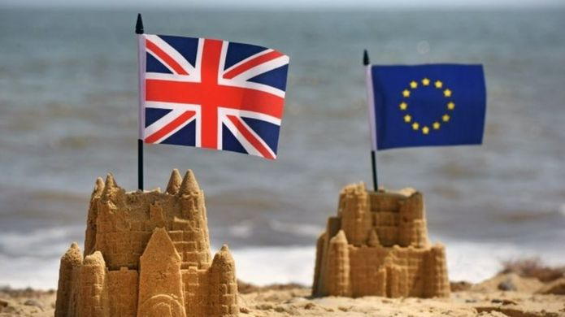

Chris House
Research Methods and GIS (M5X01904)

Content Page

1.0. Title…… Page……3
1.1. Introduction……Page……3
1.1.0 Figure 1
1.2. Literature review……Page……4
1.2.0 Figure 2
1.2.1 Figure 3
1.3. Methods……Page……5, 6
1.4. Conclusion……Page……7
1.4.0 Figure 4
1.5. Reference……Page……8

1.0 Title

Affects of Brexit on the UK property market

The word Brexit comes from the combination of Britain and Exit. It is a short explanatory way of saying UK are leaving the EU. This self written report will outline the impacts which Brexit has on the Property market within the UK including Wales. The main outline of this report will also contain why Britain left the EU and who was involved and responsible for the overall final decisions. The report will include statistically data and information in relation to previous UK house price and current house price through Brexit. From my research on the specific topic I would like to know what the difference is in the property market from 2014-2019. I will find out how many people voted to remain and how many voted for Britain to leave the EU.

1.1 Introduction

The EU which is abbreviated for the European Union is a civil bond involving 28 Countries world wide to overcome countries going into war with each other and solving the economic and political issues within each country. The EU was started after World War 2 was finished, so around September 2nd, 1945. The process of UK to leave the EU would take 2 years, Theresa May began this process on 29th March 2017, which gives a 2-year gap, the UK is notified to leave at exactly 11pm UK timing, on Friday 29th March. However, the court law states that UK can choose whether to stop the process but this involves all 28 EU members to agree to this, the current situation is that everyone is focusing on that date. There will be various comparisons between sources that are currently up to date and previous old sources, there will be contrast and what each one has to say about the vote. Using multiple sources gives a better understanding and more reliable information. My objective from this research proposal about the effect of Brexit on the property market is to understand public views as well as experts. There can be environmental influences such as Japanese Knotweed, this sort of plant grows widely in gardens and is in the effected area in which oil and other chemicals have previously been. There question is, would the council and government still grant cure for this plant? As you can not obtain a mortgage with a property that has this plant. A referendum vote was taken in place and held on Thursday 23 June 2016, 48.1% voted stay and the remaining 51.9 voted leave. Was it necessary Britain leaving the EU? Does Britain leaving the EU affect those who have property? Will there still be any benefit allowances and government grants still in place? These main questions will be answered and thoroughly explained.

Figure 1- 1.10
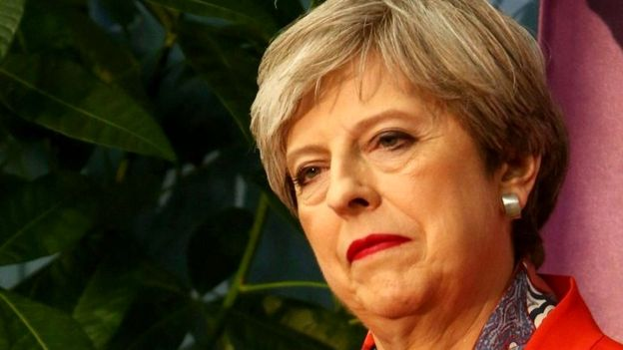
1.2 Literature Review/ Statistics

There are variable sources in which I will be using to obtain my information. From using https://www.bbc.co.uk/news/uk-politics-32810887 which is a 2019 up to date guide about the whole Brexit plan to using https://ig.ft.com/brexit-countdown/ for all my statistical data, which include what the London housing price were in mid 2016-2019. The graph which will be shown, illustrates the property pricing rising to a substantial £480,000 from £460,000 this was in 2016-2018. This is indicating positive information for those who have bought a property however, around the mid 2018, the property price drops a significant amount down to £470,000, which is a £10,000 loss. This loss was in mid 2018. Now that Brexit are on the verge of leaving in 2 months March 29th 2019, what will the drop be then after they leave. It can go back down to £460,000 or possibly even less after a period of time.

Asking experts on what they believe, also finding out what they said about the Brexit leave, would be important information. Therefore, finding out that ‘money saving expert Martin Lewis” shared that “we will have less money in our pockets if we vote to leave.” This was said on the 18/04/2016, just shortly after the decision of Britain leaving the EU. Also the Virgin CEO Richard Branson quoted “leaving would be very damaging for Great Britain.” This was said a month before the decision was made for Britain to leave. So we can see a fair few wealthy people and experts in the money market said Britain leaving would not be ideal in the fore future.

There is a government scheme in which grants can be applied and given to those who are in the low income percentage and get benefits, if they own a property by mortgage, they are able to apply for a boiler and radiator scheme. The government assess their situations and can offer these products. However due to the Brexit campaign, I had a look on find energy savings (referenced website in appendix), they had run the free boiler scheme for low income households, which their aim was to get better efficiency for there homes. The scheme was given a start and finish date, from 2012-2017, this was passed through parliament. The budget each year was 1.3billion. various types of companies such as British Gas, SSE, Npower, and E.on were the top companies who were involved in this scheme. Now with this scheme, it is still going on, but once an application has been submitted, there will be a message saying ‘sorry there is no funding in place for this scheme.’ This is telling me that Brexit leaving must have had an input to this scheme being stopped. I walked through Wales capital, Cardiff a few weeks back, I seen protests of the people with boards and banners campaigning for the funding to not stop and Brexit to stay in, so from all this there is a mix of positives and negatives which is given to me from this decision of Brexit leaving or staying. Properties may suffer insulation without the correct heating, this can lead to more maintenance in which people will not pay for and leave it, which is not a good idea in the long term as the property value will decrease, but if a new boiler was eligible for them, this would not be the case.
Figure 2- 1.2.0
Figure 3- 1.2.1
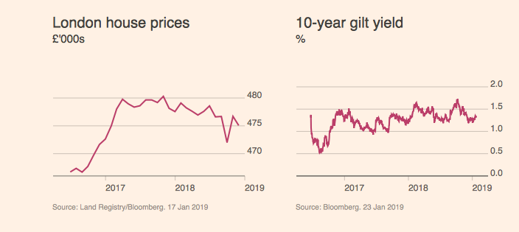
1.3 Methods

There are various methods in which I am able to obtain information for my research. Every method will have some advantages and some disadvantages but will need to look at the proposal of the research and see which will get better results and information. For example, telephone questionnaire, it is very time consuming and can be expensive. There will be certain people giving false answers to speed the process up and some hanging up mid way through it, patience would be vital. Whilst asking the public various questions about the Brexit study, noting down what they say and think is easy but doing it for 100’s of people can be extremely tiring and time consuming.

Face to face is an original method in which you can see the person’s reactions while asking them and get a better understanding from their personality and facial expressions. Going to the council asking them in person would Brexit leaving affect the schemes in place for Grant boilers, radiators for low income property owners. This method of face to face would be more ideal as you can independently get the answer yourself and have no bias answers given to you, by using an alternative method. Not only would a face to face method be useful in this scenario but would be vitally important when asking the general public opinions on the Brexit situation. Going into a village town city centre and asking members of the pubic their views and asking the type of questions which need to be answered, for the research.

A method which is modern is posting, the government and council used this method in order to gain the results they needed for the parliament decision of Brexit leaving. There is various advantages an disadvantages to using this method. Posting out petition and voting can be a waste of money for those who don’t reply and vote, however it is compulsory for those who are British Citizen’s. There can be penalty charges and fines for those who don’t reply, this is a scheme in which the government need answers from the public therefore posting out voting petitions is not a bad method to gain results. I can post out to the relevant people I need in order to complete the survey and results I need to complete my research. This can include the questions which were stated at the beginning, was it necessary Britain leaving the EU? Does Britain leaving the EU affect those who have property? Will there still be any benefit allowances and government grants still in place? These questions will have been answered and a pile of results will be gained and summarised to what people think and want.

Another method which will be used would be the internet. So social media such as Facebook, Instagram and twitter. These social sites I am able to do a poll and I can get feedback from various people about they believe and what they think the ideal scenario should be. Using sites such as Survey monkey et cetra would be a very effective way to get a lot of responses from the audience and the results and what people think can be totalled up. A key question to gain a lot of response can be, from the scale 1-10, do you believe that Brexit leaving is beneficial? The scale range people choose from would be tallied up and see what people actually think.

Finally, one other method which hasn’t been discussed is, email. Email is a method which can be used, however not everyone looks at their emails. Some emails can be lead to junk, some can’t find what their looking for, people don’t bother checking emails after a certain period of time and they intend to miss the deadline they need to finish the survey. So small factors like this would need to be carefully considered before sending out 100’s or even 1000’s of emails. Its time consuming and the end result may not be achieved as expected. Email would be suitable for a limited amount of people which I know will participate and answer what is expected. There is no guarantee that the survey sent by email will be answered therefore it is crucial to find out if people will do it and whether they will give bias or none bias answers when completing it. Friends, family, lecturers, work staff and employers would be ideal to send an email to, and giving them notice beforehand on when they will receive and when they would need to complete it by and submit their answers. There will be options for anonymous voting and what people think, this is the case if they don’t want to give their identity away and in case they get judged for what they believe is right.
1.4 Evaluation and Conclusion

To conclude this proposal, there was brief evidence about the property prices in the UK (England) from 2016 to 2019, showing the rise and the drop all being affected by Brexit. You can see experts don’t think it is a very good idea Brexit leaving, there would be problems occurring for everyone. Personally I agree that Brexit leaving is not a very good solution, due to there being no security. The UK will on be as one with no communication with other European countries. However, the UK will just save money which can be beneficial but not worth it as the security will just be poor and the UK can be a target.
To answer the proposal question, yes Brexit will have an impact in the UK property. For example, someone who’s bought a property in say 2012 in England for £380,000, the property from 29th March 2019 will have decreased, therefore they will not be happy and it will be a loss for them. Not only the general public but for high end wealthy people, they will also be taking losses. However, there are benefits in other than the property market, for example new jobs can be created, an important one would be immigration, Britain cannot prevent anyone from another state to come live in the UK. Some may see these as a bad point but everyone is entitled to their opinion. In addition to the property market, due to the prices de-valuing slowly, more people would be able to afford a property and take out mortgages. Theresa May has announced in September 2018, new funding for low cost homes, was around £2 billion to be invested. The housing associations will be allowed to apply for money for the next decade, to give them financial security stretching to as far as 2028/2029, this is a huge deal as the government has given such a long term certainty.

Figure 4- 1.4.0

1.5 Bibliography/ References

https://www.bbc.co.uk/news/uk-politics-32810887 - all about Brexit what it is, who’s involved, when UK leaves, is it happening or not.

https://ig.ft.com/brexit-countdown/ - Mostly for Literature Review

https://www.historyonthenet.com/when-did-ww2-2-end

https://www.skillsyouneed.com/learn/dissertation-methodology.html

https://www.strongerin.co.uk/experts#lOJfw3rRax30Vsva.97 - experts opinion on Brexit leaving, Richard Branson and Martin Lewis. Article from Nation builder.

https://www.which.co.uk/news/2019/01/what-will-brexit-mean-for-house-prices/ - houses prices since the Brexit vote

https://www.ncbi.nlm.nih.gov/pmc/articles/PMC5037942/

https://www.bbc.co.uk/news/uk-politics-32810887 - picture page 3, Theresa may (PM) and the British flag and European Union.

https://www.independent.co.uk/news/uk/politics/affordable-housing-social-uk-new-homes-cheap-low-cost-theresa-may-fund-a8543786.html - Theresa May on giving the housing associations huge money for a long term period, along with security.

https://sites.google.com/a/tallmadgeschools.org/tms_steam_fair/evaluation - Picture page 7 of evaluation

