IMAGES FOR MONOLOGUES

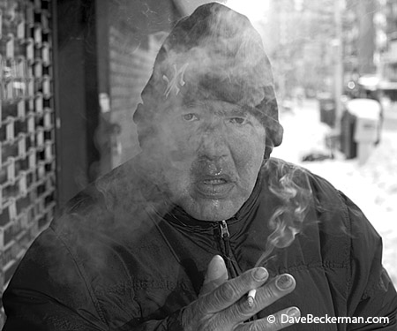

John – expert on Blues and Jazz
Dave Beckerman, 2002

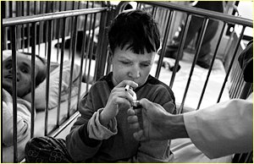

In this home for mentally and physically handicapped children in Pazaric, Bosnia, some residents spend their entire lives – even into adulthood – in cribs. Here, a nurse offers a light to a patient.
Nancy Andrews, 1998

AFTER ABERFAN

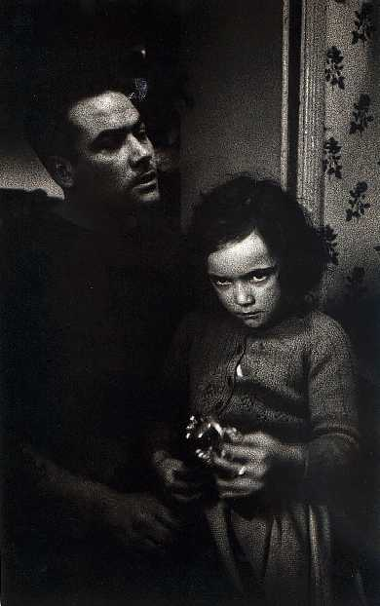

I believe her name was Cheryl. Her brother was killed in the disaster. The trauma of the events left her speechless and she wouldn't leave her father's side. Not for a minute.
I.C.Rapoport, 196

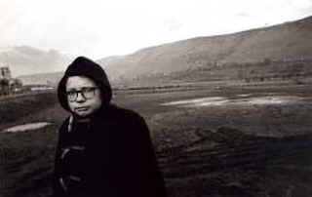

Thirty-five years have past. The boy's name now escapes me. His brother was killed in the schoolhouse. He told me he wondered why he had survived. God's will, I said. Make the best of the life you were given. Where is he now?
I.C.Rapoport, 196

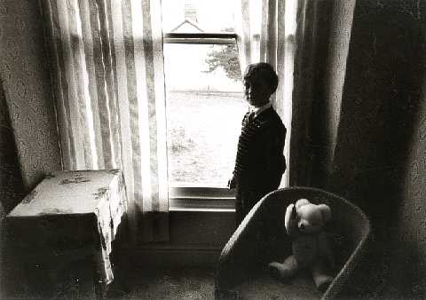

David Davies - survivor
I.C.Rapoport, 196

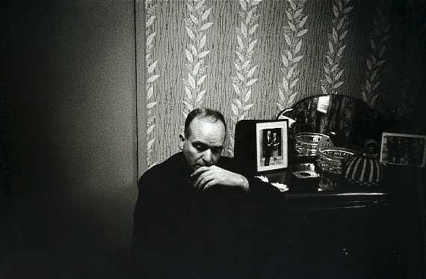

Man who lost everything: his wife, his child, and his home. Nothing was left.

I.C.Rapoport, 196

