Cormac Wynne
20th December 2019
Assignment 1
A report submitted in fulfilment of the requirements for Course ACCA4018, Department of Computing, University of Trinity Saint David’s.

Contents
Introduction 1
Comprehensive Security Policy 2
Mobile Device Management Software 4
Dataflow Diagram 6
What type of data is retained by the mobile devices connecting to CoffeeCapulus’ network? 7
What is the potential for data leakage when the participating devices leaves the office environment? 7
How to address the blending of personal and business usage when devices are in office 7
What strategy to deploy to deal with different brands of devices? 7
What strategy to deploy to deal with different Operating System platforms 7
What strategy to deploy to deal with different application on user devices 8
What mitigating strategy will be deployed when the owner of the participating device leaves their employment, or the device is lost, stolen, or fails 8
Sources 9

Introduction
This report will explore some recommendations made for CoffeeCapulus’ security policy which will cover all aspects of the network including both online and offline resources. There will also be some information on a Mobile Device Management Software that has been recommended for the entire staff BYOT. Finally there will be a report sent to the company with design the network with appropriate security configurations.

Comprehensive Security Policy
A comprehensive security policy is basically a plan that will help guide a companies (in this case Coffee Capulus) organisational structure which then ensures that their network and data is safe from security threats [1]. The University of Trinity St David’s use a BYOT system, a BYOT system is where you can bring in your own device and it’ll connect to the network and allow you to access all of your files like you would have if you were on a computer provided by the company, [3].
Using UWTSD as an example you can see that with the BYOT system they have saved lots of money as they do not need to provide each student and member of staff with a laptop or similar devices to be able to do work. Although they have a large amount of desktops and laptops for use many students and staff have their own own device that they are already comfortable with own ways.
This leads on to the next point of the advantages and disadvantages of the BYOT system. Starting with the advantages, as mentioned earlier is reduces the start up cost for CoffeeCapulus as they will not have to buy devices for people to use. Also typically the older generation find it hard to understand new devices so it will be a lot easier for them to begin work with a running start. This means that people in general will work a lot better if they already know how to use the device they use at home. By doing this it means that everyone will be a lot more comfortable doing work and will get more done sooner [4]. In return there are a couple drawbacks for CoffeeCapulus using the BYOT system, the easiest and biggest one is security, as customers can access private data on their personal device it means that that data is at risk because anyone could get a virus or something similar on their device and have it infect the entire network. Another key disadvantage is essentially an opposite version of my second advantage, as there are so many different devices that will be using this BYOT system it means that the IT security will have to be very flexible being able to use multiple different operating systems and devices, this means that they might have to increase the amount of staff they have to be able to cover the amount of security patches and updates they will have to do for every single device [5]. With these advantages and disadvantages in mind I believe that a BYOT system would work really well. This is because as a coffee shop their main demand isn’t the network it’s the coffee and if they didn’t use a BYOT then they would have to fork out for some computers that they could have in their shop and since their network isn’t their primary demand I don’t believe it’s necessary to do this.
To start with there will need to be a list of guidelines set so that personal data is not easily accessible. Most businesses have a wireless access point when using the BYOT system and they have security measures in place so that when a person firsts connects to the network they will be asked for login details to sign into the network. Users can register for free by entering their email and a password of choice and a basic new account will have minimum access granted. This first initial method is quite efficient because it means that someone with ill intent couldn’t get access immediately, they would have to create an email first which takes time so that it’s not worth them doing it. There would then be a second level of security for staff, they will have slightly more access as they have work privileges and a staff moodle. Secondly to last there will be a Manager type layer in which they will have access to the more private data and lastly there will be the Admin layer which will have access to everything. Obviously this is the most important role which means that the select few that have this role will need to make sure they have very good personal security. With this Admin role they will also be able to change the roles of other people's accounts. E.g. if a member of staff gets promoted to manager their account can just be simply upgraded to the next layer without having to remove said account in replacement for another.
Once this is in place penetration testing can start on the network to see if they can find any holes. Penetration testing, also called ethical hacking is where you test a network, computer system or a web application to see if there are any cracks or holes in said system to prevent attackers from gaining access. The basic gist of ethical hacking is gathering information before you start the test, once you’ve done this you try to identify the possible cracks or holes if there are any to try and break in to the system to later report the information you’ve gathered. [2]
Once the layered network is in place and it has been subjected to some ethical hacking, as long as there are no gaps then the system will be solid.

Mobile Device Management Software

A Mobile Device Management Software (MDMS) is used in an IT department to keep a close eye over the employees’ mobile devices. This can be quite tricky because there will be multiple mobile service providers and also lots of mobile operating systems[6]. Coming to the conclusion of research for the best MDMS Software the conclusion is that SOTI MobiControl has services with exceptional value. This is because they are well priced along with their other competitors but do a good job of getting a balance of every aspect rather than focusing on a few, it has all of the features you would normally expect with an MDMS but SOTI also has a great feature where you setup a remote control feature for the Android Platform and finally they have such an easy to read set of rules that even someone without much computer knowledge would be able to use this software. Reading reviews about SOTI however it is said that the device registration process is rather annoying and the dashboard that is used is not customisable which is a bit of a pain but the advantages greatly out way the disadvantages in this software [7]. The second choice would have been Airwatch by VMware. Although you could class these as the market leaders they have a limited support for Windows 10 devices which is just not going to be acceptable for the company [8].

MobiControl has a few services that are pretty good. But the best service is the SOTI Professional Services. As you can see from the images below it covers a lot of services that would help get the MDMS set up and working with ease.

Rapid Implementation Service :- Quickly deploy the MDMS to devices.
Migration Service :- Migrate instances of devices to other devices.
Version Upgrade :- Upgrade versions of the MDMS on the fly.
Test Server Setup :- Have a test server setup to simplify the rollouts of the MDMS.
Advanced Certificate Integration :- Data being used on the system is secured.
Customized Hourly Service :- Have a consulting service setup for hourly consulting expertise.
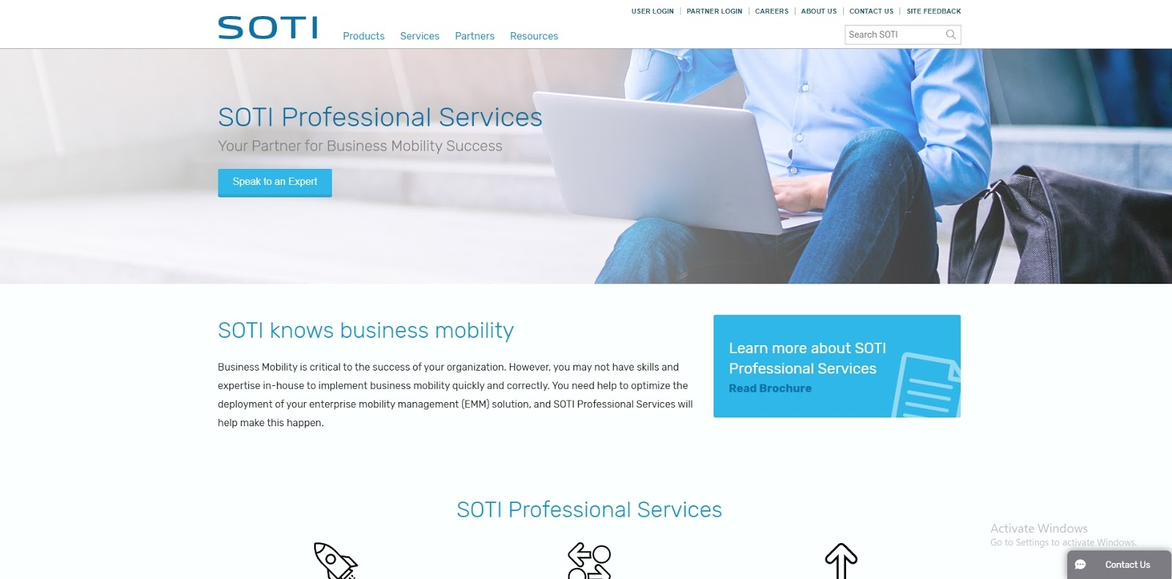
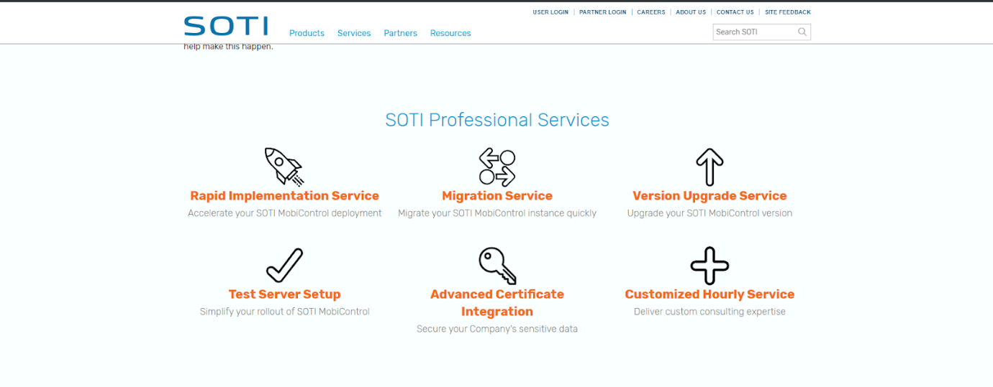

Dataflow Diagram
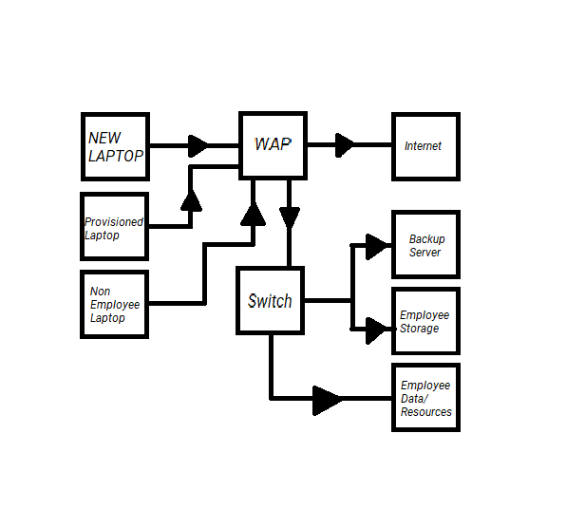
This is the dataflow diagram of my BYOT network. The New Laptop, Provisioned Laptop, and Non-Employee Laptop are connecting to the WAP (Wireless Access Point). The WAP is connected to the switch, and the internet. Each laptop has a different level of permissions. The provisioned Laptop can connect to the backup server, the employee storage server, and the employee data/resources server.

What type of data is retained by the mobile devices connecting to CoffeeCapulus’ network?
There are quite a few things that could potentially be stored on a mobile device connected to a network. The two most notable ones are the details about the wireless access point, and personal data, or data needed for home use. The wireless access point details are saved on the device so that when the device returns to the area, it can auto connect to make using the network smooth and user friendly. As for personal data, that can be things like project files, video files, audio files, etc.

What is the potential for data leakage when the participating devices leaves the office environment?
Data leakage from an office environment is quite a common problem. Though its quite common it can cause a lot of damage if not dealt with correctly. Employee’s having the ability to connect their own devices to the company network allows them to take some information away from site on their devices as spoken about above. The risk of an employee’s device getting hacked, or stolen, etc can cause a lot of damage to the network. If a hacker were to gain access to a device with high permissions on the network, they could steal data, cause damage, and ruin the network from the inside.

How to address the blending of personal and business usage when devices are in office
Blending personal and business usage when devices are in office can be quite an easy feat to achieve. The quick, basic way is to just block all social media from incoming traffic. This stops employees from using social media. You can also do this with game servers and other blacklisted addresses. The harder but better for employee’s route would to blacklist some address, but address that can be used for both personal and business are monitored. This means if anything non business related is being done on said address, the device is blacklisted from the address.

What strategy to deploy to deal with different brands of devices?
The best strategy to deploy to deal with different brands of devices is to limit the brand of devices allowed to be used on the network. Limiting laptops, and phones to Microsoft and Apple based devices allows you to control the software used on the network. This also allows you to make sure devices are capable of the work being done. Having an old device connect to the network and try to handle the work needed for the company may not be as efficient and a newer, more up to date device.

What strategy to deploy to deal with different Operating System platforms
Like what was said above, the best strategy to deploy to deal with different Operating Systems platforms is to limit what operating systems a device can use. Limiting the Operating System to windows and apple Operating Systems allows you to control what software is being used on the network. This can also help stop attacks on the network. A Linux device can have a lot more tools for hacking and breaching a network than other operating systems. This is partly due to the fact that the Operating System is open source.

What strategy to deploy to deal with different application on user devices
Limiting what applications a device can have can stop employees from wasting time through games and social media. Having a restriction on specific wireless access points can be great. For example, restricting access to social media applications and game applications when connecting to a wireless access point at the office, then when the device connects to the wireless access point at the cafeteria those applications are allowed to be accessed again. This allows for employee’s to use these applications on their free time or in an emergency, but still restrict the employee’s when they’re supposed to be doing work.

What mitigating strategy will be deployed when the owner of the participating device leaves their employment, or the device is lost, stolen, or fails
The mobile device management system allows you to do a lot of things when an employee loses a device. You’re able to ping the last GPS location of the device to get an exact location of the device. You could also lock the device while you look for it, and even copy the data on the device, wipe the device, and put the copied data onto a new device. If the device is off and isn’t connected to the network anymore, it can be requested to be wiped, and a backup could be on the backup server of the network.

Sources
[1] - https://www.proserveit.com/blog/creating-comprehensive-security-policy
[2] - https://searchsecurity.techtarget.com/definition/penetration-testing
[3] - https://www.techopedia.com/definition/28145/bring-your-own-technology-byot
[4] - https://www.msidata.com/pros-and-cons-of-byod-in-mobile-field-workforce/
[5] - https://www.1rti.com/the-advantages-disadvantages-of-byod/
[6] - https://www.webopedia.com/TERM/M/mobile_device_management.html
[7] - https://uk.pcmag.com/cloud-services/82176/soti-mobicontrol
[8] - https://uk.pcmag.com/cloud-services/76019/vmware-airwatch
[9] - https://www.soti.net/

marking criteria and Student FEEDBACK

This section details the assessment criteria. The extent to which these are demonstrated by you determines your mark. The marks available for each criterion are shown. Lecturers will use the space provided to comment on the achievement of the task(s), including those areas in which you have performed well and areas that would benefit from development/improvement.

Common Assessment Criteria Applied (Assignment 1) | Marks available | Marks  awarded
1. Research-informed Literature
Extent of research and/or own reading, selection of credible sources, application of appropriate referencing conventions.
The referencing convention used but the report lacks credible sources such a peer review articles. Only websites sources used. A number of areas within the report could utilised more referencing citation. (Grade mark: 40.00%) | 15 | 6
2. Knowledge and Understanding of Subject
Extent of knowledge and understanding of concepts and underlying principles associated with the discipline.
Based on comments above, using peer review articles to aid your discussion would demonstrate good understanding. The basic concepts of subject area were explained. (Grade mark: 43.33%) | 15 | 6.5
3. Analysis
Analysis, evaluation and synthesis; logic, argument and judgement; analytical reflection; organisation of ideas and evidence
The report inter-relate your explanations to the case study but could also with your design. See further comments within the report. Written security policy and DFD done. No final conclusion or future work was done.(Grade mark: 55.00%) | 40 | 22
4. Practical Application and Deployment
Deployment of methods, materials, tools and techniques; application of concepts; formulation of innovative and creative solutions to solve problems.
Very basic design with no security measures considered on switch and wireless router. Also no security measures considered between wireless router and the Internet. (Grade mark: 40.00%) | 20 | 8
5. Skills for Professional Practice
Attributes in professional practice: individual and collaborative working; deployment of appropriate media; presentation and organisation.
The report could do with formatting and justification. Spell out all acronyms first time used, avoid first person writing and using contraction grammar for academic report. (Grade mark: 45.00%) | 10 | 4.5

Assignment Mark (Assessment marks are subject to ratification at the Exam Board. These comments and marks are to give feedback on module work and are for guidance only until they are confirmed. ) | Late Submission Penalties (tick if appropriate) |  | 47%
 | Up to four weeks late |  | 47%
 | First Attempt? |  | 47%

