

Student: Pranchesco Jordan (2131033)
Lecture: Lloyd Beharry
2022-2023

The Models of Communication
The advantages and disadvantages
Index
- Introduction
  - Communication at work
  - Poor communication at work
  - Barrier that affects the message
- Models of Communication
  - Shannon and weaver (1948/49)
    - Own Example
  - Schramm (1954)
    - Case study
  - Berlo (1964)
    - Factors Elements
- Communication Skills
  - Verbal Communication
    - Case study
- The Advantages and Disadvantages of communication technology
  - Advantages of Communication technology
  - Disadvantages of communication technology
- Conclusion
- References

Introduction

Through the years, the different institutions have been trying to define “Communication”. Firstly, where is the word communication coming from? The Association of Perioperative Practice has view that the word is originated from the Latin word “communis”. Lunenberg (2010) has consider that communication has its root in Latin from the word “communis”. However, he considers that it means “common”, Which suggests that must be a common understanding of the message between the source and the receiver concerning the message being communicated.
Well, now that you understand the roots of the word, lets describe the process. Transmission of verbal and nonverbal messages occurs during communication. It is made up of a sender, a receiver, and a communication channel. In the process of transmitting messages, the clarity of the message may be interfered or distorted by what is often referred to as “Barriers”.
Communication at work
In our daily lives, communication is essential. Although, the communication looks like an easy skill for everyone, for some people the skill of effective communication at work is quite mysterious.
But if you are unable to communicate clearly, you risk losing the opportunity to land your ideal job, close a deal that will change your life, or advance in your career.
While effective communication may come naturally to some people, it can be challenging for others to express their ideas and emotions in a conversation, which frequently results in disagreement and fundamental issue. It’s essential to understand the importance of good communication and how it can help you become more professional at work to move forward in the working world.
Poor Communication in workplace
Companies go into developing communications strategy in order to reduce uncertainties, stress and conflicts that Employee could go through, however, become unsure of their positions and the value they provide to the firm due to poor and effective communication. Employees could unintentionally transgress rules or lose out on perks they are entitled to if a manager, for instance, fails to inform them of updated corporate policies. As a result, mistrust, annoyance and conflict between the parties concerned are possible.
Barrier that affects the message
In the communication process, we can find different barrier, for example when talking in the same language, a message’s terminology may serve as a barrier if the recipient does not completely understand it. For instance, a receiver why is unfamiliar with the terminology used will not understand a message that uses a lot of specialized jargon and abbreviations.

Models of Communication
Shannon and Weaver (1948/49)
In 1948, Shannon was an American Mathematician, Electronic engineer and Weaver was an American scientist both join to write an article an article in “Bell System Technical Journal” called “A Mathematical Theory of Communication” and called as “Shannon-Weaver model of communication”.
The Shannon-Weaver model introduces 5 key stages to the communication process:
- The sender
- The encoder
- The channel
- The Noise
- The decoder
- The receiver
The person, group, or organization who first considers the message they intend to deliver is the Sender.
The encoder takes this message and turns it into signals. In other words, this is the vocabulary we employ to communicate our ideas. It could be expressed verbally or in writing, as well as through body language or signing. Even the use of gifs and emoticons constitutes encoding!
How the communication is sent is referred to as the channel. This could be binary data sent electronically in an email or text message, sound broadcast over the airways during a spoken discussion, or both. Of course, the sender and recipient may require tools like phones or laptops depending on the Channel.
The message must be decoded after it is received. This phase outlines how the message is interpreted and translated into language by the receiver. Once more, a computer that performs this electronically using binary data is conceivable. Alternatively, our brains may be able to process all language and communication data, such as words, images, intonation, and other elements that make up a communication transaction.
Finally, the receiver has the message, interpreted by their brain into something meaningful.
Now we can find a stage that is between Channel and decoded and is named “Noise” this stage in the Shannon Weaver model. A message is interrupted as it is being transmitted from the sender to the recipient by noise. Its name refers to the notion that “noise” could prevent us from interpreting a message. Noise comes in two types: Internal and External
As any models of communication, it could have some misunderstanding. That’s why is very important to pay attention on the vocabulary because what is normal for one person, is not always ‘normal’ to others. And when conventions aren’t clear for everyone this can lead to noise, which can then eventually lead to misunderstanding and miscommunication.


Own Example
At my work my boss changes my schedule and call me saying: “Please, come to work before 5, because we are busy “but because of a noise produce because I was going under a bridge, I heard “please come to work at 5 “and I came at 5 and I was late.

Schramm (1954)
The Osgood-Schramm model is based on the idea that communication involves a sender and a receiver in both directions. This model of Communication is different from the Shannon and Weaver (1948/49) especially in the idea. This idea was circular rather than linear, requiring two individuals taking turns sending and receiving a message.
The structure of the majority of communication models can be determined by looking at their many components. The parts of the Osgood-Schramm model are quite straightforward.
Sender: The sender of a communication is the one who encodes (converts) and send it.
Message: This is the content that the parties are exchanging.
Receiver: This individual decodes (interprets) the message.
Semantic barriers: Interruptions in the communication process are referred to as semantic noise. The noise detracts from the message, causing it to fail and the communication process to fail.
Because of noise, the intended meaning with which the sender transmits the messages may also result in a modification of the message’s meaning.
Feedback: The process of the receiver communication is known as feedback. Through feedback, a receives confirms that the message has been received.
When the receiver begins transmitting information depending on the input, he has received from the sender, this information is sent back to the sender as feedback.

Case Study (Maria and Pedro)
In this example that was show and study at class, where there was a misunderstanding between Maria and Pedro where She said “Hello, Pedro, when you’re coming home, see if you can get me a chicken.” And because of the noise at the place, he didn’t listen everything and he thought she said, “when I come home, I will see you in the kitchen!” so in this case we can clearly see that the noise was semantic barriers.
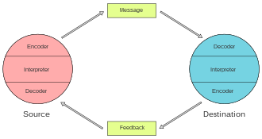

Berlo’s (1964)
The SMCR Model of Communication by David Berlo captures communication in its most basic form, Sender, Message, Channel. And Receiver are all abbreviated as SMCR.
The several elements that make up the fundamental process of communication are described by Berlo’s SMCR Model of Communication from 1960. This communication tool can be utilized for more effective communication because it also emphasizes the coding and decoding of the message.
Factors of Elements
Source: The source is situated where the message originates.
Communication skills: Individual ability to communicate (read, write, speak, listen)
Attitudes: This includes attitudes towards the audience, subject and towards oneself.
Knowledge: In order to communicate effectively, a person be knowledgeable about the subject at hand
Note: it refers, not to the general knowledge, but to the knowledge of the subject that the person is communicating and their familiarity with it
Social system: The social system refers to all the components of a society (belief, values, religion)
Culture: A given society’s culture is included in its social structure
Encoder: The encoder is the transmitter of the message, or the point at which the message.

Message
Content: The body of a message, from start to finish, makes up its content.
Elements: It includes various things like languages, gestures, body languages.
Treatment: This term refers to the messages’ packaging as well as the way it is delivered.
Structure: How a message is organized and divided into different pieces is referred to as the message’s structure.
Code: The message’s code refers to the method and format used to send the message.
Channel: It refers to the five sense organs. The following are the five
- Hearing
- Seeing
- Touching
- Smelling Tasting
Decoder: A decoder is a person who receives a message and decodes it.
Receiver: In order to properly interact with and respond to the sender, the receiver must consider all the contents and elements of the source.
Case Study (THE PROFESSOR and THE VILLAGE PEOPLE)
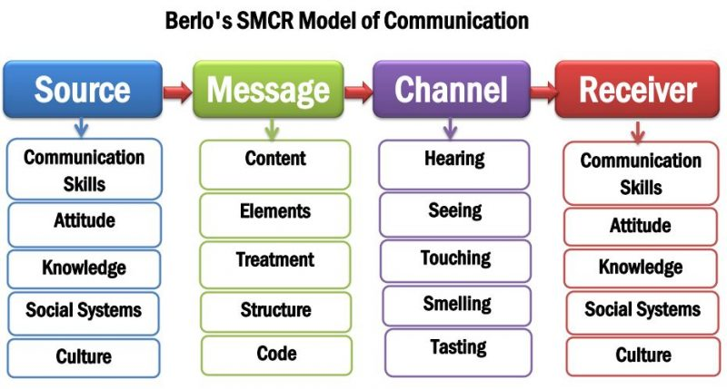
In this Case we study how a teacher suffer from a fire at his house and when he tried to ask for help at the village with the phrase “The edifice is being consumed by a great conflagration” because the vocabulary was different to the one that in the village use it, so the message wasn’t delivered because the people didn’t understood him

COMMUNICATION SKILLS
Verbal Communication
Non-verbal communication: It’s interesting to notice that nonverbal cues are employed both consciously and unconsciously.
Most of the people struggle with maintaining complete control over their facial expressions; we have all heard an unprofessional remark and raised our eyebrows in reaction, whether it was a good idea.
You will be able to master your non-verbal communication and make sure that you are communicating your message exactly how you intend to by becoming more aware of how we use it. Examples:
- Facial Expressions
- Posture
- Gesture and physical touch
- Eye contact
Verbal Communication
When we speak, we convey much more than simply the words. In order to communicate essential subtext to the person we are conversing with, we also use pitch and tone in addition to the formality of our voice. Using each of these components wisely will ensure that our message is understood just as we meant. For Example:
- Pitch
- Tone
- Content
Listening skills in communication
The ability to listen is a key component of effective communication. If you are able to effectively communicate, you can start to enhance social and professional relationship. Additionally, you’ll be able to make decisions more quickly and come to agreements with others
Empathetic listening: is a structured listening and questioning technique that allows you to develop and enhances relationships with a stronger understanding of what is being conveyed
Case Study
We study with the case of Max Multitasker where we analyze his situation. He was overload with activities to the point he lost concentration of his work, and he didn’t remember that he was told to change a date for the event and he mixed the events, this is a clear consequence of not concentration at work and as result it produce misunderstanding causing a mistake at his job.

Communications Technology Advantages and Disadvantages

ADVANTAGES
Greater Accessibility: Technology has increased access to communication. With the internet and technology, communication has become more accessible than ever before.
More Reliable way to communicate: The technology through the years has become better and making communication more reliable than ever.
More Secure: Technology has become more secure than ever because with the technology eliminates the risk of people being spied on/listen to by others, allowing for a more secure way to communicate.
More Efficient and Effective: Technology has made communication more efficient and effective. It has made communication quicker and easier, which allows us to make decision faster.

DISADVANTAGES
Privacy Issue: one of the most problems at the moment is the threat that technology face such as hacking your private information and produce leaks of information or install false information.
Increased Stress: Technology make people to work faster and as consequence make people busier and produce stress, also because of technology people get more text and call at day.
Socially Awkward: There such a thing as being “too” connected nowadays. People are constantly watching their phones and using airphones, so they can’t afford to pay attention to the people around you.

Conclusion
Through this module, we have study and explore the communication models, we were able understand how they are applying to our day lives. However, we identify the importance of be able to communicate perfectly in order to have a better experience at your workplace, we discover the benefits of have good skill communication and how can affect on your life, we study deeper each of Model and identify the difference between each one, and we were able to classify the advantages and disadvantages of the technology applied on the communication

References

Claude E. Shannon and Weaver w. (1964) “The Mathematical Theory of Communication”, The University of ILLINOIS PRESS, United States.
Faulkner A. (1984) “Communication”, Churchill Livingstone
Kobiruzzaman M. (2021) “SMCR Model of Communication David Berlo’s SMCR Model of Communication” Available at: https://newsmoor.com/smcr-model-of-communication-david-berlos-smcr-model-of-communication-example/ (Accessed 27 December 2022)
Mehta R. “Schram Model of Communication – Definition, Limitations and example”. Available at: https://digiaide.com/schramm-model-of-communication/ (Accessed 27 December 2022)
Truex M. (2002) “Shannon & Weaver’s Information Theory”. Available at: http://zimmer.csufresno.edu/~johnca/spch100/11-1-shannon.htm (Accessed 26 December 2022).
Valamis (2021) “Types of Communication”. Available at: https://www.valamis.com/hub/types-of-communication (Accessed 31 December 2022).
Wilshiere J. (2021) “The importance of listening skills in Communication”. Available at: https://www.oneeducation.org.uk/importance-of-listening-skills-in-communication/ (Accessed 27 December 2022)
Zambas J. (2021) “The importance of effective Communication in the Workplace". Available at:https://www.careeraddict.com/the-importance-of-effective-communication-in-the-workplace (Accessed 26 December2022).

