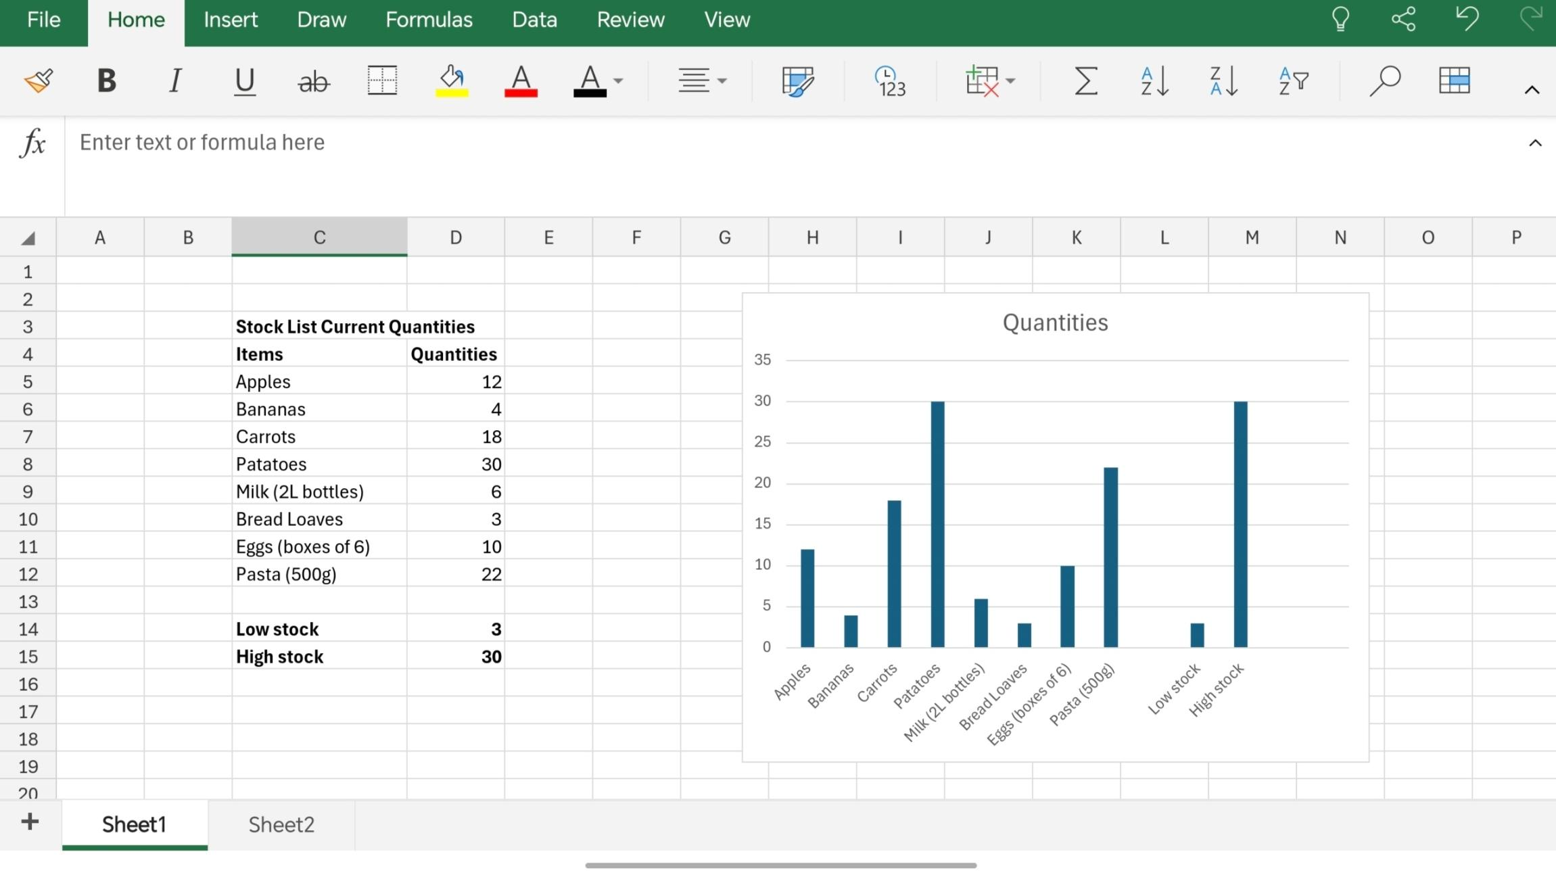
Decision &Iteration Log
1.Why I choose my tool?
I choose Microsoft excel because it is good for organising stock data,creating tables and marking charts,It helps display information clearly and makes it easier to compare quantities of different items.
2.What information I used
I used the stock list from the scenario,I included the items names,their current quantities,the low stock level(3) and the highest stock level(30)
3.How I created my artefact
a)First I entered the stock data into an Excel table
b)Then I formatted the headings in bold to make them easier to read
c)After that I created a column chart to compare the quantities of each item
d)I used the formula =MIN(D5:D12) to found the lowest quantity from my list(3) and =MAX(D5:D12)to found the highest quantity from my list(30)
e)Finally I checked the data to make sure all values were correct
4.What changes I made
a)I adjusted the labels so the items names were clearer
b)I organised the table to improve its appearance
c)I added the low stock and high stock values to summarise the data
5.Feedback I used
My tutor said the chart should be easier to read.I changed the chart layout and used bold headings to improve the presentation.
6.Final explanation
This artefact helps a business quickly see current stock levels and identify which items have the lowest and highest quantities .The chart makes the information easy to understand and support better stock management.

