Name: Keira Pritchard (2503415)
Module: Niche Marketing and Social Media
Module ID: BMTH4014
Lecturer: Chris Wilkin
Due date: 27th March 2026
Word count: 1508 words

Marketing REPORT for the House party event at the swansea arena

AI acknowledgment
I can confirm that I have not used any AI tools in the research and creation of this assignment. I confirm I have not presented any AI generated materials as my own work. I confirm I have copies of my drafts, notes, and other sources I used, which I may be asked to provide in evidence.

Table of Contents
Introduction 3
Situation Analysis 3
Objectives 5
Strategy 5
Tactics 6
Action 7
Control 7
Conclusion 8
References 8
Appendices 10

Introduction
The purpose of this is to develop an effective niche marketing report using SOSTAC to promote and publicise, while using a strategic approach for the House Party event at the Swansea Arena, targeting consumers who are 18-35 years old, seeking entertainment through music (Gen Z and young Millennials). This plan applies key marketing frameworks such as 4P’s, PESTLE, 5 C’S and RACE, while using strategic marketing and niche market planning. This report will help The House Party event gain competitive advantages. Digital Marketing concepts according to Chaffey and Smith (2023) show the integration of social media, influences, and online engagement strategies.

Situation Analysis
5C’s Analysis Model
Company: A SWOT analysis (Appendix 1) highlights how the House Party event at Swansea Arena befits from the strong venue reputation, high quality production, and its central location. However, social media engagement fluctuates, and consumers are more price awareness which remains a challenge within this market. Opportunities for the House Party event include influencer partnerships and high engagement of online content, while threats include cost of living, competition from other local venues, and changes in trends.
Customers: Based off (Appendix 2) findings the Swansea Arena appeals to Gen Z and young Millennials, demographically this includes individuals who are primarily 18–35-year-olds. These consumers depend heavily on social networks, using Facebook and YouTube (Appendix 3), also recommendation from consumers that are at similar ages, and online reviews when choosing an event (Chaffey et al, 2019). Psychographic wise, the consumers are defined by lifestyle-driven consumptions, looking for identity expression through events and music (Kotler et al, 2024).
Competitors: The competitors of the House Party event include Swansea.com, Elysium, Sin City, The Bunk House, Jack Murphys, and Hanger 18 Music Venue as these venues offer similar genres and events. Using perceptual mapping (appendix 4) highlights how the Swansea arena can position itself as affordable pricing and high-quality production, also offering differentiation at its arena (Tresidder & Hirst, 2012).
Collaborators: The collaborators of the House Party event include The Bunkhouse, Elysium, Hangar 18 Music Venue, Hippos, Sin City and University of Wales Trinity St David (ATG Tickets, 2025). These collaborators enhances’ the credibility and reach of the House Party. On the other hand, collaborating with influencers can be on the House Party event can be worthwhile in reaching consumers and can help build trust (Chaffey et al, 2019). Collaborating with these venues has promotional effectiveness and helps build distribution.
Climate: The PESTLE framework (Appendix 5) evaluates the macro environmental factors influencing the marketing and delivery of House Party. For the political environment, safety regulations are crucial as an event needs to be in a venue where it is deemed as safe to avoid any economic damage or loss of tourism (Hall, 2019). The economic factors can affect the consumers and the event with the rising inflation and interest rates it can reduce the disposable income impacting ticket pricing strategies, estimating venue costs, and the levels of attendees (Akinsowon, 2018). Pricing strategies must be able to balance affordability while still being profitable. The Swansea Arena helps with social factors as it is accessible and modern which attracts audiences who are seeking experiences. Social influences like online reviews, peer recommendations, and social media content can shape attendees’ decisions as music events serves as social movements (Bhorkar, 2025). Consumers seek authentic experiences, which aligns with grassroot events (Frochot and Batat, 2013). Technological advancements are crucial to marketing and delivering events as social media allows for promotion, community building, and engagement from consumers (Chaffey et al, 2023). Artificial Intelligence can be used for personalised marketing and enhancing attendee engagement (10times, 2023). While virtual reality allows for enhances event experiences. For legal, this includes a health and safety regulations, alcohol licensing, not being able to comply with these regulations can result in fines or the event getting cancelled, making legal factors crucial for event planning and marketing (Middleton et al, 2009). Lastly, environmental factors are important as issues like waste generation, noise pollution, and energy consumption must be addressed to meet the stakeholder’s sustainability standards.

Objectives
SMART Objectives
S: target 18–35-year-olds who are driven by social media.
M: Achieve 75% ticket sales in 6 weeks.
A: Use social media platforms and influencers to engage this demographic audience (18-35).
R: Supports the goals of engagement, attendance, and awareness.
T: Achieve all objectives within 5-6 weeks prior to House Party.

Strategy
The market strategy for the House Party event reflects the market penetration approach. The demographic 18–35-year-olds are highly engaged online, so using promotional activity on online platforms to increase attendance.
4P’s Marketing Mix
Product: The House Party is a grassroot music driven event. The branding of this event includes inclusivity, visual appeal, and music nightlife culture, this aligns with the experiential marketing principles (Middleton et al, 2009).
Price: The pricing strategy incorporates supporting the local music scene and early bird tiers. This reflects yield management that is commonly applied in hospitality and events to help with revenue (Bowie, 2017). The pricing also reflects affordability and value.
Place: Tickets are being distributed primarily through digital platforms such as AGT Tickets and Eventbrite, the demographic has a higher mobile phone usage which is crucial. Swansea Arena being located in the central supports’ accessibility and is known for being consistent with tourism.
Promotion: The House Party will rely on digital marketing, using social media platforms for advertising, and influencer partnerships. CRM tools will part audiences and have personalised communications, gaining loyalty and change (Jobber and Ellis-Chadwick, 2020).

Tactics
Race Framework
To promote the House Party event, will be used along with a mix of communication methods, this is designed to target the demographic 18–35-year-olds.
Reach: the outcome of this is to have more engagement for the event. Social media platforms such as YouTube and Facebook will be the focus, as Sparktoro (appendix 3) shows that this demographic uses these platforms for the Swansea Arena the most. Location based targeting will help reach people near or outside of Swansea. Music-based influencers will be able to help promote the event and can improve trust and visibility.
Act: To get the demographic to interact and engage with online advertisement, promoting content such as behind the scenes, short formed interactive posts, and pre-event interviews can encourage engagement. The Swansea Arena Website should have a clearer navigation on mobile to attain tickets. As (appendix 6) shows 93.44% who visit the website are mobile users. Improvements for the website could include responsive layout that automatically adjusts to fit the screen size of any device, simplifying the navigation of the website on mobile devices, and enhance the speed of the website as delay can cause users to leave the site, dropping the visit numbers on the website.
Convert: Offers like group deals and discounts for early bird tickets can attract the younger demographic as they can be affected by inflation rates making the costs more appealing. Reshowing advertisements to consumers who has shown interest on the website, helping these to complete their ticket purchase.
Engage: Once tickets have been bought, using social media hashtags and encouraging attendees to share their experience after the event will build publicity. Reviews of the event on Trip Advisor can improve the reputation. Lastly, follow up emails about future events and offers can help with consistency.

Action
The Gantt chart (appendix 7) shows the timeline for the House Partys marketing communication plan, with how the different promotional actions are scheduled across the months. For advertisements, social media ads run for a longer duration to build awareness, whereas early bird tickets and group discounts run for a shorter duration to drive urgency for ticket sales. Direct marketing includes retargeting ADs to use to deliver messages and encourage sales, particularly among the target audience 18-35 as this demographic is highly responsive to digital communication (Chaffey et al, 2019). Influencer collaboration and email marketing are timed around the event to reach engagement and create anticipation. Altogether, the Gantt chart supports the RACE framework and help to achieve the objectives, making sure marketing efforts are going into effect.

Control
Using key performance indicators (KPI) can track engagement and sales. One KPI is ticket sales, aiming for 75% sales in tickets, which shows revenue performance. Social media metric such as likes, comments, and follower growth will measure brand awareness among the target audience 18-35. Web analytics which include page visits, will track how the target audience will move from interest to buying tickets using tools like SimilarWeb. Using customer data such as number of new customers and emails signups can track audience growth. Lastly, profit levels can evaluate the financial success. Using KPI’s to monitor allows for the marketing strategy to stay effective, aligning with the objectives.

Conclusion
In conclusion, this marketing plan efficiently targets 18-35 demographic, using a structed approach such as the 5 C’s, PESTLE, and RACE frameworks. This approach highlights the importance of digital marketing, influencer engagement, and ticket sales towards the event. Overall, this strategy approach aligns with the marketing objectives and promotes the House Party as an engaging experience for the target audience.

References
10times (2023) AI in Event Planning: A Peek into the Future of Events. Accelerate the Growth of virtual & hybrid events. Available at: https://blog.10times.com/ai-in-event-planning/
(Accessed: 21 March 2026).
Akinsowon, V. (2018) 5 Ways the Economic Downturn is Impacting the Events Industry Cvent. Cvent.com. Available at: https://www.cvent.com/en/blog/events/5-ways-economic-downturn-impacting-events-industry
(Accessed: 21 March 2026).
ATG Tickets. (2025) House Party 2026. Available at: https://www.atgtickets.com/shows/house-party-2026/swansea-arena/
(Accessed: 20 March 2026).
Bhorkar, R. (2025) LinkedIn. Available at: https://www.linkedin.com/pulse/examining-social-impact-music-festivals-large-scale-events-bhorkar-ppi6c/
(Accessed: 20 March 2026).
Bowie, D. (2017) Hospitality marketing. London: Routledge, Taylor & Francis Group.
Chaffey, D. Ellis-Chadwick, F. and AbedRabbo, M. (2019) Digital Marketing. Harlow: Pearson.
Chaffey, D. and Smith, P.R. (2023) Digital Marketing Excellence: Planning, optimising and integrating online marketing. Milton Park, Abingdon, Oxon: Routledge.
Frochot, I. and Batat, W. (2013) Marketing and designing the tourist experience. Oxford: Goodfellow Publishers.
Hall, T. (2019) Access’ White Paper with We Are The Fair and the NTIA now available online - Access All Areas. Available at: https://accessaa.co.uk/access-white-paper-with-we-are-the-fair-and-ntia-now-available-online/
(Accessed: 21 March 2026).
Kotler, P. Armstrong, G. and Balasubramanian, S. (2024) Principles of Marketing. Harlow, Essex, United Kingdom: Pearson.
Middleton, V.T.C. et al. (2009) Marketing in travel and tourism. Amsterdam u.a.: Elsevier/Butterworth-Heinemann.
Similarweb (2025) Website Performance. Similarweb website. Available at: https://pro.similarweb.com/#/digitalsuite/websiteanalysis/overview/website-performance/
(Accessed: 21 March 2026).
Sparktoro.com. (2026) SparkToro Available at: https://sparktoro.com/product/custom/28424/overview
(Accessed: 20 March 2026).
Tresidder, R. and Hirst, C. (2012) Marketing in food, hospitality, tourism and events: A critical approach. Oxford: Goodfellow.

Appendices
Appendix 1
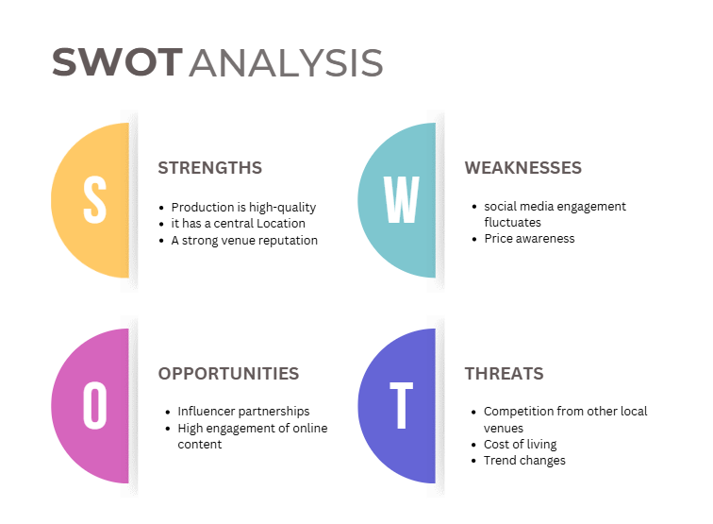

Appendix 2
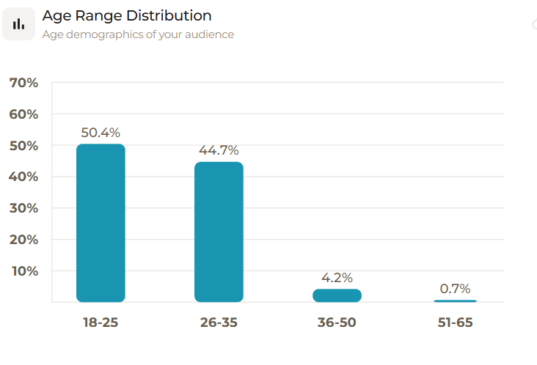
(Sparktoro, 2026a)

Appendix 3
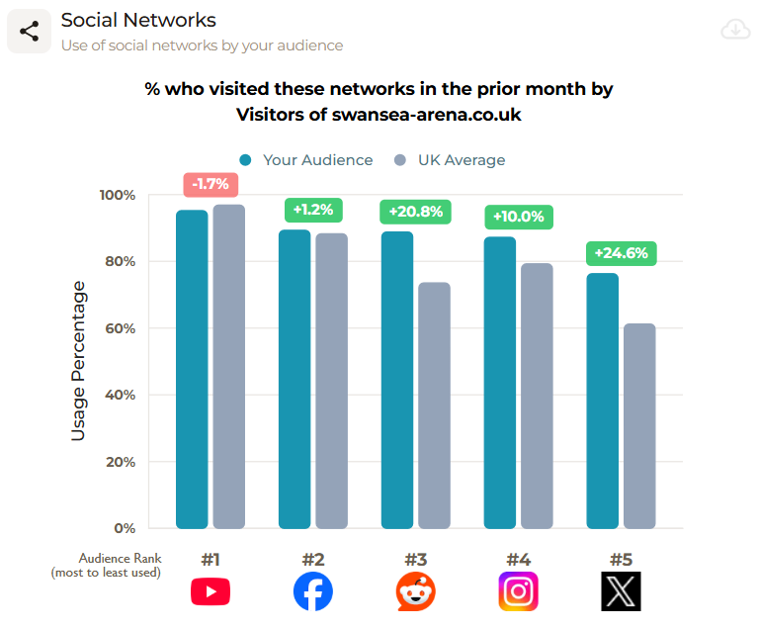
(Sparktoro, 2026b)
Appendix 4
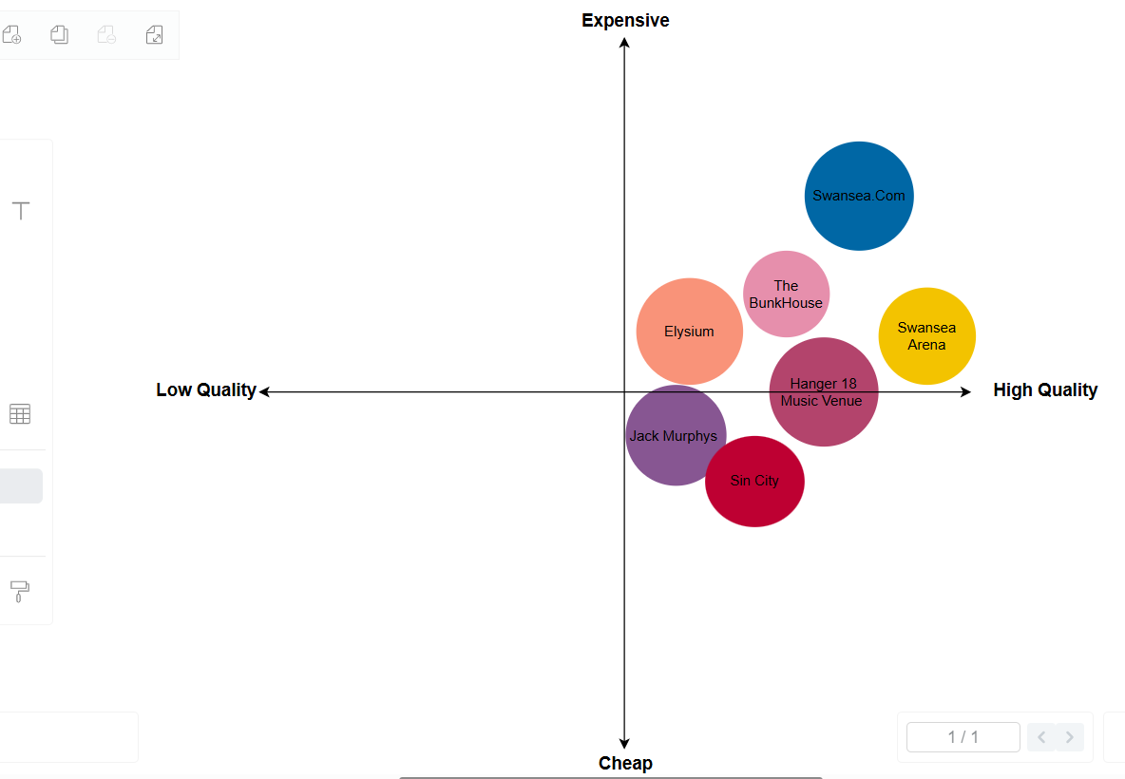

Appendix 5
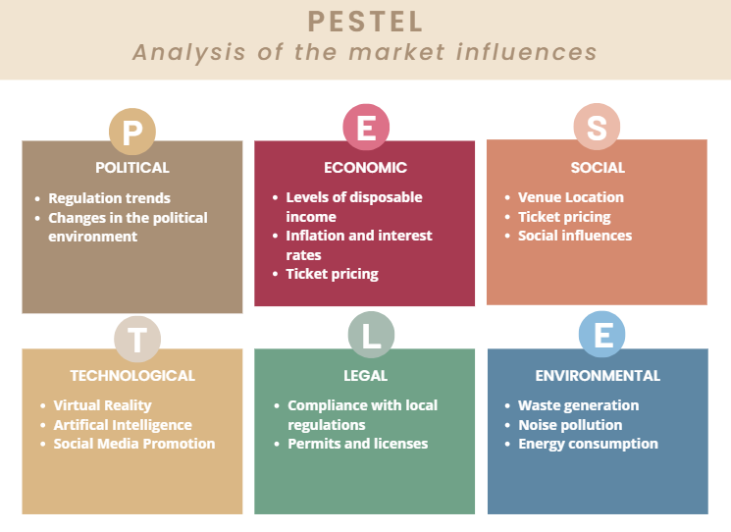
Appendix 6
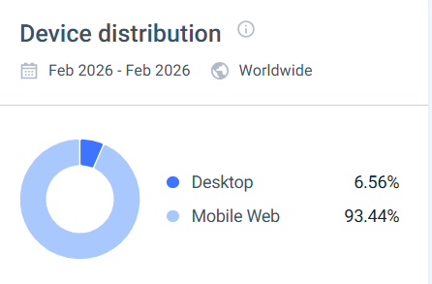
(SimilarWeb, 2026)

Appendix 7


