
PROGRAMME: MASTER OF BUSINESS ADMINISTRATION
MODULE: FINANCIAL MANAGEMENT
MODULE CODE: LCMB7002
ASSIGNMENT TITLE: FINANCIAL PERFORMANCE AND MANAGEMENT
TOPIC: STRATEGIC CFO CHALLENGE: SAVING A FAILING GLOBAL FIRM
STUDENT NAME:
STUDENT ID NUMBER:
Executive Summary
The study has reflected the struggle of General Electronics in the international landscape considering the financial evaluation and corporate restructuring. Here, the financial statements have been interpreted for the company, along with the ratio interpretation to determine the strength and threat and applied the corporate failure prediction model. Furthermore, the cash operating cycle has been analysed in the working capital management along with the recommendation to improve liquidity through capital reforms and compared the short-term with the long-term options. In addition to this, restructuring options have been suggested in the study along with its influence on shareholder value, operational flexibility, and debt structure. Also, project C has been suggested to GE for the investment, due to its higher NPV, IRR, PI, and ARR.

Table of Contents
Introduction 5
1. Financial Health Check 5
Analysis of financial statements of the company. 5
Performing ratio analysis 9
Identification of trends, strengths and threats. 11
Application of corporate failure prediction models (e.g., Altman Z-Score) to assess default risk 12
2. Working Capital Management Analysis 13
Assess the cash operating cycle. 13
Recommend strategies to improve liquidity through working capital reforms. 13
Compare short-term vs long-term financing options. 14
3. Strategic Financial Restructuring Plan 15
Recommend financial restructuring options. 15
Impact on shareholder value, debt structure, and operational flexibility. 16
Include international and ethical considerations (taxation, currency risk, inflation, CSR). 18
4. Investment Appraisal and Capital Budgeting 20
Calculation of investment appraisals and proposing the investment project 20
Final investment recommendation assuming capital rationing 23
Justification of recommendation using the company’s financial performance and project risk 25
Conclusion 26
References 27
Appendices 32
Appendix 1: Ratio Calculation 32
Appendix 2: Investment appraisal calculation 33

Introduction
General Electronics (GE) is a leading consumer electronics company, which is facing intense challenges and requires strategic management. In this evaluation, the study has been focused on the financial statements of the company to analyse its market position, performance, and threats. The analysis includes ratio calculations, as well as working capital management of the company to demonstrate the business reforms, strengths, and challenges. Furthermore, a strategic plan has been provided for the company to strengthen its financial structure and include the investment appraisal and capital budgeting for proposing efficient investment projects. Here, NPV, IRR, AR, PI, and payback period have been considered to recommend the financial investment project for the business.

1. Financial Health Check

Analysis of financial statements of the company.
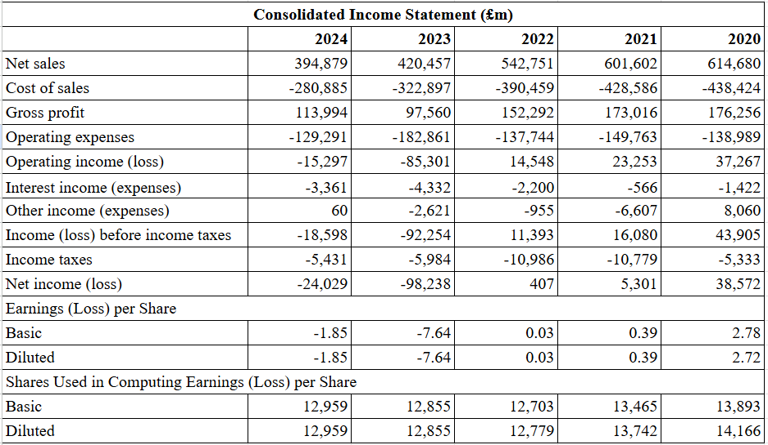
Figure 1: Income statement of GE
(Source: Provided dataset)
Figure 1 reflects the income statement of General Electronic, demonstrating a reduction in the net sales from £614,680 million in 2020 to £394,879 million in 2024. This creates a major concern in managing cash flows, as well as reduces funds for investment in R&D and expansion. According to Nohýnková (2022), a drastic reduction in revenues and increased costs has a measurable impact on an increase in net loss. Here, the company has faced a net loss of -£24,029 million in 2024 from £38,572 million in 2020. This is signalling poor performance of GE in the consumer goods industry, as well as deterring investors and potentially creating layoffs or restructuring.
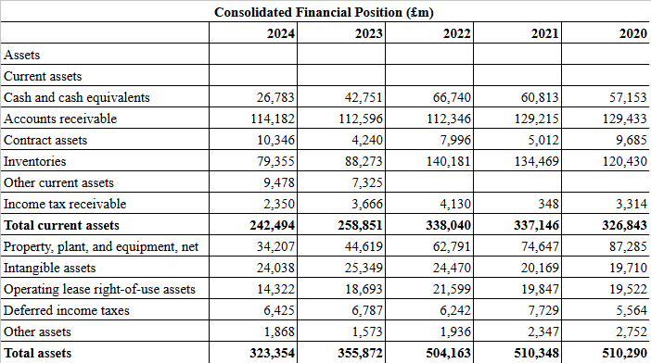
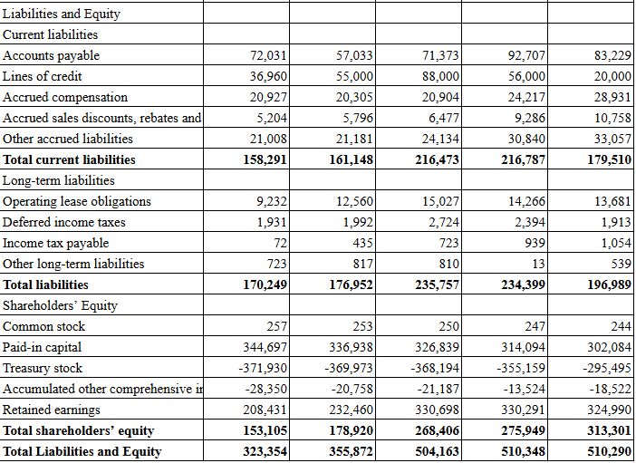
Figure 2: Balance sheet of the company
(Source: Provided dataset)
An excess in liabilities creates a tendency of bankruptcy for a business, which is followed by negative cash flow and high debt. According to Amoa-Gyarteng (2021), financial health and prevention of financial distress within a business have been managed through the optimisation of working capital by increasing current assets. The above figure illustrates a measurable decrease in the total assets from £510,290 million in 2020 to £323,354 million in 2024. This signals financial concerns for General Electronics, along with the creation of poor efficiency administration for the firm. In addition to this, the total shareholder’s equity of the company has also declined to £153,105 million in 2024, reflecting limited growth and raising investor caution due to heavy dependency on debt.
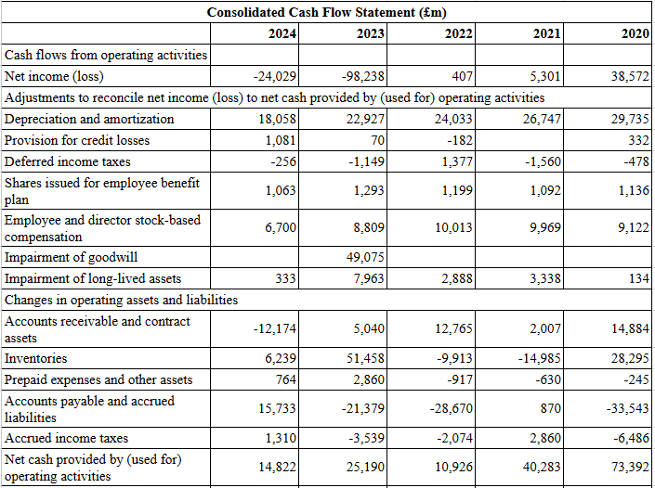
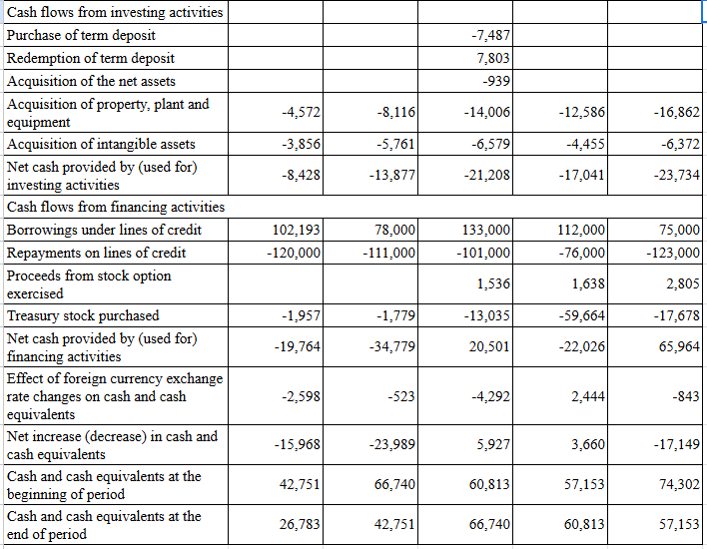
Figure 3: Cash flow statement of GE
(Source: Provided dataset)
The conceptualisation of the cash flow statement is considered as a bridge between the balance sheet and the income statement through representing the inflow and outflow of the business. As per the comment of Sugiana and Hidayat (2023), the phenomenon of operating cash flow develops through operating activities, which determines a business ability to obtain cash flow as a financing option. The figure reflects the declining operating cash flow of GE from £73,392 million in 2020 to £14,822 million in 2024, articulating damaging supplier relations. Additionally, the cash and cash equivalents of GE have also been associated with a substantial decline to £26,783 million in 2024, representing operational failures and missed opportunities for development.

Performing ratio analysis
“Financial Ratio Calculation for General Electronics
Please Note: All numbers are in £m expect ratios
Profitability Ratio | 2020 | 2021 | 2022 | 2023 | 2024
Gross Profit | 176,256 | 173,016 | 152,292 | 97,560 | 113,994
Revenue | 614,680 | 601,602 | 542,751 | 420,457 | 394,879
Gross Profit Margin: (Gross Profit/Revenue) * 100 | 28.67% | 28.76% | 28.06% | 23.20% | 28.87%
Net Profit | 38,572 | 5,301 | 407 | -98,238 | -24,029
Revenue | 614,680 | 601,602 | 542,751 | 420,457 | 394,879
Net Profit Margin: (Net Profit/Revenue) * 100 | 6.28% | 0.88% | 0.07% | -23.36% | -6.09%
Liquidity Ratios | 2020 | 2021 | 2022 | 2023 | 2024
Current Assets | 326,843 | 337,146 | 338,040 | 258,851 | 242,494
Current Liabilities | 179,510 | 216,787 | 216,473 | 161,148 | 158,291
Current Ratio: Current Assets/Current Liabilities | 1.82 | 1.56 | 1.56 | 1.61 | 1.53
Current Assets | 326,843 | 337,146 | 338,040 | 258,851 | 242,494
Inventories | 120,430 | 134,469 | 140,181 | 88,273 | 79,355
Current Liabilities | 179,510 | 216,787 | 216,473 | 161,148 | 158,291
Quick Ratio: (Current Assets - Inventories) / Current Liabilities | 1.15 | 0.93 | 0.91 | 1.06 | 1.03
Efficiency Ratios | 2020 | 2021 | 2022 | 2023 | 2024
Cost of Sales | 438,424 | 428,586 | 390,459 | 322,897 | 280,885
Inventory | 120,430 | 134,469 | 140,181 | 88,273 | 79,355
Inventory Turnover: COGS/Inventory | 3.64 | 3.19 | 2.79 | 3.66 | 3.54
Net Sales | 614,680 | 601,602 | 542,751 | 420,457 | 394,879
Accounts Receivables | 129,433 | 129,215 | 112,346 | 112,596 | 114,182
Receivables Turnover: Net Sales/Accounts Receivables | 4.75 | 4.66 | 4.83 | 3.73 | 3.46
Gearing Ratio | 2020 | 2021 | 2022 | 2023 | 2024
Total Liabilities | 196,989 | 176,952 | 235,757 | 176,952 | 170,249
Shareholder's Equity | 313,301 | 178,920 | 268,406 | 178,920 | 153,105
Debt-to-Equity Ratio: Total Liabilities/Shareholder's Equity | 0.63 | 0.99 | 0.88 | 0.99 | 1.11
Operating Income | 37,267 | -85,301 | 14,548 | -85,301 | -15,297
Interest Expenses | -1,422 | -4,332 | -2,200 | -4,332 | -3,361
Interest Coverage: Operating Income/Interest Expenses | -26.21 | 19.69 | -6.61 | 19.69 | 4.55
Investment Ratios | 2020 | 2021 | 2022 | 2023 | 2024
EPS | 2.78 | 0.39 | 0.03 | -7.64 | -1.85
Net Income | 38,572 | 5,301 | 407 | -98,238 | -24,029
Total Equity | 313,301 | 275,949 | 268,406 | 178,920 | 153,105
Return on Equity: Net Income/Total Equity | 0.12 | 0.02 | 0.00 | -0.55 | -0.16
Cash Flow Ratios | 2020 | 2021 | 2022 | 2023 | 2024
Operating Cash Flow | 73,392 | 40,283 | 10,926 | 25,190 | 14,822
Current Liabilities | 179,510 | 216,787 | 216,473 | 161,148 | 158,291
Operating Cash Flow Ratio: OCF/Current Liabilities | 0.41 | 0.19 | 0.05 | 0.16 | 0.09
Operating Cash Flow | 73,392 | 40,283 | 10,926 | 25,190 | 14,822
Net Sales | 614,680 | 601,602 | 542,751 | 420,457 | 394,879
Cash Flow Margin: OCF/Net Sales | 0.12 | 0.07 | 0.02 | 0.06 | 0.04”
Table 1: Financial ratio calculation for GE
(Source: Self-Calculated)

Identification of trends, strengths and threats.
- Trends
The financial ratios of General Electronics over the 2020-2024 period exhibit a prominent trend of progressive deterioration in profitability, mainly after 2022. The calculation examines a measurable decline in the liquidity position, yet it is higher than the industry baseline of 1.00, indicating an effective approach of the firm to manage its obligations. A ratio of 1 attribute the competency of a company to pay off all its current liabilities with its assets (CFI, 2025). Also, measurable decline in the efficiency, investment and cash flow defines missed opportunities of GE and dealing with operational challenges, leading to business failure.
- Strengths
Apart from significant issues within General Electronics, there have been several strengths associated with the financial position. Table 1 reflects the recovery in the gross profit margin of GE from 28.67% in 2020, then 28.06% in 2022, to 28.87% in 2024, initiating an effective outcome for yielding. As per the statement of Pratiwi et al. (2024), only gross profit has been eligible to change the cash flow in the future, whereas net profit and operating profit lack the ability. In addition to this, the operating cash flow of the company has been driving a positive status in all five years, which means core operations have been cash-generative. Moreover, Arsyad et al. (2021) explained that the liquidity ratios show the concept of an extent to which the assets of a company are effectively available for completing the short-term obligations. Here, the current and quick ratios have been higher than the benchmark of 1, including 1.53 and 1.03 in 2024, respectively. This demonstrates the inclusivity of GE to meet its short-term debts without the risk of immediate insolvency. Thus, the identified elements have been associated with a proficient approach to build a structured turnaround approach.
- Threats
Efficiency ratios reflect the effectiveness of operational management of the company to generate sufficient income. Based on the ratio calculation, it has been determined that the efficiency of GE has been reducing and increasing functional challenges. As per the comment of Wajo (2021), lower inventory turnover within industrial companies creates concerns regarding the working capital management, leading to poor administration. Here, the weak inventory turnover of 3.54 from 3.64, as well as 3.46 from 4.75, in 2024 and 2020, respectively, highlighting the risk of financial distress. Furthermore, a drastic increase in the gearing metrics, including D/E ratio (from 0.63 to 1.11) and interest coverage (from -26.21 to 4.55), exhibits an increase in sensitivity to economic downturns and higher reliance on debt. On the other hand, Dewi et al. (2023) stated that financial hardship has been the perception of firms going through before liquidation or bankruptcy, creating poor financial situations. A negative EPS of -1.85 and ROE of -0.16 reflects the sustained erosion of shareholder value and potential business failures. This improper operational performance of General Electronics created a drastic threat, as well as instability in the marketing context, escalating the liquidity and solvency issues.

Application of corporate failure prediction models (e.g., Altman Z-Score) to assess default risk
The model of corporate failure prediction involves the use of financial data and ratios for the forecast of a company’s risk of financial distress and bankruptcy. According to Braunsberger and Aschauer (2025), Altman Z-score has been a framework integrated into the strategic consideration of companies for the achievement of financial recovery. This involves the combination of financial ratios into one score, which enables investors to classify firms as safe (Z > 3.0), Gray (1.8 < Z < 3.0), or distressed (Z < 1.8). Consideration of the declining profitability, weak liquidity, and negative retained earnings demonstrates that General Electronics would score below the safe threshold of 3.0, articulating in the grey or distressed zone. This signals stakeholders to re-interpret the creditworthiness and decisions for fund raising on the company. The shrink in the company’s performance leads to financial distress, bankruptcy, and instability in the cash flow, assessing the default risk.

2. Working Capital Management Analysis

Assess the cash operating cycle.
The perception of the cash operating cycle or the cash conversion cycle, demonstrates the effectiveness of General Electronics to convert the funds related to inventory and receivables into cash. As per the statement of Asman et al. (2022), the concept of cash conversion cycle incorporates the performance-based evaluation for the determination of the wellness of a company to manage its working capital. In the context of GE, the duration of 2020-2024 reflects the lengthened cash operating cycle and indicates less efficiency to manage the working capital.
“Cash Operating Cycle = Inventory Period + Receivable Period - Payable Period”
The above formula demonstrates the inclusivity of GE to manage its short-term assets, such as inventories and receivables, along with liabilities, such as payables. The ratio calculation reflects a measurable decline in the inventory turnover from 3.64 times in 2020 to 3.54 times in 2024. According to Gao (2025), a reduction in the receivable turnover indicates poor collection efficiency of a company, and a corresponding lower asset turnover. Here, the weak receivable turnover from 4.75 times to 3.46 times, suggests slower collection of payments from customers. Thus, the cash operating cycle reveals that GE has been inefficient in converting its investment into actual cash for the optimisation of working capital.

Recommend strategies to improve liquidity through working capital reforms.
Focus on the acceleration of cash inflows and optimisation of cash outflows, along with a reduction in inventory ties, can be helpful to boost liquidity via working capital reforms. This can be helpful for General Electronics to streamline its financial strength and shorten the cash conversion cycle.
- Recommendation 1: Consideration of accounts receivable management to get faster cash
An inclusive implementation of strong credit policies and offering early payment discounts can be helpful for GE to speed up its liquidity through working capital reforms. According to Abdiaziz and Makori (2025), an application of accounts receivable management practice helps in the optimisation of financial performance, through trade credit policies and debtor screening, which ensure steady cash flows. This can be helpful for GE to revise its credit policy through the conduct of strict customer credit evaluation and communicating payment terms. The company can consider the digital streamlined invoicing and leveraging payment application for the reduction in processing time.
- Recommendation 2: Accounts payable management to manage cash outflows
An establishment of accounts payable management can be effective for GE to boost liquidity through negotiating longer payment conditions and streamline procedure using automation. As per the statement of Tobazaa and Gatsi (2025), accounts payable is a core element of working capital, leveraging an improvement in liquidity through allowing companies to pay cash outflows, along with the maintenance of supplier trust. This can be an effective approach for General Electronics to extend the terms of payment to preserve cash without damaging connection with the supplier. Also, the context initiates strong purchase volume for better terms, which requires the avoidance of excessive payment delays to manage the supply chain.

Compare short-term vs long-term financing options.
Relevant working capital management requires organisations to carefully balance short-term and long-term funding options. To maintain liquidity by limiting financial risks, both short and long-term financial options are pivotal to organisations for funding daily operations. Common short-term financing sources include bank overdrafts, trade credit options and commercial papers (Gandhi and Nasit, 2022). Similarly, these instruments are flexible and quickly accessible making them suitable for fluctuation management in cash operating cycles within a year. Besides, short-term financing options contain low interest rates compared to long-term debts. However, short-term financing sources often carry refinancing risk as obligation has to be paid or renewed in short notice. During fluctuations and tight cash inflow situations, companies can experience difficulty in renewing or paying obligations in the short-term that increases liquidity risks in future.
Compared to short-term, long-term financial sources are designed to provide enough time in interest payment and obligation clearance. The stable funding requirements in long-term assets investment provide secured but high interest rates for the long run. As per Choudhary and Limodio (2022), long-term financing ensures higher certainty of funding and reduces liquidity risks of shortfall that can arise within a year. This inflexibility acts as a benefit for businesses with longer cash cycle operations and seasonal revenue patterns. However, long-term financing from bank loans, debentures and bonds often increases expenses due to higher interest rates and issue expenses. Based on a working capital perspective, optimal financing strategy involves balancing the financing maturity with life of assets. The matching of financing source maturity and asset life is known as matching principle (Xuezhou et al., 2022). Based on this context, working capital should be supported with short-term financing if the firm has liquidity growth and lower financing expenses in a situation. The use of bank overdrafts can act as a flexible option to fund operations for short-term.

3. Strategic Financial Restructuring Plan

Recommend financial restructuring options.
Based on the declining profitability and asset base with increasing leverage of weak cash flow in General Electronics (GE), the comprehensive financial restructuring is required. This needs to restore stability and improve liquidity performance to limit default risk in the company. Based on the financial analysis and ratio calculations, combination of divestiture and strategic merger and equity inflow is recommended.
Divestiture of non-beneficial and underperforming business units: The divestment of non-performing or underperforming business units needs to be prioritised. A sharp decline in net assets from £510,290 million in 2020 to £323,354 million in 2024 indicated ineffective asset usage and capital lock-up in low returning segments. Besides, selling unimportant assets and discontinuing the loss-making segments can help provide GE with immediate cash flows for operations. Divestment procedures can be used to limit debt obligations and improve debt-to-equity ratio in business (Bhussar et al., 2025). The same process will help GE to ease the interest obligations reflected in volatile interest coverage ratio in the company.
Injecting equity: Through equity injection, the right issues and private equity participation of investors can help improve the D/E ratio of GE. For instance, the increasing DE ratio from 0.63 in 2020 to 1.11 in 2024 shows extra reliance on debt funding which increases financial risk. Inclusion of equity in capital will help balance the debt and equity flow and improve the solvency position of GE. Unlike debt, equity financing helps reduce solvency issues with regular capital inflow in operations (Fikri and Yolanda, 2023). Thus, injecting equity to balance working capital in GE will ensure higher productivity and solvency position.
Strategic merger/ partnership: The consideration of strategic merger of partnership helps provide long-term recovery benefits in a company (Pitelis et al., 2024). The merger with a financially stable firm can help sharing assets and funds to operate in a competitive environment. Besides, GE can scale the cost synergies and improve accessibility in the market with better economies of scale. The merger or partnership can improve inventory turnover in GE and management efficiency with optimised supply chains. Thus, GE’s weakness in efficiency and turnover ratio decline can be reversed with merger and partnership with promising companies. In addition, mergers will ensure knowledge transfer and technical innovation with risk sharing possibilities among merged groups to support long-term competition.

Impact on shareholder value, debt structure, and operational flexibility.
Divestiture of non-beneficial units has had a measurable impact on the shareholder values, which creates a strong structure for debt management, along with an improvement in operational flexibility. As per the comment of Sorensen and Yasuda (2023), private equity funds have been applicable for companies to ensure high-powered incentives and focus on maximisation of shareholder values through a variety of platforms. An equity injection enables the dilution of existing valuation of shareholders in General Electronics, along with an optimisation of debt structure. Also, strategic mergers and acquisition exhibits values through improved market power and inclusive efficiency.
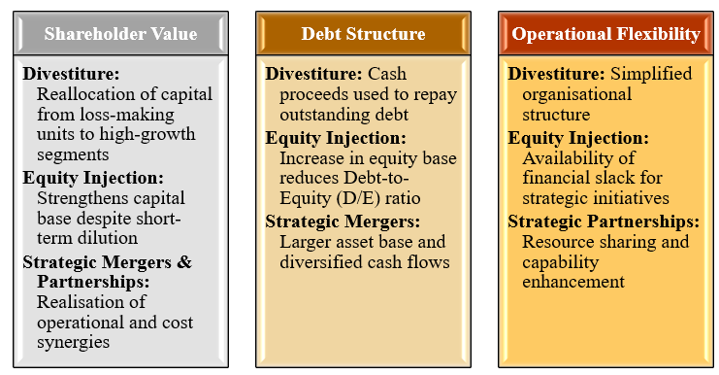
Figure 4: Impact of restructuring options
(Source: Self-Developed)
Shareholder value: Management can focus on resources, expertise, and timeframe through considering the divestiture of underperforming business units to enable high-growth areas of the company, which leads to higher returns on investment. According to Nary (2024), divesting firms depends on divestitures of corporate renewals, which reallocate resources for the optimisation of corporate scope and improve performance. Moreover, injecting new equity helps in issuing shares that increase the total number of outstanding shares, which improves shareholder values. Also, strategic mergers and partnerships of GE create shareholder values from realised synergies and access to new technologies. This phenomenon enhances shareholder values through enhancing financial stability, by eliminating loss-making segments for better profitability and EPS.
Debt structure: Divestiture has a positive influence on debt structure, which proceeds to pay down the debt for the reduction in the company’s leverage and financial challenges. As per the statement of Teschner and Paul (2021), companies often divest the assets when the strong outside pressure due to heavy losses and debt burdens affect the operations. A lower debt level and a healthier financial position of General Electronics leads to improved credit rating, which reduces WACC through divestiture of underperforming business units. Equity injection lower financial leverages for debt structure through increasing the company’s equity base and reducing D/E ratio of GE. As stated by Davydiuk et al. (2024), equity injection has been a publicly good phenomenon for all creditors, which are entitled to some compensation. The new entity’s capital reshapes the debt structure through the combination of stable cash flow and larger base of assets to improve the creditworthiness.
Operational flexibility: Divestment initiates the corporate structure and streamline the operational dynamics through the elimination of inefficiencies and complications associated with the management of business units. In addition to this, injecting equity has a significant influence on the operational and strategic flexibility through eliminating fixed obligations for periodic interest. According to Mutambik (2024), strategic partnership draws on the resource-based view theory, enabling a competitive advantage through leveraging resources and capability, considering collaborative alliances. Strategic partnership with suppliers improves the quality and maintains material supply stability of General Electronics to enhance operational quality within a specific period.

Include international and ethical considerations (taxation, currency risk, inflation, CSR).
The global consumer electronics industry has been dealing with various international and ethical considerations, related to complications in taxation rules, as well as management of currency risk. General Electronics needs to focus on international and ethical initiatives along with an implementation of financial restructuring.
Taxation and regulatory compliance: Divestitures and mergers have been reflecting GE to differentiate the corporate tax compliances and regulatory phenomenon. Based on the OECD, the share of corporate tax revenues in total tax revenues has been increased by 2%, from 15.9% to 17.8% in 2022 (OECD, 2025). Transparency in the tax activities reduces the regulatory challenges and protects the reputation of General Electronics in the consumer electronics sector. However, the ESG regulations across the international landscape creates a fragmented and inconsistent global tax perception. The use of complex corporate determination facilitates an avoidance of tax and prompts the requirement of inclusive cooperation across the international standard.
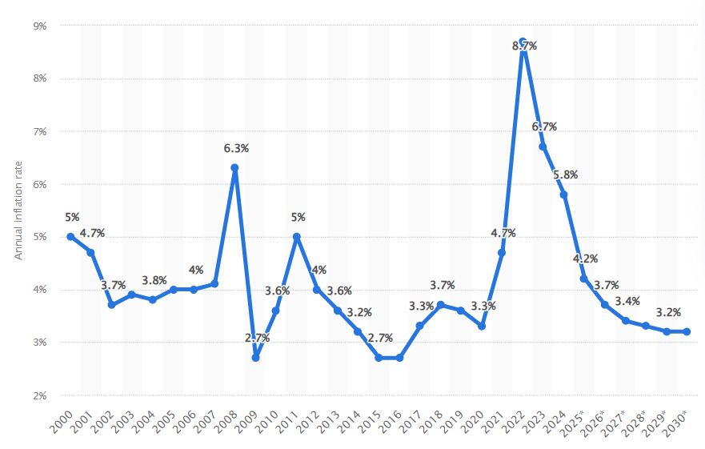
Figure 5: Global inflation rate
(Source: Statista, 2025)
Currency risk and inflation: Fluctuations in the currency have a significant impact on international business sales and profits, along with product pricing. Operational dynamics across the multiple currencies leads GE to deal with exchange rate volatility, which has a drastic impact on asset valuations and cash flow administration. There has been a conservative increase in the global inflation rate from 3.3% in 2020 to 8.7% in 2022, which is projected to reduce to 3.2% in 2030 (Statista, 2025). Additionally, the pressure due to inflation can enhance the operational cost and disrupt supply chain management, as well as increase in the price of goods and services.
Corporate Social Responsibility: A major ethical concern has been associated with fair wages, safe conditions for working, and reasonable working duration. Ethical consideration has been vital for General Electronics to enable turnaround approach, including divestiture and restructuring leading to workforce reduction and fair severance policies. As per the statement of Zakaria (2025), companies aligned with ethical business practices and sustainability are better positioned for the protection of their reputation and improve stakeholder trust. These aspects initiate sustainable global operations for GE through maintaining ESG standards during mergers and partnerships.

4. Investment Appraisal and Capital Budgeting

Calculation of investment appraisals and proposing the investment project
“Investment Appraisal for Project A (in million)
Particulars | Cash Flow | Cumulative Cash Flow | Discount Factor (10%) | Present Value
Year 0 | -£40 | -£40 | 1 | -£40.00
Year 1 | £10 | -£30 | 0.909 | £9.09
Year 2 | £12 | -£18 | 0.826 | £9.91
Year 3 | £14 | -£4 | 0.751 | £10.51
Year 4 | £10 | £6 | 0.683 | £6.83
Year 5 | £8 | £14 | 0.621 | £4.97
Net Present Value | £1.31
IRR | 11.33%
Payback Period | 3.40
Payback Period | 3 Years 5 Months
Profitability Index | 1.03
Total Cash Flow | 54.00
Total Profit | 14.00
Average Annual Profit | 2.80
Average Investment | 20.00
ARR | 14.00%”
Table 2: Investment appraisal for Project A
(Source: Self-calculated)
A positive net present value of a project derives a profitable margin, through generating more valuation for a business than its cost. As per the comment of Sinaga et al. (2023), the perception of NPV involves the measurement of feasibility of a business, considering the present value of the net cash flow. Here, the calculation represents a positive NPV of £1.31 for the Project A, as well as 11.33% of IRR, which is higher than the cost of capital. In addition to this, the payback period of the project has been around 3 years and 5 months, whereas PI metric has been 1.03 and ARR is 14.00%. These aspects signal a financially sound investment, which boost the overall valuation of GE and enable positive influence on stock prices.
“Investment Appraisal for Project B (in million)
Particulars | Cash Flow | Cumulative Cash Flow | Discount Factor (10%) | Present Value
Year 0 | -£30 | -£30 | 1 | -£30.00
Year 1 | £6 | -£24 | 0.909 | £5.45
Year 2 | £6 | -£18 | 0.826 | £4.96
Year 3 | £6 | -£12 | 0.751 | £4.51
Year 4 | £6 | -£6 | 0.683 | £4.10
Year 5 | £6 | £0 | 0.621 | £3.73
Net Present Value | -£7.26
IRR | 0.00%
Payback Period | 5.00
Payback Period | 5 Years 0 Months
Profitability Index | 0.76
Total Cash Flow | 30.00
Total Profit | 0.00
Average Annual Profit | 0.00
Average Investment | 15.00
ARR | 0.00%”
Table 3: Investment appraisal for Project B
(Source: Self-calculated)
The above table represents a negative net present value of Project B, including -£7.26, as well as 0.00% of IRR, driving a lower margin than the discount rate, making the investment unattractive for the business. As per the statement of Shou (2022), a negative net present value of a project, resulting in financial losses and indicates value destruction. In addition to this, the payback period of 5 years has been reflecting a long and inadequate liquidity perception. Also, the PI of 0.76 and ARR of 0%, indicates that the present value of inflows has not been able to cover the initial investment and generate profits.
“Investment Appraisal for Project C (in million)
Particulars | Cash Flow | Cumulative Cash Flow | Discount Factor (10%) | Present Value
Year 0 | -£50 | -£50 | 1 | -£50.00
Year 1 | £5 | -£45 | 0.909 | £4.55
Year 2 | £10 | -£35 | 0.826 | £8.26
Year 3 | £20 | -£15 | 0.751 | £15.02
Year 4 | £25 | £10 | 0.683 | £17.08
Year 5 | £15 | £25 | 0.621 | £9.32
Net Present Value | £4.22
IRR | 12.72%
Payback Period | 3.60
Payback Period | 3 Years 7 Months
Profitability Index | 1.08
Total Cash Flow | 75.00
Total Profit | 25.00
Average Annual Profit | 5.00
Average Investment | 25.00
ARR | 20.00%”
Table 4: Investment appraisal for Project C
(Source: Self-calculated)
Among the three investments, Project C has been associated with the largest initial cost, yet delivers a strong margin and inflows over time. As stated by Shham and Bouri (2023), the NPV of a project is derived through the present value of cash flows at the required return rates based on the initial investment. Here, the NPV of £4.22 and IRR of 12.72%, driving a most valuable option for General Electronics, which indicates a stronger financial position. In addition to this, the payback period of 3 years and 7 months, as well as PI of 1.08 reflecting the superior inclusivity to generate profits for the company per pound invested. Also, the ARR of 20% has been the strongest return for the business project. Based on the overall findings, it has been analysed that Project C has been the most profitable investment for General Electronics, due to its higher NPV, IRR, PI, and ARR. The cash flow of the project has been back-loaded, indicating an efficient return margin, along with an exposure to financial wealth and operational management.

Final investment recommendation assuming capital rationing
“Capital Rationing Decision (Maximum Investment: £60 million) for Project A
Particulars | Cash Flow | Discount Factor (10%) | Present Value
Year 0 | -60 | 1 | -60.00
Year 1 | 10 | 0.909 | 9.09
Year 2 | 12 | 0.826 | 9.91
Year 3 | 14 | 0.751 | 10.51
Year 4 | 10 | 0.683 | 6.83
Year 5 | 8 | 0.621 | 4.97
Net Present Value | -£18.69
IRR | -3.54%”
Table 5: Capital rationing decision for Project A
(Source: Self-calculated)
The maximum investment suggested by GE has been around £60 million, forcing choices between the opportunity with positive valuation. The perception of capital rationing is the strategic derivation used by companies to limit the number of projects through restricting investments (CPI, 2025). Based on the capital rationing, the initial investment for Project A has driven the negative NPV of -£18.69 million and IRR of -3.54%. This suggests that the project has been associated with an accounting loss, leading to destruction of value for the business. Apart from the standalone performance, Project A has been associated with financial instability due to limited capital.
“Capital Rationing Decision (Maximum Investment: £60 million) for Project B
Particulars | Cash Flow | Discount Factor (10%) | Present Value
Year 0 | -60 | 1 | -60.00
Year 1 | 6 | 0.909 | 5.45
Year 2 | 6 | 0.826 | 4.96
Year 3 | 6 | 0.751 | 4.51
Year 4 | 6 | 0.683 | 4.10
Year 5 | 6 | 0.621 | 3.73
Net Present Value | -£37.26
IRR | -19.40%”
Table 6: Capital rationing decision for Project B
(Source: Self-calculated)
Based on the calculation for project B, the net present value has also been negative, including -£37.26, which is lower than Project A. According to Hazen and Magni (2021), IRR has been associated with the most undesirable properties, which is the most substantial measurement of worth. In addition to this, the IRR of -19.40% indicates insufficient cash flow for the justification of enlarged investment perception. The result depicts that Project B has failed to meet the profit margin of the company and is unsuitable for the investment.
“Capital Rationing Decision (Maximum Investment: £60 million) for Project C
Particulars | Cash Flow | Discount Factor (10%) | Present Value
Year 0 | -60 | 1 | -60.00
Year 1 | 5 | 0.909 | 4.55
Year 2 | 10 | 0.826 | 8.26
Year 3 | 20 | 0.751 | 15.02
Year 4 | 25 | 0.683 | 17.08
Year 5 | 15 | 0.621 | 9.32
Net Present Value | -£5.79
IRR | 6.74%”
Table 7: Capital rationing decision for Project C
(Source: Self-calculated)
Considering the £60 million capital for the investment by General Electronics, Project C has also been producing negative NPV of £5.79. However, it has been relatively lower than the other projects, both A and B, indicating a superior capital incentive. Additionally, IRR has been the method used to analyse the rate of return earned on a project (CFI, 2025). Here, the calculated IRR of the project has been 6.74%, which remains below the discount rate of 10%, yet exhibits the least value erosion. Thus, Project C has been more valuable than other projects, and incorporates the most efficient capital inclusivity for investment.

Justification of recommendation using the company’s financial performance and project risk
Based on the findings, it has been recommended that Project C is suitable for the investment due to its most favourable balance between profitability, liquidity management, and capital efficiency. Here, the positive NPV of £4.22 million, strongest IRR of 12.72%, and ARR of 20%, reflect the superiority in delivering profitability and improved valuation for shareholders compared with projects A and B. In addition to this, Project C recovers the investment within 3.6 years (liquidity), which is inclusively acceptable by General Electronics considering its assumed stable operating cash flows. However, the risk has been derived through the substantially higher returns. Project A and B have been associated with lower volatility, yet weaker profit margin, resulting in limited strategic improvements. Thus, Project C represents the most inclusive capital generation efficiency and aligns with the long-term goals of the company to enhance profits and revenue streams.

Conclusion
The study has concluded that Project C has been more suitable for GE to invest in than the other projects, due to its higher NPV, effective IRR, PI, and ARR. In addition to this, the analysis identified several strengths of the company using ratios, such as positive operating cash flow, stable liquidity, and efficient gross profit margin. However, significant threats are negative net profit margin, increasing gearing ratios, lower investment ratios and efficiency ratios. Thus, investment in the relevant projects has been helpful for GE to improve its commitment to profit generation and focus on the turnaround strategy to ensure financial viability.

References
Abdiaziz, A.M. and Makori, D., (2025). Working Capital Management Practices and Financial Performance of Small and Medium Enterprises in Garissa County, Kenya. The Strategic Journal of Business & Change Management, 12(2), pp.584-606. Available at: http://dx.doi.org/10.61426/sjbcm.v12i2.3231 (Accessed: 18 December 2025).
Amoa-Gyarteng, K., (2021). Corporate financial distress: The impact of profitability, liquidity, asset productivity, activity and solvency. Journal of Accounting, Business and Management (JABM), 28(2), pp.104-115. Available at: https://journal.stie-mce.ac.id/index.php/jabminternational/article/view/447 (Accessed: 18 December 2025).
Arsyad, M., Haeruddin, S.H., Muslim, M. and Pelu, M.F.A., (2021). The effect of activity ratios, liquidity, and profitability on the dividend payout ratio. Indonesia Accounting Journal, 3(1), pp.36-44. Available at: https://ejournal.unsrat.ac.id/index.php/iaj/article/view/30119 (Accessed: 18 December 2025).
Asman, F.N., Fernandez, D., Jamaludin, N.A., Omar Zaki, H. and Ghazali, A.W., (2022). Cash conversion cycle and firm’s performance. International Journal of Academic Research in Business and Social Sciences, 12(11), pp.2682-2692. Available at: https://www.academia.edu/download/106769993/cash-conversion-cycle-and-firms-performance.pdf (Accessed: 18 December 2025).
Bhussar, M.S., Zorn, M.L., Ramaswami, S., Ramsinghaney, S. and Kelley, J.N., (2025). Clear the desk before you deal: The strategic timing of corporate divestitures. Business Horizons. Available at: https://www.sciencedirect.com/science/article/pii/S0007681325001685 (Accessed: 18 December 2025).
Braunsberger, C. and Aschauer, E., (2025). Corporate failure prediction: A literature review of Altman Z-score and machine learning models within a technology adoption framework. Journal of Risk and Financial Management, 18(8), p.465. Available at: https://www.mdpi.com/1911-8074/18/8/465 (Accessed: 18 December 2025).
CFI, (2025). Liquidity Ratio. Available at: https://corporatefinanceinstitute.com/resources/accounting/liquidity-ratio/ (Accessed: 17 December 2025).
Choudhary, M.A. and Limodio, N., (2022). Liquidity risk and long-term finance: Evidence from a natural experiment. The Review of Economic Studies, 89(3), pp.1278-1313. Available at: https://doi.org/10.1093/restud/rdab065 (Accessed: 18 December 2025).
CPI, (2025). Capital Rationing. Available at: https://corporatefinanceinstitute.com/resources/accounting/capital-rationing/ (Accessed: 18 December 2025).
CPI, (2025). Internal Rate of Return (IRR). Available at: https://corporatefinanceinstitute.com/resources/valuation/internal-rate-return-irr/ (Accessed: 18 December 2025).
Davydiuk, T., Erel, I., Jiang, W. and Marchuk, T., (2024). Common Investors Across the Capital Structure: Private Debt Funds as Dual Holders. Fisher College of Business WP, (2024-21). Available at: https://papers.ssrn.com/sol3/papers.cfm?abstract_id=4992219 (Accessed: 18 December 2025).
Dewi, D.N., Murhadi, W.R. and Sutejo, B.S., (2023). Financial ratios, corporate governance, and macroeconomic indicators in predicting financial distress. Journal of Law and Sustainable Development, 11(4), pp.1-18. Available at: http://repository.ubaya.ac.id/44736/ (Accessed: 18 December 2025).
Fikri, M. and Yolanda, A.P., (2023). Impact of liquidity and solvency ratios on financial performance: A comprehensive analysis. Indonesia Accounting Research Journal, 11(2), pp.68-82. Available at: http://journals.iarn.or.id/index.php/Accounting/article/download/223/154 (Accessed: 18 December 2025).
Gandhi, J. and Nasit, A., (2022). Comparison of short-term financing options; factoring as the best alternative. In International Research Conference on Innovations, Startup and Investments (ICOSTART-2022) (pp. 127-141). Available at: https://rku.ac.in/icostart2022/books/14-management-jenil-gandhi-(127-141).pdf (Accessed: 18 December 2025).
Gao, J., (2025). Research on the Accounts Receivable Management Problems and Countermeasures of Gree Electric Appliances Co., Ltd. Accounting, Marketing and Organization, 1(2), pp.14-30. Available at: https://doi.org/10.71204/t99rtf66 (Accessed: 18 December 2025).
Hazen, G. and Magni, C.A., (2021). Average internal rate of return for risky projects. The Engineering Economist, 66(2), pp.90-120. Available at: https://papers.ssrn.com/sol3/Delivery.cfm?abstractid=3791520 (Accessed: 18 December 2025).
Mutambik, I., (2024). The Role of Strategic Partnerships and Digital Transformation in Enhancing Supply Chain Agility and Performance. Systems, 12(11), p.456. Available at: https://www.mdpi.com/2079-8954/12/11/456 (Accessed: 18 December 2025).
Nary, P., (2024). Do corporations benefit from divesting to private equity acquirers? An empirical investigation. Strategic Management Journal, 45(10), pp.2122-2158. Available at: https://sms.onlinelibrary.wiley.com/doi/abs/10.1002/smj.3611 (Accessed: 18 December 2025).
Nohýnková, B., (2022). Calculation of the lost profit in business damage cases. European Financial and Accounting Journal, 17(1), pp.25-44. Available at: https://www.econstor.eu/handle/10419/297907 (Accessed: 18 December 2025).
OECD, (2025). Corporate Tax Statistics 2025. Available at: https://www.oecd.org/en/publications/corporate-tax-statistics-2025_6a915941-en.html (Accessed: 18 December 2025).
Pitelis, C.N., Teece, D.J. and Yang, H., (2024). Dynamic capabilities and MNE global strategy: A systematic literature review‐based novel conceptual framework. Journal of Management Studies, 61(7), pp.3295-3326. Available at: https://onlinelibrary.wiley.com/doi/pdfdirect/10.1111/joms.13021 (Accessed: 18 December 2025).
Pratiwi, S.G., Sukesti, F. and Hanum, A.N., (2024, December). The Effect of Gross Profit, Operating Profit, and Net Profit in Predicting Future Cash Flows. In Economics and Business International Conference Proceeding (Vol. 1, No. 2, pp. 931-940). Available at: https://jurnalnew.unimus.ac.id/index.php/EBiC/article/download/505/1064 (Accessed: 18 December 2025).
Shham, A.M. and Bouri, A., (2023). The Impact of Net Present Value and Adjusted Present Value on Investment Decisions: A Guide from Foreign Companies Investing in the Iraqi Environment. Revista iberoamericana de psicología del ejercicio y el deporte, 18(5), pp.587-591. Available at: https://dialnet.unirioja.es/descarga/articulo/9235460.pdf (Accessed: 18 December 2025).
Shou, T., (2022, July). A literature review on the net present value (NPV) valuation method. In 2022 2nd International Conference on Enterprise Management and Economic Development (ICEMED 2022) (pp. 826-830). Atlantis Press. Available at: https://www.atlantis-press.com/article/125975449.pdf (Accessed: 18 December 2025).
Sinaga, A.S., Sari, M.M., Hutasuhut, A.A., Zahara, S.T., Amanda, A., Fitri, A. and Caesario, M.A., (2023). Comparison of capital budgeting methods: NPV, IRR, PAYBACK period. World Journal of Advanced Research and Reviews, 19(2), pp.1078-1081. Available at: https://pdfs.semanticscholar.org/35f5/923a958b071288b38d4e960e8268477ec19a.pdf (Accessed: 18 December 2025).
Sorensen, M. and Yasuda, A., (2023). Stakeholder impact of private equity investments. In Handbook of the economics of corporate finance (Vol. 1, No. 1, pp. 299-341). North-Holland. Available at: https://www.sciencedirect.com/science/article/pii/S2949964X23000073 (Accessed: 18 December 2025).
Statista, (2025). Annual global inflation rate for the Consumer Price Index (CPI) from 2000 to 2030. Available at: https://www.statista.com/statistics/256598/global-inflation-rate-compared-to-previous-year (Accessed: 18 December 2025).
Sugiana, N.A. and Hidayat, W.W., (2023). The effect of operating cash flow, operating capacity and sales growth on financial distress. Indonesian Journal of Business Analytics, 3(3), pp.785-802. Available at: http://repository.ubharajaya.ac.id/32306/1/FORMOSA-ICI-Jjuni2023-sudah.pdf (Accessed: 18 December 2025).
Teschner, N. and Paul, H., (2021). The impact of divestitures on shareholder wealth–The DACH case. European Journal of Management and Business Economics, 30(1), pp.55-71. Available at: https://sms.onlinelibrary.wiley.com/doi/abs/10.1002/smj.3611 (Accessed: 18 December 2025).
Tobazaa, S.G. and Gatsi, J.G., (2025). The impact of accounts payable management in enhancing liquidity of the energy sector companies in Ghana. International Academic Journal of Economics and Finance (IAJEF)| ISSN 2518-2366, 5(1), pp.1-18. Available at: https://www.iajournals.org/articles/iajef_v5_i1_1_18.pdf (Accessed: 18 December 2025).
Wajo, A.R., (2021). Effect of cash turnover, receivable turnover, inventory turnover and growth opportunity on profitability. ATESTASI: Jurnal Ilmiah Akuntansi, 4(1), pp.61-69. Available at: https://jurnal.feb-umi.id/index.php/ATESTASI/article/view/165 (Accessed: 18 December 2025).
Xuezhou, W., Hussain, R.Y., Salameh, A.A., Hussain, H., Khan, A.B. and Fareed, M., (2022). Does firm growth impede or expedite insolvency risk? A mediated moderation model of leverage maturity and potential fixed collaterals. Frontiers in Environmental Science, 10, p.841380. Available at: https://doi.org/10.3389/fenvs.2022.841380 (Accessed: 18 December 2025).
Zakaria, Z., (2025). Evaluation of Ethical Dilemmas and Business Sustainability in Maintaining a Company's Reputation in Global Markets. Paradoks: Jurnal Ilmu Ekonomi, 8(3), pp.837-851. Available at: https://jurnal.feb-umi.id/index.php/PARADOKS/article/view/1490 (Accessed: 18 December 2025).

Appendices

Appendix 1: Ratio Calculation
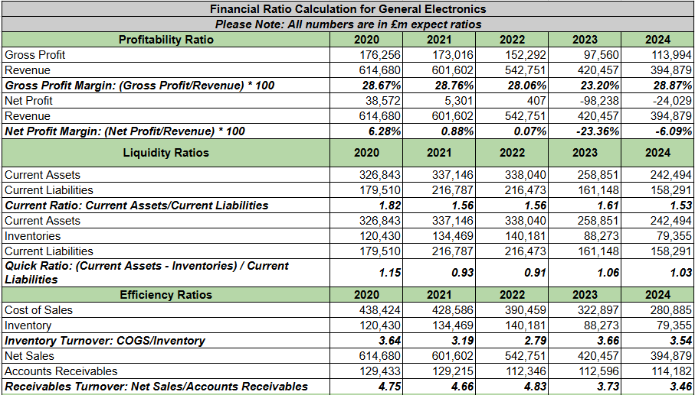
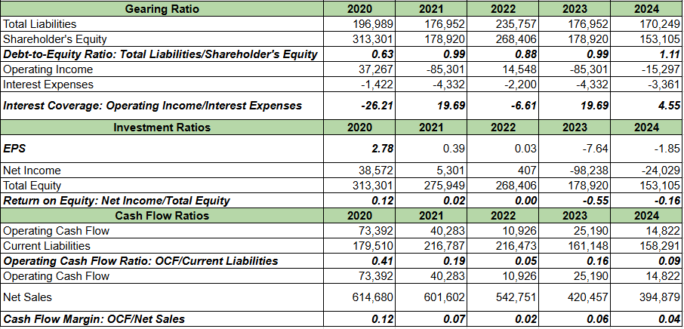

Appendix 2: Investment appraisal calculation


