Witness Interview Handling Stolen Goods Task Sheet
Scenario 8 Handling Stolen Goods – Witness brief

Witness: Use your own details (address in Bridgend)
Overnight Saturday-Sunday, your car (use your own vehicle details) was broken into whilst outside your home. You must have left it unlocked as there was no damage to the locks but you found it with the near side door wide open. Your NavMan Sat Nav was missing. You did not report the theft to the Police or insurance as you felt it was your mistake.

The SAT NAV was a NavMan XL and valued at £100.00. It is identifiable as you marked it in an indelible red pen with a large DOT by the on off button.

This morning at 11am, you were walking around Bridgend indoor market
You walked around the stalls and saw a local person that you know on a stall called ‘THE BARGAIN BOOTH’. The person was standing behind a stall. You remember the person from school so you stopped to speak to them.
!! Watch the film clip !!

You bring your Sat Nav home with you and phone the Police.
*** The photo of the sat nav is the actual item ***

Aims of the Scenario

- The aim of investigative interviewing is to obtain accurate and reliable accounts from victims, witnesses or suspects about matters under police investigation.
- Investigators must act fairly when questioning victims, witnesses or suspects. Vulnerable people must be treated with particular consideration at all times.
- Investigative interviewing should be approached with an investigative mind-set. Accounts obtained from the person who is being interviewed should always be tested against what the interviewer already knows or what can reasonably be established.
- When conducting an interview, investigators are free to ask a wide range of questions in order to obtain material which may assist an investigation.
- Investigators should recognise the positive impact of an early admission in the context of the criminal justice system.
- Investigators are not bound to accept the first answer given. Questioning is not unfair merely because it is persistent.
- Even when the right of silence is exercised by a suspect, investigators have a responsibility to put questions to them.

Outcome of the Scenario

- Aim: To Provide interviewers with the competence to prepare and plan interviews with suspects.
- Objectives
- Assess information gathered about suspect(s)
- Assess the type and current condition of the suspect to inform the approach to the interview in accordance with legal requirements.
- Establish the correct interview approach utilising the engage and explain phase aide memoir
- Identify the nature of the allegation and identify investigative important information
- Produce a written interview plan that takes account of the suspect assessment , the needs of the investigation and legal requirements
- Select and set up the necessary interview location, resources and personnel.

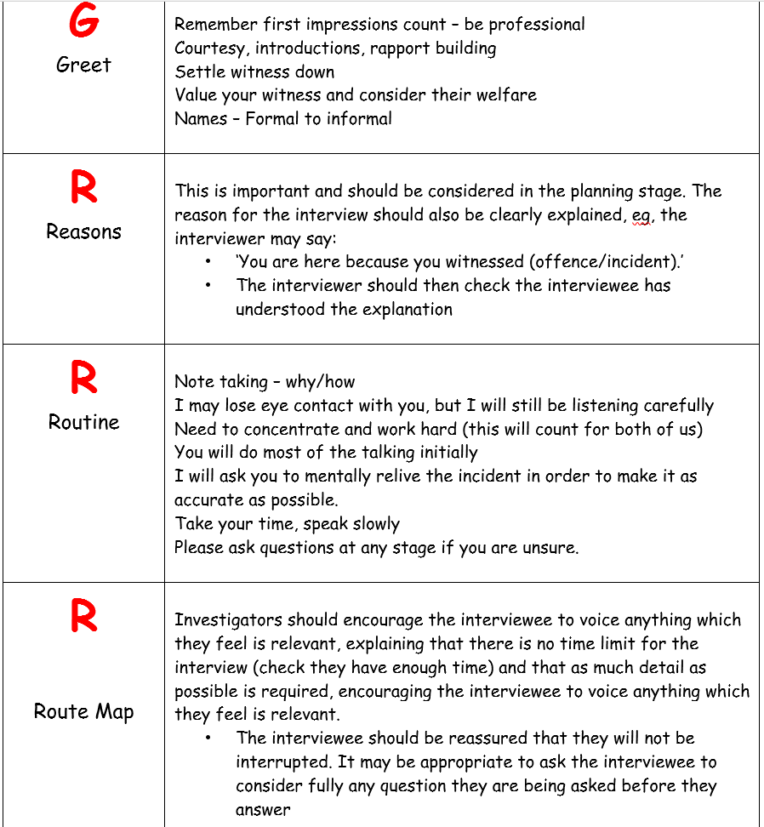

Section 1 of the Theft Act 1968 provides the legal definition of theft.
1(1) A person is guilty of theft if he dishonestly appropriates property belonging to another with the intention of permanently depriving the other of it and 'thief' and 'steal' shall be construed accordingly.
1(2) It is immaterial whether the appropriation is made with a view to gain, or is made for the thief's own benefit.
1(3) The five following sections of this Act shall have effect as regards the interpretation and operation of this section (and, except as otherwise provided by this Act, shall apply only for purposes of this section).
Notes
(i) The wording which makes the above an offence is found in section 7 of the Act. All five of these elements must be proved to obtain a conviction. The term 'property' in this Act is not the same as that in the offence of criminal damage.
(ii) Immigration officers have a power of arrest for theft (see section 14 of the Asylum and Immigration (Treatment of Claimants, etc.) Act 2004). This power is available to an immigration officer who uncovers evidence of this (and other offences) whilst in the course of their usual duties (investigating immigration matters).
(iii) A secure network which protects jewellery, watches and other treasured items, providing the police with a nationwide database to search and trace the owners of recovered items can be found at www.police.e-register.net.
(iv) Please see the document on carjacking, where the offence of theft may be applicable.
(v) There are a substantial number of cases concerning the different terms used as part of the definition of theft. These cases are not listed under this document, but under the documents containing the definition of that particular term. For example, cases relating to the meaning of 'property' can be found by accessing document D4 on the subject of 'property in theft' and viewing a list of cases from that document. Any case listed in this document is only concerned with the general concept of stealing and not the specific terminology. This principle applies to other topics broken down in this way.
(vi) With reference to subsection 1(2), an example might be, an oil tanker is parked at the side of the road and a suspect releases its valve. The oil pours out and down the drains. Has the suspect gained anything? No - apart from the dubious satisfaction of seeing the oil wasted. Providing he fulfils the requirement for 'dishonesty' then he has 'appropriated property' (oil) 'belonging to another' (the oil company) 'with the intention of permanently depriving the other of it' (pouring it down the drains).

Section 22 of the Theft Act 1968 creates various offences relating to handling stolen goods.
22(1) A person handles stolen goods if (otherwise than in the course of the stealing) knowing or believing them to be stolen goods he dishonestly receives the goods, or dishonestly undertakes or assists in their retention, removal, disposal, or realisation by or for the benefit of another person, or if he arranges to do so.
22(2) penalty only - see below
Notes
(i) The term of dishonesty is expanded in the cases of R v Feeley and R v Ghosh
(ii) There are two basic types of offender, the person who actually receives the goods and the person who, for want of a better expression, 'manages' the goods for the benefit of another. There are many different ways in which 'managing' stolen goods can be committed. An offender should not be charged with several different offences of handling the same stolen goods just by using variations in the wordings. Such action has been ruled as being bad for 'duplicity' (a legal term for attempting to double an offender's liability before a Court based on one set of facts). However, it is quite proper to create a 'managing' charge incorporating all of the alternatives.
(iii) Be aware of further provisions relating to this offence in section 24 and section 27.
(iv) If the items which are the subject of the investigation are artifacts or antiquities from anywhere in the world (and which have been removed from a site illegally), consider the offence of dealing in cultural objects contrary to section 1 of the Dealing in Cultural Objects (Offences) Act 2003.
(v) Immigration officers have a power of arrest for theft (see section 14 of the Asylum & Immigration (Treatment of Claimants, etc.) Act 2004). This power is available to an immigration officer who uncovers evidence of this (and other offences) whilst in the course of their usual duties (investigating immigration matters).
(vi) A secure network which protects jewellery, watches and other treasured items, providing the Police with a nationwide database to search and trace the owners of recovered items can be found at www.police.e-register.net .
(vii) Otherwise than in the course of stealing: Sometimes the facts of a case may fit either stealing or handling. In order to determine whether goods were handled 'otherwise than in the course of stealing', it should be considered whether or not the actions of the suspect formed an on-going part of the theft, or if the theft was complete and he/she was a third party becoming involved after the event. In many instances where the circumstances are unclear it will be for the Court to make the decision and alternative charges of theft and handling should be preferred. For example, S, who works in a warehouse, throws goods out of an open window onto spare ground. Then . . . .
- By pre-arrangement, an accomplice, X, is waiting and takes the goods away. X commits theft.
- By pre-arrangement, an accomplice, X, arrives half an hour later and takes the goods. It is most likely that X commits theft particularly if his role was a joint enterprise and the goods were to be shared out between the two men. However a court may consider handling appropriate if X was taking the goods and giving S cash in payment (in which case it may not matter if the removal was half an hour later or at the time the goods were thrown out of the window).
- After work S goes to a pub and tells a friend, Y, what he has done. The friend goes and collects the goods. Y commits handling.
For all practical purposes, a thief can only become the handler of property that he/she has stolen, once he/she has severed his/her control over the property and later decides, (whilst they are still stolen goods) to have dealings with the property once again. For example:
T steals a television. He sells it to H who sells it on to V (both believing it to be stolen). Unexpectedly, T gets a better offer for the television from a different source and buys it back from V. T would be a handler of the television.
(viii) Knowing and Believing: Knowing includes having actually been told that the goods are stolen, by someone with first-hand knowledge, such as the thief or burglar. Believing means the state of mind of a person who says to himself that he could not be certain that goods are stolen, but there could be no other reasonable conclusion in the light of all the circumstances. Knowledge or belief that goods are stolen can be proved by direct evidence from the thief, an admission by the handler or circumstantial evidence such as - the low price paid for them; the method of storage; furtive disposal; removal of identifying marks; denial of possession; possession soon after the theft (i.e. the doctrine of recent possession (R v Abramovitch (1916) 11 Cr AppR 45), if someone is found in possession of stolen goods, shortly after they have been stolen, "the jury should be told that they may in the absence of any reasonable explanation, find the prisoner guilty."). Unlawful acts by individuals must be proved, but it has been held that gestures such as a nod or a wink may be sufficient to help prove guilt. There are also statutory provisions relating to special evidence which could help with this element of the offence. See also R v Hall 1985 and R v Elizabeth Forsyth 1997.
(ix) Receiving: Is not specifically defined, but case law has established its meaning as 'gaining possession (actual or constructive) or control' . For more on common law possession and the relevant cases, see the main document on the subject. There does not need to be any benefit to the receiver. The receipt of the goods must be proved. If the receiver is still negotiating the receipt then another aspect of the offence of handling stolen goods could apply. The receiver must have knowledge that the goods are stolen at the time of their receipt, a bona fide innocent purchaser cannot become a handler at a later date (R v Bloxham 1982).
(x) Undertakes or Assists: Undertakes has been held to include where the person agrees to perform the act or acts constituting the offence. Assists has been held to include allowing someone to store goods in a flat and refusing to answer police questions about their whereabouts (R v Brown 1968). The act may be one of omission, such as the owner of premises allowing stolen goods to remain there after he becomes aware that they are stolen.
(xi) Retention - Removal - Disposal - Realisation: These terms are not specifically defined in the Act and should therefore be given their ordinary dictionary meaning. More than one of the terms might fit a particular set of circumstances. If in doubt, charge them as alternatives. Retention means keeping in one's own possession or control. Removal means moving a thing to another place. Disposal means the act of disposing or getting rid of, or bestowing or giving. Realisation means conversion into cash or money.
(xii) Benefit of Another: The person gaining benefit must gain some sort of advantage from the arrangement (although in some circumstances he/she may not be aware of it at the time) and it need not be financial. Except in very rare circumstances (see 'in the course of stealing' above) a thief cannot be the handler of the property he has stolen, but can be the person who benefits from, for example, someone else storing it for him . The term 'another person' cannot mean the person purchasing goods from the individual who is disposing of them or co-defendants on the same indictment (R v Gingell 1999). The cases of R v Bloxham 1982 and R v Tokeley-Parry 1998 in the below list of cases may also be of assistance.
(xiii) Arranges to do so: This phrase is intended to include the go-between or middleman who makes the arrangement, but may never go near the stolen goods themselves.

