A report focusing on: Health and safety legislation
In an active building site.

Created for:
R. Thomas

Created by:
Ieuan Vokes

Completed on:
01/05/2023

Word count:
2122

Table of contents
1.0 Summary of works – Page 3
2.0 Procedures – Page 3
3.0 Terms of reference – Page 3 – 4
4.0 Findings – Page 4 – 7
5.0 References – Page 7
6.0 Appendix – Page 8 – 10
7.0 Glossary – Page 10

1.0 Summary of works
This report is being created to allow me to show off my knowledge and understanding within the world of health and safety legislation. As the director has asked me to create a report on an active building site this is where my report will focus when it comes to talking about legislations. However, I will also show my understanding of the CDM regulations throughout the report as well as showing my knowledge of risk assessments and highlight some of the risks that can occur on an active building site. For me to complete this report to the best of my ability I will also look to complete research on these subjects to better understand them. This report must be completed by the 4th of May.

2.0 Procedures
In this section of my report, I will look to identify the ways I will complete research for this report. And the styles that I will use.
2.1 The main way that I will look to complete research is through using the internet. Anything can be found on the internet, and it is a great way to complete research and gain information. However, not all websites, blogs and papers can be accurate. Because of this it means that I will need to make sure I can identify which websites will be reliable sources.
2.2 I will also look to use information that can be found within the UWTSD library which is on campus in Swansea. Here I will be able to find lots of information on health and safety and can be very useful information.
2.3 Finally, I will look to use the information I have been able to gain from my lectures.

3.0 Terms of references
3.1 - Discuss relevant Health and Safety legislation for a project like Crown Place. Pay particular attention to how legislation influences practice and how health and safety is managed on site.
There are many different legislations that will come into effect on a building site such as Crown place. These legislations are put into place to make every type of building site as safe as possible. These legislations will cover every possible part of the building process as to make it as safe as possible for both the public and the people working on the site. These legislations will be set out by the government and need to be required by any construction company operation within the UK. If these legislations are not followed, they will have fixed penalties for not complying with them. These penalties can range form fines to total shut down of projects.

3.2 – Show your understanding of CDM regulations and how they are relevant to different parties involved with the construction process.
“The Construction (Design and Management) (CDM)regulations 2015. These regulations were created as a way of preventing construction accidents and fatalities. They ensure that constructions work is carefully planned so that risks are managed from start to finish.” (humanfocus.co.uk, August 2022)
The CDM covers every single part of the construction process. This includes the duties the client must take to keep everything safe as well as the duty holders’ roles. They also cover general safety requirements that take place. For example, this can be as simple as arranged traffic routes to cause the least amount of congestion or safety procedures that need to be covered in case of an evacuation.

3.3 - Create risk assessments for 5 significant activities in this type of project.
(This risk assessment will be found within the appendix.)
Risk assessments are a perfect way for everyone to see the most likely risks on the building site. Within these risk assessments there will also be an area showing how best these risks can be avoided and dealt with. Not just that but it will also have an area which shows the severity of each risk. This will usually be shown through a numbers system for example, 1 – 10. With 1 being no risk at all to 10 being very likely to happen and very dangerous. Usually, risk assessments can be found within the construction phase plan. This will be kept on site and can give you all the information that you need in case of an accident.

4.0 Findings
4.1 I will now begin to look at the different types of legislation that you would most likely come across when dealing with a build such as crown place.
The first legislation that you would come across would be the health and safety at work act 1974 (HSWA). This is the most well-known act within the construction industry since it covers such a vast amount of the industry. This legislation covers occupational health and safety in the UK. It sets out the general duties that employers must have towards employees and members of the public, employees have to themselves and each other and certain self-employed have towards themselves and others. (hse.gov.uk)
When it comes to the first duty I mentioned (employers to employees) according to the hse website, this part of legislation means that whilst working. The employer has a duty of care towards their employees to a reasonable extent. By this I mean that the employer needs to make sure all the correct systems are in place for the workers to be safe. In terms of a project such as crown place. Anyone that is on that site would need to be wearing the correct PPE to make sure that any risks from the building site can be avoided. For example, making sure all personnel on the site are wearing steal toe cap boots to avoid anything falling on their feet. This will also cover maintenance issues that may occur with the machines on site. If these machines are not looked after correctly it could lead to injuries or worse for anyone on site. As well as damages to the building itself. (legislation.gov.uk)
The next duty that I mentioned is the duty employees have to themselves. As an employee, they need to make sure they take a reasonable level of care for themselves in any setting they may find themselves in. Not just that but they also have a duty or care to anyone who maybe effected by their actions. When it comes to working on a building site such as crown place, this can apply in many ways. For example, an employee would need to look at their own safety in a situation where they need to complete works at height. However, the conditions are not good. They would need to them make the decision whether it is safe to complete the works at this height. Also, they would need to think how their actions effect other employees or even members of the public. For example, if an employee left the site unlocked it could lead to someone breaking in and causing damaged or stealing property or even hurting themselves. (Legislation.gov.uk)
The final duty that I mention is the duty self-employed work. As a self-employed worker, you will have the duty to take care of yourself and people that can be affected by your actions. The employer of the site would have some duty of care towards you on a building site as you are on there site. For someone who is self employed you would be in the same situation as an employee, however, if there was an accident the employer would not be able to take responsibility for you.

4.2
The next legislation that I will look at is the control of substances hazardous to health regulations 2002 (COSHH). These regulations require employers to control substances that are hazardous to health. (Including nanomaterials). This is required by employers as a means of keeping employees working with these substances as safe as possible. On a building site such as crown place you would find that they will need to deal and handle materials that can be toxic. A common material that will need to be handled would be different solvents. “Solvents are found in many products such as paints, thinners, resins and glues. Poorly controlled work with solvents can create both short-term ill-health effects and longer-term disease”. (hse.gov.uk). Solvents can come in many forms and be harmful to skin and eyes if there is contact. Not just that but some solvents can be breathable vapours. Most of these are found in paint. Solvents also can get into your digestive system. This can be from food contamination. This can be very dangerous and lead to ill-health. This is one reason why it is so important for these regulations to be in place. Because if it is labelled as a solvent, it means that employees then know what precautions need to be taken to make sure that they are safe and keeping others safe. This also applies to any substance that can be considered hazardous on a building site. (hse.gov.uk)
As a building site any materials containing a hazardous substance would need to be labelled correctly. The COSHH gives out different labels for different substances and what they do. For example, something like gas would be labelled as flammable. (These labels will be shown in the shown in the appendix (6.2))
On a building site such as crown place. The cosh is going to be a very important set of legislations. This is because it is going to be a very busy building site and because of the scale of the site there is going to be a lot of these hazardous materials on site. This will mean that it is vital that they are correctly labelled otherwise it could lead to an employee or a member of the public suffering from injuries or in some cases even worse.

4.3
The next legislation that I am going to look at will be one of the most important legislations within terms of Crown place. This is the working at height regulations (2005) This will be very important because crown place is a tall building, and a large amount of works will need to be completed at height. The purpose of these regulations is to prevent any injuries or death from falling from height. These regulations will apply to any employer who is working on a contract at height. These works need to be “properly planned, supervised and carried out by competent people”. Because working at height can be so dangerous every single part of the process needs to be planned. The correct equipment needs to be used to make sure it is as safe as possible. However, depending on the height you are working at will determine the amount of planning that will need to take place. By this I mean that low risk, low level height will not take much planning, However, as you increase in height you also increase the amount of risk that occurs meaning that the more planning will need to be completed before works can start. (hse.gov.uk)
4.4
I am now going to investigate the CDM regulations 2015. As stated within the terms of reference (3.2). The CDM regulations are split up into different sections/parts.

The first area these regulations look to identify are the duties of the client. The CDM regulations defines a client as “any person or organisation who has commissioned a construction project and who has overall responsibility.” So, this section of the regulations will apply to anyone who falls in this group. Clients have a duty to make sure that certain construction projects are reported to the HSE. Clients must also appoint duty holders and make sure they perform there given duties.
The next section within the CDM regulation is the duty holder roles. Each duty holder will have their own specific legal responsibilities depending on their roles within the project. These responsibilities can vary very largely. As they can go all the way from the initial design phase to the construction phase.
The CDM then goes onto talk about general safety requirements, these are standard requirements that must be followed on any building site where they apply, A good example of this Is arranging traffic routes for all vehicles to take to get to the building site. These will always be put in place for several reasons. One reason could be to take the route where there will be the smallest amount of traffic. Or the most cost-efficient route. This part of the CDM will also talk about requirements such as precautions that need to be put into place in case there was a need to evacuate the site.
5.0 References
https://www.hse.gov.uk/legislation/hswa.htm
https://www.legislation.gov.uk/ukpga/1974/37/section/2
https://www.legislation.gov.uk/ukpga/1974/37/section/7
https://www.pinterest.co.uk/pin/coshh-the-control-of-substances-hazardous-to-health-regulations-2002-law-requires-employers-to-contro--844706473829055528/
https://www.hse.gov.uk/construction/healthrisks/hazardous-substances/solvents.htm
https://www.hse.gov.uk/nanotechnology/coshh.htm#:~:text=COSHH%20is%20the%20law%20that,to%20health%20(risk%20assessment)%3B
https://www.hse.gov.uk/work-at-height/the-law.htm
https://humanfocus.co.uk/blog/cdm-regulations-summary/

6.0 Appendix
6.1 Risk assessment - 5 standard risk assessments that can be found on a building site like crown place.
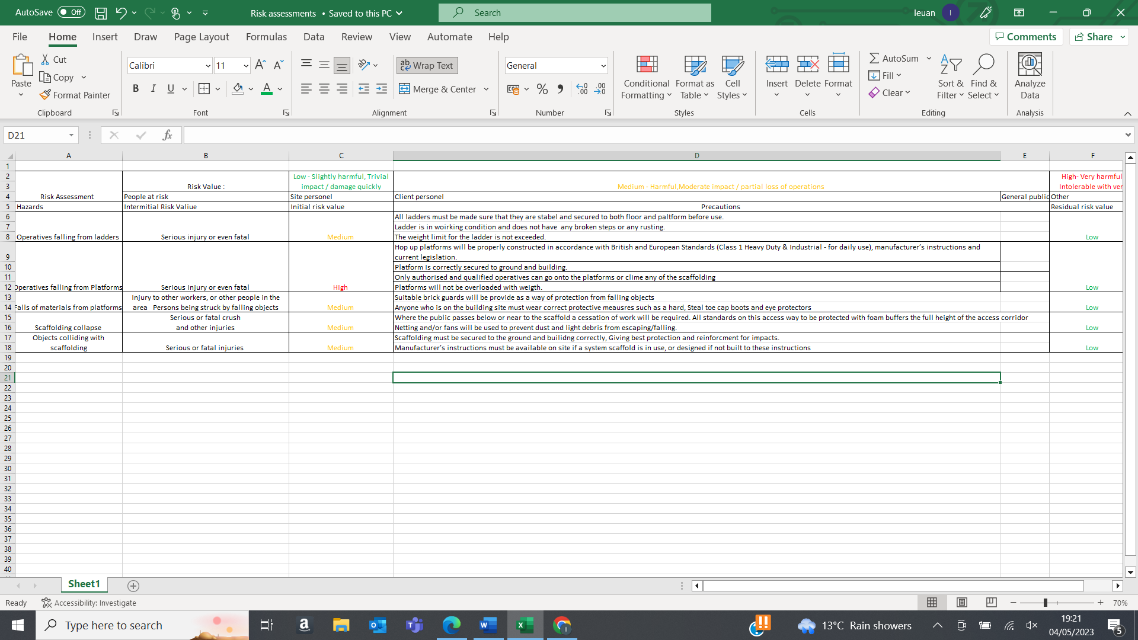

6.2 COSHH labels - https://www.pinterest.co.uk/pin/coshh-the-control-of-substances-hazardous-to-health-regulations-2002-law-requires-employers-to-contro--844706473829055528/

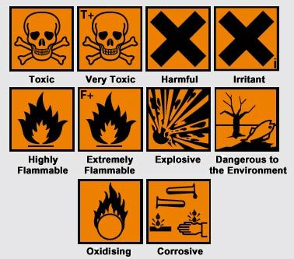

6.3 Images of Crown place

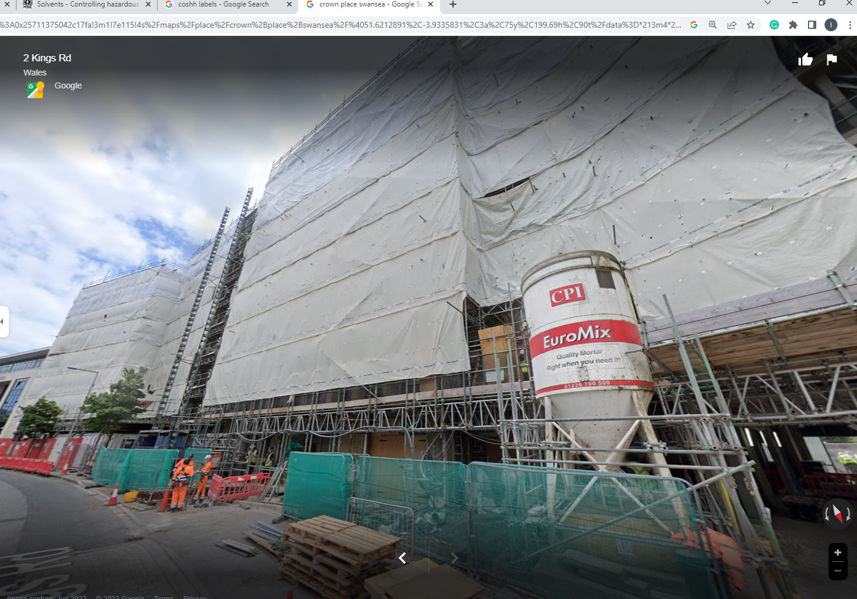

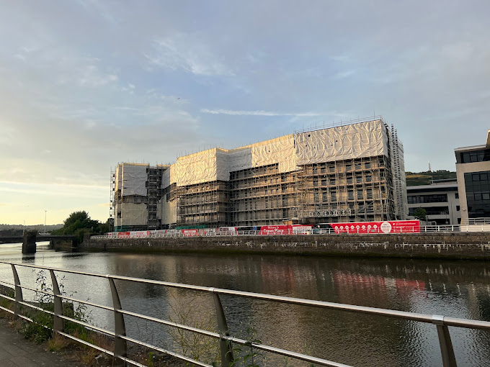

7.0 Glossary
HSWA | Health and safety at work act
COSHH | control of substances hazardous to health
CDM | Construction design and management regulations

