The Recognition of Faces Following a Distractor Task
Rebecca Harding
1700014
University of Wales Trinity Saint David
Research Methods
ECPS4002

Abstract
This study intended to identify own-biased face recognition. It consisted of 29 participants (7 males and 22 female) (mean age= 18 to 60. M=27.31, SD= 10.81) completing a face recognition study by recalling images of faces they had previously seen within the study. The hypothesis was of own-biased, same race, face recognition. Analysis consisted of a paired sample t test, and assessed which faces were recalled accurately. Participants’ demographical information was used to determine their ethnicity, this was then used to determine the relationship between the tvalue and the results. This study failed to support the hypothesis of own-race bias face recognition and future research is needed to determine why some faces are recognised and others are not.

Introduction
Facial recognition is an information process of the brain, based on encoding and memory; it allows a person to distinguish between people. A person’s face is important to identify a person and their ethnicity, emotions, and often some social information.
Many theories have been investigated about how and why a person may recognise others or recall seeing them previously. It can be argued that there is a clear own-race bias in recognition of same race faces than other race faces, however many studies have attempted to identify the reason for this, but is still yet to be understood (Valentine 1991).
The norm-based coding model suggests that an individual will recognise same race faces more quickly and accurately than other race faces, in tasks where different race faces will be displayed. Although, in contrast to this, the multi-dimensional framework model suggests that same race faces are normally distributed around the central tendency, and are encoded more easily, which suggests that, due to distinctiveness, faces of other races are stored in memory and are encoded away from the central tendency.
One study conducted by Cross, Cross and Daley (1971) found that children from a white community showed an own-race bias in face recognition, as opposed to other white children from an integrated community, although in contrast to this Cross et al (1971) did not find the same results with black children from the same settings. Brigham et al (1982) reported a significant link, albeit slightly tenuous, between cross-racial experience and their recognition of other race faces. This suggests that exposure to other races does play a part in the facial recognition process as suggested by Cross, Cross and Daley (1971), although, on the contrary, Brigham and Barkowitz (1978) did not find a significant relationship between cross- racial experience, and suggested this could be down to the fact that a person does not want to be portrayed as racist, which may influence a person’s results of their relationships/interactions.
Another hypothesis that was explored was that own-race bias face recognition may be a result of a person having racial attitudes and prejudices, however this was not supported by evidence. Lavrakas, Buri and Mayzner (1976) did not find a significant link between a person with a prejudiced ethnic attitude and their response to facial recognition.
Goldstein, (1979a, 1979b) hypothesised that it may be difficult to recognise faces of other races, although this has not been backed by any empirical findings, which is what the study within this paper is set to provide support and evidence for.
Valentine and Endo (1992) found that own-race faces were, indeed, recognised more accurately than other race faces. The present data reported within this paper is an attempt to try and demonstrate a finding to support that a person will recognise and identify same race faces more accurately than other ethnic groups.
The present study challenges a person’s memory by providing a distraction between seeing the faces and then retrieving them from memory, to test the hypothesis of own-biased same race face recognition.
Method
A total of 29 white students were recruited from a university lecture in a group setting containing (7 male and 22 females). The age range was 18 to 60 M = 27.31, SD = 10.81.
To analysis the responses, a paired sample t test was conducted to calculate the tvalue, which consisted within subjects. The independent variable was the ethnicity, and the dependant variable was the number of faces present recalled correctly.
A PowerPoint presentation was used to create the study, the first slide containing instructions for the participants in what to do during the first part of the study. Twelve faces were shown individually for a period of two seconds each (6 white faces and 6 black faces).
Part two of the study included a total of 36 faces being shown on 6 pages, with 6 faces on for a total of twelve seconds each.
A response sheet was also given to participants, which collected demographical data (gender and age) with space provided for participants to report their responses of what faces they recalled seeing during part one.
The participants were firstly provided with a consent form (Appendix A) and asked to complete this before taking part in the study. The participants were then instructed to watch the screen which provided additional instructions within the PowerPoint sides. The participants were then asked by the researcher to remain silent throughout, to allow everybody to have the same opportunities to concentrate. A countdown from 3 to 0 on the presentation then began part one, followed by the presentation of the twelve initial faces beginning. When the first part ended, a distraction in the form of the researcher introducing information about the study was given for one minute. Participants were then asked to look back to the screen, before a countdown from 3 again began and further instructions were given. A presentation of 36 faces was shown, each picture being numbered. The participants were asked to recall which of the 12 faces they had previously seen in section one of the study, identifying by writing down the number next to the corresponding picture in the space provided. After the presentation had finished a debrief form/information (Appendix B) was presented on the screen for participants to read; within the information explained the main purpose of the study, and participants were informed if that if they wished to have their data withdrawn from the study they should speak to the researcher. Participants were also informed that all information was confidential. Participants were also given an opportunity to discuss aspects of the research with the researcher if they so wished.
Results
A paired sample t test (Appendix C) was conducted to calculate the tvalue, in order to determine whether participants remembered more white faces than black faces accurately following a short period of distraction. The results show that participants recalled significantly more black faces (M = 3.34m SD = 2.42) than white faces (M = 2.67, SD = 1.97): t (28) = 3.12, p < .0.5, therefore the original hypothesis that a person will recognise and identify same race faces more accurately than other race faces must be rejected.
Discussion
The main purpose of this study was to test and confirm the hypothesis that a person will recognise and identify same race faces more accurately than other race faces, after a period of distraction was given to test which race faces where encoded in memory more accurately. A paired sample t test was used to measure the differences in the scores obtained from the study. The results showed that participants significantly recalled more black faces than white faces when presented, after the distraction was given for a minute. The most important finding here is that there is a significant difference in the recall of black faces compared to white faces during the study. It is important to note that all participants where white, which is why the hypothesis is rejected, as no own bias face recognition was displayed. This present study does not support the norm-based coding model, and is more consistent with the multidimensional framework model.
This study is in stark contradiction with the findings of studies undertaken by Cross, Cross and Daley (1971) or Goldstein, (1979a, 1979b). The present study does however support the distinctiveness hypothesis. This could be due to distinctiveness being more easily encoded within memory, as suggest by the studies of Valentine (1991).
Although the findings were not as predicted, there were limitations within this study, which could be taken in to consideration for future studies. The present study only included a small number of 29 participants, which means that the results cannot be generalised, whereas larger numbers of participants means stronger reliability of results, which can then be transferred to estimate general population results. Another limitation of the present study identified was the setting in which the study was conducted. Due to the fact that the setting was group-based, future studies could be conducted in an isolated setting to allow every participant the same opportunity to concentrate. A group setting does also raise the question of reliability of participants’ results, as it cannot eliminate the possibility that participants copy another person’s for any reason. During this present study, all the participants were from one ethnic group, and, due to this fact, we are unable to make comparisons between different races, which Cross et al (1971) found during their studies. Such cross-racial comparisons are highly beneficial in gaining a clearer picture of the hypothesis, in order to attempt to provide justification for it. Therefore, selecting participants from a single race could prove a significant limitation for this study. This does, however, provide opportunity for future research. Another factor that could be adapted during future studies is the differences in size of the pictures presented to the participants; section one of the study pictures were significantly bigger than those in section two, and as participants were in a group setting, some participants where sat further away from the screens. This could have raised an issue with viewing the pictures clearly, and the reliability of their results due to poor view of the pictures.
In conclusion, although this present data does not support the current hypothesis of own race bias presented within this paper, it does, however, require further research to explore the full effects of why a person may recall some faces more than others, despite their race.

References
Bringham, J. C., & Barkowitz, P. (1978). Do they look alike? The effect of race, sex, experience and attitudes on the ability to recognise faces. Journal applied psychology, 8, 306-318
Bringham, J. C., Mass, A., Snyder, L. D., & Spaulding, K. (1982). Accuracy of eyewitness identification in a field setting. Journal of personality and social psychology, 42, 673-681
Chance, J. E., Goldstein, A. G., & Anderson, B. (1986). Recognition memory for infant faces: An analog of the other-race effect. Bulletin of the Psychonomic society. 24, 257-260
Chiroro, P., & Valentine, T. (1995). An investigation of the contact hypothesis of the own-race bias in face recognition. The quarterly Journal of experimental psychology. 48A, (4), 879-894
Cross, J. F., Cros, J., & Daley, J. (1971). Sex, race, age and beauty in factors in recognition of faces. Perception and pschophysis, 10, 393-396
Goldstein, A. G. (1979a). Race-related variation of facial features: Anthropometric data 1. Bulletin of the Psychonomic society, 13, 187-190
Goldstein, A. G. (1979b). Facial feature variation: Anthropometric data 2. Bulletin of the Psychonomic society, 13, 191-193
Lavrakes, P. J., Buri, J. R., & Mayzner, M. S. (1976). A perspective on the recognition of other-race faces. Perception and psychophysics, 20, 475-481
Malpass, R. S., & Kravitz, J. (1969). Recognition for faces of own and other race. Journal of personality and social psychology, 13, (4), 330-334
Valentine, T. (1991). A unified account of the effects of distinctiveness, inversion and race in face recognition. The Quarterly Journal of Experimental Psychology, 43A, 161-204
Valentine, T., & Endo, M. (1992). Towards an exemplar model of face processing: the effects of race and distinctiveness. The Quarterly Journal of Experimental Psychology. 44A, 671-703

Appendices
Appendix A – consent form. 
School of Psychology
Townhill Campus
Swansea

Study Consent Form
I understand that taking part in this research study will involve me viewing a number of faces and attempting to recall the faces I have already seen.
I understand that this study consists of two parts. Part one will take approximately two minutes and will consists of me viewing a number of faces. For part two, I understand that I need to pay attention to the faces being presented and record which faces were shown in part one.
I understand that participation in this study is entirely voluntary and I am free to withdraw at any time without giving a reason. I am aware that if I have concerns about the study I can discuss these concerns with the researcher at any time during or after the study.
I understand that the information provided by me will be used for the purpose of providing data for analysis, but that this data will be held confidentially and anonymously, with a code assigned in place of my name. These data will be stored in accordance with the Data Protection Act.
I also understand that at the end of the study I will be provided with a debrief form and the opportunity to discuss any issues with the researcher.
I, ___________________________________( NAME) consent to participate in the study conducted by Stacey Coleman, School of Psychology, University of Wales Trinity Saint David, Swansea.

Participant Signature:________________________________________________

Date:___________________
Name and signature of researcher taking consent:
Stacey Coleman
Appendix B – Debrief form/information.
Debrief information

Thank you for taking part in this study.
The main aim of this study was to explore whether people are better able to recall and identify faces that belong to the same ethnicity as them – their ‘in-group’. We specifically hypothesised that participants would be able to recall significantly more faces that belonged to their in-group than their out-group.
If you wish to withdraw your data from the study you must tell the researcher now. After this point, all of your data will remain confidential and we will not trace it back to you.

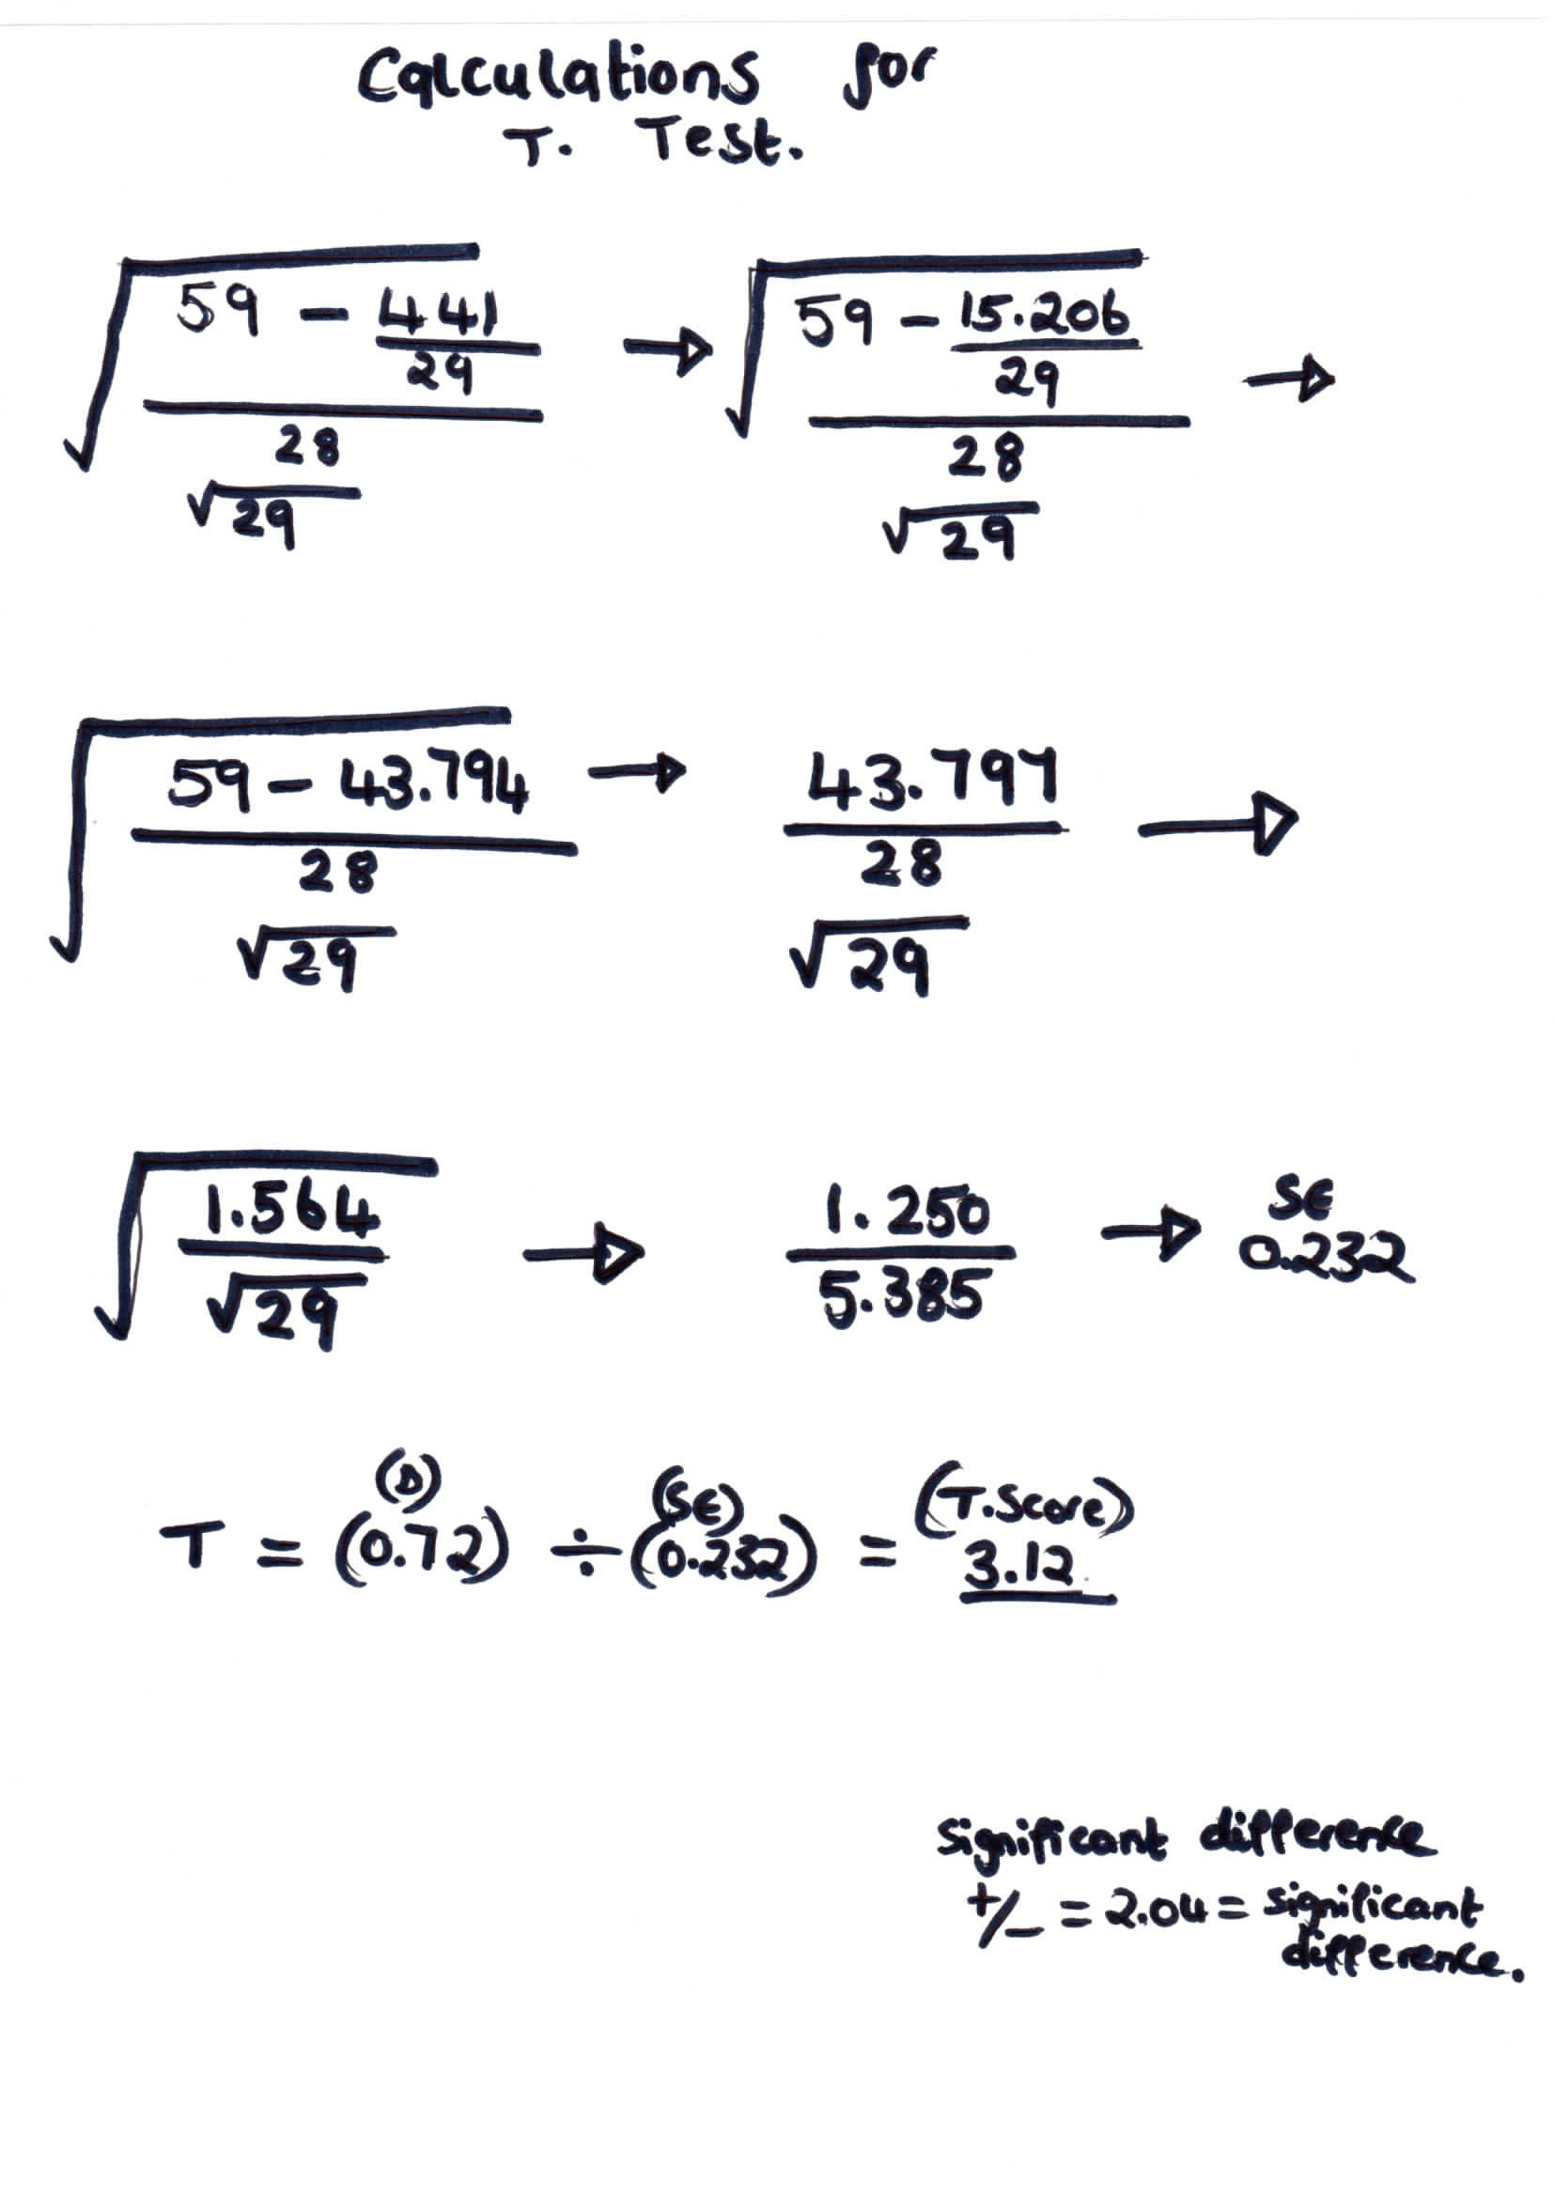
Appendix C – Calculations for T.Test.

