Business Plan for

STALLION INN GLAMPING RESORT

Produced By:

GROUP MEMBERS:
Student Name | Student No.
Jayson Luba | 2245377
Eddyson Fernandes | 2245647
Florentina Babache | 2240975
Catalina Ianos | 2232322

Dated: 15/11/2024

Module Name: Entrepreneurship
Module Code: BMIH5001
Lecturer Name: Charlotte Joyner
Word count:3500+ -10%

CONTENT PAGE
1. | Executive Summary |  |  | 4
2. | The Business Idea |  |  | 5
3.  5. | The Team  Skills Gaps & Key Partners |  |  | 7  9
6. | Market Research |  |  | 12
7. | Marketing Plan |  |  | 15
8. | Key Resources |  |  | 18
9. | Finances & Start-Up Support |  |  | 20
APPENDICES:
Appendix A |  |  |  | SWOT Analysis |  |  |  | 26
Appendix B |  |  |  | PEST Analysis |  |  |  | 28
Appendix C |  |  |  | Copy of Pitch Supporting Material |  |  |  | 29

AI Declaration:

I acknowledge the use of Grammarly (https://www.grammarly.com/) on 15/11/2024 to check my work.

I confirm that I have not presented any AI-generated text as my work. I confirm I have copies of my drafts, notes, and other resources I used before, and after the use of AI tools which I may asked to provide in evidence.

- EXECUTIVE SUMMARY

The luxury glamping paradise of Stallion Inn in Rasnov, Romania is set up to provide eco-sustainable and exclusive outdoor experiences for travellers who love to travel in the natural environment (Romanian Tourism Board, 2023). Set in the mountains of Brasov County, our glamping site offers the rusty old-world appeal of container development alongside the indulgences of a resort.
It’s our competitive advantage — we have a private, first-class facility, and connection to nature that appeals to environmentally conscious tourists, adventurers, and couples in search of the ultimate honeymoon (Statista, 2023). The introductory investment will go towards building the site, purchasing the best equipment and marketing in order to make Stallion Inn a leader in Romania’s eco-tourism sector (Sustainable Marketing Insights, 2023).

2. THE BUSINESS IDEA

2.1 The Product/Service
Stallion Inn operates within Romania’s eco-tourism sector, providing high-end, eco-friendly container accommodations combining glamping thrills with luxury hotel comforts. Our clients include tourists, couples, and eco-conscious visitors who want a unique and sustainable outdoor experience (Association of Ecotourism in Romania, 2023).
Features and Benefits:
- Features: All containers are replete with eco-friendly amenities, solar lights (Romania Solar Solutions, 2023), composting toilets, and sustainable furniture (Green Living Furniture, 2023).
- Benefits: Guests can enjoy the tranquillity of nature with the comforts of a hotel, catering to those who value outdoor experiences without sacrificing comfort (Smith, 2022).
Value Proposition: Our glamping site offers an exclusive, low-environmental-impact experience by blending sustainability with luxury, appealing to travellers who prioritize responsible tourism (Ovidius University, 2020; MDPI, 2023).

2.2 SWOT Analysis Summary
- Strengths: Research from AEVIS (2020) points to the growing significance of sustainable practices in tourism, which aligns directly with our commitment to eco-friendly hospitality. Unique location, eco-friendly and luxurious accommodations, strong appeal to eco-conscious travellers (Travel and Tour World, 2023).
- Weaknesses: High initial setup costs and potential for seasonal occupancy variation (World Bank, 2019).
- Opportunities: Romania's National Strategy of Tourism (2023-2035) emphasizes the expansion of eco-tourism nationwide, presenting a strategic growth opportunity for businesses like Stallion Inn (National Strategy of Tourism in Romania, 2023-2035) The growing trend toward eco-tourism and glamping, supported by government incentives (Transition Pathways, 2023).
- Threats: Economic fluctuations affecting travel budgets and competition from traditional hotels (Statista, 2023).
3. THE TEAM

3.1 Key Personnel

Name and company position: Jayson Luba Operation Manager
Skills and Experience: Jason has a background in hospitality management and over five years in eco-tourism (Smith, 2022). His expertise in managing day-to-day operations and coordinating logistics makes him essential for running the glamping site smoothly.

Role and Responsibilities: Oversaw daily operations, managed bookings, coordinated with suppliers, ensured a smooth guest experience, and maintained site standards.

Name and Company Position: Eddyson Fernandes. Marketing and sales manager
Skills and Experience: With a strong background in digital marketing and tourism sales, Eddyson has successfully led marketing campaigns targeting tourism markets (Sustainable Marketing Insights, 2023). His knowledge of social media, SEO, and influencer marketing will be key to driving awareness and bookings.

Role and Responsibilities: Developing and executing marketing strategies, managing social media accounts, establishing partnerships, driving customer engagement and overseeing promotions.

Name and Company Position: Florentina Babache. Sustainability Coordinator
Skills and Experience: Florentina holds a bachelor of science in environment studies and experience in sustainable tourism. Her experience in green management and her commitment to low impact tourism will ensure that our company is an environmentally sound business (Transition Pathways, 2023).

Role and Responsibilities: Working with green and keeping sustainability on track, procuring green materials, and keeping an eye on environmental impact.

Name and Company Position: Catalina Ianos. Guest experience manager
Skills and Experience: Catalina is a customer service specialist, having worked in luxury hospitality for over 5 years. Her presence will offer the guests a safe and enjoyable journey according to their desires and requirements.

Role and Responsibilities: Managing guests’ interactions, handling feedback, organizing personalised experiences and overseeing customer service standards.

3.2 Skills Gaps & Key Partners

3.2.1 Additional Staff Requirements (Roles and Responsibilities):
Technician for Maintenance
- Responsibilities: Make sure all facilities are in good operating condition by performing routine maintenance and inspections, resolve maintenance requests as soon as possible and when necessary, do general repair, electrical, and plumbing work.

Employees in Housekeeping
- Cleaning and upkeep of the general spaces and hotel rooms in the container are your responsibilities, Mversee the laundry services and make sure that clean towels and toiletries are available to guarantee cleanliness and take care of any maintenance issues, do routine inspections.

Receptionist at the Front Desk
- Greeting visitors when they arrive and overseeing the check-in and check-out procedures are among your duties, respond to questions, make reservations, and handle payments

3.2.2 Training and Development:
- Customer Service Training
Online resources like Courser LinkedIn Learning, or a nearby hospitality training organisation improve the customer service abilities of the receptionist and guest experience. A one-day class costs about €300-1,779 RON per participant, whereas an online course costs about €50 -296.5 RON (Ladhari, 2009).

- Training in Housekeeping and Maintenance
A training provider with expertise in a certain industry. gives maintenance personnel the fundamental repair abilities and housekeeping staff the necessary cleaning procedures. A one-day moving average training session costs about €250-1,482.5 RON while an online module costs about €40-237.2 RON.

- Training in social media and Digital marketing online classes or a local marketing firm.
Gives the marketing coordinator the tools they need to advertise the container hotels on the internet. Digital marketing courses, such as those recommended by Chaffey (2020), equip our marketing team with essential skills to effectively promote our glamping site. The price is free for online classes (Chaffey, 2020)

3.2.3 Outsourced Support / Key Partners:

- Agency for Digital Marketing
We hired the local company VIVA to design and manage social media and internet marketing campaigns (Sustainable Marketing Insights, 2023). The service, which will range between£ 250 (1,482.5 RON) and £400(2,372 RON) a month, would include online advertising and SEO optimization to attract traffic (Chaffey, 2020).

- Upkeep Services
We locate ENG Repair, an adjacent repairer, for container hotel upkeep and repair. Each month, the services — including annual check-ups and emergency repairs — will run from about £300-1,779 RON.

- Company for Housekeeping Supplies
Wow Cleaning Srl promises a continuous supply of linens and cleaning products.
The provision, which will cost between £200-1,186 RON a month, will consist of monthly delivery of soaps and detergents.
4. MARKET RESEARCH

4.1 Market Information, Trends and External Factors

According to the Romanian National Institute of Statistics (2023), Brasov County tourism recorded a robust growth each year, proving its strategic significance for eco-tourism operators like Stallion Inn. The glamping market in Romania is expanding very rapidly thanks to growing demand for sustainable travel (Romanian Tourism Board, 2023) and wilderness tourism. Recent tourism statistics show that eco-tourism in eastern Europe has grown by 20% per year, and Romania is particularly growing thanks to its unique landscapes and cultural attractions (Tourism Industry Insights, 2023). That shift puts Stallion Inn at the forefront of an eco-friendly travel market.
Key trend
- Eco-Tourism Growth: Travellers want eco-friendly accommodations because they want to go places where it is sustainable (Romania Insider, 2023). This reflects our commitment to low-impact tourism.
- Unique travel Experiences: Travellers nowadays seek out special, memorable stays instead of staying at a hotel, particularly millennial and Generation Z who are looking for unique travel experiences.

4.2 Customer Profiles

- Eco-conscious Travelers
- Demographics: Majority 25-45, educated, mid-high income (MDPI, 2023).
- Behaviour: Values environmentally friendly options, respects nature, and prefers sustainable accommodation. Organisations such as the Romanian-American Foundation (2023) have played a vital role in the promotion of eco-tourism, which leaves room for projects such Stallion Inn.
- Why They Choose Us: Our green credentials and luxurious accommodations reflect their values.
- Adventure Seekers
- Demographics: All-ages, adventurous, valuing special moments.
- Behaviour: Moves around frequently looking for adventures, and always looking for places that offer outdoorsy pursuits.
- Why They Choose Us: Rasnov Brasov’s proximity to nature offers a perfect place to do hike, cycle and other outdoor pursuits (Romanian-American Foundation, 2023).
- Couples Seeking a Getaway
  - Demographics: 30-50 years old, frequently seeking out romantic getaways (Sustainable Tourism Actions in Romania, 2023).
  - Behaviour: Affords luxury, isolated, private homes to unwind and spend time with.
  - Why They Choose Us: Our quaint, private glamping camp is an ideal romantic destination with an opulent flair to fit every special occasion.

  - Competitor Profiles

- Competitor 1: Ecolodge Romania
o Pros: Proven brand presence in Romania and environmental integrity. As Dinca (2015) argues: ‘there’s clearly a need for eco-tourism that offers both luxury and comfort, and Stallion Inn is trying to fill the void in Romania’s eco-tourism market.
o Flaws: Fewer luxury services than Stallion Inn (Green Camping Supplier, 2023).
o The Competitive Edge: Stallion Inn offers higher-end rooms and more nature-based camping.

- Competitor 2: Forest Retreat & Spa
o Strengths: Great for vacationers that desire a scenic escape.
o Defects: More of a wellness resort without the outdoor-adventurous glamping vibe.
• Strategic Edge: We focus on glamping travelers and provide more outdoorsy experiences (Travel and Tour World, 2023).

- Competitor 3: Romanian Adventures Camp
o Advantages: Targets adventurers on a budget.
o Achilles’ heel: Lack of lavish facilities and sustainable practices.
o Edge: We offer better comfort and environmental resiliency to the eco-conscious, high-end travellers.
5. MARKETING PLAN

5.1 Price
- Stallion Inn will establish itself as a mid-to-high-end luxury glamping location where the prices reflect the specific eco-friendly features and top-tier amenities. Our pricing policy will ensure accessibility for both domestic and foreign customers while expressing quality and exclusivity (Romania Insider, 2023). For example:
- Deluxe Container pods: £75-130 (Ron/Lei) 444.75-770.9 per night, depending on season.
- Extra Packages (e.g., romantic arrangements, guided nature tours): £30 - £50 (Ron/ Lei) 177.9-296.5
We’re priced are at around 50%less from our competitors

5.2 Product

Stallion Inn’s design will be a combination of rustic elegance and urban sophistication. Every container pod will be thoughtfully designed with natural, sustainable materials as a testament to our green vision. We will employ earthy colours, nature inspired illustrations, and simple, elegant elements in our brand visuals to convey a sense of exclusivity (Sustainable Marketing Insights, 2023).
Branding Elements:
• Logo and colour scheme are based on earthy tones (greens, browns, and whites).
• Promotional materials with aerial photographs of the property and surrounding scenery.
• Add-ons, such as tailored romantic configurations or guided tours, add to the experience and are reserved for special occasions.

5.3 Placement

We will promote our services both on and offline:
• On-line: on booking sites, such as Airbnb, Booking.com, and eco-tourism sites. We will also have our own website where we can book direct reservations and promote our brand (Transition Pathways, 2023).
• Offline: Working with the local tourism offices, travel companies, and eco-tourism fairs to expand our presence and entice visitors from the local areas (Sustainable Marketing Insights, 2023).
From our location in Rasnov Brasov we can access to natural beauties and that Stallion In is an ideal base for explorers that will be promoted both online and offline.
5.4 Promotion
We’ll optimize our promotion plan to ensure high brand awareness and engagement:
1. Social
We’ll be using Instagram and Facebook to show off our glamping property and the natural setting. Prompt photography, guest reviews, eco-tourism advice will be featured using the hashtags such as #GlampingRomania and #EcoLuxury (Romanian Tourism Board, 2023).
2. Influencer
Partnerships with travel bloggers and eco-tourism bloggers will create brand equity. By partnering with influencers, we hope to generate true reviews and boost social media traffic.
3. Content
We’ll write about sustainable travel, Romanian tour guides, and eco-friendly living (Statista, 2023). Such information will attract environmentally conscious tourists and generate traffic to our website.
4. Email
We’ll build up a mailing list so you can share seasonal offers, special deals, and travel advice with past and future guests. To reward subscribers, we’ll give them 10% off on their first booking.
5. Local
We’ll also have partnerships with local adventure tourism companies (hiking, bike rental) and local restaurants that allow us to sell package deals and cross-promote one another.
6. Promotional
Our participation in tourism and eco-tourism fairs, both in India and the surrounding regions, will bring us into closer proximity with travellers who are seeking sustainability oriented experience.
6. KEY RESOURCES

6.1 Premises
Stallion Inn requires a minimum land area of 10,000 square meters to accommodate luxury tents and shared amenities. The land should be in a secluded area of Rasnov , close to natural attractions while offering privacy to guests.
- Ideal Location: A plot near the Rasnov Fortress and surrounding forested areas.
- Cost Estimates: Based on similar listings in the Brasov area, leasing or purchasing land is estimated at £5,000 - £8,000 (Ron/Lei) 29,750-47,440 per year (Local Real Estate Listings, 2023).
- Facilities: We’ll include a small central building for administration, guest check-in, and storage of supplies and maintenance equipment.
6.2 Equipment
In order to do this effectively, Stallion Inn will require sturdy and environmentally friendly technology.
• Premium containers: Premium, all-weather insulated, capable of accommodating at least 4 guests per unit. Cost per container: £1,200 - £1,500 Ron/Lei 7,116 – 8,895.
• Solar Power: Solar panels to light and provide low electricity to each container £5,000 Ron/Lei 29,650 + initial fitting costs.
• Water Storage & Filtration: To maintain a sustainable water supply for guests and reduce environmental impact. Estimated price: £1,000 - £1,500 Ron/Lei 5,930 – 8,895 (Romania Solar Solutions, 2023; Green Living Furniture, 2023).
• Furniture and Decor: Premium Furniture made from environmentally sustainable material such as beds, tables, and green decor. Average cost per tent: £500 Ron/Lei 2,975
• Fire pit outdoors: For a warm evening experience with safety. Price range: £200 Ron/Lei 1,186 each

  - Key Suppliers

  - Environmentally friendly container Supplier: We source our sustainable and weather-proof units directly from our source which ensures us that the units are of high quality and durability (Eco-Friendly Camping Supplier, 2023).
o Supplier Example:
o Price: £1,200- £1,500 Ron/Lei 7,116–8,895 Pods per container.
2. Solar Service: A local renewable energy supplier to supply and install our panels (Romania Solar Solutions, 2023).
O Supplier Example:
o Price: Around £5,000 Ron/Lei 29,650 for the setup.
3. Sustainable Furniture Manufacturer: We’ll buy our furniture from a manufacturer that produces its products using eco-friendly, sustainable raw materials (Green Living Furniture, 2023).
O Supplier Example:
o £500 Ron/Lei 2,975 per pod configuration.

7. FINANCES AND START-UP SUPPORT

A basic projection for Year 1 of Stallion Inn includes both expenditure and income estimates. These numbers are derived from cost research, supplier quotes, and expected occupancy rates. We convert the pounds in local coin as Ron (£1=5.93 RON)

EXPENDITURE. £ | Year 1 RON
Company Registration £500 | 2965
Rent/Rates £6500 | 38545
Staff Wages. £20000 | 118600
Travel/Accommodation. £1000 | 5930
Telephone (mobile) £250 | 1482.5
Broadband. £250 | 1482.5
Utilities. £1500 | 8895
Marketing and materials £3000 | 17790
Insurance. £2000 | 11860
Capital Expenditure/Equipment £15000 | 88950
Training & Development. £500 | 2965
Accounting/Legal. £1000 | 5930
Outside Services. £3600 | 21348
Stock/Materials Purchases. £1500 | 8895
Bank Charges. £2000 | 11860
Office Consumables £500 | 2965
Loans Repayments £1500 | 8895
Total Expenditure. £60600 | 359358 RON
INCOME £ | Year 1  RON
Sales A? £30000 | 177900
Sales B? £18700 | 110891
Sales C? £8700 | 51591
Capital Introduced. £20000 | 118600
Funding £5000 | 29650
Loans/Borrowing £ 10000 | 59300
Total Income. £92400 | 547932 RON
YEAR ONE PROFIT/LOSS. £ | RON
Total Income. £92400 | 547932
Total Expenditure. £60600 | 359358
Profit/Loss. £31800 | 188574 RON

7.1 Financial Summary
Expenditure: Key expenses include staff wages, leasing costs, and the initial setup of tents and solar systems. These figures are based on average supplier costs and regional wage standards. Our marketing and promotional budget will focus on digital channels, influencer partnerships, and local tourism collaborations (Transition Pathways, 2023).
Income: Revenue projections are based on an estimated occupancy rate of 60-70% during peak months and 40% in off-peak months (Sustainable Marketing Insights, 2023). Additionally, we expect revenue from add-on services such as guided tours and romantic setup packages.
Start-Up Support:
- We are exploring potential support from eco-tourism grants offered by the Romanian government (Romania Insider, 2023) and may apply for a small business loan of £5,000 to support initial capital needs.

Reference List
AEVIS, 2020. AER Conference Report on Sustainable Tourism. [pdf] Available at: https://www.aevis.org/wp-content/uploads/2020/09/AER-18_09_2020.pdf [Accessed 2 November 2024].
Association of Ecotourism in Romania, 2023. Ecotourism Destinations Part I: 10 Years of Evolution in Romania. [online] Available at: https://www.eco-romania.ro/en/pet-project/ecotourism-destinations-part-i-10-years-of-evolution-in-romania/ [Accessed 2 November 2024].
Association of Ecotourism in Romania, 2023. The Recovery of Romanian Tourism from a Sustainability Perspective. [online] Available at: https://www.eco-romania.ro/en/noutati-blog/conference-the-recovery-romanian-tourism-sustainability-perspective/ [Accessed 2 November 2024].
Association of Ecotourism in Romania, 2023. Ecotourism in Romania. [online] Available at: https://www.eco-romania.ro/en/ [Accessed 2 November 2024].
Association of Ecotourism in Romania, 2023. Sustainable Tourism Actions in Romania. [online] Available at: https://asociatiaaer.ro/en/sustainable-tourism-actions-in-romania/ [Accessed 2 November 2024].
Dinca, M., 2015. Developing Ecotourism Destinations in Romania: A Case Study Approach. Academia.edu. [online] Available at: https://www.academia.edu/19700570/Developing_ecotourism_destinations_in_Romania_A_case_study_approach [Accessed 2 November 2024].
MDPI, 2023. Sustainable Agriculture. [online] Available at: https://www.mdpi.com/2077-0472/14/11/1917 [Accessed 2 November 2024].
MDPI, 2023. Sustainable Tourism. [online] Available at: https://www.mdpi.com/2071-1050/13/5/2649 [Accessed 2 November 2024].
National Strategy of Tourism in Romania, 2023-2035. Tourism Strategy Report. [pdf] Available at: https://prccsf.com/paper/pdf/Romania-National-Strategy-of%20Tourism-2023-2035.pdf [Accessed 2 November 2024].
Ovidiu’s University, 2020. Sustainable Tourism Development in Romania. [pdf] Available at: https://stec.univ-ovidius.ro/html/anale/RO/wp-content/uploads/2020/02/Section%20II/7.pdf [Accessed 2 November 2024].
Romania Insider, 2023. Environment Ministry to Finance Development of Ecotourism in Romania. [online] Available at: https://www.romania-insider.com/environment-ministry-finance-development-ecotourism-romania [Accessed 2 November 2024].
Romanian National Institute of Statistics, 2023. Tourism Statistics for Brasov County. [online] Available at: https://www.insse.ro [Accessed 2 November 2024].
Romanian-American Foundation, 2023. Development of Ecotourism Destinations. [online] Available at: https://rafonline.org/en/program/development-of-ecotourism-destinations/ [Accessed 2 November 2024].
Smith, J., 2022. 'The Sustainable Traveller: Understanding Eco-Conscious Tourism Demand'. Journal of Sustainable Tourism, 30(2), pp.123-145.
Statista, 2023. Growth in Eco-Tourism Markets Worldwide. [online] Available at: https://www.statista.com [Accessed 2 November 2024].
Statista, 2023. Travel and Tourism in Romania. [online] Available at: https://www.statista.com/topics/7436/travel-and-tourism-in-romania/ [Accessed 2 November 2024].
Sustainable Marketing Insights, 2023. Effective Marketing Strategies for Eco-Tourism Ventures. [online] Available at: https://www.sustainablemarketing.com [Accessed 2 November 2024].
Tourism Industry Insights, 2023. Romania’s Top Growing Sectors in Tourism. [online] Available at: https://www.tourismindustryinsights.com [Accessed 2 November 2024].
Transition Pathways, 2023. Romania's Tourism Development Strategy 2019-2030: Vision for Sustainable Growth. [online] Available at: https://transition-pathways.europa.eu/ro/policy/romanias-tourism-development-strategy-2019-2030-vision-sustainable-growth-and [Accessed 2 November 2024].
Travel and Tour World, 2023. Romania's Danube Delta Launches Eco-Friendly Slow Tourism Routes. [online] Available at: https://www.travelandtourworld.com/news/article/romanias-danube-delta-launches-eco-friendly-slow-tourism-routes-a-new-era-for-sustainable-travel/ [Accessed 2 November 2024].
World Bank, 2019. World Bank Group Partnership with Romania: Achieving Sustainable and Inclusive Growth. [online] Available at: https://www.worldbank.org/en/results/2019/09/13/world-bank-group-partnership-with-romania-achieving-sustainable-and-inclusive-growth [Accessed 2 November 2024].

APPENDICES
.
Appendix A – SWOT Analysis
- Strengths:
  - Special Place: It is located near Rasnov Fortress and the forest, so attracts tourists who appreciate nature.
o Sustainability: Our sustainability philosophy appeals to the green traveller.
o Premium Facilities: Offering premium accommodations, including solar power and good quality furniture that sets us apart from ordinary campsites.
- Weaknesses:
o Expensive Up-front: Significant upfront investment in land, infrastructure, and construction.
o Occupancy Across Seasons: Lower occupancy rates during cooler months can have a negative effect on consistent revenue.
- Opportunities:
o Green Tourism: Growing demand for sustainable travel experiences as part of our business model.
o Local Partnerships: Ability to partner with local businesses on package deals and joint promotions.
o Social Media Reach: An opportunity to utilize social media and influencers to connect with eco-tourism seekers across the globe.

- Threats:
o Economic Cycles: Uncertain economic scenarios might impact discretionary luxury travel spending.
o Environmental Rules: New rules might change things, but eco-friendly methods lower this risk.
o Invites: There is a growing selection of glamping in Romania but not quite the luxury and ecological ones like ours.

Appendix B – PEST Analysis

• Political:
o Tourism is well-established, and government policy supports eco-friendly initiatives, thus making Romania a prime location for Stallion In. We may experience occasional changes in tourism policy or taxes which might affect our operations but we are in compliance with all the laws in force.
• Economic:
o Exchange rates render Romania a very reasonable destination for most tourists. But international tourism might be affected by the global economic landscape. With a mix of local and international visitors, Stallion In could alleviate some of these dangers.
• Social:
o Environmental, sustainable travel is on the rise. Travellers increasingly crave exotic, nature-based experiences and that’s exactly what we provide. Our brand is geared especially towards young professionals and sustainable tourists who appreciate natural practices.
• Technological:
o Advances in online booking and digital marketing services make things more accessible and visible. Our brand exposure via social media is relatively cheap and our adoption of sustainable technologies such as solar power is a great way to keep people engaged with us and increase our popularity.
Appendix C – Copy of Pitch Supporting Material
This appendix will include visuals and supporting materials for investor presentations, including:
- Logo and Branding Mock-Ups: A preview of the Stallion In logo, featuring earthy tones and nature-inspired elements.
- Site Layout and Container Interior Design: Visuals showing the layout of the interior and common areas.
Sample Marketing Content: Examples of social media posts, influencer collaboration ideas, and blog content topics focused on eco-tourism and glamping.

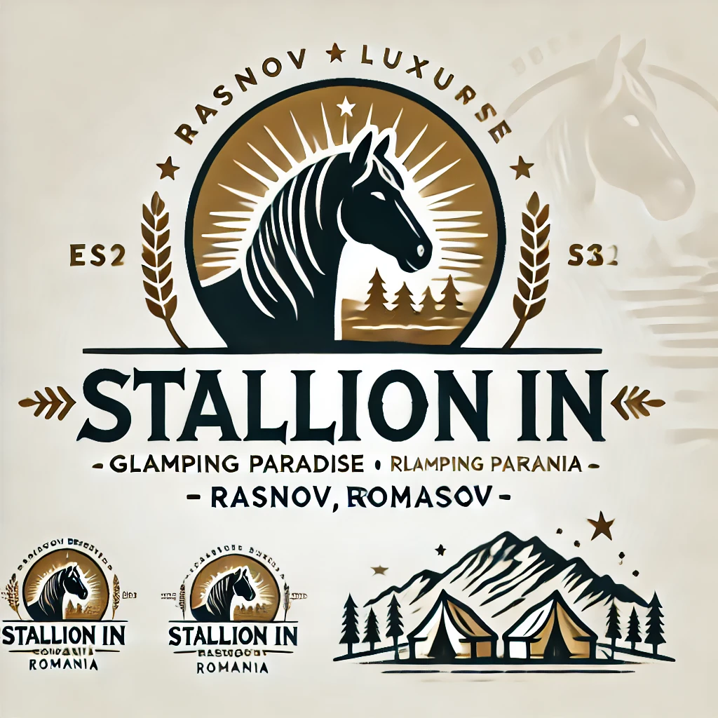
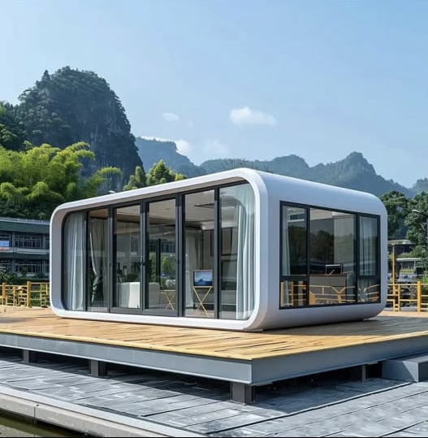

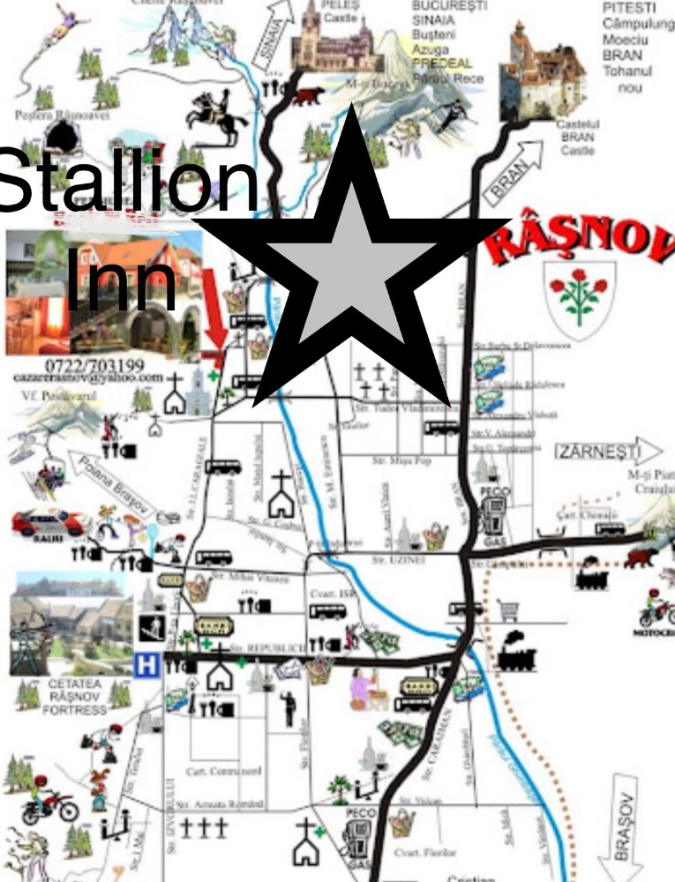

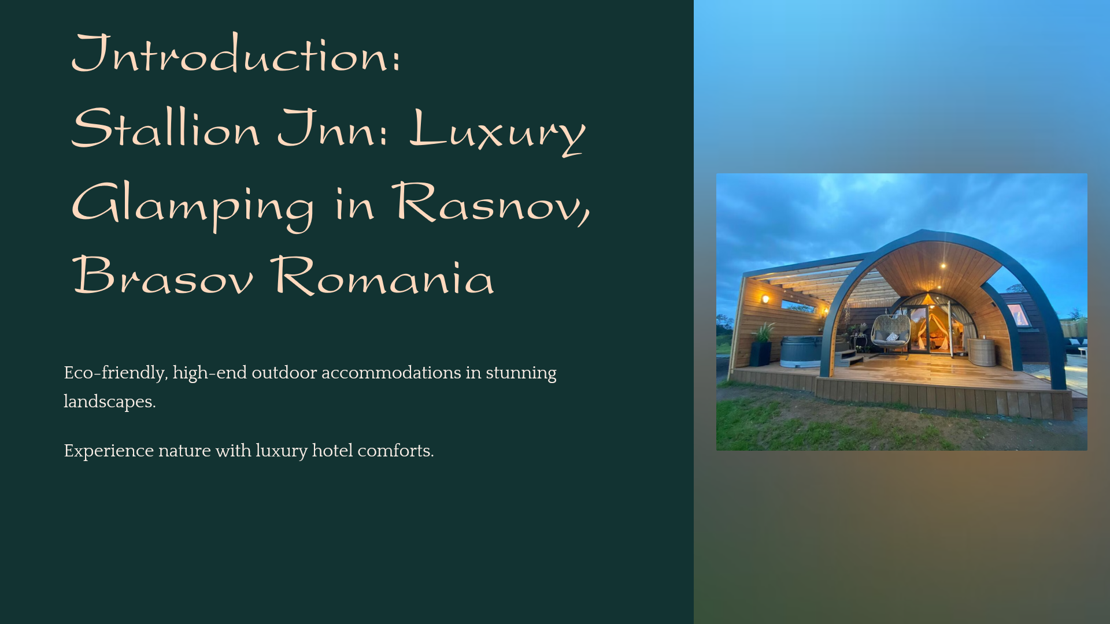
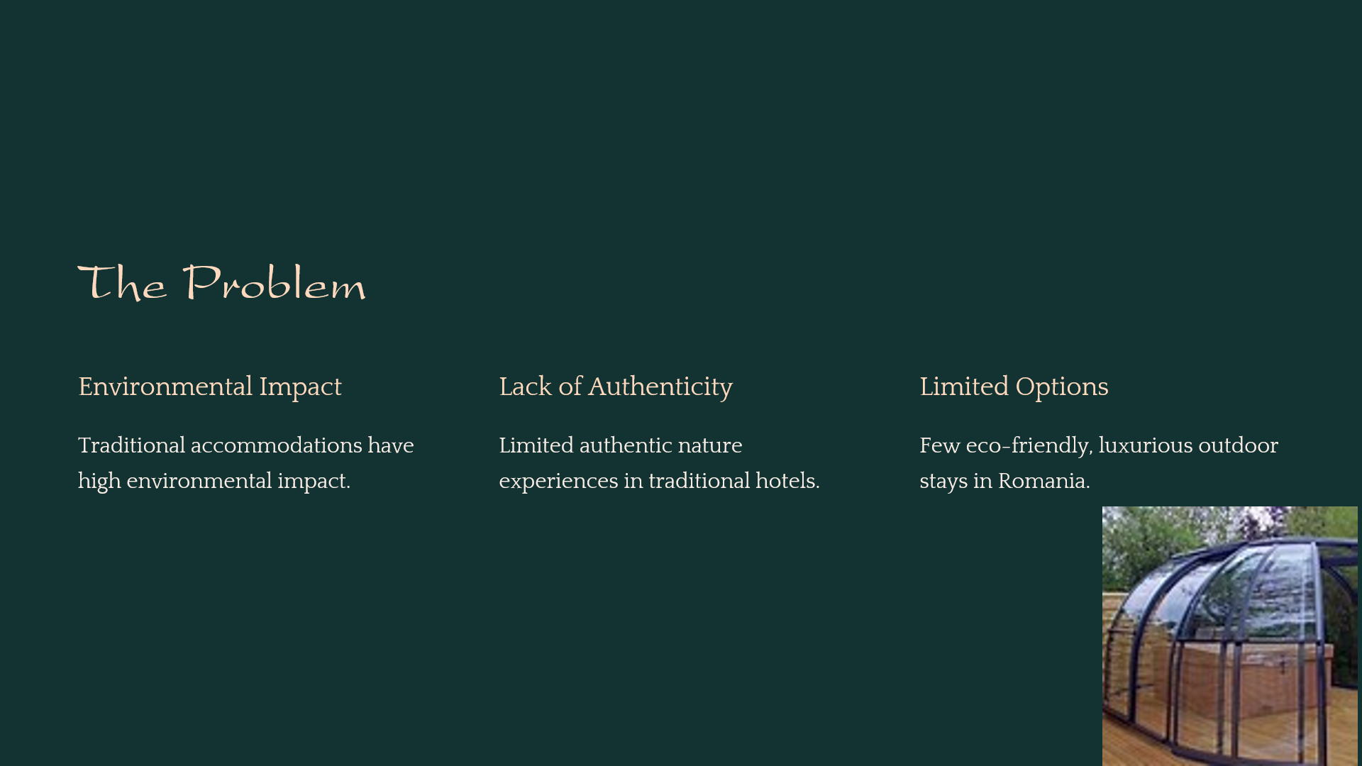
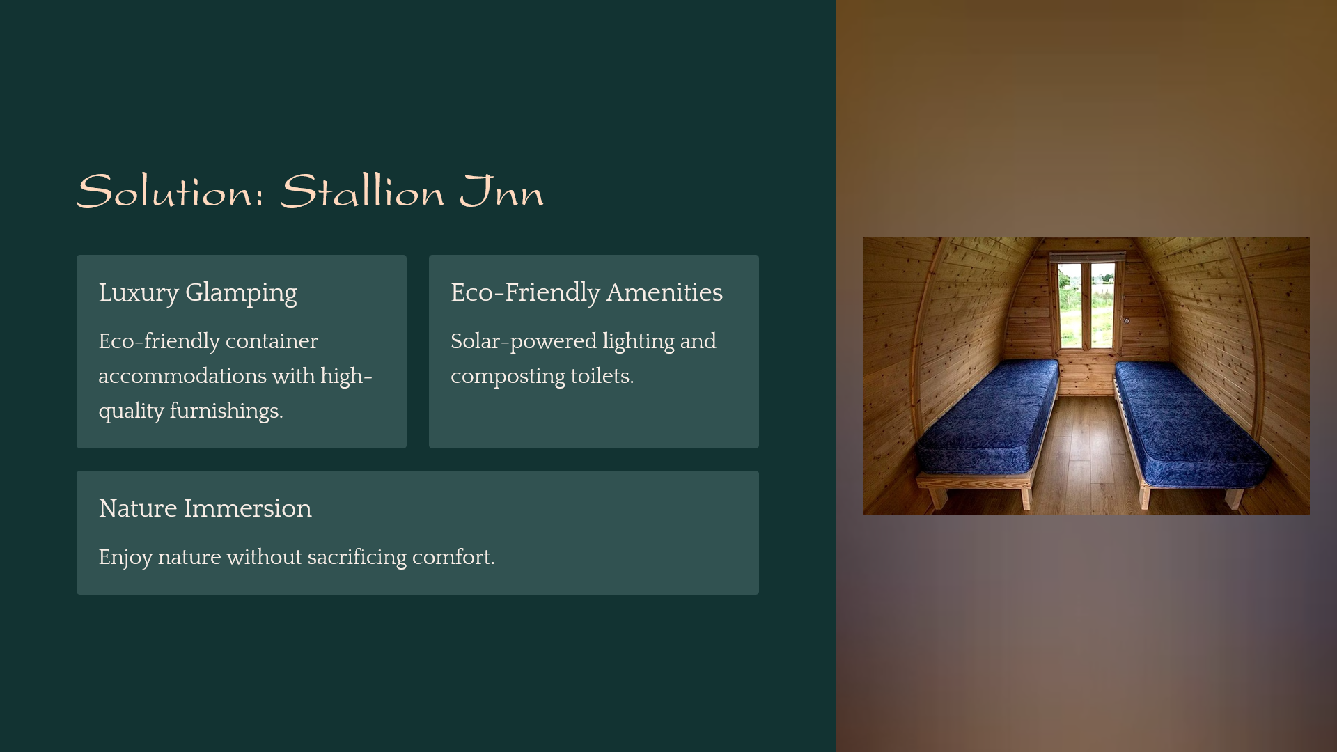
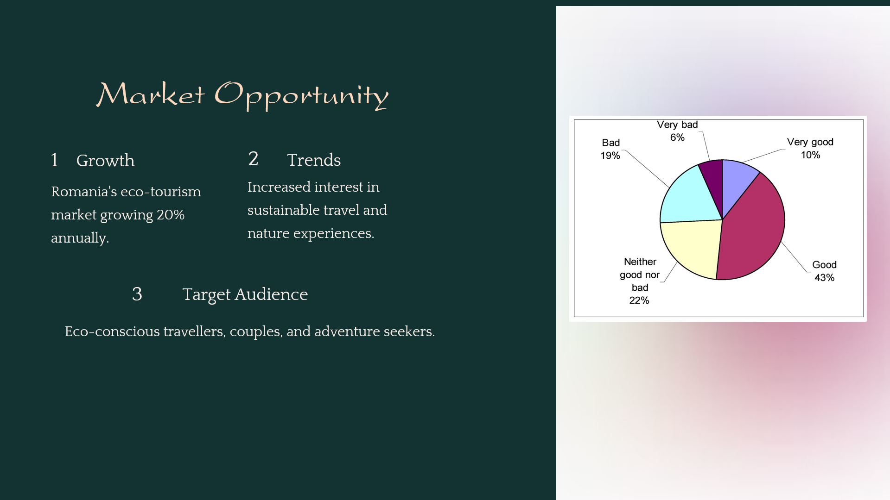
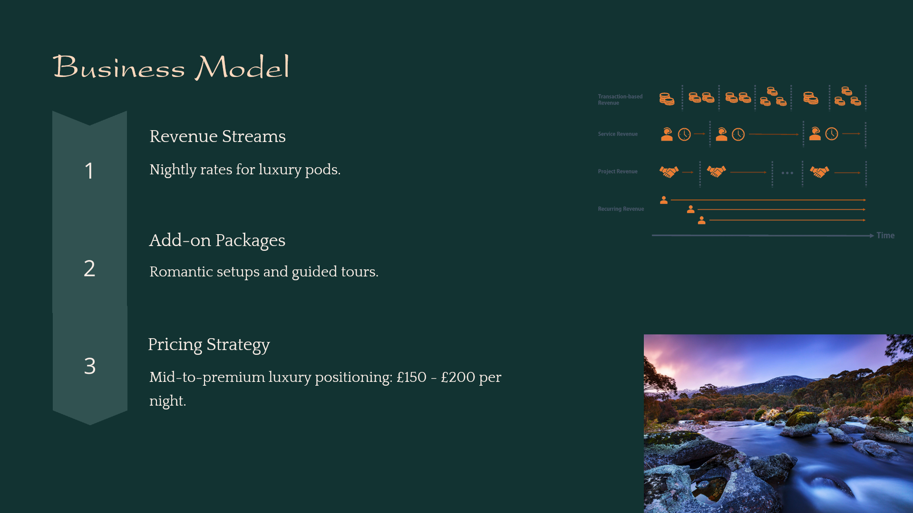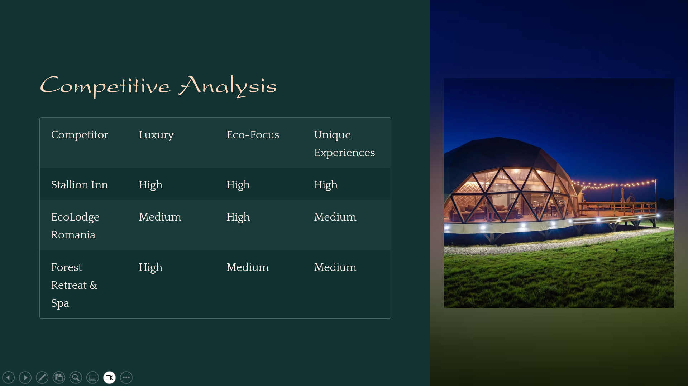
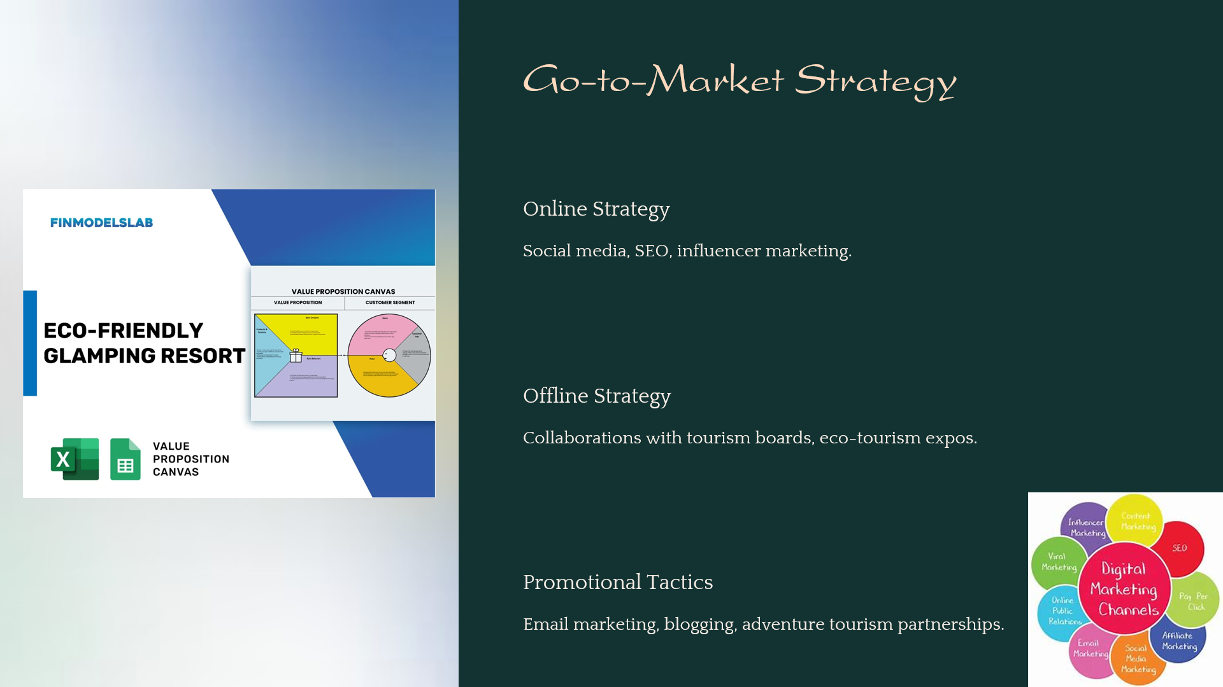
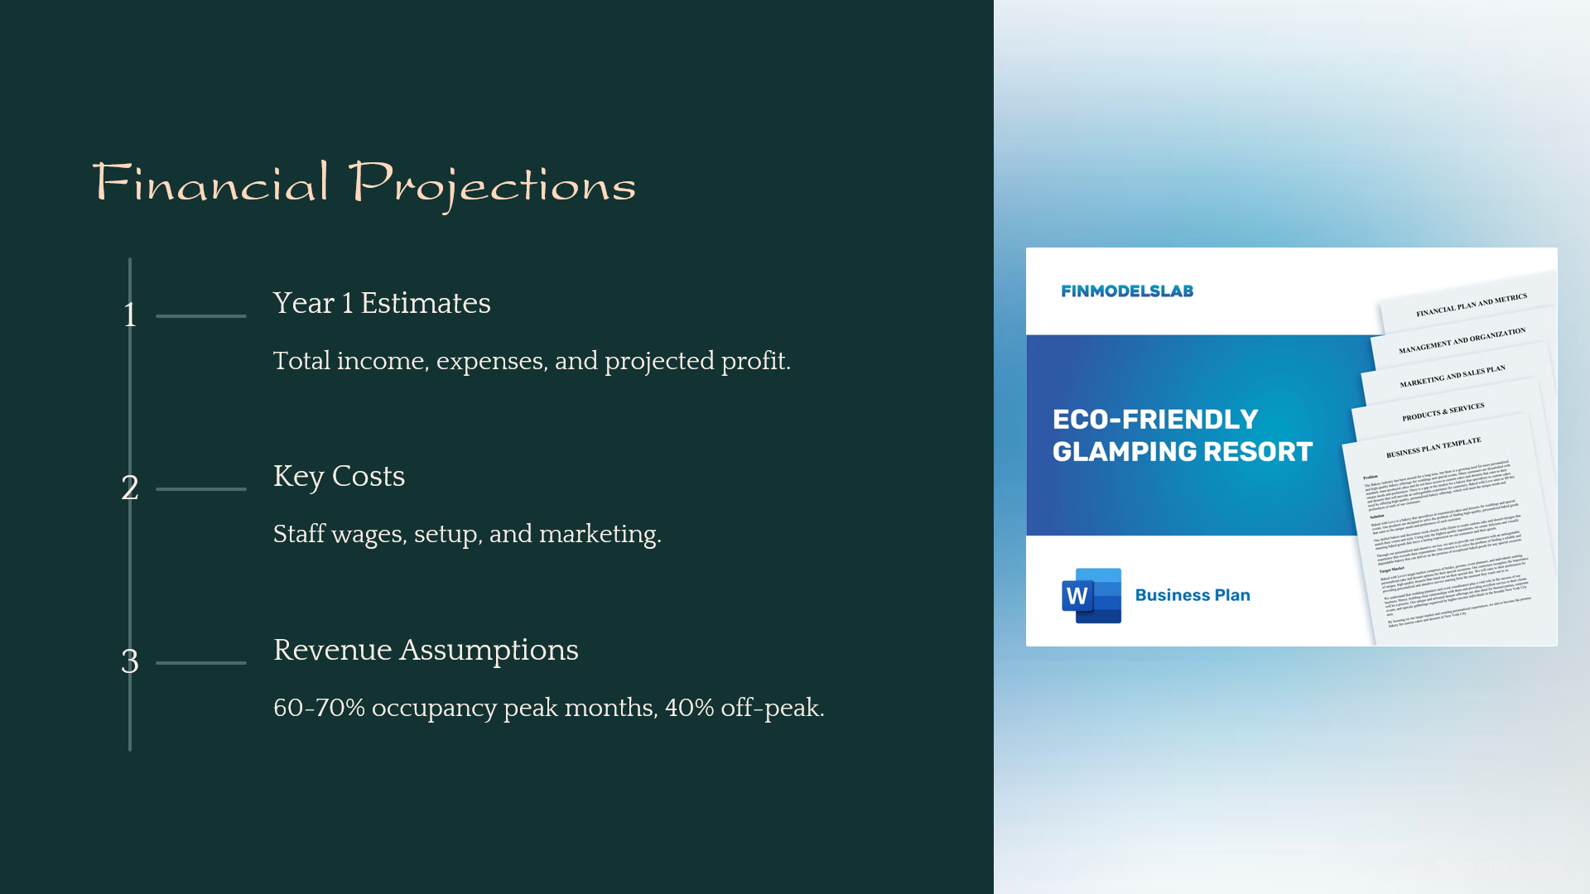
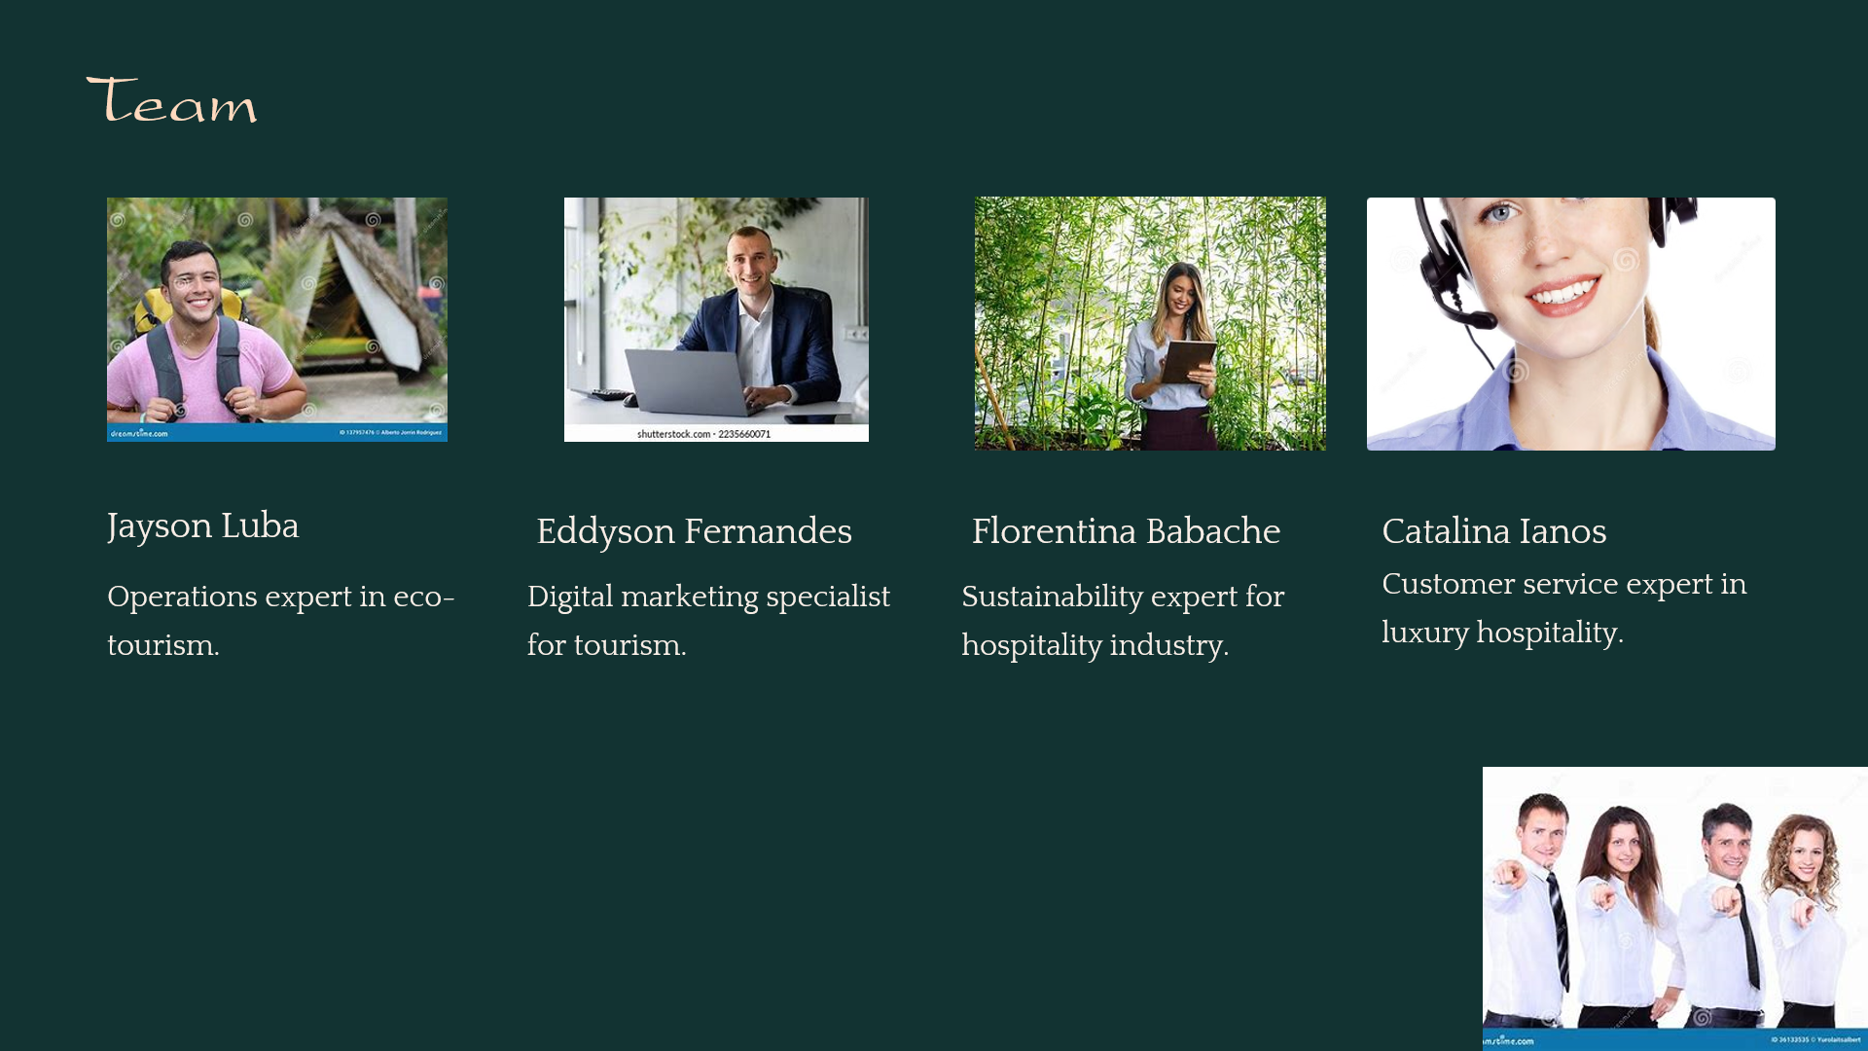
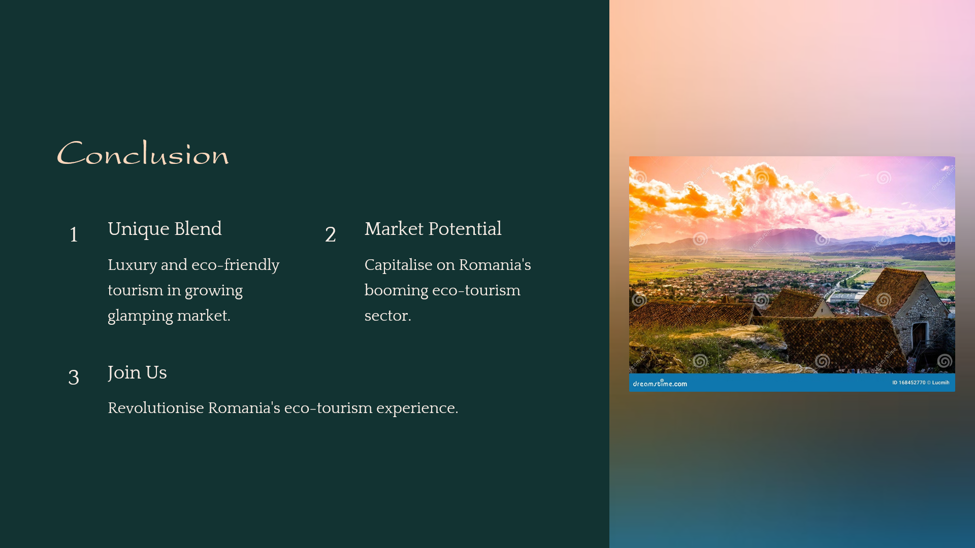

REFERENCE LIST:
- Romanian Tourism Board, 2023. Eco-Tourism Growth in Romania. [online] Available at: https://www.romaniatourismboard.ro [Accessed 2 Nov. 2024].
- Statista, 2023. Growth in Eco-Tourism Markets Worldwide. [online] Available at: https://www.statista.com [Accessed 2 Nov. 2024].
- Romanian National Institute of Statistics, 2023. Tourism Statistics for Brasov County. [online] Available at: https://www.insse.ro [Accessed 2 Nov. 2024].
- Smith, J., 2022. 'The Sustainable Traveler: Understanding Eco-Conscious Tourism Demand', Journal of Sustainable Tourism, 30(2), pp.123-145.
- Sustainable Marketing Insights, 2023. Effective Marketing Strategies for Eco-Tourism Ventures. [online] Available at: https://www.sustainablemarketing.com [Accessed 2 Nov. 2024].
- Tourism Industry Insights, 2023. Romania’s Top Growing Sectors in Tourism. [online] Available at: https://www.tourismindustryinsights.com [Accessed 2 Nov. 2024].
- Transition Pathways, 2023. Romania's Tourism Development Strategy 2019-2030: Vision for Sustainable Growth. [online] Available at: https://transition-pathways.europa.eu/ro/policy/romanias-tourism-development-strategy-2019-2030-vision-sustainable-growth-and [Accessed 2 Nov. 2024].
- Association of Ecotourism in Romania, 2023. Ecotourism Destinations Part I: 10 Years of Evolution in Romania. [online] Available at: https://www.eco-romania.ro/en/pet-project/ecotourism-destinations-part-i-10-years-of-evolution-in-romania/ [Accessed 2 Nov. 2024].
- MDPI, 2023. Sustainable Agriculture. [online] Available at: https://www.mdpi.com/2077-0472/14/11/1917 [Accessed 2 Nov. 2024].
- Transition Pathways, 2023. Navigating EU Funding Guide for Tourism Businesses and Stakeholders. [online] Available at: https://transition-pathways.europa.eu/learning-resources/navigating-eu-funding-guide-tourism-businesses-and-stakeholders [Accessed 2 Nov. 2024].
- Travel and Tour World, 2023. Romania's Danube Delta Launches Eco-Friendly Slow Tourism Routes. [online] Available at: https://www.travelandtourworld.com/news/article/romanias-danube-delta-launches-eco-friendly-slow-tourism-routes-a-new-era-for-sustainable-travel/ [Accessed 2 Nov. 2024].
- Transition Pathways, 2023. Romania's Tourism Development Strategy 2019-2030: Vision for Sustainable Growth. [online] Available at: https://transition-pathways.europa.eu/ro/policy/romanias-tourism-development-strategy-2019-2030-vision-sustainable-growth-and [Accessed 2 Nov. 2024].
- Statista, 2023. Travel and Tourism in Romania. [online] Available at: https://www.statista.com/topics/7436/travel-and-tourism-in-romania/ [Accessed 2 Nov. 2024].
- MDPI, 2023. Sustainable Tourism. [online] Available at: https://www.mdpi.com/2071-1050/13/5/2649 [Accessed 2 Nov. 2024].
- World Bank, 2019. World Bank Group Partnership with Romania: Achieving Sustainable and Inclusive Growth. [online] Available at: https://www.worldbank.org/en/results/2019/09/13/world-bank-group-partnership-with-romania-achieving-sustainable-and-inclusive-growth [Accessed 2 Nov. 2024].
- Romania Insider, 2023. Environment Ministry to Finance Development of Ecotourism in Romania. [online] Available at: https://www.romania-insider.com/environment-ministry-finance-development-ecotourism-romania [Accessed 2 Nov. 2024].
- Association of Ecotourism in Romania, 2023. Ecotourism Destinations Part I: 10 Years of Evolution in Romania. [online] Available at: https://www.eco-romania.ro/en/pet-project/ecotourism-destinations-part-i-10-years-of-evolution-in-romania/ [Accessed 2 Nov. 2024].
- Association of Ecotourism in Romania, 2023. The Recovery of Romanian Tourism from a Sustainability Perspective. [online] Available at: https://www.eco-romania.ro/en/noutati-blog/conference-the-recovery-romanian-tourism-sustainability-perspective/ [Accessed 2 Nov. 2024].
- Association of Ecotourism in Romania, 2023. Ecotourism in Romania. [online] Available at: https://www.eco-romania.ro/en/ [Accessed 2 Nov. 2024].
- Association of Ecotourism in Romania, 2023. Sustainable Tourism Actions in Romania. [online] Available at: https://asociatiaaer.ro/en/sustainable-tourism-actions-in-romania/ [Accessed 2 Nov. 2024].
- Romanian-American Foundation, 2023. Development of Ecotourism Destinations. [online] Available at: https://rafonline.org/en/program/development-of-ecotourism-destinations/ [Accessed 2 Nov. 2024].
- AEVIS, 2020. AER Conference Report on Sustainable Tourism. [pdf] Available at: https://www.aevis.org/wp-content/uploads/2020/09/AER-18_09_2020.pdf [Accessed 2 Nov. 2024].
- National Strategy of Tourism in Romania, 2023-2035. Tourism Strategy Report. [pdf] Available at: https://prccsf.com/paper/pdf/Romania-National-Strategy-of%20Tourism-2023-2035.pdf [Accessed 2 Nov. 2024].
- Ovidius University, 2020. Sustainable Tourism Development in Romania. [pdf] Available at: https://stec.univ-ovidius.ro/html/anale/RO/wp-content/uploads/2020/02/Section%20II/7.pdf [Accessed 2 Nov. 2024].
- Dinca, M., 2015. 'Developing Ecotourism Destinations in Romania: A Case Study Approach', Academia.edu. [online] Available at: https://www.academia.edu/19700570/Developing_ecotourism_destinations_in_Romania_A_case_study_approach [Accessed 2 Nov. 2024].

