

Applied Computing

Wales Institute of Science and Art (WISA)

Advanced Networking (ACCA5024)

Lab 9: (Part 1) IPv6 Static Routing



n.kaliyamurthy@uwtsd.ac.uk 1

Topology
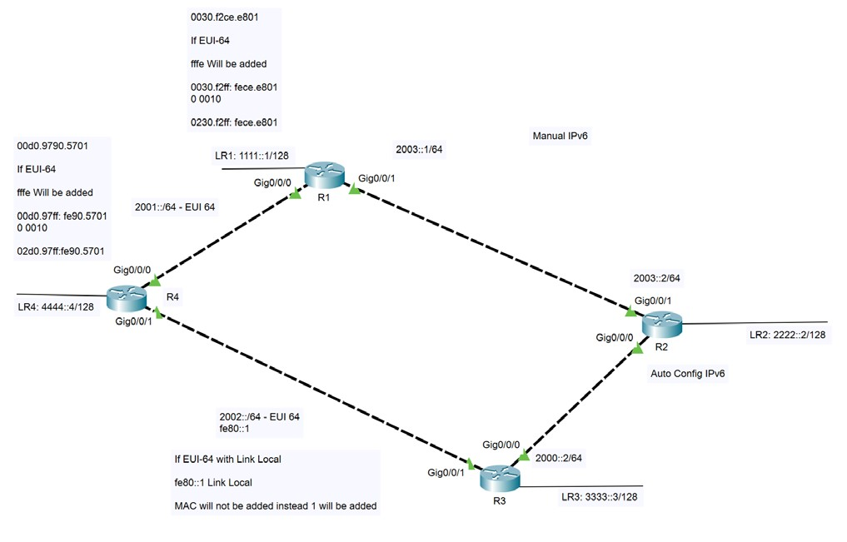

TASK 1
References (Configuring IPv6 Address) Practice the below commands with the above topology.
Manual Configuration
R1 Gi0/0/1 ipv6 address 2003::1/64
R2 Gi0/0/1 ipv6 address 2003::2/64
EUI – 64 Configuration
R1 Gi0/0/0 ipv6 address 2001:: /64 eui-64
R4 Gi0/0/0 ipv6 address 2001:: /64 eui-64
GigabitEthernet0/0/0 [up/up] FE80::2D0:97FF:FE90:5701
2001::2D0:97FF:FE90:5701
EUI – 64 Configuration with Link Local
R3 Gi0/0/1 ipv6 address 2002:: /64 eui-64 ┘ fe80::1 Link Local R4 Gi0/0/1 ipv6 address 2002:: /64 eui-64 ┘ fe80::2 Link Local
GigabitEthernet0/0/1 [up/up]
FE80::1
2002::1
GigabitEthernet0/0/1 [up/up]
FE80::2
2002::2
Auto Configuration
R3 Gi0/0/0 ipv6 address 2000:: 2/64 eui-64 ┘
R2 Gi0/0/0 ipv6 address Autoconfig eui-64 ┘
GigabitEthernet0/0/0 [up/up]
FE80::260:47FF:FE8A:E01
2000::2
Other Commands
Show interface gi0/0/0
Show ipv6 interface brief
Show ipv6 interface brief
Debug ipv6 nd
Debug ipv6 packets
Ping

Configuring Static IPv6 Route
Ipv6 route ipaddr (1111::/16 or /64 as per scenario) Next hop ip addres 2000:12::1
Ipv6 route ipaddr (::/0) Next hop ip addres 2000:12::1

TASK 2
Design this Topology and Configure IPv4 and IPv6 Addresses as per the description below (image) and configure Static/ Default routes to establish communication successfully.

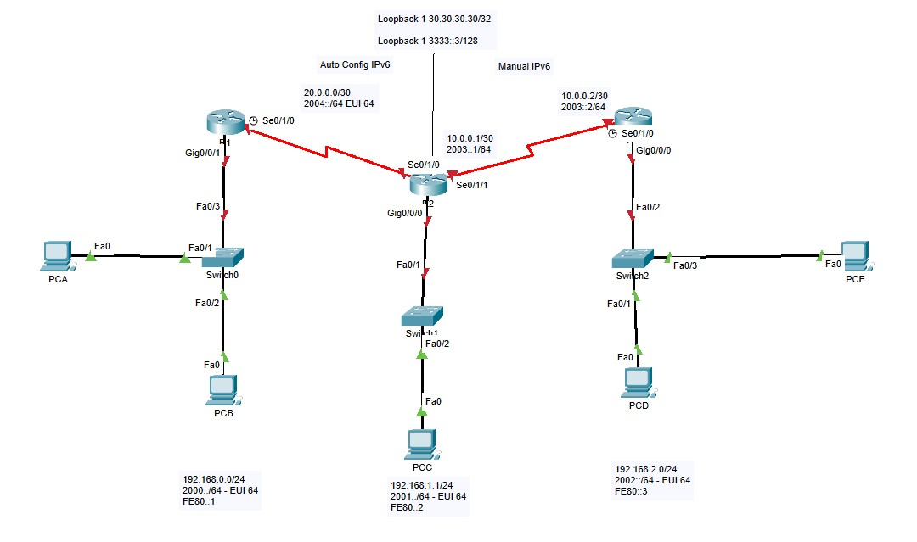

TASK 3
Complete the two PKA Files (Available in Moodle and Teams)

