CT Audit Services

Guest Service & Hospitality Audit Report
Of
The Grand Hotel, Llandudno.
24 April 2003

Distribution CT Audit Services
Managing Director Ceri Thomas, Owner
General Manager Ctas@gmail.com

Report Ref/CT/00001

Table of Contents

- Executive Summary…………………………………………………….. Page 1
- Audit Report & Recommendations……………………………… Pages 2 - 8
- Appendix………………………………………………………………………Page 9

Executive Summary
This internal audit was conducted on 23 April 2023 for The Grand Hotel, Llandudno. The Grand Hotel is a 3* property, comprising 168 rooms, with conference facilities. The hotel is owned by the Britannia Group.
The target market of the Grand Hotel is families, wedding parties, couples, retirees and those who travel for work.
For comparison, a similar offering has been identified in a different region. The comparison accommodation is Grand Hotel du Lido, Argeles Plage, France. This is a family run accommodation which is slightly smaller than The Grand Hotel.
Both hotels lead directly to beaches and have prominent positions within their locality.
The scope of this audit is limited to online guest reviews.
This report highlights 5 main areas of concern/weakness which are identified within this report as: Safety, Cleanliness, Comfort, Culture and Guest Service/Hospitality.

1.

Audit Findings & Recommendations
Finding 1.
Safety: In depth research on Trip Advisor, Booking.com and YouTube reviews highlight several safety concerns at The Grand Hotel.
The main issues appear to be, abandoned housekeeping trolleys in corridors and public areas, and this is a potential threat to access in case of fire. HM UK Government Fire Safety Risk Assessment guidance asserts that is “essential” that access is both routinely checked and maintained as to not cause any obstruction (HM Government, 2015). In addition, there are several reviews pointing out the “rusty” balcony railing (trip advisor reviews, 2021). Whilst some access areas to the balcony are cordoned off to restrict access, the perception of lack of safety is worrying to the clientele. This has potential to discourage repeat business, according to Maslow’s Hierarchy of Needs, the need to feel safe is the foundation of all future decision making (Maslow, 1943).
No safety concerns have been highlighted at the Grand Hotel du Lido.
Recommendation 1.
Not only are abandoned trolleys an eyesore, they are also a safety hazard. Therefore when not in use, all housekeeping equipment should be properly and safely stored away. The housekeeping team should be made aware of the fire regulations and undertake training in compliance. The General Manager should make regular checks of the landing and public areas to ensure they are clear of debris.
2.
The balcony railings should be assessed/cleaned/repaired/replaced as necessary with immediate effect.

All cleaning equipment should be properly stored when not in use. The housekeeping team should have daily and monthly briefings to communicate any particular areas of concern or breaches to this protocol re access issues. Forbes recommends recurring staff briefings as a way of “delivering clear messages” (Panel®, 2021).
There are no safety concerns highlighted in reviews of Grand Hotel du Lido.
Finding 2.
Cleanliness: The majority of bad reviews of The Grand Hotel, Llandudno cited cleanliness as a big issue and coming out of the Covid 19 Pandemic it is an even more important factor in the guest experience (Srivastava et al, 2021). According to (Andrea L, et al, 2022) the hotel is described “grimy … disgusting … dusty … dirty” (Tripadvisor reviews, 2022).
This is clearly an unacceptable level of complaint in one of the most basic influencing factors of hotel choice (Chamberlain, 2021).
There are no such cleanliness issues at the Grand Hotel du Lido. In comparison, this hotel scores almost full marks for cleanliness, with descriptors of “clean and well kept” and “impeccable” (Tripadvisor reviews, 2022).
Recommendation 2:
Deep cleaning of all hotel rooms and public areas.

3.
With immediate effect, deep clean 5 rooms per week, until completed. Deep clean all public areas during the night shifts and maintain subsequent cleaning protocol.
Decommissioning rooms during deep cleanse will affect yield, however not doing so will be more costly. If an establishment receives more bad reviews than good, they could lose up to 22% of future bookings, further, if bad reviews are posted on more than one site, the hotel could lose up to 70% of customers (Customer Alliance, 2022). The cleanliness of this hotel is also mentioned in Booking.com (Anne, et al, 2022) and on YouTube (Walk with me Tim, 2021)
Whilst rooms are out of commission, paint and repair where necessary. This process should take no than 40 weeks in total.
In the longer term, a full refurbishment of this hotel is required.
Finding 3.
Guest Comfort:
There were several disappointing reviews about guest comfort on trip advisor, some of the hotel as described “sad … gloomy … depressing” (booking.com reviews 2020). Forbes Executive Trainer, Karelle Van Elslande describes guest comfort as making the guest feel like everything is taken care of so they can relax and should include “good lighting” and a “relaxing” atmosphere (Van Eslande, 2022).
Grand Hotel du Lido, there is one comment regarding the firmness of a mattress and ‘dated’ bathroom (Tripadvisor review, 2022) which hasn’t significantly affected its review score.
4.

Recommendation 3:
Ensure public areas and rooms are well lit, a weekly check to ensure that all bulbs work should be sufficient, however, if a guest reports a broken or missing bulb, act on the information swiftly.
Windows should always be sparkling clean, it gives a good and lasting impression and with such a beautiful view to enjoy, clean windows are a must.
Monthly cleaning of the outside windows from a professional company is required, housekeeping should ensure inside windows are clean during their room checks.
Attention to detail is vital and all staff should be fully trained and aware of issues likely to affect a guests’ comfort. J. Willard Marriot is quoted as saying “close attention to the fine details ... makes that operation first class” (Came, 2022)
Timeframe: with immediate effect and ongoing consistently.

Finding 4.
Culture:
There is no evidence of Welsh culture or heritage at The Grand Hotel.
Culture or localisation is an important marketing tool, a sense of place or scene setting within a natural environment is what makes a memorable experience for the guest (Jarrett et al, 2018).
5.
There is no specific mention of culture in the trip advisor reviews for the Grand Hotel du Lido.
Recommendation 4.
Brand the hotel as traditionally Welsh, fly a Welsh flag from the top of the hotel building.
Produce hotel postcards, to sell or give away to guests.
Offer traditional Welsh fayre such as Laver bread with the breakfast.
Create a sense of Hiraeth, which has no precise translation in the English language but is generally considered as a sense of longing to return (Crossley-Baxter, 2021)
Answer the telephone bilingually, greet guests with a genuine ‘Croeso’ welcome (Welsh Government, n.d)
Finding 5.
Guest Service & Hospitality:
Unfortunately, The Grand Hotel scores poorly on guest service and hospitality, some reviews describe staff as “very abrupt”...”service terrible”…”awful” and the Manager as not “understanding customer service” (Tripadvisor reviews, 2022)
In comparison, the Grand Hotel du Lido has an almost perfect score for service, with review descriptors such as “friendly and efficient”…..”very good service”….”superb” and further, some staff are mentioned by name as “excellent” and “superb” (Tripadvisor reviews, 2022). Moreover, this hotel is
6.

described as having “ambience”….”charisma” and as having a “soul” where
“Everyone is focussed on making you feel welcome” (Tripadvisor reviews, 2022)
Recommendation 5.
Staff training in customer care, service and hospitality. The culture of The Grand Hotel needs a drastic overhaul, to embrace true customer service and hospitality. The hotel is currently advertising the post of General Manager (Leisure Jobs, 2023) and this would be an excellent opportunity to employ a manager with the necessary skills in hospitality.
Creating a memorable experience for the guest is key in the hospitality industry, for new and repeat business, guests must feel a sense of belonging and loyalty to the venue and its staff. More than fantastic customer service, which is a reactive approach, true hospitality comes from the heart (Solomon, 2016) it creates warmth and empathy, between staff and patrons.
Welcoming guests like family and using personalisation is a good place to start, 80% of consumers exclude brands that do not offer a personised experience (Morgan, 2020)
The guest must perceive the amazing ambience, care, and atmosphere to create a memorable experience that they long to repeat. “Recalled memories…..are an important influencer (Cho, 2022).
An easy way to instantly create a memorable experience is to offer a free room upgrade, the goodwill of the offer is priceless to the hotel yet costs nothing.
7.
Conclusion:
It is clear that The Grand Hotel, Llandudno needs a lot of financial investment in the longer term in order to carry out works to restore its previous glory and ‘Grand’ name. Still, in the meantime much can be done to restore its good name and reputation. Faded grandeur may be considered as charming and endearing, and may be forgiven, however serious safety issues, poor hygiene, lack of comfort, culture and hospitality cannot.
In the short term, it is essential that the hotel is deep cleaned and the most in need areas redecorated. Safety issues must be addressed with immediate effect and housekeeping checked regularly to maintain standards. A sense of place is fairly easily achieved with the right mind-set and effort. Guest service and hospitality needs to be at the heart of everything the hotel stands for, embedded in the culture and always striving to improve.

Ceri Thomas
23rd April 2023

8.
Appendix

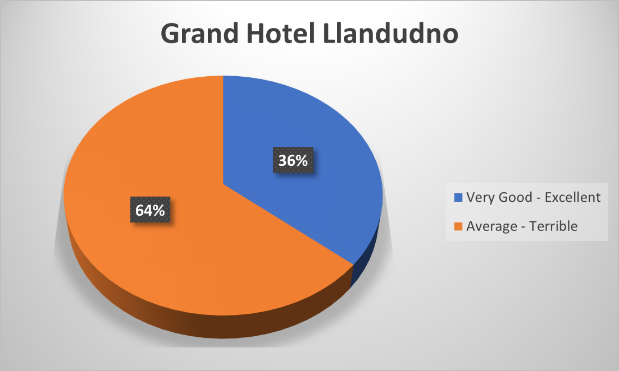
Fig 1: overall guest satisfaction expressed as a percentage.

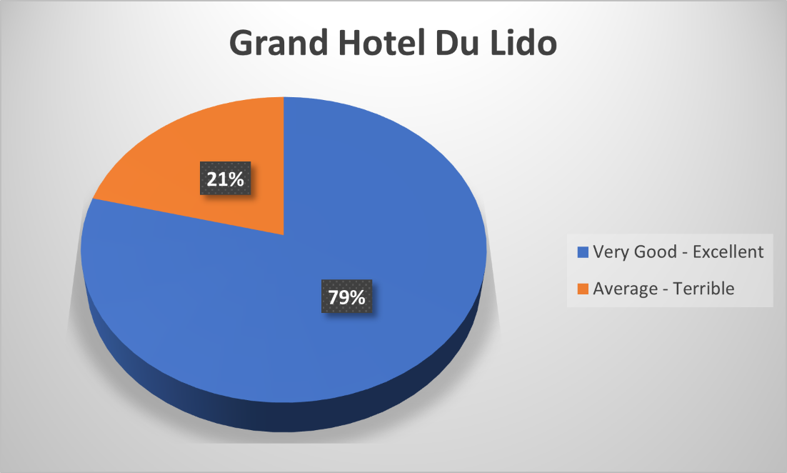
Fig 2: overall guest satisfaction expressed as a percentage.

9

Bibliography
Andrea L, AliOldColwyn, Sweetnkeen and Achady29 (2022). THE GRAND HOTEL - LLANDUDNO - Updated 2023 Reviews. [online] Tripadvisor. Available at: https://www.tripadvisor.co.uk/Hotel_Review-g190724-d269285-Reviews-The_Grand_Hotel_Llandudno-Llandudno_Conwy_County_North_Wales_Wales.html [Accessed 4 May 2023].
booking.com reviews (2022). The Grand Hotel, Llandudno, UK. [online] Booking.com. Available at: https://www.booking.com/hotel/gb/llandudnograndhotel.html?aid=304142&label=gen173nr-1FCAEoggI46AdIM1gEaFCIAQGYATG4ARfIAQzYAQHoAQH4AQKIAgGoAgO4Aof5zaIGwAIB0gIkNWRmZjM5ZjctMGIzNS00MGUxLTgxZTAtNzYyNjg3OWU1OWRm2AIF4AIB&sid=2490081c8ac3e0220263a015612a9f45&dest_id=222079 [Accessed 4 May 2023].
Came, S. (2022). 15 Inspirational quotes from hospitality greats. [online] blog.guestrevu.com. Available at: https://blog.guestrevu.com/15-inspirational-quotes-from-hospitality-greats.
Chamberlain, M. (2021). 12 Top Guest Expectations in a Hotel: And How to Meet Them. [online] Hotefy. Available at: https://get.hotefy.com/guest-expectations-in-a-hotel-how-to-meet-them/.
Cho, K. wook (2022). A Review of Memorable Experiences and Their Implications for Tourism Experiences in Management and Marketing Science. Mondes du tourisme. doi:https://doi.org/10.4000/tourisme.5053.
Crossley-Baxter, L. (2021). The untranslatable word that connects Wales. [online] www.bbc.com. Available at: https://www.bbc.com/travel/article/20210214-the-welsh-word-you-cant-translate.
Customer Alliance (2022). What is the cost of a negative review for your hotel? [online] Customer Alliance. Available at: https://www.customer-alliance.com/en/resources/article/cost-of-negative-review-for-hotels/#:~:text=It%20is%20estimated%20that%20an.
HM Government (2015). Fire Safety Risk Assessment for Sleeping Accomodation.
Jarratt, D., Phelan, C., Wain, J. and Dale, S. (2018). Developing a sense of place toolkit: Identifying destination uniqueness. Tourism and Hospitality Research, 19(4), pp.408–421. doi:https://doi.org/10.1177/1467358418768678.
Leisure Jobs (2023). general manager llandudno - Google Search. [online] www.google.com. Available at: https://www.google.com/search?q=general+manager+llandudno&oq=general+manager+llandudno&aqs=chrome..69i57j33i160l2.3689j0j7&sourceid=chrome&ie=UTF-8&ibp=htl [Accessed 5 May 2023].
Maslow, A.H. (1943). A theory of human motivation. United States: BN Publishing, pp.370–396.
Morgan, B. (2020). 50 Stats Showing The Power Of Personalization. [online] Forbes. Available at: https://www.forbes.com/sites/blakemorgan/2020/02/18/50-stats-showing-the-power-of-personalization/.
Panel®, E. (2021). Council Post: Ensure Effective Communication With Each Of Your Team Members With These 11 Tips. [online] Forbes. Available at: https://www.forbes.com/sites/forbescommunicationscouncil/2021/09/03/ensure-effective-communication-with-each-of-your-team-members-with-these-11-tips/.
Solomon, M. (2016). The Heart of Hospitality. SelectBooks, Inc.
Srivastava, P.R., Sengupta, K., Kumar, A., Biswas, B. and Ishizaka, A. (2021). Post-epidemic factors influencing customer’s booking intent for a hotel or leisure spot: an empirical study. Journal of Enterprise Information Management, ahead-of-print(ahead-of-print). doi:https://doi.org/10.1108/jeim-03-2021-0137.
Tripadvisor review (2022). GRAND HOTEL DU LIDO - Updated 2023 Prices (Argeles-sur-Mer, France). [online] Tripadvisor. Available at: https://www.tripadvisor.co.uk/Hotel_Review-g196598-d621791-Reviews-Grand_Hotel_du_Lido-Argeles_sur_Mer_Pyrenees_Orientales_Occitanie.html#REVIEWS [Accessed 5 May 2023].
Tripadvisor reviews (2020). THE GRAND HOTEL - LLANDUDNO - Updated 2023 Reviews. [online] Tripadvisor. Available at: https://www.tripadvisor.co.uk/Hotel_Review-g190724-d269285-Reviews-The_Grand_Hotel_Llandudno-Llandudno_Conwy_County_North_Wales_Wales.html#REVIEWS.
Tripadvisor reviews (2021). THE GRAND HOTEL - LLANDUDNO - Updated 2023 Reviews. [online] Tripadvisor. Available at: https://www.tripadvisor.co.uk/Hotel_Review-g190724-d269285-Reviews-The_Grand_Hotel_Llandudno-Llandudno_Conwy_County_North_Wales_Wales.html#REVIEWS [Accessed 4 May 2023].
Van eslande, K. (2022). Guest Comfort & Convenience. [online] www.youtube.com. Available at: https://www.youtube.com/watch?v=4HRjP_2Z5_g [Accessed 4 May 2023].
Walk with me Tim (2021). WORST RATED Hotel - The Grand Hotel, Llandudno. [online] www.youtube.com. Available at: https://www.youtube.com/watch?v=CKTOaL8wyEg [Accessed 4 May 2023].
Welsh Government (n.d.). The Wales Identity, A sense of Place.

