

Task 1 – Reading Task Template
Upload your photo of your A3 in-class notes here:
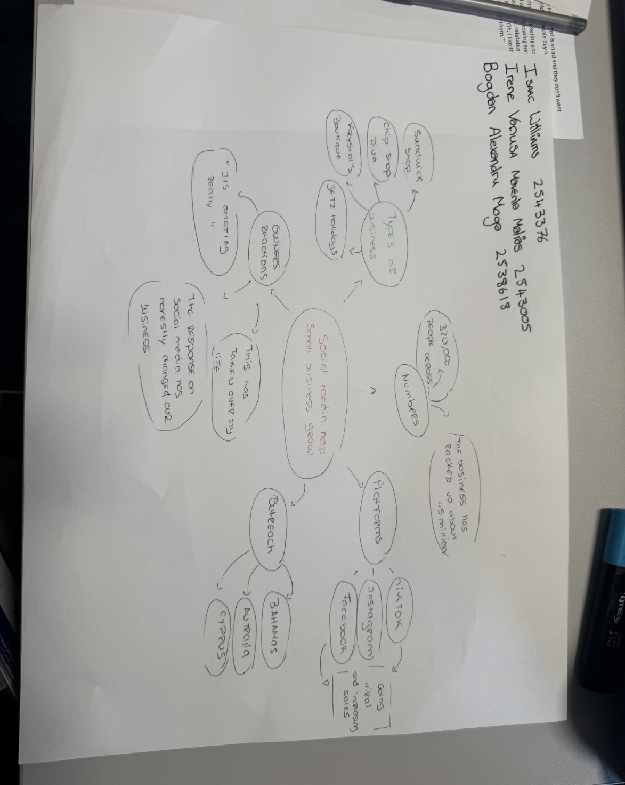

1. Answer these questions using the sentence starters below
a. What is the main idea of the text?
The main idea is that social media helps small businesses grow. It is the care idea, the most important information. It involves looking at the base of a text and identifying, key words, getting a basic sense of words that repeat throughout the text. Then finding words we consider important, such as “the platforms where the business went viral, making them as important “. Underlining text or circling them.
We can use skimming, wich is quick search where we try to get a quick idea of the text without reading it entirely. To welp myself, I first place the key word in centre (social media helps small businesses grow), then I can make a list, add colour markings for important words, or build a map for quick overview and try to gather all the information.
Asking small questions such as: “Why did it go viral?”

b. What are two key points?
One key point is for example (the company names). We can find in the text that went viral, such as: Sandwich shop, Jet2 Holidays, Krystal boutique etc ..
Another key point is the facts, platforms. Which platforms helped the business go viral. In the text we can find: Instagram, Tiktok, Facebook. When the customer mentions “They travel miles to visit the place” due to posts on social media.
c. What part of the text did you find most important? Why?
The most important part is how platforms can help small businesses. The owners were not responsible for the popularity. “it was customers who made the difference, through their posts and share on social media”. Because of this, other people travel miles to experience eating in that place. It is therefore important to use social media because it can enrich our business and make it known.
Building a visual image without being in the space and feeling the need to want to try or visit it, based on other costumers’ experiences.
d. Was anything unclear or difficult to understand?
I was not sure about how find the key information in the text. Working in the a group, looking at the text and not understanding it. With skimming I learnt to read quickly and get a basic sense of what the text is about.

e. How did your group help you understand the text better?
My group helped me by when we got together to read the text individually. Each person gathered the most important information for themselves, then we came together and shared our opinions to find the best way understand the text. We divided the task, created a mind map with key word, used colours to identify the second words, and this way we got a better understanding of the text. We were able to understanding what it was about more easily. We shared with other groups in the class, compared our work and saw that could focus on just one single word. We made the text more understandable for everyone.
3. One sentence reflection
Question: What did you find challenging about this task?
The hardest part was organising all information in mind map. Even with key word as starting point, it is not simple to summarise an entire text in visual and clear way. To build the map, you need to read the text carefully and have a general idea of what it is about.
Realising that too much information on the map can make it harder to understanding. A text without headings or visual highlights, makes it even more difficult to separate the main ideas from secondary ones.
From this task I learn that good mind map should be simple and objective. Less information, well organised, communicates better that trying to include everything,

Irene Matias

