

Fundamentals of Electrical and Electronic systems
ACBD4018

Rory Bowen

Astable 555 Timer Logbook

Supervisor: Olubenga Olubodun
July 2025

Academic integrity declaration
I declare that:
- the thesis submitted has been written by me alone.
- the thesis submitted has not been previously submitted to this university or any other.
- that all content, including primary and/or secondary data, is true to the best of my knowledge.
- that all quotations and references have been duly acknowledged according to the requirements of academic research.
I understand that to knowingly submit work in violation of the above statement will be considered by examiners as academic misconduct.

Abstract
This report outlines the design and evaluates the students as table 555 timer. The resistor values were calculated using equations, listed in the report, from assumed LED currents. Proteus Professional 8 was used to generate simulation to produced timing tables and that matched expected theoretical predictions. The 555-timer circuit was then assembled on a breadboard, and a multi-meter was used to measure capacitance charge and discharge. The report shows troubleshooting steps to further improve reproducibility of results to have a higher confidence in results. The results confirm the 555 timer’s ability to produce astable pulse shown by a blinking of the different coloured LEDs. The value of capacitance it was then plotted to show how the simulated and practical circuits produced the same rough graphs.

Table of Contents
Academic integrity declaration i
Abstract ii
List of Figures iv
List of Tables iv
List of Equations iv
List of Abbreviations v
1 Circuit 6
1.1 Description 6
1.2 Operation 6
2 Schematics 7
2.1 Simulated 7
3 Design Calculations 9
3.1 Resistance 9
3.2 On/Off Time 9
3.3 Period 9
3.4 Frequency 9
4 Simulated Measurements 10
4.1 Timing 10
4.2 Graphing 10
5 Breadboard 11
5.1 Building 11
5.2 Testing 11
5.3 Graph 11
6 References 13
Appendix A Graphing Data 14
Appendix B Appendix 16

List of Figures
Figure 1 - Circuit for Astable 555 Timer simulated on Proteus 7
Figure 2 - Lecturer given example of 555 Circuit 8
Figure 3 - Graph of capacitor (C1) voltage and output voltage against time for simulated circuit 11
Figure 4 - Breadboard 555 Timer Circuit 13
Figure 6 - Graph showing the C1 Capacitor Voltage and Output Voltage against time on the built bread board circuit. 14

List of Tables
No table of figures entries found.

List of Equations
No table of figures entries found.

List of Abbreviations
IT | Information Technology

Circuit

Description
This report contains a computer-based simulation, and a physical construction of an astable 555 timer integrated circuit (IC). The astable configuration, of the 555 timer operates as an oscillator, continuously generating a square waveform without the need for an external trigger.
The timing of the circuit is determined by two resistors (R3 and R4) and a capacitor (C1). These components determine the charging and discharging cycles of the capacitor, which defined the pulse duration and frequency of the output wave. The function of each component was necessary to the generation of consistent and predictable oscillations in square waves. The following bullet points list outlines the functional roles of the key components.
- Functional Role of Key Components
- 555 Timer IC: Functions as the core of the pulse square wave, which produced a high and low output at regular intervals.
- Resistors R3 and R4: Determine the timings of the charging and discharging phases of the capacitor C1.
- Capacitor C1: Controls the rate of voltage change across pin 6 and 2, which influenced the timings of the output.

Schematics

Simulated
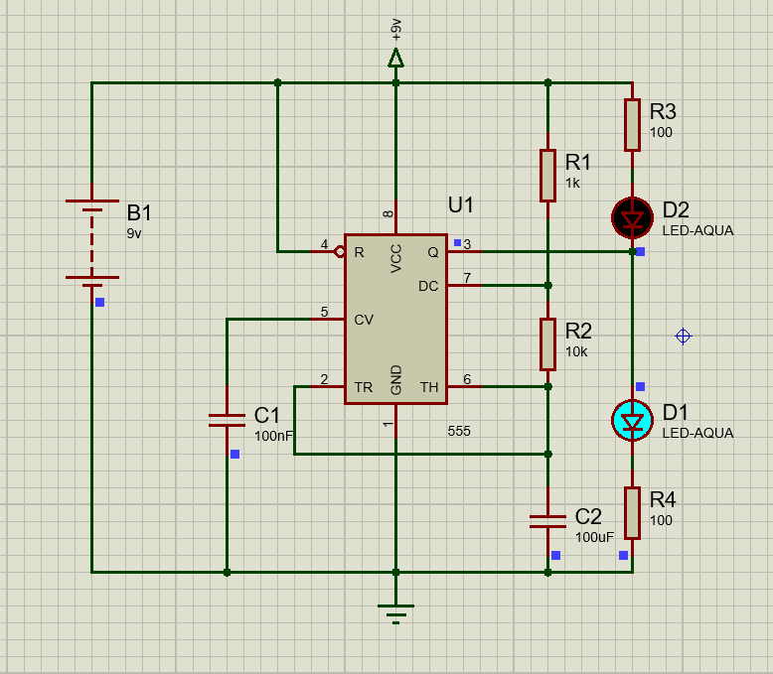
Figure 1 - Circuit for Astable 555 Timer simulated on Proteus
The circuit shown in the photo above was drawn with the assistance of the given 555 timer circuit listed below.
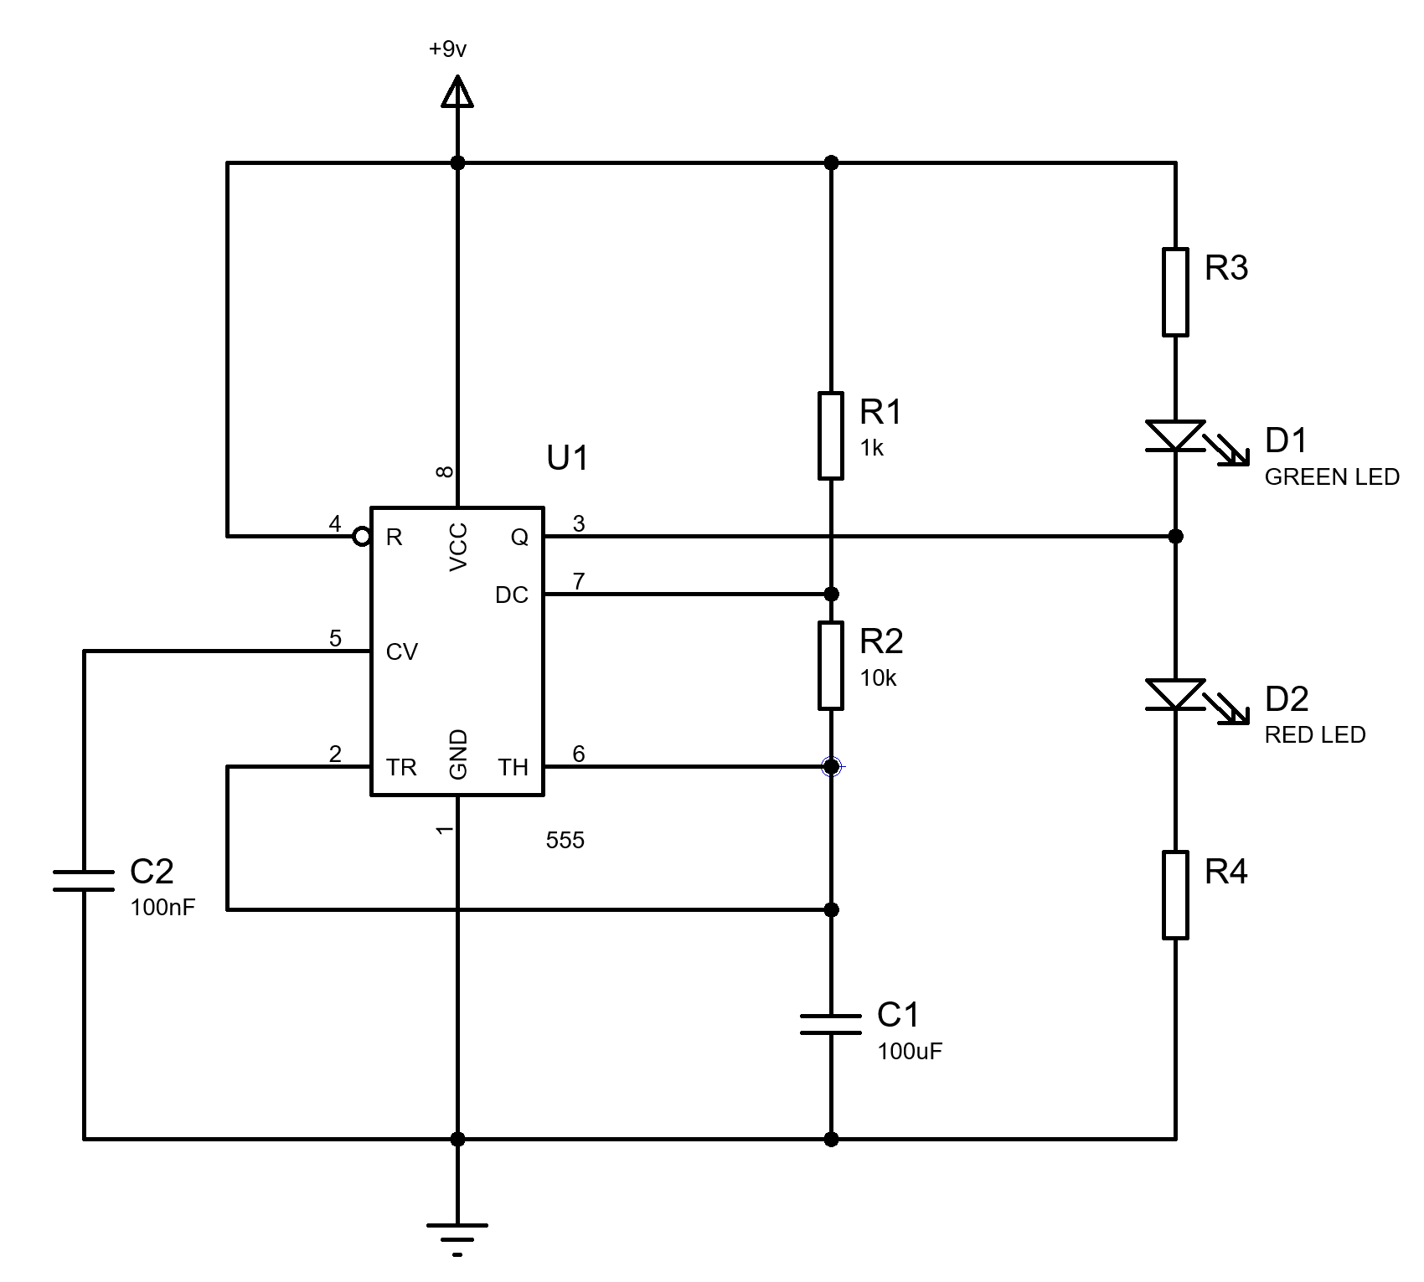
Figure 2 - Lecturer given example of 555 Circuit
The proposed circuit was modelled and simulated using Proteus Professional 8 simulation software. The software’s component library was used to build the schematic. The simulation was designed with a 9V DC power supply. Voltage probes and oscilloscope channels were placed across the output (pin 3) and the timing capacitor (C1) to observe square waveforms.
The simulation parameters included time-base adjustments and a waveform capture setting which allowed the student to gather an accurate reading of the voltage across C1 charging, discharging and timing intervals.

Design Calculations

Resistance
To determine the timings of the astable multivibrator, the timing equations for 555 timers were applied. Resistors R3 and R4 were calculated with the said timing equations. The LED voltage was cross referenced with references

Selected Components
- R = $\frac{V_{supply}- V_{LED}}{A}$
- R_3 = $\frac{9- 3}{20x{10}^{-3}}$ = 300Ω
- R_4 = $\frac{9- 2}{20x{10}^{-3}}$ = 350Ω

Timing Equations
Equation 1 - t_on=0.693 × (R_3+R_4) × C_1
$$t_{on}=0.693 × \left(R_{3}+R_{4}\right) × C_{1}$$
Equation 2 - t_off=0.693 × R_4 × C_1
$$t_{off}=0.693 × R_{4} × C_{1}$$
Equation 3 - T= t_on+ t_off
$$T= t_{on}+ t_{off}$$
Equation 4 - f= 1/T
$$f= \frac{1}{T}$$

On/Off Time
$$t_{on}=0.693 × \left(R_{3}+R_{4}\right) × C_{1}$$
$t_{on}=0.693 × \left(300+350\right) × 100μF$ = 0.045s
$$t_{off}=0.693 × R_{4} × C_{1}$$
$t_{off}=0.693 × 350 × 100μF$ = 0.024s

Period
$$T= t_{on}+ t_{off}$$
$T= t_{on}+ t_{off}$ = 0.069s

Frequency
$$f= \frac{1}{T}$$
$f= \frac{1}{T}$ = 14.43Hz
These calculations provided a basis for verifying the simulation and experimental results.

Simulated Measurements

Timing
Due to Proteus simulation software having its own graphing software the following graph in section 4.2 was produced. However, the data of said graph is not produced so the following table shows the voltage at second intervals which still produced a good graph as seen in figure ---.

Graphing
Figure 3 - Graph of capacitor (C1) voltage and output voltage against time for simulated circuit
Table 1 - Proteus simulation data points
 | Proteus
Time (s) | Voltage across C2 100uF (v)
0 | 9.00
1 | 3.35
2 | 5.58
3 | 4.93
4 | 3.47
5 | 5.76
6 | 5.05
7 | 3.57
8 | 5.67
9 | 4.91
10 | 3.53
11 | 5.71
12 | 4.64
13 | 3.55
14 | 5.87
15 | 4.85
16 | 3.62
17 | 5.85
18 | 4.96
19 | 3.48
20 | 5.71
21 | 4.80
22 | 3.52
23 | 6.07
24 | 4.84
25 | 3.56
26 | 6.12
27 | 4.81
28 | 3.36
29 | 6.05
30 | 4.72

Figure 4 - Graph made from Proteus simulation Data points
The output waveform from pin 3 displays a charging and discharging wave with a predictable cycle and frequency. The consistent wave corresponding with the expected exponential charge and discharge profiles. The confirmed the proper operation of the astable 555 timer. The transition between voltage levels is sharp, which help to indicate that the capacitor and resistors are functioning and are acceptable.

Breadboard

Building
The breadboard circuit was constructed on a solderless breadboard using an identical component value to those used in the simulation. A regulated 9V DC power source was used for powering the circuit. The following bullet points list the components used in the circuit
- Component List
- 555 Timer IC
- R_1: 1kΩ
- R_2: 10KΩ
- R_3: 10KΩ
- R_4: 10KΩ
- C_1: 100µF
- Breadboard
- Power supply: 9v bench power supply

Testing
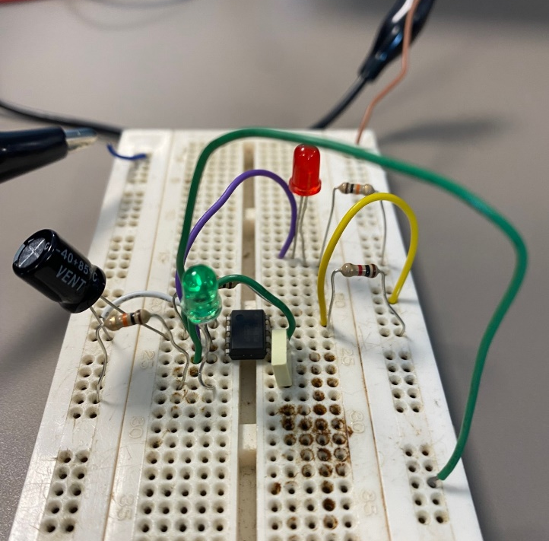
Figure 5 - Breadboard 555 Timer Circuit
A systematic approach was used to validate the astable 555 timer performance. The following steps were executed:
- The 555 Timer IC was properly oriented and inserted into the breadboard.
- Resistors R3 and R4 were connected between Vcc, pin 7 (discharge), and pin 6 (threshold).
- The timing capacitor C1 was connected from pin 6/2 to ground.
- Pins 6 and 2 were connected to facilitate threshold-trigger coupling.
- Pin 3 (output) was monitored using an oscilloscope.
- The power supply was connected, and the circuit was activated.
- Measurements of waveform parameters were obtained using an oscilloscope and multimeter.
- Observations were made to evaluate consistency with theoretical and simulated results.

Analyse of Data
The following table outlines that C1 charges and discharges between 1/3 and 2/3 of the supply voltage, this helps to show the circuit was functioning as intended. This behaviour matches an astable 555 timer when the data is plotted the voltage pattern forms a square-like waveform alternating between 2.6v and 5.6v.
Table 2 - Breadboard Data Points
 | BreadBoard
Time (s) | Voltage across C2 100uF (v)
0 | 0
1 | 4.58
2 | 2.58
3 | 5.46
4 | 2.76
5 | 5.55
6 | 2.64
7 | 5.6
8 | 2.61
9 | 5.63
10 | 4.37
11 | 2.66
12 | 4.31
13 | 5.67
14 | 2.6
15 | 5.66
16 | 4.13
17 | 2.62
18 | 4.12
19 | 2.66
20 | 5.62
21 | 2.69
22 | 5.62
23 | 2.7
24 | 4.18
25 | 2.7
26 | 5.26
27 | 2.7
28 | 4.06
29 | 5.6
30 | 3.95

Graphical Analysis – Breadboard Results

Figure 6 - Graph showing the C1 Capacitor Voltage and Output Voltage against time on the built bread board circuit.
Analyse of this graph shows the oscillations are periodic, which matches the simulated results of a repeating charge-discharge cycle. The consistency of the peaks and troughs implied the capacitor charges and discharges in response to a standard capacitor. The oscillations are due to a square wave, in which the regular oscillations suggest the circuit is working correctly.

Conclusion
The measured wave on the physical breadboard showed a correlation between both the theoretical predictions and simulation results, however there were some minor differences were observed. firstly, the differences could be attributed to the component tolerances, and potential breadboard connection resistances. Despite these small differences, the output waveform maintained a stable frequency and consistent cycle, which help to validate the design.

References
Click here to enter reference list.

Graphing Data
 | BreadBoard | Proteus
Time (s) | Voltage across C2 100uF (v) | Voltage across C2 100uF (v)
0 | 0 | 9.00
1 | 4.58 | 3.35
2 | 2.58 | 5.58
3 | 5.46 | 4.93
4 | 2.76 | 3.47
5 | 5.55 | 5.76
6 | 2.64 | 5.05
7 | 5.6 | 3.57
8 | 2.61 | 5.67
9 | 5.63 | 4.91
10 | 4.37 | 3.53
11 | 2.66 | 5.71
12 | 4.31 | 4.64
13 | 5.67 | 3.55
14 | 2.6 | 5.87
15 | 5.66 | 4.85
16 | 4.13 | 3.62
17 | 2.62 | 5.85
18 | 4.12 | 4.96
19 | 2.66 | 3.48
20 | 5.62 | 5.71
21 | 2.69 | 4.80
22 | 5.62 | 3.52
23 | 2.7 | 6.07
24 | 4.18 | 4.84
25 | 2.7 | 3.56
26 | 5.26 | 6.12
27 | 2.7 | 4.81
28 | 4.06 | 3.36
29 | 5.6 | 6.05
30 | 3.95 | 4.72

