University of Wales Trinity Saint David
Wales Institute of Science & Art



Engineering Design and Materials
Material Selection Report & GD&T Drawings (ACHA4001)

Sam Stainsby
2305051
April 2024
Contents
1 Introduction 2
2 Component Design Specifications 3
2.1 Function on Purpose 3
2.2 Material and Fabrication 3
2.3 Lobe Profile 3
2.4 Timing and Phasing 3
2.5 Bearing and Lubrication 3
2.6 Performance considerations 4
2.7 Quality Control 4
3 Material Selection 6
4 Manufacturing Process Selection 8
4.1 Pattern Making and Molding: 8
4.2 Melting and Pouring: 8
4.3 Cooling and Solidification: 8
4.4 Shakeout and cleaning: 8
4.5 Machining: 8
4.6 Quality Control and Inspection: 9
4.7 Finishing and Assembly: 9
5 Conclusion 10
6 Reference List 11

Introduction
In this report, the following will be covered; component design specification, which will allow for the clear outlining of the component and its uses; material selection, to show how different materials will react and the best material for the selected component; and manufacturing process selection on the chosen component, to present how to go about fabricating a component, which will be the camshaft from a 2015 Mitsubishi Shogun.

Component Design Specifications
When in the process of creating a camshaft, the design specification is extremely important in defining its purposes prior to starting manufacturing. The camshaft design specification will have to cover multiple points:

Function on Purpose
In order to make a camshaft, the purpose and function must be known. According to (MAT Foundry Group LTD, n.d.): “…they act to control the valves” which gives the purpose. The camshaft has lobes which spin on the rod or shaft, and open the valves and the timing for it is extremely important, as it ensures efficient power delivery and overall engine performance when done correctly.

Material and Fabrication
The materials used for camshafts will be explored further in this report, and according to (Myagkov, Mahkamov, Chainov, & Makhkamova, 2014): “…the camshafts (or cam lobes) are made of chilled cast iron… The wear resistance of chilled cast iron is considerably higher of that of ductile cast iron.”
The camshafts will be fabricated using different machines, such as: Lathe/Milling machine, Cam Lobe Milling machine, Deep Fillet Roller machine, CNC machine, Cylindrical grinders, and centreless grinders. The manufacturing process will be explored further.

Lobe Profile
The profile of the lobe will determine the valve lift, timing, and duration which are all extremely important to allow the engine to run properly, the dimensions will need to be correct, the lobe dimeter can be different from car to car, and engine size. The lobe lift is also important as it will determine the max displacement caused by the camshaft, and the ramp angles (rise and fall of lobe profile).

Timing and Phasing
If the timing is off, it can cause problems in the engine so the camshaft is connected to the crankshaft via a timing belt. If it was not timed properly, the power and fuel delivery would be affected, along with the emissions. Adjustable camshaft sprockets will allow for fine tuning and can allow for the engine to run much more efficiently.

Bearing and Lubrication
The camshaft uses bearings to rotate on the engine block, and will need the use of lubrication. The lubrication comes from the engine oil as the engine runs it will lubricate the bearings through passages in the engine.

Performance considerations
The Mitsubishi Shogun can be used offroad, meaning the lobe separation angle (LSA) should be wider because according to (Magda, 2015) “…widening the separation tends to build peak torque higher in the rpm range.” Which will allow for better capabilities in more rough terrain. This will also help focus on low-end torque over high-end power, as it will not necessarily have to be fast in order to tackle rough terrain.

Quality Control
In order to ensure that the camshaft runs well without fault, quality control and tests will need to be carried out, this will include;
- Visual inspection: Examine camshaft for surface cracks or any other defects, and identify any problems with the lobes or oil passages.
- Dimension checks: Ensure lobe lift, and base circle diameter are of correct measurements and comply with the specs.
- Hardness Test: Can conduct Rockwell test to verify hardness of surface, and the material used should show desirable effects.
- Dynamic Test: Install the camshaft into the engine test bench which will allow the testing of lobe lift, duration, and the timing of the camshaft.

- Oil Flow Test: Verify the oil flow through oil passages on the camshaft, cover in sufficient lubricant to prevent early wear.

Material Selection
There are multiple materials that can be used, such as:
- Billet steel: It has high strength, great wear resistance, and good machineability, however is very heavy and steel is a material very susceptible to corrosion.
- Carbon steel; It has moderate strength, useful for induction hardened camshafts, hardening characteristics, but is very brittle when not heat treated correctly, lacks wear resistance in comparison to chilled cast iron.
- Spheroidal graphite cast iron: good wear resistance, heat treatable from 52 to 58 Rockwell C, and has similar hardenability as iron. However, it has lower tensile strength resistance than a material like steel, it is also less ductile than steel. This material is also difficult to machine due to its hardness.

For the material selection, chilled cast iron is widely the most used among manufacturers as it has the required properties, that being:
- Being exceptionally hard
- Rapid cooling forms hard surface layer
- It withstands sand, gravel and other abrasive matter
- Abrasion resistant overall
- Good compressive strength helps with load-bearing operations.
However it has its downsides, like being quite brittle and very difficult to machine, wearing down tools used on it.
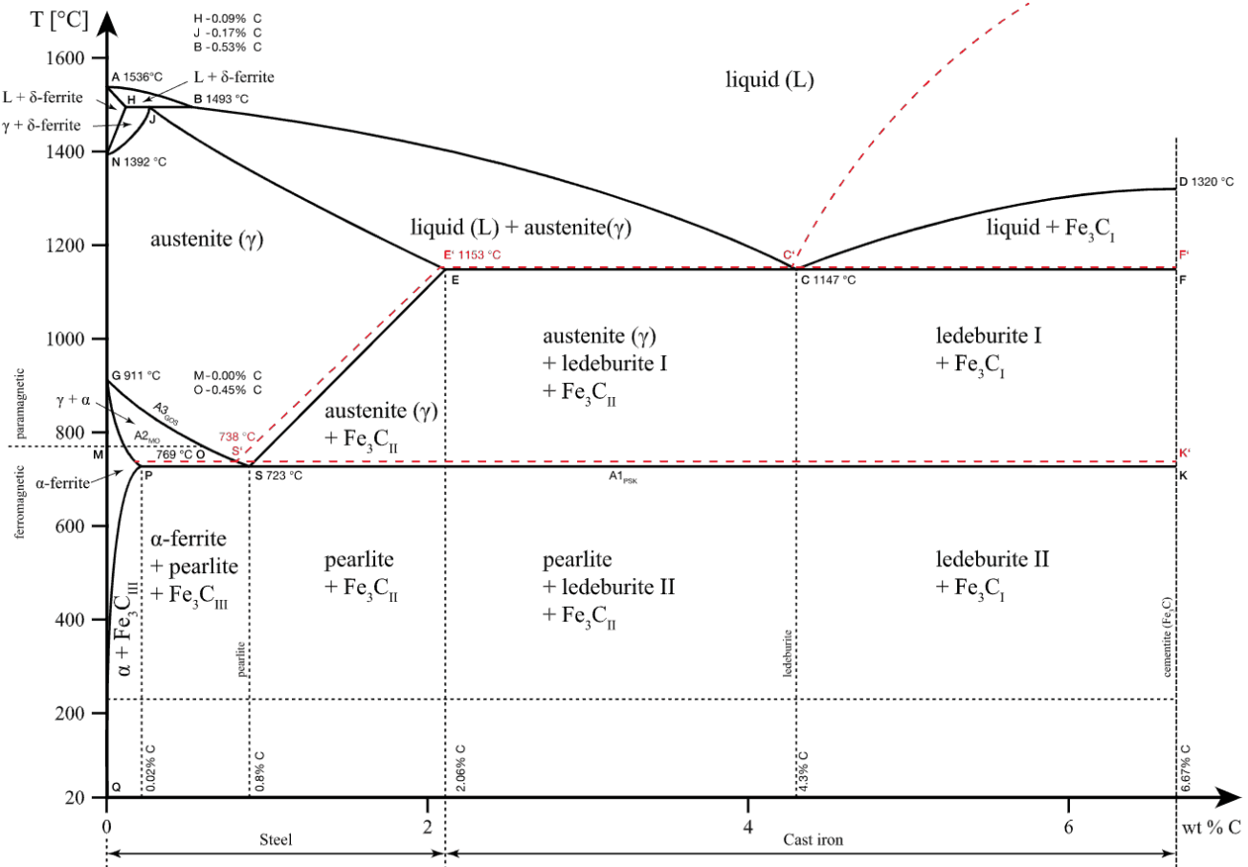
Figure 1: iron-iron carbide phase diagram
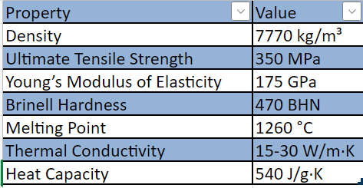
Figure 2: Table of Properties of chilled cast iron on excel

Manufacturing Process Selection
In order to manufacture and fabricate the camshaft, the selection is as follows:

Pattern Making and Molding:
To do this there must be a pattern made, from either wood or metal, in the shape of the camshaft to be fabricated. The pattern created can be used to create sand molds, which will then be used later for casting.

Melting and Pouring:
This next step requires the chilled cast iron to be melted in a furnace, then the previously created sand molds will be used as the molten iron will be poured into the molds. During the cooling process, there will form a hard white surface layer, which is a characteristic of the chosen material.

Cooling and Solidification:
Once the molten iron has been poured into the sand molds, the cooling process begins and the hard layer forms, this is why the material is called “chilled” cast iron, due to the rapid cooling of the iron.

Shakeout and cleaning:
Once the previous step is complete, the cast iron can then be removed from the molds, and once they are removed, the castings need to be cleaned to remove any sand or debris that may still be leftover.

Machining:
This is where the camshaft will start to take place, the following machines will be used;
- CNC turning centres: Computer controlled, and are used to shape the main body, journals, and all other cylindrical features. This will ensure precise dimensions.
- CNC Milling centres: These are also computer controlled, and are used to create the lobes on the camshaft, the oil passages and all other complex features that are on the component.
- Deep Fillet Roller machine: These machines will perform the filleting over the camshaft, and will provide these areas to help durability, it will also improve the load-bearing capacity of the camshaft.
- Heat Treatment Furnace: These furnaces will help with achieving hardness of the component, and provide the controlled heating and cooling cycles.
- Grinding machine: both cylindrical grinders and centreless grinders are used in helping grind the camshafts journals.

Quality Control and Inspection:
This links back to 2.7, there will need to be an inspection of the camshaft for defects, dimensions and surface finish and ensure there are no cracks in the component. Ensure to follow the designs specifications whilst inspecting the part.

Finishing and Assembly:
Finish off the part, do necessary touches, including polishing and grinding the camshaft to achieve the desired surface finish, and assemble the camshaft into the engine.

Conclusion
In conclusion, there is lots to consider when making a component such as a camshaft, and the desired materials can vary. Also, following the design specifications of the part is extremely important when making the part, this is due to the fact that there can be multiple things that go awry during the fabrication of the camshaft, and if specifications that have been set are followed, this should eliminate some of those factors.

Reference List
- Bambhania, Haresh, Cast Iron: Definition, Properties, And Uses, 2020, https://www.engineeringchoice.com/what-is-cast-iron/?utm_content=cmp-true [Accessed 27th April 2024]
- DMTG Ingersoll CM Systems, CRANKSHAFT AND CAMSHAFT MACHINES, n.d, https://www.ingersollcmsystems.com/crankshaft-machining [Accessed 21st April 2024]

- Kelford Cams, Inside the World of Vehicle Camshaft Manufacturing, 2024, https://kelfordcams.com/vehicle-camshafts [Accessed 20th April 2024]

- Magda, Mike, TECH QUICKIE: Camshaft Lobe Separation Angle And Power Relationship, 2015, https://www.enginelabs.com/engine-tech/engine/tech-quickie-camshaft-lobe-separation-angle-and-power-relationship/#:~:text=“On%20a%20naturally%20aspirated%20engine,higher%20in%20the%20rpm%20range. [Accessed 20th April 2024]

- MAT Foundry Group LTD, What is a Camshaft and How Does it Work, n.d., https://www.matfoundrygroup.com/blog/what-is-a-camshaft-and-how-does-it-work [Accessed: 10th April 2024]

- Material Properties, What is Composition of Cast Iron – Definition, 2020, https://material-properties.org/what-is-composition-of-cast-iron-definition/ [Accessed 28th April 2024]

- Myagkov, Leonid L. and others, Alternative Fuels and Advanced Vehicle Technologies for Improved Environmental Performance, (Woodhead Publishing, 2014) [Accessed 10th April 2024]

- Newman Cams, Info on Camshaft Material, 2016, https://www.newman-cams.com/camshaft-material/ [Accessed 20th April 2024]

- The Engineers Post, WHAT IS CAMSHAFT? PARTS, FUNCTION, APPLICATION, 2021, https://www.theengineerspost.com/camshaft-parts-and-function/?utm_content=cmp-true [Accessed 20th April 2024]

- Zwickroell, Torsion testing camshafts at ThyssenKrupp Presta, n.d, https://www.zwickroell.com/news-events/case-studies/torsion-testing-of-camshafts/#:~:text=Due%20to%20their%20area%20of,built-up%20camshaft%20will%20loosen [Accessed 23rd April 2024]

