

LCBB 4002
COMMUNITY ENGAGEMENT

A Local Council Report on Satellite Education Hub in Cradley Heath Project
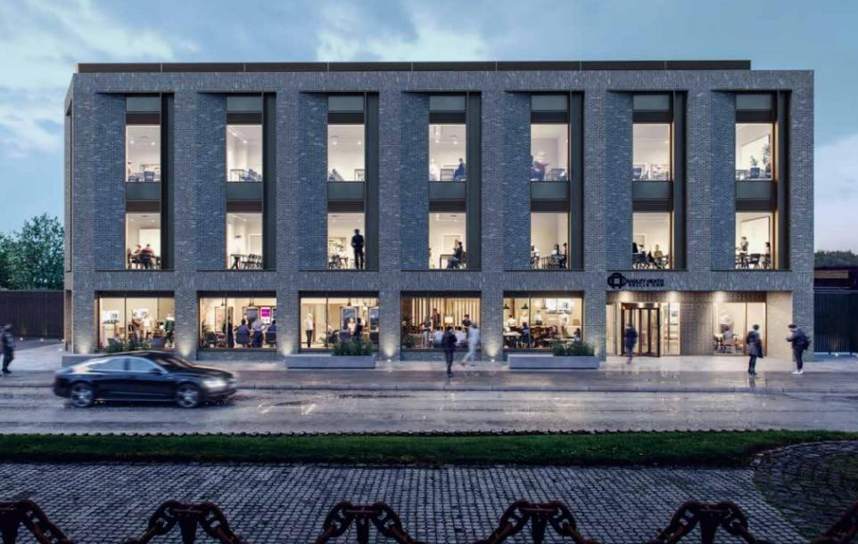
Source: Tandemprojects.com

Student name: Vali Daniela Pantazi
Student number: 2212835

Lecturer: Efua Adams
Table of contents

Introduction 3
Engaging the community 4
Communication 5
Consultation 5
Planning and designing 6
Standards for community engagement 7
Inclusion standard 8
Planning standard 8
Methods standard 8
Working together standard 8
Support standard 8
Communication standard 8
Conclusion 9
References 10

Introduction


Source: www.atsdr.cdc.gov
Community engagement is no longer a one-way type of communication, when the communities are just being informed about what is going to happen in their living area, but a continuous dialogue between the stakeholders and the people that make decisions (Bates, 2019). By engaging and enabling dialogue with the community, decision-makers can have a better idea about how certain initiatives will impact the community, and whether these are going to be liked or disliked. Also, when the perspective of the community is better understood, the initiative can be framed and communicated in a way that people will embrace it and will align with the top priorities of the public (Bates, 2019). According to Bassler (2008), community engagement is important as citizens who participate in consultations show a high level of commitment in helping projects to happen, create effective solutions, empower people from different socio-cultural backgrounds and increase trust in the local governance.
The project to be discussed is about Sandwell College aiming to build a new Satellite Education Hub in the Cradley Heath area, part of the Metropolitan Borough of Sandwell. Planning permission is being sought and if approved by Sandwell Council, the Hub is meant to revitalize the local talent by offering different opportunities for construction, health and social care, hair and beauty, but most importantly, will offer education and training in Digital skills, Maths or English at basic levels (www.sandwell.gov.uk, 2023). This project plans to involve local community groups to facilitate access to medical and social education services and advice and to overcome the barrier to the area’s economic growth which is caused by a lack of skilled workers and access to an appropriately skilled workforce (www.sandwell.gov.uk, 2023).
The idea of this hub came from the need of improving the skilled workforce, as according to Streetcheck.co.uk (2020), out of 19,690 inhabitants of a postcode in the area, male and female, only 5985 are skilled workers, less than one quarter, which is a very low number.

Also, according to Census UK (2011) in Cradley Heath the residents have either no qualifications or qualifications equal to 1, under the national average.

QUALIFICATION | Cradley Heath
No Qualifications | 30%
Level 1 | 14.3%
Level 2 | 16.7%
Apprenticeship | 3.5%
Level 3 | 11.9%
Level 4 | 19.2%
Source: www.ilivehere.co.uk

Purpose of the Satellite Education Hub
The Education Hub aims to offer three programmes to overcome the economic growth barrier posed by the lack of skilled workers in the Black Country area and parts of Sandwell (www.sandwell.gov.uk, 2023):
1. Essential Skills- access to basic levels in Maths, English and Digital Skills
2. Boost- development of programs providing studies at Level 3 and further access to Higher Education.
3. Gateway to opportunity-enable people looking for a new career or promotion, access live job opportunities, and build a set of skills to improve employability (www.sandwell.gov.uk, 2023).
If the project is successful, it will be built on the site of what used to be a car park, made available by Sandwell Council which gives this project an environmental purpose, due to a new modern building arising on that deprived space (www.sandwell.gov.uk, 2023).

Engaging the community

To achieve a successful community engagement, according to Bassler (2008), Sandwell Council should follow some principles: increase citizen’s awareness about the project proposed, encourage them to create additional knowledge and understanding, use the information to improve the project, create different opportunities for citizens to engage and ensure that effective communication becomes regular in the process.

Communication

Sandwell Council chose the ground-up engagement model in partnering with the community. This model was adopted due to its level of empowering the local community and leading to the development of effective partnerships and improving social well-being, eventually making the community sustainable (Shatar and Sabran, 2016). As a large community project, Sandwell Council understands the importance of involving and engaging the community to gain a positive outcome. To achieve its goals, Sandwell Council organized Open days at the Cradley Heath Library, where people could see the proposed construction plans and express their opinions. Also, for any questions that may arise, the e-mail of Jason Fretter, Project Manager at Tandem Project, was made available via Sandwell Council (Tandem Projects, 2023). Communicating effectively with the community imposed that the Council allocates a consultant to be present at the Open days to collect feedback and offer further clarifications on the plans proposed (www.sandwell.gov.uk, 2023).
Also, the Council shared the plans with the community via a local Radio station, on the Council’s Facebook page, MP James Morris shared it on his Facebook and Twitter pages, encouraging people to share their opinions (Morris, 2023).
In this case, the Council chose various means of communicating (online and face-to-face), so everyone can have access to information, showing an inclusive approach, as at times communicating may be difficult and a range of communication platforms and formats are needed (Darzin Stakeholder Management, 2020).

Consultation

Consultation is a very important part of community engagement as it means giving local people the opportunity to express opinions and influence important decisions and involves listening and learning before decisions are made (www.local.gov.uk, n.d.). Regarding the Education Hub, the Council is actively answering questions and responding to finan concerns on its Facebook page, as people are more responsive and involved on social media platforms.
Some members of the community were concerned about the funding of this new building, and Sandwell Council responded on Facebook that the project will be funded by the Towns Fund, a governmental program, and the Hub will be one of the 16 Sandwell Towns Partnership projects, which should offer opportunities for 16 to 25+ years old, either in employment, training or skills (Facebook, 2023). In 2021, Rawley Regis, Smethwick, and West Bromwich, part of Sandwell Borough, were selected by the central government to receive funding in the national Towns Fund initiative. There are 16 projects over these three towns: six for West Bromwich and five for each Smethwick and Rawley Regis, totalling £ 67.5 million (www.sandwell.gov.uk, 2023). Other members expressed concerns regarding the building blocking the light of the houses behind and others commented on the bad transport links, and that the Council should look a bit into this aspect (Facebook, 2023). According to the Council Twitter’s page (2023), the news about the Education Hub has been viewed by 906 people and tweeted by only 3 persons; in this case, I would advise the Council to be more proactive and update the pages with news and progress of the project. 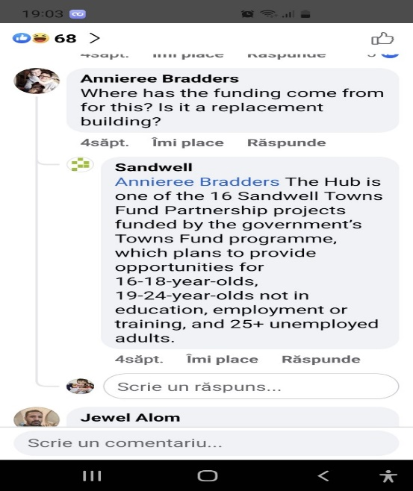 Source: Facebook
Tandem Project Construction Company was appointed to manage the project to its completion, and in projecting the plans for the construction they encountered some challenges, such as the site being too small to allow on-site parking and the time for construction is too short (Tandem Projects, 2023). The company tried to manage these issues by engaging a specialist Transport Consultant with the Highways Authority by trying to convince them that a no-parking strategy is viable as part of highly sustainable development (Tandem Projects, 2023). Jason Fretter, Project Manager at Tandem failed to answer e-mails coming from citizens, although his e-mail address has been made available on the website. My advice to the Council would be to appoint contact persons with more time to answer questions and be more committed to the community.

Planning and designing

Following communication and consultation with the community, the Council can now plan and design future development in the area. As the public was actively engaged in the process, and shared their opinions and concerns, the Council has sufficient information to debate the plans and make the best decision in approving or not the construction plans (www.gov.scot, 2021). Effective public engagement can improve plans, lead to making better decisions, and help avoid potential delays in the Hub being completed (www.gov.scot, 2021).
According to Facebook (2023), the outcome of empowering the community to have a say in the development of this project seems to be a positive one, as most of the opinions on social media have been positive, with citizens being enthusiastic about the opportunities this Education Hub will bring in the area and future economic growth. As for the concerns, Sandwell Council is still to answer and solve them, as no update has been published yet.
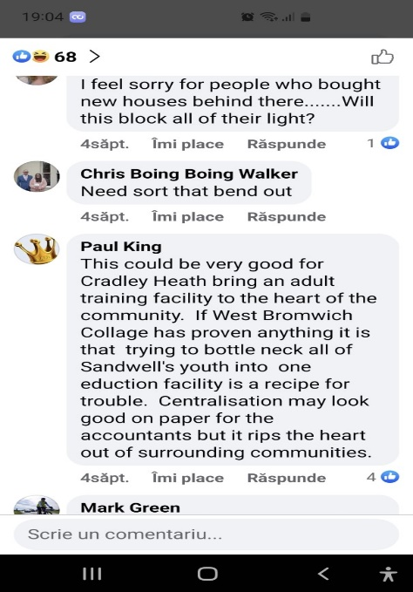
Source: Facebook

Standards for community engagement

According to National Standards for Community Engagement (2020), standards in Community Engagement represent a clear set of principles intended to act as references for best practices and meant to be used to achieve high quality results and a better impact. In approaching the community regarding the project of the Satellite Education Hub, Sandwell Council used several of these standards to achieve good community engagement.

Inclusion standard

In making public the plans, organizing open days at the local Library, and using social media platforms, newspapers and radio to inform the community about the plans, Sandwell Council showed that did not exclude anyone in the community and promoted equality (National Standards for Community Engagement, 2020). By not including people of different groups in this project, Sandwell Council would fail to apply inclusion standard, feedback would be negative and all the planning would have to be retaken (Savina, 2019).

Planning standard

Sandwell Council presented to the community clear plans right at the beginning of the project and was clear in communicating the purpose of the project and what it meant to achieve if approved. Also, put in place most of the means of gathering evidence from the community (National Standards for Community Engagement, 2020).

Methods standard

In approaching the community, the methods used were appropriate for the purpose, these were accessible to all participants and there were various methods used to gain feedback (National Standards for Community Engagement, 2020). Although when using this standard, the council could use other means of gathering feedback e.g., regular meetings, or going out in the community.

Working together standard

Regarding this standard, the roles of each one involved seemed clear e.g., Council, Sandwell College, Government, citizens, and future beneficiaries, the methods of communication were appropriate for all participants, and the information was shared in time but the communication following the presentation of the project is lacking (National Standards for Community Engagement, 2020).

Support standard

This standard does not seem to be used as there is no evidence that the Council took all the necessary steps to support the community by offering access to interpreters, or specialized transport or enabling access to social media for the ones that cannot afford it (National Standards for Community Engagement, 2020). If the Council would use this Standard, the community would feel protected, looked after, and the sense of trust in the Council will definitely increase.

Communication standard

Sandwell Council used this standard in approaching the community, when presenting the project and plans. Communication was accurate and clear, confidentiality has been kept but the relevant information was released to the public, but failed to follow some steps of this standard by not communicating regularly with the community members, not updating the citizens about the progress of the project (National Standards for Community Engagement, 2020).

Conclusion

Following research on the websites, I could not find any updates on how the project is developing, whether Sandwell Council is going to approve the construction plans, or whether are there any issues with the project. The current status of the project is in progress.
In engaging with the community, Sandwell Council adopted effective models and strategies to engage and involve the community, but there is always more that can be done to achieve positive outcomes and avoid delays. I would advise the Council to initiate an online and face-to-face Survey Campaign that will enhance the knowledge about what the larger community wants and needs, as the online platforms do not seem to offer enough feedback. Also, allocating a member of the Council to go and visit locals at their homes may prove efficient in gathering more evidence. Organizing Tea Mornings at the Local Library would be beneficial as could attract elderly groups to go and express their opinions and thoughts (nonprofitgrowth.co.uk, 2020).
My advice to Sandwell Council is also to improve the community engagement standards, especially the Support, Working together, and Communication Standards, as these have not been completed, which can lead to difficulties in the process of engaging the community and eventually to a negative outcome and a lack of trust.

References

Bassler, A. (2008). Developing Effective Citizen Engagement: A How-to Guide for Community Leaders. [online] Google Books. Center for Rural Pennsylvania. Available at: https://books.google.co.uk/books/about/Developing_Effective_Citizen_Engagement.html?id=MMwCPwAACAAJ&redir_esc=y [Accessed 23 Feb. 2023].
Bates, O. (2019). 6 Reasons Why Public Participation and Community Engagement is Important. [online] Social Pinpoint - A Place to Engage Your Community. Available at: https://www.socialpinpoint.com/blog/6-reasons-to-participate-community-engagement/#:~:text=Here%20are%20six%20reasons%20why%20an%20effective%20community [Accessed 2 Feb. 2023].
Center for Economic and Community Development (Penn State University). (2019). Why Community Engagement Matters (Center for Economic and Community Development). [online] Available at: https://aese.psu.edu/research/centers/cecd/engagement-toolbox/engagement/why-community-engagement-matters [Accessed 23 Feb. 2023].
Darzin Stakeholder Management App. (2020). What is community engagement? Definitions, examples & more. [online] Available at: https://www.darzin.com/blog/what-is-community-engagement/ [Accessed 23 Feb. 2023].
Ellevate Network (2017). Quotes About the Power of Community. [online] Ellevatenetwork.com. Available at: https://www.ellevatenetwork.com/articles/8538-quotes-about-the-power-of-community [Accessed 1 Feb. 2023].
Facebook. (2023). Log into Facebook. [online] Available at: https://www.facebook.com/sandwellcouncil [Accessed 23 Feb. 2023].
iLiveHere: Best & Worst UK Towns Reviewed. (2011). Socio-economic statistics for Cradley Heath, Dudley. [online] Available at: https://www.ilivehere.co.uk/statistics-cradley-heath-dudley-9897.html?utm_content=cmp-true [Accessed 23 Feb. 2023].
Morris, J. (2023). Log into Facebook. [online] Facebook. Available at: https://www.facebook.com/JamesMorrisHRR [Accessed 23 Feb. 2023].
National Standards for Community Engagement. (2020). Available at: https://static1.squarespace.com/static/5943c23a440243c1fa28585f/t/63c6badff203e74f2ba4c4d3/1673968356909/NSfCE%2Bonline_October.pdf [Accessed 23 Feb. 2023].
nonprofitgrowth.co.uk. (2020). Different Ways to Engage Your Community. [online] Available at: https://nonprofitgrowth.co.uk/different-ways-to-engage-your-community/ [Accessed 23 Feb. 2023].
S
Savina (2019). 7. Inclusive community engagement. [online] INHERIT. Available at: https://inherit.eu/inclusive-community-engagement/ [Accessed 28 Feb. 2023].
Shatar, M. and Sabran, B. (2016). (PDF) Evaluating the Top-Bottom and Bottom-Up Community Development Approaches: Mixed Method Approach as Alternative for Rural Un-Educated Communities in Developing Countries. [online] ResearchGate. Available at: https://www.researchgate.net/publication/305272818_Evaluating_the_Top-Bottom_and_Bottom-Up_Community_Development_Approaches_Mixed_Method_Approach_as_Alternative_for_Rural_Un-Educated_Communities_in_Developing_Countries [Accessed 21 Feb. 2023].
StreetCheck (n.d.). All Postcode Districts Covered by StreetCheck. [online] StreetCheck. Available at: https://www.streetcheck.co.uk/postcodedistrict [Accessed 1 Feb. 2023].
Tandem Projects. (2023). Jason Fretter. [online] Available at: https://tandemprojects.co.uk/our-people/jasonfretter/ [Accessed 21 Feb. 2023].
Twitter. (2023). https://twitter.com/sandwellcouncil. [online] Available at: https://twitter.com/sandwellcouncil [Accessed 23 Feb. 2023].
www.bing.com. (2023). satellite education hub in cradley heath - Search. [online] Available at: https://www.bing.com/search?q=satellite+education+hub+in+cradley+heath&form=ANNTH1&refig=d73a634cc4bc4e56b462a9719ee87731&sp=1&qs=NWT&pq=satellite+education+hub+in+cradley+&sc=6-35&cvid=d73a634cc4bc4e56b462a9719ee87731 [Accessed 14 Feb. 2023]
www.gov.scot. (2021). Planning and architecture: Community involvement in the planning process - gov.scot. [online] Available at: https://www.gov.scot/policies/planning-architecture/community-planning-process/ [Accessed 23 Feb. 2023].
www.local.gov.uk. (n.d.). Section 4: Consulting residents | Local Government Association. [online] Available at: https://www.local.gov.uk/our-support/leadership-workforce-and-communications/comms-hub-communications-support/resident#:~:text=Consultation%20is%20technically%20any%20activity%20that%20gives%20local [Accessed 23 Feb. 2023].
www.sandwell.gov.uk. (2023). Sandwell Council to consider plans for a Satellite Education Hub in Cradley Heath | Sandwell Council. [online] Available at: https://www.sandwell.gov.uk/news/article/6595/sandwell_council_to_consider_plans_for_a_satellite_education_hub_in_cradley_heath [Accessed 1 Feb. 2023].

