Joanne Allen
2405880
HPAH7010
Part one
Commentary of Isis Lactans from Antinoe
Content and Context
The image of Isis Lactans breast feeding her son Horus, has many connotations. She has been associated with the divine mother, motherhood, childbearing and the ‘protector of children’ (Gordon, 2012). Her portrayal as the divine mother breast feeding her son has been notably linked to depictions of the Christian figure Mary (Maria Lactans). The Antinoe statue of Isis Lactans (figure 1) stands at one metre and was made from limestone, during the fourth century or early fifth century CE. It represents the goddess Isis breast feeding her son Horus (Elsner, 2018, p. 206). This interpretation, whilst embedded in Egyptian origins, reflects the amalgamation of Graeco-Roman influence, particularly in the attire. The statue presents Isis seated on a high-backed throne, wearing Graeco Roman dress which is draped to the floor. Her sandals are on display and her dress has been pulled down revealing her left shoulder and left breast which she offers to the baby Horus as she cradles him in her left arm and hand. Her hairstyle is typical of the Graeco Romano style (Figure 1. 147 in Elsner, 2018, p. 206).
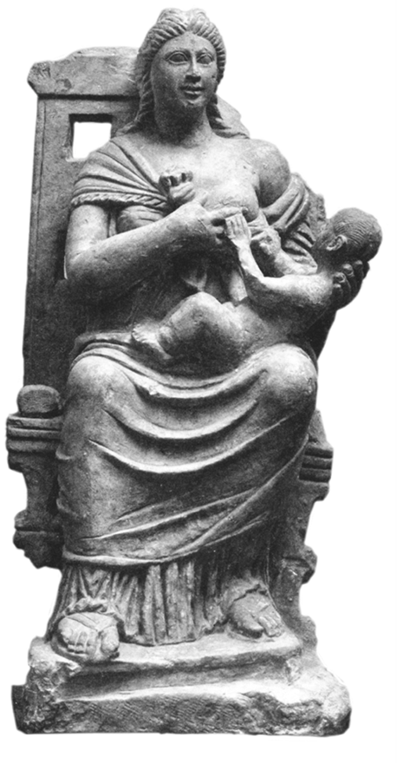
(Figure1. 147 in Elsner 2018, p. 206).
The statue was discovered in Antinoe/ Antinoopolis, Egypt, founded by the emperor Hadrian in honour of his companion Antinous in 130 CE. It was built entirely of Graeco-Roman style, with no Egyptian design (Cockle, 2012; Bell, 1940, p. 133; Leclercq, 1907). In 286 CE, under the emperor Diocletian, Antinoe, became the head of the ‘Egyptian nome’, and therefore head of administration in Egypt (Cockle, 2012). Due to the persecution of Christians under the emperor Diocletian, Christianity in Antinoe gained publicity and martyrs’ (Lane-Fox, 1988, p.592). Furthermore, after the emperor Constantine’s conversion to Christianity in 312 CE, the East, became increasingly Christian (Veyne, 2010, pp.1-3). Antinoe, during the reign of the Eastern military emperor Valens 364-378 CE, was presided over by two bishops, one of Monophysite faith, who believed Jesus Christ completely divine and the other of Orthodox (Cockle, 2012; Stillwell, 1976, p. 60). The emperor Valens put down the revolt of the Pagan Procopius at Nacolea in 366 CE, yet he was also complicit in persecuting Catholics under the instructions of his brother and co-emperor Valerian (Tomlin, 2012). While, the Bishops and monks destroyed Pagan ideals, and temples. Pagan iconography, therefore, would have been a ‘source of ‘infection’ to their congregations’, (Brown, 2004, p. 111).
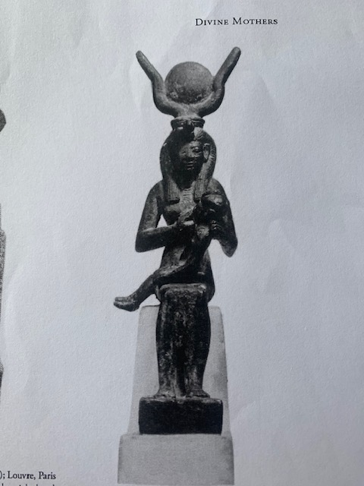
(Figure 2. Figure 2 in Higgins, 2012, p. 84).
Up to this point, the goddess Isis had been ‘widely worshipped’ throughout the East and the Classical Graeco Roman world as the ‘divine mother’ (Corrington, 1989, p. 398). Images of her have been discovered in the Eastern and the Western parts of the world often seated and breast-feeding Horus or on her own seated or standing in various poses and wearing various clothing (Higgins, 2012, p. 71). She often depicts the country she had been worshipped in, for example in Egypt she will be presented wearing Egyptian garb. The typical depiction of the Egyptian goddess Isis Lactans shows her seated upright, adorned with the throne hieroglyph on her head symbolising her name. Occasionally, she is also shown with the solar disk and cow horn, which are attributes associated with another goddess, Hathor, another instance Isis is linked with another deity as seen below (Figure 2 in Higgins, 2020, p. 84; Corrington, 1989, p. 398; Higgins, 2020, p. 73). Apuleius, a writer from 120-170 CE, describes the goddess Isis being identified with other goddesses, in a sense combining numerous deities to represent the ‘one true god’:
‘I the parent of the nature of things …supreme of divine powers…first of heavenly beings […] the first-born Phrygians call me Mother of the Gods at Pessinus; the indigenous Athenians, Minerva, daughter of Cecrops; the wave-washed Cypriots, Venus of Paphos; the archers of Crete, Dictynna Diana […] Stygian Proserpina […] the most ancient goddess Ceres; different people call me Juno, or Bellona, or Hecate [but] the Egyptians […] call me by my real name: Queen Isis’
(Apul Met 11.5;).
Whilst Isis Lactans of Antinoe does bear a resemblance to Maria Lactans, as both are seen as divine mothers and life givers, the imagery and literature describing Mary as breast feeding are less prominent and more ambiguous in this period, as discussed below (Kramer-Rolls, 2004, p. 39). The imagery of Isis breastfeeding her son, nonetheless, portrays her as divine mother, giving salvation to her son and humanity (Apul Met 11.15; Corrington, 1989, p. 398). In Apuleius Metamorphoses (11.5) Isis states ‘I am here, having taken pity on your misfortune’ in other words Isis is humanities salvation, and this salvation can be seen in the iconography of Isis Lactans and the life-giving, healing properties of breastmilk. Healing properties of breast milk can be traced from ancient Egypt through to Greece, Etruria and Rome (Laskaris, 2008, p. 459). The ancient Egyptians used human milk for healing, referring to it as ‘Isis milk’. Milk from a mother would be poured into an ‘anthropomorphic vase depicting Isis nursing Horus’. The milk was then used a healing remedy and placed onto the body as an ointment rather than ingesting (Laskaris, 2008, p. 460). Later the Romans, carrying out similar rituals would ingest human milk for medicinal purpose (Laskaris, 2008, p. 460; Mulder, 2017, p. 228).Pliny the Elder, writing in around the mid-1st century CE, describes in his Natural Histories (7.121-122) that a woman breast fed her ill mother in prison, so to heal her (Mulder, 2017, p. 227).
Analysis of Isis Lactans iconography.
The Isis Lactans statue of Antinoe blends Graeco-Roman and Egyptian elements illustrating the fluid religions and cultural identities of late antiquity. This challenges the idea of a fully Christianized Egypt in the late Roman/early Byzantine period and highlights the shared iconography between ancient Pagan religions and early Christianity. Elsner (2018, p.204) describes this period as a ‘melting pot where all traditions of antiquity’ from all aspects of life came together in an ‘new product that would be Christianity’. Similarly in his book The World of Late Antiquity, Peter Brown (2004, p. 54) was among the first to suggest that the rise of Christianity was more complex series of adaptations (Higgins, 2012, p. 71). His argument was against the idea that Christianity held direct domination over Pagan ideals, proposing instead that a combination occurred, and society had been for some time looking for ‘one true god’ not just in the Christian sense (Brown, 2004, p. 58; Higgins, 2012, p. 71). This can be seen in the rise in mystery cults, such as Isis, circulating in the empire for some time before late antiquity. Kramer-Rolls (2004, p. 35) suggests that Isis did not stop being worshipped when the Virgin Mary became prevalent in Egypt. Instead, the cult of Isis continued alongside Mary, showing continuity. However, Higgins (2012, p. 72) and Dijkstra (2005, p. 168) advise caution in assuming the cult of Mary fully merged with the cult of Isis. Tram Tam Tinh (1973, p.1) notes that images of Isis Lactans ceased after the fifth century CE, and images of Maria Lactans began in the seventh century CE, with the images of Maria Lactans prominently featuring a child seated in the lap, rather than breast-feeding.
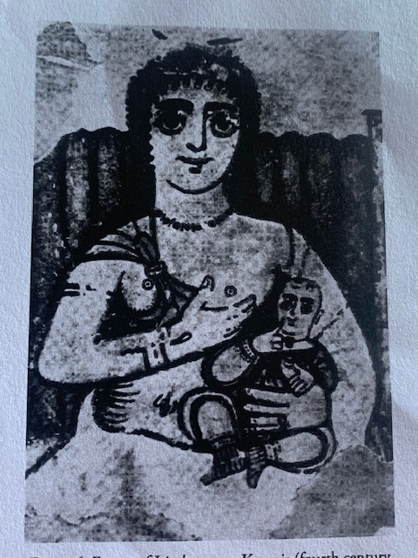
(Figure 3. Image 6 in Higgins, 2022, p. 86).
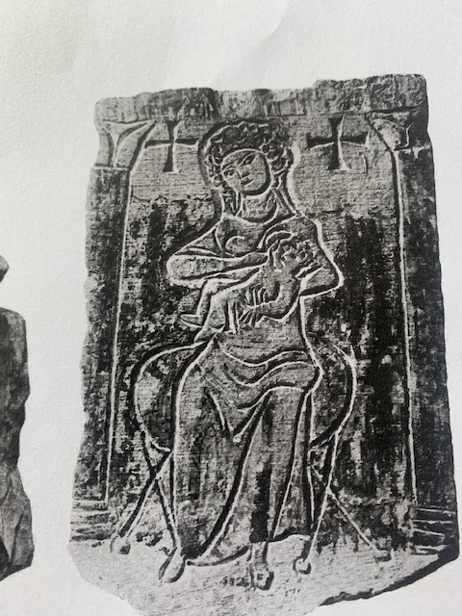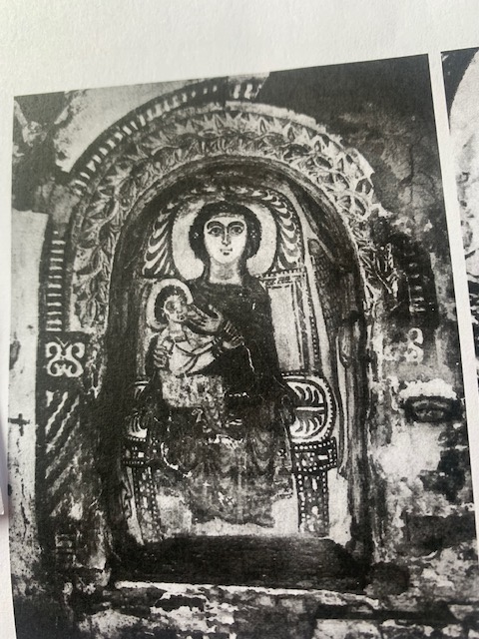
(Figure 4. Ige 8 in Higgins, 2020, p. 87). (Figure 5. Image 9 in Higgins, 2020, p. 88).

Yet, whilst he does acknowledge the similarities, his theory cannot explain obvious likenesses between the iconography of Isis and Mary, see figure 3 and 5 (Higgins, 2012, p. 73). Neither does it explain figure 4, a funeral relief, from the fourth century and clearly depicting a breast-feeding woman with the chi rho situated either side of her, symbolising the cross (Higgins, 2012, p, 87). In this context, the hypothesis that adoption did not occur is less definitive. Furthermore, the notion that the seated child and the breast-feeding child are separate entities can be challenged based on these images. Tran Tam Tinh does indicate, however, that the minimal link that is seen between Isis and Mary is primarily in the ‘Lactans iconography’ (Higgins, 2012, p. 72; Tram Tam Tinh, 1973, p. 1). Higgins (2012, p. 72) likewise, concedes that the Christian tradition adopted an image from the cult of Isis, specifically the iconography.
To conclude, Christianity did not triumph over the cult of Isis per se, instead both religions gradually blended and coexisted, eventually becoming fully Christian. Moreover, the iconography of Isis Lactans from Antinoe can be interpreted as being a precursor to the Christian Maria Lactans, with Mary’s image resembling that of Isis, as both were viewed as maternal figures and nurtures, whether the child was breast-feeding or seated. Scholars agree, even when the evidence is tenuous, that the iconographic details are very similar, in that the nurturing ideals of the divine mother and breast milk are both seen, yet in the period of late antiquity the images of Isis Lactans are prevalent over Maria Lactans.
WORD COUNT-1489

Bibliography
Apuleius (2020). The Golden Ass: The transformations of Lucius Apuleius and the rites of Isis. Translated by A.S.Kline. Available at: https://www.poetryintranslation,com/klineasapuleius.php. Accessed on the 11^{th of} March 2025.
Brown, P. (1971). The World of Late Antiquity: From Marcus Aurelius to Muhammed. London. Thames and Hudson.
Cockle, W. (2012). Antinoöpolis. In The Oxford Classical Dictionary. Oxford University Press.
Corrington, G. P. (1989). The Milk of Salvation: Redemption by the mother in Late Antiquity and Early Christianity. The Harvard Theological Review, 82(4), 393–420.
Dijkstra, J.H.F. and Van Loon, G.J.M. (2010). A Church Dedicated to the Virgin Mary in the Temple of Isis at Aswan?. Eastern Christian Art, 7: 1-16.
Elsner, J. (2018). The Art of the Roman Empire: AD 100-450. Oxford. Oxford University Press.
Gordon, R. (2012). Isis. In The Oxford Classical Dictionary. Oxford University Press. Available at: https://www-oxfordreference-com.ezproxy.uwtsd.ac.uk/view/10.1093/acref/9780199545568.001.0001/acref-9780199545568-e-3342. Accessed on the 13th of March 2025.
Kramer-Rolls, D. (2004). The Emergence of the Goddess Mary: from Late Antiquity to the Middle Ages. The Pomegranate, 6, 34-50.
Lane-Fox, R. (1988). Pagans and Christians. In the Mederranean World from the Conversion of Constantine. London. Penguin Books.
Laskaris, J. (2008). Nursing Mothers in Greek and Roman medicine. American Journal of Archaeology, 112 (3), 459-464.
Leclercq, H. (1907). Antinoe. In The Catholic Encyclopedia. New York: Robert Appleton Company.
Mulder, T. (2017). Adult Breastfeeding in Ancient Rome. Illinois Classical Studies; 42 (1): 227–243. Available at: https://doi.org/10.5406/illiclasstud.42.1.0227 Accessed on the 13th of March 2025.
Pliny the Elder. (1855). The Natural History. Translated by John Bostock. London. Taylor and Francis.
Stillwell, R. (1976). The Princeton encyclopedia of classical sites. Princeton, N.J. Princeton University Press.
Tomlin, R. (2012). Valens. In The Oxford Classical Dictionary: Oxford University Press. Available at: https://www-oxfordreference-com.ezproxy.uwtsd.ac.uk/view/10.1093/acref/9780199545568.001.0001/acref-9780199545568-e-6658. Accessed on the 14th of March 2025
Tran Tam Tinh, V. (1973). Isis Lactans. Corpus des monuments Greco-romains d’Isis allaitant Harpocrate. Leiden. Brill.
Veyne, P. (2010). When our World became Christian 312-394. Translated by J.Lloyd. Malden. Polity Press.

