
Hotel Handbook for Intercultural Competence

Name: Sophie Edmunds
Student Number: 2100303
Module Title: Cultural Awareness
Module Number: BMIH5003
Lecturer’s Name: Rodrigo F. Aguilera

Word Count: 1,094

Contents Page:

Executive Summary………………………………... 3

Introduction………………………………………….. 4

Japan – Hotel Location…………………………….. 4

The application of Hofstede’s model - Japan…….. 4-5

The culture of the United Kingdom………………… 5-6

Country Analysis……………………………………… 6-7

The Hotel Handbook (the do’s & don’ts)…………… 7

Conclusion…………………………………………….. 8

References……………………………………………..9

Executive Summary
This report has examined the cultural differences between Japan and the UK. The objective of the report is to provide guidance for Japanese hotel staff to familiarise and be aware of how they can communicate and approach situations with British guests.
Furthermore, the report expresses it is essential to understand culture in a hotel’s operation because no two nations are the same. Having a sound knowledge and understanding of the key differences of cultural norms of a hotel’s visiting guests will lead the business to growth and success. Delivering optimum service to all guests is pivotal, though tailoring an experience to go above and beyond for guests and recognising differences in their cultures can place prestige of the cultural competence of the staff performance and excellence.
Additionally, the report has conducted research using methods from theorists like Geert Hofstede and his Six-Dimensional model (1980) and reference to Trompenaars Hampden-Turner. The tool that was used to conduct the findings of the cultural differences was Hofstede Insights (2022), which is referenced frequently throughout, and Cultural Atlas (2022). It has guided the report to allow critical analysis of the two countries and suggest recommendations for the hotel handbook.
For instance, the tool has found key findings in the significant differences in the individualism, uncertainty avoidance and indulgence vs. restraint of the UK and Japan. Further research has referenced other experts that have guided the report to its conclusion and highlighted the limitations of Hofstede’s model.
It is important for this report to be read and understood by staff to conduct the best performance of customer service to represent the hotel in an honourable manner and respect of other cultures, to provide guests from the UK with a comfortable and memorable stay in Japan.

Introduction
This report will understand and critically analyse the culture of Japan and the United Kingdom with the use of Hofstede’s Six-Dimensional model (1980). It will then evaluate some of the main differences between the two countries and provide a table of the “dos and don’ts” that the Japanese hotel staff can use as guidance to be culturally aware of its British guests, prevent mistakes and bad practice. The outcome of this report is to assist departments to adapt and provide the best service possible for their guests.
Japan – Hotel Location
According to National Geographic (2022), the location of Japan is on an “archipelago, meaning a string of Islands”. The hotel is based within Tokyo, the capital of Japan. The culture of the Confucianist Japanese society is described as a culture of harmony and respect (Scroope, 2021) and (ClickView, 2021). National Geographic continue to expand by saying that Japanese people are also famous for their “willingness to work hard,” and to do what is necessary for their family or organisation.
These factors can be reflected within the application of Geert Hofstede’s Six-Dimensional model (Hofstede, 2001) which analyses the differences in global cultures.

The application of Hofstede’s Model - Japan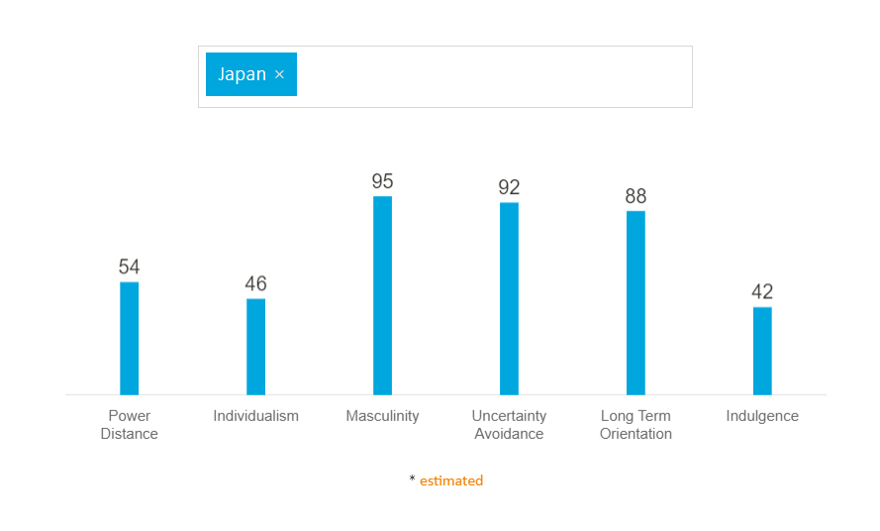
Chart sourced from Hofstede Insights (2022).
With the use of Hofstede’s model (1980) and Hofstede’s Insights or HI (2022), we can analyse the dimensions:
- The power distance in Japan is borderline showing that the population are aware of their social position and hierarchy take time making decisions.
- Japan holds characteristics of a collective society.
- Masculinity scores a remarkably high rating in Japan, which underlines their drive for “excellence and perfection.” They are highly work orientated.
- The country of Japan is “one of the most uncertainty avoiding countries on earth.” Meaning they are highly resistant to change and must be prepared for any uncertain situation.
- The society of Japan believe that you should do your best and be guided by good virtues.
- Typical Japanese culture are highly restraint, they do not place much value on leisure time and to desires.
The Culture of the United Kingdom 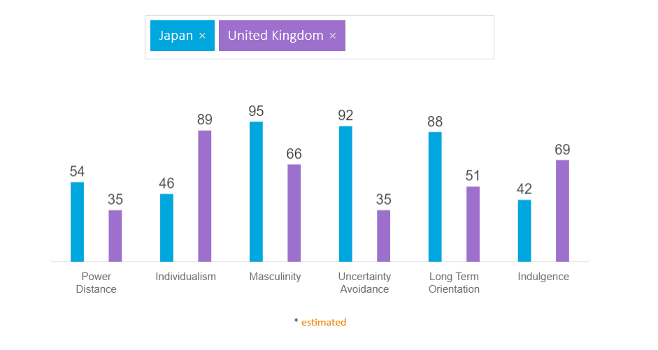
Chart sourced from Hofstede Insights (2022).
Using Hofstede’s Insights (2022), the country of Great Britain (UK):
- Have a low scale of power distance, which reveals the culture of optimism where equality is valued and there should be no limit as to how far you can travel in life.
- The UK have a high score of an individualist society, meaning that they are very private people and happiness is found through personal fulfilment.
- The UK are a masculine society; “highly success orientated and driven.”
- The UK scores low on uncertainty avoidance. Their culture is comfortable with adjusting to frequent change. Therefore, their long-term orientation cannot be defined.
- The culture of the UK is highly indulgent. People express their willingness and positivity to exhibit their desires and impulses, to enjoy life and have fun.
Country Analysis
A comparison of Japan and the United Kingdom must be addressed to convey any differences between the two cultures that could create a poor guest experience from staff when interacting with guests in the hotel.
With use of HI (2022), uncertainty avoidance has a significant variation between the UK and Japan. Therefore, Brits visiting Japan may be more accepting to conform to the customs, culture of Japan, and adapt to the change from their normal hospitality environment.
Moreover, there is a notable difference in individualism of the two countries. Japan is more a collectivist society compared to the UK where they are more individualist. Meaning, in relation to hospitality, British people may find it unusual to see tables of strangers sit, eat, drink, and talk together in Japan (May, 2022).
In relation to interaction and guest experience of British people who visit Japan, it is important to understand that those visiting may not have of an intercultural understanding of norms in Japan and may find it hard to adjust to (Wagner, 2022). For example, when entering traditional restaurants, British people may find it bizarre to swap shoes for slippers and sit on the floor to eat. Even eating in public streets is considered absurd (May, 2022).
From the use of HI (2022) and knowledge from Hofstede’s Dimensions (1980), it develops the knowledge of intercultural competence of Japan and the UK as cultures and nations. According to Samovar et al. (2017, pg. 18), they say “all cultures offer people a common frame of reference”, implying that not every individual is defined within their own culture, rather placed into a perspective.
When approaching intercultural barriers, it is essential to assume nothing of similarity between two cultures (Jandt, 2017, pg. 97). Moran & Abramson (2017, pg. 59) writes becoming more “ethnocentric” is a method of understanding cultural sensitivity, which teaches us “that culture and behaviour are relative.”
It is also important to note that Hofstede’s Six-Dimensional Theory (1980) is outdated, that although of its relevance, the study has limitations. Other theorists like Trompenaars Hampden-Turner have developed an innovative approach to identify and define behaviours of cultural differences and look at the “people side” of value systems (Trompenaars & Wooliams, 2004, pg. 29). This conveys that it is vital to appreciate that recent studies are frequently being developed and adapted to encourage liberal and conforming behaviours between cultures.
Hotel Handbook

The handbook below provides a guidance for hotel staff in Japan to reference when interacting with British guests.

Do’s: | Don’ts:
Make eye contact with guests and smile while communicating with them. | Don’t avoid eye contact and insincere expressions.
Politely refuse a tip from the guest if offered. | Don’t be offended at Brits for leaving/offering a tip.
F&B: Leave cutlery on tables for guests to use. | Don’t expect them to know how to use chopsticks.
F&B: Seat British guests on separate tables for privacy. | Don’t seat British guests with Japanese guests, unless requested.
Provide English translations for service and communications boards. | Don’t assume all guests understand Japanese.
Front Desk: Bow to guests to be polite, or offer a handshake | Don’t assume that many British guests know how to greet in Japan.

Conclusion
This report has summarised and discussed the differences between the cultures of the UK and Japan. The use of Hofstede Insights and use of further research has provided an awareness of what hotel staff in Japan should be understanding of when interacting and dealing with British guests. A handbook has been supplied of the ‘dos and don’ts’ with the objective of providing knowledge to staff to guide them to deliver the best customer service to British guests, and some points on how to avoid awkward situations for both parties.

References
ClickView, (2021) The Culture of Respect in Japan, video on YouTube. Available at: [https://www.youtube.com/watch?v=z3W7waKeMk0] (Accessed on: 10/11/2022).
Hofstede, G. (2001) Culture’s Consequences, 2nd ed. Sage Publications: California.
Hofstede, G. (1980, 84) Culture's Consequences, International Differences in Work-Related Values, vol. 5. Sage Publications: California.
Hofstede’s Insights, (2022) Country Comparison, Japan and the UK. Available at: [https://www.hofstede-insights.com/country-comparison/japan,the-uk/] (Accessed on: 10/11/2022).
Jandt, E. Fred, (2017) An Introduction to Intercultural Communication: Identities in a Global Community, 9th ed. Sage Publications, Inc: California.
James May, Our Man in Japan (2021) on Amazon Prime Video, Ep. 1 & 2. Available at: [https://www.amazon.co.uk/gp/video/detail/B0875MC63X/ref=atv_dp_share_cu_r] (Accessed on: 25/11/2022).
Moran, T. Moran & Abramson, R. Neil, (2018) Managing Cultural Differences: Global Leadership for the 21st Century, 10th ed. Routledge: Oxon.
National Geographic, Japan Facts, Available at: [https://kids.nationalgeographic.com/geography/countries/article/japan] (Accessed on: 10/11/2022).
Samovar, L. A, Porter, R. E, McDaniel, E. R, Roy, C. S, (2017) Communication Between Cultures, 9th ed. Cengage Learning: Canada.
Scroope, C. (2021) Japanese Culture, Do’s and Don’ts. Cultural Atlas. Available at: [https://culturalatlas.sbs.com.au/japanese-culture/japanese-culture-do-s-and-don-ts#japanese-culture-do-s-and-don-ts]
Trompenaars, F. & Woolliams, P. (2003) Business Across Cultures, Capstone: Chichester.
Wagner, D. (2022) The Importance of Adapting in Japan, LinkedIn. Available at: [https://www.linkedin.com/pulse/importance-adapting-japan-david-wagner?trk=articles_directory] (Accessed on: 14/11/2022).

