

Programme: Master of Business Administration
Module: Human Capital Management
Module code: LCMB7023
Assessment component 1: Individual report
Lecturer: Eno Maycock (Birmingham)
Name: - Azbabanu Mohmmadanish Malek
Course: - MBA IN INTERNATIONAL BUSINESS
Student ID: - 2610331
Submission date: - 15/10/2026
Subject: - Human Capital Management
Word count: - 2538

Table of Contents
Introduction 3
Task A: Designing Innovative Working Practices 3
A.1 Traditional work design vs Contemporary innovative working practices 4
A.2 Recommend innovative working practices for NexSpace health system 7
Task B: Designing Innovative Working Practices 9
B.1 Creating an Environment Where Talent Can Flourish 9
B.2 Comprehensive talent growth strategy for NexSpace health system………………… 13
Task C: Reflective Report…………………………………………………………………………………14
C.1 AI as a strategic tool………………………………………………………………………………….14
C.2 Reflective analysis……………………………………………………………………………………15
C.3 Personal action plan…………………………………………………………………………………15
References……………………………………………………………………………………………………. 16

Introduction
Human capital is important because employees’ knowledge, skills and abilities improve business performance and create competitive advantage (Boon et al., 2018)
This report focuses on NexSpace Health Systems (NHSX), a healthcare technology organisation with around 600 employees across the UK, India and the UAE. Its main challenges include limited creativity, weak collaboration in hybrid working, limited career development and balancing employee well-being with high performance.
(et.al, 2018) (Boon, 2018)The report explores innovative working practices (Task A), talent development (Task B), and the role of artificial intelligence (AI) in HR decision-making and professional development (Task C).
Task A: Designing Innovative Working Practices
NHSX needs to improve its working methods to encourage innovation, teamwork and flexibility. This task compares traditional and contemporary work design and explores how employee involvement, flexible working practices and technology can help create a more adaptable and high-performing workforce.
A.1 Traditional work design versus Contemporary innovative working practices
Traditional work design follows a hierarchical structure where senior managers make most decisions, employees perform specific tasks, and communication flows from top to bottom. It often relies on fixed working hours, formal communication and limited employee involvement. Although this approach provides clear responsibilities, it may reduce flexibility, creativity and organisational innovation (Armstrong and Taylor, 2021).
In contrast, contemporary innovative working practices promote flexible structures, teamwork, shared decision-making and digital technologies. Tools such as artificial intelligence (AI), human resource information systems (HRIS) and online communication platforms improve information sharing and collaboration across different locations. These practices also support employee well-being, work-life balance and autonomy, helping organisations improve innovation and respond to changing business needs (Stone et al., 2015; Brewster et al., 2020).
High-Performance Work Systems (HPWS) and High-Involvement Work Systems (HIWS)
High-Performance Work Systems (HPWS) and High-Involvement Work Systems (HIWS) are HR practices that improve employee skills, motivation, performance and participation. HPWS focuses on training, rewards and development opportunities, while HIWS encourages employees to share ideas, participate in decision-making and take responsibility for their work. These practices can support employee learning, creativity and positive workplace behaviour (Cao, Zhao and Xu, 2022; Boxall and Macky, 2009).
For NHSX, these systems could address limited career development and weak collaboration by providing training, mentoring, regular feedback and opportunities for employees across the UK, India and the UAE to contribute to project decisions. However, NHSX should balance performance expectations and employee involvement with manageable workloads to protect employee well-being.
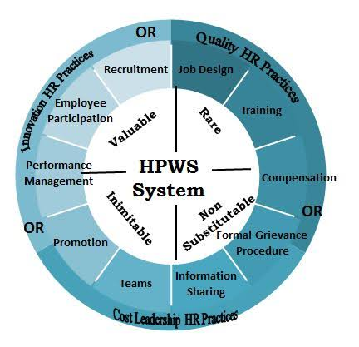
Figure 1: - HPWS
(Source: B. Nicole Rasool. 2013)

Agile and Hybrid Working Models
Agile working allows employees to adapt to changing organizational needs, while hybrid working combines office-based and remote work to provide greater flexibility and work-life balance. Agile working can improve team adaptability (Steegh et al., 2025), while flexible working and organizational support can improve employee engagement and performance (Naqshbandi et al., 2024; Jindain and Gilitwala, 2024).
For NHSX, these practices could improve collaboration between employees in the UK, India and the UAE. However, the organization should provide clear communication, managerial support and equal opportunities for all employees to ensure effective teamwork and protect employee well-being (Roper et al., 2022).
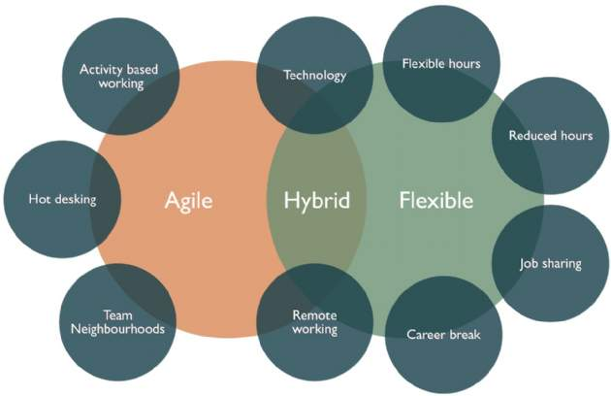
Figure: 2 Hybrid, Agile and Flexible models

Flexible Working Practices
Flexible working practices allow employees to have greater control over when and how they work, supporting employee well-being and autonomy. Research suggests that flexible working can increase trust in management and reduce job-related anxiety (Yunus and Mostafa, 2021). For NHSX, flexible arrangements could help employees balance work and personal responsibilities while maintaining clear expectations, employee engagement and performance.
Sociotechnical Systems Theory
Sociotechnical Systems Theory emphasizes the importance of integrating technology with employees, teamwork and organizational processes. Successful digital transformation requires technology and organizational factors to work together (Gao, Su and Yu, 2021). For NHSX, combining AI-enabled technologies with employee training, teamwork and appropriate support could improve collaboration, encourage innovation and enhance organizational performance.
A.2 Recommend innovative working practices for NexSpace Health Systems

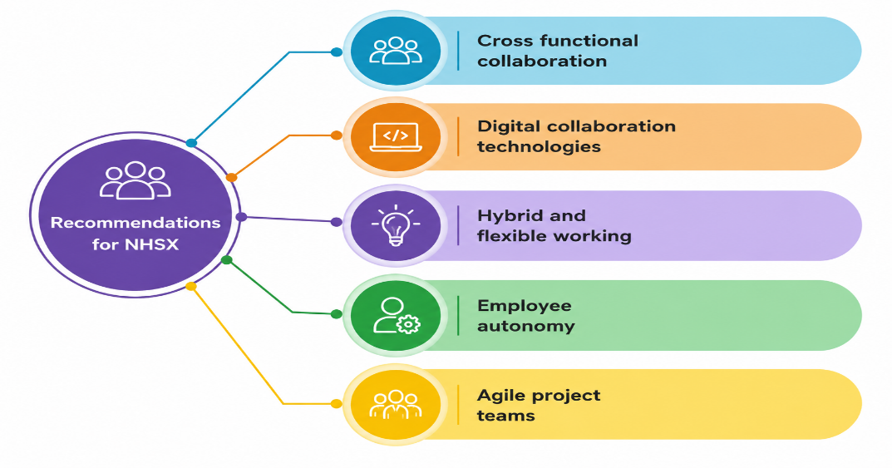
Figure: 3 Recommendations for NHSX
(Source: Self-made)
Cross-Functional Collaboration
NHSX should establish cross-functional teams involving employees from different departments to share knowledge, solve problems and develop innovative healthcare technologies. Cross-functional collaboration can support product innovation, particularly when teams have shared responsibilities, trust and clear goals (De Clercq, Thongpapanl and Dimov, 2011). For NHSX, this approach could strengthen collaboration between clinical experts, software developers and AI engineers. However, clear roles and effective communication are necessary to ensure successful teamwork.
Hybrid and Flexible Working
Hybrid and flexible working practices allow employees to work from different locations and adjust their working hours according to their needs. These arrangements can improve work-life balance, employee well-being and productivity. For NHSX, introducing hybrid and flexible working could help employees across the UK, India and the UAE collaborate more effectively while managing their personal responsibilities. However, NHSX should establish clear communication methods, regular team meetings and suitable performance targets to maintain collaboration and ensure that all employees receive equal support.
Employee Autonomy
NHSX should give employees greater autonomy by allowing them to make decisions, share ideas and take responsibility for their work. Employee autonomy can improve motivation and encourage employees to participate in decision-making. Research by Zeshan et al. (2025) examines the relationship between rewards and employee autonomy, highlighting the importance of enabling employees to have control over their work. Therefore, NHSX should involve employees in setting work goals and allow them appropriate freedom to decide how tasks are completed while maintaining clear performance expectations (Zeshan et al., 2025).

Agile Project Teams
NHSX should introduce agile project teams that allow employees from different departments to collaborate, respond quickly to changes and solve problems efficiently. Bechtel, Kaufmann and Kock (2022) found that agile practices can improve teamwork quality and contribute to project success. NHSX could apply these practices by organising regular team discussions, reviewing progress and adapting project plans when developing innovative healthcare technologies. However, managers should avoid excessive control that restricts teamwork and flexibility (Bechtel, Kaufmann and Kock, 2022).
Digital collaboration technologies
NHSX should introduce digital collaboration technologies, such as online communication platforms, shared workspaces and virtual meetings, to improve communication and knowledge sharing among employees in the UK, India and the UAE. Digital technologies can support collaboration and transform how people work and share information. However, NHSX should provide appropriate training and support to ensure employees can use these technologies effectively (Fischer, Lundin and Lindberg, 2020).
Task B: Designing Innovative Working Practices
B.1 Creating an Environment Where Talent Can Flourish
Learning Organization (Senge)
A learning organization encourages employees to share knowledge, develop skills and continuously improve. Senge (1990) explains that organizations can improve learning through team learning, shared vision and systems thinking. This is relevant to NexSpace Health Systems because its employees work across the UK, India and the UAE. The company can encourage knowledge sharing, provide regular training and help employees learn from mistakes. Caldwell (2012) critically examines Senge’s theory and highlights the importance of understanding organizational learning and change in practice. These practices can improve collaboration, support innovation and prepare employees for future challenges (Senge, 1990; Caldwell, 2012).
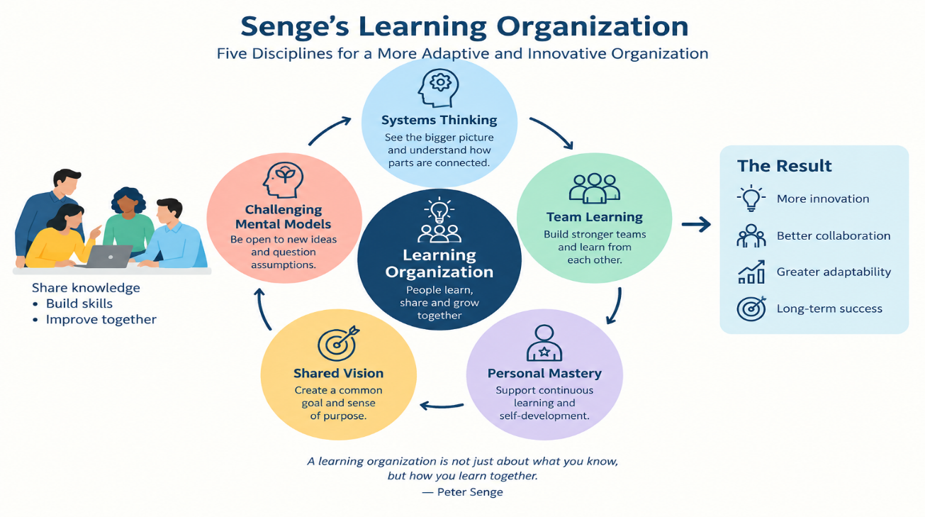
Figure:4 Senge Learning Organisation
(Source: Use AI)
Growth Mindset (Dweck)
A growth mindset is the belief that people can develop their abilities through learning, effort and feedback. Yeager and Dweck (2020) discuss growth mindset research and highlight the importance of understanding how mindset interventions can support learning and development. This is relevant to NexSpace Health Systems because employees need to learn new skills, adapt to new technologies and improve their performance. The company can encourage employees to accept constructive feedback, learn from mistakes and participate in regular training. This can support continuous learning, employee development and innovation (Yeager and Dweck, 2020).

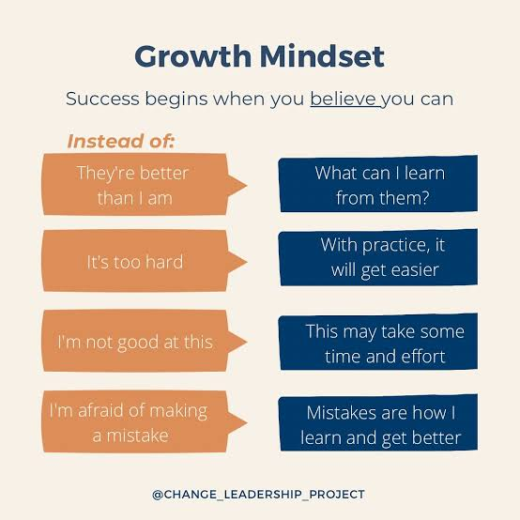
Figure:5 Growth Mindset
(Source: Use AI)
Psychological Safety (Edmondson)
Psychological safety means employees feel safe to share ideas, ask questions and report mistakes without fear of blame. This is relevant to NexSpace Health Systems because employees need to share knowledge and collaborate across international teams. Managers can encourage open communication, listen to feedback and treat mistakes as learning opportunities. This can improve trust, teamwork and innovation while reducing employees’ fear of speaking up (Ferrère et al., 2022)
Talent Management Framework
A talent management framework helps organizations attract, develop and retain skilled employees. Van Zyl et al. (2017) explain the importance of effective talent management practices. NexSpace Health Systems can provide regular training, career development opportunities and support for employee growth. These practices can reduce employee turnover, improve skills and support the organization’s long-term success (van Zyl et al., 2017).

Job Crafting Theory and Self Determination Theory
Job crafting allows employees to adjust their work responsibilities and find better ways to complete tasks. Self-Determination Theory explains how employees’ motivation is influenced by their psychological needs, including autonomy, competence and relatedness. This is relevant to NexSpace Health Systems because managers can give employees more responsibility, encourage initiative and support skill development. These practices can improve employee motivation, job satisfaction and continuous learning (Wu et al., 2023).
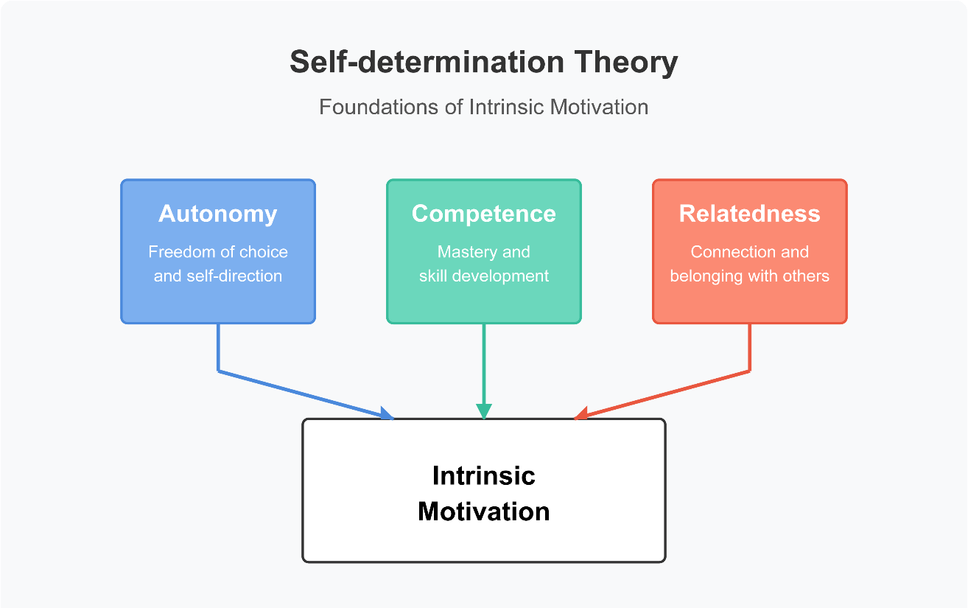
Figure:6 Self Determination Theory
(Source: Edward L. Deci and Richard M. Ryan)
Employee Experience (EX)
Employee experience refers to employees’ overall experience throughout their time in an organization. Gustafsson et al. (2024) discuss the importance of understanding employee experience and workplace interactions. NexSpace Health Systems can improve employee experience by providing learning opportunities, supporting employee well-being and encouraging collaboration. These practices can improve employee engagement, satisfaction and retention (Gustafsson et al., 2024).
B.2 Comprehensive talent growth strategy for NexSpace Health Systems
Employee Training and Development
Employee training and development helps employees improve their skills and knowledge. Armstrong and Landers (2018) explain how gamification can make employee training more engaging and effective. NexSpace Health Systems can provide interactive digital training and regular learning opportunities to help employees adapt to new technologies. This can improve employee skills, motivation and performance while supporting the organisation’s future needs (Armstrong and Landers, 2018).
Career Development and Succession Planning
Career development and succession planning help organisations prepare employees for future roles and leadership positions. Leuzinger, Barr and Brannon (2016) highlight the importance of mentoring in supporting career development and preparing future leaders. NexSpace Health Systems can introduce mentoring programmes, leadership training and clear career progression opportunities to help employees improve their skills and gain experience. The company should also identify high-performing employees who have the potential to take on senior roles in the future. These practices can improve employee motivation, reduce staff turnover and ensure the organisation has skilled employees ready for future leadership positions (Leuzinger, Barr and Brannon, 2016).
Talent Management and Retention
A critical challenge for contemporary organisations is translating talent management initiatives into tangible retention outcomes. Pandita and Ray (2018) argue that talent management practices alone are insufficient unless they cultivate a strong psychological bond between the employee and the organisation. Their conceptual study demonstrates that effective talent management, including clear career development, recognition and growth opportunities, directly influences employee engagement, which in turn acts as a crucial mediator for talent retention. For NexSpace Health Systems (NHSX), which is experiencing attrition of high-performing employees due to perceived limited career growth, this relationship is particularly pertinent. It suggests that the current issue is not merely a lack of training programmes, but a failure to create an engaging talent experience that makes employees feel valued and invested in. This aligns with the concept of Employee Experience (EX), where the holistic journey of the employee determines commitment (Plaskoff, 2017).
TASK C: Reflective Report
C.1 AI as a Strategic Tool
Artificial Intelligence (AI) is increasingly recognised as a strategic tool that can improve organisational performance and competitive advantage (CIPD, 2023). In human resource management, AI is no longer just used for administrative tasks, but for strategic decision-making. According to Chamorro-Premuzic et al. (2023), AI can analyse large amounts of employee data quickly and identify patterns related to recruitment, performance and retention that humans may miss.
For organisations like NexSpace Health Systems (NHSX), which operates across the UK, India and the UAE, AI can play a critical role in managing talent. For example, AI-powered applicant tracking systems can reduce bias in recruitment by screening CVs fairly, while AI-driven learning platforms can recommend personalised development plans based on individual skills and career goals (Deloitte, 2023). Furthermore, predictive analytics can help managers to identify employees who are at risk of leaving, allowing early intervention through engagement and growth opportunities.
However, the use of AI also brings challenges. Brougham and Haar (2020) argue that if AI is not used ethically and transparently, it can create fear of job loss and reduce psychological safety. Therefore, for NHSX, it is important to use AI to support human decision-making, not to replace it. When used responsibly, AI can improve efficiency, support talent growth and enhance the overall employee experience.

C.2 Reflective Analysis
In this assessment, I used AI in three ways.
First, for research and information gathering, AI helped me to narrow down HRM concepts and research directions for NHSX. However, I learned that information and references generated by AI must be verified independently to avoid inaccuracies (CIPD, 2023).
Second, for critical analysis and decision-making, AI assisted me to analyse and compare traditional and innovative working methods for NHSX. Nevertheless, I realised that relying too much on AI suggestions can reduce my own independent thought and judgement.
Third, for writing and professional communication, AI helped me to identify unclear sentences and improve academic communication (Khalifa and Albadawy, 2024). However, over-reliance on AI may affect my own voice and writing ability.
Overall, these experiences show that AI can enhance efficiency and learning, but it cannot replace human judgement, ethical responsibility and independent verification.
C.3 Personal Action Plan
Capability  Area | How I Will Develop It | SMART Timeline | Success  Evidence
1. Digital & Data Capability | I will build data interpretation skills by learning HR analytics tools and understanding how to read talent data. I will check AI-generated data with original sources before using it. | 0-4 months | Create 2 sample HR data reports with accurate referencing
2. Problem Solving & Independent Judgement | I will strengthen my own judgement by solving HR problems manually first using theories like Senge (1990) and Dweck (2006), then use AI only to compare viewpoints. | 2-6 months | Write 3 reflective logs showing my own solution vs AI solution
3. Professional Confidence & Teamwork | I will improve confidence by actively joining group discussions, knowledge-sharing activities and Learning Labs to practice clear communication. | 3-9 months | Collect peer feedback and record 3 presentations
4. Career Readiness & Continuous Growth | I will prepare for future employment by building a portfolio of my projects on employee development and retention and update my IDP regularly. | 6-12 months | Final portfolio with 5 pieces of evidence and updated CV

References
Armstrong, M. and Landers, R. N. (2018) 'Gamification of employee training and development', International Journal of Training and Development, 22(2), pp. 162-169.
Armstrong, M. and Taylor, S. (2021) Armstrong's handbook of human resource management practice. 15th edn. London: Kogan Page.
Bechtel, J., Kaufmann, C. and Kock, A. (2022) 'The influence of agile practices on project success', International Journal of Project Management, 40(6), pp. 600-611.
Boon, C., Eckardt, R., Lepak, D. P. and Boselie, P. (2018) 'Integrating strategic human capital and strategic human resource management', International Journal of Human Resource Management, 29(1), pp. 34-67.
Boxall, P. and Macky, K. (2009) 'Research and theory on high-performance work systems', Human Resource Management Journal, 19(3), pp. 227-238.
Brewster, C., Chung, C. and Sparrow, P. (2020) Contemporary issues in HRM. London: Routledge.
Brougham, D. and Haar, J. (2020) 'Technological disruption and employment', Journal of Management & Organization, 26(2), pp. 143-154.
Caldwell, R. (2012) 'Systems thinking, organizational change and agency', Systems Research and Behavioral Science, 29(2), pp. 155-169.
Cao, M., Zhao, S. and Xu, L. (2022) 'High-performance work systems and employee creativity', Personnel Review, 51(3), pp. 890-907.
Chamorro-Premuzic, T., Akhtar, R. and Winsborough, D. (2023) 'The datafication of talent', Harvard Business Review, pp. 1-9.
CIPD (2023) CIPD Profession Map. London: Chartered Institute of Personnel and Development.
De Clercq, D., Thongpapanl, N. and Dimov, D. (2011) 'A closer look at cross-functional collaboration', Journal of Product Innovation Management, 28(5), pp. 680-695.
Deloitte (2023) Global Human Capital Trends. London: Deloitte Insights.
Dweck, C. S. (2006) Mindset: The new psychology of success. New York: Random House.
Ferrère, A., et al. (2022) 'Psychological safety and knowledge sharing', Journal of Knowledge Management, 26(8), pp. 2001-2020.
Fischer, C., Lundin, J. and Lindberg, O. (2020) 'Rethinking digital collaboration', Human Resource Development International, 23(4), pp. 345-362.
Gao, S., Su, Y. and Yu, Z. (2021) 'Sociotechnical systems and digital transformation', Technological Forecasting and Social Change, 173, p. 121075.
Gustafsson, S., et al. (2024) 'Employee experience and workplace interactions', Employee Relations, 46(2), pp. 310-328.
Jindain, C. and Gilitwala, B. (2024) 'Flexible work and employee engagement', International Journal of Organizational Analysis, 32(1), pp. 45-62.
Khalifa, M. and Albadawy, M. (2024) 'Using artificial intelligence in academic writing', Journal of Academic Writing, 14(1), pp. 1-15.
Leuzinger, J., Barr, J. and Brannon, M. (2016) 'Mentoring and succession planning', Journal of Business and Psychology, 31(4), pp. 521-534.
Naqshbandi, M. M., et al. (2024) 'Organizational support and agile working', Personnel Review, 53(2), pp. 412-430.
Pandita, D. and Ray, S. (2018) 'Talent management and employee engagement', Industrial and Commercial Training, 50(3), pp. 104-116.
Plaskoff, J. (2017) 'Employee experience: the new human resource management approach', Strategic HR Review, 16(3), pp. 136-141.
Roper, I., et al. (2022) Critical issues in human resource management. London: Bloomsbury.
Senge, P. M. (1990) The Fifth Discipline: The art and practice of the learning organization. London: Doubleday.
Steegh, F., et al. (2025) 'Agile working and team adaptability', Journal of Organizational Behaviour, 46(1), pp. 88-105.
Stone, D. L., et al. (2015) 'The influence of technology on the future of HRM', Human Resource Management Review, 25(2), pp. 216-231.
Van Zyl, E. S., et al. (2017) 'Talent management practices', SA Journal of Human Resource Management, 15(1), pp. 1-12.
Wu, C., et al. (2023) 'Job crafting and self-determination theory', Journal of Vocational Behavior, 142, p. 103864.
Yeager, D. S. and Dweck, C. S. (2020) 'What can be learned from growth mindset controversies', American Psychologist, 75(9), pp. 1269-1284.
Yunus, S. and Mostafa, A. M. S. (2021) 'Flexible working practices and employee well-being', Human Resource Management Journal, 31(4), pp. 972-989.
Zeshan, M., et al. (2025) 'Rewards and employee autonomy', Employee Relations, 47(1), pp. 55-72.

