March 18, 2019
Lisa Davies

Evaluating a contemporary theme in health management and its impact on organisational behaviour within the HEALTH CARE sector

Contents
Abstract………………………………………………………2
Introduction…………………………………………………..2
Main Body……………………………………………………2
Conclusion…………………………………………………...4
Recommendations…………………………………………..4
Appendices…………………………………………………..6
References…………………………………………………...7

Abstract
This report contains evidence of a shortage of staff within the NHS and how this affects nurse’s motivation and morale showing how ineffective leadership and management results in the breakdown of management and employee relationships, communication and trust. The report contains evidence of the impact that poor management and leadership can have on a team and how this can be addressed and resolved professionally. Whilst also showing evidence how excellent management and leadership can have in a working environment.

Introduction
This is a report evaluating the role of leadership and management within the NHS and aims to identify and discuss the differences in leadership and management styles, the effectiveness of the structures and cultures within the NHS and how lack of communication might result in an inappropriate working culture. The purpose of the report is to cover all aspects of positive and negative management styles and how they impact on the nursing environment.
Main Body
The NHS was launched in 1948 and the idea behind this extraordinary system was to help every individual in need regardless of wealth and was driven on three core principles which were that it met the needs of everyone, was free at the point of delivery and it was based on clinical need and not the ability to pay (NHS, 2019). According to NHS (2019) more than 1.5 million people over the years making it one of the world’s largest workforce organisations. Despite these figures Better Healthcare (2017) states scary figures of almost 100,000 unfilled jobs within the NHS and classing it as ‘dangerously understaffed’. Lack of staff within the NHS is an even bigger problem than a lack of funding states Nigel Edwards who is the chief executive of the Nuffield Trust, this is supported by a chief executive and general secretary at the Royal College of Nursing named Janet Davies who explains that all evidence collected proves that patient care standards rise and fall as nurse numbers do (Better Healthcare, 2017). Similarly, O’Dowd (2014) highlights unsafe care within the NHS due to staff shortages resulting in a heavy reliance on agency staff, along with other problems these problems have resulted in closure of its part.
The lack of staff within the NHS inevitably affects the care patients receive which means that patients are waiting longer for appointments or how quickly call bells can be answered, which is obviously a concern of safety as staff are unaware of reason for the call until they respond (Campbell, 2014). An inspector in a local hospital found that shortage on night staff workers mean that the number of falls among elderly patients had increased at the times when staffing levels are low (Campbell, 2014). In extreme cases BBC News (2017) have reported that patients are dying alone on the wards as there is not enough time for nurses to care for their patients with some nurses stating they felt unsafe and resulting in being overwhelmed at the end of their shift.
RCN (2013) have evaluated and discussed different sources and levels of stress among the nursing workforce. RCN (2013) carried out research asking various health care professionals to rate their level of stress from 1-10, with 1 being the lowest and 10 being the highest, (which can be found on page 6, table 1a in appendix) shows highest and lowest stress scores depending on job title, (which can be found on page 6, table 1b in appendix) shows highest and lowest scores in relation to area of practice. Chart 2 (which can be found on page 6, table 2 in appendix) shows the reasons for increased levels in stress and state other issues that were highlights were lack of support from management and not having enough time to take breaks (RCN, 2013). Staff shortages ranked second in all reasons of stress with 70.2% which is considerably high (RCN, 3013).
Due to shortage of staff within the NHS it has found that this effects nurse’s motivation and morale due to stress (Finlayson, 2002). Finlayson (2002) highlights that when staffing levels are low this has an impact on nurse’s motivation and morale and states the importance of keeping these high as it is essential for a healthy workforce within the NHS which then has a positive effect on patient care. Reflecting on the findings of Campbell (2014) the research carried out by Finlayson (2002) was also found that the effect off short staff was affecting the type and quality of care nurses were able to provide.
Management and leadership are two very different roles as leaders influence followers whilst managers manage the people who work for them (go2HR, 2019). Successful managers and leader are needed within the NHS to drive each team towards a vision of success (go2HR, 2019). Managing a team is administering and keeping on top of everybody making sure things are running as they should whilst leading a team is getting people onboard with the organisations vision and understanding what needs to be done to achieve set goals (go2HR).
Staff at Birmingham Children’s Hospital highlighted the fact that they were struggling to cope with the pressures and stress at work and as a result of this management created ‘caring for BCH’ which was a strategy undertaken to help tackle stress and improve staff’s ability to cope with challenges (NHS Employers, 2015). These have been steps to success and have received positive feedback from staff surveys and have seen a drop in work related stress reducing stress related absence by over 10% (NHS Employers, 2015). This shows an excellent management style and how solutions like this can be resolved. In relation, Drucker’s (2012) theory supports this style of management used by NHS Employers (2015) as managers identified problems which was stress, set a target to overcome this problem, negotiated with staff what was needed to achieve these targets and evaluated at a later date to see if it was a success. Drucker’s management theory states that managers should be a prominent figure within an organization and believed effectiveness was more important than efficiency (Daley and Walsh, 2010).
McGregor (1960) believed that a manager’s view of employees can have an impact upon organisational function and productivity. The assumptions which were Theory X and Theory Y describe how employees work according to different management styles (McGregor, 1960). Theory X believed that employees were lazy and disliked work therefore the management style would be to control and direct these individuals which could then lead to mistrust and resentment from those they managed (McGregor, 1960). Theory Y believed that employees do not inherently dislike work and will work well given trust and less control therefore resulting in a more positive way (McGregor, 1960). Use of both Theory X and Theory Y management styles will affect and motivate employees in different ways, and many managers may use strategies from both theories to get positive results (McGregor, 1960).
As a result of staff shortages which can cause low levels of motivation and morale within the NHS this reflects on poor leadership and management undertaken. Scott (2015) states how NHS Scotland has been slammed for poor leadership and management and have effectively created an inappropriate working culture due to this. The Academy of Medical Royal Colleges created a report in Scotland which found major failings across Scotland including poor leadership at all levels resulting to a disconnection between staff and management, also resulting in staff shortages and poor staff morale and motivation (Scott, 2015). This shows a poor management style and how a breakdown between a team can result in a negative way. Gray, Field and Brown (2010) believe that forming productive relationships is at the heart of effective leadership with who we work alongside irrespective of job title. In relation, Adair’s (2006) theory states the importance that focus needs to be given on individuals and team and not just targets and numbers or this will result in low morale and motivation of staff. Another failing of management found by Gold, Mumford and Thorpe (2010) states that patients were dying needlessly at a certain NHS trust due to appalling management style.
Three styles of leadership are traditionally used within the management setting, these are authoritarian, democratic and laissez-faire (Flynn, 2015). An authoritarian leadership approach is seen as directive, a leader asserting authority and taking control and dominance over situations (Schuh, Zhang and Tian, 2013). A democratic leadership style is an open approach based on mutual respect which includes participants and leaders collaborating and sharing visions and ideas (STU, 2018). A Laissez-faire leadership style is non-authoritarian and is based on trust. It gives people least possible guidance and space to make their own decisions when working on projects (STU, 2018).
Conclusion
The report found the importance of positive leadership and management within the NHS and how this has an excellent outcome for management and employee relationships and the performance of employees when appropriate action is taken. The report also finds the negative impact poor leadership and management has within the NHS and how this effects staff and patient care. A range of sources were used in the report to compare with the struggles of positive and negative management and leadership styles found within the NHS. The report highlights the terrifying numbers of staff shortages in all areas of the NHS and how this greatly effects staff’s motivation and morale due to work related stress. Lack of motivation and morale was identified as creating an unhealthy workforce and management need to ensure to do whatever possible to create a healthy working environment. Graphs included in the report gives a small insight to the many reasons of stress within the NHS and the areas of practice who struggles the most. Graphs are commonly used within research as they visually illustrate research found when text is usually too complicated or long to present (Slutsky, 2014). Theories involved in the report such as authoritarian, democratic and laissez-faire support the different styles of management and leadership used within different areas of the NHS conclude how some management styles work whilst others do not.

Recommendations
- Positive Communication
It is suggested that trusting relationships are positively related to communication between management and employee, suggesting that when positive communication is used employees are more likely to be motivated and have a higher morale which form trusting relationships within the organisation (Jo and Shim, 2005).

- Trusting Relationships
Management and employee both contribute to building trusting relationships within and organisation by practicing openness, being honest and speaking their feelings, also by showing dedication and consistency, all contributing to a positive trusting relationship within the organisation (Callaway, 2007).

- Leadership and Management
Leadership and management skills are essential for any health care professional regardless of job title and are used within the working environment in everyday practice (Gopee and Galloway, 2017).

Appendices

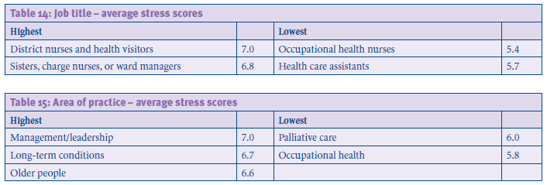
1b
1a
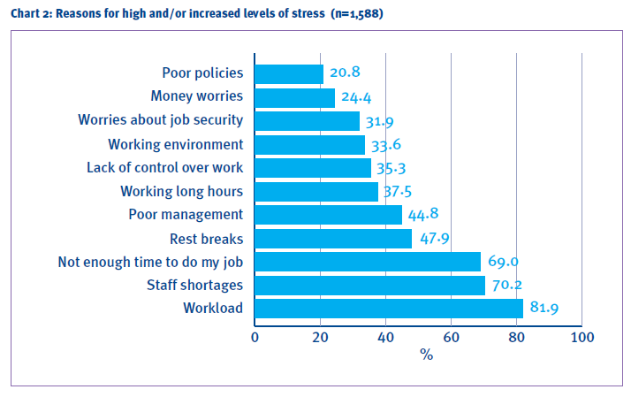
2

References

Adair, J.E. (2006) Leadership and Motivation: The Fifty-fifty Rule and the Eight Key Principles of Motivating Others. 2nd Ed. London: Kogan Page.

BBC News (2017) NHS staff shortages 'mean patients dying alone' in hospitals. Available at: https://www.bbc.co.uk/news/health-41433159 (Accessed: 18th March 2019).

Better Healthcare (2017) NHS suffering from lack of staff. Available at: https://www.betterhealthcare.co.uk/nhs-suffering-lack-staff/ (Accessed: 16th March 2019).

Callaway, P. (2007) The Relationship of Organizational Trust and Job Satisfaction: An Analysis in the U.S. Federal Work Force. Florida: Universal-Publishers.

Campbell, D. (2014) ‘NHS staff shortages pose risk to patients, warns watchdog’, The Guardian, 17th October. Available at: https://www.theguardian.com/society/2014/oct/17/nhs-staff-shortages-risk-patients-cqc-report (Accessed: 18th March 2019).

Daly, P. and Walsh, J.S. (2010) Drucker's theory of the business and organisations: challenging business assumptions, 48(4), pp. 500-511, DOI: https://doi.org/10.1108/00251741011041319.

Drucker, P.F. (2012) The Practice of Management. UK: Routledge.

Finlayson, B. (2002) ‘Counting the smiles’ moral and motivation in the NHS. Available at: https://www.kingsfund.org.uk/sites/default/files/field/field_publication_file/counting-smiles-morale-motivation-nhs-belinda-finlayson-kings-fund-1-march-2002.pdf (Accessed: 19th March 2019).

Flynn, S.I. (2015) Authoritarian, democratic, and laissez-faire leadership. Available at: http://connection.ebscohost.com/c/articles/37219618/authoritarian-democratic-laissez-faire-leadership (Accessed: 20th March 2019).

Gold, J., Mumford, A. and Thorpe, R. (2010) Leadership and Management Development. 5th Ed. London: Kogan Page Publishers.

Gopee, N. and Galloway, J. (2017) Leadership and Management in Healthcare. 3rd Ed. New Delhi: SAGE Publications.

Go2 Tourism HR Society (2019) Understanding the Differences: Leadership vs. Management. Available at: https://www.go2hr.ca/management-leadership/understanding-the-differences-leadership-vs-management (Accessed: 21st March 2019).

Gray, I., Fields, R. and Brown, K. (2010) Effective Leadership, Management and Supervision in Health and Social Care. London: Learning Matters Ltd.
Jo, S. and Shim, S.W. (2005) Paradigm shift of employee communication: The effect of management communication on trusting relationships, 31(2), pp. 277-280. DOI: https://doi.org/10.1016/j.pubrev.2005.02.012.

McGregor, D. (1960) Theory X and Theory Y: Organization theory, 358, pp. 374.

NHS Employers (2015) Birmingham Children's Hospital - Implementing health and wellbeing initiatives to reduce stress at work. Available at: https://www.nhsemployers.org/-/media/Employers/Publications/HWB/HWBBirmingham-June-2015IMPLEMENTING-HEALTH-AND-WELLBEING.pdf (Accessed: 19th March 2019).

NHS (2019) Principles and values that guide the NHS. Available at: https://www.nhs.uk/using-the-nhs/about-the-nhs/principles-and-values/ (Accessed:18th March 2019).

NHS (2019) About the NHS. Available at: https://www.nhs.uk/using-the-nhs/about-the-nhs/the-nhs/ (Accessed:18th March 2019).

O’Dowd, A. (2014) Medical care at Mid Staffs is deemed unsafe as trust prepares to close, 349, pp. 1-2. DOI:10.1136/bmj.g6160.

RCN (2013) ‘Beyond breaking point?’, A survey report of RCN members on health, wellbeing and stress. Available at: https://www.bing.com/search?q=beyond+breaking+point%3Fa+survey+report+of+rcn+members+on+health%2Cwellbeing+and+stress&form=EDGTCT&qs=PF&ccvi=d9a053bc561b448e834d7faf256d1e54&refig=94bded2a558a4229ed8df10d9a1fd1e8&cc=GB&setlang=en-US (Accessed at: 21st March 2019).

Schuh, S.C., Zhang, X. and Tian, P. (2013) For the Good or the Bad? Interactive Effects of Transformational Leadership with Moral and Authoritarian Leadership Behaviors, 116(3), pp.629-640. DOI: https://doi.org/10.1007/s10551-012-1486-0.

Scott, M. (2015) Poor management leads to 'serious failings' at the NHS in Scotland. Available at: https://www.managers.org.uk/insights/news/2015/july/poor-management-leads-to-serious-failings-at-the-nhs-in-scotland (Accessed: 19th March 2019).

Slutsky, D.J. (2014) The Effective Use of Graphs, 3(2), pp. 67–68. DOI:10.1055/s-0034-1375704.

STU (2018) What is Democratic/Participative Leadership? How Collaboration Can Boost Morale. Available at: https://online.stu.edu/articles/education/democratic-participative-leadership.aspx (Accessed: 19th March 2019).

STU (2018) What is Laissez-Faire Leadership? How Autonomy Can Drive Success. Available at: https://online.stu.edu/articles/education/what-is-laissezfaire-leadership.aspx (Accessed: 19th March 2019).

