End-User Computing
End-User Computing report
M6X01097

Student: David Price
Student number: P131188
Lecturer: Beverley Holland
Table of Contents
List of Tables and Figures 3
Introduction 4
Overview of End-User Computing 4
Case Study 5
Homepage 5
Schedule 6
Invoice 7
Customer Database 7
Bookings database 8
Integrated software packages 10
Conclusion 11
References 12
Bibliography 13

List of Tables and Figures
Figure 1 - Case study homepage. 6
Figure 2 - Case study schedule. 6
Figure 3 - Case study invoice. 7
Figure 4 - Case study customer database 8
Figure 5 - Case study (Adding a new customer) 8
Figure 6 - Case study bookings database. 9
Figure 7 - Case study booking form. 9

Introduction
End-user computing is software created by programmers that allow non-programmers to complete IT related tasks, End-user computing or more commonly coined EUC is software aimed for non-programmers to easily and efficiently complete tasks. These tasks can involve navigating and storing information through sequences of button clicks as an example, it depends on what the non-programmers may need available to them to complete the desired task, this must be taken into consideration by programmers when proceeding through the development phase.
Management information systems are becoming more prominent and relied upon by businesses to store and efficiently manage information pertaining to that company. The software is conventionally used only IT professionals as they would have complete access to a computer in business. This ideology has become obsolete with how technology is evolving and being used in businesses, an example of this is the prominence of BYOD (Bring Your Own Device) in businesses, this would influence businesses to create an End-user experience without straying too far from the business standards and procedures whilst increasing productivity.
In this report, there will be a case study on a cosmetic dentist based in Swansea in which they are looking to computerise their current systems, the solution is to make an end-user system for the practice which allows the employees to easily complete the day-to-day tasks of the practice. There will be evidence shown of how the system will work and a brief discussion on integrated software packages such as Microsoft Office, on how these packages could be applied to this proposed system.

Overview of End-User Computing
End-user computing “refers to the everyday use of computers for both business and personal use. At every level, many workers interact with personal computers (PCs) to accomplish their work”[1], it is usually developed for a non-IT professional in mind, so they can complete a task without help from an IT professional. Providing them with the tools necessary to complete a task, sometime to create an interface that only allows them to complete a certain goal.
The users of an end-user computing system can be broken down into 3 categories:
- Indirect user
  - People who tend to use applications by others who have written code and that know nothing about programming e.g. Receptionists
  - “They neither program nor use report generators. Access to computerized data is through a limited, menu-driven environment or a strictly followed set of procedures.”[2].
- Intermediate user
  - People who have some computer knowledge, who need to provide data or reports etc. e.g. office worker.
- Direct user
  - IT professionals “who utilize both command and procedural languages directly for their own personal information needs. They develop their own applications, some of which are used by other end users.”[2].
End-user computing has some problems which are unavoidable at times which businesses must address to their clients and employees, just some of the problems are:
- Waste
  - This can be E-waste, time, money or any resources that are used to their full potential or that do not contribute anything positive to the business or their users.
  - “Waste also occurs when end users purchase software that does not meet their needs as well as a competing program, or they purchase software that costs more than a similar package”[1]
- Mistakes
  - Human errors will happen regardless of what industry, users tend to be careless or uninformed of what is the correct way of using certain applications this can lead to mistakes which affect productivity and morale.
- Loss of data
  - Many of the users may not know to back up regularly or use the cloud to save vital data, this has many drawbacks which affects all other aspects of the business for a duration.
  - “Data loss happens when data may be physically or logically removed from the organization either intentionally or unintentionally”[3].
- Privacy issues
  - Commonly used applications within a business can be exploited and private information may be exploited, business policies must be issued and abide by.

Case Study
This report will look at providing a solution for a dentist in the Swansea area called ‘Your Teeth Our Smile’, the problem is that they realise it is time to computerise their current booking method and to provide an overall better experience. The proposed solution will be shown in Microsoft Excel and screenshots of the solution will be provided showing how it will work if implemented.
The problems this business faces are as followed:
- Computerise and print invoices
- Manage customers
- Manage bookings
- Update a schedule
The following sections of this case study will look at each individual page of the proposed system with explanations and demonstrations of each interaction within the system, each page must seamlessly flow with one another as if they belong together and they must provide the capability for non-IT professionals to understand and operate these pages.

Homepage
Firstly, the homepage is the main navigator within a system. It should provide a clear understanding of what button achieves what and must be user-friendly, it must provide the user with specified guidelines to complete a task. In this case, this could be several tasks such as preparing an invoice, make a booking and add a new customer into the database.

Figure 1 - Case study homepage.
As you can see from this homepage, it clearly provides the user with the available options of what possibly could be done along with the with the company logo. This clear design shows the end-user what options are available and what can be done in this application.

Schedule
Secondly, the schedule is vital for the business as it provides the upcoming appointments for each day, sorted by week number. This allows the user to clearly see what time slots are available and provides an overview of what appointments are made for that week, the schedule can also be filtered by room number as the dentistry has multiple rooms, each room has its own schedule.
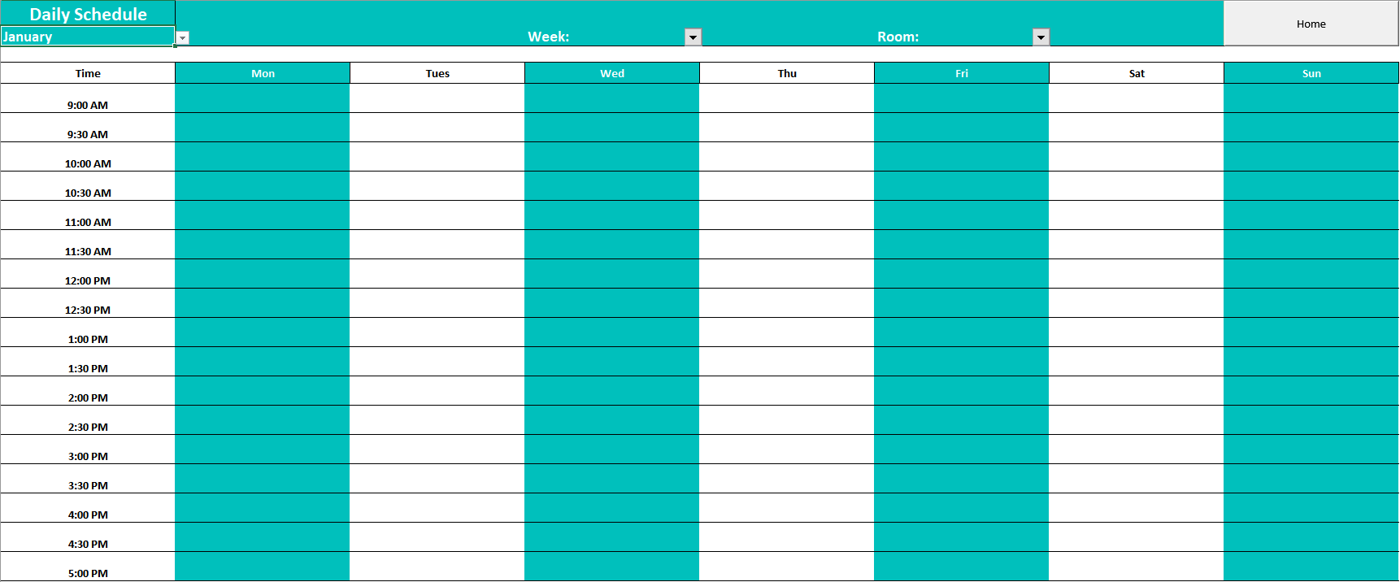
Figure 2 - Case study schedule.
The schedule will have drop-down boxes allowing the user to filter between months, week number and room number. This will provide the user an overview of the upcoming appointment by the month, week number and room number. The data collected in the booking database can be relayed back onto the schedule to have it automatically updated once a booking has been made, so it would go directly onto the schedule for the user to see.

Invoice
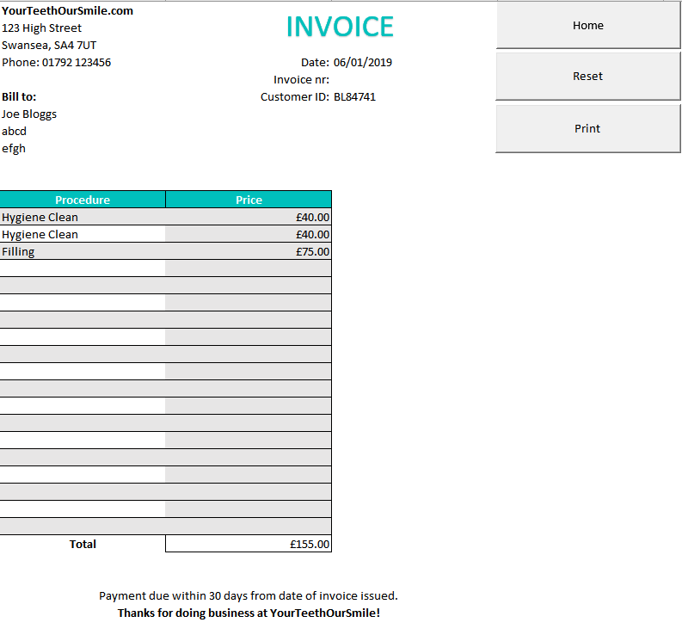
Figure 3 - Case study invoice.
The invoice shows a list of the procedures that a customer (specified by their unique ID) has had done, along with a breakdown of the costs and that is a receipt which the user is able to print off. The procedures can be added via a drop-down list which then the prices are acquired via an excel formula VLOOKUP and a sum is provided at the bottom of the table within the invoice.

Customer Database
The customer database is the area of the system where you can manage the customers, and it provides an overview of current customers with other options. This database allows the addition, update, and deletion of customers within the database.
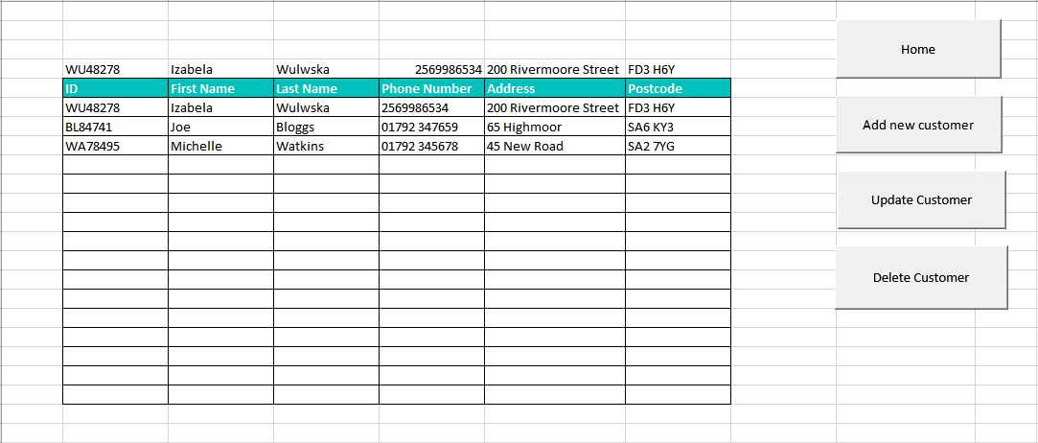
Figure 4 - Case study customer database
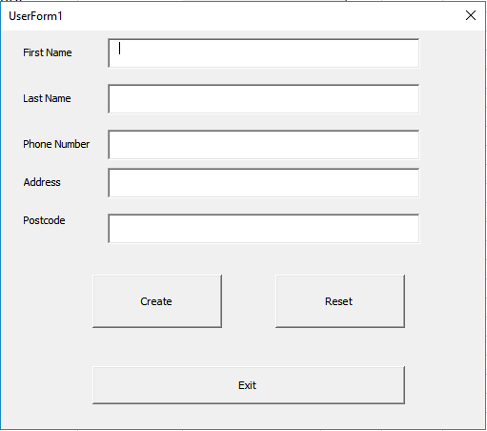
Figure 5 - Case study (Adding a new customer)
When selecting add new customer a form appears which allows the user to fill out and therefore add a new customer into the database, once the form has been completed and exited. The data will be added to the current list in the database and the customer will be provided with a unique ID.

Bookings database
Bookings database allows the user to make, update and delete bookings. The same principle and layout as the customer database. This sheet provides information on the type of procedure, rooms, time and date which can then be linked to the invoice to easily navigate and find the correct procedure for the correct customer.
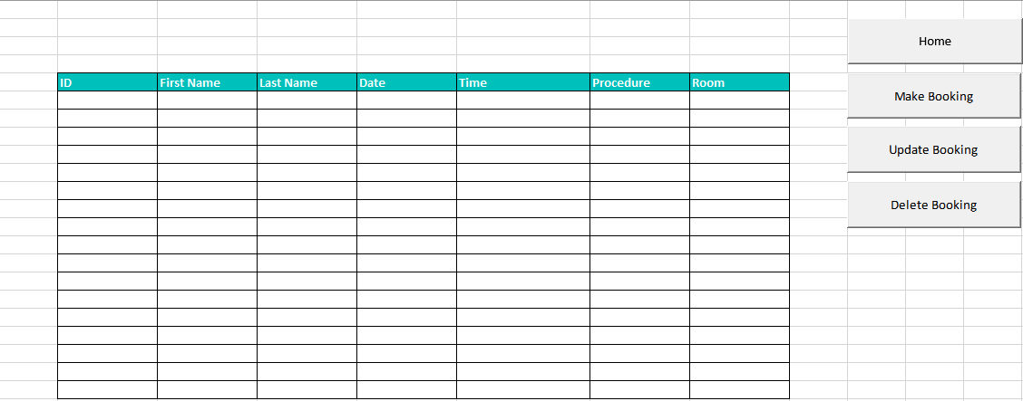
Figure 6 - Case study bookings database.
When adding a new booking, the user will be prompted with a user form to be completed with various text boxes to fill out which will then be added to the booking database.
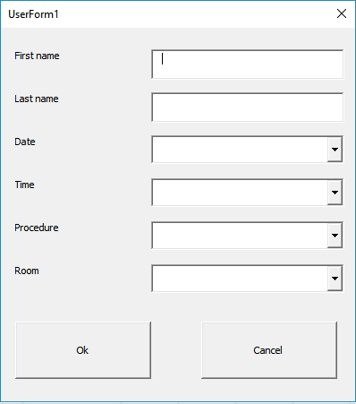
Figure 7 - Case study booking form.
Once the booking has been completed and added to the booking database sheet, the data from there can be extracted and used in the other sheets such as schedule and invoice.
Management Information Systems is the key factor to facilitate and attain efficient decision making in an organization[4]. As MIS is such a broad and complex approach to managing a business, there are many factors into which MIS serves a purpose too. Each of these factors plays a vital role in how a business operates on a day-to-day basis, managing and understanding each of these factors will allow a more efficiently operated and successful business. MIS is important in businesses as it can act as a “rapid conveyor belt for appropriate high quality information from its generation to its users.”[5].

Integrated software packages
Integration has been a buzzword in the technology industry over the past years, it is described by Khun as “as the practice of joining the functions of a set of subsystems, software or hardware, to result in a single, unified system that supports some need of an organization”[6]. The need to integrate applications into a package is to make the software more widely available and to bridge the gap between emerging software, the more applications at use for the user will make their overall productivity increase.
Integrated software packages have become more viable and accessible as technology develops, “It encourages the use of software packages as an alternative to in-house development”[7]. The software packages play a vital role in which route a business might go down, where they rely on in-house development system or store all information onto software packages based on the cloud, both premises have pros and cons. Which route a business might take is dependent on multiple factors and whether they can make their own software package. The premise for integrated software packages is that they accommodate everyone regardless of how highly computer literate they may be, the packages operate as an intermediary to accommodate all users.
The most commonly used software package is Microsoft Office which includes multiple different applications that allow individuals and businesses to complete operations pertaining to their goal. Microsoft Office has many applications to choose from such as:
- Word
- Excel
- PowerPoint
- Outlook
- OneNote
- Publisher
- Access
Each of these applications provides the user with the tools to complete a task that is related to their business. The prominence of integrated software packages has many advantages and disadvantages with the software applications included, depending on what is trying to be achieved these packages are usually designed to help most end-users to complete their task.
Business advantages:
- Lower cost
- Collaboration expansion
- Inspires innovation
  - “It produces ideas and encourages technical innovation while also creating more opportunities for innovation”[8]
- Business Functionality
  - It allows the “ability to keep teams small which in turn improves productivity and communication”[8]
Technology advantages:
- Reliable
- Security
- Performance
- Less maintenance required
- Regularly updated
- Usually developed to meet the needs of the end-user
- Better communications within the business and to easier to communicate with other related businesses
Business disadvantages:
- Can be quite costly to develop in-house
- Cost of service
- Training required
Technology disadvantages:
- The packages may not be compatible with their current system or for the tasks at hand
- The implementation of software packages tends to be slow and tedious, which equals slowdown in productivity
- Low functionality, doesn’t meet the required needs of the user.

Conclusion
As technology grows, businesses must keep up with the trend and to identify what aspects of technology can make their business more efficient that in return will provide an increase in productivity and an overall increase in results. One of the many ways to achieve this is to implement a EUC experience for non-IT employees within a business, the case study proposal has looked at the current problems the business is experiencing and delivering potential solutions to these problems, the case study proposal has clearly shown how the solutions would work if implemented.

References
[1] Course Technology, “Introduction To End-User Computing,” pp. 1–36, 2004.
[2] L. S. F. Rockart, John F., “the Management of End User Computing a Research Perspective,” Massachusetts Inst. Technol., no. 100, pp. 1410–83, 1983.
[3] B. Purohit and P. P. Singh, “Data leakage analysis on cloud computing,” Int. J. Eng. Res. Appl., vol. 3, no. 3, pp. 1311–1316, 2013.
[4] A. J. Karim, “The Significance of Management Information Systems for Enhancing Strategic and Tactical Planning,” JISTEM J. Inf. Syst. Technol. Manag., vol. 8, no. 2, pp. 459–470, 2011.
[5] A. Adekeye, “The importance of management information systems,” Libr. Rev., vol. 46, no. 5, pp. 318–327, 1997.
[6] D. R. Khun, “On the Effective Use of Software Standards in System Integration,” Proceeding First Int. Conf. Syst. Integr. New Jersey., pp. 455–461, 1990.
[7] S. Frankel, “Introduction to Software Packages,” Natl. Bur. Stand. (DOC), Washington, DC. Inst. Comput. Sci. Technol., pp. 1–65, 1984.
[8] L. Morgan and P. Finnegan, “Benefits and Drawbacks of Open Source Software: An Exploratory Study of Secondary Software Firms,” IFIP Int. Fed. Inf. Process., vol. 234, pp. 307–312, 2007.

Bibliography
http://smile.uom.gr/publications/bch/2008-evaluation%20of%20CAT%20-%20in%20End-User%20Computing.pdf
http://citeseerx.ist.psu.edu/viewdoc/download;jsessionid=94D8794E8F3CDFFA39EC69A418E66F01?doi=10.1.1.667.4762&rep=rep1&type=pdf
http://departments.agri.huji.ac.il/economics/gelb-manag-4.pdf
http://www.aabri.com/manuscripts/10736.pdf
https://pdfs.semanticscholar.org/dc7d/1bb1cf4f84e6b3571ca1a3e300cea25e699a.pdf
https://pdfs.semanticscholar.org/96db/0df8fc6a8c685da54844f508262fbf4ee11f.pdf
https://file.scirp.org/pdf/JSEA_2014060514264712.pdf

