Tesco
Scan-As-You-Shop
Digital skills and research methods (BMSW4003_LON)

Mirela-Margareta Lazar (1921853)
Background;
Challenge(s)

Jackie Kizitto (1921186)
Technology introduced

Aurora Copae (1919900)
Impact of technology

Maryam Malik (1919971)
Lessons learned

Paul Jenkins (Lecturer)

INTRODUCTION
We have chosen to talk about Scan as You Shop because of the current pandemic. Scan as You Shop has been successful in supporting pandemic rules such as keeping a distance and lowering contact with others. Tesco introduced this technology in 2010 and successfully collaborated with Revision the global leader in self-scanning solution in retail sector. By 2014 “Scan as you shop” service was available in 300 Tesco stores. This presentation gives opportunity to understand technology introduced and look at its impact to costumers and retail industry.

Background of Tesco

Tesco was founded in 1919 by Jack Cohen after the Great War when he returned from the Royal Flying Corp.
He set up a stall in East London with the idea that affordable food should be at the hands of everyone.
He ended up with a profit of £1 after making a sale of £4. (Tim Clark, October 2014)


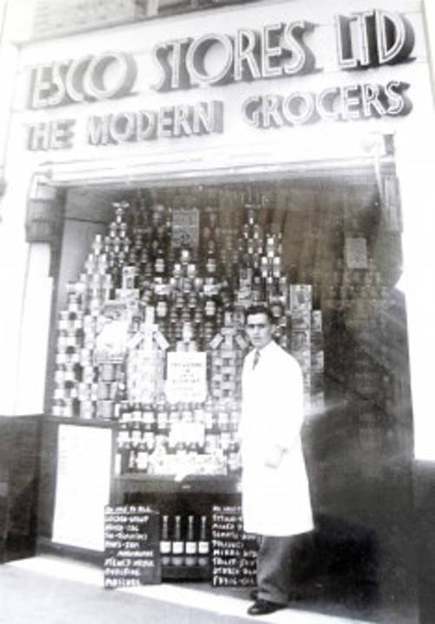

The first Tesco store arose in Burnt Oak, North of London in 1929, along with a headquarter and a warehouse 5 years later.
It sold dry goods and its first branded product which was Tesco Tea.
Vol 3, No 2 (2020) > Bin Rosnizam

In 1946 Cohen flew to America and brought back the idea of self-service where the customer will choose their own products from the shelf.
Over the course of 5 years from 1955, Cohen would purchase 500 stores which increased sales and customers.

In 1963 Green Shield stamps were introduced to customers. The system worked in a collective way where each stamp was equivalent to a certain number of pence.
After 1995 this system would switch to the Tesco Clubcard with the same idea (Wilson, J. 2017).
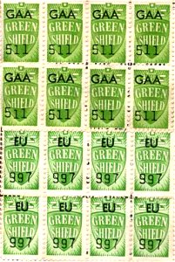

The main challenge that Scan as You Shop addressed

Background of Tesco

One of the main challenges before Scan as You Shop was introduced were the long queues time due to popularity.
To tackle this, Scan as You Shop has allowed customers to multitask by checking out every item right from the shelf. This ensured that the customer checks out quicker without the need to scan every item at the register. Not only does that make the workers job easier but ensures that the customer does not experience any discomfort in store.
Following the survey, Tesco identified some problems such as stock of products not being up to date. Customers also reported that they felt the membership card did not give them any advantage.
Tesco made the membership card a Scan as You Shop requirement and gave back to the customers – every time you used Scan as You Shop, you earned a certain amount of points linked to your membership card which you can then exchange for vouchers.
This gave a reward to those with membership cards and made sure that it gave the card a valuable use.

Insights into the modern Technology introduced at Tesco

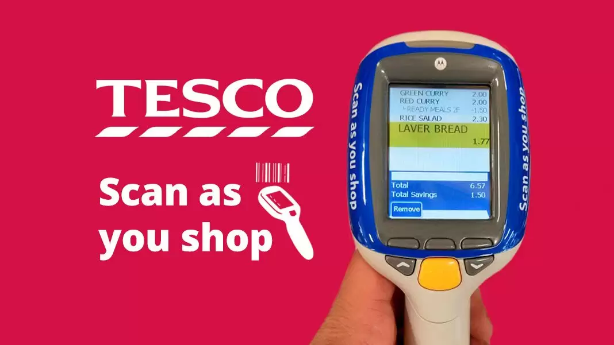

Scan as You Shop.
Insights are developing ideas or solutions that help global businesses get the best out of their people at work.
Tesco has digitally transformed its customer experience and operating model through investing in a state of the art by functionally introducing new technology.
The system was introduced in January 2010 with a roll out of 200 stores in 2012 – 2013. Tesco planned an expansion for the service further to 100 stores is 2014. It is now exclusive to only club card members and available in more than 500 stores in the United Kingdom.

How Scan as You Shop Works.

The Scan as you shop operates in such a way that you must be a registered club card member to be able to use the system. The customer starts by swiping their club card at the scanner wall to release the handset. Then the customer scans the chosen items using a barcode scanner while going around the store until finished. The customer then packs their shopping items from the trolley and proceeds to make payment at the dedicated checkout stations. Tesco also reserves the right to cross check any customer’s shopping at any time before leaving the store.
Scan as you shop is believed to be one of the best systems invented especially for the busy people because it gives a sense of accomplishment after your shopping has been done.
It helps save money as well as providing a time saving and convenient way to complete your shopping in specified duration.
Scan as you shop enables you to check your total price during the shopping process, so it does not catch you off guard at the till.
It allows customers to handle and process their own shopping to the end and has been termed as one of the quickest ways to shop.
In the presence of corona virus, scan as you shop offers a convenient way to shop without staff interactions or customer interruptions whilst venturing in the stores which has been a benefit during the pandemic period.

Difficulties Encountered with the Scan as You shop Technology.

Like any other new technologies introduced, Scan as you shop has encountered some difficulties along the way.
On 13 January 2020, Tesco confirmed that the service was making changes. It started by providing details to customers by printing messages on their receipts. The message stated that the scan as you shop system will only be accepting card payments effectively.
The news was met by disappointed customers who promised to take their business elsewhere if this change was not revised. In response to the changes, customers that pay using cash felt as though they were being punished.
Customers further argued that everyone needs to be accommodated and given chance to make their own choice of payment when they come to shop.
Customers have raised issues about their embarrassing scan as you shop experiences of weak Wi-Fi signals when they visit the stores. The Tesco staff have explained that the internet sometimes fails to pick up the full list of items scanned which is why the random checks are performed on customers.

The impact of "Scan as you shop technology"
introduced at Tesco

The introduction of, Scan as you shop’’ had a positive impact on both sides on Tesco Stores productivity and on its customer experience.

Scan as you shop helped customers to shop more efficiently by enabling them to scan products as they walk around the shop. This new resolution shortened shopping time for each customer and coming to solve one of the main challenges, the time spent in a queue.
By introduction of the new system, Tesco was able to place more staff in the shop around, instead of sending them at the tills. This arrangement enabled store to save money because they did not have to employ more staff and can increase the profit by reducing salary expenses, and if more staff will be on the floor that will solve other challenges regarding to stock update (Sian, 2017).
Shopping was made easier by eliminating the need to unload and reload all the products from the trolley.

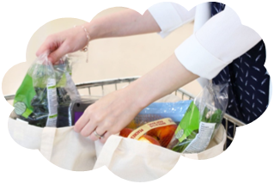



It saves time which normally is needed to place shopping on the tape to unload and then load them back in the bags. Instead, customer goes straight to check out and make a payment (Mumford, 2017).
Keeping a track of how much spend “Scan as you shop’’ enables customers to monitor how much money they will spend in one shopping transaction (Sian, 2017).
The customers can keep track of any deals and promotions by knowing how much they spent. The system came to help customers when there are deals and offers to get vouchers, so they can see if they would be eligible.
Special offers. The technology came like a way for customers to check for offers if are still available and to verify other advertise offers
The system is helping customers to check the prices of the items , they can check prices before making a decision to buy and if they think that the price is not the right one, then they can always erase that item on the device and put the item back on the rack (Sandor, E. 2017)The technology came to build Clubcard members loyalty as an extra bonus, Clubcard members can get one point for every £1 spent using "Scan as you shop".

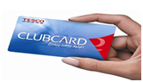

The negative impact of Scan as you shop technology at Tesco

Anytime when something new is introduced there are always negative effects and issues that may need some improvement
The technology requires customers to be a Tesco Clubcard member to use the scan as you shop system. Customers will have to sign up to Clubcard to be able to use the Scan as you shop system, if the customers are not enthusiast in having a Clubcard that means they cannot use the system.
There is a fundamental component of trust with Tesco scan as you shop, that customers can pick the items packing in their bags without scanning them.
There are items without a barcode on them, which can upset customers as they will have to waste time trying to find a member of staff to get help (Sian, 2017).

Lessons that can be drawn from the case study

Partnership of Tesco– Revision - Zebra

Is crucial for new technologies to be released in a small number first, the method called trail. In 2010 Scan as you Shop technology been trialed for six months in a Tesco store in Romford.
Tesco cooperation with REVISION the leading global self-scanning provider made the project very straightforward.
Zebra Technologies Services team engineer visit each store once every two weeks and commission its devices. Its performing levels are high, therefore ensures that Tesco gains the most value from its investment.
Partnership turned out to be success. Scan as you shop is now available in more than 500 Tesco stores. With over 120,000 Zebra mobile computing devices in various services across Tesco retail industry (Zebra, 2015).

RE-vision The Global Leader in Self-Scanning Solution

Highlights customer choices in the main strengths of scan and bag service

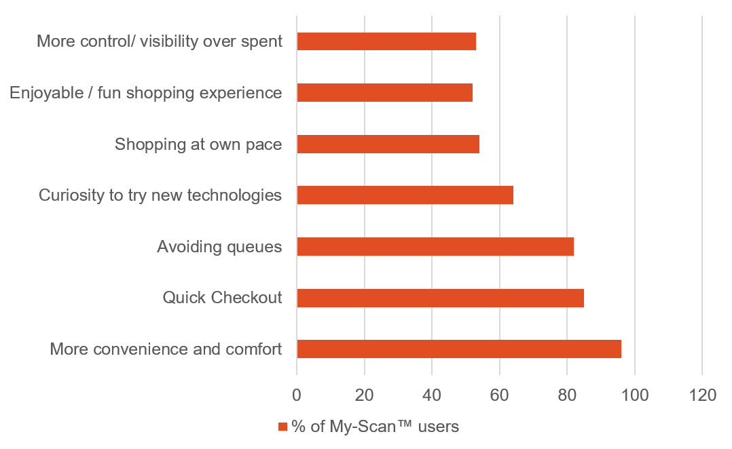

Self-service leads to better service, not less. (Revision, n.d.)

WE are in the Era of the Consumer

It’s natural that not all customers are ready for new technologies in retail environment.” Convenience” is not the case, one-size-fits-all.
Removing options, especially the once customers will naturally expect to have sets higher risk of customers dissatisfaction (Sillitoe, 2020).
Improving technologies and adding new services always gives positive results. The threat of theft – accidental or not – is an ongoing issue. Frustrated customers having to rescan entire shopping. Equally
Tesco needed to provide additional training and protection measures to tackle potential loss.
Pandemic could be the beginning of Scan as You Shop revolution
Tesco confirmed the increased popularity in Scan as You Shop service over the past few months.
Technology allows costumers greater control over the number of people they need to interact with.
Significant numbers in the UK, household budget changed dramatically due to pandemic increased job loss and reduced working hours. Allowing customers view entire shopping balance at any time gives more confidence over the spending (Nott, 2020).



Conclusion

Tesco is a leading retailer with more than 3700 stores in the UK and Ireland. Which has Scan as You Shop service available in 573 large-scale stores (Nott, 2020). Studies reveal that customers of different age still favor shopping in physical stores. Loyalty card enable the retailer to collect customers detailed about shopping habits. That could indeed help improve customer service. It’s important to understand Scan as You Shop will not suit every costumer, however majority of people finds it convenience specially now in the pandemic situation. It could be the beginning of Scan as You Shop revolution.

Reference

Chapman, M. (2018, 02 13). Essentialretail.com/., from https://www.essentialretail.com/features/scan-as-you-shop-technologies/ (Accessed: 08 04 2020)

European Supermarket Magazine, (2014) 31 May. Available at: https://www.esmmagazine.com/technology/tesco-expands-scan-as-you-shop-service-5039 (Accessed: 20 July).
IGD, (2016) ‘Tesco extends Scan as you Shop service’, Retail Analysis, 6 September. Available at: https://retailanalysis.igd.com/news/news-article/t/tesco-extends-scan-as-you-shop-service/i/11664 (Accessed: 7 August 2020).

Mumford, E.(2017) Saving money with Tesco’s scan as you shop, 14 September .Available online at: https://emmamumford.co.uk/scan-as-you-shop-tesco/ (Accessed on 04 August 2020)

Nott, G. (2020, 07 23). thegrocer.co.uk/store. from https://www.thegrocer.co.uk/store-design/why-coronavirus-is-driving-a-scan-and-go-shopping-revolution/646695.article (Accessed: 08 08 20)

Nott, G. (2020) ‘Why coronavirus is driving a scan & go shopping revolution’, The Grocer, 23 July. Available at: https://www.thegrocer.co.uk/store-design/why-coronavirus-is-driving-a-scan-and-go-shopping-revolution/646695.article (Accessed: 9 August 2020).

Racheal Pugh, L. L. (2020, January). from https://www.dailypost.co.uk https://www.dailypost.co.uk/news/uk-world-news/tesco-confirms-scan-you-shop- (Accessed: 08 02 2020)

Rosnizam, M. R. A. B., Kee, D. M. H., Akhir, M. E. H. B. M., Shahqira, M., Yusoff, M. A. H. B. M., Budiman, R. S., & Alajmi, A. M. (2020). Market Opportunities and Challenges: A Case Study of Tesco. Journal of the community development in Asia, 3(2), 18-27. http://ejournal.aibpm.org/index.php/JCDA/article/view/807 [Accessed:28th July].

Ravichandra, M.( 2019) Tesco “Scan as you shop” eases your shopping experience; 11 January, Available at: https://www.interactivething.com/2019/01/11/tesco-scan-as-you-shop-eases-your-shopping-experience /(Accessed on 04 August 2020)

Revision, (n.d.) ‘Customer Benefits. Available at: https://www.re-vision.nl (Accessed: 7 August 2020).
Sillitoe, B. (2016) ‘Tesco extends scan as you go retail technology in UK stores’, Essential Retail, 5 September. Available at: https://www.essentialretail.com/news/tesco-extends-scan-as-you-go/ (Accessed: 20 July 2020).

Sian,(2017) The Latest Way to shop at Tesco ; Available at : http://www.mgtdesing.co.uk/smart-devices/scan-as-you-shop-the-latest-way-to-shop (Accessed on 04 August 2020)

Sandor, E.(2017) Scan as you shop – Smart shopping at Tesco ; Available at: http://www.eatweartravel.com/lifestyle/scan-as-you-shop-smart-shopping-at-tesco/(Accesed on 04 August 2020)

Tesco A Digital Transformation. (n.d.). Retrieved July 23, 2020, Available at Digital HBS: https://digital.hbs.edu/platform-rctom/submission/tesco-a-digital-transformation/ (Accessed 08 10 2020)

Tim Clark, T.M, Szu Ping Chan, S.P.C, (4th October 2014), ‘A history of Tesco: The rise of Britain’s biggest supermarket’ , The Telegraph https://www.telegraph.co.uk/finance/markets/2788089/A-history-of-Tesco-The-rise-of-Britains-biggest-supermarket.html [Accessed:30th July]

Wilson, J. ( https://www.tescoplc.com/about/our-history/ 2017, 11 11). from destination-innovation.comhttps://www.destination-innovation.com/the-innovation-process-at-tesco/ (Accessed: 08 10 2020)

Winchester, L. (2020) ‘Tesco shoppers fuming as it axes cash payments on “scan as you shop” services’, The Sun, 2 January. Available at: https://www.thesun.co.uk/money/10645557/tesco-scan-as-you-shop-cash-payment-card (Accessed: 7 August 2020).

Zebra, (2015) Optimizing Efficiency and The Customer Experience, Case study Tesco. Available at: https://www.zebra.com/content/dam/zebra/success-stories/en-us/pdfs/tesco-en-emea.pdf (Accessed: 10 August).

