Deyby Alexis Osorio Guevara

Network Operating Systems and Services
Configure and manage the Virtualised Enterprise network
Lecturer : Md Abrar Jahin Almazi Bipon

Contents
1. Routing 3
2. Domain Server 10
4. Users 16
5. Domain Membership 16
6. DHCP Server 19
7. Test and Troubleshoot 26
8. Disk Drive 29
10. Remote Desktop Services 35
References 38

1. Routing
Install Remote Access and Routing role services The following is visible on the screenshot: Server Manager includes Remote Access, DirectAccess and VPN (RAS), and Routing in the installation manifest.[1]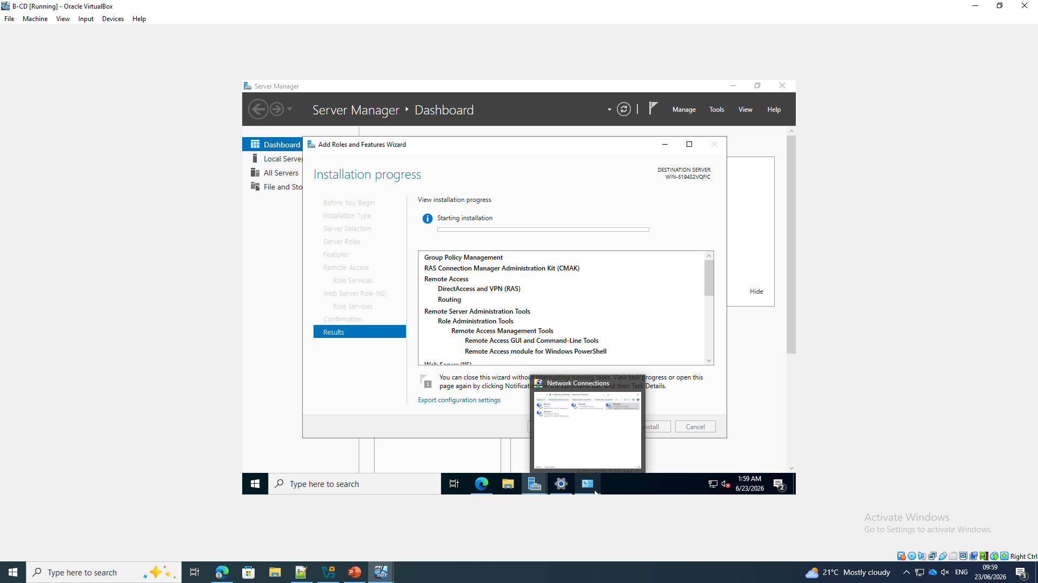
Start the RRAS configuration wizard. The screenshot displays the B-DC Routing and Remote Access Server Setup Wizard opened as we can see on the screen, to start configuring the router. 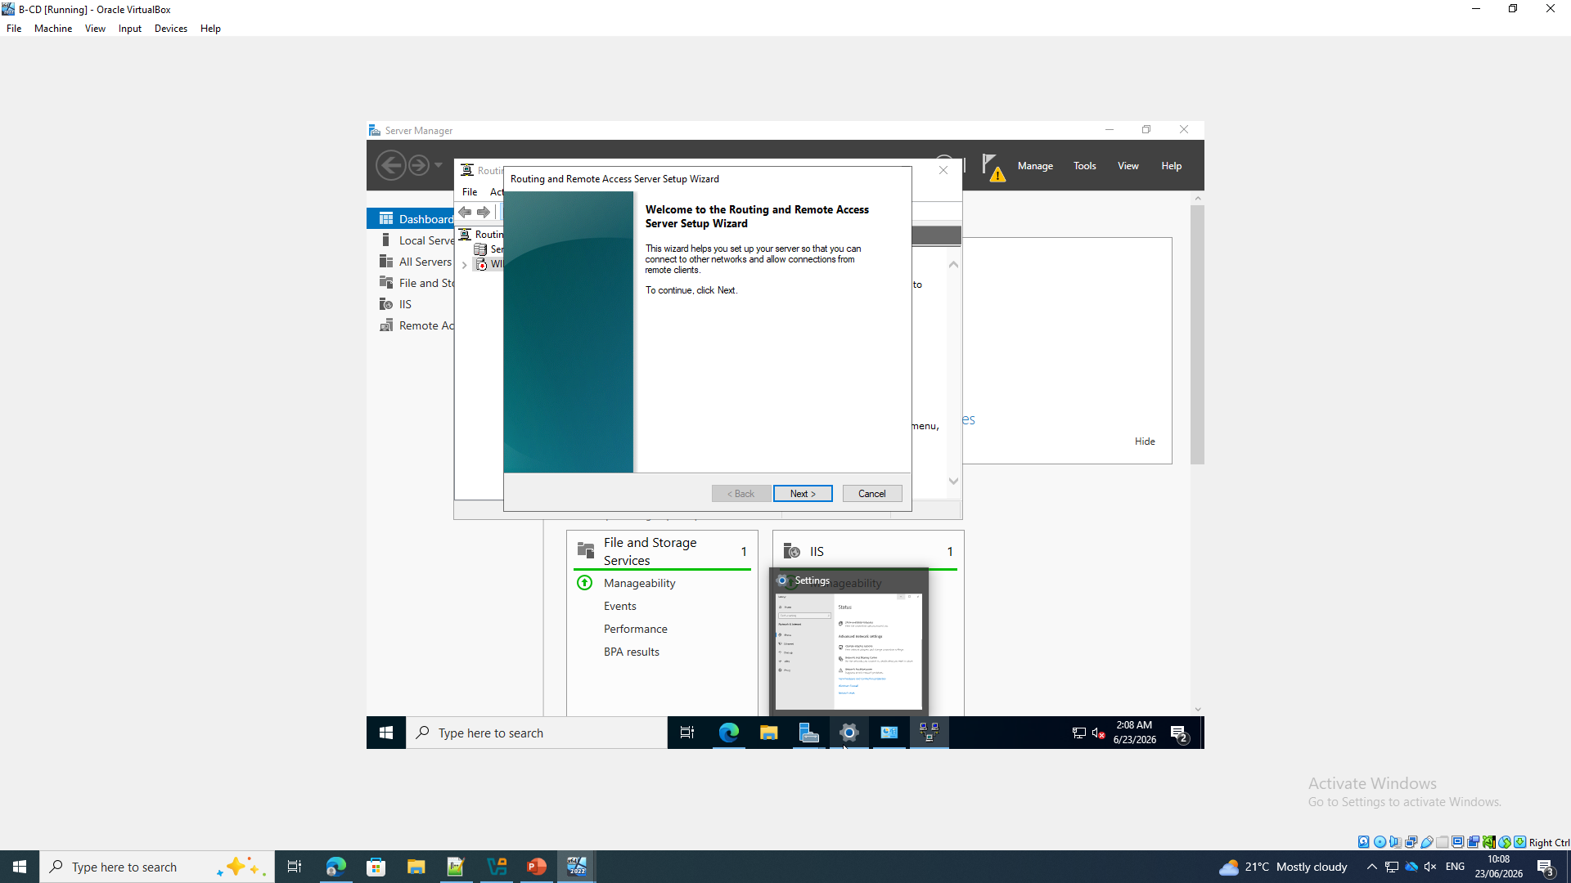
Select the desired RRAS settings. From this screen you see that the Custom configuration is selected and you will then be able to enable the exact routing services for the topology.
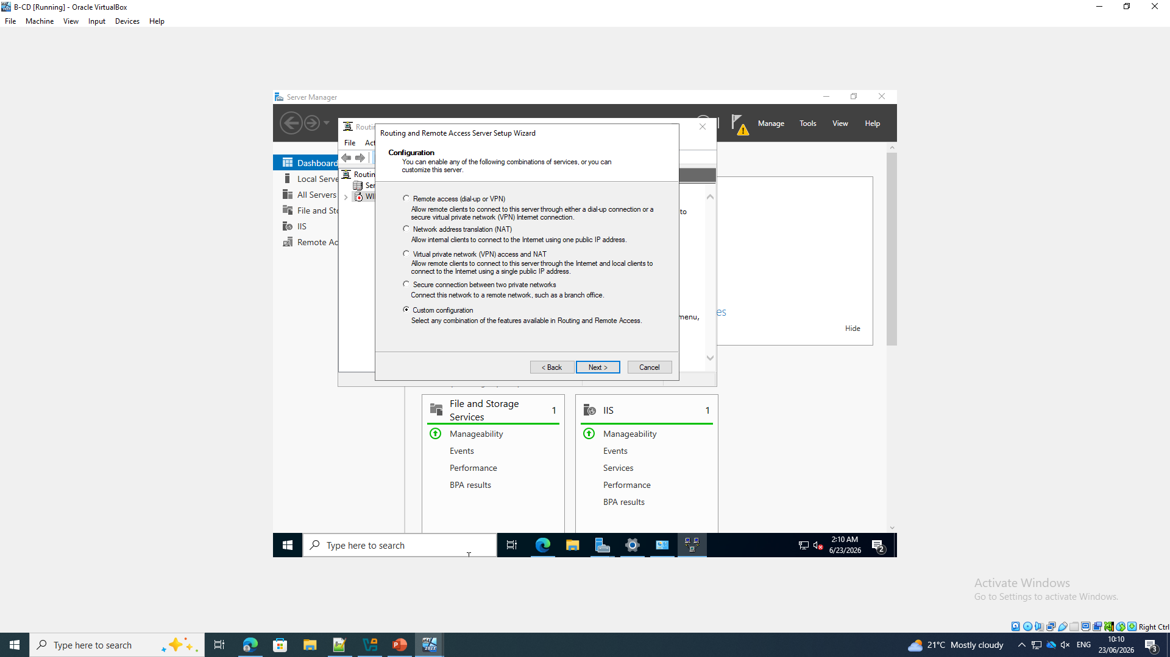
Make NAT and LAN routing enabled. In the screenshot, you can see that the following services were selected: Network Address Translation and LAN routing.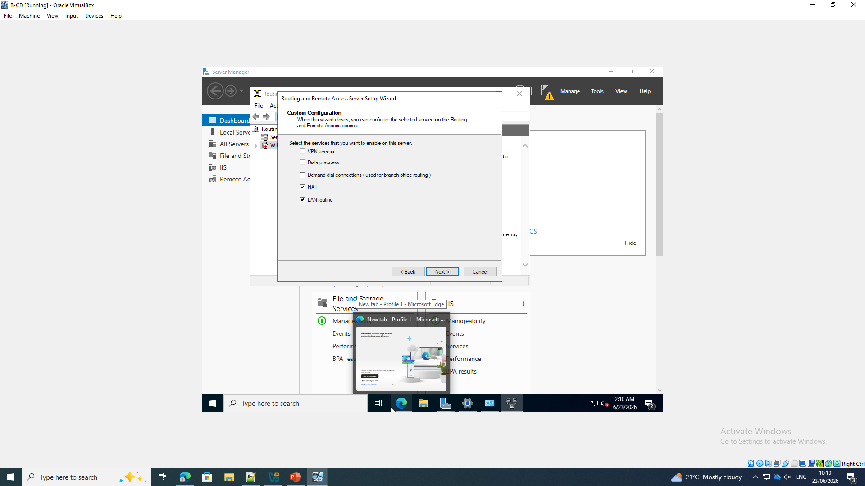

Start to use Remote Access Management.Begin implementing Remote Access Management. The screenshot shows the following: The RRAS wizard starts the Remote Access Management service after the routing roles are selected. 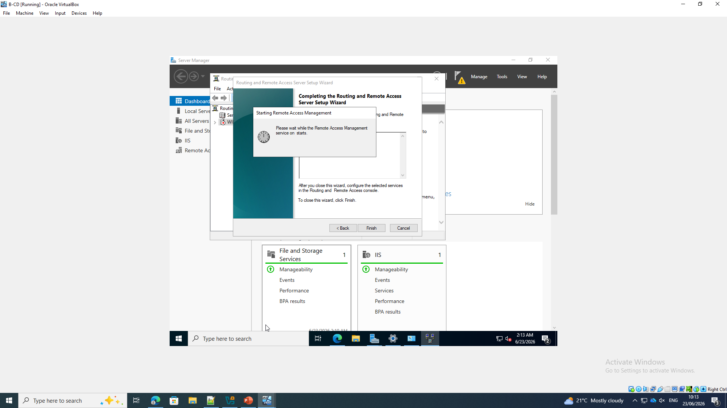
Add external interface to NAT. The following is displayed in the New Interface B-DC network adapters are listed , allowing for the proper public-facing adapter to attach to NAT.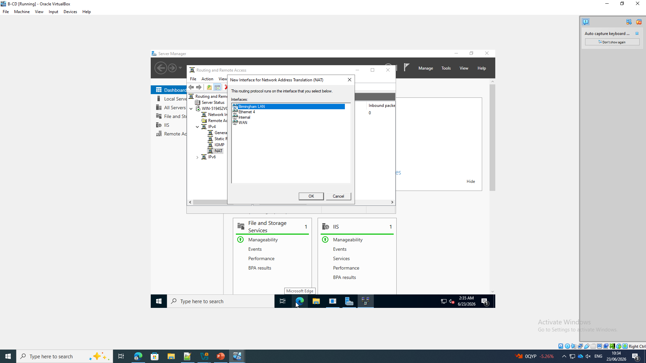
Enable NAT on the public interface: The following is displayed in the screenshot: The selected adapter uses a public interface, and it is connected to the Internet. NAT is enabled.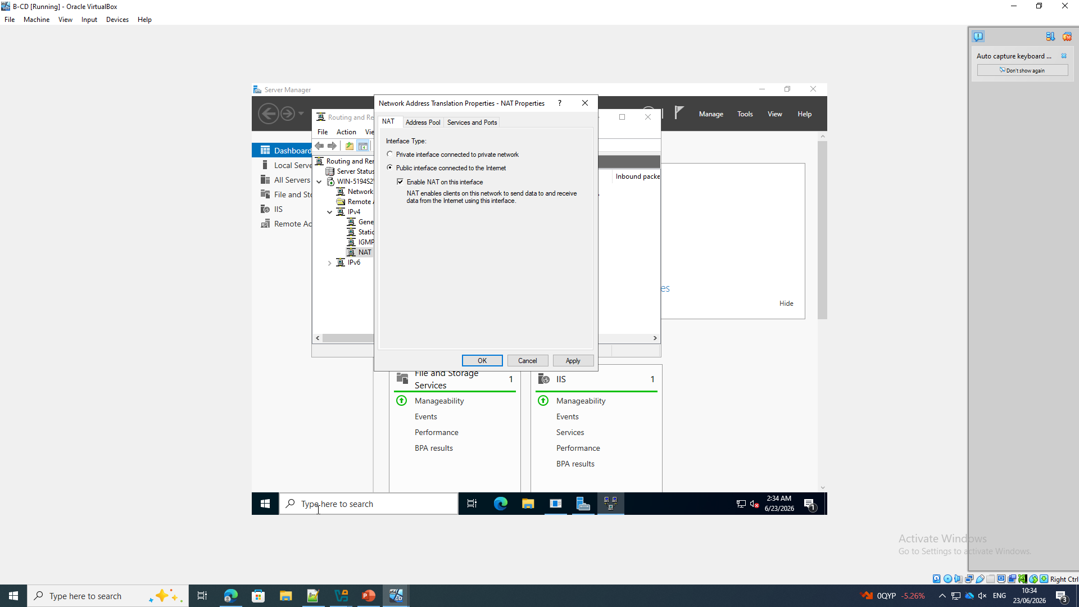
Click on Add the LAN interface in Birmingham. The following is depicted in the screenshot: The Birmingham LAN adapter is checked to add it to NAT configuration.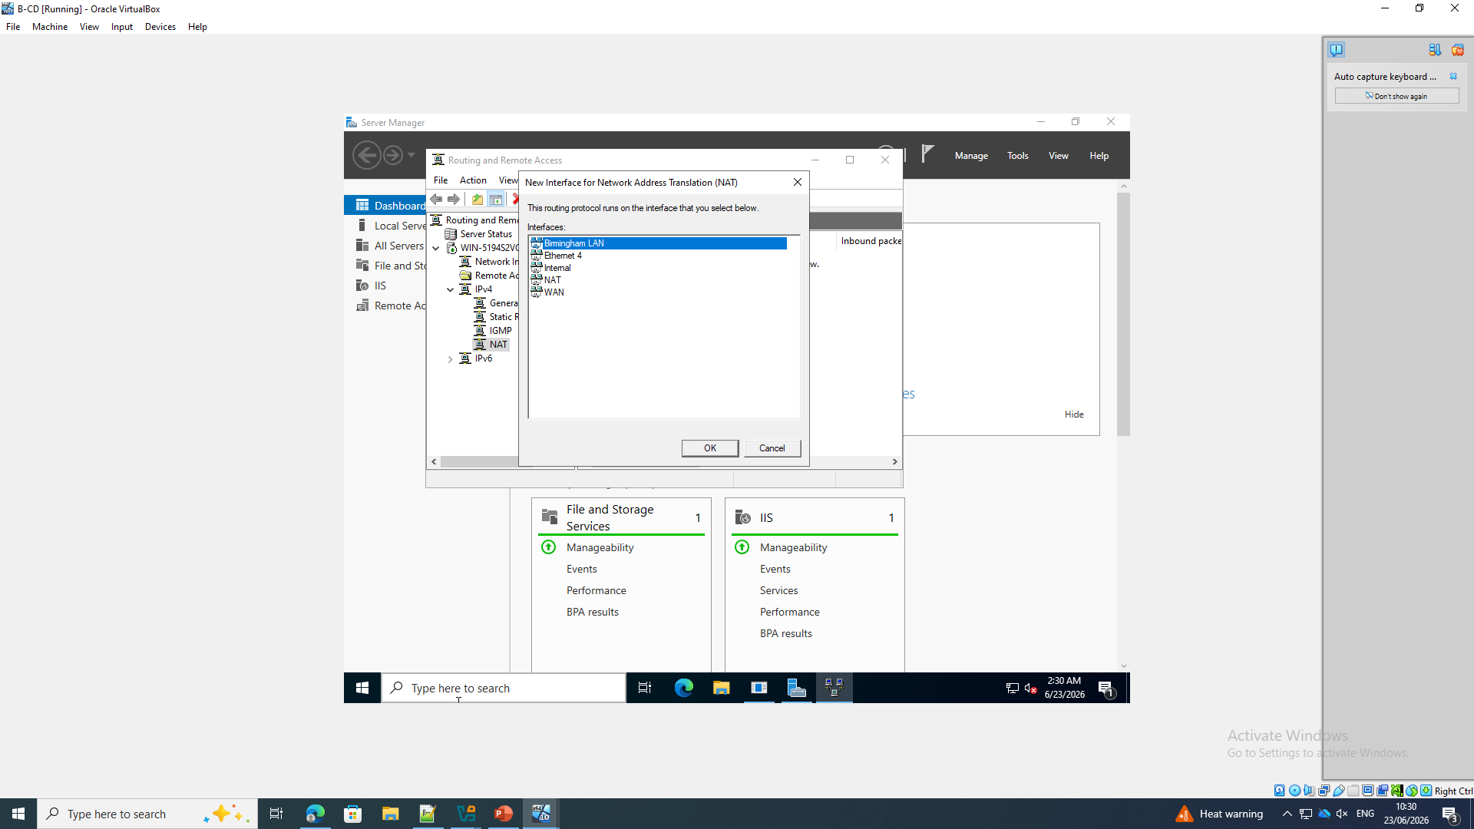
Check the RRAS NAT interfaces. The following is displayed on the RRAS console: NAT, Birmingham LAN and WAN interfaces are listed on the RRAS console, which indicates that the adapters have been added to the IPv4 NAT configuration.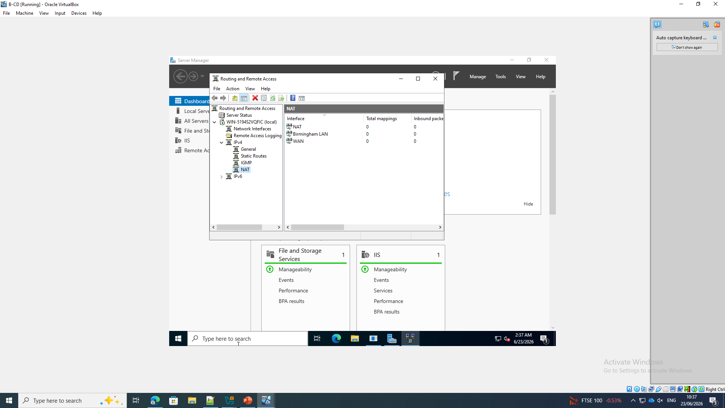
Draw the permanent route to London The following is displayed on the screen: A persistent Windows route is created for the London subnet 172.16.2.0/24, with the gateway 10.0.0.2.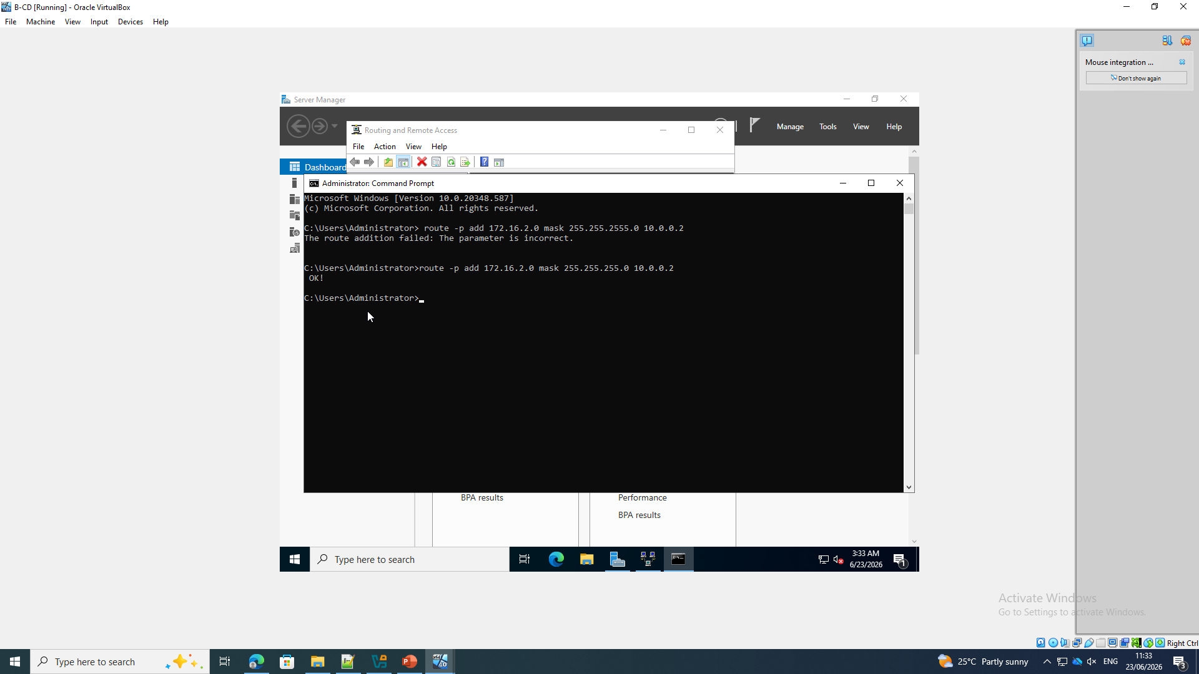
Confirm the "active route" to London.
The following is displayed on the screen: The B-DC IPv4 routing table lists the destination address 172.16.2.0/24, which is in front of gateway 10.0.0.2 on the 10.0.0.1 interface.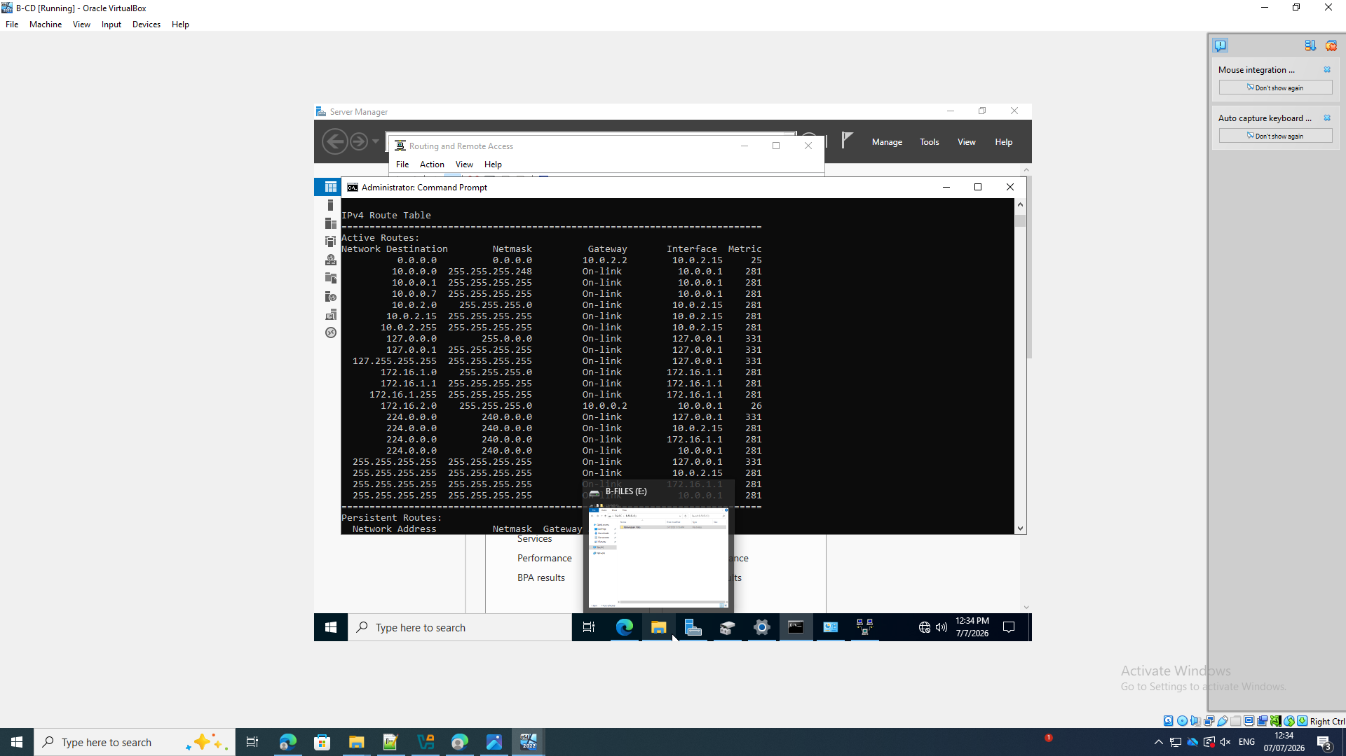
Persist IP forwarding setting
The above is displayed in the screen. The net.ipv4.ip_forward=1 setting is added to /etc/sysctl.conf.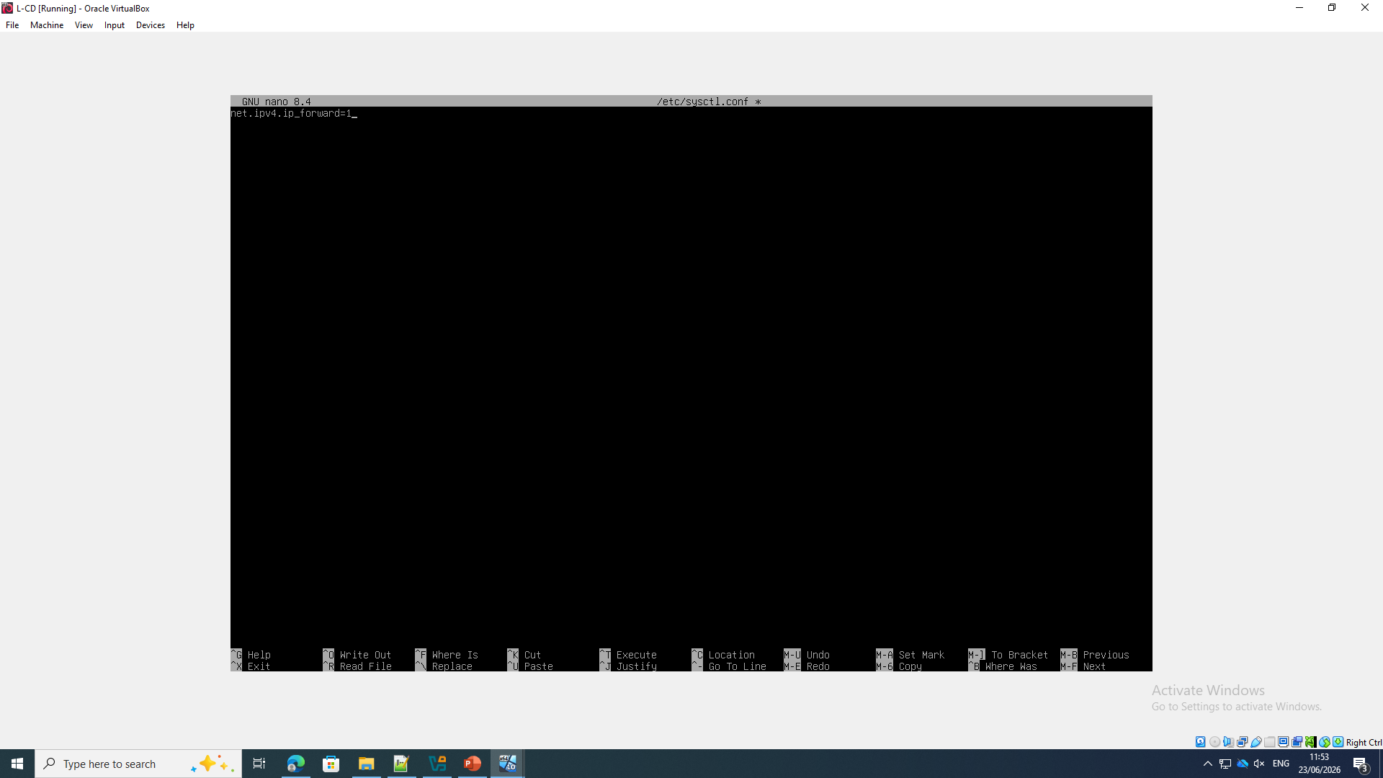

Verify London forwarding and routing
The screenshot shows the following: L-CD displays the route to 172.16.1.0/24 through 10.0.0.1, reloads sysctl.conf and confirms /proc/sys/net/ipv4/ip_forward contains 1.
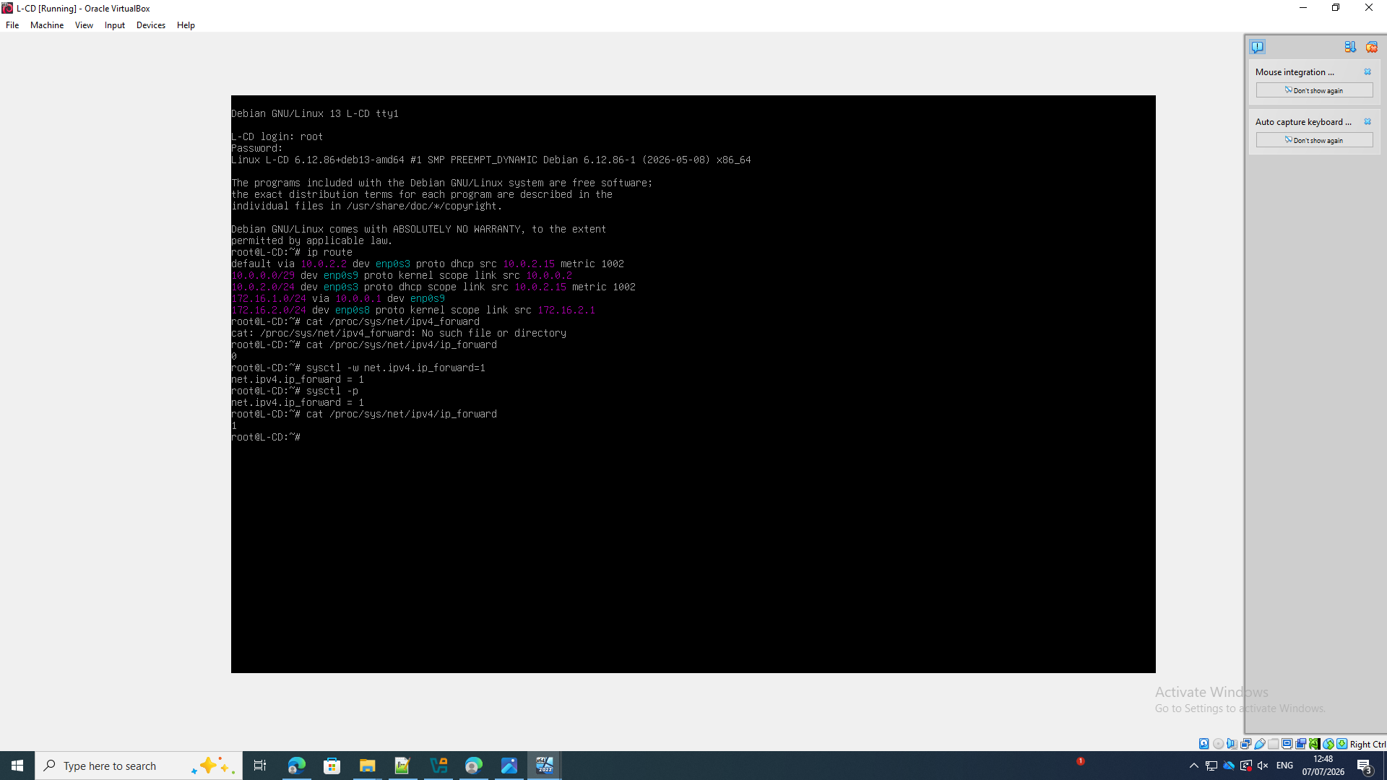
Make the trip to London repeatable
The above screen shot illustrates that the London and inter-site addresses are defined in L-CD /etc/network/interfaces, and that the inter-site route 172.16.1.0/24 is restored using a post-up command that is defined in L-CD /etc/network/interfaces.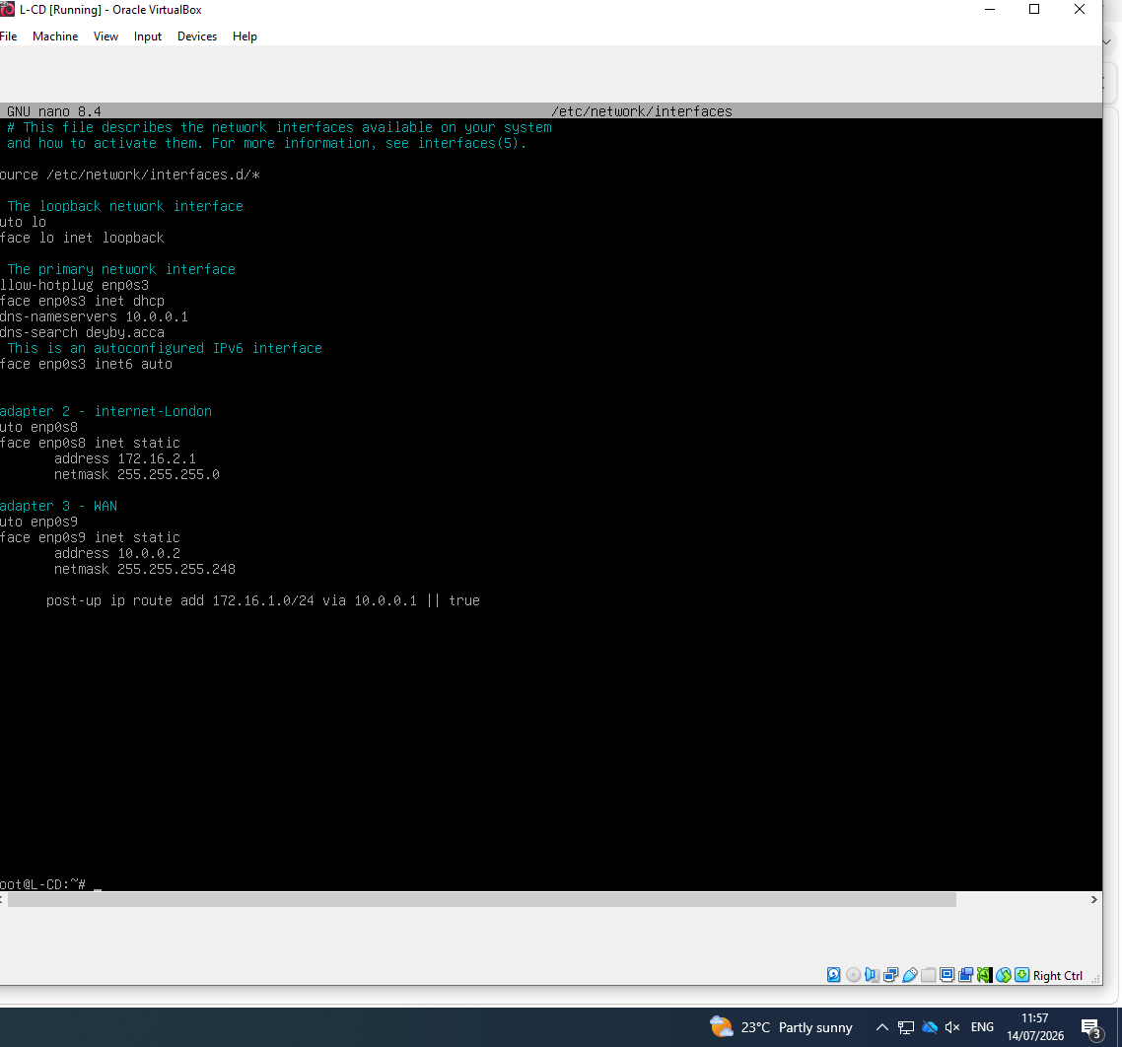

2. Domain Server
Choose an Active Directory forest to select
The screenshot shows the following: The AD DS Configuration Wizard selects Add a new forest and enters the deyby.acca root domain name.[2]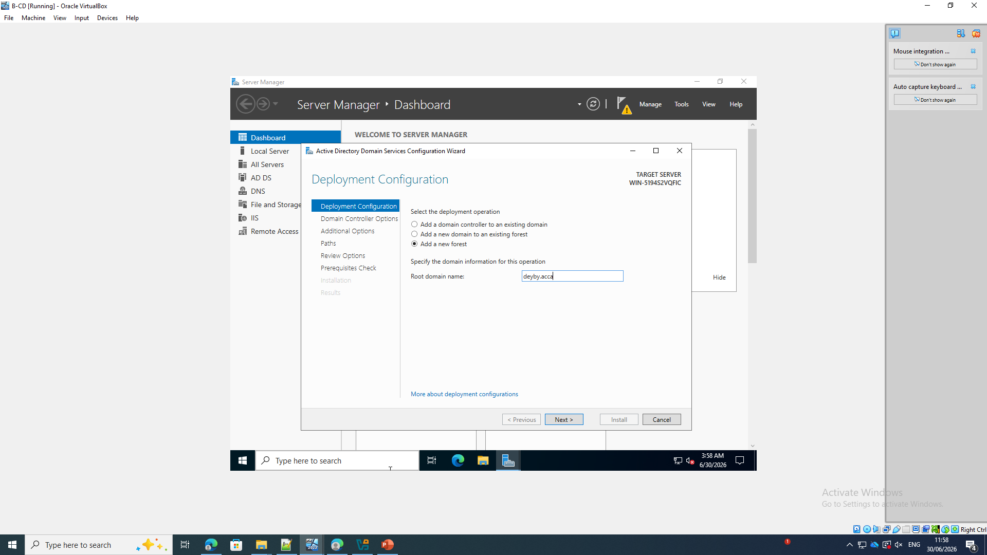
Verify the NetBIOS domain name.
The Additional Options page contains the following: The DEYBY NetBIOS name for the deyby.acca forest is derived from it.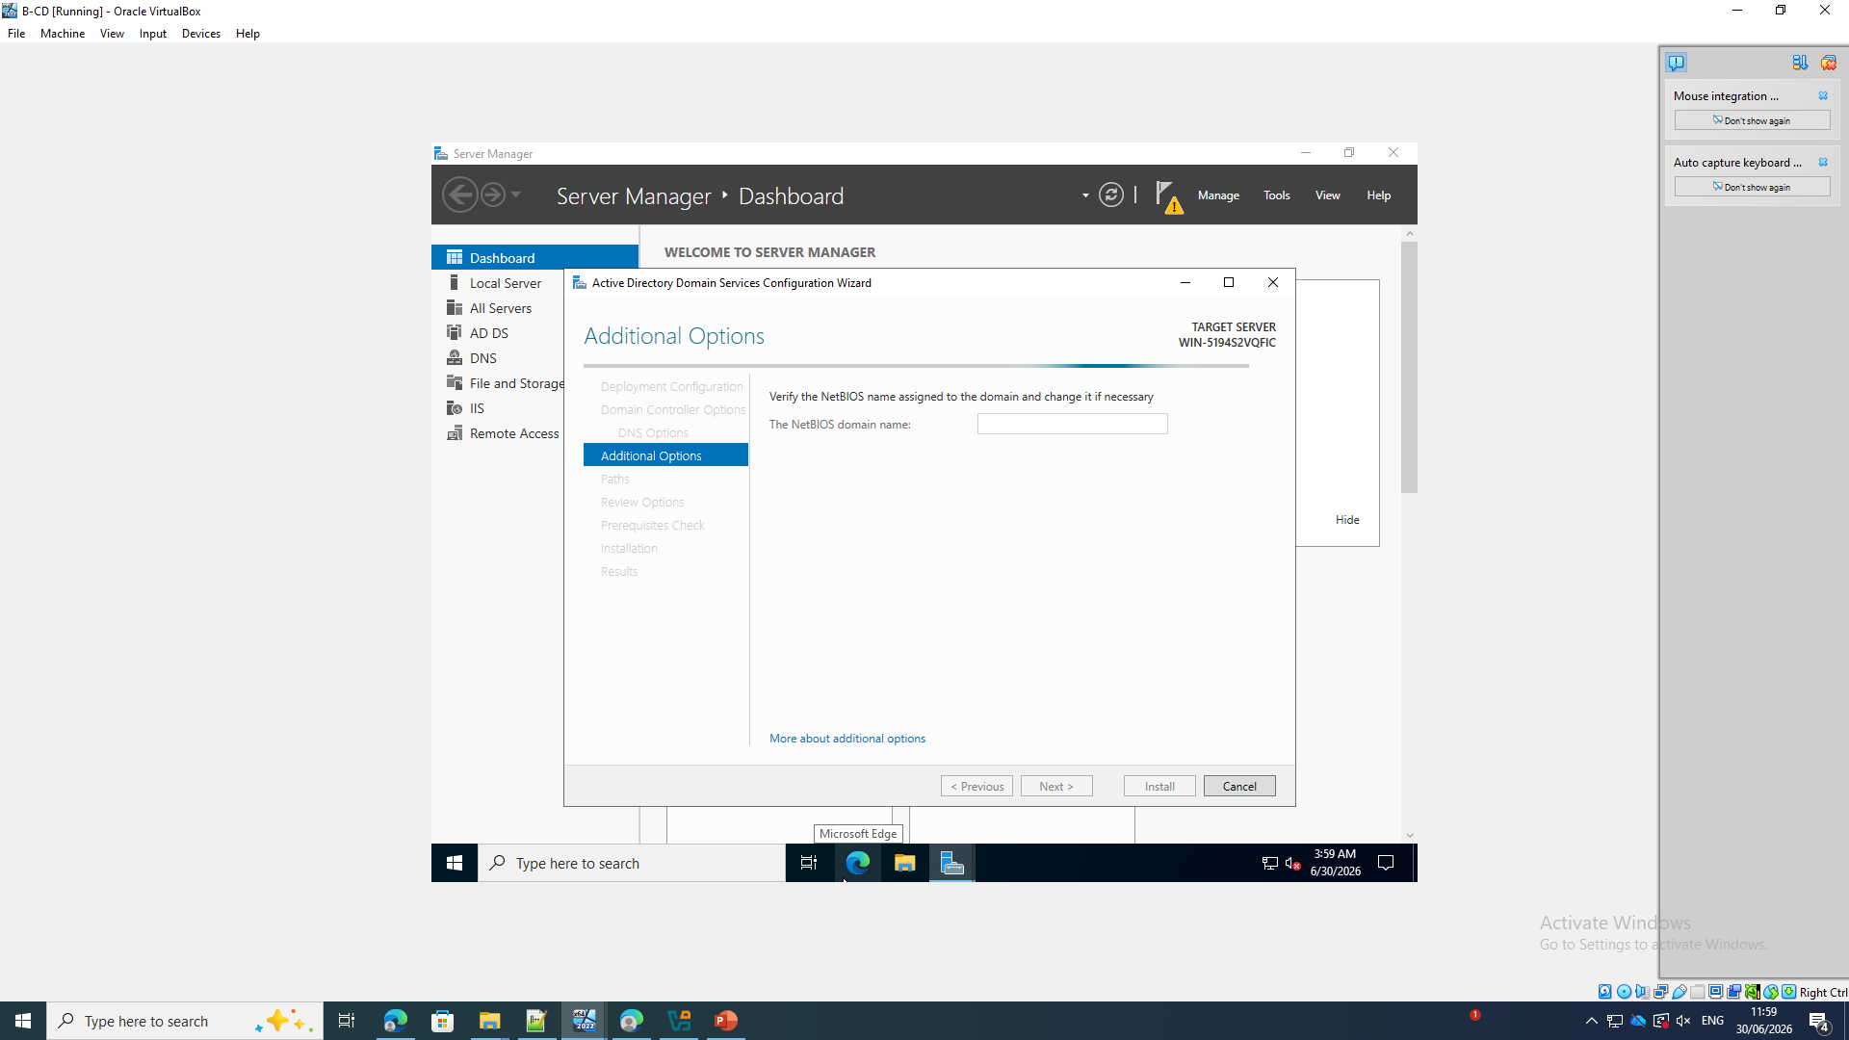
Pass the AD DS prerequisite checks
The screenshot shows the following: The wizard reports that all prerequisite checks passed before.
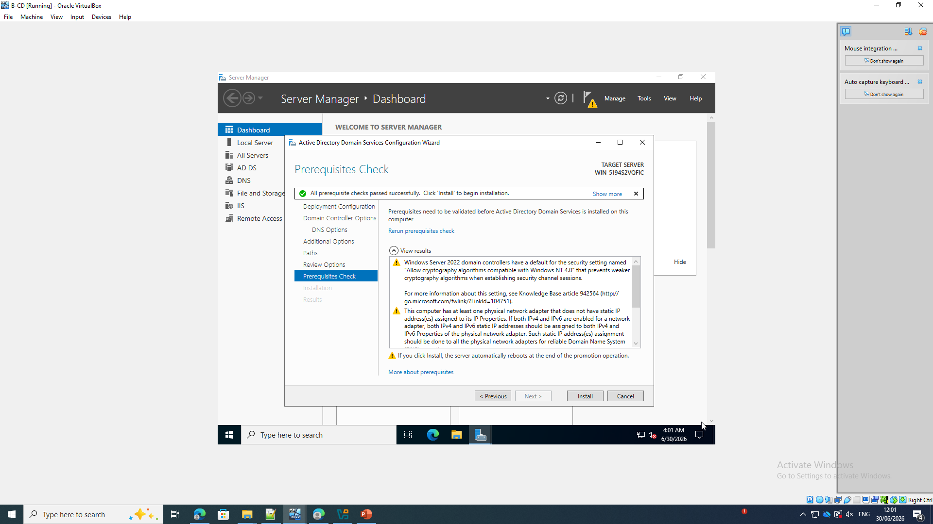
Check the forward lookup zone(s)
The screenshot shows the following: DNS Manager shows the _msdcs.deyby.acca and deyby.acca Active Directory DNS zones.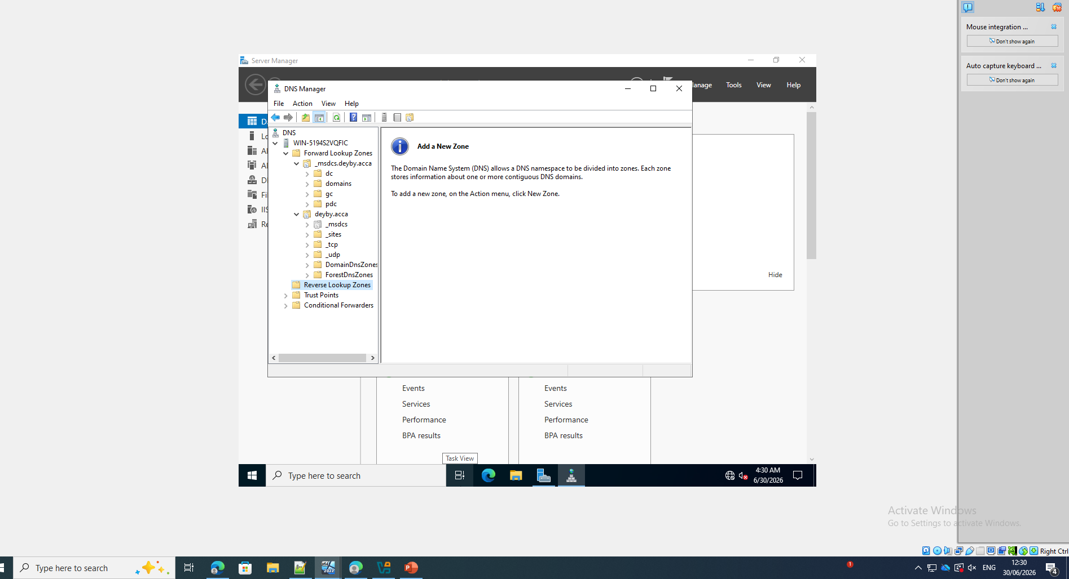
Create the B-DC host record:
The screenshot depicts the following: B-CD.deyby.acca with address 172.16.1.1 the New Host and a related PTR record.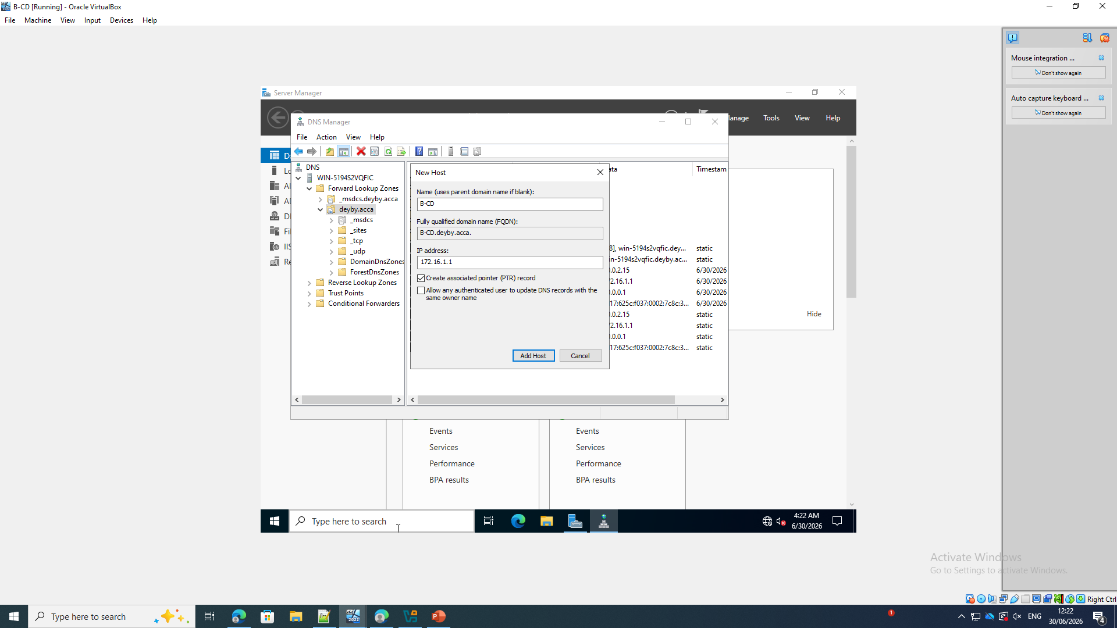
Verify server and service A records
The screenshot shows the following: The deyby.acca zone lists B-CD, webs, rds and files at 172.16.1.1 alongside the domain controller interface records.
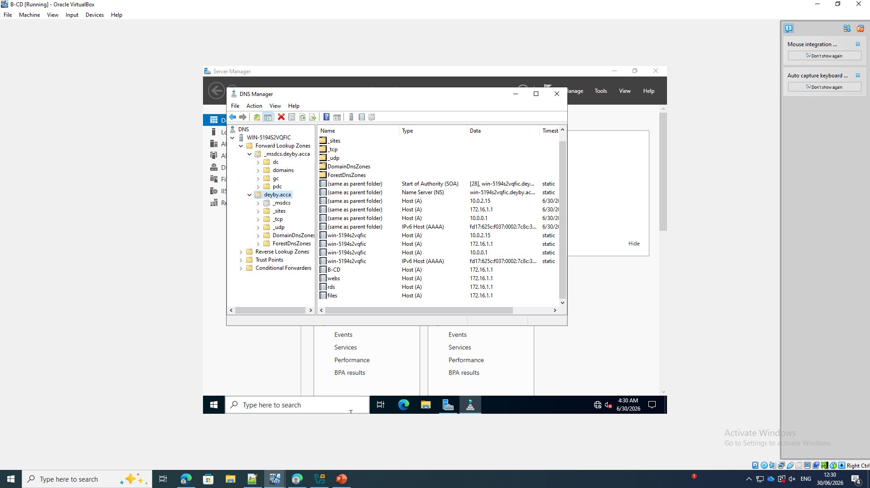

Configure DNS forwarders
The screenshot shows the following: The DNS server forwarders include 1.1.1.1 and 1.0.0.1 for names the local zones cannot resolve.
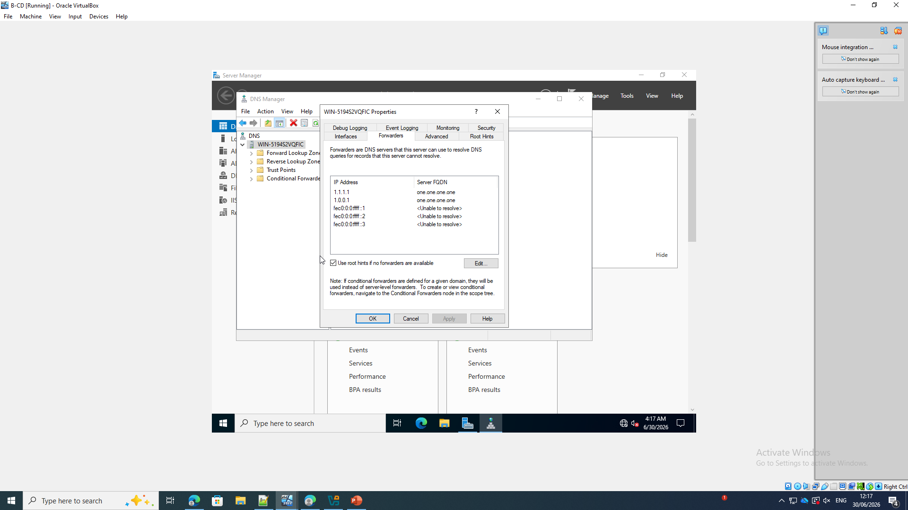
Choose an AD-integrated primary reverse zone
The screenshot shows the following: The New Zone Wizard selects a Primary zone stored in Active Directory as we can see on the screenshot
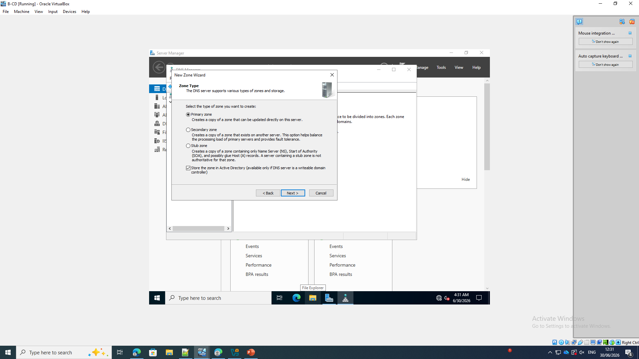

Set reverse-zone replication scope
The screenshot shows the following: The reverse zone is configured to replicate to DNS servers running on domain controllers in deyby.acca.
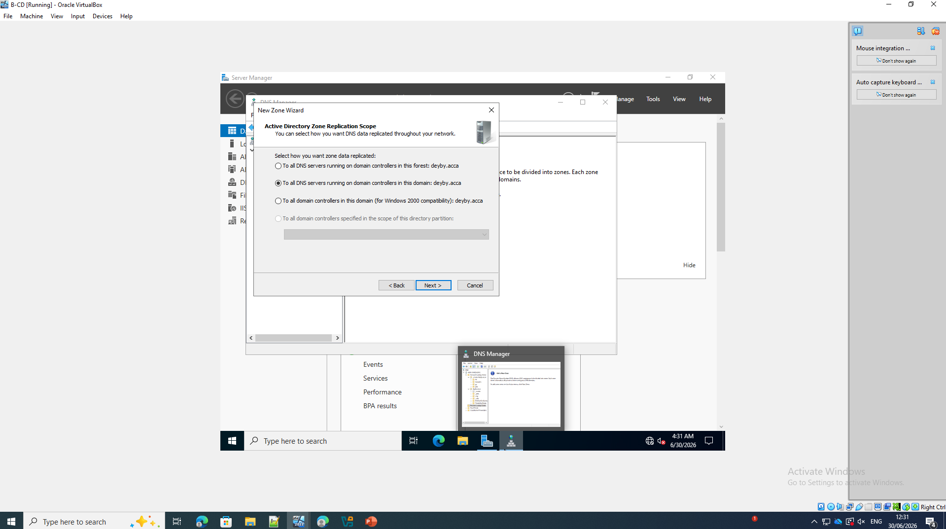
Choose an IPv4 reverse lookup zone
The screenshot shows the following: The wizard selects an IPv4 Reverse Lookup Zone for the infrastructure subnet.
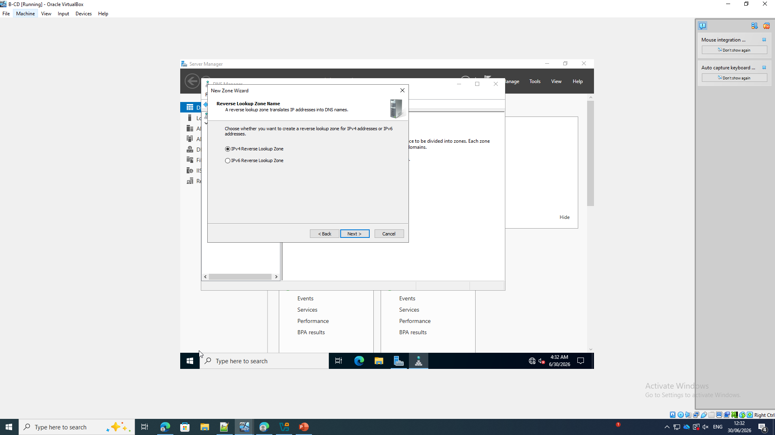
Enter the reverse-zone network ID
The screenshot shows the following: The network ID 172.16 generates reverse zone 1.16.172.in-addr.arpa.
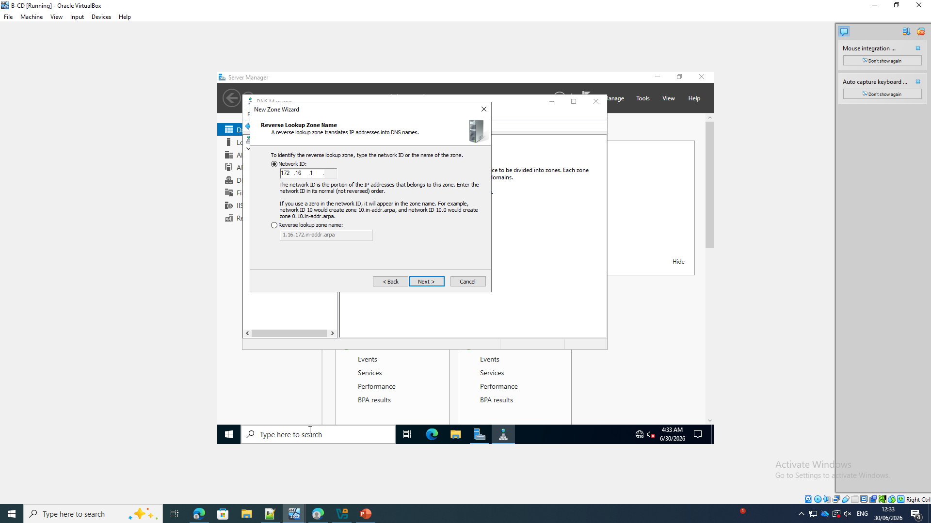
Verify service PTR records
The screenshot shows the following: The reverse zone lists PTR records for b-cd.deyby.acca, rds.deyby.acca, webs.deyby.acca and files.deyby.acca.
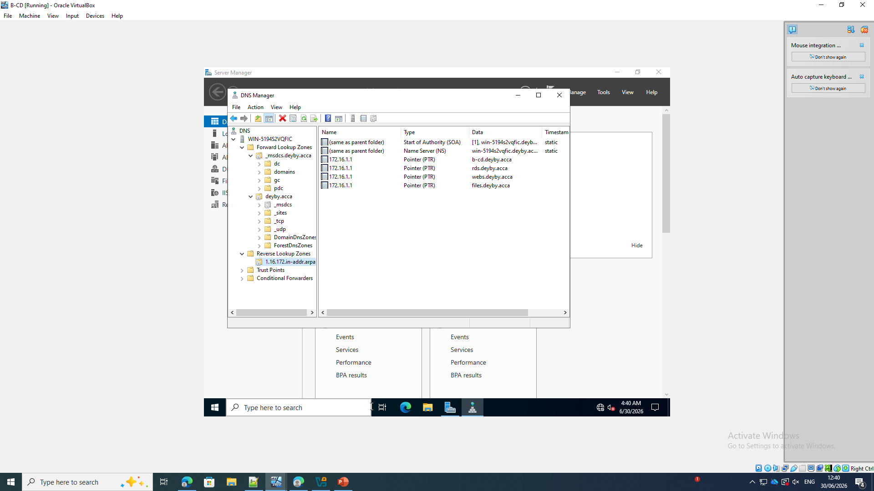

4. Users
Run the PowerShell user-import script
The screenshot shows the following: PowerShell applies a process-scoped execution-policy bypass and runs C:\ADImport\Import-ADUsers.ps1, which reports five created accounts using the required first-initial-dot-surname convention.
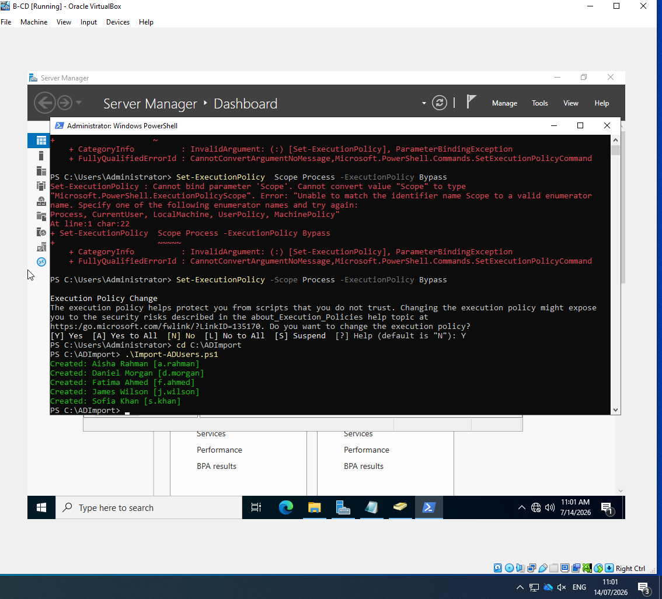

5. Domain Membership
Select the deyby.acca domain on ClientS1
The screenshot shows the following: The Computer Name/Domain Changes dialog identifies ClientS1 and selects membership of deyby.acca.
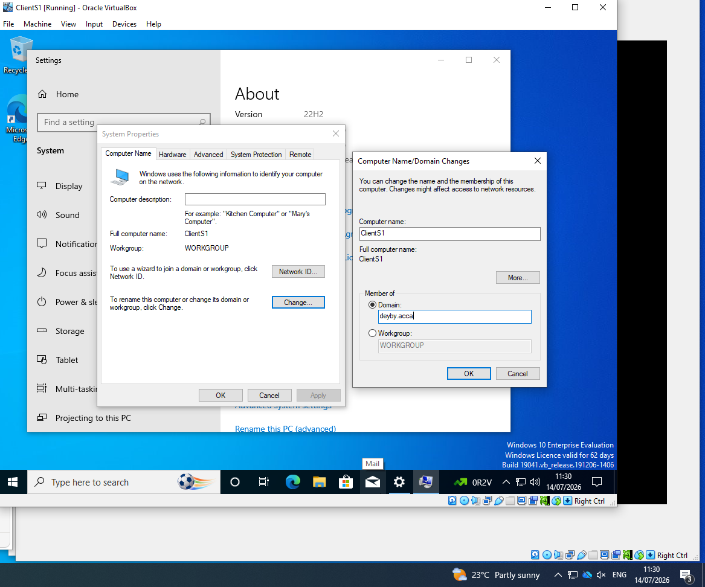
Authenticate the domain join
The screenshot shows the following: The Windows Security prompt requests authorized deyby.acca credentials to complete the ClientS1 join.
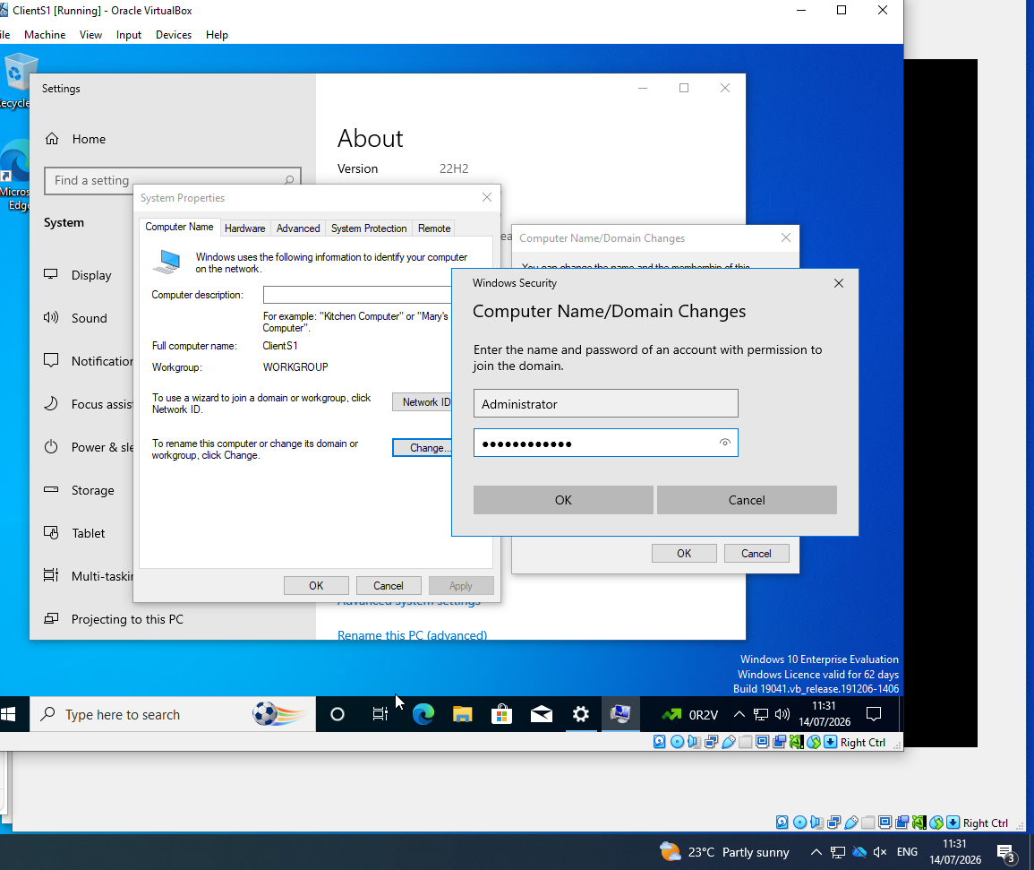
Apply the membership change
The screenshot shows the following: System Properties confirms that ClientS1 must restart to apply the deyby.acca domain-membership change.
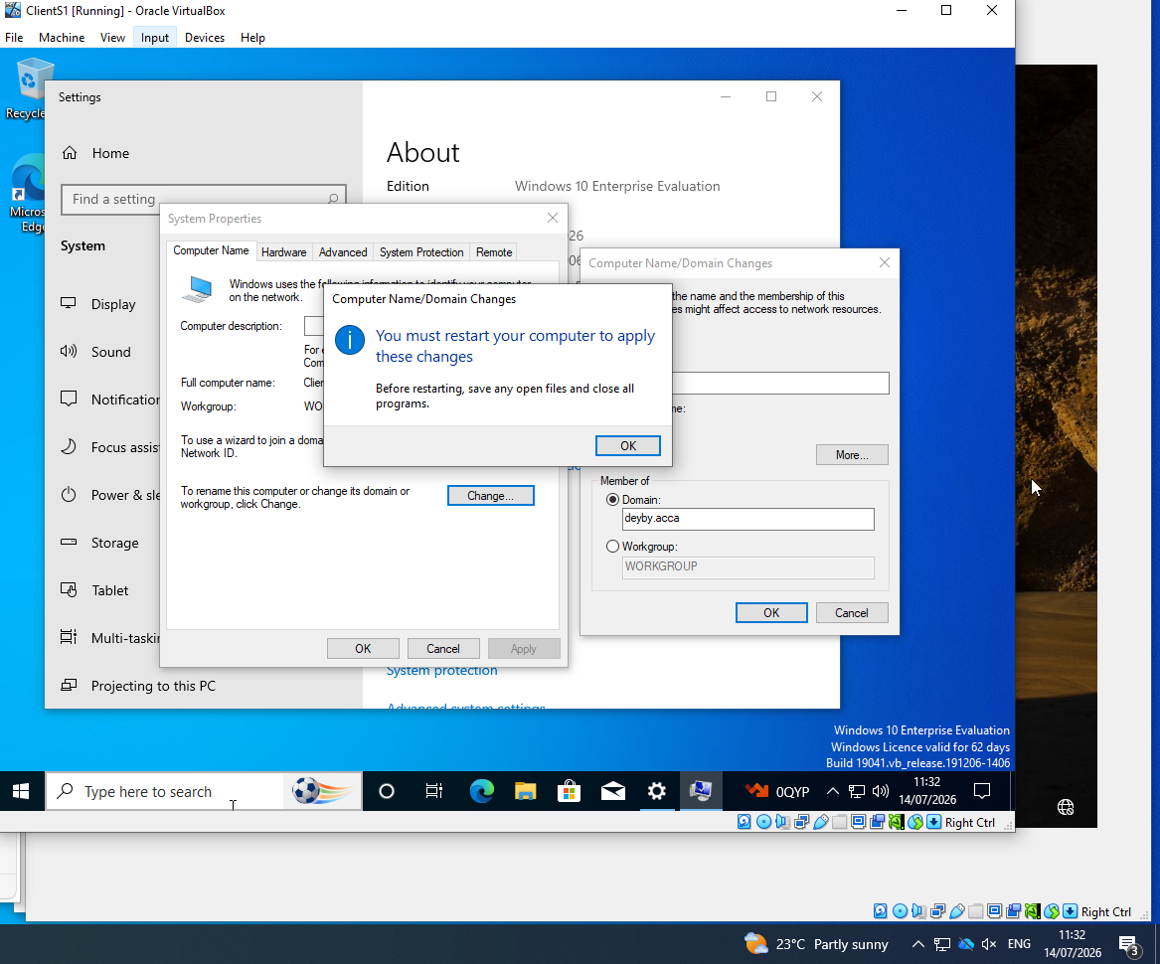
Verify the ClientS1 computer object
The screenshot shows the following: Active Directory Users and Computers show CLIENTS1 in the domain Computers container.
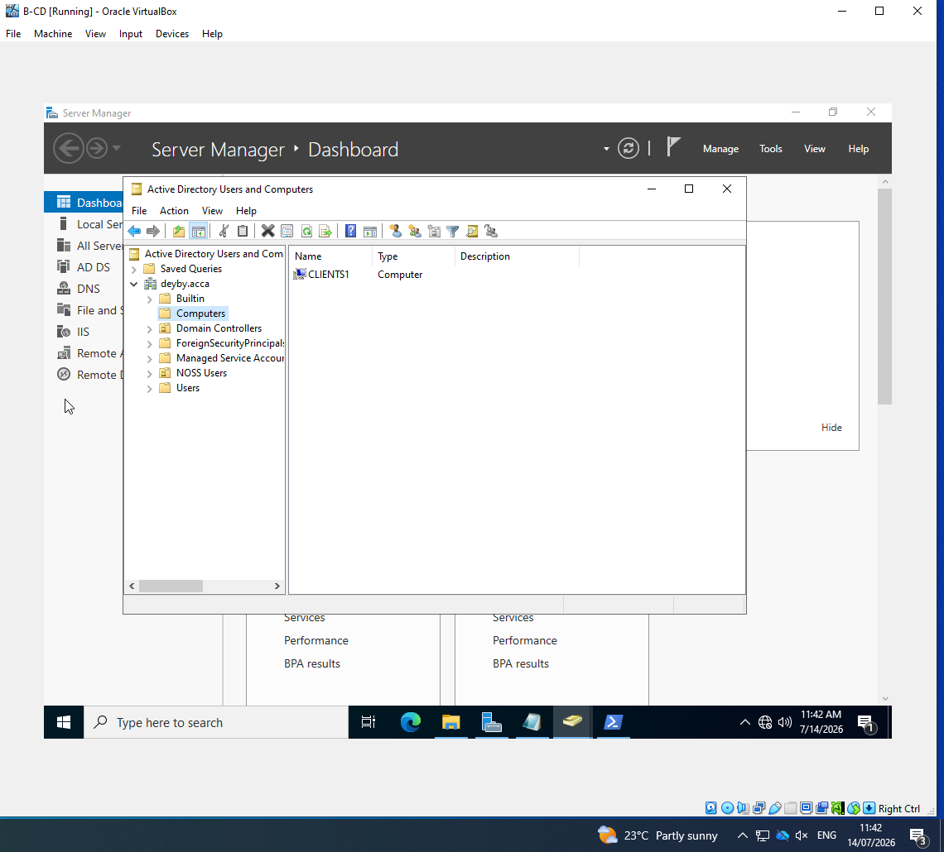
Verify a domain-user login on ClientS1
The screenshot shows the following: the whoami command returns "deyby\a.rahman" on ClientS1, confirming domain authentication after the join.
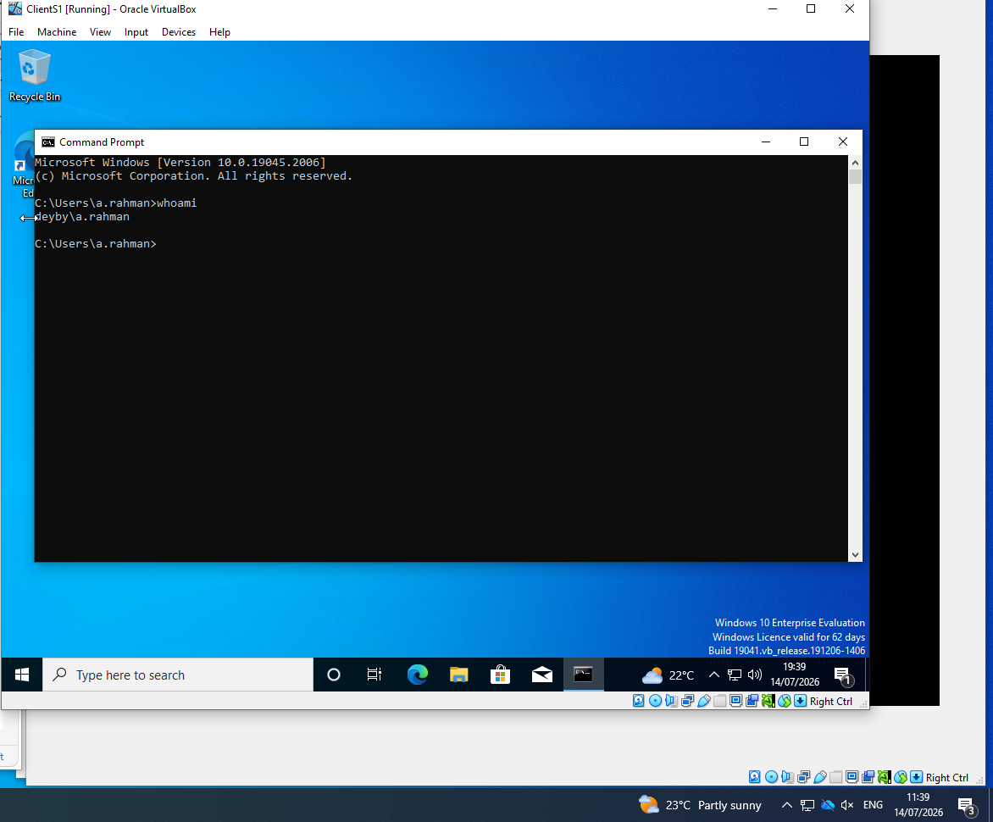

6. DHCP Server
Complete DHCP Server installation
The screenshot shows the following: Server Manager reports that the DHCP Server role installation succeeded on the deyby.acca server.[3]
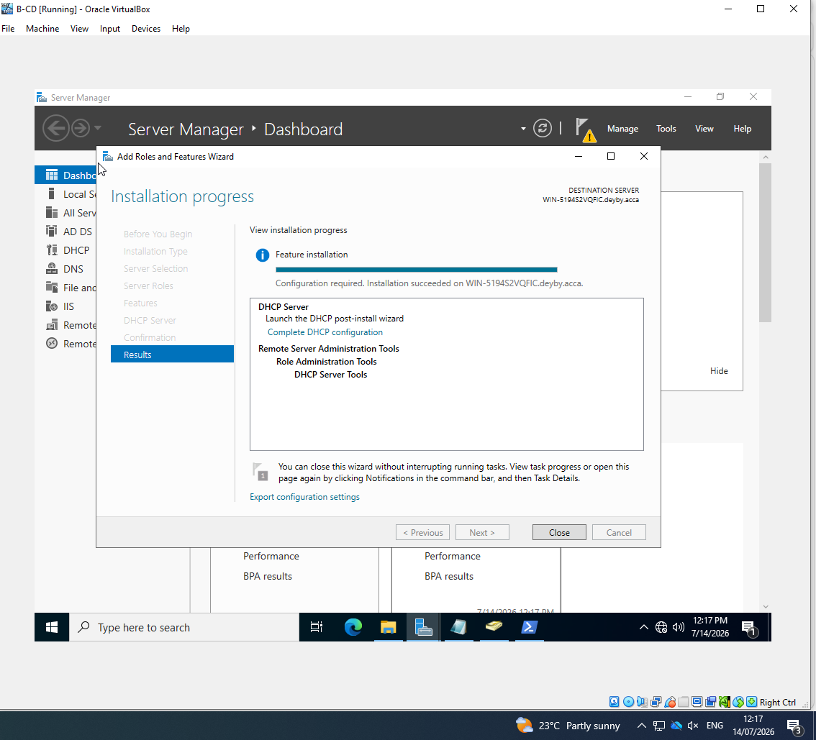
Authorise DHCP with domain credentials
The screenshot shows the following: The DHCP post-installation wizard uses DEYBY\administrator to authorize the server in Active Directory.
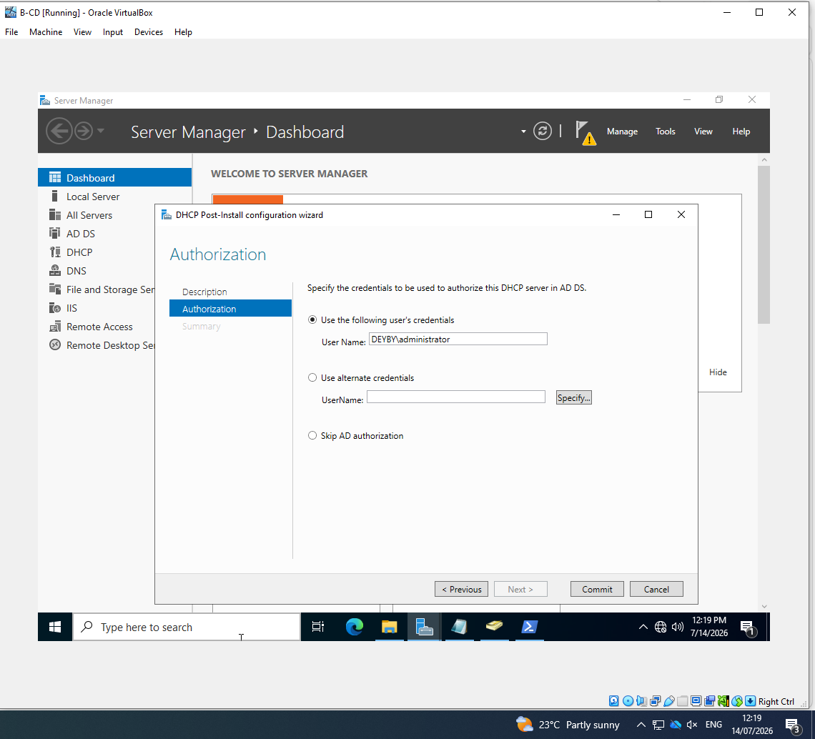
Verify the DHCP service is running
The screenshot shows the following: The Services console shows DHCP Server with the Running state.
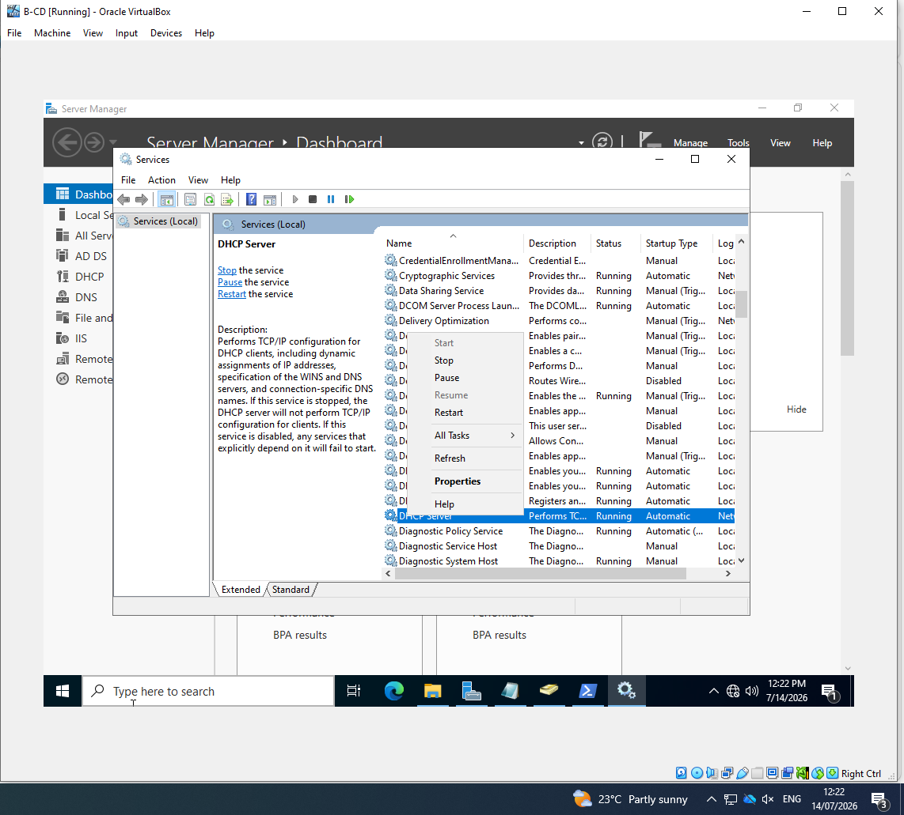
Name the Birmingham scope
The screenshot shows the following: The New Scope Wizard creates Birmingham Scope for the Birmingham client network.
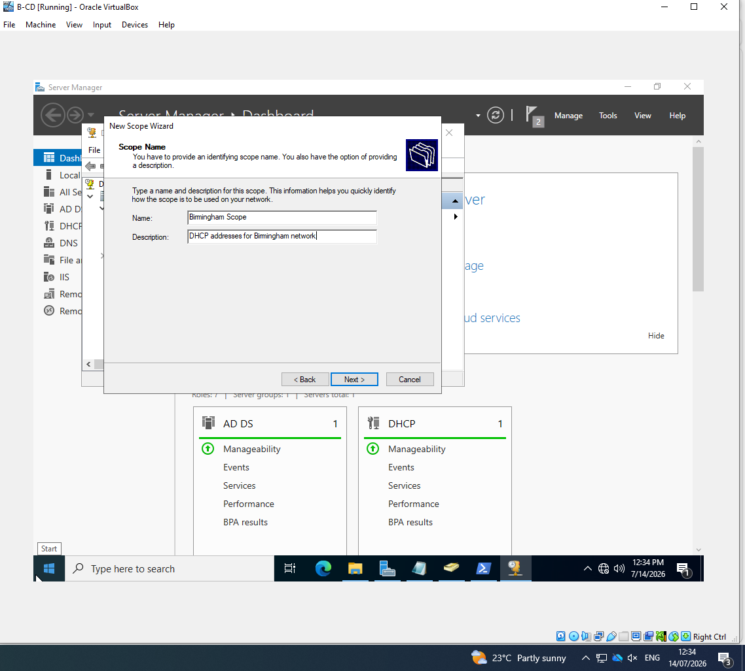

Set the Birmingham address range
The screenshot shows the following: The scope range is 172.16.1.10 through 172.16.1.20 with a 255.255.255.0 (/24) mask.
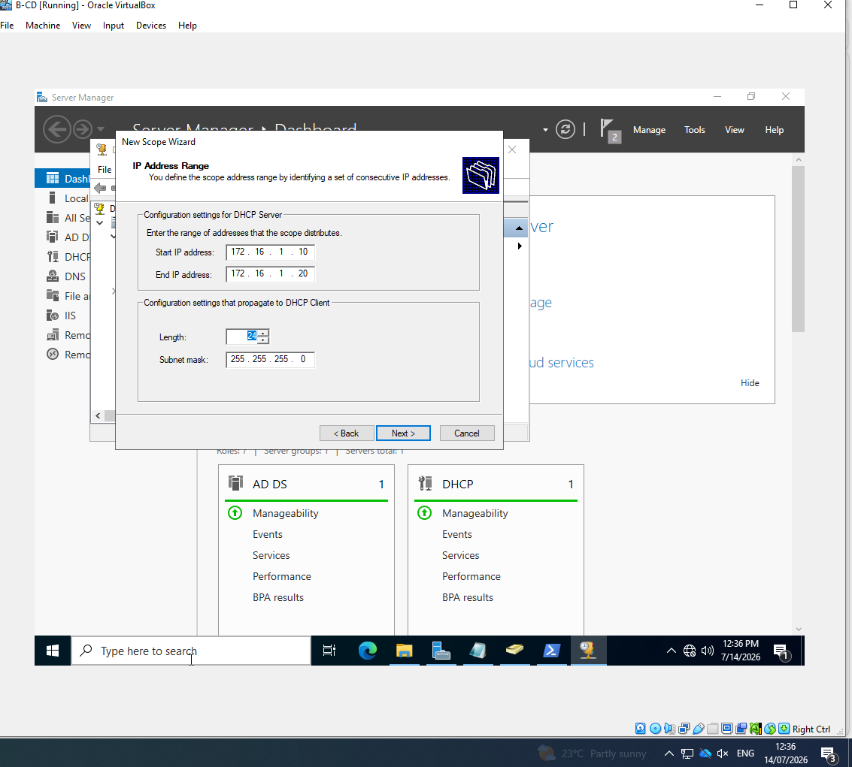
Set the Birmingham lease duration
The screenshot shows the following: The wizard displays the lease-duration settings used for Birmingham clients.
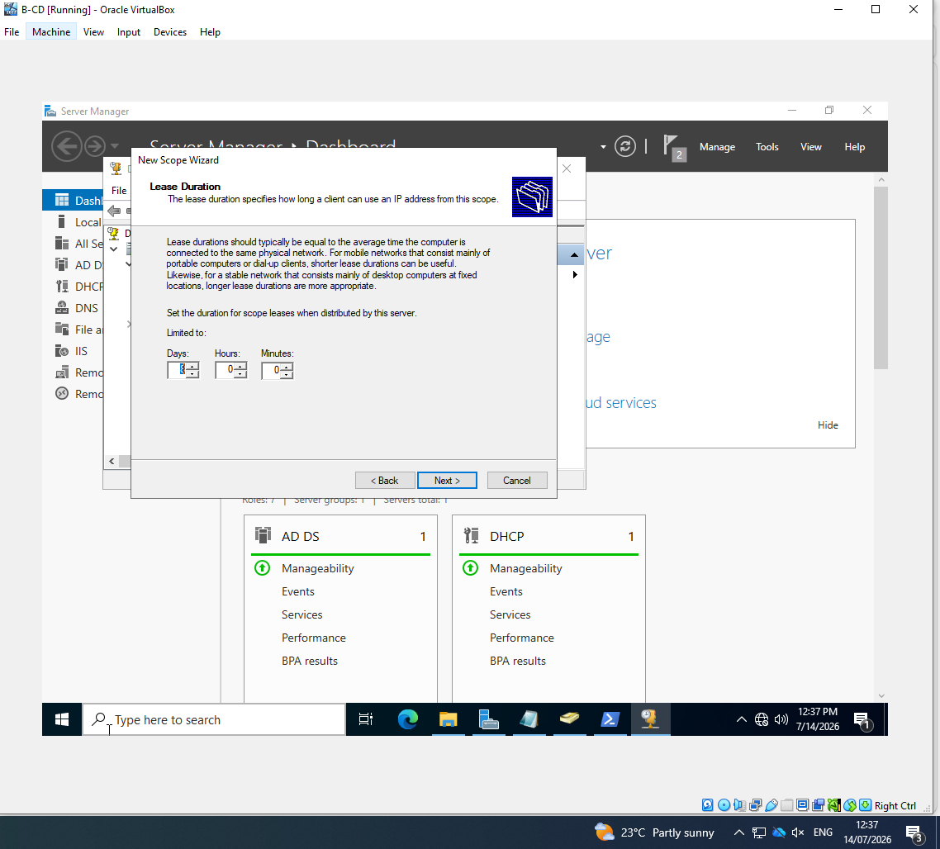

Verify Birmingham scope options
The screenshot shows the following: The completed scope lists router 172.16.1.1, DNS servers 10.0.0.1 and 172.16.1.1, and DNS domain deyby.acca.
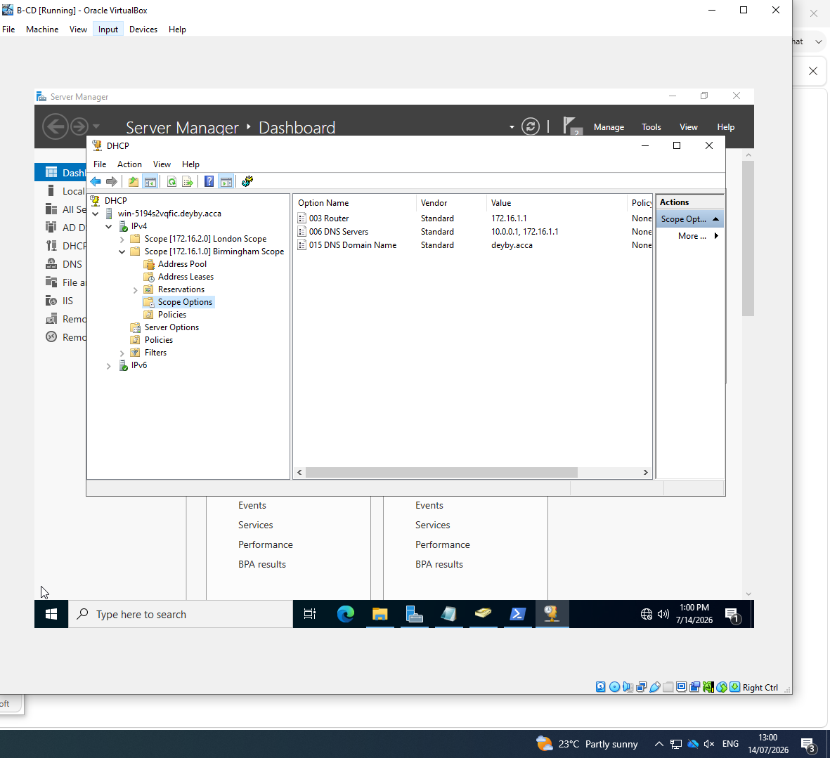
Name the London scope
The screenshot shows the following: The New Scope Wizard creates London Scope for addresses delivered to the London network.
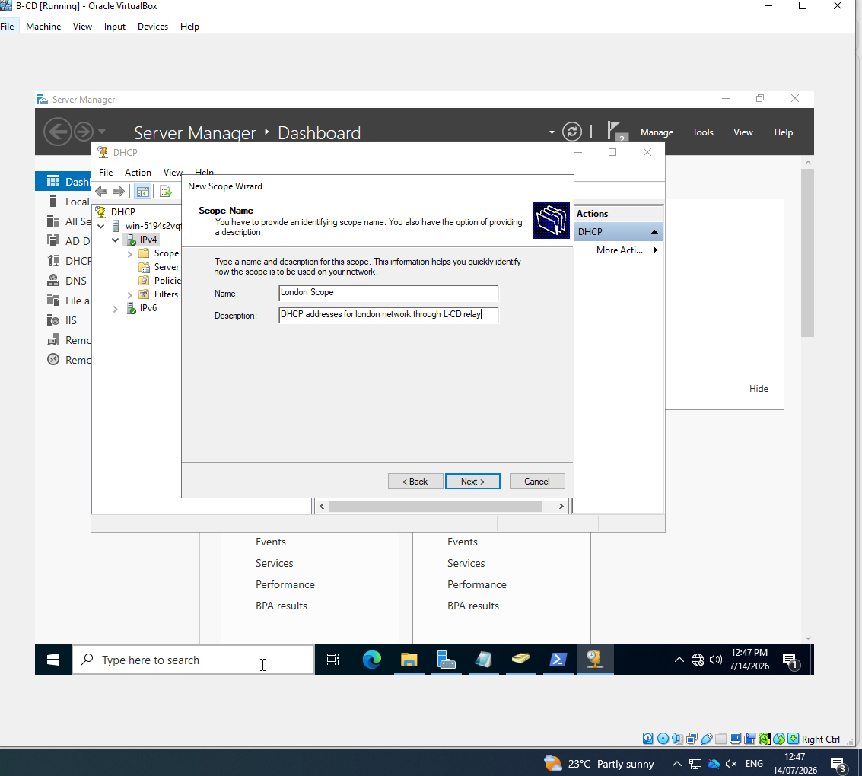

Set the London address range
The screenshot shows the following: The scope range is 172.16.2.10 through 172.16.2.20 with a 255.255.255.0 (/24) mask.
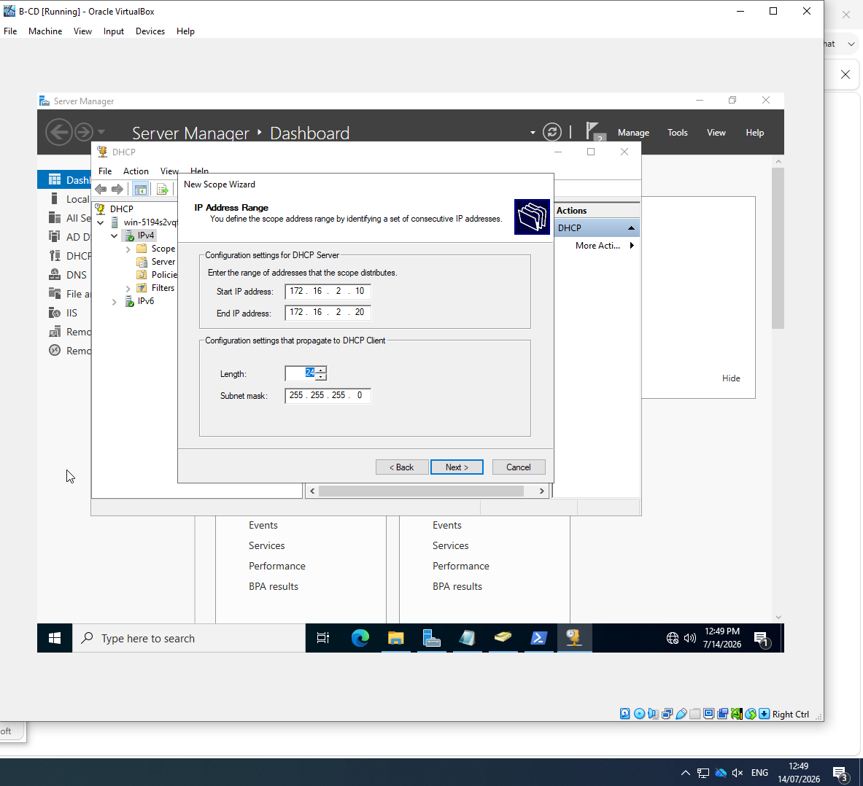
Set the London default gateway
The screenshot shows the following: The Router option is configured with 172.16.2.1 for London DHCP clients.
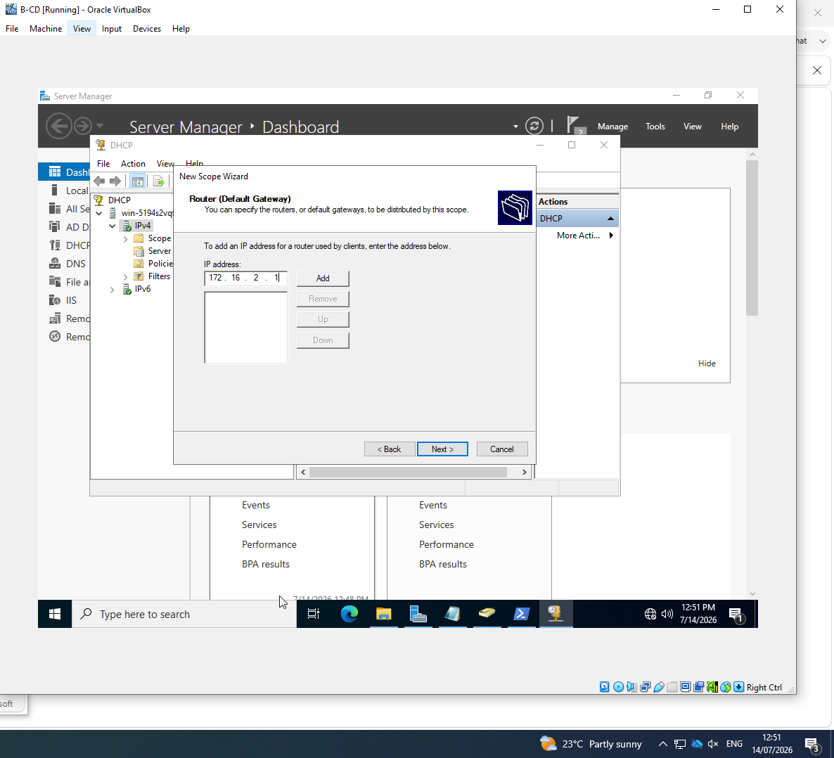

Set the London DNS server and domain
The screenshot shows the following: The wizard configures deyby.acca as the parent domain and B-DC as the DNS service for London clients.
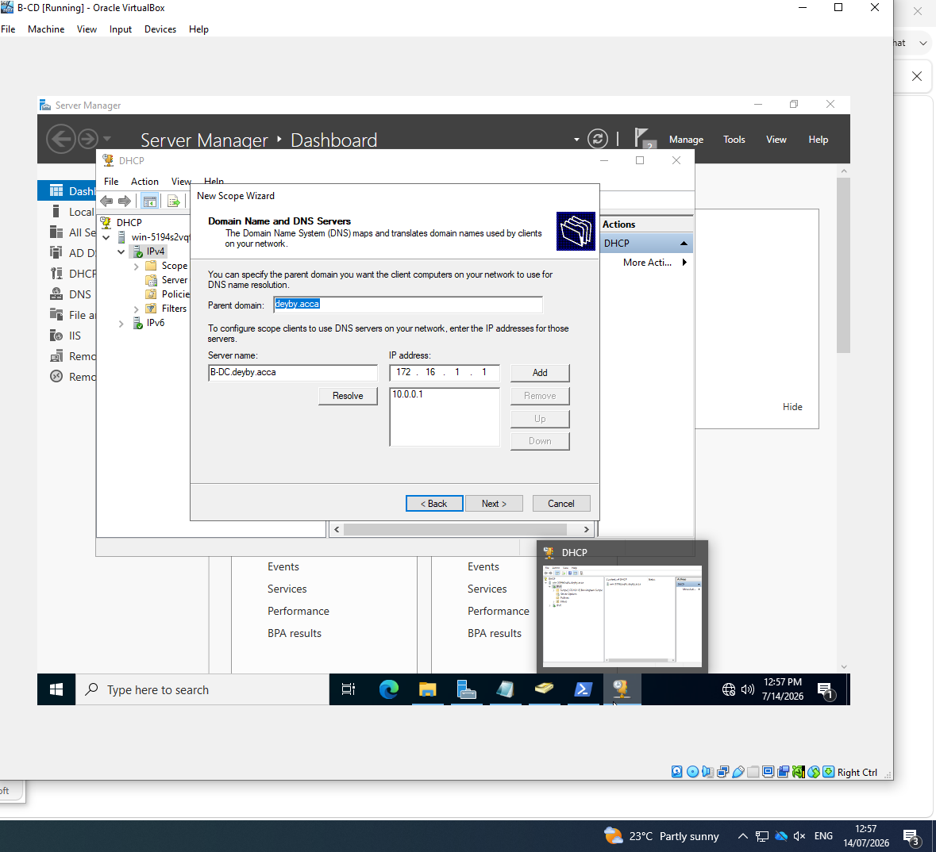
Verify London scope options
The screenshot shows the following: The completed scope lists router 172.16.2.1, DNS servers 10.0.0.1 and 172.16.1.1, and DNS domain deyby.acca.
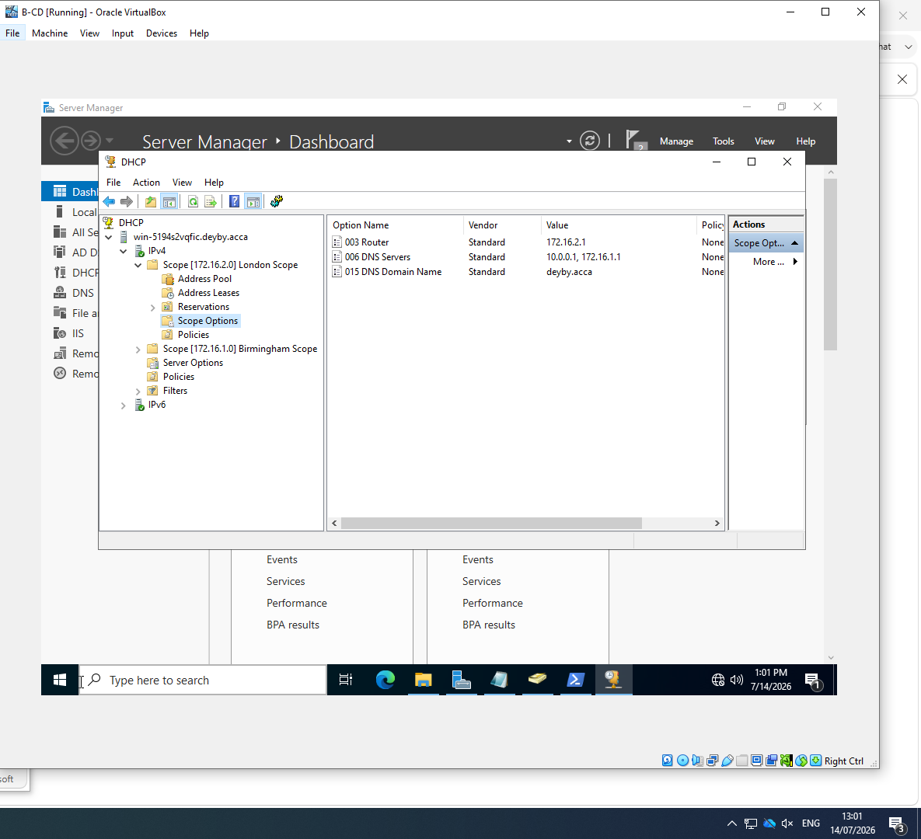

Verify both DHCP scopes are active
The screenshot shows the following: The DHCP console lists Birmingham Scope and London Scope with Active status under B-DC.
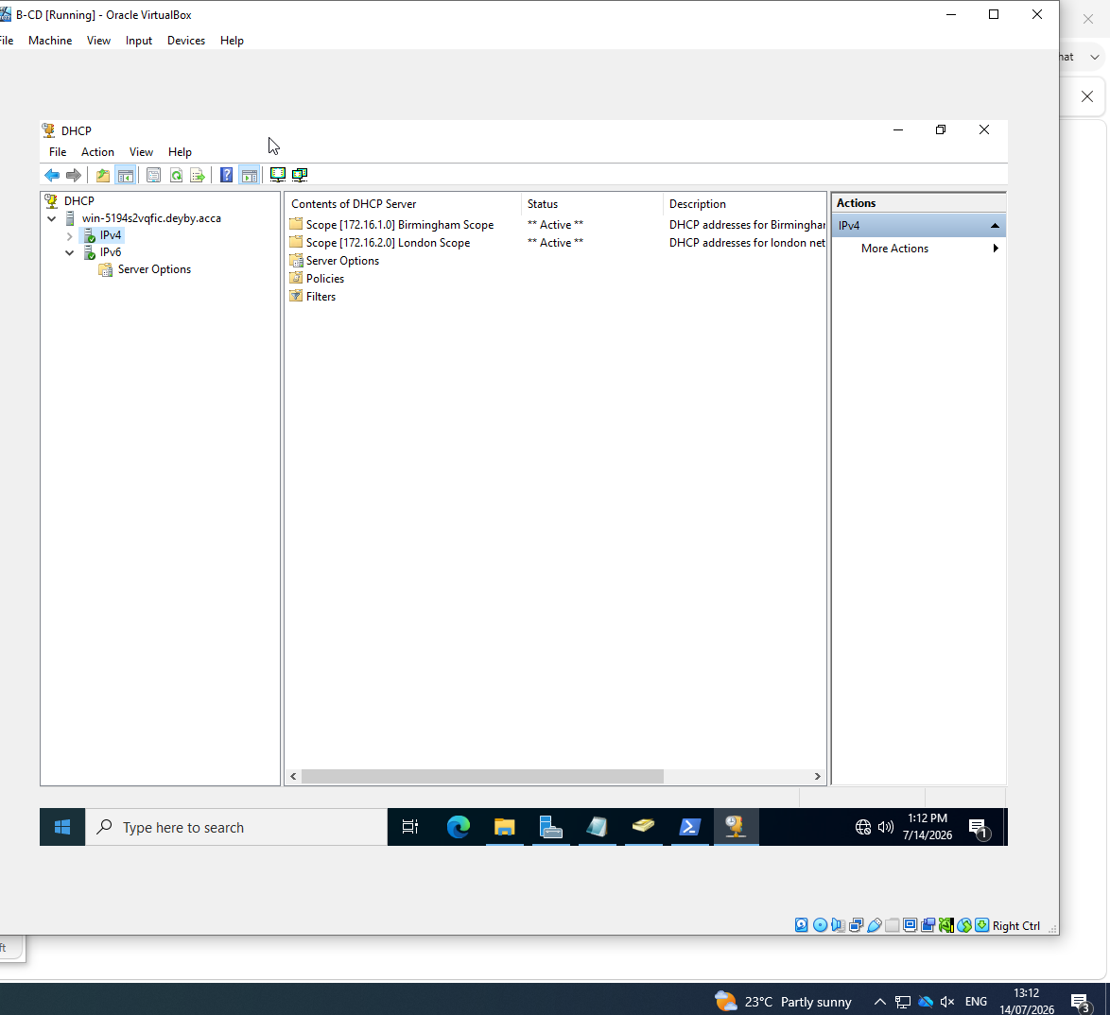
Verify the London client address
The screenshot shows the following: ClientL1 displays IPv4 address 172.16.2.10, which falls at the beginning of the assignment’s required 172.16.2.10–172.16.2.20 range.
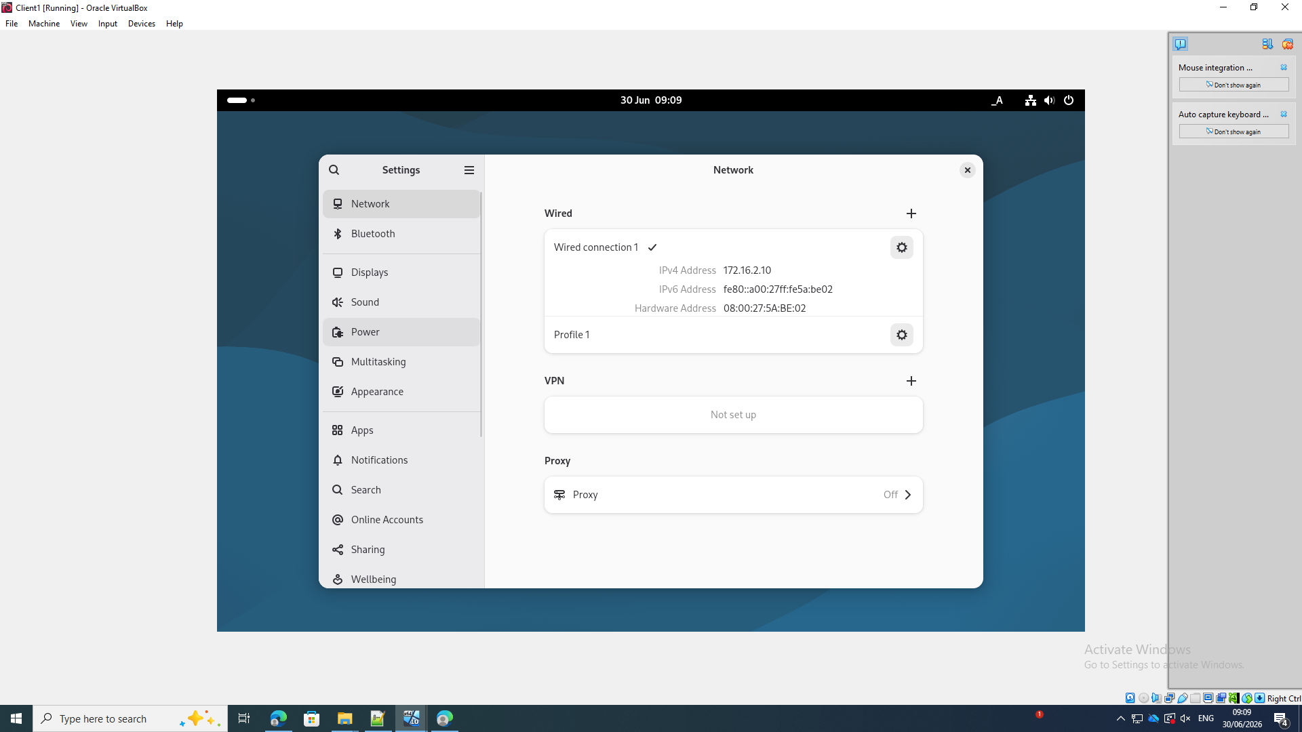

7. Test and Troubleshoot
Record the initial RRAS firewall warning
The screenshot shows the following: RRAS reports that it cannot open the required Windows Firewall ports automatically and instructs the administrator to open them manually.
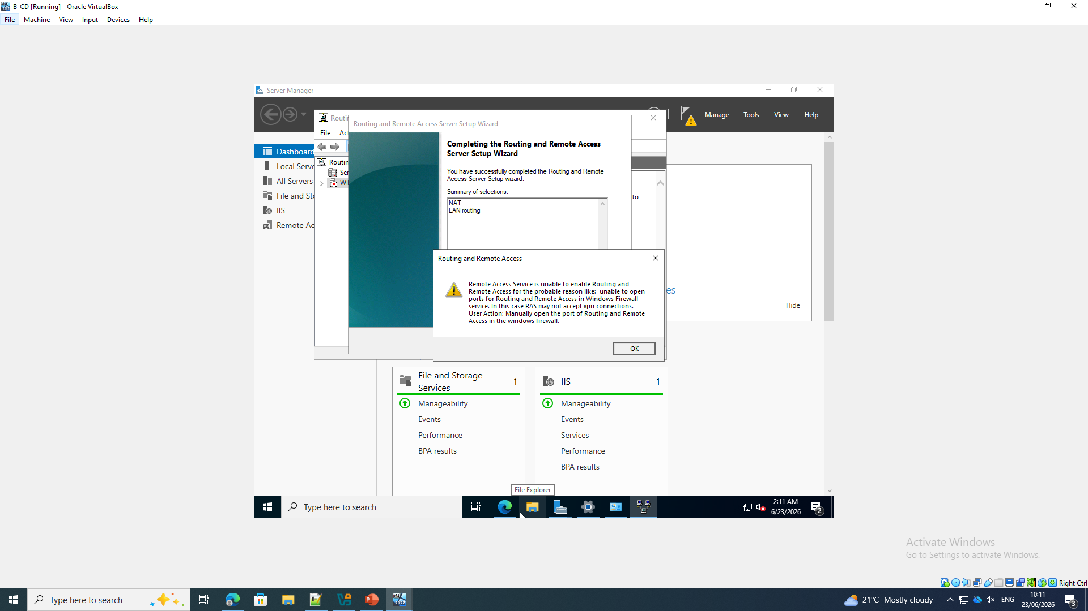
Verify the B-DC host record
The screenshot shows the following: An nslookup query for B-CD.deyby.acca returns 172.16.1.1 from the domain DNS server.
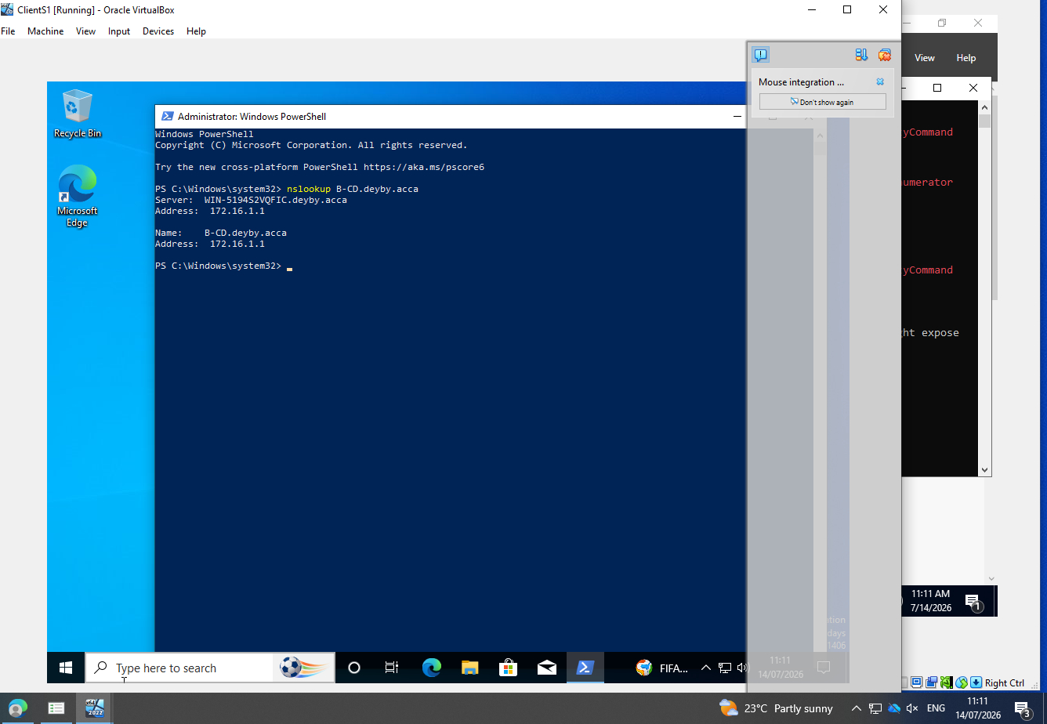

Verify the Active Directory LDAP service record
The screenshot shows the following: After correcting the query syntax, nslookup returns the _ldap._tcp.dc._msdcs.deyby.acca SRV record with port 389 and a deyby.acca domain-controller host.
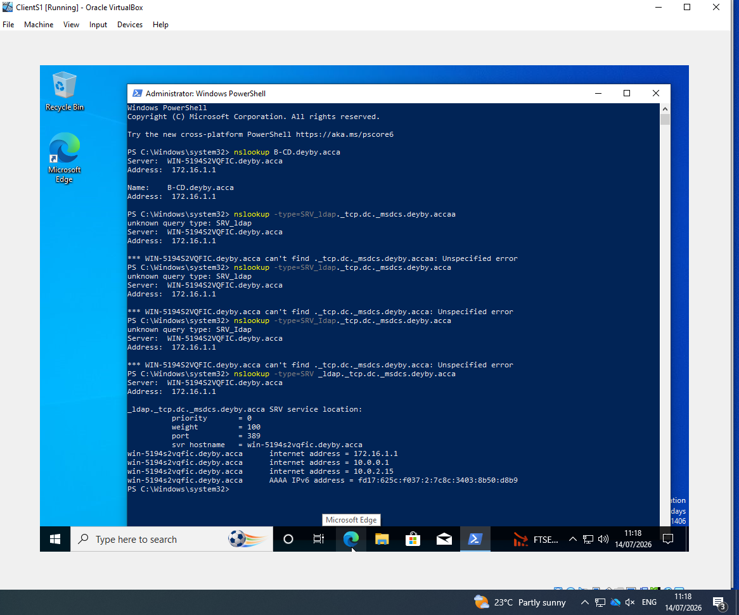
Verify ClientS1 access to the London network
The screenshot shows the following: ClientS1 receives successful replies from the London router 172.16.2.1 and ClientL1 172.16.2.10, with 0% packet loss.
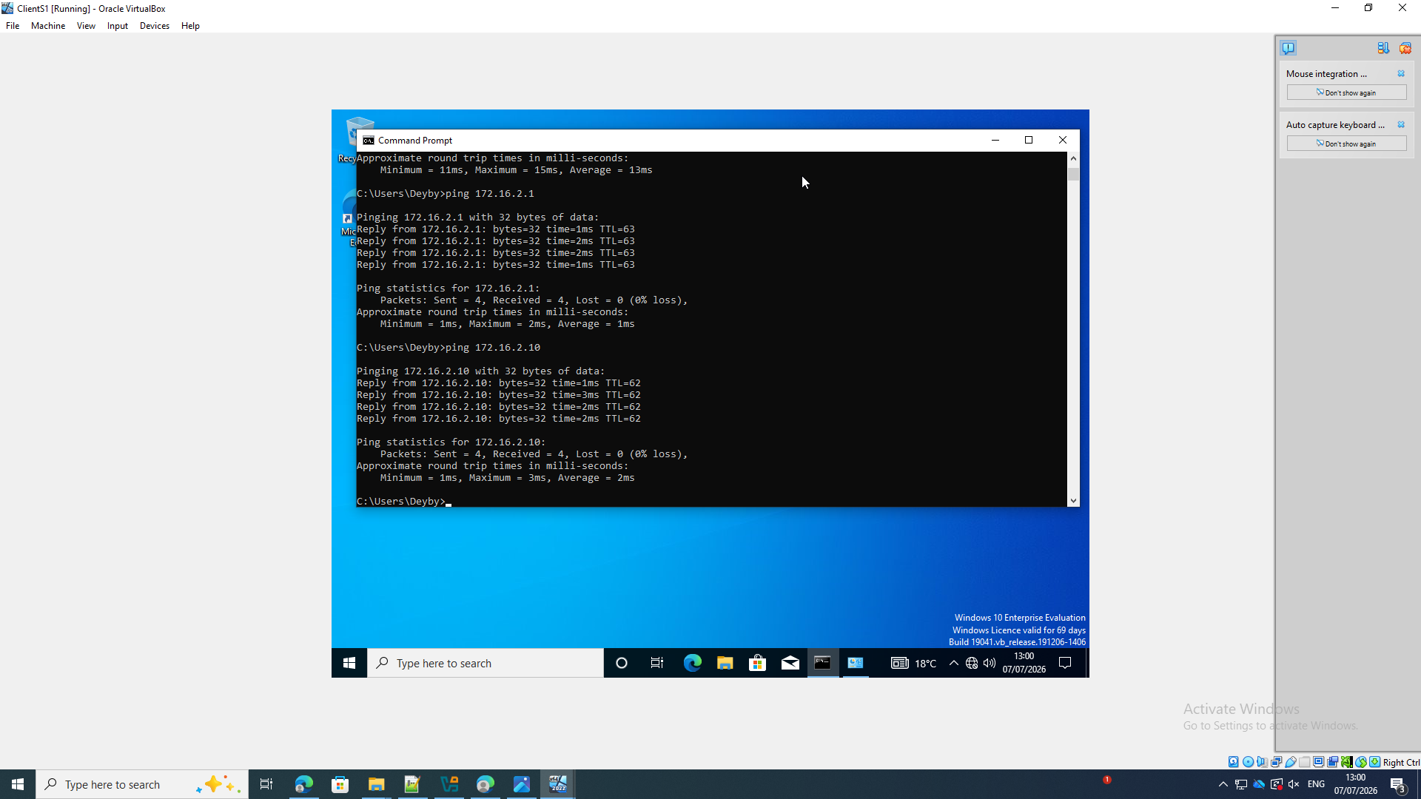

Verify ClientS1 DNS and Internet access
The screenshot shows the following: ClientS1 resolves google.com to 142.250.151.139 and receives four replies with 0% packet loss.
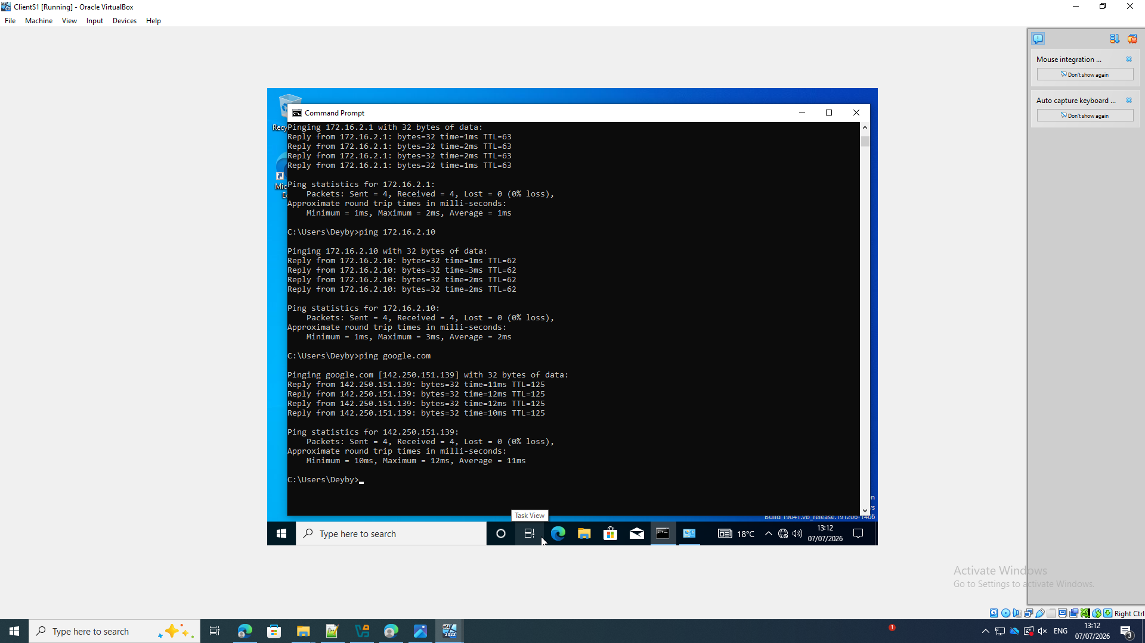
Verify ClientL1 access to Birmingham
The screenshot shows the following: ClientL1 receives 19 replies from B-DC at 172.16.1.1 with 0% packet loss.
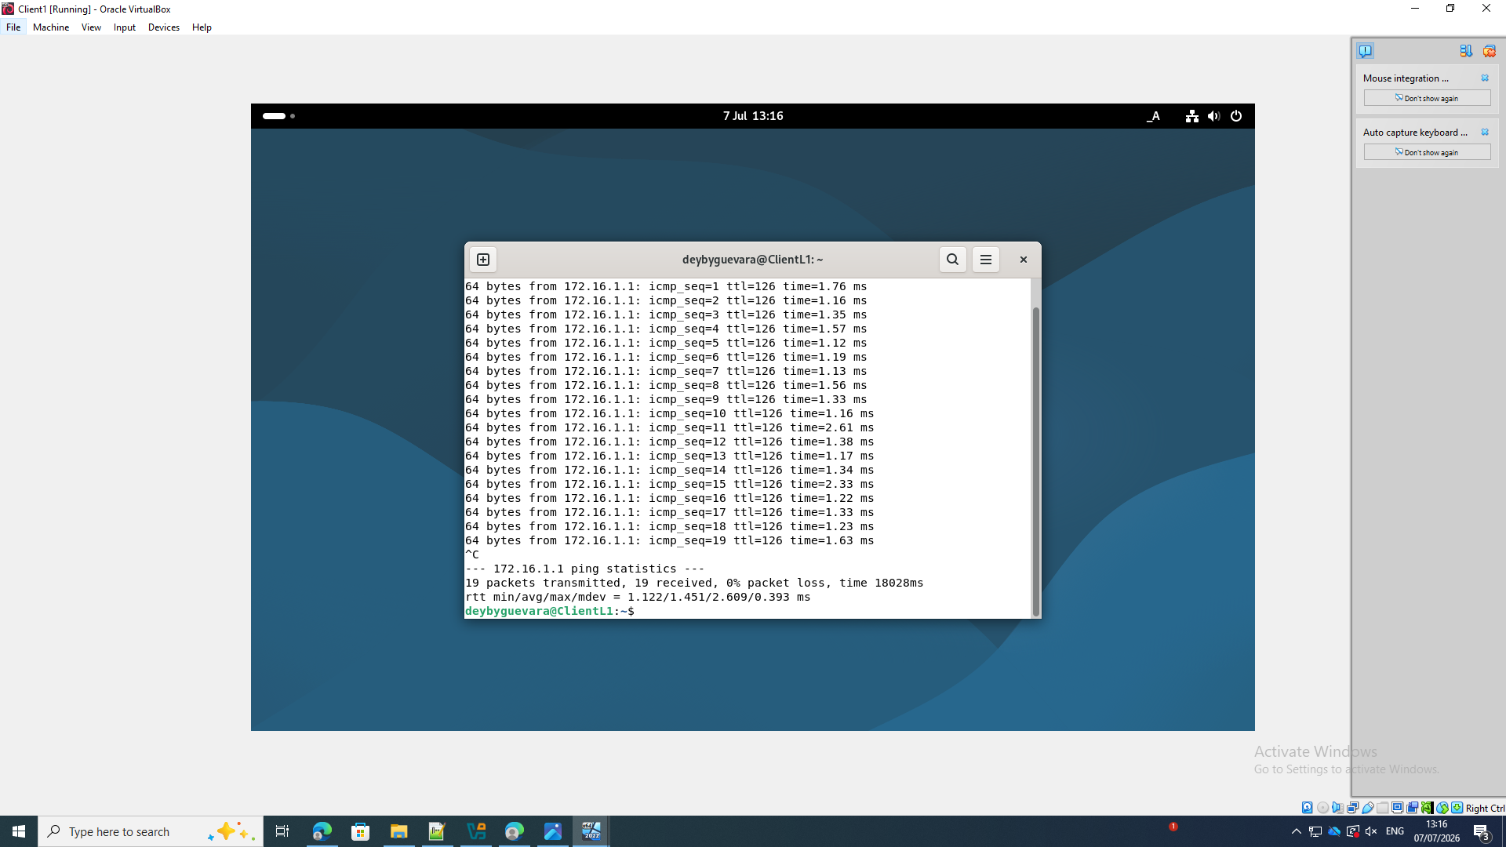

Verify ClientL1 Internet access
The screenshot shows the following: ClientL1 receives three replies from 8.8.8.8 with 0% packet loss.
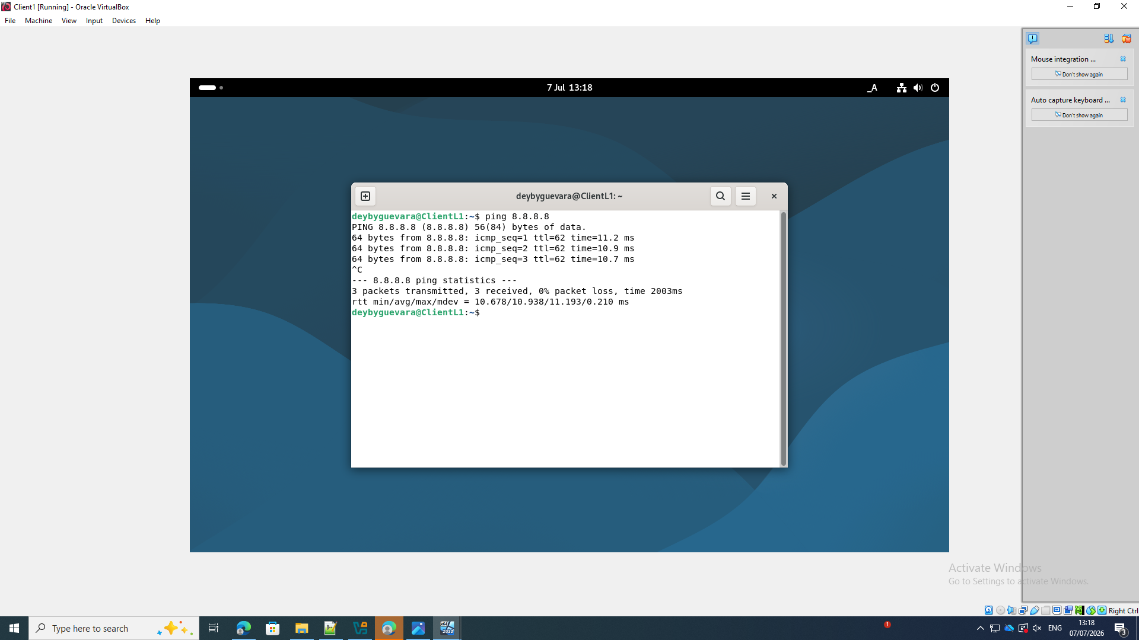

8. Disk Drive
Attach a second virtual disk
The screenshot shows the following: VirtualBox creates B-CD_2.vdi as an additional virtual hard disk for the server.[4]
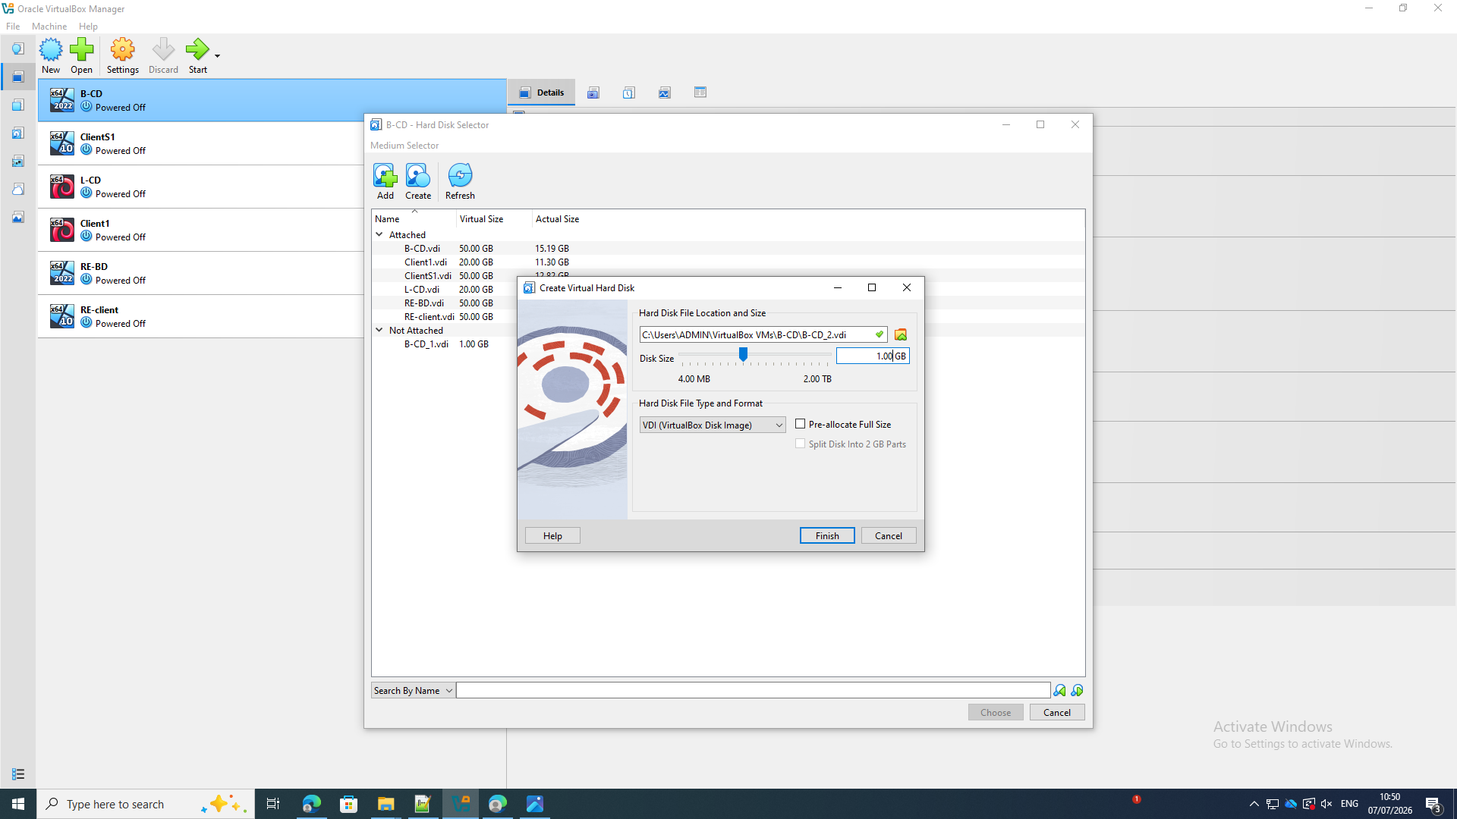

Initialize the disk using GPT
The screenshot shows the following: Windows Disk Management detects Disk 1 and selects GUID Partition Table (GPT).
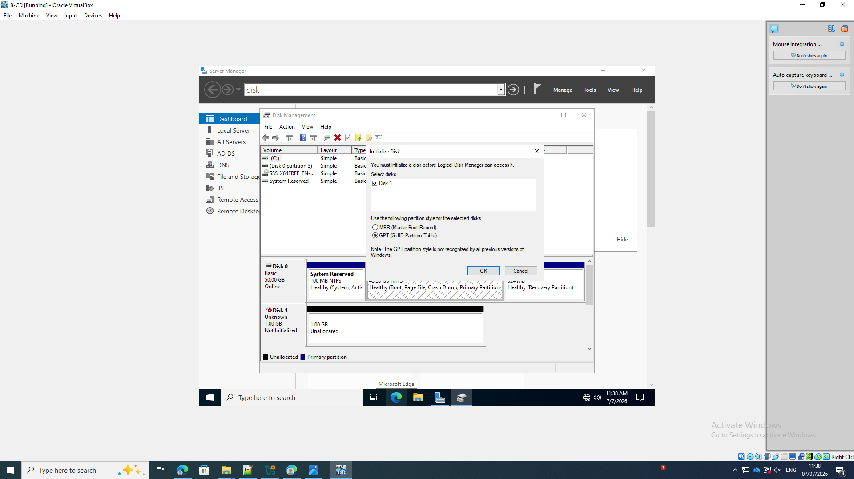
Start the New Simple Volume Wizard
The screenshot shows the following: The new unallocated disk is prepared as a simple volume.
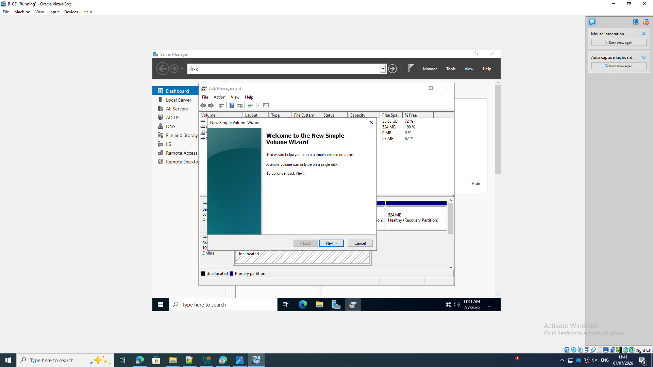
Format and label the volume
The screenshot shows the following: The volume is assigned label B-FILES and formatted using the options shown in the wizard.
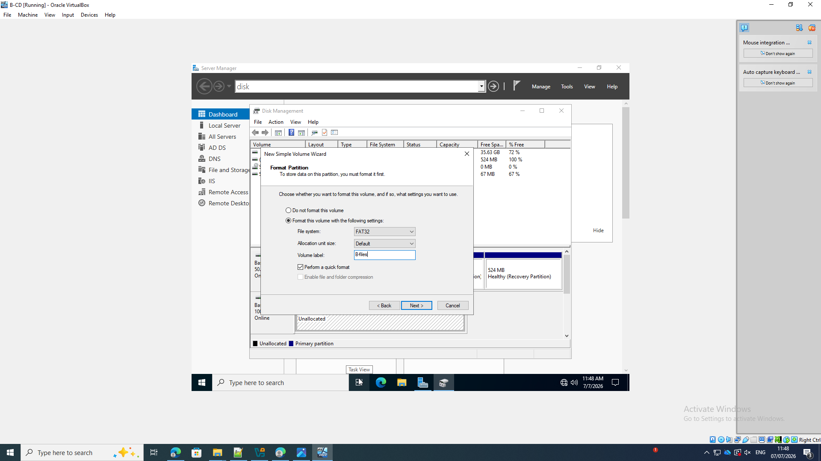
Verify the mounted B-FILES volume
The screenshot shows the following: Disk Management shows B-FILES as drive E: and Healthy.
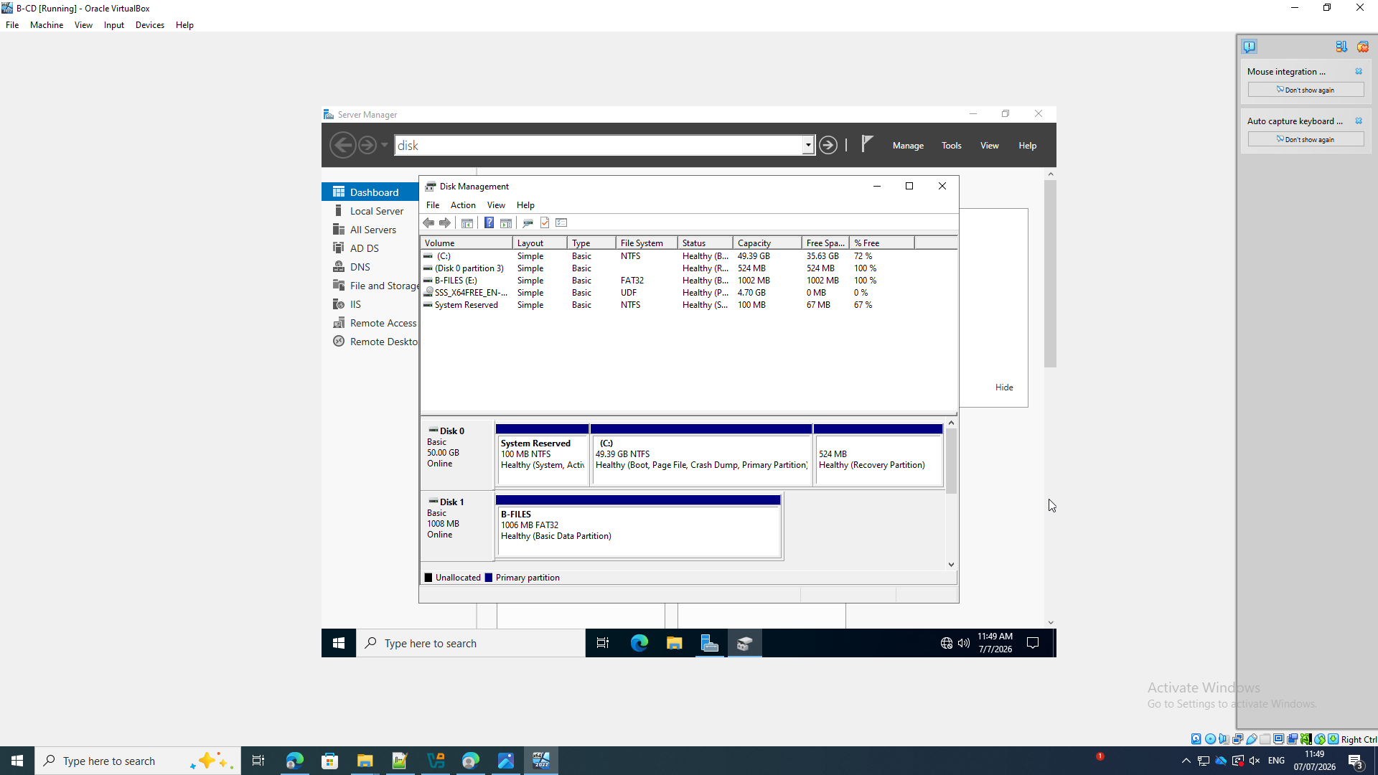

Create the Birmingham Files folder and test file
The screenshot shows the following: File Explorer shows Birmingham Files on B-FILES (E:) with a text document inside.
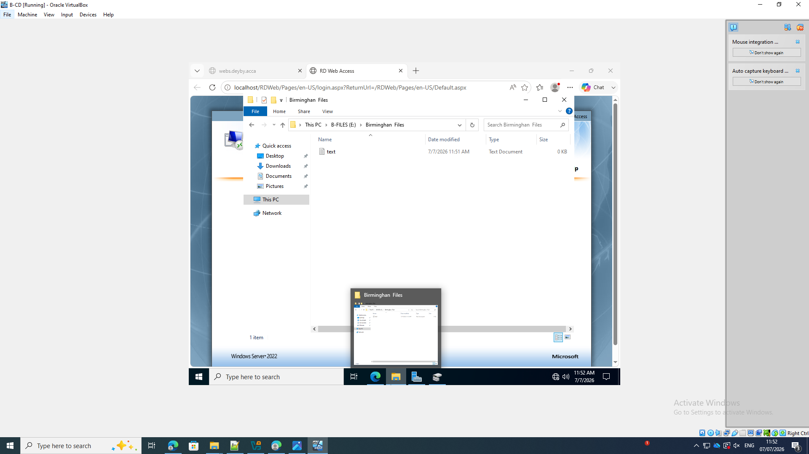
Select the domain security principals
The screenshot shows the following: The sharing workflow searches the deyby.acca domain for users and groups.
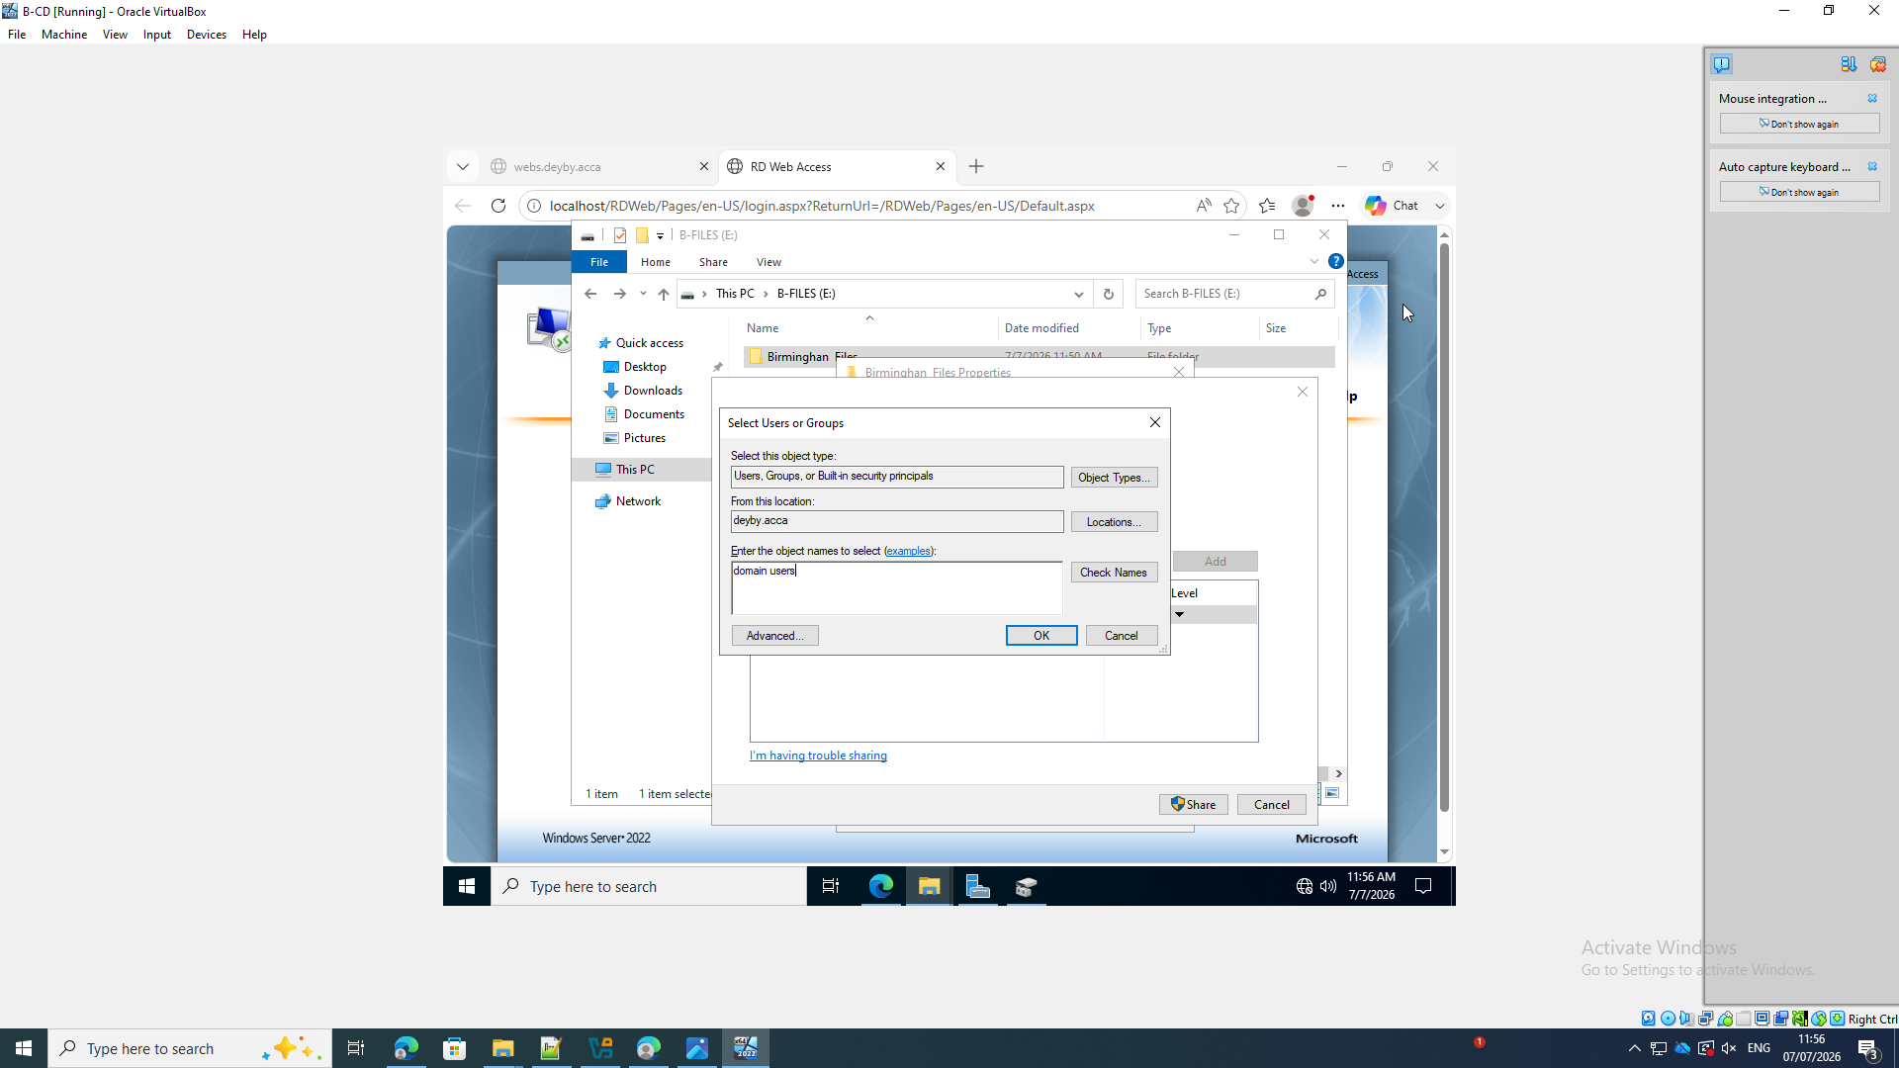
Assign Domain Users read/write sharing access
The screenshot shows the following: The Network Access dialog lists Domain Users with Read/Write permission.
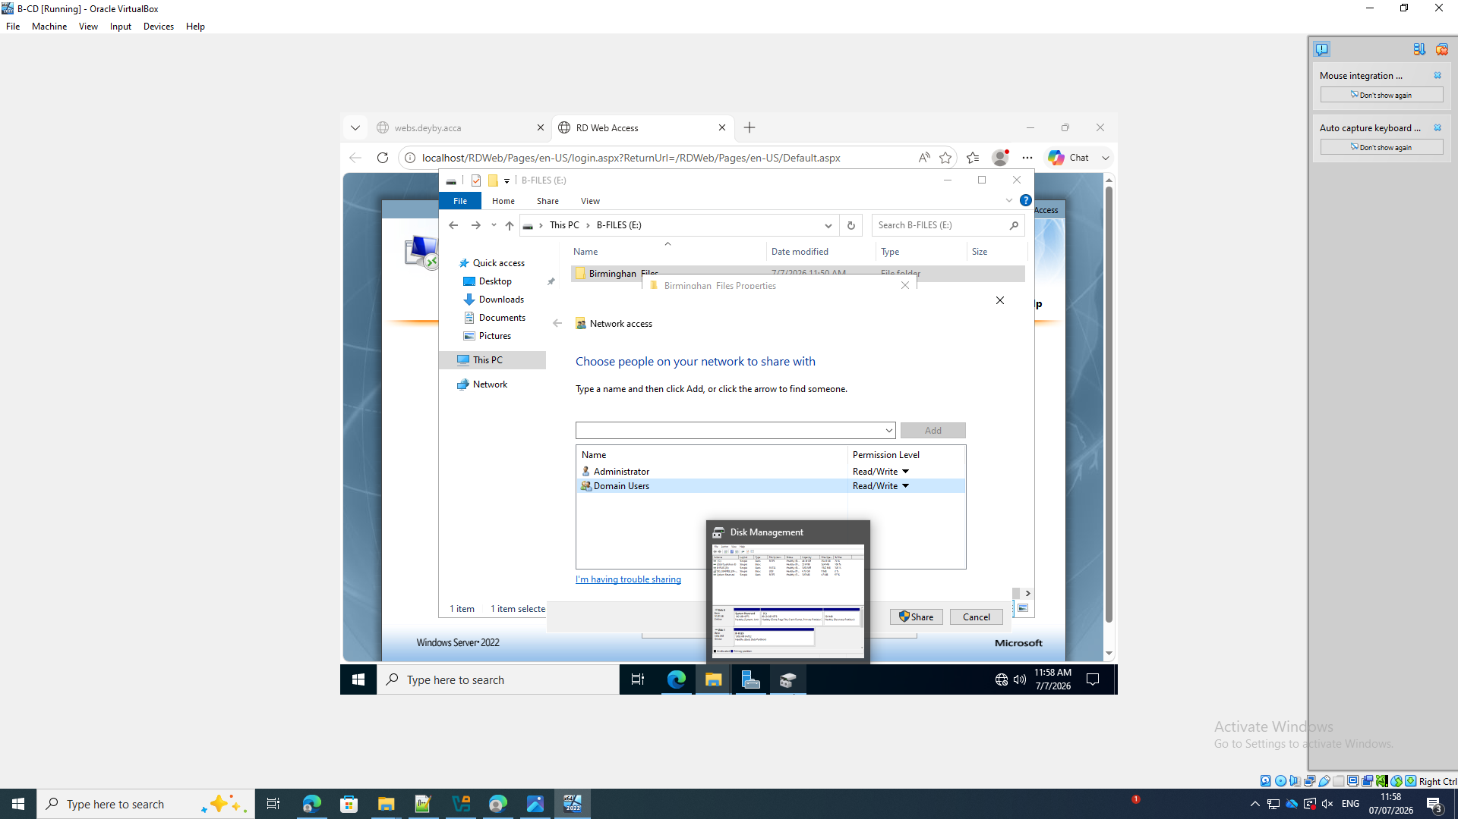
9. IIS Server
Open IIS Manager on B-DC
The screenshot shows the following: IIS Manager is active on B-DC and lists Birmingham Website and Default Web Site.
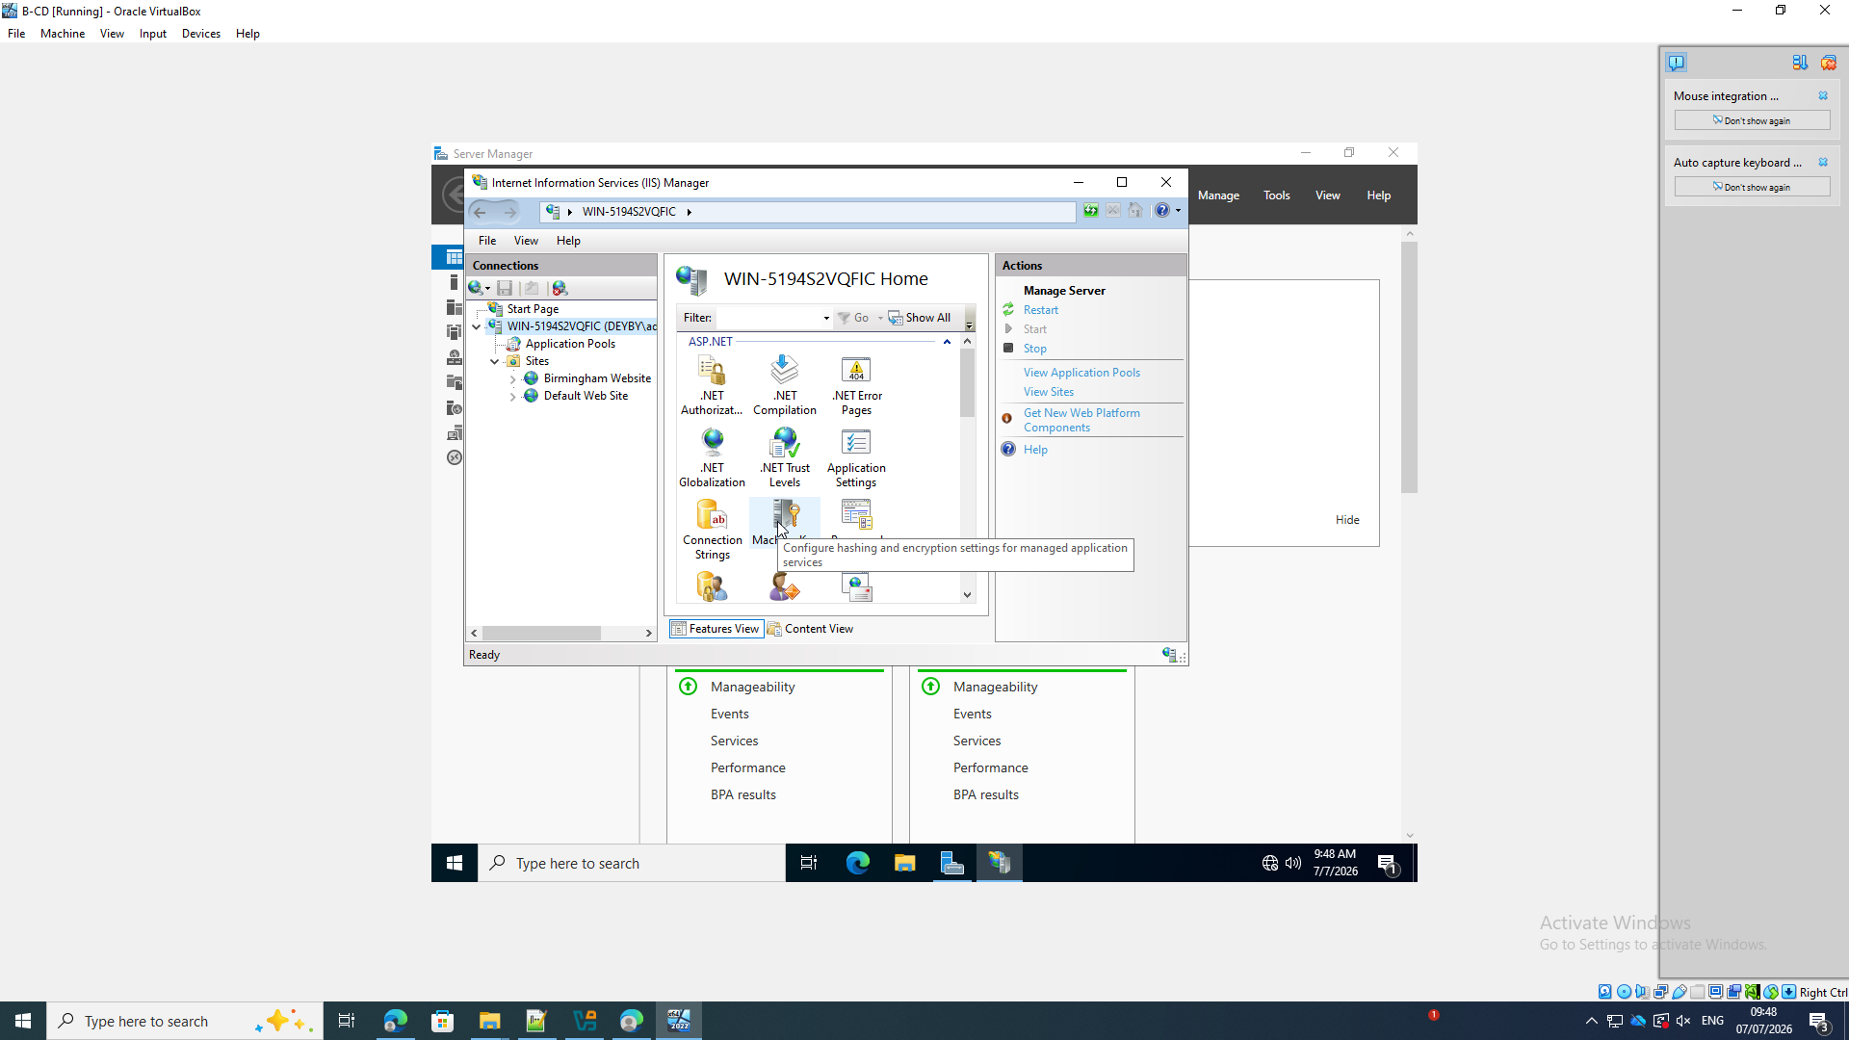

Verify the Birmingham Website binding
The screenshot shows the following: The Birmingham Website action pane offers Browse webs.deyby.acca on 172.16.1.1:80 using HTTP.
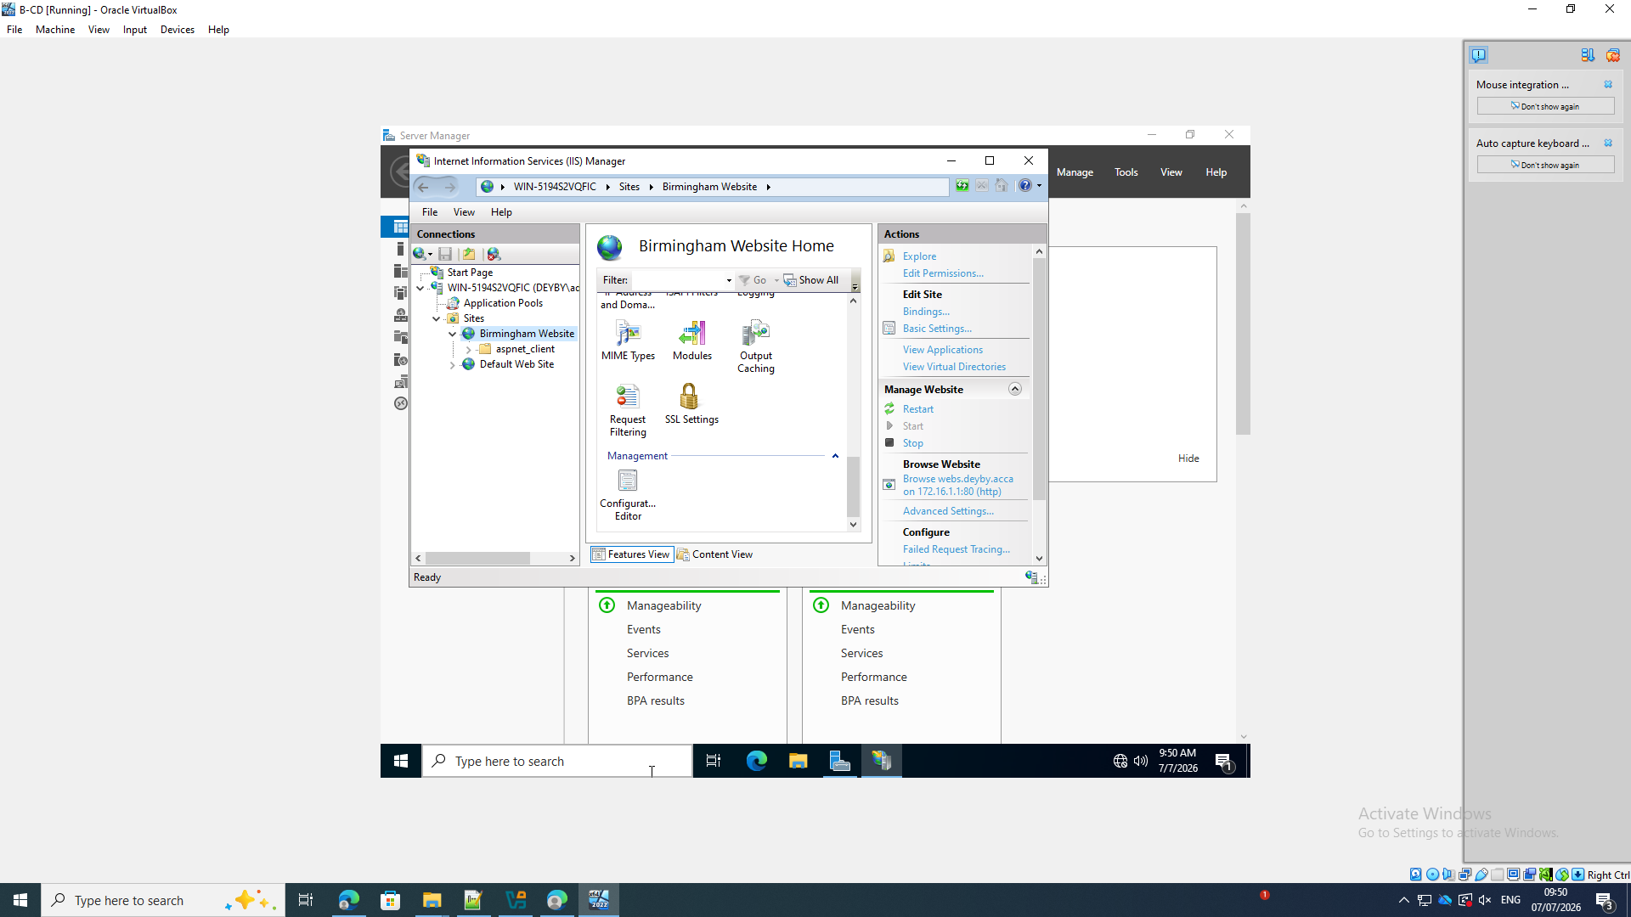
Browse the website by DNS name
The screenshot shows the following: The browser reaches webs.deyby.acca and displays the default IIS welcome page.
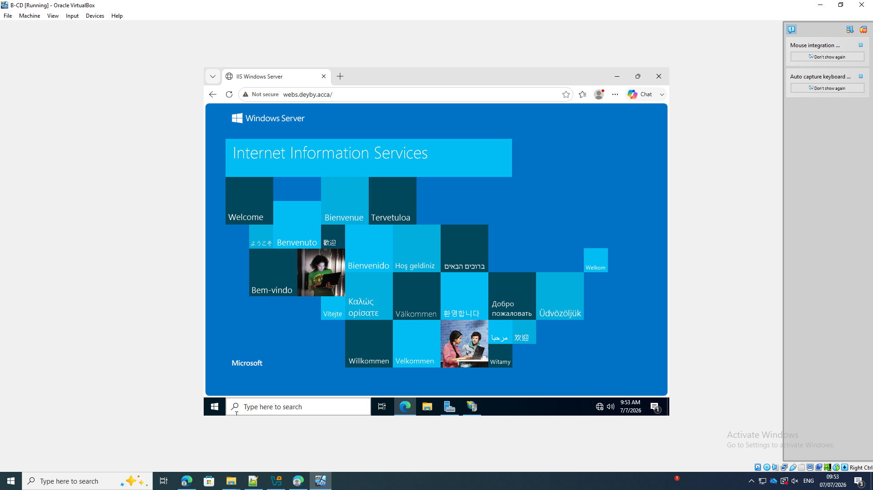

10. Remote Desktop Services
Select RDS role services
The screenshot shows the following: Remote Desktop Session Host and Remote Desktop Web Access are selected in Server Manager.
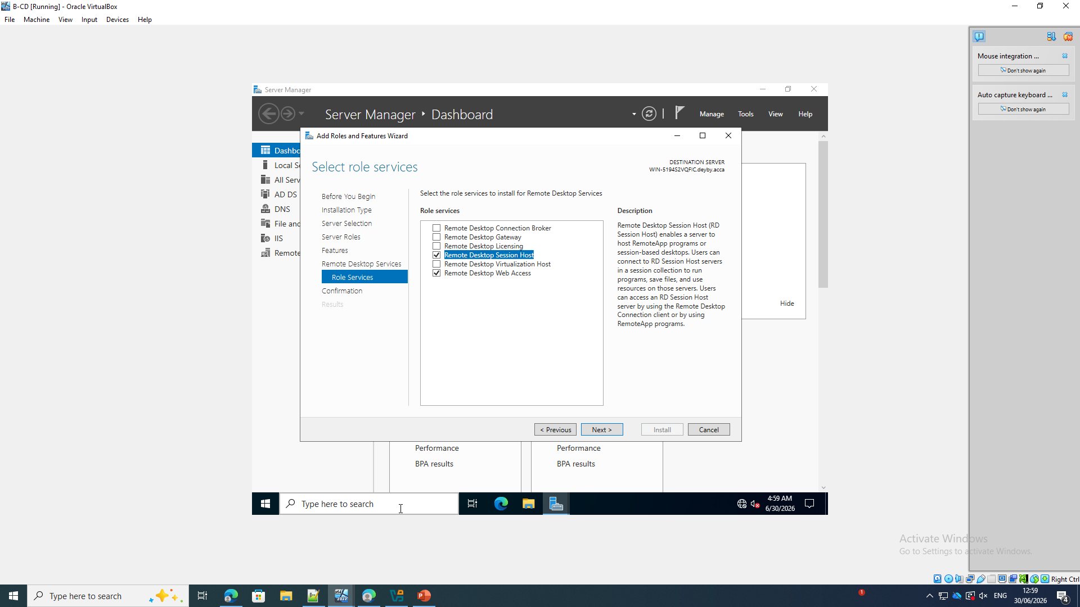
Add the RDS management features
The screenshot shows the following: Server Manager adds the tools needed to manage Remote Desktop Session Host.
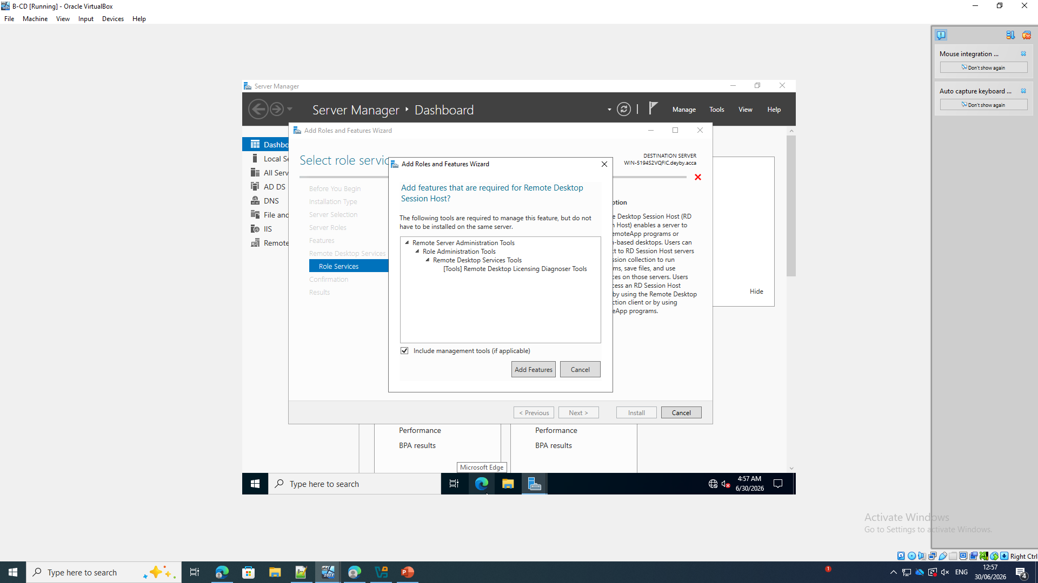

Confirm the RDS installation
The screenshot shows the following: The installation summary includes Remote Desktop Session Host, Remote Desktop Web Access and the administration tools.
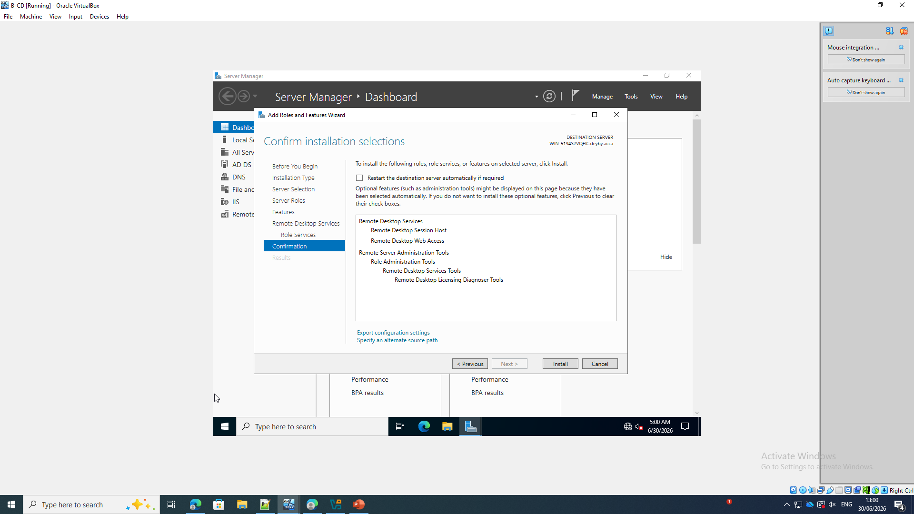
Verify the RDWeb IIS application
The screenshot shows the following: IIS Manager shows the RDWeb application under Default Web Site with HTTP and HTTPS browse actions.
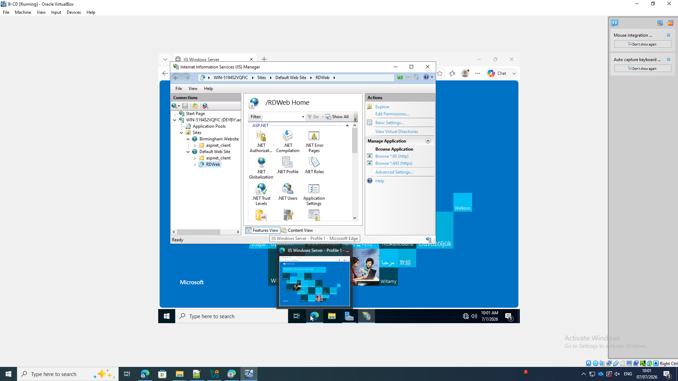

Open the RD Web Access login page locally
The screenshot shows the following: The server displays the RD Web Access login page at localhost/RDWeb.
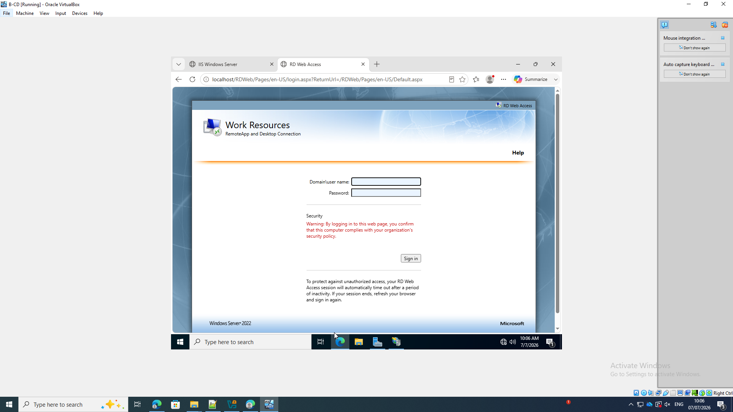
Open RD Web Access from ClientS1
The screenshot shows the following: ClientS1 reaches the RD Web Access login page at 172.16.1.1/RDWeb.
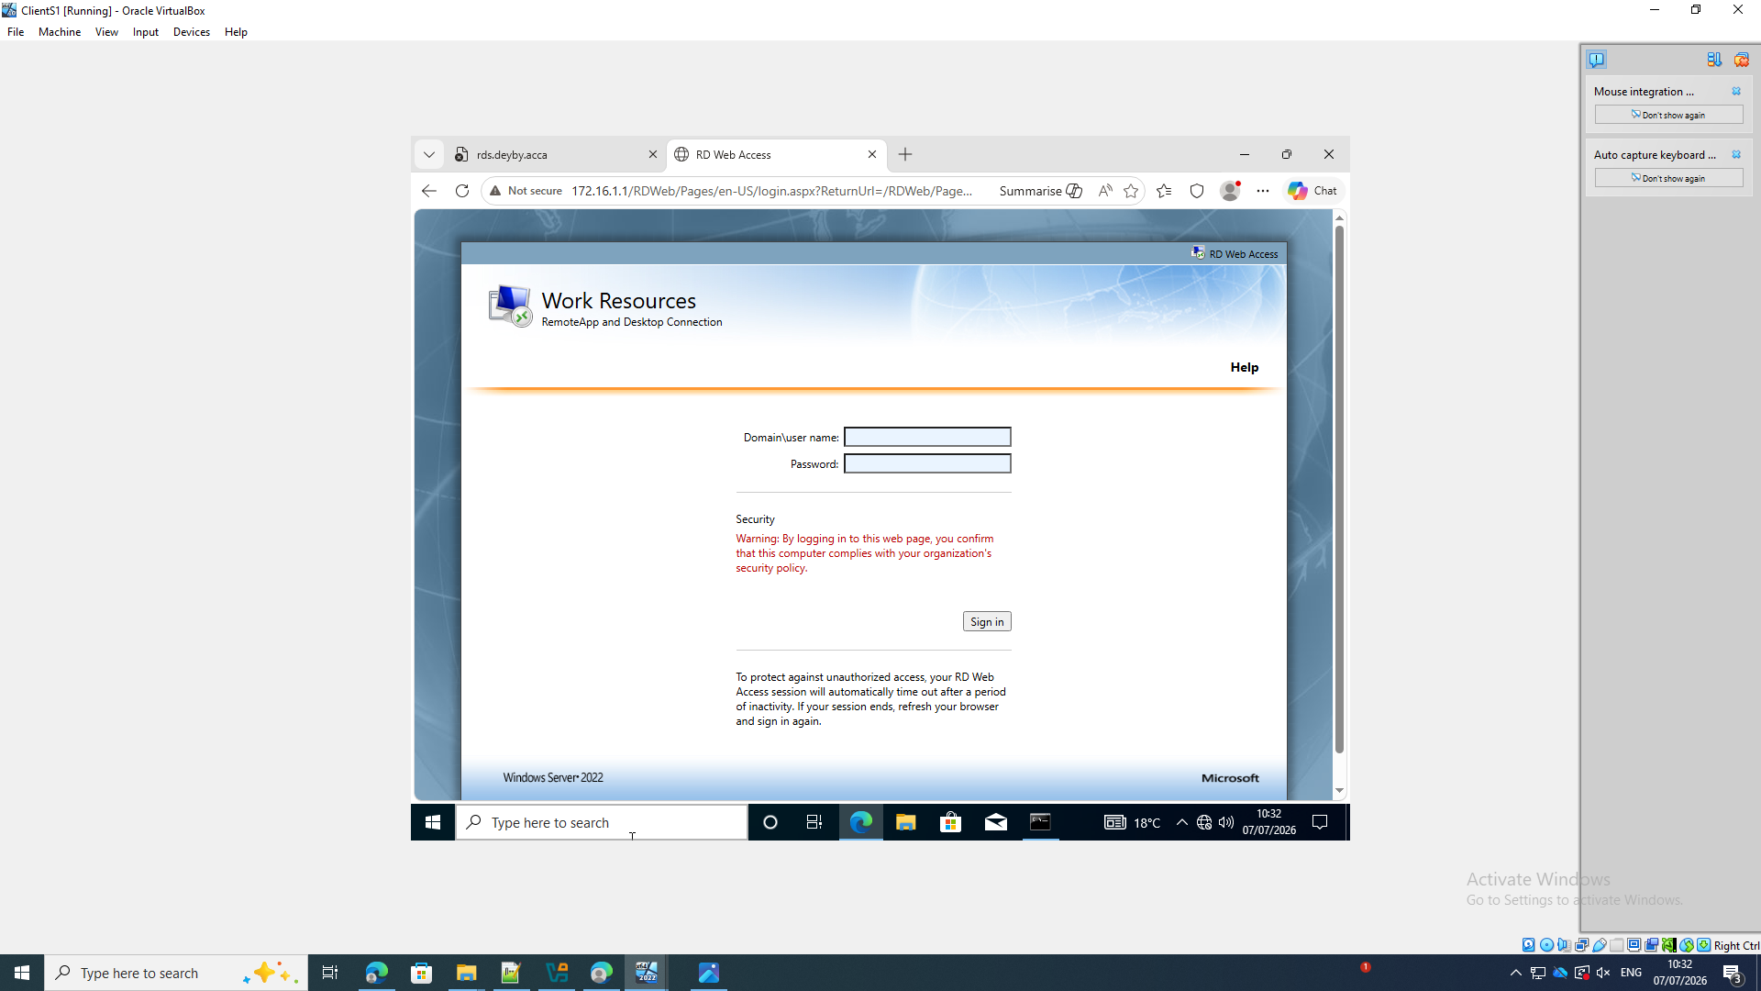

References
[1] Cisco, “What is routing?,” Cisco. [Online]. Available: https://www.cisco.com/site/us/en/learn/topics/networking/what-is-routing.html. [Accessed: Jul. 22, 2026].
[2] AEANET, “What is a domain server?,” AEANET. [Online]. Available: https://www.aeanet.org/what-is-a-domain-server/. [Accessed: Jul. 20, 2026].
[3] “DHCP Server for Windows,” DHCP Server for Windows. [Online]. Available: https://www.dhcpserver.de/cms/. [Accessed: Jul. 21, 2026].
[4] Lucas, “How to extend Server 2022 system partition size easily and securely,” AOMEI Partition Assistant, Dec. 4, 2024. [Online]. Available: https://www.diskpart.com/articles/extend-server-2022-system-partition-size-0825.html. [Accessed: Jul. 22, 2026].

