Danielle Gwynn (1804288)

Abstract
This assignment highlights the range of personal and academic skills used thorough complete four verities of assignment writing. This will include an exam, a report and two essays. It will also include 4 self-assessment performers which have been completed to highlight the strengths and weaknesses within the work.
Personal and Academic Development

Contance Page

 | Page
Example of Work 1- Essay critique | Pg. 2-5
Student Feedback Form | Pg. 6-7
Example of Work 2- | Pg. 8-13
Student Feedback Form | Pg.14-15
Example of Work 3- Exam | Pg. 16-30
Student Feedback Form | Pg.31-32
Example of Work 4 | Pg. 33-42
Student Feedback Form | Pg. 43-44

Example of Work 1-
Communication and counselling- Assignment Critique

This reflective critique outlines the information taken from a simulated counselling session. It will outline the observations found within the recording simulation between a counsellor and a client from the perspective of the counsellor and the strategies used, highlighting and discussing the importance of Carol Rogers counselling methods where relevant, focusing on how it shapes the way a relationship is built. The importance and value that these counselling and communication skills have in the nursing and health care environment will be evaluated.
Rogers had six conditions and that are “necessary and sufficient in a counselling relationship” (Midwinter and Dickson, 2015, p.13). They also express that there are three core conditions that are required for successful counsellor client relationships to exist. These are congruence or genuineness, unconditional positive regard or acceptance and empathy. From the work that Rogers established, there is a belief that congruence or genuineness should consist of, not being false but that the psychotherapist openly portrays what they are feeling at the moment (Rogers, 2004).
It is evident the client is uncomfortable in the situation, as they sit with their legs crossed and their hands clenched on their lap. This shows that their body language and gestures are closed at this point and they are not open to a counselling relationship. A counselling relationship should show a willingness to be open and to be genuine with the client and show characteristics of an empathic bond, only when these elements are present can the client grow or self actualise. This is further supported by Mearns and Thorne (2007) as they explain that the counsellor is in a familiar environment and the client is not, the counsellor knows the processes and functions of counselling a client, the client may not have been within a therapy situation before. This would need to be addressed within a person-centered approach by developing a counselling relationship where the client feels safe and are able to discuss their issues without judgement and therefore a feeling of acceptance. Rogers highlighted that a “Helping relationship” (Rogers,1967. p39) is evident when both the counsellor and client are equal within a counselling relationship and it is believed that client is in fact the expert within the relationship and not the counsellor. The relationship becomes more relaxed, their body language becomes more open which allows the client to feel that they are can open up more because they are not fearing judgement and that the client and counsellor are equal. This furthers engenders a feeling of safety that allows the client to focus on the inner feeling without fear or inhibition (Thorne, 1998). It is important as a healthcare professional to provide these characteristics when encountering both patients and their relatives. It is vital to give a feeling of empathy, acceptance and genuineness as this develops the ability to build a positive and caring relationship. This concept of care and to be caring has become a fundamental aspect of the healthcare profession. The 6cs is a framework for nursing. (NHS, 2015) This framework pinpoints that compassion, alongside care, competence, communication, courage, and commitment are essential elements. A narrow definition is provided by Goetz et al (2010) as the desire to help when seeing someone else suffering, however the Department of Health broadens this to encompass empathy, sympathy and dignity.
From the video simulation the counsellor uses a substantial amount of non-verbal empathy responses. Within the counselling relationship, the counsellor listens attentively to the client without interruption. This allows the client to continue with her train of thought. Rogers’s work states that “simply listening to a client, very attentively” (Rogers, 1980.p137) can be a vital way to help them. This gives the client the opportunity to hear the concerns aloud and then reflect on them. Also, the client and the counsellor mirror each other’s body language, therefore the counsellor is continuing to show empathetic responses towards the client. Midwinter and Dickson (2015) define these subtle responses as eye contact, mirroring of body language and shared laughter. These non-verbal empathetic responses can be seen throughout the video simulation and this would be consistent with Rogers’ notion that empathy is a core condition to establish within a counselling relationship. It could also be suggested that these non-verbal empathetic responses are also relevant to the healthcare profession as it enables care givers to better understand and relate to the personal and health requirements of that patient (Nursing and Midwifery Council, 2015)
When viewing the video, the client is asked to describe the feeling of stressful, the client reveals she would like a more balanced lifestyle. The counsellor then asks, “how do you feel you are balancing that feeling you describe?” and the client then expresses a dominant feeling of worry. It could be argued that questioning a client, is not the approach that Rogers would have used. Rogers firmly believed that every client has the power to do this for themselves. Rogers described that experiencing feeling in a safe relationship with unconditional positive regard would lead to the client accepting themselves and “feeling more confident in their own abilities to cope” (Hough,1998. p103). However, it could be argued that the counsellor is trying to lead the client through the questioning and highlighting what they have already started to do for themselves and the use of practical solutions such as a diary which the client was using.
During the simulation, the counsellor enables the client to reflect. This is evident because the councillor reflects and paraphrases back the clients verbal and non-verbal cues. This enables reflection and gives the client a sense that they have been heard and are listened to, this continues to build a trusted helping relationship. Hough (1998) states that paraphrasing and reflection are both important strategies in building a positive counselling relationship. Wilkins (2010) further states the importance of councillors demonstrating an understanding of what the client is experiencing and therefore illustrating their unconditional positive regard.
It is evident the client's previous negative experiences at university are creating a fear response towards her current studies. A fear of repeating failure is preventing the client from taking further risks. However, Midwinter and Dickson (2015) suggest that risks are necessary in order to learn from them. It could be argued that this is the role of the counsellor to use the strategies outlined through Rogers core conditions and the client centred style of counselling, to create a notion of self-actualising with the client.
During the video, the client has a revolutionary moment and pours out her feelings to the councillor. The client highlights several feelings such as being isolated, lost and lonely and a feeling of needing to do this “right” or “wrong”. This illustrates Rogers premise that individuals are motivated to achieve their own potential. (Rogers, 1959)
Therefore, to conclude, the work of Rogers and his client centered approach to counselling, it is evident that while the counsellor has not fully adhered to all the principles of Rogers work, there is a point where the counsellor is leading the client through questioning. This is strictly the way in which Rogers would have held a counselling session, however, it could be suggested that the client was not completely self actualise for themselves and fundamentally being led by the counsellor. Many of the key points that Rogers highlights in his work such as being genuine within the counselling relationship and creating a relationship where the client is able to feel safe enough to share their experiences that they had had during a previous event in their life have been demonstrated and the client feels secure enough to share the experiences. The counsellor shows significant empathy for the client and this promotes the development of the “helping relationship” as outlined by Rogers. It is important to understand that theses counselling skills can be transferred to a health care setting to build a trusting and sporting relationship with a patient.

References
Department of Health (2012) Winterbourne View Hospital: Department of Health review and response. Gateway reference 18348. Available at: https://www.gov.uk/government/publications/winterbourne-view-hospital-department-ofhealth-review-and-response (Accessed 16th November 2018)

Goetz JL, Keltner D, Simon-Thomas E. (2010) Compassion: An Evolutionary Analysis and Empirical Rewiew. Psychological Bulletin 136(3): 351-374

Hough, M. (1998) Counselling Skills and Theory. London: Hodder and Stoughton

Mearns, D. and Thorne, B. (2007) Person-Centered Counselling in Action. 3rd ed. London: Sage

Midwinter,R. And Dickson, J. (2015) Embedding Counselling and Communication Skill. East Sussex: Routledge

Nursing and Midwifery Council (2015) The Code Prossesional Standards of Practice and Behaviour for Nurse and Midwives. Available at http://www.nmc.org.uk (accessed: 16th November 2018)

Rogers, C.R (1990) The Carol Rogers Reader. London: Constable

Rogers, C. and Koch, S. (1959). A Theory of Therapy, personality, and interpersonal
Relationships. New York: McGraw-Hill.

Rogers, C.R. (2004) A Therapist’s View of Psychotherapy on Becoming A Person. London: Constable and Robinson

Thorne, B. (1998) Person- Centered Counselling Therapeutic & spiritual Dimensions. London: Whurr Publishers

Wilkins, P. (2010) Person Centered Therapy 100 Key Points. Hove: Routledge

Student SELF FEEDBACK FORM LEVEL 4

You will need to submit AT LEAST ONE of these and link it to one of the assignments you are submitting. We recommend self-assessing your interview write up. Use the criteria on the last page below to help you self-assess.

Generic Assessment Criteria | Marks available | Marks  awarded
1. Engagement with Literature Skills
.
I feel that there is an excellent range of credible and relevant material used from a number of sources. There is also accurate referencing used. | 10 | 7
2. Knowledge and Understanding Skills

I feel that there is excellent knowledge and understanding of the concept’s principles. | 20 | 16
3. Cognitive and Intellectual Skills

I feel there is an excellent understanding of concept and the data has been interpreted well with very good insight of the topics. I feel there is very good arguments with relevant evidence to support it with valid judgements. | 20 | 15
4. Practical Application Skills

I feel there is a very good application of basic skills, suitable material with very good understanding of the taught concepts. It is also felt that there is very good to excellent application of the content with well thought out themes and problem-solving elements. | 25 | 20
5. Transferable Skills for Life and Professional Practice

I feel that there is, overall, a very good to excellent use of independent work. The work is coherent, fluent and well presented. | 25 | 20

Assessment Mark (Assessment marks are subject to ratification at the Exam Board. These comments and marks are to give feedback on module work and are for guidance only until they are confirmed. ) | Late Submission Penalties (tick if appropriate) |  | %
 | Up to 1 week late (40% Max) |  | %
 | Over 1 week late (0%) |  | %

Example of Work 2-
Assignment- Counselling and Communication Compare and Contrast

This assignment will compare and contrast three counselling approaches, these are the Humanistic Approach, Cognitive Behavioural Therapy or CBT and the Psychodynamic Approach. It will highlight the work of theorists such as Carl Rogers, Albert Ellis and Aaron Beck and Sigmund Freud. It will also look at the British Association of Counsellors and Psychotherapists and analyse one area within its framework, focussing specifically on building appropriate relationships. This framework is set out for good counselling practise and for a client to be able to refer to, if they feel unsatisfied with their therapy. The main purpose of this is to gain an understanding of how they can be used in a health care environment. It will also illustrate the importance of using these styles of therapeutic practices within a health care setting and how the differences between professional practise in counselling and the use of counselling skills are useful within a healthcare setting.

When looking at the humanistic approach, mainly outlined by Carl Rogers, this theory is a phenomenological approach and is based on the philosophy of human nature. Where a person is striving for self-actualisation and has the ability to develop to a person’s full potential. It highlights the importance of three core conditions. These are congruence, unconditional positive regard and empathy. These elements are seen as imperative to be able to establish a counselling relationship. Rogers felt that it was fundamental that all these three core conditions were in place to enable a counselling relationship. Similarly, Ellis (1991) expresses that “People have it within themselves the resources and willpower necessary to effect lasting and healthy change” (Hough, 2014, p.246). While this element coincides with the ethos of Rogers, this differs from the overall approach of Cognitive Behaviour Theory also known as CBT. Mcleod defines it as an Epistemology approach to counselling, meaning that it is evidence based and the therapy is time limited. (Mcleod, (2013) Overall, the work is problem focused and structured. The counsellor highlights this by asking the client where the physical evidence is of their thoughts or feelings. CBT is outlined as the way a thought, then creates a feeling, then creates the behaviour that the client is showing or expressing. The CBT method of counselling enables the identification of an unhelpful thought or behaviour and by changing that thought or behaviour it then enables change.

The Humanistic Approach places a great importance on empathic responses and that empathy leads to self-empathy. (Barrett-Lennard,1997) From this a feeling of being listened to by someone that understands them, then enables that person to be able to listen to themselves, more accurately with greater empathy, from their own experiences (Rogers,1980). By receiving empathy this then allows a person to be able to be empathic towards others. Through Rogers work, it is felt that the client is the expert and not the counsellor, that they are equal. Through the evolution of the cognitive behavioural theory some of the elements from the client centred approach are now also found within the cognitive behavioural therapy. Previously, very little attention was placed on the client- counsellor relationship but it is now viewed, as explained by Colledge to be a vital part of the treatment process (Colledge,2002).
When exploring the Cognitive Behaviour Approach, founded by Albert Ellis and Aaron Beck, they emphasise that “People are not disturbed by events themselves directly ,but by the way they interpret those events” (Trower,2015, p3) These elements, emphasised through both the work of Ellis and Beck, could be argued to overlap, with the thinking of Freud’s Psychodynamic Approach to counselling because Freud’s theory explains, that peoples responses to a current event ,in their life, are as a result of subconscious, dormant responses to the past experiences.
Furthermore, Beck also proposed that such emotional disorders are characterised in three stages. The first being a ‘surface level’ thought, which is automatic and are negative, often distorting their perceptions and their memories. These thoughts intrude the clients mind, often without them realising. The second, at a less conscious level, the client will have dysfunctional assumptions, an example of this being ‘if I fail at something, I am a failure’ and the third, often described as the least consciously accessible level is ‘negative core beliefs’. Beck suggested that emotional conditions such as this, are indicated at the outer level by Negative Automatic Thoughts (NAT’s) which enter into client's conscious minds often unwittingly and adversely twisting perceptions and recollections. These beliefs are thought to be unconditional and seen to be the truth about themselves, that they are a failure. This work by Beck (cited in Trower, 2015, p3) established that the dysfunctional assumption and the core beliefs are elements of cognitive schemas that were established in early life. Ellis’s model similarly proposes that “emotional disturbances are the consequence (c) of beliefs (B) about adverse events (A)” (Trower, 2015, p4) also known as the ABC approach. It is suggested that both Ellis and Becks two types of beliefs are, inferences for example, if that happens then this will then happen, and the second type of belief is propositions. Whether they are true or false and then either a positive or negative judgement on this suggestion is formed. Ellis and Beck each had their own theories to Cognitive Behaviour Therapy and this over time has consolidated and forms the practises that are now routinely used. (Trower, 2015)
In comparison, when looking at the Cognitive Behavioural Therapy approach, it is evident that this is a partnership between both the client and the counsellor with defined goals for each session to create a sense of achievement and change in thinking in achievable steps, over a period of 6-8 weeks. Beck suggests that Cognitive Behaviour Theory is about “turning on the intercom” (Briers, 2012, p.5) and that the issue lies with what the client is telling themselves.
While the Cognitive Behavioural Therapy is a partnership between a client and a counsellor, it is felt that CBT is not a fixed way of doing things like the Psychodynamic Approach but, as highlighted by Briers, “Learning the skills you need to solve your own problems” (Briers, 2013, p204). Therefore, this illustrates that there are elements of the ethos of Rogers’ client centred approach within Beck’s theory, within the cognitive behaviour theory and these elements overlap.
However, in contrast to these, the Psychodynamic Approach, developed by Sigmund Freud, explains that through the psychodynamic counselling approach a counselling relationship is created, that has the ability to use what is happening in the here and now, and places a greater emphasis, on the counsellor’s ability to use what is unfolding in the present to be able to explore, the feelings and relationships that are causing problems in the client’s everyday life. (Mcleod, 2014). There is a belief, that the behaviour that is being exhibited, is as a result of early childhood experiences. That the past is now being presented in the present. Therefore, this suggests, and as Hough explains, that “The role of the unconscious is a fundamental concept” in counselling (Hough, 2014, p.77). This is further strengthened by Hough’s thought that the focus was on childhood experiences and the way in which these experiences can shape adult life. Freud believed that such events stay with the person until, they are triggered in the present by an event, as explained by Colledge (2002). Freud’s theory consisted of a number of concepts and through these concepts Freud developed three methods to access these forces. These were free association, where a client is encouraged to talk freely about their thoughts, dream interpretations, where Freud felt that dreams were a window into the true thought processes, and then lastly slips of the tongue also known as “Freudian slips”. These slips were seen as a way to express true feelings. Kennedy and Charles (2001) go as far as to explain that a Freudian slip can be a form of catching a person out and creates both a feeling of a triumph and a “Game like quality” (Kennedy. 2001, p.60) between a counsellor and client. It could be argued that this would go against the principles of Rogers client centred approach as it outlines where the relationship between the client and counsellor are equal and of a helping nature. (ACA. 2015) Rogers explains that a helping relationship should be one that at “Least one of the participants has the intent of promoting growth” (Rogers, 1994. P40) A way of interrupting a Freudian slip can in fact diminish rather than encourage a relationship between a counsellor and client and this in itself can be a way of “Exercising higher wisdom” (Kennedy. 2001, p.60) over the client. This could not be a further contrast to the Client centred approach as defined by Rogers, where the therapist will find “Themselves experiencing a warm acceptance of each aspect of the client’s experience” (Rogers, 1990, p.224)
Freud suggests that experiences are unconscious or conscious and cannot be voluntarily accessed. The arising conflict between the unconscious and conscious thoughts is what influences our behaviour. Freud believed that our thoughts are largely driven by unconscious forces and he developed a method of therapy to look as this (Nelson-Jones,2000). Later, Freud believed that human personality was made up of the ID, which is the primitive and instructive part of the mind comprising of sexual and aggressive motives and buried memories, the EGO, which is the realistic element that moderates between the desires of the ID and Superego and lastly the Superego, which is where moral conscience happens. These three areas interact between each other constantly. This illustrates the battle that goes on in our minds between the id, ego and superego. (Freud and Edmundson, 2003)
The British Association for Counselling and Psychotherapists (BACP) is an ethical framework adopted in 2018 and its overall ethos is to “Commit to sustaining and advancing good practice” (BACP, 2019). This framework illustrates good practise in counselling and is aimed at counsellors, trainers and supervisors within the counselling field. It is important to outline that the BACP is split into sections and numbered by points and these points can cross over between the topic areas. The BACP framework is designed to provide both the counsellor and the client with a structure of aims and values that provides the best experiences for all those using these counselling skills. When looking more closely at the BACP framework it is evident that building appropriate relationships is seen to be essential across all areas.
The BACP framework illustrates that a client needs to be able to participate freely as they work with a practitioner to achieve the goals they have defined. To achieve this the client needs to feel that they can trust the practitioner with “Their wellbeing and sensitive information” (BACP, 2019). The BACP framework outlines the essential things that need to be implemented and maintained within a counselling relationship and it is highlighted that the first necessary element is “Making clients our primary concern while we are working with them” (BACP,2019) This expresses that this is a fundamental area that should be adhered to. It could be suggested that this element of the BACP is very similar to the thinking of Carl Rogers. Rogers believed that at a counselling relationship is successful when the client feels understood and are therefore able to make independent choices about their dilemma. Are able to put their trust in the counsellor fully and that the counsellor empathy, unconditional positive regard and genuineness, were seen as more important to the efficiency of the counselling sessions then the theoretical approaches used. (ACA,2015) This way of creating a counselling relationship means that the client’s thoughts and feelings are paramount, and this is in fact how an effective counselling relationship is created.
When looking at the BACP framework, it is clear there is a strong emphasis on professional practise. There would be a set of clear expectations for each counselling session, and a need to maintain confidential practice. A formal contract would be in place and agreed upon and it would also be expected that regular sessions would be necessary with a set time and day and an expectation to complete tasks to improve However, in contrast, as a health care professional the counselling skills implemented by the practitioner, although just as essential, are less formal and take the form of listening actively and showing empathic responses towards the patient. This could take the form of illustrating understanding and compassion, but not having a defined slot of time, nor would it involve applying an expectation to complete a task.
In conclusion, this essay has considered three differing counselling approaches, The Humanistic, Cognitive behavioural therapy, and Psychodynamic theory and has compared and contrasted the approaches, that interlink between them. It is evident that each theory is different and has a differing approach to achieve a desired goal for the client. However, is it apparent that elements of each of the three theories overlap within each other and form similarities between them. It could be argued that although there are similarities in the physical theory, what differs is the way in which that theory and then therapy is carried. It has also reflected on the BACP frameworks emphasis on building good relationships and also the necessary elements for good counselling practices, both in a formal counselling setting and also in regard to using counselling skills in a less formal healthcare environment.
It could be suggested that some clients are not able to find their own answers and that there are no set interventions or set techniques that would be suitable for everybody. Therefore, it could be suggested that a combination of therapeutic models such as CBT and Psychodynamic theory would be required to achieve the best outcome for the client.

References

American Counselling Association. (2015) The ACA Encyclopedia of Counselling. Whily & Sons: United States.

Barrett-Lennard, G.T. (1998). Carl Rogers’ Helping Systems: journey and Substance. London: Sage.

Briers, S. (2012). Cognitive Behavioural Therapy. 2nd ed. Harlow: Pearson

British Association for Counselling Practitioners Ethical Framework for Counselling Professionals (2019) BACP Available at: http://www.bacp.co.uk (accessed on 20th December 2018)

Colledge, R. (2002) Mastering Counselling Theory: Hampshire: Pavgrave Macmillam

Freud, S. and Edmundson, M. (2003) Beyond the Pleasure Principles. 3rd ed. London: Penguin.

Hough, M. (2014). Counselling Skills and Theory. 4th ed. London: Hodder and Stoughton.

Kennedy, E. and Charles, C. (2015) On Becoming a Counsellor: A Basic Guide for Nonprofessional Counselors and Other Helpers.

Mcleod, J. (2013). An Introduction To Counselling. 5th ed. Berkshire: Open University Press.

Nelson-Jones, R. (2000). Six Key Approaches to Counselling and Therapy. London: Sage

Rogers, C.R (1994). A Therapist’s View of Psychotherapy on Becoming A Person. London: Constable and Company

Rogers, C.R. (1980). The World of Tomorrow, and the person of tomorrow. In
C.R. Rogers A Way of being (pp. 339-56). Boston: Houghton Mifflin.

Trower, P. Jones, J. Windy, D. (2016) Cognitive Behavioural Counselling in Action. Available at: https://uk.sagepub.com/sites/default/files/upm-binaries/66987_Trower_et_al___Cognitive_Behavioural_Counselling_in_Action.pdf

Student SELF FEEDBACK FORM LEVEL 4

You will need to submit AT LEAST ONE of these and link it to one of the assignments you are submitting. We recommend self-assessing your interview write up. Use the criteria on the last page below to help you self-assess.

Generic Assessment Criteria | Marks available | Marks  awarded
1. Engagement with Literature Skills
.
I feel there has been very good engagement with relevant material with a range of sources used to give strength to the work. I feel that the reference is consistent and appropriate. I feel that the referencing was consistent throughout. | 10 | 8
2. Knowledge and Understanding Skills

I feel that there is very good use of underlying concepts although some concepts were more difficult than others. I feel that a lot of background reading was needed to understand the topics before writing the assignment. | 20 | 14
3. Cognitive and Intellectual Skills

I feel there is good to very good understanding of the concepts and principles. With good analyses of the information and I am able to make vailded judgements. | 20 | 15
4. Practical Application Skills

I feel that there is a very good application of basic skills and underlaying concepts. The topic was understood and appropriate use of material and tools. | 25 | 18
5. Transferable Skills for Life and Professional Practice

I feel that there are on the whole very good to excellent use of independent work. The work is coherent, fluent and well presented. | 25 | 20

Assessment Mark (Assessment marks are subject to ratification at the Exam Board. These comments and marks are to give feedback on module work and are for guidance only until they are confirmed. ) | Late Submission Penalties (tick if appropriate) |  | %
 | Up to 1 week late (40% Max) |  | %
 | Over 1 week late (0%) |  | %

Example of Work 3- Exam

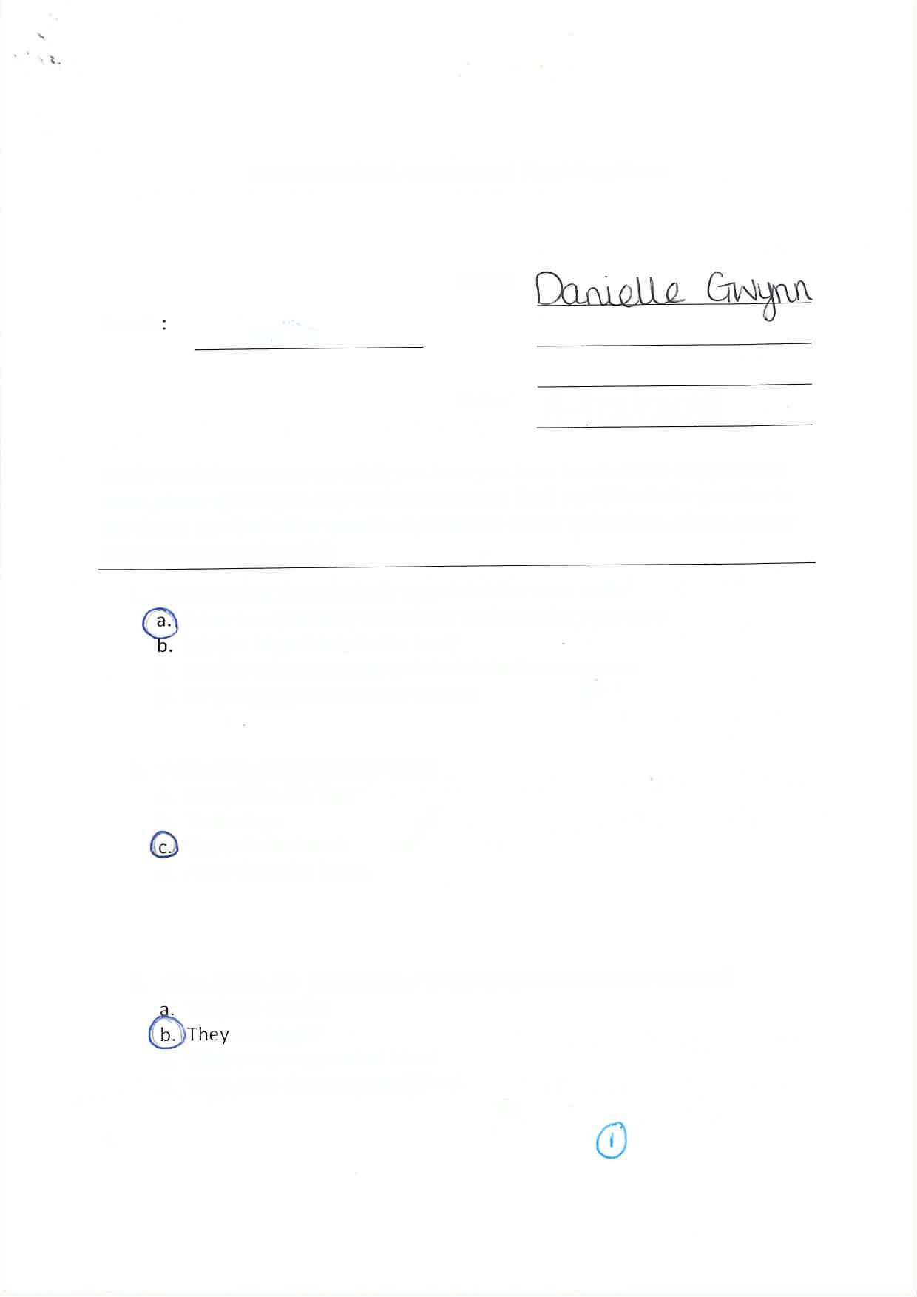
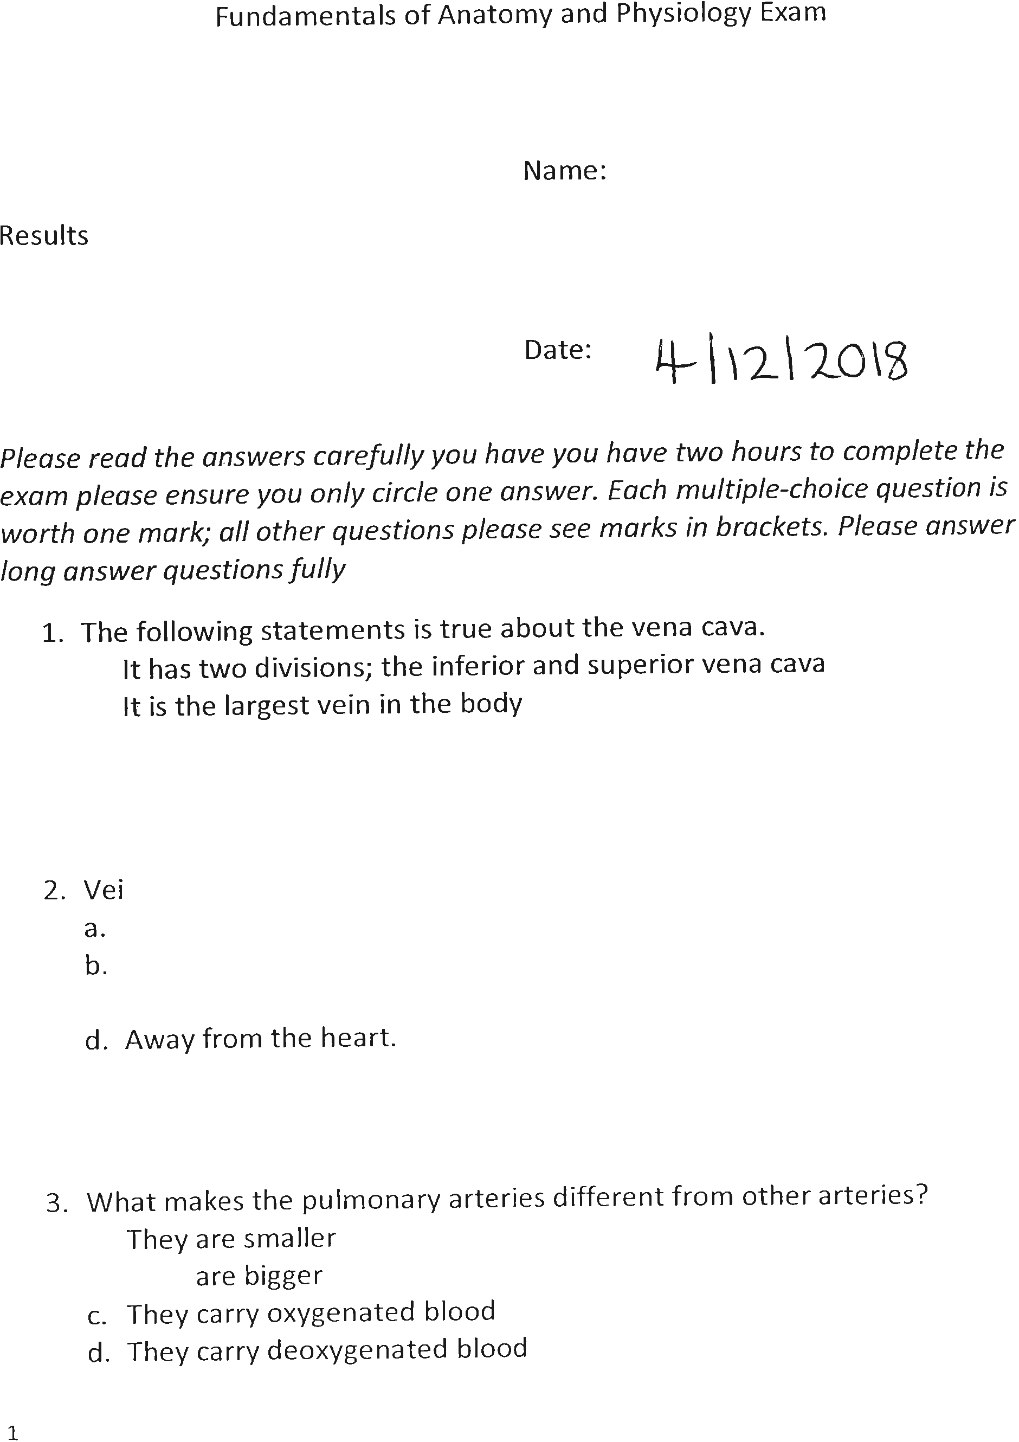

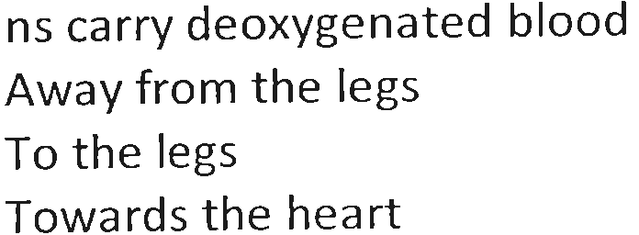

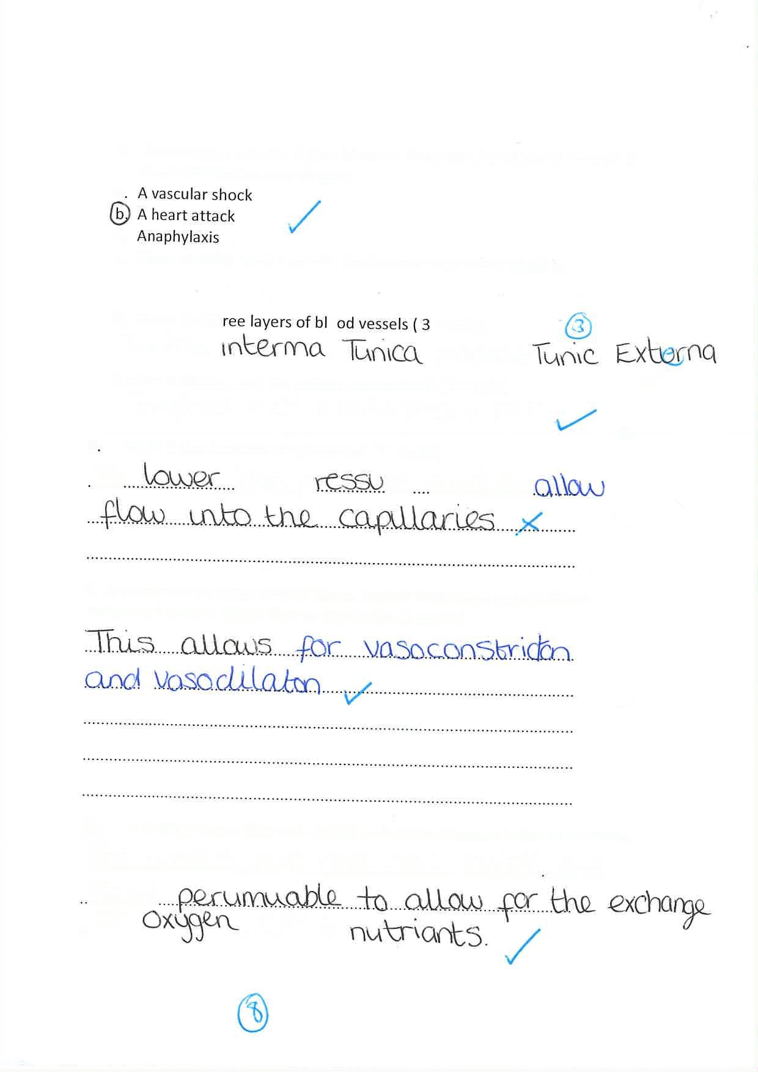
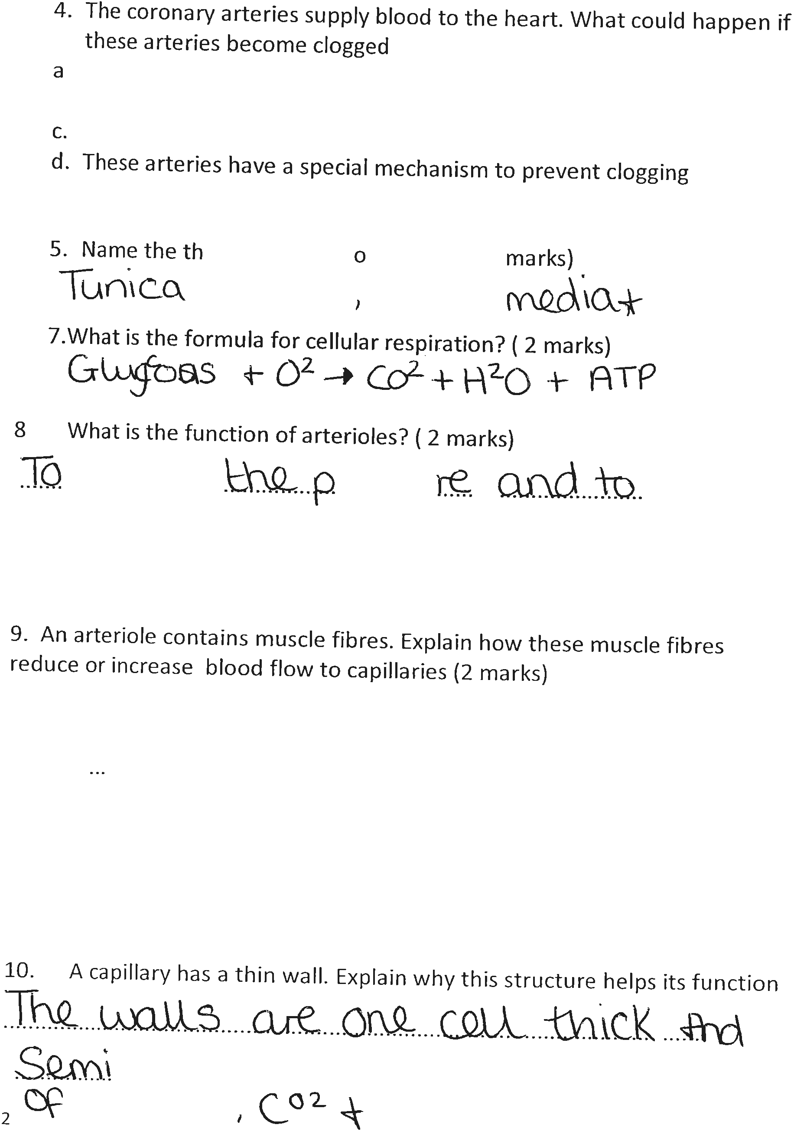


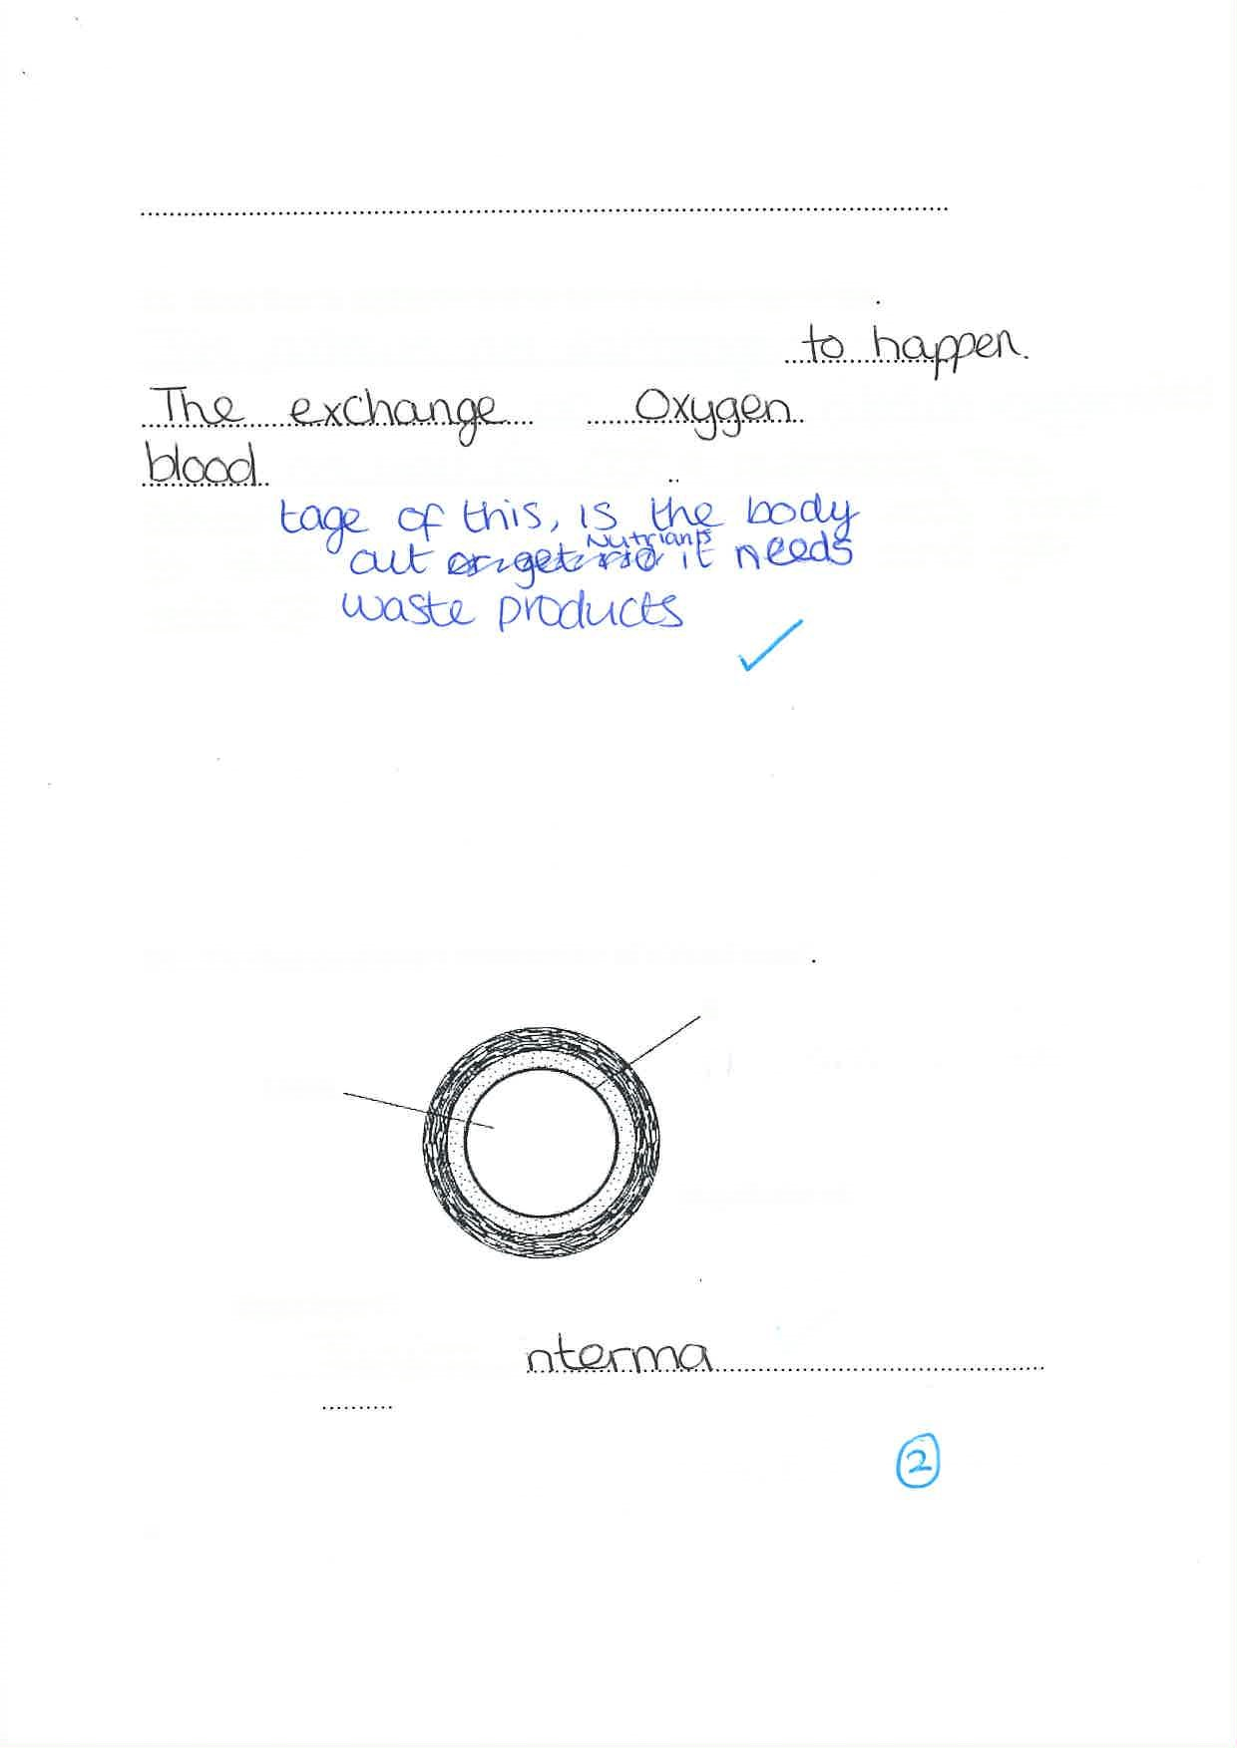
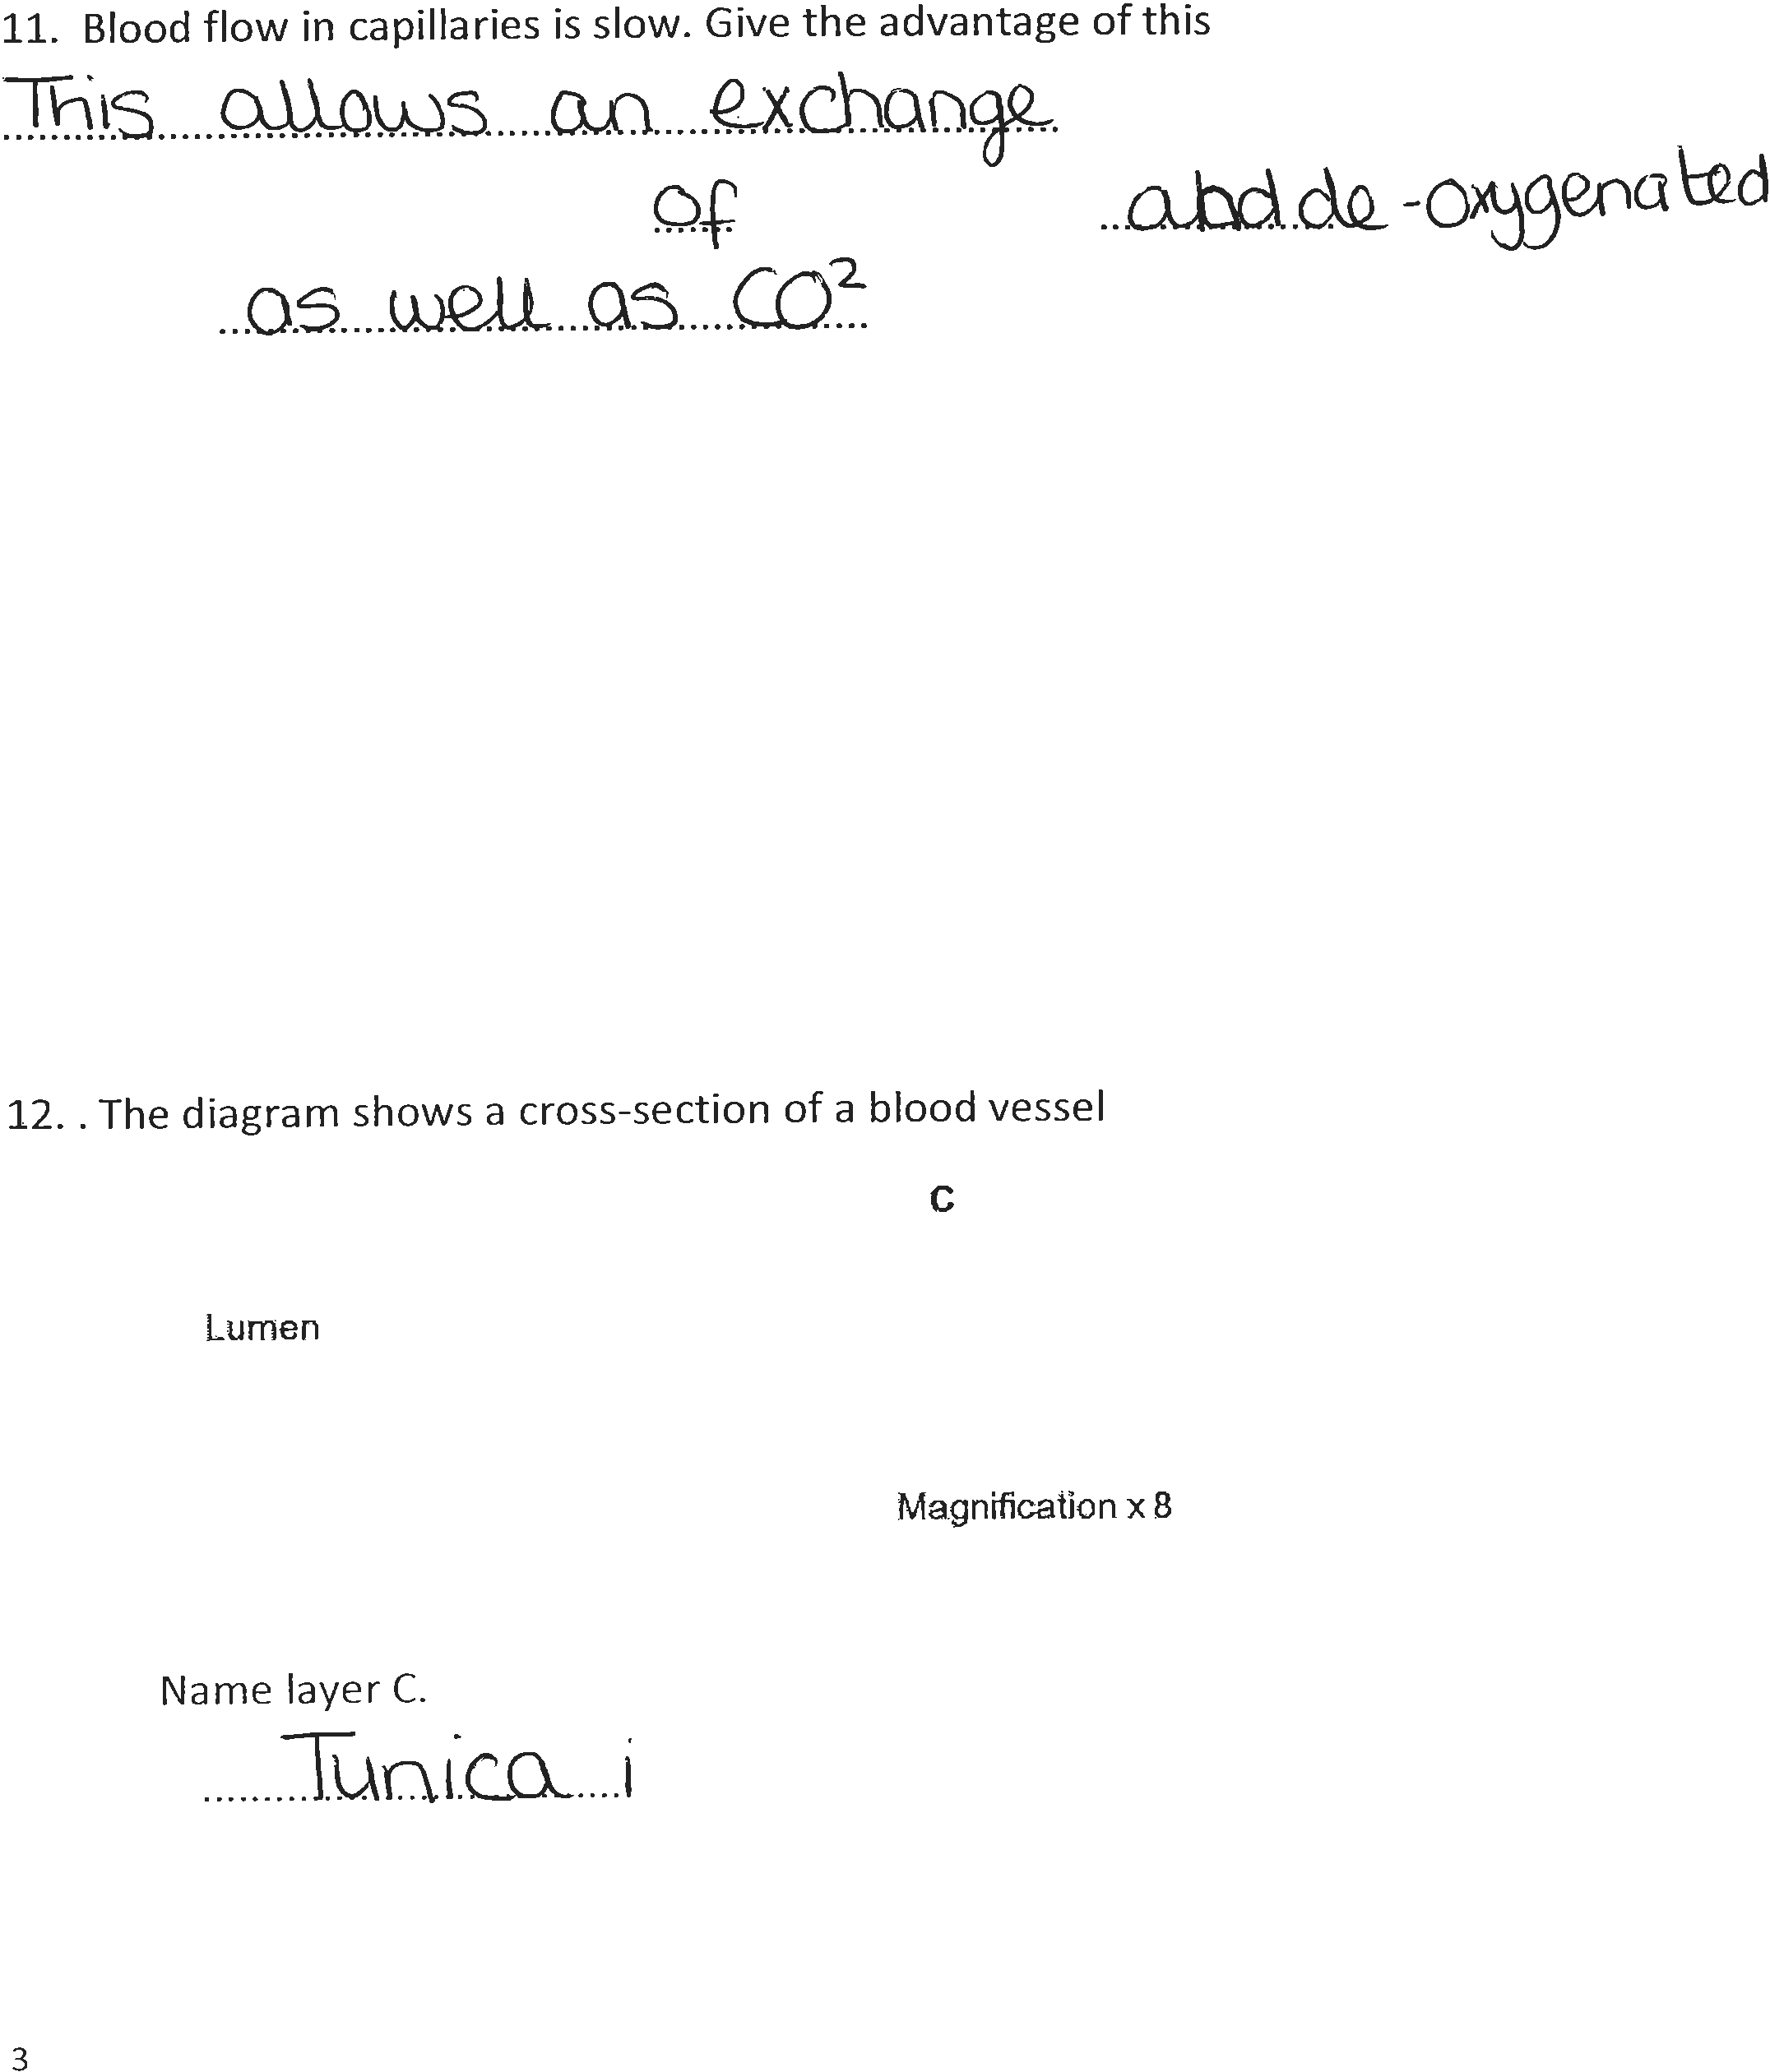


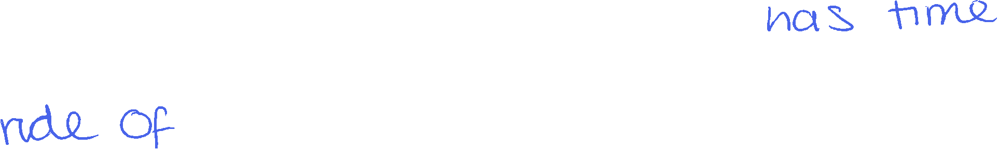

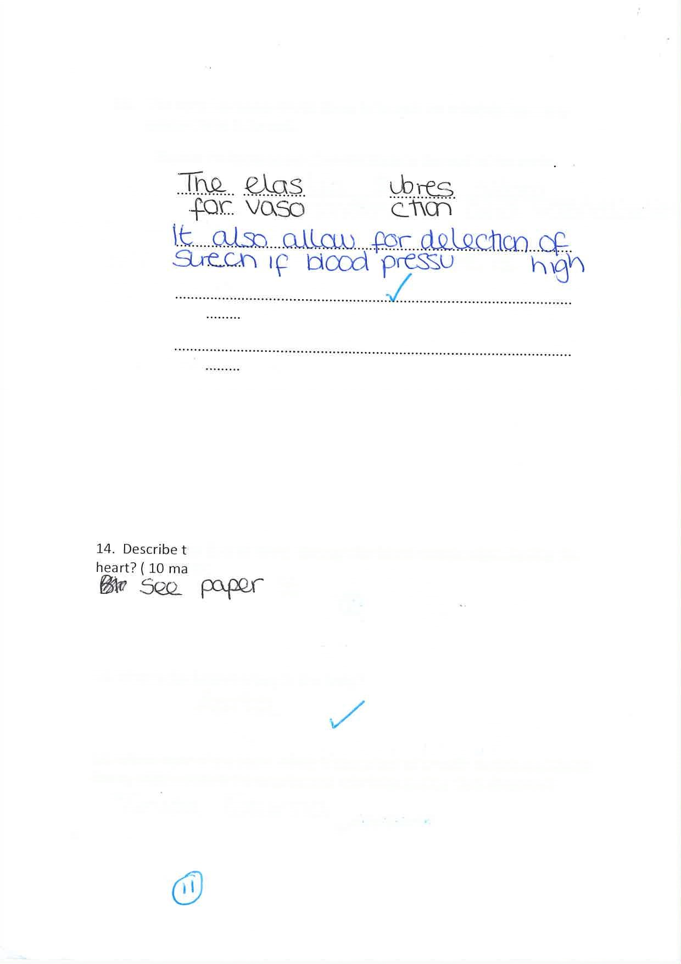
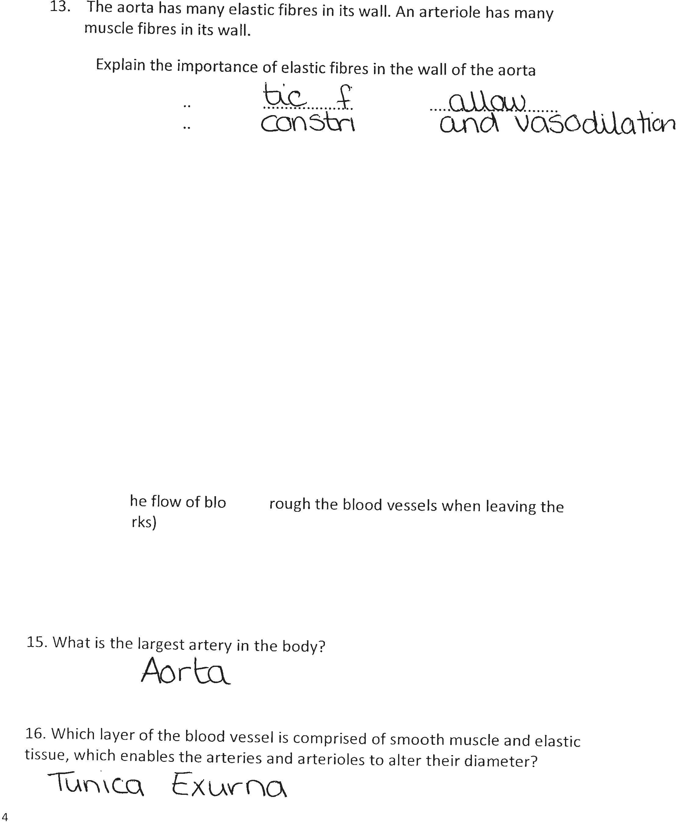




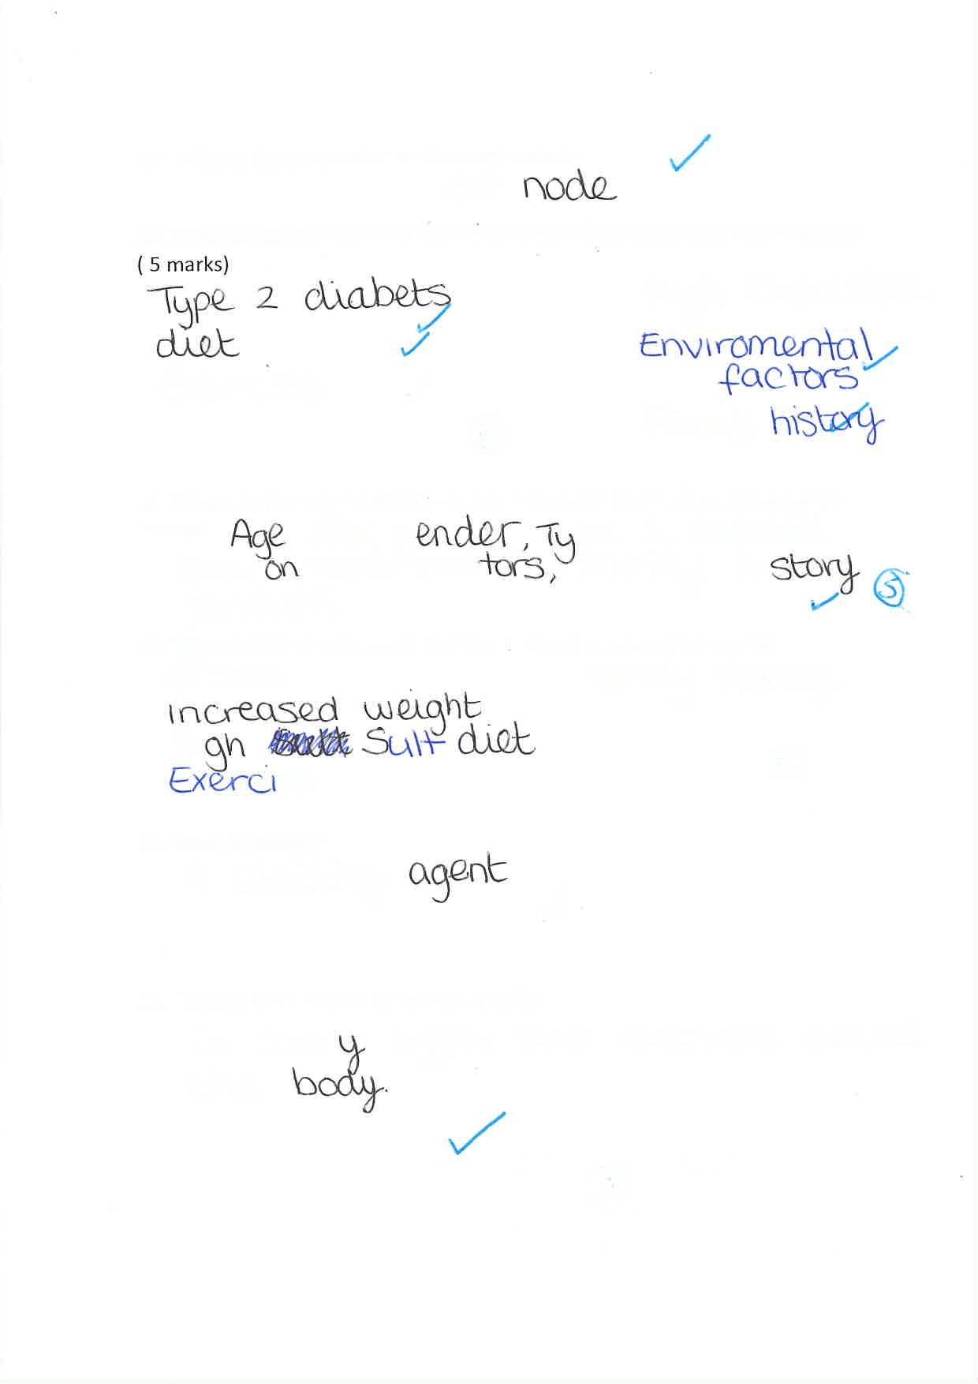
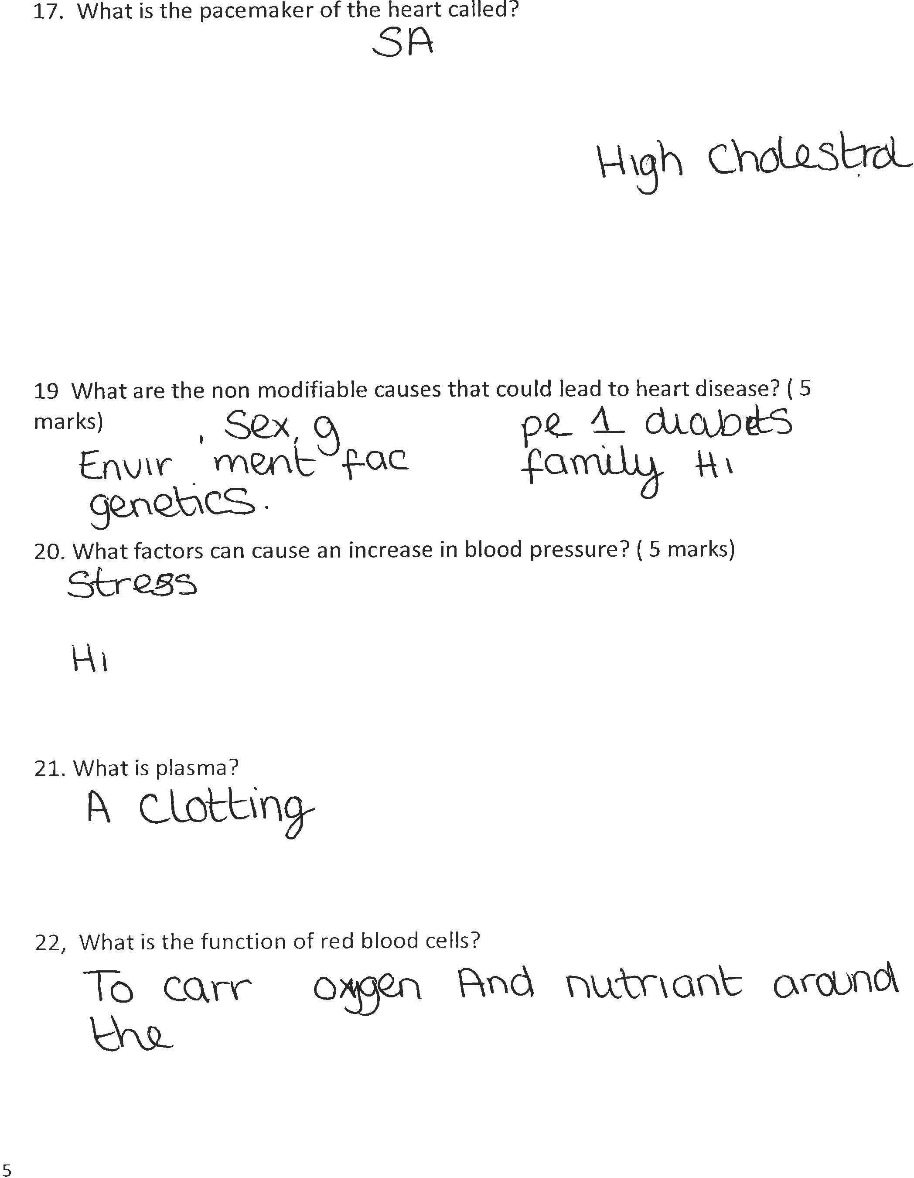






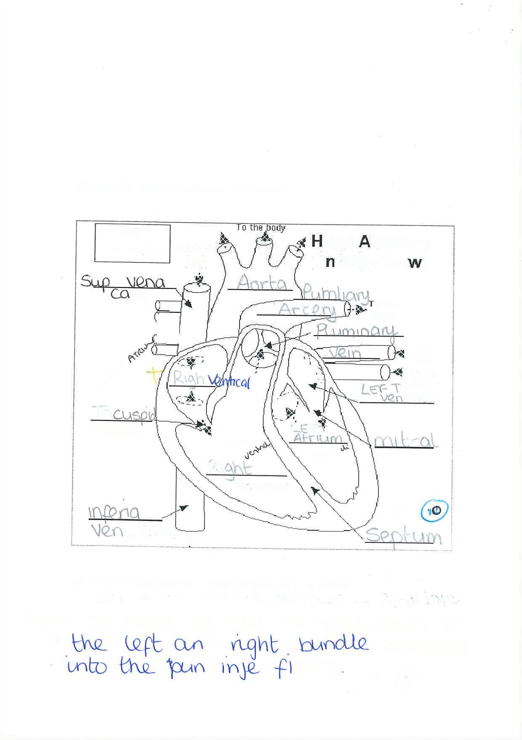
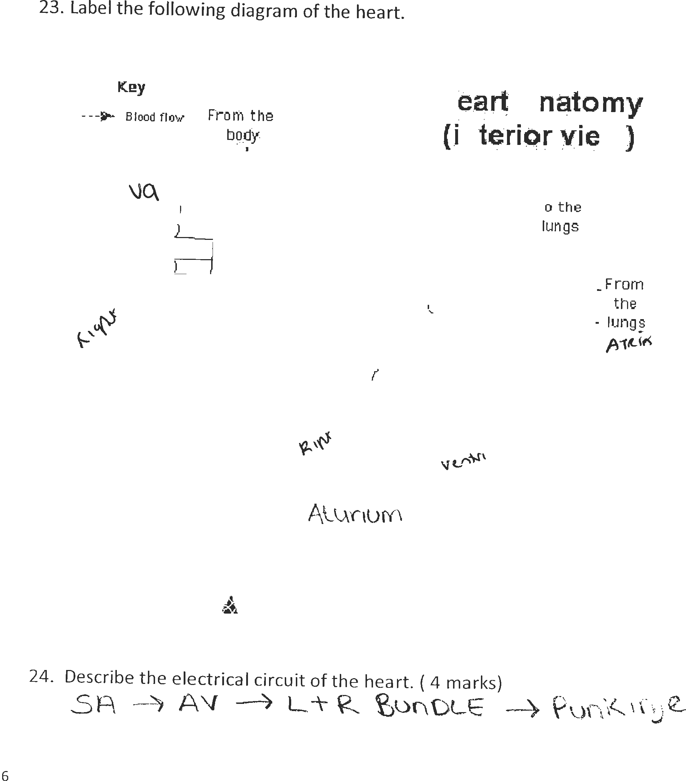




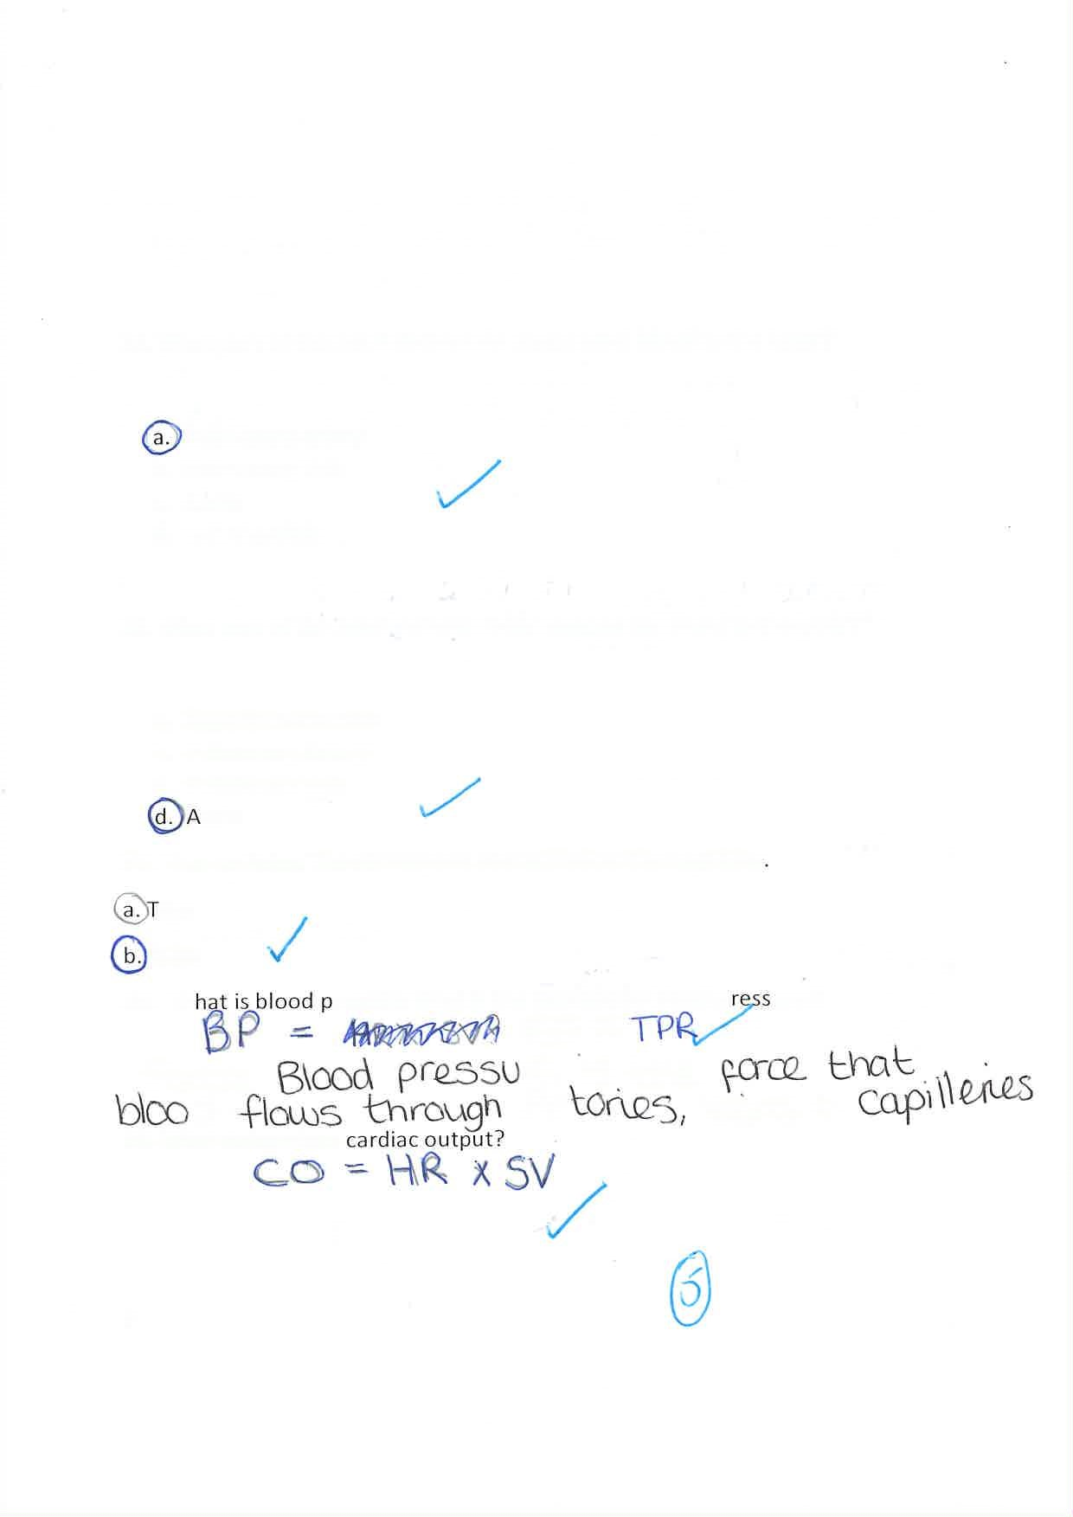
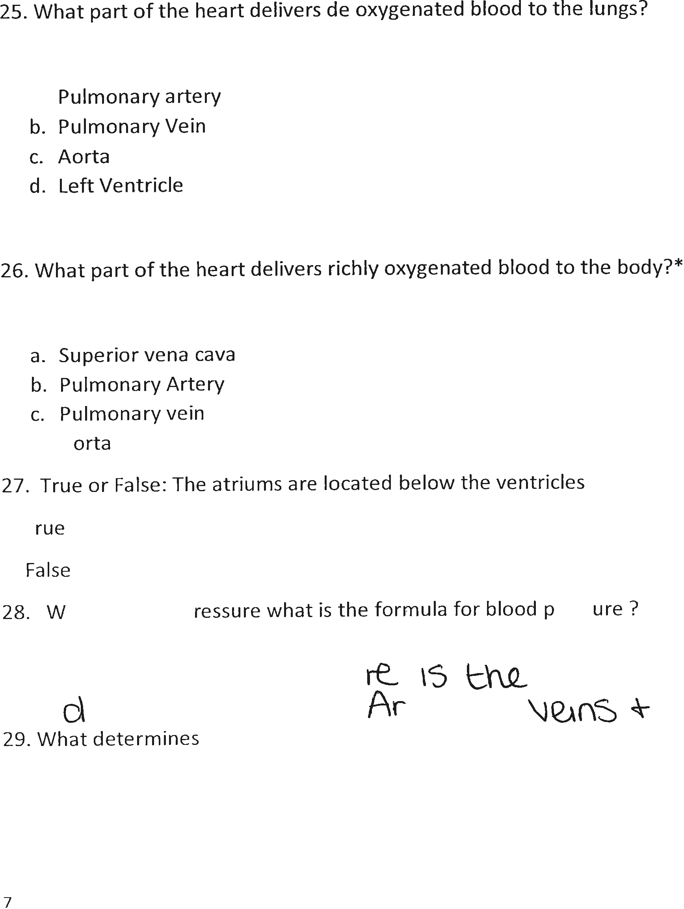


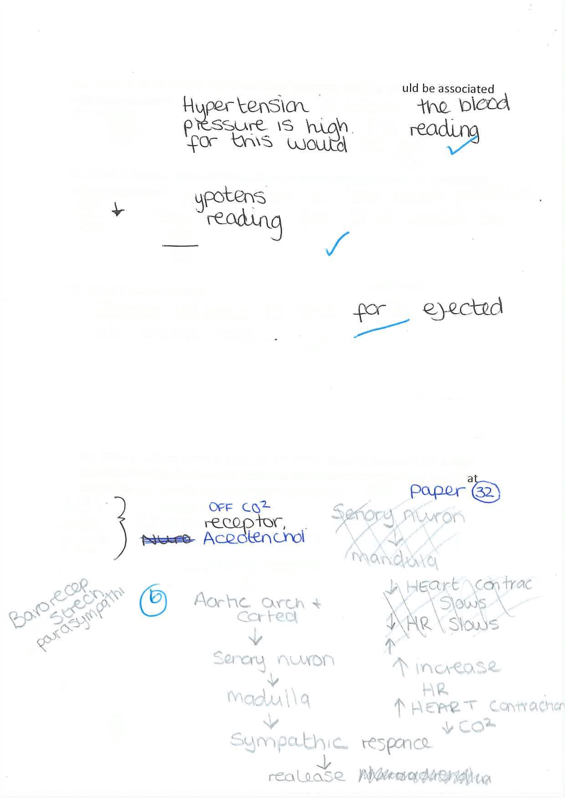

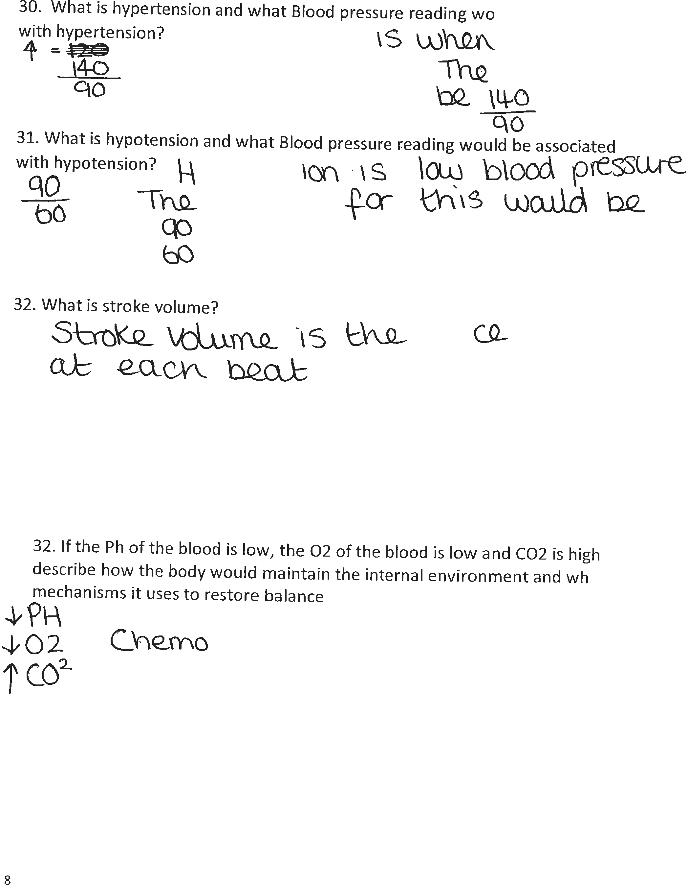





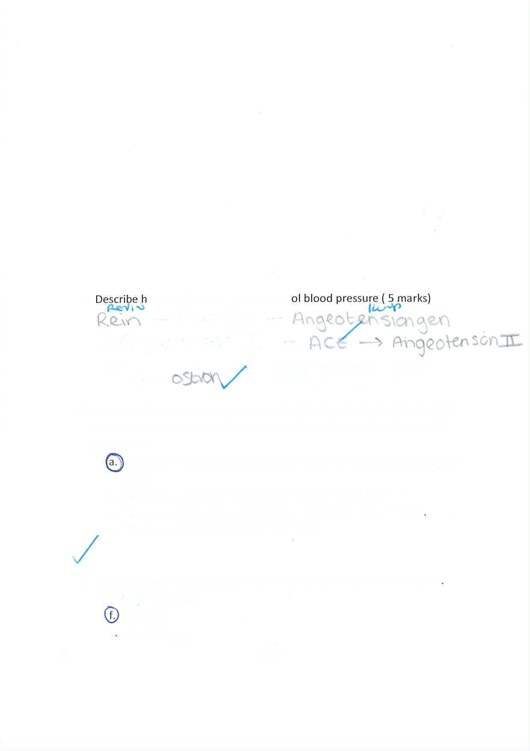
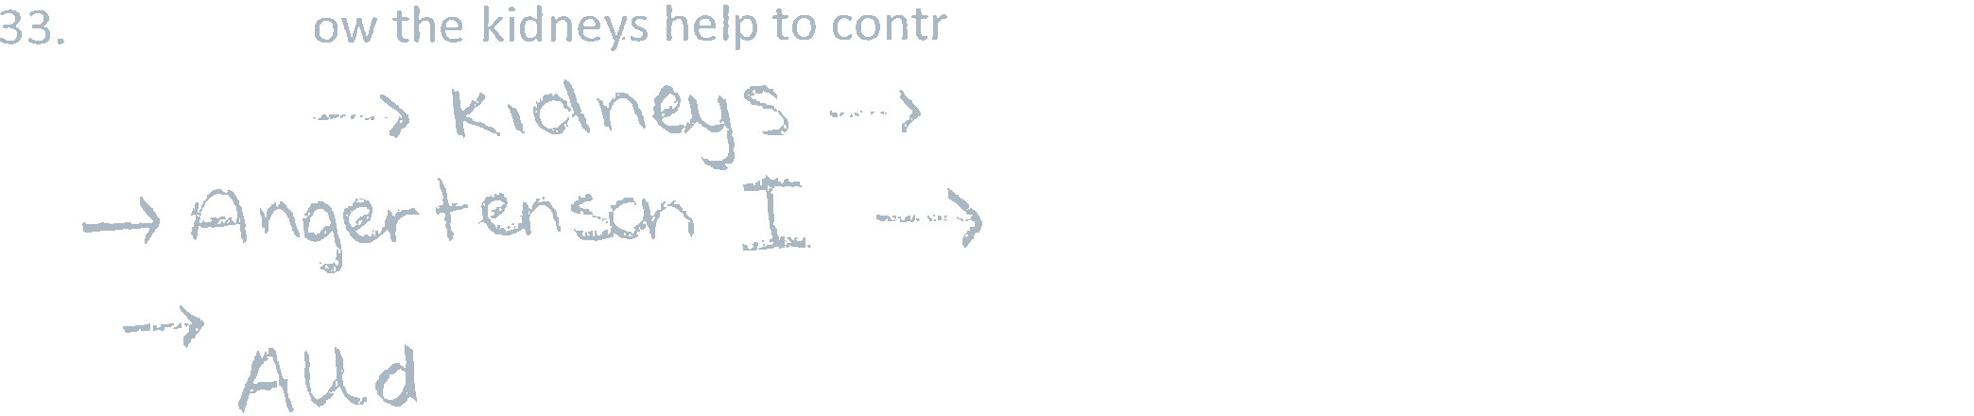

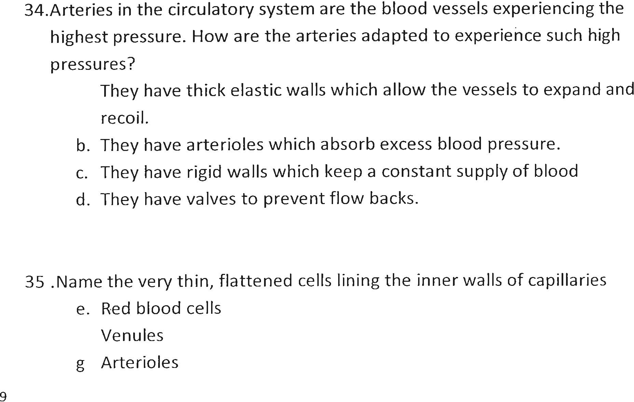


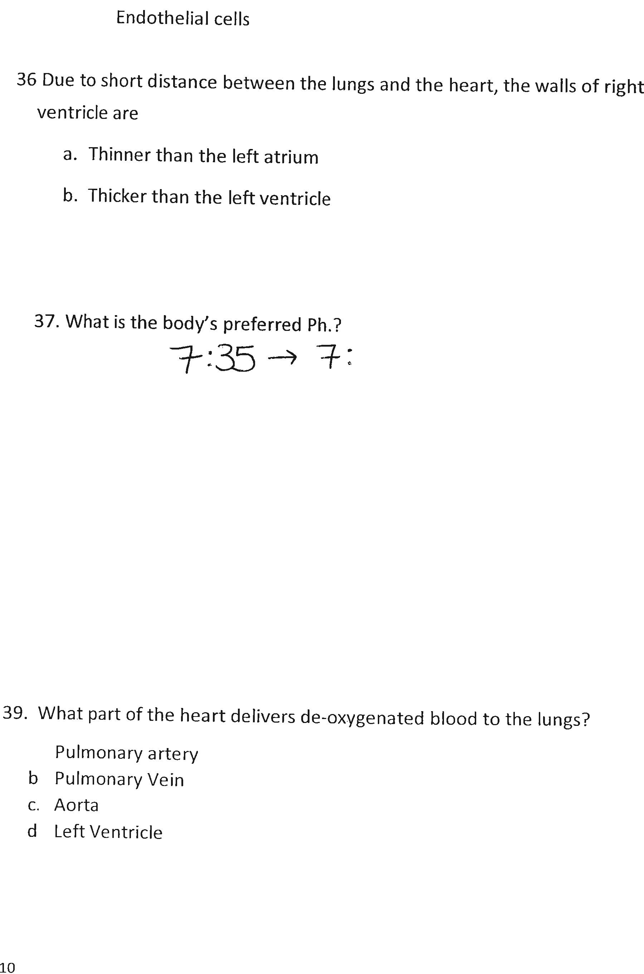


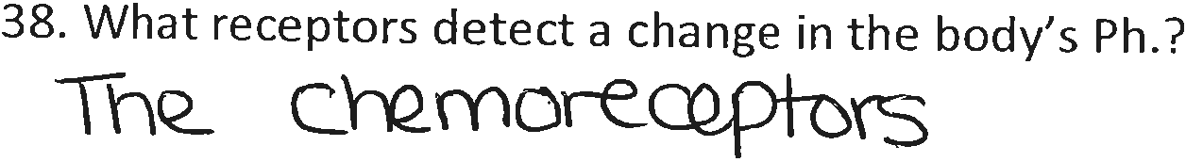


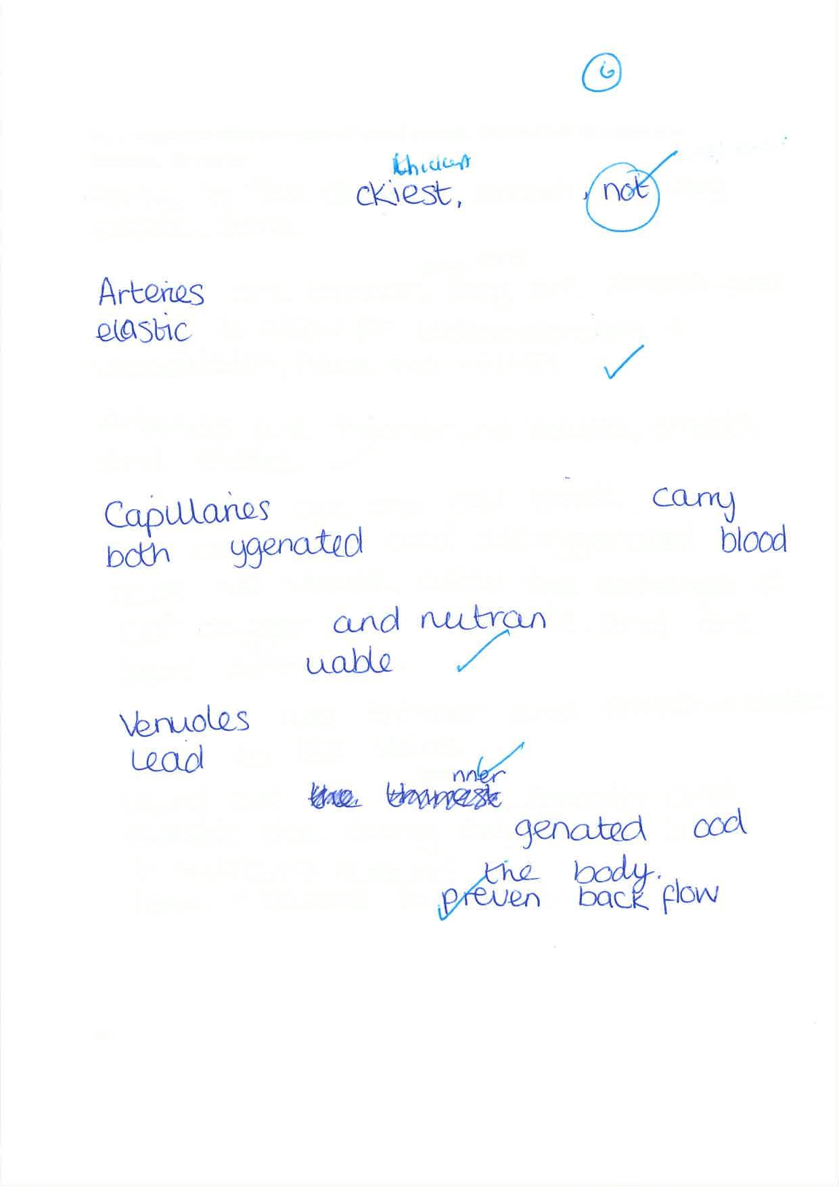
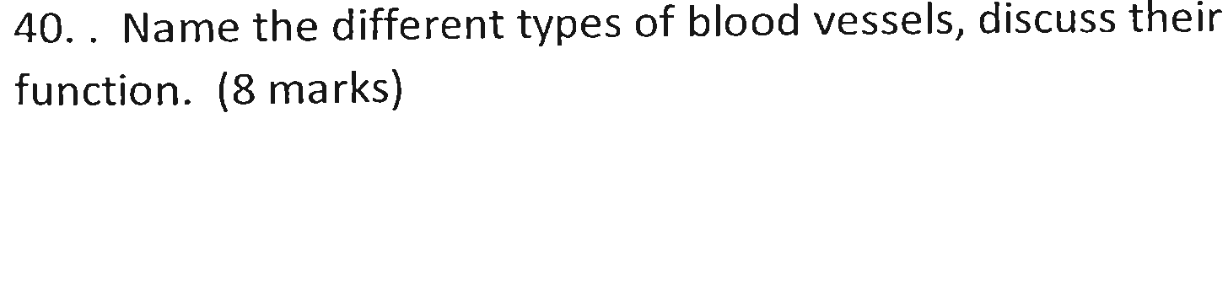



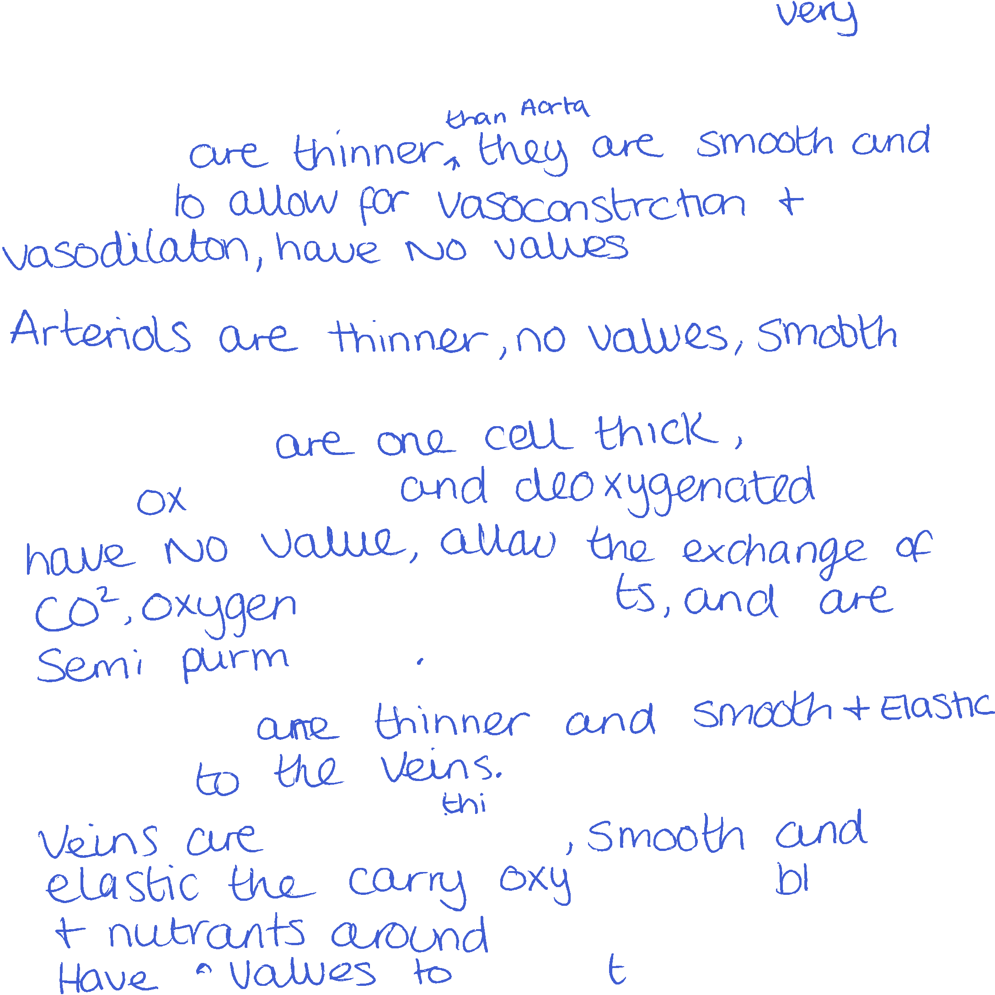
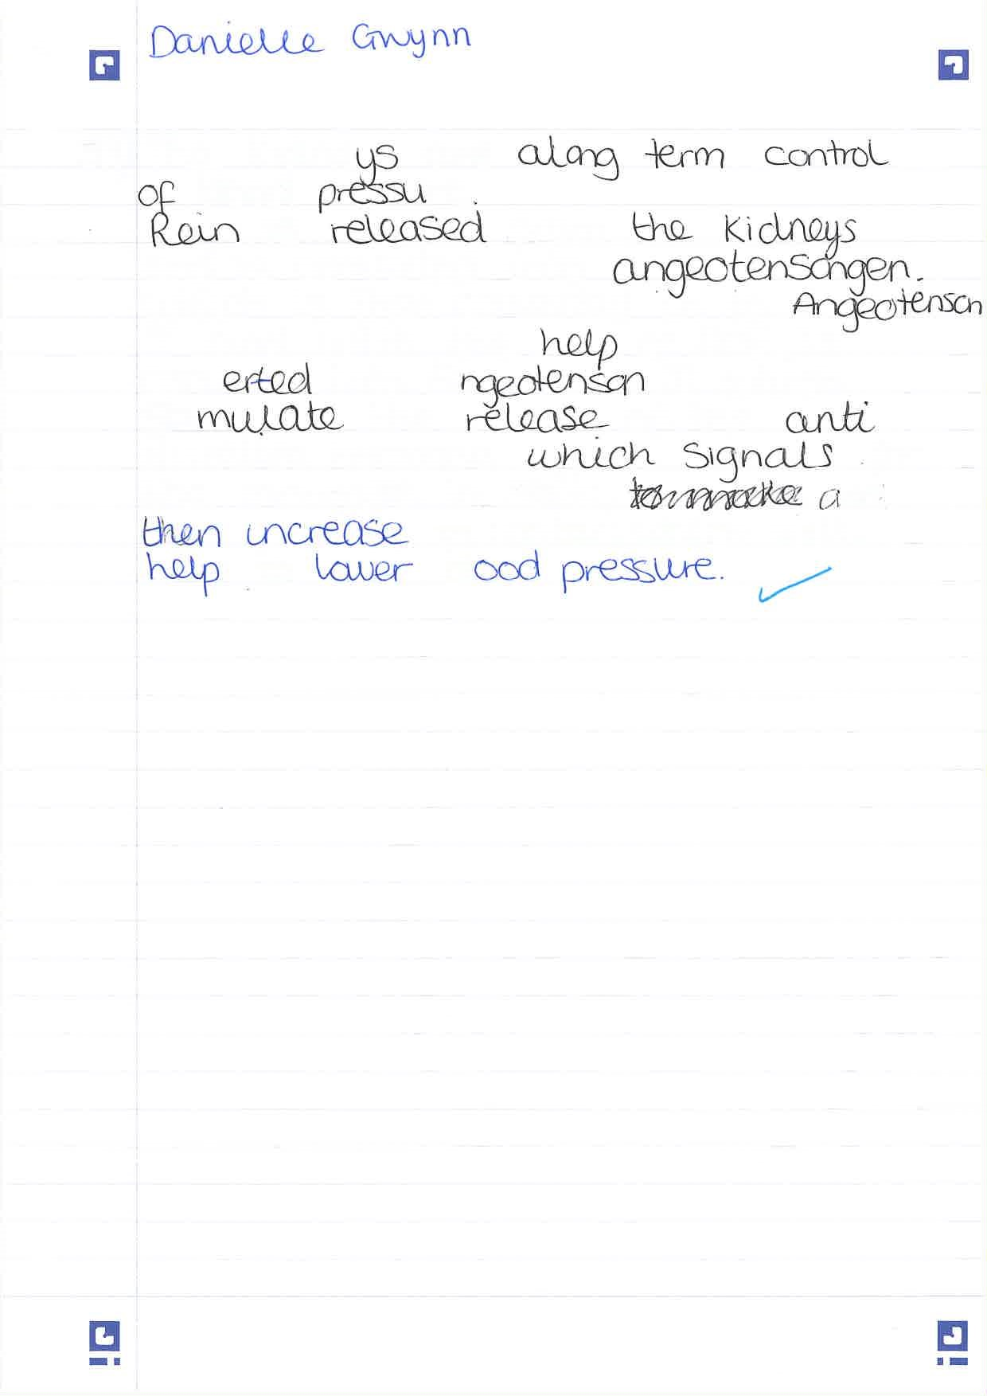
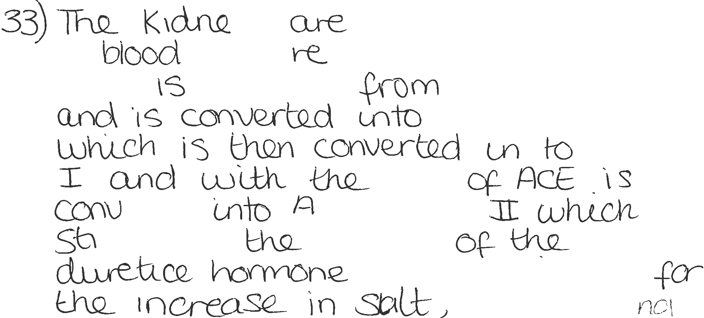

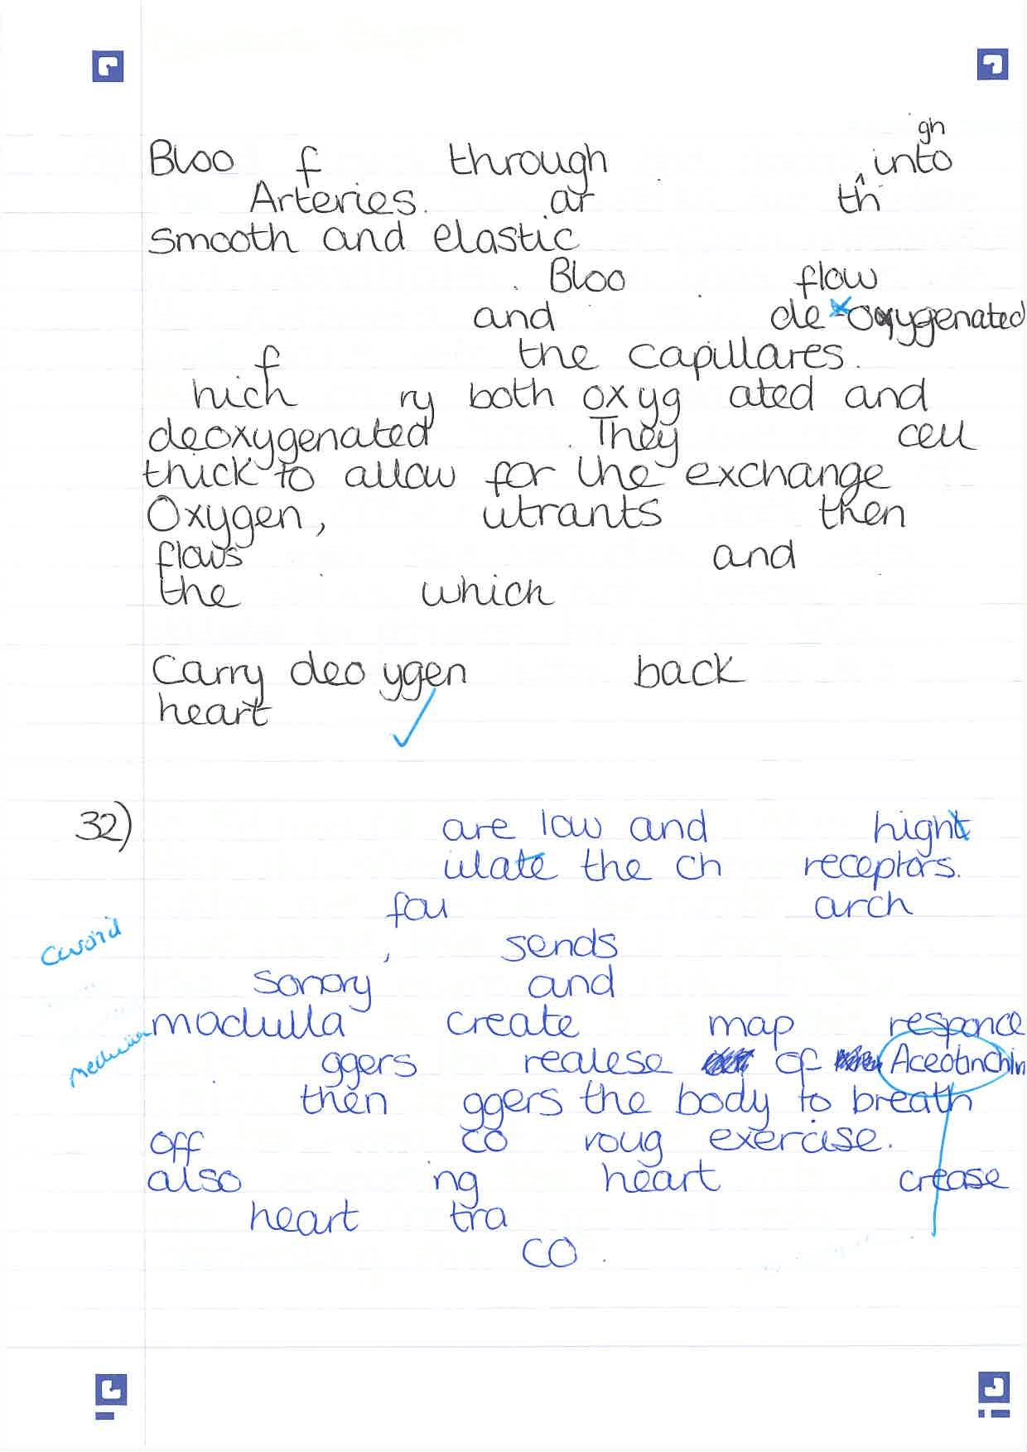
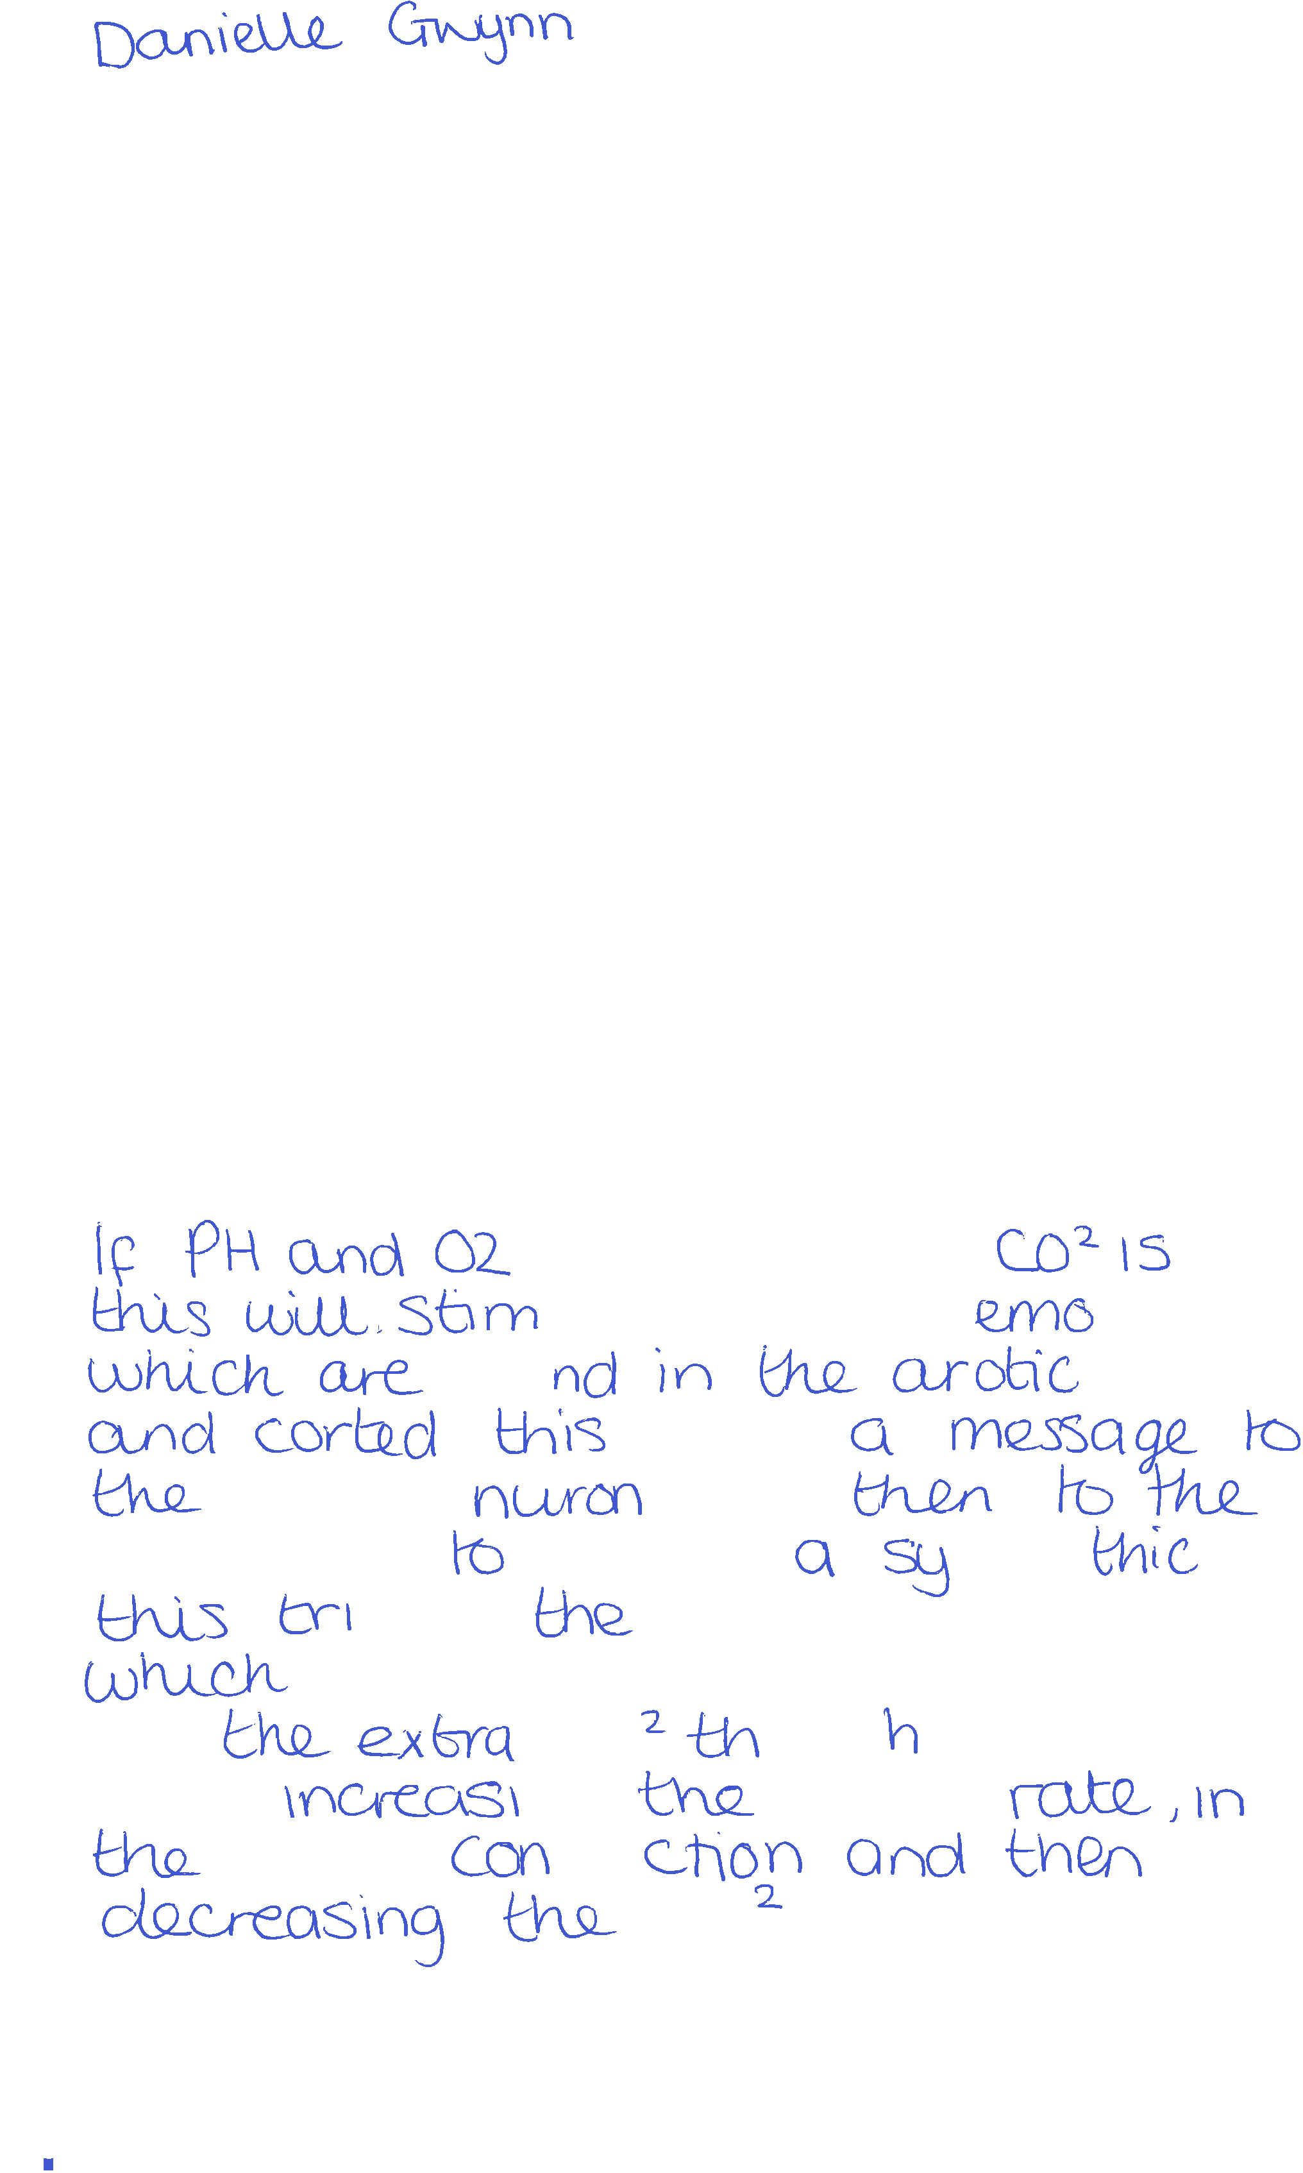
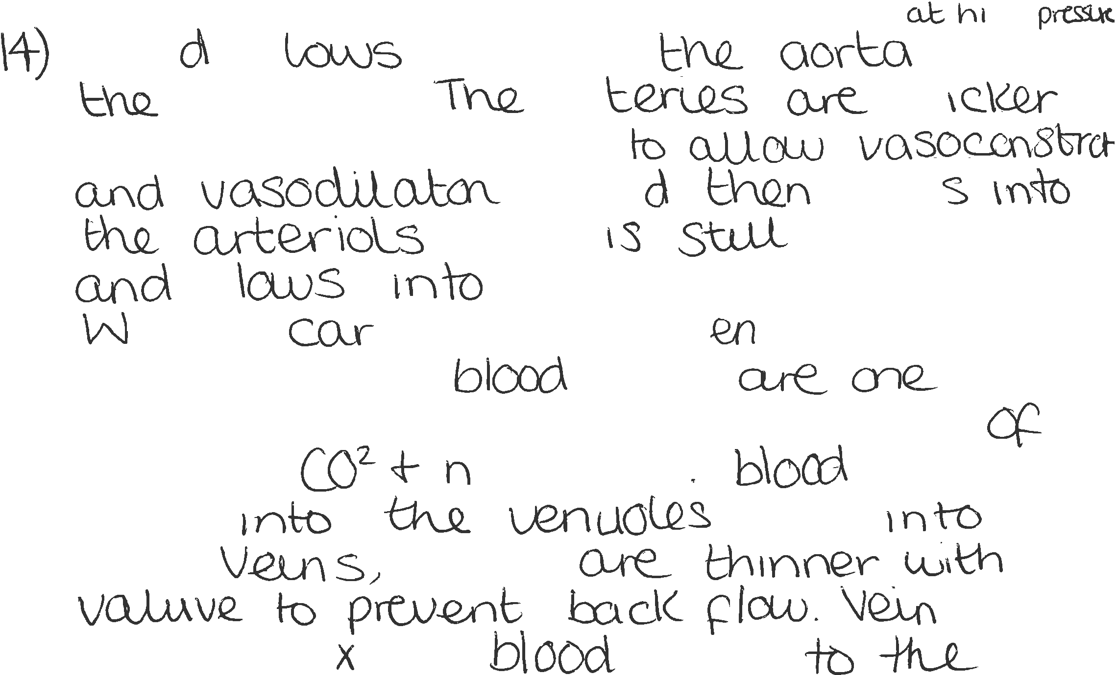



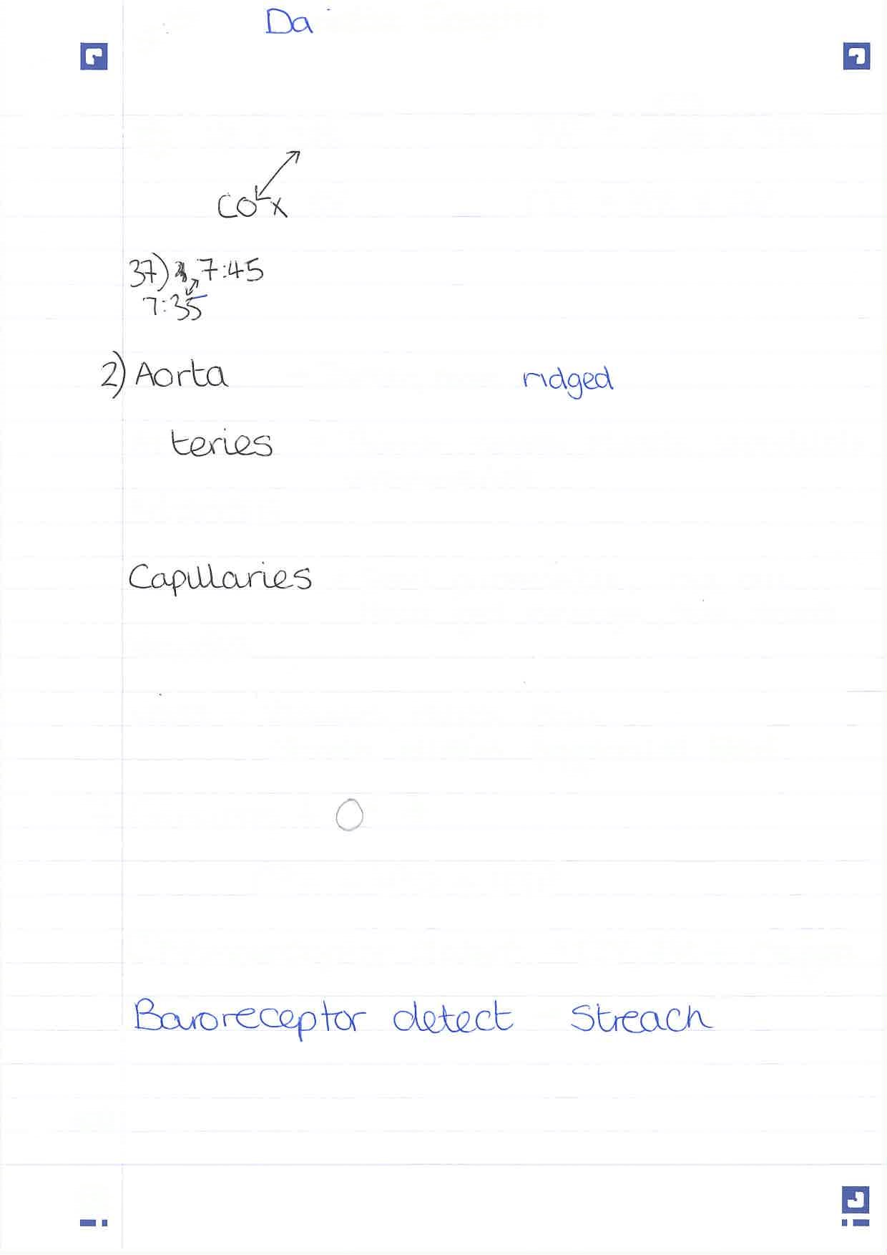


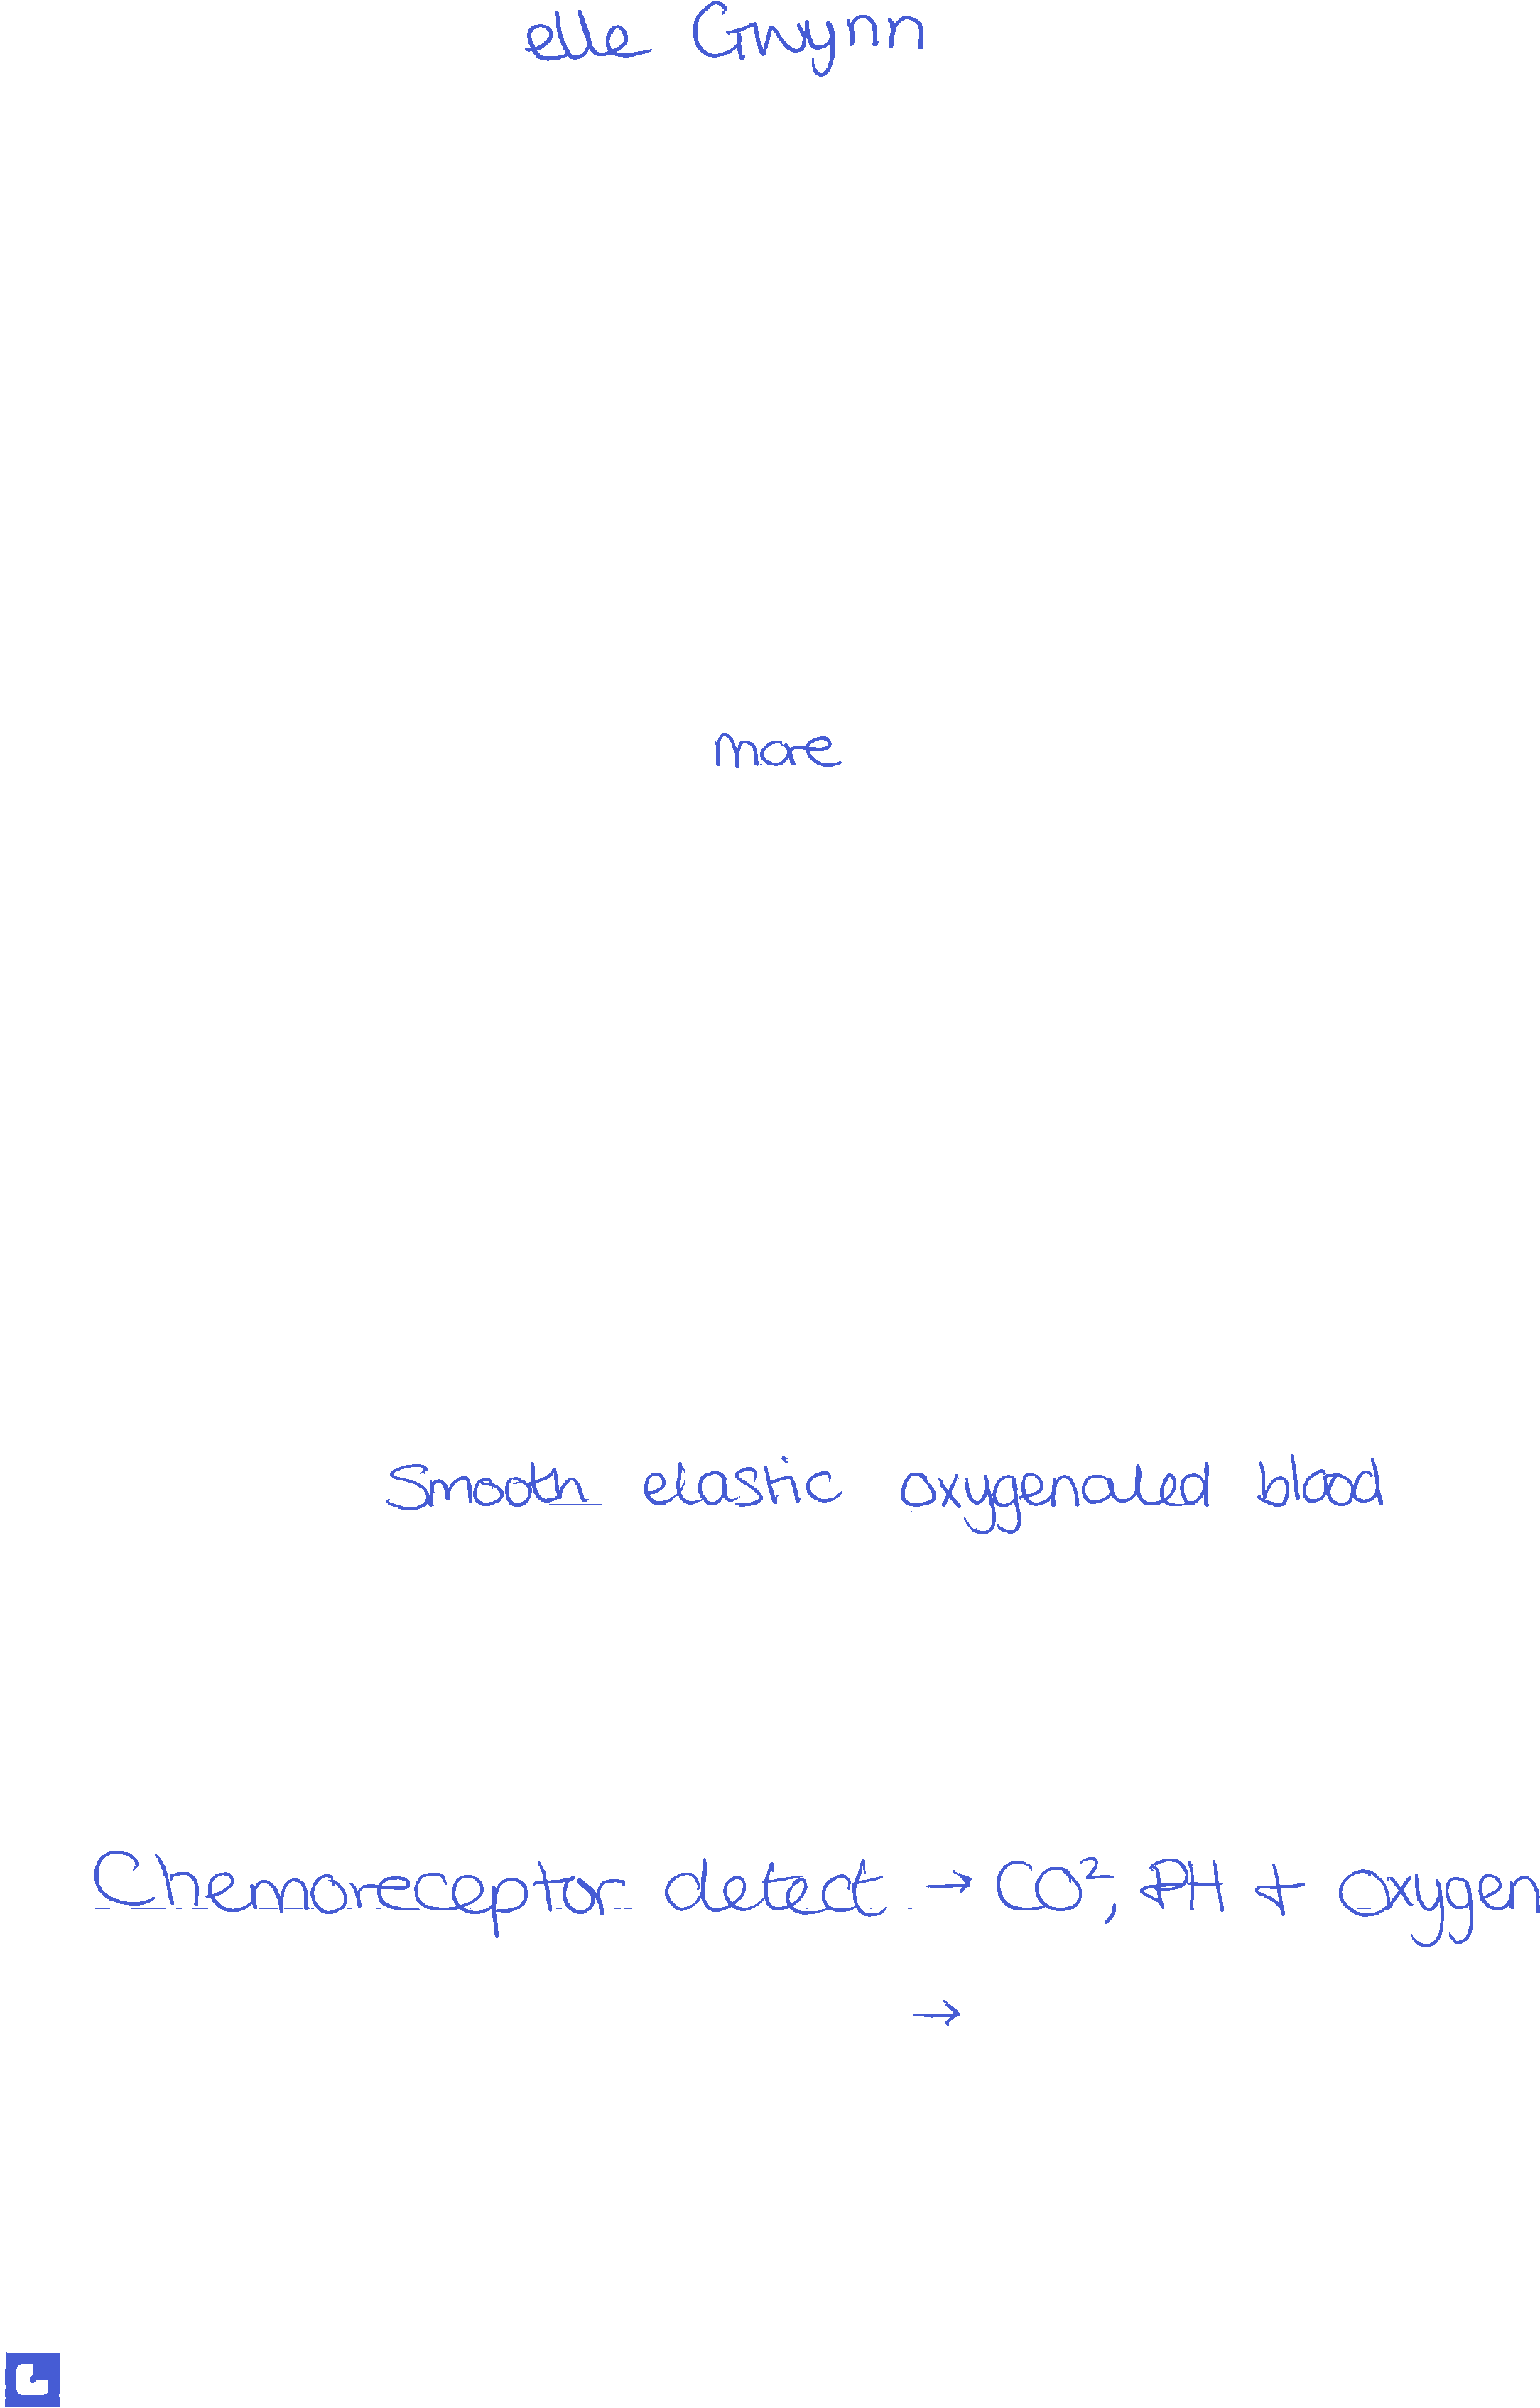
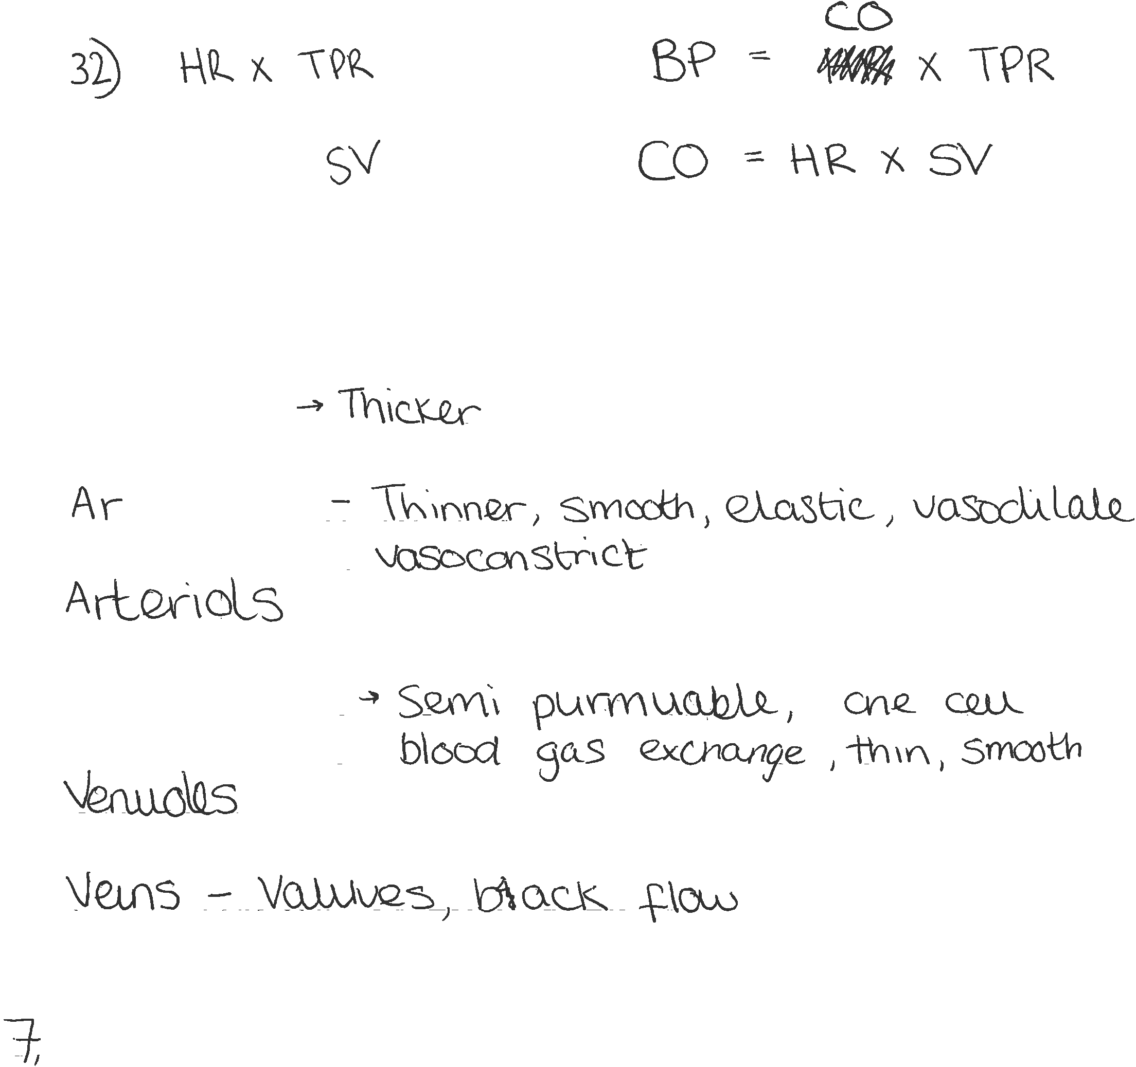


Student SELF FEEDBACK FORM LEVEL 4

You will need to submit AT LEAST ONE of these and link it to one of the assignments you are submitting. We recommend self-assessing your interview write up. Use the criteria on the last page below to help you self-assess.

Generic Assessment Criteria | Marks available | Marks  awarded
1. Engagement with Literature Skills
.
I feel that I can engage with the literature with good understanding of the topics. | 10 | 8
2. Knowledge and Understanding Skills

I feel that there is a good understanding of the topic covered. However, would struggle to re-sit this paper again and achieve the same mark, due to not retaining the information. | 20 | 15
3. Cognitive and Intellectual Skills

I feel there is good understanding of the concepts and there is more knowledge there if a time pressure was not present. | 20 | 15
4. Practical Application Skills

I feel these skills would be a basic stepping stone to a greater understanding of the topics covered. | 25 | 15
5. Transferable Skills for Life and Professional Practice

I feel that this information will provide a solid ground for further skills required. The work is clear, however could be jumbled in places due to the need to get the information down on paper. | 25 | 15

Assessment Mark (Assessment marks are subject to ratification at the Exam Board. These comments and marks are to give feedback on module work and are for guidance only until they are confirmed. ) | Late Submission Penalties (tick if appropriate) |  | %
 | Up to 1 week late (40% Max) |  | %
 | Over 1 week late (0%) |  | %

Example of Work 4-
Assignment 4- Report Witting

Contents Page

Abstract | Pg. 2
Introduction | Pg. 2
Findings | Pg. 2
Conclusion | Pg. 7
Recommendations | Pg.7
Appendix | Pg. 8
References | Pg. 10

Abstract
The purpose for this report is to highlight how management and leadership and the theory that relates to management practices used. This report will focus on the Nation Health Service and its structure. It will also address what culture is presently within the NHS and way effect this has had. It will consider the relationship between service uses and staff and the effects this has had. Finally, it will consider how staffing levels impact staff and patient care.

Introduction
This report will highlight the impact of effective leadership and management in relation to the motivation of employers in the National Health Service (NHS). It will also highlight the impact of the organisational structure and culture in supporting or hindering leadership and management within that setting. This report will also focus on the impact this could have on service users if the NHS employees are lacking in motivation. This report may also make recommendations for change, if appropriate within the NHS.

Findings
When looking at leadership and management it is important to define what this means. The term leadership can be difficult to define but it generally involves a relationship where one person has influence over how others behave (Mullins, 2002.) This suggests that leadership focuses on moving people and the organisation forward, with an emphasis on dealing with people, increasing the competency of staff and the way in which teams work together. Mullins (2013) defines management as an active process that has an impact on how people behave and makes things happen. Therefore, it can be suggested that while leadership is about influencing behaviour, management is more about the process of getting things done through other people. Moreover, in contrast, leadership is the way management methods and processes are used. Harvey-Jones (2003) argues that leadership and management are linked. Adair (2009) further states that an understanding of how they are linked is crucial in providing positive leadership.

When looking at the NHS, it is evident that its structure is complex. The structure of the NHS is predominantly from outside of a hospital and from The Secretary of State for Health. They have overall responsibility (NHS. 2019. NHS England). From there Responsibility falls to The Department of Health and Social care (DHSC) who are in control of ‘strategic leadership and funding’. Responsibility then cascades down to NHS England, and then to local authorities and primary care services such as General Practitioners (GPs). Finally, there are health boards which all have responsibilities for areas of care. This complex structure is before you have reached a hospital, which itself will have its own management and leadership team. (See Appendix 1)

Swansburg (1996) states that the theory of modern management has developed from the work of Fayol, who outlined several principles that he found useful when running a large organisation. However, it was also suggested that these principles could be applied to other forms of society such as “political, religious and philanthropic” (Bagad. 2009. Pg25) settings. Fayol outlined that there were four main elements of management and these are further divided into fourteen principles, including division of work, authority, discipline, unity of direction, remuneration of personnel, centralisation, scalar chain, order, equity, stability, initiative and subordination. Fayol theory is widely used today. When looking at the structure of the NHS Division of work would be essential for a large organisation with a large proportion of managers and leaders.
Adair (2009) states that on developing the Action-Centered Leadership Model, he reflected on Maslow’s Hierarchy of Needs and Herzberg’s Motivation theory, both of which look at achieving potential through motivation. This illustrates that Adair’s Action- centered leadership model uses the insight of the works of Maslow, Herzberg and Fayol and the thinking around human needs and motivation. When looking at the theory of managing organisations, Adair (1997) outlined three areas of leadership responsibility, these areas are “task need, team maintenance need and individual need” (Adair.1997. Pg16) These elements will overlap when managing the needs of individuals and also the needs of the group.(see appendix 2) Adair also goes on to express that because of these overlapping areas, if the team member does not feel able to complete the task outlined, then the team will suffer as a result and the task will be more difficult to complete. Therefore, to be able to succeed as a manager there is a need to command all three areas.

It is important to understand how the structure and culture of the NHS can support or hinder leadership and management within it. West et al (2014) explains that the NHS needs a highly professional and skilled level of leadership in order to deal successfully with the demands of financial and service pressures. Therefore, it can be suggested that the leadership and management model would need to be highly effective to support this thinking. However, it could also be argued that due to the number of apparent issues currently in the NHS this is not the case.

Schein (1992) states that a culture be a shared set of assumptions that become embedded in an organisation and ‘taken for granted’. This then shapes how the employers in that organisation work and respond to things. For instance, it could be argued that the concept of working longer and not being paid for this time has become a culture in the NHS and therefore expected of its employees. This theme was highlighted in the Royal College of Nurses Employment survey. This survey shows that 50% of nurses were not paid for the extra hours they have worked. (See Appendix 3) The report also highlights that there is a link between work pressures and pay and that this is closely linked to the pay not being matched with the reasonability expected of them. The “Trusted to Care” report by Andrews highlights that “the culture of care can be defined both by what care is provided and how it is provided” (2014. Pg10). Therefore, a culture can be how care is provided both in the sense of good care and poor care. This culture is often shared between staff and be as a result of expectations on them being high and the number of staff being low. The Andrew’s (2014) report suggests that service users are being provided with poor experiences in hospital, an anonymous quote from service users and staff were used throughout. It was stated that this was because of staff shortages due to suspensions and illness.

Mullins (1999) explains that “The relationship between organisations and their workforces is governed by what motivates individuals to work at their best and the satisfaction they derive from their activities”. When looking at The Francis report, it illustrates that a shift in culture is needed to “end the climate of fear, bullying and harassment that can stop clinicians from speaking out against poor care” (2013.Pg1) It goes onto explain that it is important for staff and management to jointly promote a new culture of being able to raise concerns and that this behavior is acceptable and positive. Furthermore, the NHS is moving towards “Collective leadership” (West et al, 2014. Pg5) and this means creating a new culture of everyone taking responsibility for the success of the organisation and not just for their own job or work area. (West et al, 2014)
In accordance with Schin’s (2016) thinking, an organisation has three levels of culture. “Artifacts “are the surface or outer edges of the organisation. These are visual elements such as the organisation logo, the building structures and the clothing. “Espoused Values”, are elements of the organisation that surround its standards, values and the code of conduct, these values are not visible. Lastly “Basic Underlaying Assumptions” are often core values of culture that are deeply embedded in the organisation. Schein believed that discussions were needed with as many employees as possible to discover the underlying culture and the background. Schien also believed that a behavioural culture had to be unlearnt first before a new one could be learnt in its place. (Schein, 2010) When applying the thinking of Schein, it can be argued that many of the culture issues within the NHS are deep rooted and would fall into Schien thinking that they are Basic Underlaying Assumptions. Therefore, for this culture within the NHS to change, the current cultures need to be unlearnt.

When considering the relationships between employees and service users, West et al (2104. Pg5) argues that “every interaction in an organisation both reveals and shapes its culture” In the NHS today it seems that many of the interactions between service users and staff are presented the way they are due to a culture of ‘this is how it was always done before’ and therefore is normalised (Department of Health , 2015 )
This is evident from the findings of the Francis Report where a “weak board driven by national demands” meaning those managing those staff below them, therefore created a “toxic culture” where the focus was meeting targets and balancing finances. The primary aim was not to care for service users but to meet targets and financial issue in the hospital. (Department of Health, 2015) Furthermore, when considering Mintzberg’s theory of managerial Roles, there are 10 roles or behaviours that can be used when categorising the role of a manager. These include “a Figurehead, leader, liaison, monitor, disseminator, spokesperson, entrepreneur, disturbance handler, resource allocator and negotiator” (Christy. 2013. Pg436). These are then grouped together into three groups, these are interpersonal where the manager manages thorough people, Informational, when the manager manages through the information that is acquired and decisional, when the manager manages through action. (Christy. 2013) Therefore, when applying Mintzberg theory to the structure of the NHS, it could be argued that nurses are expected to be “leaders”. Mullins suggests that this is the “most significant of roles” (2013, Pg.436) and are expected to motivative, guide and be responsible for staffing levels, while also fulfilling the nursing role.

According to McGregor (1960) “a motivated and supported workforce will create challenges for themselves to achieve organisational objectives”. Therefore, in effective leadership and management, as outlined by McGregor, X Theory expresses that the manager believes that the workers do not want to work very hard and that the manager needs to impose strict rules, constant supervision and a threat of punishment (Weiss, 2014). However, McGregor also notes that this attitude can become self-fulfilling, in that staff then tend to become passive and reliant on being told what to (Schermerhorn. 2010) It could be argued that this theory is reflected within the NHS structure as the management has often focused on meeting targets such a waiting times and managing budget restrictions therefore, the consequences of these actions are overstretched staff, that feel undervalued and as a result become poorly motivated and perhaps too afraid to show initiative . The nursing profession has noted that the job role has changed. They are expected to do far more paper work including care plans and recording charts, as well as an increase in tasks that doctors are not willing to do such as taking blood. Therefore, these elements do not make the job rewarding. The NHS is fundamentally known for being under staffed, this is more evident with increased work load. The National Institute for Health and Care Excellence (NICE) developed safe staffing levels on wards. These guidelines suggest a safe level of staff are needed to be able to provide quality of care. Although the NICE guidance does not specifically say what the staff to patient ratio should be, they suggest that the risk of harm to patients increases if one nurse has more than eight patients. (NHS,2016). This is further supported by the Francis Report. It highlights “chronic under staffing” became a way to meet the financial pressure the hospital was subjected to by the health board. (Department of Health, 2014. Pg22) Moreover, Herzberg outlines (1968, Pg11) “motivation is a function of growth from getting intrinsic rewards out of interesting and challenging work”. Herzberg expressed that job satisfaction was more important and not increasing the workload. This was believed to be key to motivating employees to work. (Herzberg 1968). The NHS can only be effective and successful if they have the cooperation and willingness of motivated staff (Domey, 2016). It has been cited that there are a number of reasons for staff shortages in the NHS such as poor pay, stress in the work place, and low job status. (Madi and Mabel, 2002) This creates a feeling of dissatisfaction and in turn lowers staff morale and increases staff turnover, thus increasing costs. Moreover, McGregor’s Y Theory would argue that if staff are given more responsibility and freedom in carrying out the roles, they would then be more motivated and happier in their job and therefore less inclined to leave. (Schermerhorn. 2010)

The NHS in England and Wales has seen a number of high-profile scandals centered around Quality and Safety of care. The “Francis Report” evolved, then the “Andrew’s Report” followed and from this came the “Trusted to Care” report (2014). These reports give an insight into institutional and cultural failures. Woods et Al (2017) state large scale failures of control and leadership at multiple levels, from what social scientists’ term as the ‘blunt end’ where decisions, policies, rules, regulations, resources and incentives are generated, through to the sharp end, often known as the front line, where care is provided to patients.

Conclusion
Therefore, to conclude, when looking at why leadership and management within the National Health Service is important it can be suggested that it is vital to the way the oranganisation functions.

Recommendations
- Improve the way targets and financial pressures are translated down to staff on the frontline.
- Reduce nursing work load to make it feel more manageable.
- Improve staff moral particularly amongst nursing staff.

Appendix
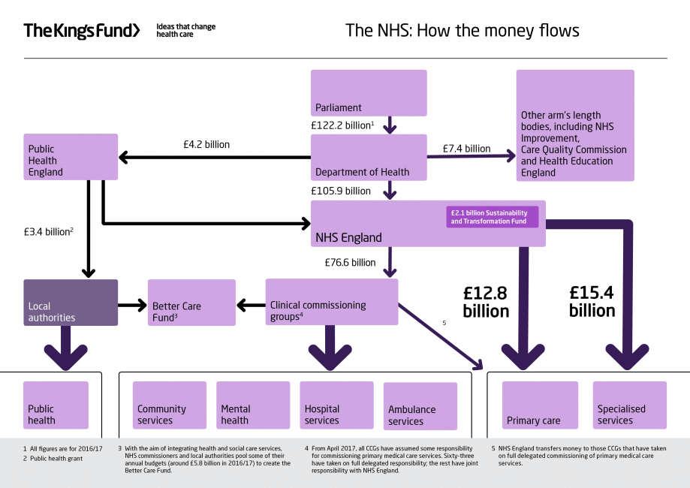

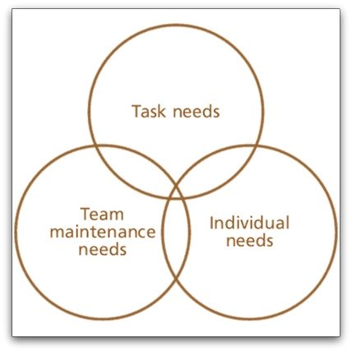
2.

- 6.1.1 Most nursing staff work additional hours, much of which is unpaid
The majority of nurses (71%) reported working additional hours at least once a week and this has increased substantially from 10 years ago, when only 58 per cent reported working additional hours. Fifteen per cent worked additional hours on every shift, 35 per cent did so several times a week, 22 per cent did this once a week, and 21 per cent reported working additional hours less than once a week. Just seven per cent of nurses did not work additional hours (Figure 6.1).

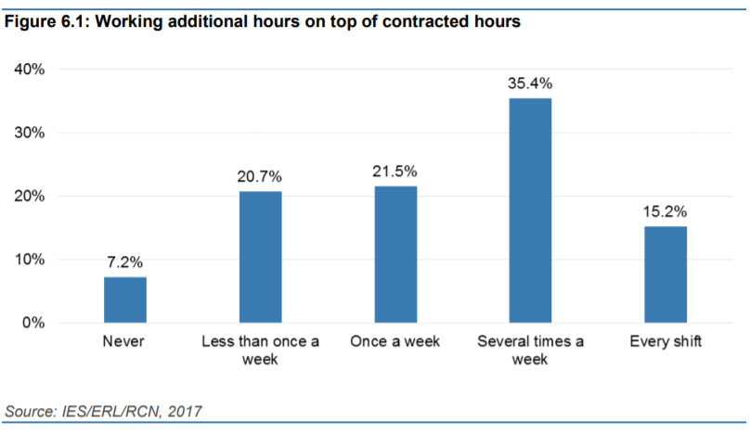

References

Adair, J. (2009) How to Grow Leaders. Kogan Page: Great Britain.

Adair, J. 2009. Leadership and Motivation: The Fifty-Fifty Rule and the Eight Key Principles of Motivating Others. Kogan Page: London

Andrew. J and Bulter. M (2014) Trusted to Care: An independent review of the Princess of Wales Hospital And Neath Port Talbot Hospital at Abertawe Bro Morgannwg University Health Board.

Bagad, V.S. (2009). Principles of Management. Technical Publication: India

British Medical Authority. (2013) Recommendations of the Francis Report into the Mid Staffordshire Hospitals NHS Foundation Trust. Available at https://www.bma.org.uk/-/media/B59F222D6AC24F04A07D9F676484BA2B.ashx [accessed on 15th March 2019]

Department of Health (2015) Culture Change in the NHS. Applying the lessons of the Francis Enquiry. Available at https://assets.publishing.services.gov.uk/government/uploads/attachment_data/file/403010/culture-change-nhs.pdf [Accessed on 22rd March 2019]

Domey, J. (2016) Meeting the Challenge: Successful Employee Engagement in the NHS. Available at https://www.nhsconfed.org/-/media/Confederation/Files/Publications/Documents/New-care-models-staff-engagement-FINAL.pdf [accessed on 24th February 2019]
Francis, R. (2013) Report of the Mid Staffordshire HNS Foundation Trust Public inquiry. Available at https://webarchive.nationalarchives.gov.uk/20150407084231/http://www.midstaffspublicinquiry.coc/report [ accessed on 24th February 2019]

Harvey-Jones, J. (2003) Making It Happen: Reflections on Leadership. London: Profile Books:

Herzberg IF (1968) One more time: how do you motivate employees? Harvard Business Review. 46,1, 53-62.

House of Commons Health Committee. 2010. The Nursing Workforce. Available at https://publications.parliament.uk/pa/cm201719/cmselect/cmhealth/353/353.pdf [Accessed on 17th March 2019]

Mabel. J. (2013) Recruitment and retention: A study in motivation Nursing Management (through 2013); London Vol. 9, Iss. 8, (Dec 2002): 17-21. Available at https://search-proquest-com.ezproxy.uwtsd.ac.uk/docview/220163916?accountid=130472 [accessed on 22rd March 2019]

Mullins, L. (2002). Management and Organisational Behaviour. Sixth edition. London. Pitman.

McGregor D (1960) The Human Side of Enterprise. London, McGraw-Hill.

Schermerhorn, R. (2010) Management. 11th ed. New York: Wiley & Sons

Schin, E. (2016) Organizational Culture and Leadership. 5th ed. Wiley and Sons: New Jersey

Swansburg, R. (1996). Management and Leadership in Nurse Managers. 2nd ed. Jones and Bartlett: Burlington.

The Kings Fund. (2016) How is the NHS Structure? Available at https://www.kingsfund.org.uk/audio-video/how-new-nhs-structured [accessed on 23rd March 2019]

Wood, M D et Al. 2017. Culture and behavior in the English National Health Service. Available at https://Qualitysafety.bmy.com [Accessed 18th March 2019]
West, M. et al, 2014. Leadership for Health Care. Available at https://www.kingsfund.org.uk/sites/default/files/field/field_publication_file/developing-collective-leadership-kingsfund-may14.pdf [accessed on 24th March 2019]

Student SELF FEEDBACK FORM LEVEL 4

You will need to submit AT LEAST ONE of these and link it to one of the assignments you are submitting. We recommend self-assessing your interview write up. Use the criteria on the last page below to help you self-assess.

Generic Assessment Criteria | Marks available | Marks  awarded
1. Engagement with Literature Skills
.
I feel that this was a difficult topic to understand. However, there are elements of good to very good engagement with the literature and independently sourced work. | 10 | 6
2. Knowledge and Understanding Skills

I feel that there is a competent knowledge of the basic underlaying concepts although a wider and more basic range of reading was needed to understand the concepts. | 20 | 14
3. Cognitive and Intellectual Skills

I feel that there is sound evaluation of the underlaying concepts although difficult to understand at times. I feel the data was interpreted well with the necessary understand of the topic obtained. | 20 | 12
4. Practical Application Skills

There is good use of evidence that is appropriate with good application of basic methods, materials and tools with some clear application of the context of the work. | 25 | 15
5. Transferable Skills for Life and Professional Practice

I feel that there are very good to excellent use of independent working. The work is coherent, well- structured, fluent and well presented | 25 | 20

Assessment Mark (Assessment marks are subject to ratification at the Exam Board. These comments and marks are to give feedback on module work and are for guidance only until they are confirmed. ) | Late Submission Penalties (tick if appropriate) |  | %
 | Up to 1 week late (40% Max) |  | %
 | Over 1 week late (0%) |  | %

