

MARKETING MANAGEMENT



Student Name: Fennyben Vijaykumar Surti
Student ID Number: 2534403
Course Name: MBA International Business Management
Lecturer Name: Dr. Laila maazouz
Term: June 2026
Word count: 2545
Submission deadline: 24th July 2026

Table of Contents
Task 1: Marketing Environment Analysis 3
1.1 Company Selection and Context 3
1.2 External Marketing Environmental Actor 1: The Natural Environment 4
1.3 External Marketing Environmental Actor 2: Political-Legal Environment 6
Task 2: Strategic Growth and Competitive Positioning 7
2.1. Strategic Growth Recommendation Using the Ansoff Matrix 7
2.2 Competitive Advantage Through a Low-Carbon Business Model 9
Task 3: Critical Reflection on AI Usage 11
3.1 Tool Disclosure 11
3.2 Critical Evaluation of AI Output 11
3.3 Contribution Analysis 11
3.4 Ethical & Professional Reflection 12
References 13

Task 1: Marketing Environment Analysis

1.1 Company Selection and Context
Codelco is Chile’s publicly-owned mining enterprise and is also recognised as the largest copper producer on a global basis. This firm supplies copper to industries that include construction, electronics, renewable energy and electric vehicles. Rising sustainability expectations and stricter regulations increase the demand for responsibly sourced minerals. In response to this demand, there is a transition towards a lower-carbon mining business by Codelco. A strong commitment has been made by Codelco to reduce Scope 1, 2 and 3 emissions by 2030 and 2050 and for this it integrates several initiatives that include improvement in energy efficiency and clean energy use (Codelco, 2025). Current stakeholders’ demand is met with the transition towards a lower-carbon production model at the firm level, and it also strengthens competitiveness in the market.
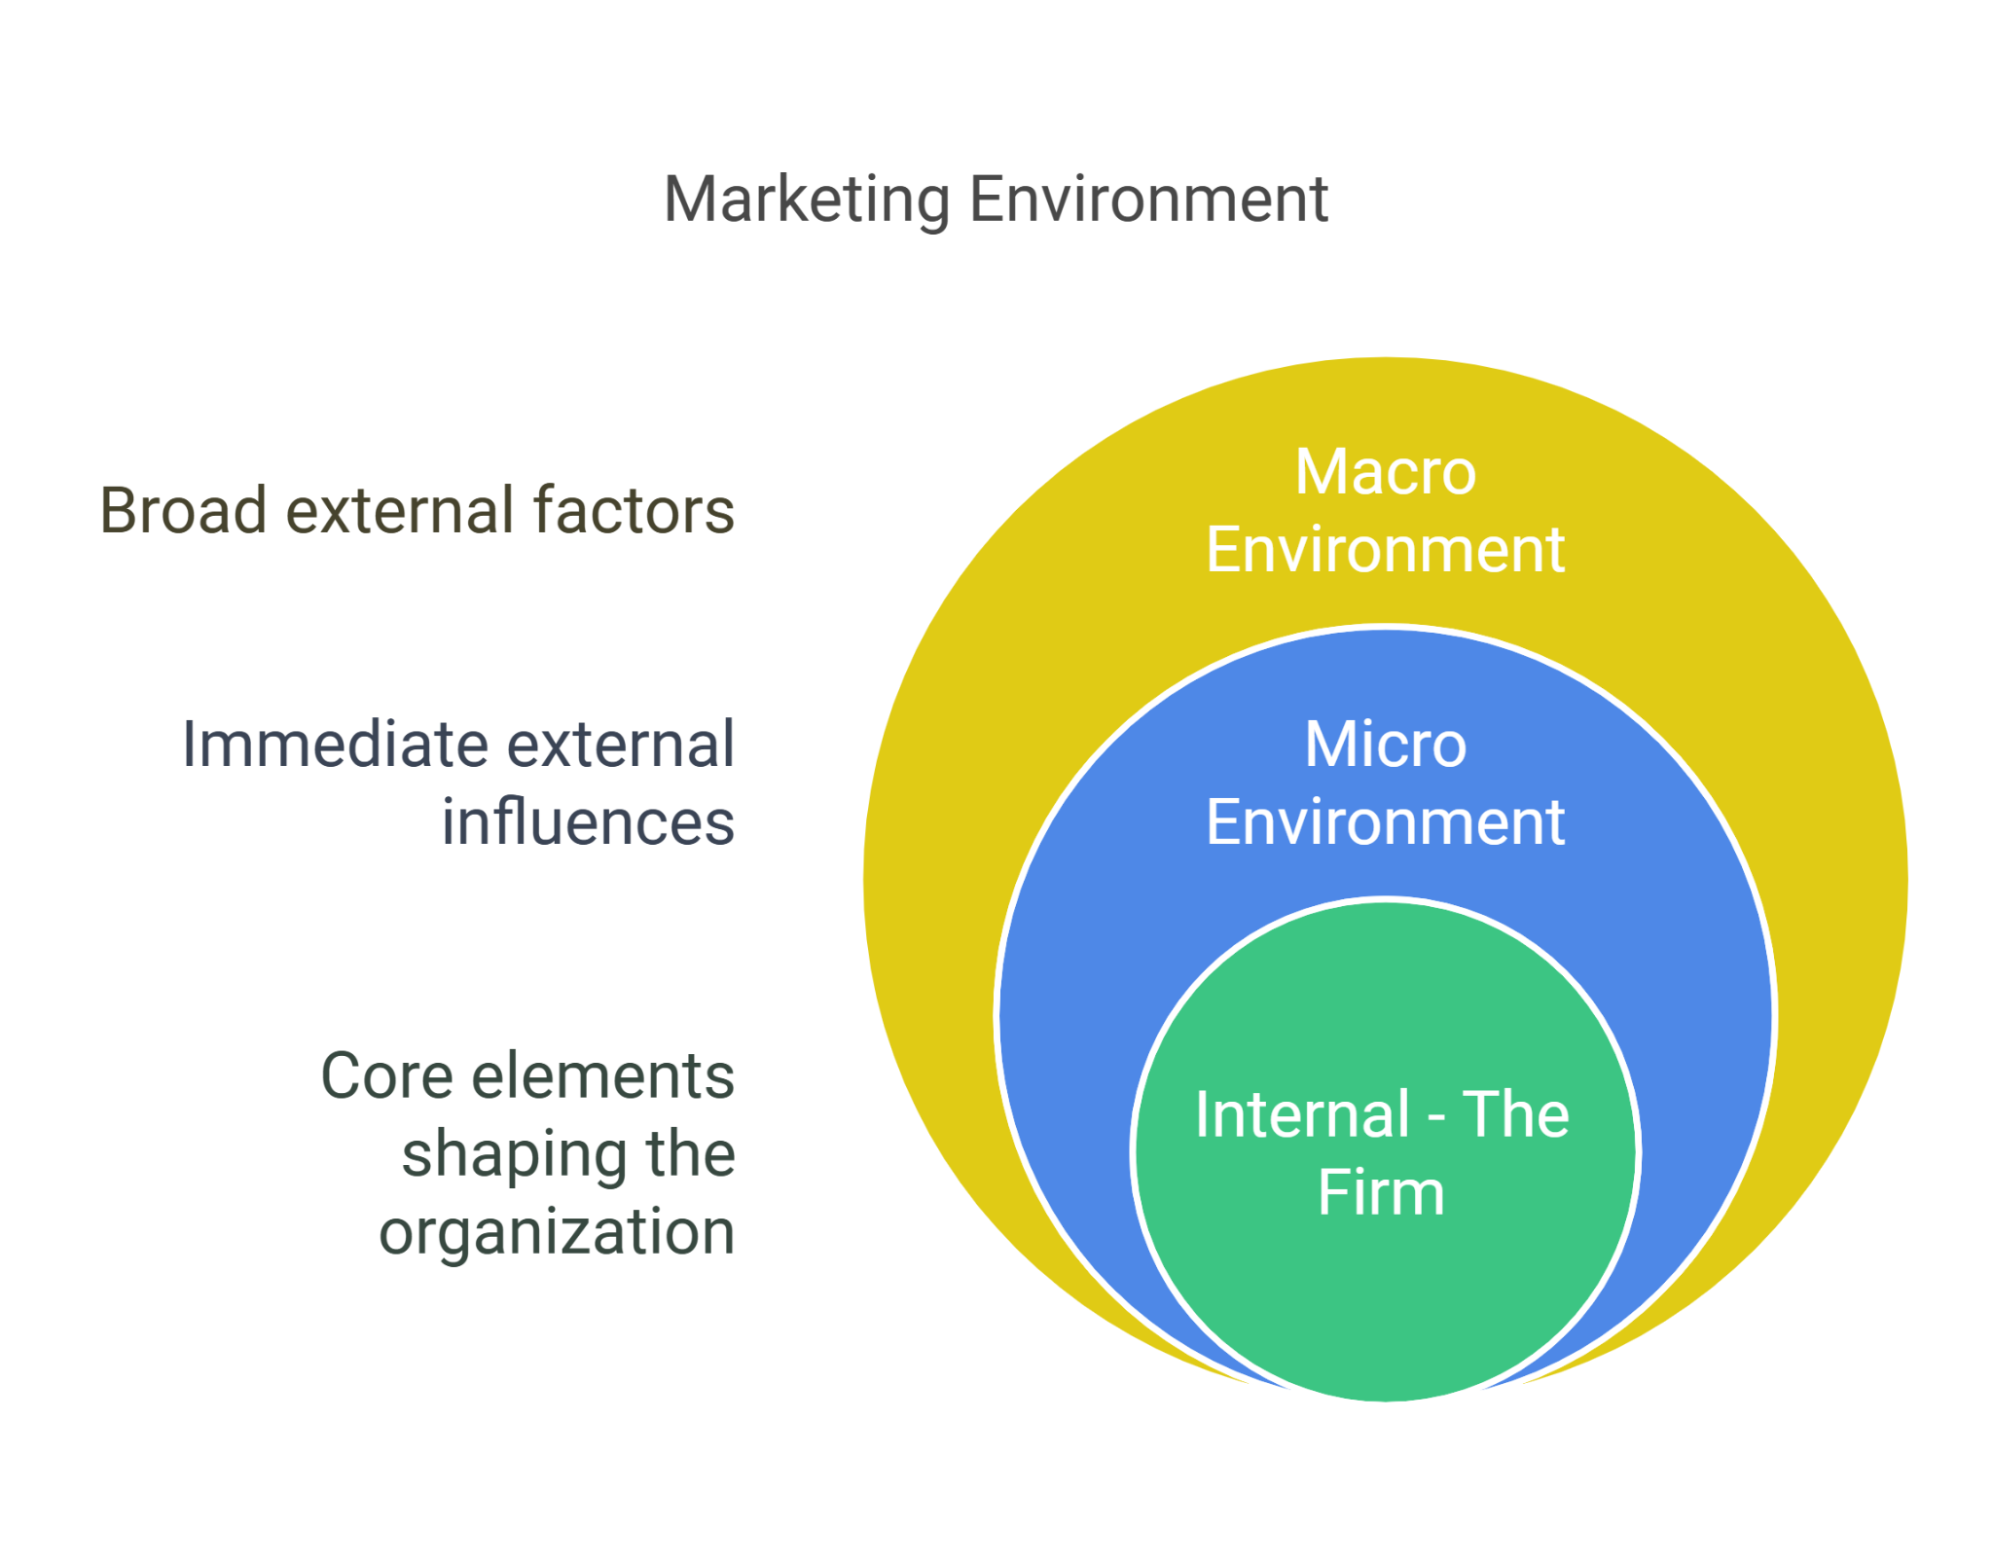
Figure 1: Marketing Environment Framework
(Source: Marketingmap, 2025)
The marketing environment is classified into two segments, which include internal and external forces from the view of Kotler’s Marketing Environment framework that poses significant impact on firms’ operations and their ability to maintain long-term relationships with stakeholders. Internal stakeholders and market participants that include suppliers, intermediaries, customers and competitors build the microenvironment (Vojdanian et al., 2024). Organisational performance is directly controlled by the microenvironment. In contrast, the macro environment includes socio-cultural, technological, natural, economic, political, and legal factors. These broader external forces pose significant influence on a firm’s decision-making process and operation (Umosen and Essien, 2026). However, firms like Codelco cannot take full control of external forces. Macro-environment actors: Natural Environment and Political and Legal Environment have been used in this study for critical-level insights into Codelco's transition towards lower-carbon mining.

1.2 External Marketing Environmental Actor 1: The Natural Environment
In Codelco’s transition towards lower-carbon products, there is notable influence of the natural environment. High temperatures, prolonged droughts, water scarcity and glacier reduction are key challenges that have been experienced by Chile due to climate change (Unepfi, 2024). Northern Chile is mostly affected due to changes in climate, where Codelco's major mining sites are located. Due to such challenges, operational risk at Codelco has intensified in terms of production and supplies (OECD, 2023). Stakeholders’ perceptions and purchasing decisions of consumers are negatively influenced due to lack of supply reliability, operational disruption and increased cost levels. However, its positive influence is that Codelco is encouraged to make substantial investment in sustainable mining practices. Market differentiation through consistent efforts on the improvement in environmental performance can strengthen stakeholders’ confidence and support significant operational growth.
Decarbonisation strategy has become central at Codelco’s operation, where its strategies include electrification in mining and energy efficiency. Low-carbon technologies have also been gradually integrated into its operation. Compared with 2019, Codelco, with its sustainable approaches, has been able in the reduction of 27% Scope and Scope 2 emission by 2024. By 2030, its aim is to reduce Scope 3 emissions by 25% and become carbon neutral in 2050 (Codelco, 2025). With sustainable approaches products of Codelco can be presented as low-carbon copper. Industrial consumers' sustainability expectations fulfilment is effective in enhancing their engagement level. However, the low-carbon mining transition presents multiple issues like the requirement of higher upfront costs, supply chain collaboration and technological innovation (Heydari et al., 2025). Overall, financial and implementation challenges can slow down the progress of Codelco towards low-carbon mining.
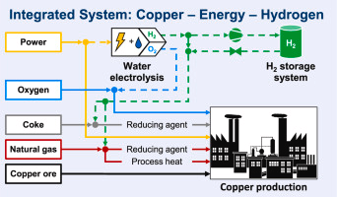
Figure 2: Decarbonising copper production
(Source: Röben et al., 2021)
The importance of responsibly sourced copper is also growing at the current time as there is an increasing demand from electronic producers, renewable energy developers, and electric vehicle manufacturers. IEA reported that by 2040, the demand for copper will increase by 30% (IEA, 2025). With this growing demand, Codelco supplying low-carbon copper by applying ethical business practices can maintain a positive brand image and strengthen its competitive position. However, ongoing sustainability communication and ESG reporting are equally important for strengthening trust levels and holding a long-term resilient position in Chile and the global base.
Despite these sustainable efforts, it cannot be guaranteed that Codelco can hold a competitive position in a disrupted mining business environment. Codelco’s competitors, like BHP and Rio Tinto continuously making substantial investments in decarbonisation strategies (Theguardian, 2026). Competitors’ lower-carbon mining transition may undermine the ability of Codelco to hold a long-term unique market position. In response to such a challenge, evidence-based stakeholder engagement and transparent ESG reporting provide a significant advantage in its operation.

1.3 External Marketing Environmental Actor 2: Political-Legal Environment
Codelco's transition towards lower-carbon copper also faces significant influence from the political and legal environment. Stricter government regulation has been implemented by the Chilean government to fulfil its commitment of becoming net zero by 2050. USD 5.3 million Net-Zero Nature-Positive Accelerator Programme with a time period of four years has been launched in Chile (UNEP, 2025). Due to stricter policies, Codelco faces increasing pressure for accelerating its decarbonisation efforts. However, compliance with changing environmental regulations requires substantial capital investment. Increased operational costs reduce operational profitability and limit the capability of the firm in making investments in future growth initiatives. Marketing approach of Codelco’s further influenced by international regulations.
Carbon transparency and sustainability disclosure maintained by firms are highly prioritised by the European Union's Carbon Border Adjustment Mechanism (CBAM) and the Corporate Sustainability Reporting Directive (CSRD) (Roihupalo, 2024). While, responsible business conduct (RBC) is encouraged by the OECD so that firms are encouraged for engaging ethical sourcing and accountability in supply chain operations (OECD, 2026). Codelco, following all strict regulation become able to strengthen its brand reputation and successfully enter into international marketplace. However, failure to comply with such laws may undermine its reputation and increase administrative complexity. Therefore, the requirement of being adaptable to changes in laws to investment in governance is required for sustaining a significant market position.
Marketing Implications
Codelco's marketing department needs to prioritise regular, sustainable communication, effective engagement of stakeholders and transparent reporting that enable addressing issues that arise from natural and political-legal factors. Corporate brand reputation and resilient market position can be maintained by this firm through verified environmental performance and stricter regulatory compliance. Positive impacts associated with it are increased confidence of investors and maintaining positive and long-term relationships with industrial firms.

Task 2: Strategic Growth and Competitive Positioning

2.1. Strategic Growth Recommendation Using the Ansoff Matrix
Critical environmental assessment reflects that Codelco’s objective of transitioning towards a low-carbon mining business faces significant challenges associated with climate-related changes and stricter legal requirements. A strategic growth approach has become central for Codelco’s operation with growing low-carbon copper demand and strict environmental regulation. Growth opportunities for Codelco can be identified with the application of the Ansoff Matrix, which can strengthen its competitive position.
Applying the Ansoff Matrix
Based on product and market development alternatives, four strategic growth approaches are proposed by the Ansoff Matrix, which is a well-known strategic tool that supports significant growth opportunities for businesses.
Market penetration: This growth approach priority in enhancement sales of existing products. Codelco’s integrating this initiative can increase its existing copper products sales. Here the focus is on adopting competitive pricing, ongoing sustainable marketing and building stronger positive relationships with consumers. The risk associated with this approach is relatively small. However, in a highly mature and competitive global copper market, it limits growth potential.
Market development: Under this strategy, there is a recommendation for firms to introduce existing copper products into new industrial markets or geographical locations. Global transition to clean energy and electrification increases the demand for responsibly and ethically sourced copper (Podobińska-Staniec et al., 2025). This gives greater expansion opportunities for Codelco’s operation. Despite notable growth opportunities, it also brings challenges like compliance requirements with diverse rules and regulations, initially higher-level investment and new distribution networks. Strategic operational risk thus may be introduced at Codelco’s business.
Product development: For existing consumers using this growth initiative, firms develop new or improved products. Under this approach, Codelco has to focus on the expansion of its low-carbon copper production using sustainable mining technologies, electrification and renewable energy sources. Environmental degradation concerns increase consumers' demand for environmentally responsible materials (Bonthula et al., 2023). The product development strategy is well-aligned with current consumers’ demand and helps in maintaining a unique position in the market.
Diversification: New product development for new market requirements is reflected through these growth initiatives. This is the highest-risk strategy, though at Codelco’s operation it can create future revenue streams. Higher-level expertise is required for Codelco’s business. However, with this approach, its strategic focus may be reduced.
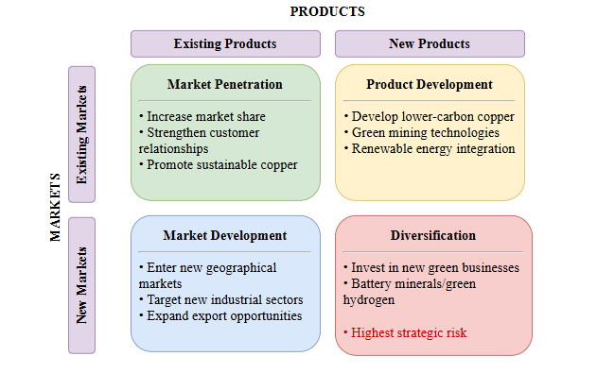
Figure 3: Ansoff Matrix
(Source: Self-developed)
Among all these approaches, product development is the most suitable approach for Codelco that can support its growth in its transition towards a low-carbon mining business.
Recommended Strategy
Codelco, by incorporating a product development strategy, can create greater consumer value and strengthen competitive differentiation that support its long-term business growth. Under this approach, the introduction of lower-carbon copper products can enable Codelco to meet changing consumers’ demand and also respond effectively to growing regulatory and environmental pressure. Carbon-neutral mining practices and renewable-powered production are effective for Codelco in strengthening the sustainability of its existing product portfolio. Transparency in environmental performance for products can be ensured by firms with the adoption of digital product passports (Shee Weng, 2024). Better environmental performance of Codelco’s copper products is effective in meeting the changing expectations of regulators, investors and industrial consumers. At the current time, a sustainable supply chain has become a key priority for electronics producers, renewable energy developers and electric vehicle manufacturers, where Codelco’s low-carbon offering can help it in maintaining long-term positive relationships.
Corporate image of the firm can be strengthened with verified sustainability credentials and credible ESG performance. Its associated benefits are increased investor confidence and an environmentally conscious market; it gets the opportunity to adopt a premium pricing approach for its products (Garcia-Zavala et al., 2023). However, low-carbon copper development requires higher-level capital investment in digital technologies, electrification and renewable energy transition, which puts additional cost pressure. In this transition, there is also a requirement for continuous innovation, sustainability certifications that are globally recognised and ongoing sustainability communication.

2.2 Competitive Advantage Through a Low-Carbon Business Model
Porter’s differentiation strategy needs to be adopted at Codelco’s operation for maintaining a significant market position rather than cost leadership. The production cost of the firm is enhanced due to substantial capital investment in decarbonisation technologies, electrification and renewable energy. The low-carbon copper transition is effective for Codelco in strengthening its unique value proposition (Orihuela et al., 2026). This value proposition can be further strengthened with transparent ESG reporting, accredited sustainability certifications and a digital tracking system. Codelco’s continuous innovation in green technologies and transparent sustainability communication as a forward-thinking firm increases active engagement of stakeholders and helps it in achieving long-term business growth. Superior consumer value development by Codelco not only helps it in strengthening its competitive position but also makes it difficult for its competitors like Rio Tinto and BHP to easily replicate it.
Future Marketing Developments
Advanced digital technologies with their predictive data analytics enable firms in maintaining transparency, sustainability in operations and effective consumer engagement. Thus, the mining industry in future will be increasingly dependent on modern technologies. Codelco, integrating predictive analytics and artificial intelligence (AI) into its operations, can easily and accurately predict demand in the market and can adopt proactive actions in real-time for fulfilling such demand (Umucu et al., 2025). For carbon tracing, there can be the use of IoT and a digital product passport, which can help it in maintaining transparency throughout its overall supply chain system. Transparency and low-carbon operation are significant in strengthening stakeholders’ trust and increasing their active engagement in business. Real-time sustainability insights can be gained through big data analytics and an ESG dashboard. However, their success depends on the quality of data, the acceptance level of stakeholders and the availability of experts in operation.
Risks
Lower carbon transition at Codelco’s operation at the initial stage raises issues associated with higher upfront cost, uncertainty in technologies, disruption in the supply chain, and concerns for greenwashing. For effective navigation of such challenges, there is a requirement for strategic partnership, a continuous innovation priority and independent carbon certification. These approaches are effective for potentially addressing risk and strengthening the trust level of stakeholders, and maintaining a competitive edge.

Task 3: Critical Reflection on AI Usage

3.1 Tool Disclosure
For developing this report, the AI tool ChatGPT has been used, and there has also been use of databases like Google Scholar. For brainstorming ideas, the structure of the project and its logical flow have been maintained with the assistance of ChatGPT. Peer-reviewed articles and journals are accessed with the use of Google Scholar, which provide contextual insights into lower carbon mining practices benefits and challenges for Codelco. However, I have not used it for critical synthesis of the study and proposing meaningful conclusions and recommendations for a practical case. Overall, independent interpretation has been maintained for ensuring academic integrity and critical evaluation throughout the study.

3.2 Critical Evaluation of AI Output
AI-generated information has been verified by comparing information from peer-reviewed articles and journals. Information from industry reports like OECD and IEA that provides broader and up-to-date insights. AI-generated information often gives outdated data, which has been addressed by adopting this approach, which enables maintaining accuracy in reporting by correcting hallucinations. Comparison of credible resources also ensured logical consistency in overall writing. Analytical quality has been strengthened with the use of only reliable evidence.

3.3 Contribution Analysis
AI has been applied within this study for gaining topic ideas and the basic structure of this research. Market environmental factors that influence the operation of Codelco while transitioning towards low-carbon copper production have been identified with the successful implementation of theoretical frameworks like the Ansoff Matrix and Porter's Generic Strategy. Comparison of evidence has been done in an independent manner. Relevant academic theories use is effective for proposing relevant recommendations (Thongchotchat et al., 2023). I have critically interpreted advantages and limitations associated with different strategic suggestions for transitioning towards low-carbon business processes. With critical synthesis, I have found that product development is the most appropriate approach that can be used by Codelco for its business transition. Independent judgment within this study, without relying on AI-generated work, has helped in maintaining academic integrity and rigour.

3.4 Ethical & Professional Reflection
Ethical and professional responsibilities are highly important in academic research while using artificial intelligence. Rather, the dependence on AI-generated tools for whole academic writing should only be used as a supporting tool with the purpose of maintaining academic integrity. During writing, independent critical thinking is important for strengthening overall academic rigour. I acknowledged that there is a requirement for clear disclosure of the use of AI, as it ensures transparency in the project and reflects that the work is one's own work. Biased information may be produced by an AI system, which needs to be verified properly for ensuring accuracy in findings (Mensah, 2023). Responsible AI use means there is a requirement to verify information and ensure academic policies are properly maintained. Real-world understanding of stakeholders’ needs requires human judgement. In future marketing related decision there is growing importance of AI as its predictive analytics enable in gaining real-time information and adopting proactive actions. AI use with critical evaluation are effective in making evidence-based decisions and achieving better outcomes.

References
Bonthula, S., Bonthula, S.R., Pothu, R., Srivastava, R.K., Boddula, R., Radwan, A.B. and Al-Qahtani, N., (2023) ‘Recent advances in copper-based materials for sustainable environmental applications’. Sustainable Chemistry, 4(3), pp.246-271.Available at: https://www.mdpi.com/2673-4079/4/3/19
Codelco, (2025) Codelco launches its first Climate Change Report and consolidates its strategy toward more resilient and low-emission mining. Available at: https://www.codelco.com/en/prensa/2025/codelco-lanza-su-primer-reporte-de-cambio-climatico-y-consolida-su. (Accessed: 11 July 2026).
Codelco, (2025) Position on climate change. Available at: https://www.codelco.com/prontus_codelco/site/docs/20251002/20251002120038/climate_change_report.pdf. (Accessed: 11 July 2026).
Garcia-Zavala, C., Ordens, C.M., Pagliero, L., Lebre, E., Aitken, D. and Stringer, M., (2023) ‘An approach for prioritising environmental, social and governance (ESG) water-related risks for the mining industry: The case of Chile’. The Extractive Industries and Society, 14, p.101259. Available at: https://www.sciencedirect.com/science/article/pii/S2214790X23000503
Heydari, M., Mitchell, P., Cullen, L., Andrieu, B., Serrenho, A.C. and Cullen, J., (2025). ‘A systematic review of resilience in the critical minerals supply chains, needed for the low-carbon energy transition’. Renewable and Sustainable Energy Transition, p.100127. Available at: https://www.sciencedirect.com/science/article/pii/S2667095X25000261
IEA, (2025) Overview of outlook for key minerals. Available at: https://www.iea.org/reports/global-critical-minerals-outlook-2025/overview-of-outlook-for-key-minerals. (Accessed: 11 July 2026).
Marketingmap, (2025) The Marketing Environment. Available at: https://marketingmap.pressbooks.tru.ca/chapter/the-marketing-environment/. (Accessed: 11 July 2026).
Mensah, G.B., (2023) Artificial intelligence and ethics: a comprehensive review of bias mitigation, transparency, and accountability in AI Systems. Preprint, November, 10(1), p.1.Available at: https://www.researchgate.net/profile/George-Benneh-Mensah/publication/375744287_Artificial_Intelligence_and_Ethics_A_Comprehensive_Review_of_Bias_Mitigation_Transparency_and_Accountability_in_AI_Systems/links/656c8e46b86a1d521b2e2a16/Artificial-Intelligence-and-Ethics-A-Comprehensive-Review-of-Bias-Mitigation-Transparency-and-Accountability-in-AI-Systems.pdf
OECD, (2023) Mining Regions and Cities in the Region of Antofagasta, Chile. Available at: https://www.oecd.org/content/dam/oecd/en/publications/reports/2023/10/mining-regions-and-cities-in-the-region-of-antofagasta-chile_95d5ee09/336e2d2f-en.pdf. (Accessed: 11 July 2026).
OECD, (2026) Responsible business conduct. Available at: https://www.oecd.org/en/topics/policy-issues/responsible-business-conduct.html. (Accessed: 11 July 2026).
Orihuela, J.C., Irarrázaval, F. and Flores, C., (2026) ‘Chile at the green window of opportunity: the troubled road to new productive capabilities’. Journal of Globalization and Development, 16(2), pp.277-304. Available at: https://www.degruyterbrill.com/document/doi/10.1515/jgd-2024-0090/html
Podobińska-Staniec, M., Wiktor-Sułkowska, A., Kustra, A. and Lorenc-Szot, S., (2025). ‘Copper as a critical resource in the energy transition’. Energies, 18(4), p.969. https://www.mdpi.com/1996-1073/18/4/969
Röben, F.T., Schöne, N., Bau, U., Reuter, M.A., Dahmen, M. and Bardow, A., (2021) ‘Decarbonizing copper production by power-to-hydrogen’: A techno-economic analysis. Journal of Cleaner Production, 306, p.127191. Available at: https://www.sciencedirect.com/science/article/pii/S0959652621014104
Roihupalo, L., (2024) ‘The implementation of a reporting process for carbon border adjustment mechanism (CBAM)’. Available at: https://lutpub.lut.fi/bitstream/handle/10024/167230/Diplomityo_Roihupalo_Liisa.pdf?sequence=1&isAllowed=y
Shee Weng, L., (2024) ‘Digital Product Passports: Transforming industries through transparency, circularity, and compliance’. Digital Product Passports: Transforming Industries Through Transparency, Circularity, and Compliance (November 10, 2024). Available at: https://papers.ssrn.com/sol3/Delivery.cfm?abstractid=5158550
Theguardian, (2026) Former top BHP economist urges tougher government policies to push miners to decarbonise. Available at: https://www.theguardian.com/business/2026/jul/10/former-bhp-economist-carbon-price-emissions. (Accessed: 11 July 2026).
Thongchotchat, V., Kudo, Y., Okada, Y. and Sato, K., (2023) Educational recommendation system utilizing learning styles: a systematic literature review. IEEe Access, 11, pp.8988-8999. Available at: https://ieeexplore.ieee.org/iel7/6287639/6514899/10022322.pdf
Umosen, L.E. and Essien, B.S., (2026) ‘Macro-environmental forces and sme operational performance: Empirical evidence from Lagos State, Nigeria using PESTLE framework’. International Journal of Business and Management (IJBM), 5(1), pp.924-951. Available at: https://iessociety.org/index.php/IJBM/article/download/282/104
Umucu, Y., Deniz, V. and Gürsoy, Y.H., (2025) ‘Artificial Intelligence In Mineral Processing: Transforming Mining Operations Through Smart Technology’. Bilimsel Madencilik Dergisi, 63(2), pp.67-85.Available at: https://dergipark.org.tr/en/download/article-file/3809319
UNEP, (2025) Chile Launches USD 5.3 Million Program to Accelerate Climate Action and Biodiversity Protection. Available at: https://www.unep.org/gef/news-and-stories/press-release/chile-launches-usd-53-million-program-accelerate-climate-action-and. (Accessed: 11 July 2026).
Unepfi, (2024) Sectoral Risk Briefings: Insights for Financial Institutions. Available at: https://www.unepfi.org/wordpress/wp-content/uploads/2024/05/Climate-Risks-in-the-Metals-and-Mining-Sector-1.pdf. (Accessed: 11 July 2026).
Vojdanian, S., Mortazavi, S., Kuivalainen, O. and Faroque, A., (2024) ‘The role of individuals as stakeholders in B2B marketing for sustainable innovation’. In Individuals in B2B Marketing (pp. 31-47). Routledge. Available at: https://osuva.uwasa.fi/bitstreams/2538f11a-c1bf-42e8-aad1-d97a6ce6be62/download

