BMIH6005
Organisational Consultancy
Report

Enhancing Operational Efficiency in the Housekeeping Department of Sydney Harbour Marriott Hotel at Circular Quay, Sydney, Australia.

Student name: Adrian Marian Oprea
Student ID:1714749

Name of consultancy: A2Z Consultancy Firm

Table of Contents
1. Executive summary 3
2. Introduction 6
2.1 Introduction 6
2.2 Background of Sydney Harbour Marriott Hotel at Circular Quay 6
2.3 About the A2Z Consultancy Firm 6
2.4 Identified Issues in the Housekeeping Department 7
2.5 Analytical Frameworks Used in the Report 7
2.6 Purpose of the Report 7
3. Analysis 9
3.1 Issue Identification 9
3.2 Impact Analysis 9
3.3 STEEPLED Analysis 10
3.4 SOAR Analysis 12
3.5 TOWS Analysis and Strategic Recommendations 14
4. Recommendations and Change Management 17
4.1 Recommendations for Improving Operational Efficiency 17
4.2 Managing Change Implementation – ADKAR Model 21
4.3 Cost Analysis and Budget Allocation 24
4.4 Measuring Success and Long-Term Benefits 24
5. Action plan 26
6. Conclusion 28
References 30

1. Executive summary
The purpose of this report is to provide a comprehensive analysis of operational inefficiencies in the housekeeping department of Sydney Harbour Marriott Hotel at Circular Quay, Australia, and strategic recommendations are made to increase efficiencies, reduce costs, and increase service quality. Inefficiencies in the hotel’s housekeeping department can lead to instances where the housekeeping department is not doing its job to maintain the hotel’s luxury level and contribute to guest satisfaction, which can be caused by numerous reasons; as well as, these inefficiencies can negatively affect guest experiences, operational expenses, employee productivity, and the hotel’s overall reputation.
Key challenges identified in the report were affecting housekeeping operations. Delays in room turnover due to suboptimal allocation of tasks and inefficient communication systems have affected guest satisfaction as well as front office operations. Furthermore, the excessive use of manual cleaning processes led to inconsistent service quality and increased labour costs. Ineffective staff scheduling leads to high overtime expenses, straining the department's budget and contributing to employee fatigue. On top of that, non-sustainable cleaning practices are becoming a financial burden due to the rising operational costs, as well as resistance to the technological and procedural changes slowing down the adoption of modern housekeeping solutions.
To address these problems, the report suggested lots of recommended actions, which would make the housekeeping department more efficient and orientated towards technology and green tracing. Digital implementation of a housekeeping management system was recommended to improve how task allocation is done, the communication between colleagues, and to reduce the time required to turn rooms over. It would help boost efficiency, improve hygiene standards, and eliminate the need for a great deal of manpower by introducing smart cleaning equipment and automation, such as robotic vacuum cleaners and UV sterilisation devices. This report should optimise staff shift structures and cross-train employees to balance workload distribution, reduce overtime spending, and enhance the overall flexibility of the user workforce. Furthermore, it would support sustainability-driven cost reduction initiatives, including the implementation of eco-friendly cleaning products, energy-efficient laundry practices, and guest linen reuse programs, which would help in reducing the operational cost in the long term and strengthen the hotel’s environmental responsibility.
Since a successful implementation of these recommendations is dependent on the actual implementation of the change management strategy, this model was specified in accordance with the ADKAR model. In this model, there was an emphasis on such aspects as awareness, desire, knowledge, ability, and reinforcement to guarantee that employees are educated and trained enough to accept new processes. The strategy also relied heavily on hands-on training, employee engagement, and ongoing support to overcome resistance and achieve long-term success.
The success of these improvements was measured in terms of the key performance indicators (KPIs) needed to achieve a reduction in room turnover time, reduced labour costs, and an increased guest satisfaction score. These metrics will assist the hotel in monitoring progress and making sure the advised strategies bring out measurable and lasting outcomes. As a concentrated luxury hospitality market player, the Sydney Harbour Marriott Hotel at Circular Quay expects efficiency, cleanliness, and service excellence to remain key criteria. However, operational inefficiencies have led to challenges in guest satisfaction and financial performance within the housekeeping department, ultimately impacting not only guest satisfaction but also understanding and financial performance. Due to delayed room turnover times, high overtime costs, inconsistent cleaning standards, and resistance to change, this level of efficiency has not improved to the desired level, and a structured intervention is necessary.
The report of this consultancy concludes with the finding that ineffective task allocation and communication in the housekeeping department have resulted in inefficiencies that are slowing down the housekeeping department’s daily operations. In the absence of a centralised digital housekeeping system, there is no task assigned automatically, and therefore the communication of change in tasks is also manual, which results in miscommunication, time lag, and unbalanced work. Additionally, relying solely on regular cleaning can lead to physical stress among staff, reduce productivity, and result in inconsistent cleanliness. Without automation and smart cleaning solutions, staff are spending excessive amounts of time doing repetitive, man-made cleaning work, which affects service speed and quality. Further pressure on the finances comes from rising labour costs, labour expenses, and, beyond cleaning, unsustainable cleaning practices—all of which necessitate moving towards cost-effective, technology-driven solutions.
An action plan was structured with a breakdown of each solution proposed with a timeline, budget, and expected outcomes that allowed the hotel to take action and deliver new changes promptly. The initiatives that are proposed mirror the upscale brand position in which Sydney Harbour Marriott is situated, and proposed management measures would not permit operational changes to mar the integrity of Sydney Harbour Marriott’s service quality. Finally, this consultancy report has offered Sydney Harbour Marriott Hotel a cross-functional strategic roadmap to achieve more efficiency and savings related to the related housekeeping department and also to have better guest experiences. The hotel can future-proof its operations and maintain its competitiveness in the Sydney luxury hospitality market by embracing technology, implementing process improvements, and exploring sustainability-driven strategies.

2. Introduction

2.1 Introduction
Within the hospitality industry, operational efficiency that contributes to a high level of guest satisfaction and cost-effectiveness is vital for keeping the business running. Housekeeping has always been a cornerstone of service quality within luxury hotels, with guest experience, online reviews, and the brand's reputation reliant upon cleanliness and efficiency within the process. The inefficiencies in the housekeeping department of the Sydney Harbour Marriott Hotel at Circular Quay have significantly impacted operational costs, employee productivity, and customer satisfaction. With this report prepared by the A2Z Consultancy Firm, intending to analyse the problems of the hotel housekeeping department in the operation and then recommend strategies to optimise the operational efficiency, reduce costs, and also improve the service quality.

2.2 Background of Sydney Harbour Marriott Hotel at Circular Quay
Sydney Harbour Marriott Hotel at Circular Quay is a top five-star hotel in Sydney, Australia. Built in 1989 with a focus on luxury, fine amenities, and exceptional service for all its leisure and business travellers, the hotel has established itself as one of the most well-known in the Philippines. The property features 595 elegantly designed guest rooms and suites, Sydney Harbour, the Opera House, and the city skyline (Sydney Harbour Marriott Hotel, 2025). The hotel is located close to Sydney’s prime gems, such as Circular Quay, The Rocks, and the Royal Botanic Gardens. The Sydney Harbour Marriott offers a complete hospitality experience, with multiple dining venues, conference facilities, a fitness centre, and an executive lounge.

2.3 About the A2Z Consultancy Firm
It is a consulting firm founded with the key purpose of providing services regarding organisational efficiency in hospitality management, the preparation of business plans with the aim of expanding and growing organisations and implementing changes in their operations. The firm boasts extensive experience in hotel operations and offers data-driven insights and a personalised approach to enabling hotels to optimise their service delivery. A strategic roadmap for improvement is being assessed for current operational inefficiencies in the housekeeping department by the consultancy for Sydney Harbour Marriott Hotel at Circular Quay.

2.4 Identified Issues in the Housekeeping Department
The first challenge that the housekeeping department at Sydney Harbour Marriott Hotel faces is multifield. The housekeeping department allocates tasks sub optimally and communicates inefficiently, leading to delays in room readiness and guest dissatisfaction. Inconsistencies in the application of cleaning standards and the rising costs of operations result from excessive manual labour. The high overtime expenses from poor staff scheduling are putting pressure on the budget and exhausting the employees. Long-term financial drain and environmental issues for the offshore industry, combined with rising operational costs from non-sustainable cleaning methods. Lack of resistance to technological progress and procedural changes is restricting innovation, and productivity increases possibilities.

2.5 Analytical Frameworks Used in the Report
In the STEEPLED Analysis framework, the housekeeping department shall be examined for external macroenvironmental factors, which include social, technological, economic, environmental, political, legal, ethical, and demographic influences. The SOAR analysis model for the supply chain of Sydney Harbour Marriott Hotel will consider its hotel strengths, opportunities, aspirations, and the results for finding out the areas of their strength and areas of improvement. Since the SOAR analysis has already been done, the TOWS matrix can now be used to formulate strategic solutions that tackle the attractions and opportunities of the external environment while utilising internal capabilities.

2.6 Purpose of the Report
The purpose of this consultancy report is to guide Sydney Harbour Marriott Hotel in preparing a suitably structured and evidence-based plan for improving the operational efficiency of its housekeeping department. Modern technology and process optimisation, combined with sustainable practices, give the hotel the ability to reduce costs, increase employee productivity, and raise guest satisfaction to a new level. In addition, a change management strategy will be described in this report, as to implement new systems and processes in a way that would not provoke resistance but rather a culture of continuous improvement.

3. Analysis

3.1 Issue Identification
The Sydney Harbour Marriott Hotel at Circular Quay is a premier luxury accommodation provider that has issues continuing with the best operational efficiency in its housekeeping department. Housekeeping is a major function that directly impacts the guests’ satisfaction, the position in the market, and revenue generation (Yusuf et al., 2021). In short, though, inefficiencies have been found across the board in many aspects, such as a lack of staff, managing time effectively, clogging events, inconsistent service quality, and simply not utilising the technology as efficiently as they could.

3.2 Impact Analysis
Guest Satisfaction and Reputation: One of the most reviewed aspects in guest feedback is housekeeping. Reputation is greatly impacted online by negative experiences surrounding the cleanliness of a property, as well as slow service and not having rooms ready when it is time to check in (Wangsa et al., 2024). While TripAdvisor, Booking.com, or Google Reviews showcase mixed feedback regarding housekeeping performance, they also complain about late room availability and inappropriately cleaned rooms.
Revenue and Financial Performance: The problems of more overtime and greater reliance on temporary staff arise through inefficient operation. A delay in room readiness can reduce occupancy rates by preventing incoming guests from checking in on time. In addition, negative feedback decreases future bookings and may result in income loss. Because the hospitality market in Sydney is inherently competitive, poor housekeeping results in suboptimal operations that can affect long-term profitability.
Employee Workload and Morale: Typically, the housekeeping department operates under strict schedules, with a high room cleaning quota for each shift (Waaje et al., 2025). When combined with higher guest expectations for quality results and a lack of additional staffing, the housekeeping staff often faces understaffing and high levels of stress, leading to burnout, absenteeism, and a high turnover rate. The hotel must provide extensive training to the new 'intake' to ensure they meet the hotel's service standard, precisely when it has already become inefficient.
Operational Bottlenecks: Challenges in inventory management, scheduling, and communication between front office and housekeeping teams contribute to inefficiencies. Delayed room assignments for arriving guests occur due to a lack of real-time updates regarding room status (W Fakhry et al., 2022). In addition, outdated cleaning equipment and disabling manual tracking methods detract from productivity.

3.3 STEEPLED Analysis
Social Factors: Gone are the days when ‘hotel guests’ came to expect a certain degree of standard hospitality; during the COVID-19 pandemic, the hospitality industry has undergone massive changes in what guest expectations are (Trull et al., 2024). Guests now demand and expect visibly clean and sanitised hygiene and cleanliness in hotels, which means an increased demand for superior cleanliness and hygiene standards. Guests are drivers for services such as food printing and food pickup, which need to have immaculate housekeeping operations that ensure both the family rooms, and the staff clean rooms are disinfected and safe.
Technological Factors: Technology-driven modernisation of housekeeping operations has been increasingly impactful, yet many hotels have not fully embraced this technology. Automation tools, such as the housekeeping management software, have to be used at Sydney Harbour Marriott to improve efficiency. The systems also provide instant updates on room status, task assignment, and inventory tracking, thereby reducing delays in room turnover (Srivastava and Tyagi, 2024b).
Economic Factors: Rising labour costs negatively affect Australian housekeeping, just like they do for most hospitality operations. Sydney, being a popular tourist destination, has seen a significant increase in the cost of living, leading hotel staff to demand higher wages. The hotel must ensure that its competitive salaries align with its operational cost efficiency requirements.
Environmental Factors: Recently, sustainability has come to be an increasingly important factor in hotel operations, influencing how various hotel services, including housekeeping, are operated (Zhang et al., 2018). Since Sydney Harbour Marriott is required to comply with environmental regulations, it must implement eco-friendly measures such as reducing water and energy consumption. Sustainable cleaning methods that involve the use of biodegradable cleaning agents should be carried out by the housekeeping teams, who also do away with plastic waste in the guest rooms.
Factor | Impact on Housekeeping Operations
Social | Increasing demand for high cleanliness standards post-COVID-19 has raised guest expectations.
Technological | Limited adoption of automation tools like housekeeping management software delays operations.
Economic | Rising labor costs in Australia impact staff hiring and retention.
Environmental | Sustainability requirements demand eco-friendly cleaning solutions, increasing operational costs.
Political | Changing labor laws affect working hours, wages, and employment policies in hospitality.
Legal | Compliance with hygiene and safety regulations requires frequent audits and adjustments.
Ethical | Fair labor practices and employee well-being initiatives are increasingly scrutinized.
Demographic | A diverse workforce with language barriers can lead to communication issues and inefficiencies.

Table 1: STEEPLED Analysis (Source: own)
Political Factors: Government policies and labour laws directly affect the housekeeping workforce. Changes in wage policies, employee benefits, and working hour regulations impact staffing costs and scheduling (Tiwari et al., 2022). Hotel workers in Australia have the right to "fair wages and working conditions" as per the national labour laws of Australia, but failure by hotels to adhere to them can result in legal complaints. Immigration policies also impact the availability of housekeeping staff.
Legal Factors: Hygiene and safety regulation compliance is crucial for housekeeping operation. The Australian hospitality industry must maintain strict health and safety standards for cleanliness. To ensure that the Sydney Harbour Marriott is complying with regulations pertaining to sanitation protocols, chemical handling, and occupational safety measures in its housekeeping programs, regular audits need to be conducted by the organisation.
Ethical Factors: The hospitality industry is now under increased scrutiny for fair labour practices and employee welfare initiatives. Housekeeping work is very heavy and involves doing long cleanups, lifting, and keeping up to very high levels of productivity. Hotels should ensure fair treatment and breaks for employees, as well as wages that are not too low. An inclusive and supportive work environment at Sydney Harbour Marriott can help retain staff and raise employee morale.
Demographic Factors: Housekeeping operations may have opportunities and challenges in a workforce of diverse people (Thoriq et al., 2024). Being located in a multicultural city, Sydney Harbour Marriott staff come from many different cultural and linguistic backgrounds. Language barriers can arise between guests and staff, as well as within the staff itself. Effective training programs and multilingual communication tools can address these challenges. In order to function effectively, housekeeping supervisors must be trained to usher a diverse team production.

3.4 SOAR Analysis
Strengths
Established Brand with a Strong Reputation for Luxury: As part of the global Marriott International brand, Sydney Harbour Marriott is known for its reputation of excellence in the hospitality industry. There is some reputation for providing high-quality services and luxurious accommodations that the hotel has built (Tiwari et al., 2024). This brand recognition is exceptional and recruits discrete guests with very high housekeeping standards. With this reputation, this hotel can use it as leverage to introduce innovative housekeeping practices without incurring the cost of loss of credibility.
Prime Location Attracting High Tourist Traffic: Sydney Harbour Marriott is situated at Circular Quay—the simple walking distance to iconic landmarks like the Sydney Opera House and the Harbour Bridge, as well as The Rocks. There are always plenty of demands from business travellers, international tourists, and event attendees, so the hotel always has high occupancy rates (Tavitiyaman et al., 2022). It helps to ensure the housekeeping department is always on at least during the years.
Dedicated Housekeeping Staff with Extensive Experience: The hotel employs a professional team from its housekeeping department, all of whom are familiar with Marriott's service standards and guest expectations. High cleaning and hygiene standards mean they are able to keep excellent standards for the guests. The hotel boasts a stable workforce, including housekeeping staff members who have been with the hotel for several years, eliminating the constant need for retraining.
Strengths | Opportunities
Established brand with a strong reputation for luxury. | Implementing smart technology solutions to enhance efficiency.
Prime location attracting high tourist traffic. | Partnering with cleaning technology providers for automation.
Dedicated housekeeping staff with extensive experience. | Employee training programs to improve productivity.
High guest retention and loyalty program benefits. | Sustainability initiatives to align with eco-conscious traveler expectations.
Table 2: SOAR Analysis (Source: Own)
Opportunities
Implementing Smart Technology Solutions to Enhance Efficiency: Technology-driven housekeeping management can tremendously boost operational efficiency. The addition of smart housekeeping software enables Sydney Harbour Marriott to know exactly how the rooms are running at any given time, completing tasks faster and more effectively, and managing inventory more efficiently (Srivastava and Tyagi, 2024a). Applications that use digital communications to notify housekeeping staff of availability and respond to guest requests reduce delay and confusion.
Partnering with Cleaning Technology Providers for Automation: There is an ongoing trend of automation in housekeeping in the hospitality industry. There is an opportunity for the hotel to work with cleaning technology providers to bring in automated vacuum cleaners, UV disinfection robots, and AI-driven cleaning schedules. These innovations can, however, decrease the physical burden on housekeeping staff, which will free their hands to engage in quality control instead of performing repetitive manual tasks.
Employee Training Programs to Improve Productivity: Overall, investing in comprehensive training programs can help the housekeeping staff work more efficiently. The practice should include training on the best practices of cleaning techniques and time management, as well as the use of new technology (Tsaur and Lin, 2018). It also allows that in case of a staff shortage, the department can still operate smoothly, as it would get cross-trained staff members to handle different housekeeping tasks.

3.5 TOWS Analysis and Strategic Recommendations
Strengths and Opportunities (S-O): Leveraging Brand and Technology for Efficiency: Banking on its positive brand reputation, Sydney Harbour Marriott has the right to be an appealing recruiter for top housekeeping talent. This way, the hotel can attract and retain top skilled staff by offering competitive wages and benefits as well as career development (Singh and Singh, 2022). In addition, the hotel can enhance its operational efficiency by investing in the automation of the tools to reduce the manual housekeeping tasks. Collecting valuable feedback on housekeeping services also offers an opportunity for continuous improvement if thought about in terms of leveraging guest loyalty programs such as Marriott Bonvoy (Lennon, 2023).
Strengths and Threats (S-T): Addressing External Challenges While Maintaining Excellence: Nevertheless, the hotel has a strong reputation, yet it is prone to several external threats, like increasing labour costs and changing guest expectations about sustainability. However, to accommodate these, Sydney Harbour Marriott should embrace automation in ways that are not only cost-efficient but also another way to maintain high service standards. Besides, there’s a need to always comply with changing labour laws and sustainability regulations. The hotel needs to adapt to an industry shift by moving away from using single-use plastics and biodegradable cleaning products proactively while maintaining the reputation.
Strengths (S) and Opportunities (O) | Strategies
Leverage strong brand reputation to attract top housekeeping talent. | Competitive salaries and benefits to improve staff retention.
Invest in automation tools to reduce manual housekeeping tasks. | Implement digital housekeeping management systems.
Use guest loyalty programs to encourage feedback on housekeeping services. | Continuous improvement based on guest preferences.
Weaknesses (W) and Threats (T) | Strategies
Address high turnover by improving staff morale. | Wellness initiatives, flexible scheduling, and incentives.
Upgrade outdated cleaning processes to enhance efficiency. | Invest in modern cleaning equipment and training.
Mitigate rising operational costs. | Sustainability-focused cost-saving measures.

Table 3: TOWS Analysis (Source: Own)
Weaknesses and Opportunities (W-O): Improving Processes Through Innovation and Training: The reliance of the housekeeping department on traditional cleaning methods is one of its key weaknesses, such as its time-consuming and labour-intensive nature (Rashid et al., 2021). Sydney Harbour Marriott can take advantage of this by updating old cleaning processes and training staff members on the latest techniques. In order to improve the overall housekeeping experience, the employee training programs should teach the new cleaning technologies to be adopted, the cultural sensitivity towards international guests, and provide personalised guest services (Azzahra and Asshofi, 2024).
Weaknesses and Threats (W-T): Mitigating Rising Costs and Workforce Challenges:
The hotel has a high staff turnover and rising operational cost challenge that can impact housekeeping efficiency (Prakash et al., 2023). Therefore, Sydney Harbour Marriott needs to invest in employee wellness programs, flexible hours, and generous incentives to ensure they do not lose experienced staff. To decrease turnover and service consistency, an organisation can create a positive work environment with career development opportunities (Chen et al., 2022). At the same time, such sustainability-focused savings in cost, such as energy-efficient laundry systems and bulk purchasing for eco-friendly supplies, are other means of contending with increasing costs.

4. Recommendations and Change Management

4.1 Recommendations for Improving Operational Efficiency
Implementing a Digital Housekeeping Management System
The use of a digital housekeeping management system is one of the most impactful changes the hotel can make (Verma and Singh, 2021). Traditionally, the manual management of task assignments, recording of room status, and communication between housekeeping and the front office has been time-consuming, prone to errors, and has not prioritised real-time monitoring and optimisation of task assignments, room status, and communication. The hotel can integrate a cloud-based housekeeping management system, which can dramatically solve the task allocation, inventory control, and proper coordination of the entire workflow. The supervisor can assign and monitor real-time tasks to roles, ensuring prompt room cleaning.
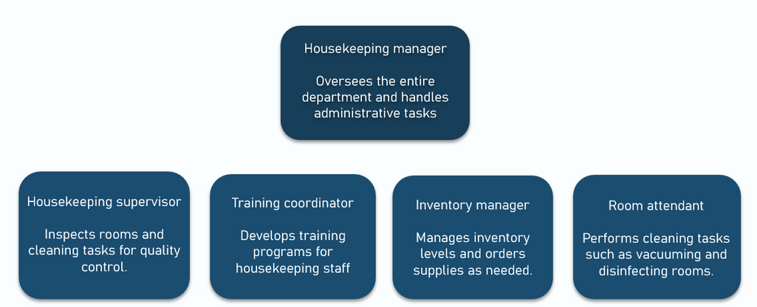
Figure 1: Steps for Implementing a Digital Housekeeping Management System (Ramadan et al., 2023)
On Optii Keeper or HotSOS, the supervisor can regulate the process and see who cleaned which room when. To implement such a system, it should be rolled out in phases—the hotel first trains the housekeeping supervisors and staff to use the software because they have to use the app (Abalaka et al., 2023). Moreover, the hotel should integrate the system with its current PMS to facilitate data sharing across various departments. The hotel should carry out hands-on training sessions, provide ongoing support, and emphasise that technology simplifies workloads rather than getting a radical job replacement (Sharma et al., 2023). A reduction of 15–20% of room turnover time in six months, increased housekeeping productivity, and fewer guest complaints regarding the room readiness can be a great sign of success.
Introducing Smart Cleaning Equipment and Automation
The introduction of smart cleaning equipment and automation represents a significant advancement in improving the efficiency system (Ambardar et al., 2023). Manual effort required for the traditional housekeeping operations consumes a lot of time and is also inconsistent. The hotel can integrate robotic vacuum cleaners, ultraviolet sterilisation robots, and electrostatic sprayers to enhance cleaning speeds and decrease hygiene standards and labour efficiency (Srivastava and Tyagi, 2024c). In terms of floor cleaning, robotic vacuum cleaners can lower the time needed to spend on cleaning floors, as opposed to UV disinfection robots, which can help to sanitise high-touch areas effectively and help to comply with standards following the post-pandemic hygiene. Electrostatic sprayers allow for more efficient disinfection of guest rooms and public areas as compared with using excessive amounts of chemical cleaners (Nadjmuddin and Hanadya, 2024).
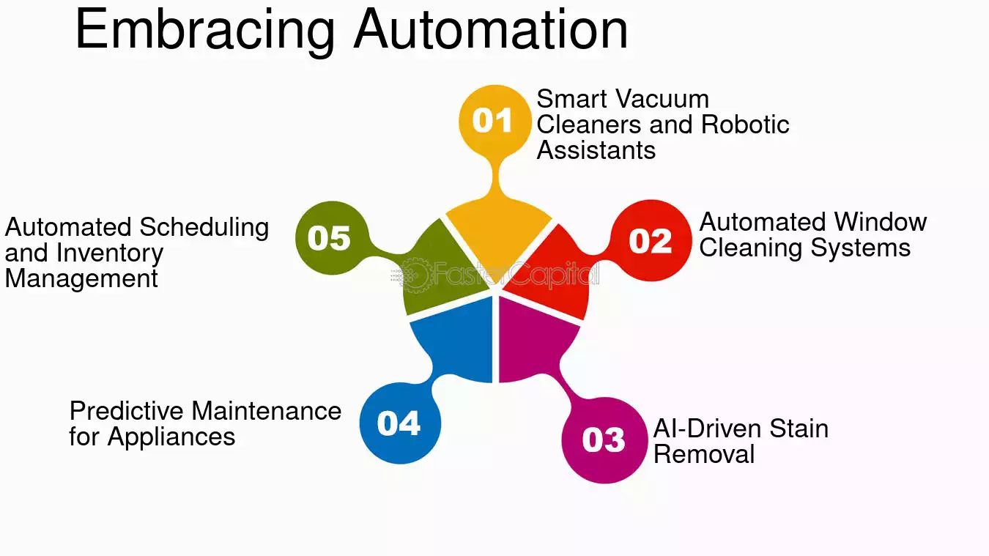
Figure 2: Smart Cleaning Equipment and Automation (Nadjmuddin and Hanadya, 2024)
However, if the hotel wants to implement automation successfully, first these smart devices should be deployed in areas where there is a lot of traffic, such as in lobbies and less crowded, premium suites, and the results should be tested while further implementation is done (Liu et al., 2020). It is up to the hotel to make it clear these tools are not meant to supplant staff but rather to expand them and work together with them. In order to be successful with automation, Sydney Harbour Marriott Hotel can measure success based on that result, which would be removing 25% of room cleaning time, increasing compliance with hygiene, and producing a 10–15% drop in annual cleaning product costs (Kusuma et al., 2022).
Redefining Housekeeping Staff Roles and Shift Structures
Management also offers another crucial recommendation for caring for the rooms more efficiently optimising staff roles and shift structures. Factors that affect efficiency and increase overtime expenses include housekeeping staff schedules that do not optimally align with peak check-in and check-out times (Mardhiah et al., 2022). The hotel, in its part, can get the right number of staff at all times by introducing demand-based scheduling where shifts are fixed according to occupancy forecasts. Moreover, staff cross-training at different housekeeping functions, i.e., linen management, deep cleaning, and guest-request services, can improve workforce flexibility and efficiency (Magova et al., 2020).
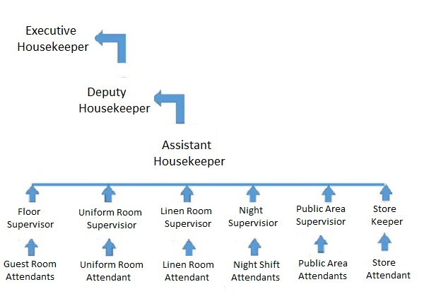
Figure 3: Housekeeping Staff Roles and Shift Structures (M’hamed and Idrissi, 2024)
A shift rotation policy can also minimise the workload and prevent employees from burning out at the same time and at the same level, providing the same level of service throughout the day. However, housekeeping staff are already in the habit of routine often resist shift changes (Mangco and Andales, 2023). The hotel should make this change as effective as possible through gradual adjustments, reaching employee feedback, benefits such as extra holidays, benefits based on performance, and shift preference for highly performing employees. This strategy has the following impact: It reduces overtime costs by 10–20%, has higher employee satisfaction scores, and takes a shorter time for room turnaround (Avula and Sithole, 2024).
Sustainability-Driven Cost Reduction Initiatives
Other than technological and workforce improvements, the hotel must give top priority to sustainability-based initiatives for housekeeping so as to reduce operational costs while improving its environmental position (Koukpaki et al., 2021). Being in line with the guest’s expectation of sustainable practices not only allows for long-term cost savings but also aligns with the practices. Outside of this, transitioning to eco-friendly cleaners has always been one of the key initiatives in place— replacing chemical-based cleaners with biodegradable, non-toxic cleaners that are less toxic to both guests and staff (Ning and Yim, 2021). Furthermore, the hotel should utilise advanced laundry practices, for example, low-temperature wash cycles and microfiber towels, which reduce water and vitality utilisation to a great degree (Jain and Srivastav, 2024).
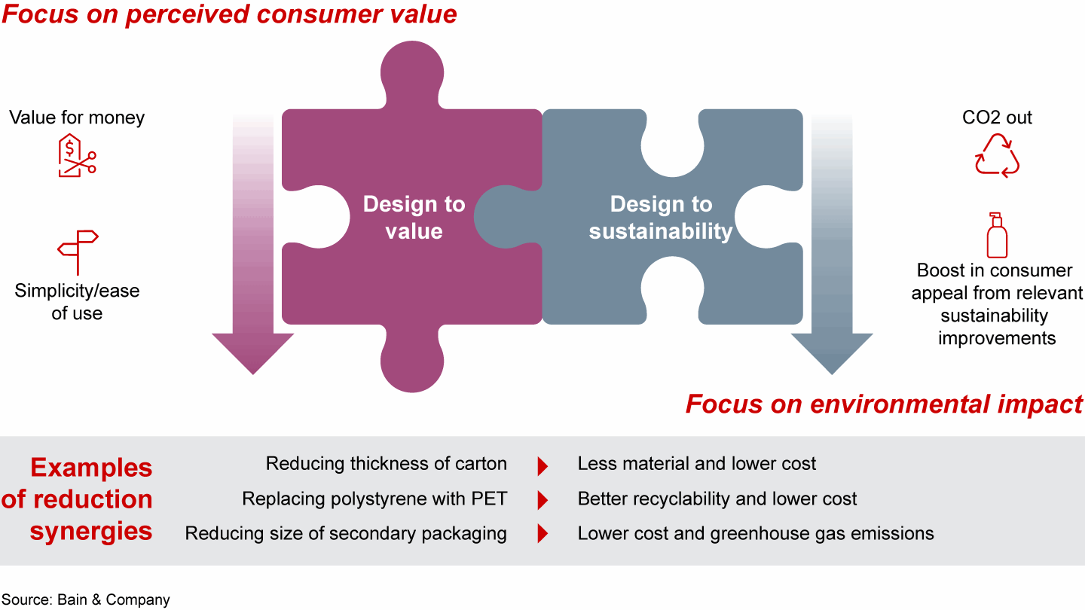
Figure 4: Sustainability-Driven Cost Reduction Initiatives (Sadhale, 2021)
One thing they have also done is the towel and linen reuse initiative, where the guests are invited to decline the changing of linen daily, which results in declining unnecessary laundry operations (Lin et al., 2023). To enable the success of these initiatives, the hotel should use guest education strategies, namely placing informational signage in guest rooms describing the environmental benefits of participating in the program (Kusuma et al., 2022). Also, they should teach housekeeping staff to practice water-efficient cleaning practices to complement their efforts for conservation. These sustainability efforts can be accounted for by a 20%–30% reduction in laundry-associated water consumption, a 15% reduction in cleaning supply expenditures, and positive guest comments on the hotel's environmental efforts (Alcalde-González et al., 2021).

4.2 Managing Change Implementation – ADKAR Model
Awareness
The first stage of the ADKAR model is Awareness. The first stage involves informing the staff about the impending changes. The hotel should start with the awareness campaigns to inform the staff about the new steps in housekeeping operations (Jayanti, 2023). To explain the benefits of adopting digital housekeeping management systems, meeting and town hall sessions can be organised to provide explanations ranging from the use of automation tools to discussions on sustainability in housekeeping (Kim et al., 2022). For these meetings, the hotel should highlight how the improvements will not only increase operational efficiency but also improve guest experience, cut manual labour, and match the demand for eco-friendly hospitality practices.
Desire
The next stage is Desire; it is time to motivate employees to participate in the change and help drive it forward. One-on-one consultations are necessary to address staff members’ concerns about job security, potential disruptions, interference, or changes to their roles (Ikhsan et al., 2024). This will enable the staff to voice their concerns and the management to rectify any misunderstandings. Also, the hotel can create incentives for employees who actively participate in the transition (Anwar et al., 2024). For instance, the hotel could offer performance bonuses or rewards for early adoption of digital tools and automated equipment, which would facilitate employees' adjustment to the new changes (Husaini and Lubis, 2024).
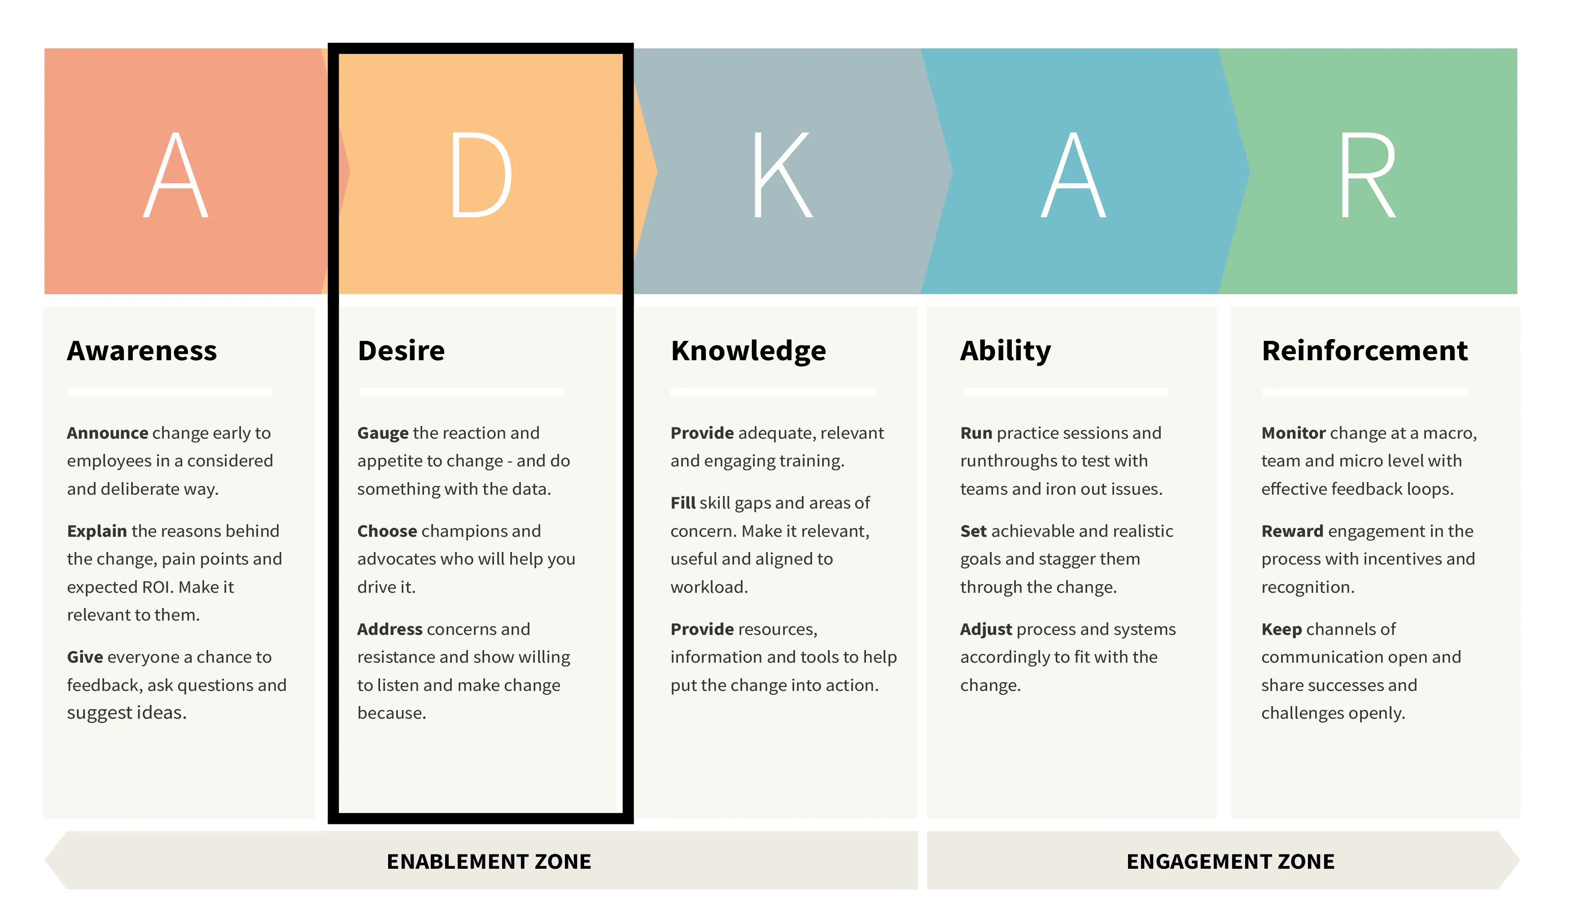
Figure 5: ADKAR Model (Ghosh, 2023)
Knowledge
At the end, Knowledge, the third stage, directs that employees are equipped with the requisite skills and information required to make use of the new digital systems and automated cleaning tools (Chaudhari, 2021). To ensure that the staff knows how to operate and manage new equipment savvy, for instance, robotic vacuums, UV sterilisation robots, and housekeeping management software, the hotel has to implement training workshops that focus on hands-on instruction. Secondly, the hotel should provide clear guidelines and step-by-step manuals for the staff to refer to when using the new systems (Al-Hyari et al., 2023). Support of the process should include assigning change champions, i.e., experienced supervisors, to designate who will provide peer support and guidance to staff as they learn the new technologies.
Ability
At the Ability stage, Sydney Harbour Marriott Hotel want to ensure that employees can actually use the new systems and tools in real terms. To make this possible, the hotel could hold trial runs where staff tested the new equipment and software on their actual housekeeping tasks so that they would be ready for the process (Bharwani and Mathews, 2021). Such tests would be in real time and will give valuable insights into any operational challenges or issues that might come in the line of implementation. Given staff feedback, the hotel can modify training sessions to deliver staff who are completely competent when using the new tools (Chang and Tsaur, 2022).
Reinforcement
The hotel's culture and operations should sustain and carry the changes throughout the Reinforcement stage, which is the final step. The hotel should use a system that permits it to monitor performance and that checks whether the adoption of the new housekeeping practices was successful by tracking the reduction in room turnaround times and guest satisfaction, as well as productivity (Chatterjee, 2022). Additionally, regular feedback sessions, as well as employee recognition programs, can be set up to praise people who reasonably excel in adapting to the new processes (Gaspani and Recchi, 2024). Early adopters and change champions will help to disincentivise negative thinking about changes by recognising people who have made adjustments to a positive attitude and will feed into motivating other people to adapt fully to the new ways of working.

4.3 Cost Analysis and Budget Allocation
Initiative | Estimated Cost - Yearly
Digital Housekeeping System | £100,000
Smart Cleaning Equipment | £75,000
Staff Cross-Training Programs | £20,000
Energy-Efficient Laundry Upgrades | £30,000
Eco-Friendly Cleaning Supplies | £15,000
Employee Incentive Program | £10,000

4.4 Measuring Success and Long-Term Benefits
Reduction of room turnover time becomes the first KPI, reducing the cleaning time to less than 15–20% shorter. A reduction in this service item guarantees an increase in the hotel’s overall operational efficiency, since the quicker room turnover directly affects the number of guests that can be accommodated in a shorter period (Hyde and Bagdan, 2021). Additionally, higher guest satisfaction is contributed to by a faster turnover time, which allows rooms to be cleaned and are most certainly ready for check-in without any unnecessary delays. Over a six-month period, performance will be tracked through the housekeeping management system and feedback from the staff and the guests, and the 15-20% will be monitored (Jaswal, 2020).
The second KPI, which focusses on labour cost savings, aims to reduce overtime expenses by 10 to 20 percent. The hotel must effectively manage the operating expenses, which constitute the majority of its operating costs, to maintain profitability (Iranmanesh et al., 2022). The hotel can reduce overtime use by implementing more efficient scheduling, optimising staffing levels according to occupancy forecasts, and cross-training employees. This KPI has a time frame of 1 year because one year is enough time for evaluating the whole impact of the changed shift structures and the improving operational efficiency caused by automation and her adoption (Gajić et al., 2024). It helps in tracking regular overtime expenses and labour cost reports and hence evaluates the progress towards this goal.
The last KPI is about achieving 90% or more positive cleanliness ratings in guest satisfaction scores. It is well known that cleanliness plays a crucial role in guest satisfaction and severely impacts the hotel’s reputation and the repeat business (Ervina et al., 2024). Sydney Harbour Marriott Hotel anticipate implementing smart cleaning equipment, training staff, and integrating sustainability-focused practices to enhance and promote cleanliness (Andriani et al., 2024). Sydney Harbour Marriott Hotel are going to track this KPI on a continuous basis by means of guest surveys, online reviews, and internal feedback mechanisms. The consistently high cleanliness score for the hotel is necessary to hold its place in the luxury hospitality market.

5. Action plan
Action plan for the Sydney Harbour Marriott Hotel is given below:
No. | Problem | Solution | Desired Outcome | Time Scale | Completion Date | Planned Budget
1 | Suboptimal assignment of housekeeping tasks and communication. | Establish a digital housekeeping management system (e.g., Optii Keeper, HotSOS) to automate job allocations and room status updates. | Faster work allocation, lowered room turnover time by 15-20%, and enhanced cleaning efficiency. | 6 months | Aug-25 | £50,000 (software purchase, training, and integration)
2 | Excessive manual labour and variable cleaning standards. | Implement intelligent cleaning devices, such as robotic hoover cleaners and UV sterilisation robots, to alleviate physical exertion on personnel and enhance operational efficiency. | Cleaning time decreased by 25%, better hygiene standards, and reduced dependency on chemical cleaning agents. | 9 months | Nov-25 | £80,000 (equipment procurement and staff training)
3 | Excessive overtime expenses and ineffective personnel scheduling. | Execute demand-driven shift scheduling and cross-training initiatives to enhance worker allocation. | A 10-20% decrease in overtime costs and more operational flexibility. | 12 months | Feb-26 | £30,000 (training and workforce planning tools)
4 | Increasing operational expenses attributable to unsustainable cleaning methodologies. | Utilise environmentally sustainable cleaning agents, use energy-efficient laundering methods, and initiate a guest linen reuse initiative. | Decreased water and chemical use by 20-30%, reduced operating expenses, and enhanced environmental standing. | 12 months | Feb-26 | £40,000 (procurement of eco-friendly supplies, guest communication campaigns)
5 | Opposition to technological and procedural modifications. | Execute change management techniques with the ADKAR paradigm, including workshops, practical training, and employee incentives. | Enhanced staff acceptance and involvement in novel housekeeping procedures. | 6-9 months | Oct-25 | £20,000 (training sessions, employee incentives, and ongoing support)

The action plan was created to streamline the operational efficiency of the Sydney Harbour Marriott Hotel's housekeeping department by improving task allocation, cleaning standards, labor costs, sustainability, and change management (Das et al., 2021). By implementing such a digital housekeeping system, communication will be improved, and turnaround time for rooms will be diminished; smart cleaning technology will increase efficiency and hygiene. Sustainable cleaning practices and optimised staff scheduling will reduce overtime expenses, thereby reducing costs and their environmental impact. Change management strategies will smooth the adoption with staff engagement. These solutions, when they lie within a structured budgeted timeline, will lead to long-term efficiency and cost savings as well as guest satisfaction.

6. Conclusion
The purpose of this report is to provide a comprehensive analysis of operational inefficiencies in the housekeeping department of Sydney Harbour Marriott Hotel at Circular Quay, Australia, and strategic recommendations are made to increase efficiencies, reduce costs, and increase service quality. Inefficiencies in the hotel’s housekeeping department can lead to instances where the housekeeping department is not doing its job to maintain the hotel’s luxury level and contribute to guest satisfaction, which can be caused by numerous reasons; as well as, these inefficiencies can negatively affect guest experiences, operational expenses, employee productivity, and the hotel’s overall reputation.
Key challenges identified in the report were affecting housekeeping operations. Delays in room turnover due to suboptimal allocation of tasks and inefficient communication systems have affected guest satisfaction as well as front office operations. Furthermore, the excessive use of manual cleaning processes led to inconsistent service quality and increased labour costs. Ineffective staff scheduling leads to high overtime expenses, straining the department's budget and contributing to employee fatigue. On top of that, non-sustainable cleaning practices are becoming a financial burden due to the rising operational costs, as well as resistance to the technological and procedural changes slowing down the adoption of modern housekeeping solutions.
To address these problems, the report suggested lots of recommended actions, which would make the housekeeping department more efficient and orientated towards technology and green tracing. Digital implementation of a housekeeping management system was recommended to improve how task allocation is done, the communication between colleagues, and to reduce the time required to turn rooms over. Smart cleaning equipment and automation, such as robotic vacuum cleaners and UV sterilisation devices, will increase efficiency, improve hygiene standards, and reduce manpower. We should optimise staff shift structures and cross-train employees to balance workload distribution, reduce overtime spending, and enhance the overall flexibility of the user workforce. Furthermore, it would support sustainability-driven cost reduction initiatives, including the implementation of eco-friendly cleaning products, energy-efficient laundry practices, and guest linen reuse programs, which would help in reducing the operational cost in the long term and strengthen the hotel’s environmental responsibility.
Since a successful implementation of these recommendations is dependent on the actual implementation of the change management strategy, this model was specified in accordance with the ADKAR model. In this model, there was an emphasis on such aspects as awareness, desire, knowledge, ability, and reinforcement to guarantee that employees are educated and trained enough to accept new processes. It also outlined the value of training in practice, in spells of engagement, and in continuous support in order to defeat resistance and ensure lasting success.
The success of these improvements was measured in terms of the key performance indicators (KPIs) needed to achieve a reduction in room turnover time, reduced labour costs, and an increased guest satisfaction score. These metrics will assist the hotel in monitoring progress and making sure the advised strategies bring out measurable and lasting outcomes.
An action plan was structured with a breakdown of each solution proposed with a timeline, budget, and expected outcomes that allowed the hotel to take action and deliver new changes promptly. The initiatives that are proposed mirror the upscale brand position in which Sydney Harbour Marriott is situated, and proposed management measures would not permit operational changes to mar the integrity of Sydney Harbour Marriott’s service quality.
Finally, this consultancy report has offered Sydney Harbour Marriott Hotel a cross-functional strategic roadmap to achieve more efficiency and savings related to the related housekeeping department and also to have better guest experiences. The hotel can future-proof its operations and maintain its competitiveness in the Sydney luxury hospitality market by embracing technology, implementing process improvements, and exploring sustainability-driven strategies.

References
Abalaka, A., Olaniyi, O. O., and Adebiyi, O. O. (2023). Understanding and overcoming the limitations to strategy execution in hotels within the small and medium enterprises sector. Available at SSRN 4614043.
Alcalde-González, V., Mozo, A. G., and Bustos, A. V. (2021). No clean rooms, no hotel business: Subversion tactics in Las Kellys’ struggle for dignity in hotel housekeeping. Annals of Tourism Research, 91, 103315.
Al-Hyari, H. S. A., Al-Smadi, H. M., and Weshah, S. R. (2023). The impact of artificial intelligence (AI) on guest satisfaction in hotel management: An empirical study of luxury hotels. Geo Journal of Tourism and Geosites, 48, 810-819.
Ambardar, A., Singh, A., and Singh, V. (2023). Barriers on implementing ergonomic practices in hotel housekeeping. International Journal of Hospitality and Tourism Systems, 16(2).
Andriani, S., Ramanayaka, L., and Bhatt, V. (2024). Towards educational excellence: utilizing education hotels as an innovative learning base for hospitality accommodation program students. Journal Evaluation in Education (JEE), 5(2), 74-80.
Anwar, F. A., Deliana, D., and Suyamto, S. (2024). Digital Transformation in the Hospitality Industry: Improving Efficiency and Guest Experience. International Journal of Management Science and Information Technology, 4(2), 428-437.
Avula, M., and Sithole, T. (2024). Artificial Intelligence's Potential to Improve Operational Efficiency and Customer Experience in the Hospitality and Tourism Sectors. In Impact of AI and Tech-Driven Solutions in Hospitality and Tourism (pp. 351-382). IGI Global.
Avula, M., and Sithole, T. (2024). Artificial Intelligence's Potential to Improve Operational Efficiency and Customer Experience in the Hospitality and Tourism Sectors. In Impact of AI and Tech-Driven Solutions in Hospitality and Tourism (pp. 351-382). IGI Global.
Azzahra, M. S., and Asshofi, I. U. A. (2024). Study of the cooperation relationship between the front office and housekeeping departments through communication at hotel tentrem semarang. Journal of Gastro Tourism, 2(2), 75-92.
Bharwani, S., and Mathews, D. (2021). Techno-business strategies for enhancing guest experience in luxury hotels: a managerial perspective. Worldwide Hospitality and Tourism Themes, 13(2), 168-185.
Burnes, B. (2014) 4th Edition, Managing Change, Great Britain, Prentice Hall.
Buttrick, R. (2009) The Project Workout, London: Prentice Hall.
Chang, T. Y., and Tsaur, S. H. (2022). Evaluating the operating efficiency of international tourist hotels using the modified DEA model. Journal of Hospitality and Tourism Research, 46(2), 234-256.
Chatterjee, P. (2022). Role of Housekeeping Cleaning Equipment and Agent in the world of Hospitality Industry. International Journal of Research Publication and Reviews, 3(8), 1642-1646.
Chaudhari, M. P. S. (2021). Hotel Housekeeping Services And Customer Satisfaction. Ilkogretim Online, 20(1), 5837-5844.
Chen, X. A., Wang, R., and Zhang, J. (2022). Divide and conquer: A hygienic, efficient, and reliable assembly line for housekeeping. Manufacturing and Service Operations Management, 24(2), 938-955.
Das, P., Sarkar, K., Agarwal, S., and Saxena, S. (2021). Implementation and Effectiveness of New Technologies in Housekeeping Department. Annals of the Romanian Society for Cell Biology, 995-1001.
Ervina, E., Suryawardani, B., Prabawa, G., Hanifa, F. K., and Husna, A. K. (2024). The Development of a Room Division Application Implementing an Intelligent Planning System (IPS) to Enhance Hotel Operational Performance. Momentum Matrix: International Journal of Communication, Tourism, and Social Economic Trends, 1(2), 38-50.
Gajić, T., Petrović, M. D., Pešić, A. M., Conić, M., and Gligorijević, N. (2024). Innovative Approaches in Hotel Management: Integrating Artificial Intelligence (AI) and the Internet of Things (IoT) to Enhance Operational Efficiency and Sustainability. Sustainability, 16(17), 7279.
Gaspani, F., and Recchi, S. (2024). Job quality and health conditions in the hotel industry: the case of housekeeping workers. International Review of Sociology, 1-23.
Ghosh, M. (2023). Analysing Iot Automation Facilities In Hotel Rooms: Enhancing Guest Experience And Operational Efficiency. Rajasthali Journal, 2(4), 54-60.
Husaini, F., and Lubis, D. S. W. (2024). The Role Of Supervisors And Standard Operating Procedures For Cleaning Rooms In Improving The Performance Of Employees Housekeeping Department Hotel Grand Mercure Medan. Jurnal Ekonomi, 13(02), 1316-1328.
Hyde, S. L., and Bagdan, P. J. (2021). Improving Effectiveness and Efficiency. In Operations Management in the Hospitality Industry (pp. 211-241). Emerald Publishing Limited.
Ikhsan, A., Rosari, D., Pambudi, J. E., Lubis, P. K. D., and Fadillah, T. D. (2024). the Effect of Audit Committee, Internal Auditor and Audit Quality on Firm Value on Hotel Industry in Indonesia. International Journal of Economics and Finance Studies, 16(1), 337-354.
Iranmanesh, M., Ghobakhloo, M., Nilashi, M., Tseng, M. L., Yadegaridehkordi, E., and Leung, N. (2022). Applications of disruptive digital technologies in hotel industry: A systematic review. International Journal of Hospitality Management, 107, 103304.
Jain, G., and Srivastav, D. (2024). Breaking the Glass Ceiling: Overcoming Challenges Faced by Women in the Housekeeping Sector. Int. J. Sci. Res. in Multidisciplinary Studies Vol, 10(5).
Jaipuriar, S. Role of Technology in Accommodation Operation Department of Hotel: An Employee’s Perspective. Hospitality and Tourism Emerging Practices in Human Resource Management, 70.
Jaswal, R. (2020). Analyzing the Integration of Robotics and AI in Hotel Housekeeping: Enhancing Productivity and Guest Experience. Global Journal of Management and Business Research: E Marketing, 20(1), 1-8.
Jayanti, J. (2023). Hotel Housekeeping Management: Changing Trends and Developments. Goodfellow Publishers Ltd.
Kim, J., Kim, S. I., and Lee, M. (2022). What to sell and how to sell matters: Focusing on luxury hotel properties’ business performance and efficiency. Cornell Hospitality Quarterly, 63(1), 78-95.
Koukpaki, A. S. F., Adams, K., and Boakye, K. O. (2021). Talent Management in Hotels during Covid-19: Upper Echelons and Dynamic Attention-Based Perspectives. International Journal of Contemporary Hospitality Management, 33(6), 2057-2077.
Kusuma, B. S., Hasibuan, A., Nasution, S. P., Utami, A. P., and Dalimunthe, A. R. (2022). An increasing knowledge about the importance of occupational safety and health (k3) in housekeeping labor hotels. INFOKUM, 10(5), 424-431.
Kusuma, I., Antara, D. M. S., and Murni, N. G. N. S. (2022). The Implementation of Green Housekeeping to Increase Efficiency of Operational Cost of Housekeeping Department at Holiday Resort Lombok (Doctoral dissertation, Politeknik Negeri Bali).
Lennon, J. (2023). Productivity in the hospitality sector: can management apps really improve work productivity in the housekeeping department?. In Council for Australasian Tourism and Hospitality Education Conference 2023: West, East, South, North: Redirecting Research in Tourism, Hospitality and Events.
Lin, C. S., Shyu, C. S., and Li, C. P. (2023). The greener the hotel, the better operating efficiency it has? A sustainable tourism perspective. Sustainability, 15(14), 10927.
Liu, P., Chen, Y., and Teo, C. P. (2020). Limousine Service Management: Capacity Planning with Predictive Analytics and Optimization. arXiv preprint arXiv:2009.05422.
M’hamed, E. G., and Idrissi, R. E. (2024). Transforming Hospitality: Harnessing Artificial Intelligence for Enhanced Guest Experience and Operational Efficiency. In The International Workshop on Big Data and Business Intelligence (pp. 173-185). Cham: Springer Nature Switzerland.
Magova, G. B., Masele, J. J., and Warren, T. (2020). Bridging knowledge management and training to boost hospital efficiency: Evidence from private hospitals in Uganda. Knowledge Management Research and Practice, 18(3), 307-319.
Mangco, C. A., and Andales, N. (2023). Assessing Hygenic Practices, Sanitation Procedures of Housekeeping Department Perceived by Hotels-Motels Housekeeping Heads. Interdisciplinary Social Studies, 2(8), 2186-2193.
Mardhiah, A., Farisha, N., Yuan, W. P., and Tony, F. N. (2022). Investigating the Influence of Perceived Ease of Use and Perceived Usefulness on Housekeeping Technology Intention to Use. International Journal of Academic Research in Business and Social Sciences, 12(11), 1306-1314.
Nadjmuddin, M., and Hanadya, D. (2024). Effective Communication Skills for Housekeeping Staff: Improving Guest Interaction in English. INTERACTION: Jurnal Pendidikan Bahasa, 11(2), 291-305.
Ning, X., and Yim, D. (2021). Adoption of smart sustainability performance measurement system (SPMS) in hotels and variations across ratings, reviews, and operational efficiency scores. Journal of Smart Tourism, 1(2), 13-18.
Noordzife, G. (2014) Project Management of Hotel Opening Processes: Exploring Better Ways to Manage New Hotel Openings, CreateSpace.
Prakash, S., Sharma, V. P., Singh, R., and Vijayvargy, L. (2023). Adopting green and sustainable practices in the hotel industry operations-an analysis of critical performance indicators for improved environmental quality. Management of Environmental Quality: An International Journal, 34(4), 1057-1076.
Ramadan, M. A., Al Dhaheri, M. K., Maalouf, M., Antony, J., Bhat, S., and Gijo, E. V. (2023). Application of Six Sigma methodology to enhance the productivity and performance of a hotel in the UAE. The TQM Journal, 35(2), 554-576.
Rashid, T. A., Toghramchi, C. I. S., Sindi, H., Alsadoon, A., Bacanin, N., Umar, S. U., Shamsaldin, A. S., and Mohammadi, M. (2021). An Improved BAT Algorithm for Solving Job Scheduling Problems in Hotels and Restaurants. arXiv preprint arXiv:2109.14441.
Sadhale, M. (2021). The Changing Role of Housekeeping Department in Hotels Post COVID-19 Pandemic. Eureka Publications.
Sharma, V., Bideshi, R. K., and Bajpai, S. (2023). " Impact of Sustainable Housekeeping Practices on Environmental Stewardship and Operational Efficiency in the Hotel Industry.
Singh, A., and Singh, V. K. (2022). The impact of ergonomic practices on housekeeping employee retention and efficiency in hotels during COVID-19 in India.
Srivastava, P., and Tyagi, P. K. (2024). Assessing Disruptive Technology’s Influence on Housekeeping Operations and Employee Dynamics in Star Category Hotels. In International Conference on Innovation and Regenerative Trends in Tourism and Hospitality Industry (IRTTHI 2024) (pp. 317-325). Atlantis Press.
Srivastava, P., and Tyagi, P. K. (2024). Implications of AI in Hotel Housekeeping Operations. In Hotel and Travel Management in the AI Era (pp. 337-356). IGI Global.
Srivastava, P., and Tyagi, P. K. (2024). Smart Solutions in Hospitality: Enhancing Housekeeping Through Advanced Technologies. In Hotel and Travel Management in the AI Era (pp. 467-484). IGI Global.
Sydney Harbour Marriott Hotel (2025). Sydney Harbour Marriott Hotel - About us. Available at: https://www.marriott.com/en-us/hotels/sydmc-sydney-harbour-marriott-hotel-at-circular-quay/overview/?scid=f2ae0541-1279-4f24-b197-a979c79310b0. [Accessed on: 3rd February, 2025].
Tavitiyaman, P., Tsui, B., Chan, C. L. F., and Miu, H. W. (2022). Employee productivity of hotel room attendants: an input–output perspective. International Journal of Hospitality and Tourism Administration, 23(5), 959-986.
Thoriq, N., Intiar, S., Jabbar, U. A., Aryaningtyas, A. T., and Aswan, M. K. (2024). The Future Of Hotel Housekeeping: New Trends And Modern Approaches. MSJ: Majority Science Journal, 2(3), 61-67.
Tiwari, A., Singh, M., and Dahiya, A. (2022). Outsourcing Hotel Housekeeping Services: An Investigation into the Critical Challenges during the Pandemic Times. International Journal of Hospitality and Tourism Systems, 15(COVID-19 Issue), 8.
Tiwari, A., Singh, M., and Dahiya, A. (2024). The Impact of Outsourcing on Job Satisfaction and Productivity of Hotel Housekeeping Employees. Hospitality and Tourism Emerging Practices in Human Resource Management, 38.
Trull, O., Peiro-Signes, A., Garcia-Diaz, J. C., and Segarra-Ona, M. (2024). Prediction of energy consumption in hotels using ANN. arXiv preprint arXiv:2405.18076.
Tsaur, S. H., and Lin, Y. C. (2018). Promoting service quality in tourist hotels: The role of HRM practices and service behavior. Tourism Management, 69, 56-66.
Verma, P., and Singh, M. (2021). Sustainable Housekeeping Practices in Hotels: A Review of Trends in Sustainability Practices Performed By Housekeeping Staff. Hospitality and Tourism Emerging Practices in Human Resource Management, 79.
W Fakhry, B., Saad, S., and Ibrahim, Y. (2022). Factors affecting the turnover of entry-level employees in housekeeping department in five star hotels. International Journal of Tourism, Archaeology and Hospitality, 2(1), 3-16.
Waaje, A., Karim, R., Roshid, M. M., and Meem, T. N. (2025). Minimizing Waste in the Hospitality Industry: The Opportunities and Challenges of Lean Tourism. Sustainable Waste Management in the Tourism and Hospitality Sectors, 125-166.
Wangsa, V., Erwen, I. V., Natasha, S., Shielline, P., Poluan, R. C., Wulandari, N., and Kalfin, K. (2024). The Impact Of Outsourcing on Hotel Efficiency and Performance. International Journal of Humanities, Law, and Politics, 2(1), 33-37.
Whittington, R. et al (2020) Exploring Strategy. Harlow: Pearson Education Limited.
Yusuf, M., Irwanti, N. D., and Indonesia, B. (2021, February). Implementation of 5S in the Pantry Housekeeping of Hotels to Increase Work Productivity. In ICONEBS 2020: Proceedings of the First International Conference on Economics, Business and Social Humanities, ICONEBS 2020, November 4-5, 2020, Madiun, Indonesia (p. 281). European Alliance for Innovation.
Zhang, J. J., Joglekar, N. R., and Verma, R. (2018). Exploring resource efficiency benchmarks for environmental sustainability in hotels. Cornell Hospitality Quarterly, 53(3), 229-241.

