Research in Data Security and Compliance
Accessing a network in a safe way: VPNs
Cristian Stefan Stancu
Student University of Wales Trinity St David, Swansea, Wales
2008911@student.uwtsd.ac.uk

Abstract: There’s a tremendous amount of increase in attacks and threats on the public networks so the security of data exchanged has become one of the main concerns of all the companies connected to Internet. Every single connected device to a public network can become a potential victim unless it’s being protected. Back in 90’s, the VPNs were mostly associated with and used by businesses to access their private business networks.
Keywords: VPN, PPTP, OpenVPN, WireGuard

Introduction
Virtual Private Networks (VPN) is being used to establish a high level of security over the public networks. The history of VPN (virtual private network) technology dates back to 1996, when a Microsoft employee developed the peer-to-peer tunneling protocol, or PPTP. Effectively the precursor to modern VPNs, PPTP creates a more secure and private connection between a computer and the internet. [1] The idea behind this was to establish a connection over the public network to a private network and the client to have access to the resources on that private network. Originally, the VPN technology has been used by businesses, organizations, governments, entities holding sensitive information and which were at the time at risk of hacking or data loss when using the public network. Imagine the VPN as a local network in which different devices are directly connected to each other with no need for open connection to Internet except using it to transit the connection. Is, as the name of the initial protocol says, Peer-To-Peer-Tunneling-Protocol a secured tunnel between the client and the network to be accessed.

Protocols

PPTP
The initial protocol published, PPTP, is still one of the most common, easiest to setup and is one of the fastest still. The speed is the reason for that protocol to be used in high speed demands applications such as video and/or audio streaming and on older limited computing power devices. Also, one more pros of this protocol is the compatibility across the devices being supported from older devices to the newest ones.
However, PPTP is one of the weakest when it comes to security being well known for serious security vulnerabilities. Security experts have listed numerous known vulnerabilities of the protocol.

MS-CHAP-V1 is Fundamentally insecure
Tools exist that can easily extract the NT Password hashes from MS-CHAP-V1 authentication traffic. MS-CHAP-V1 is the default setting on older Windows Servers

MS-CHAP-v2 is Vulnerable
MS-CHAP-V2 is vulnerable to dictionary attacks on captured challenge response packets. Tools exist to crack these exchanges rapidly.

Brute Force attack Possibilities
Back in 2012, at Defcon 20 it was demonstrated the cracking of MS-CHAPv2 with a 100% success rate just like a brute-force attack on a single DES key. Considering that successful demonstration, Marlinspike, one of the authors concluded: “All users and providers of PPTP VPN solutions should immediately start migrating to a different VPN protocol. PPTP traffic should be considered unencrypted.” [2]

L2TP/IPSec
Layer 2 tunneling protocol (L2TP) it’s a VPN tunnelling protocol which is more like an extension to PPTP and is only creating a connection between the client and the VPN server with no encryption at all. Because it doesn’t have any kind of encryption or authentication, L2TP is paired with IPsec (Internet Protocol Security) protocol to provide the encryption of the data that’s travelling through connection. Being old and outdated, many devices don’t support it anymore and is less frequently used. Another issue with L2TP is that L2TP sometimes has problems with firewalls because of its use of UDP port 500, which some firewalls have been known to block according to ExpressVPN [3]

IPSec/IKEv2
IKEv2 – Internet Key Exchange version 2 is a tunnelling protocol based on IPsec which is used to establish a secure tunnelling connection and defines negotiation and authentication processes for IPsec security associations. The IKEv2 part is doing the security association while IPsec is handling the data transmission.

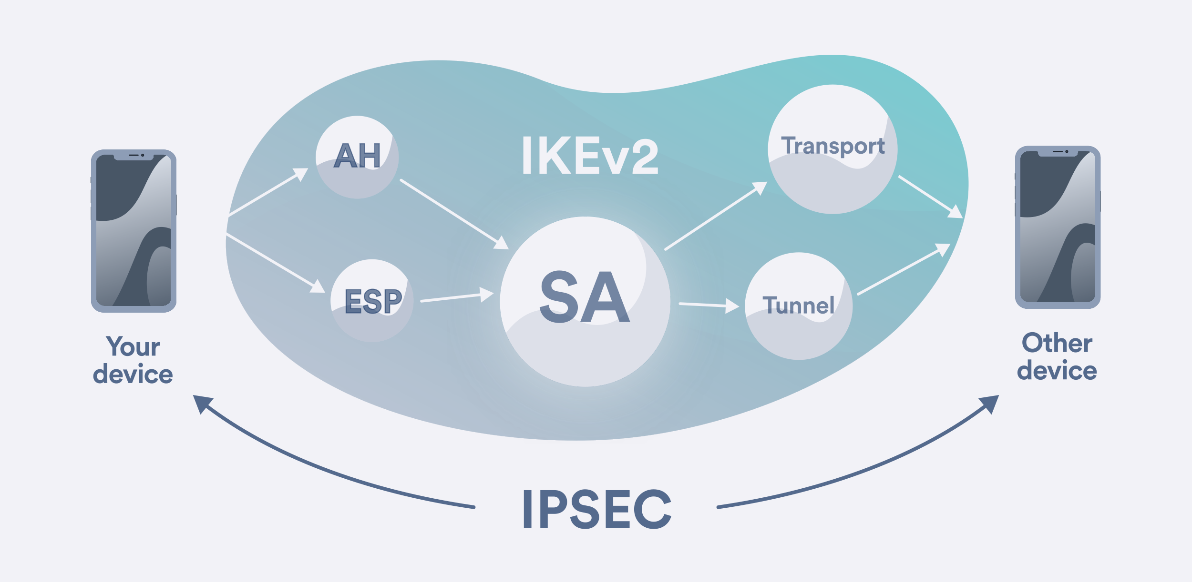
Figure 1

The version 2 of the protocol is a version optimized for speed and efficiency by pruning and optimizing of some processes. Also is made to consume less bandwidth and has built-in NAT (Network Address Translation) traversal. Up until now, IKEv2 has no known vulnerabilities on its own.

OpenVPN
OpenVPN is some of the most well-known protocol used and very secure. It can run on either TCP or UDP. As name says, it’s Open source and anyone can inspect the source code for any potential backdoors or vulnerabilities hidden in the code, things that can be a threat to your VPN security. Compared to the other ones, OpenVPN is more complex and that can be considered a con for it. The reason is that OpenVPN is a protocol and a software which is implementing that protocol. The software has been developed by James Yonan in 2001 and published under the GNU General Public License (GPL). It is by far the most widely-used VPN protocol. It uses the OpenSSL library to provide encryption of the packages of data so that makes the OpenVPN very flexible as OpenSSL itself supports a number of different cryptographic algorithms including:
- AES, Blowfish, Camellia, ChaCha20, Poly1305, DES, Triple DES, GOST 28147-89, SM4 for encryption and authentication
- MD5, MD4, SHA-1, SHA-2, MDC-2, BLAKE2 for hashing
- UDP and TCP as the Transport Layer protocol
Open VPN has so far no known security vulnerabilities and since 2001 has been audited many times by many security experts and companies.

WireGuard
WireGuard is taking the VPN world by storm. It promises big improvements over existing VPN protocols and so far in 2022, we’ve seen more VPN services moving to WireGuard. [4]
Wireguard is a recent proposed protocol to estabilish a connection through a secure network tunnel operating at layer 3. Its main goal was to be so good to offer an alternative to OpenVPN and IPsec. In his own paper it’s being stated that unlike IPsec which uses the Linux transform (“xfrm”) layer, WireGuard does away with these layering separations. [5] As for encryption, Wireguard is using one of the strongest recognized encryption ciphers named: ChaCha20. It is cross platform and can be used on Linux, MacOS, iOS, Android and Windows systems. It is very lightweight too so compared to OpenVPN which is having 70.000 lines of code, it has only around 5.000. Also, many benchmarks have pushed Wireguard in top of the VPN protocols as being the fastest many of the test revealing a 2x times or even more faster than OpenVPN.

IPSec Cryptography
The original Internet Protocol had no security or encryption but once with the expansion of the public network, it was noticed an increasing number of attacks and threats hence in the beginning of 90’s, the Internet Engineering Task Force known as IETF formed the IP Security Working Group to standardize the security extensions to IP called IPSec. IPSec uses cryptography to accomplish the secure transmission of data across media. This cryptographic process is divided into three parts: the key, a cryptographic mathematical function and a message. This processes extremely simplified is: a message is put into an algorithm which uses a ‘key’ to transform the message into a format that is unbreakable to anyone who does not have the key [6]
There are two types of encryption that is used by VPN software:
- Symmetric encryption
- Asymmetric encryption

Symmetric encryption
This kind of encryption relies on the same encryption key which makes it more vulnerable to attacks. One common attack mentioned by security experts is ‘man in the middle’ or MITM and the principle is simple: catching the symmetric key and then using that is able to decrypt any message.
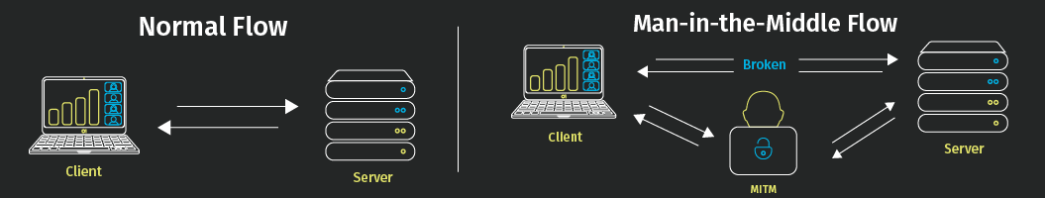
Because of this vulnerability, IPSec utilises the Diffie-Hellman key agreement which is a public key encryption method providing a way to estabilish a shared secret key that only the clients knows.

Asymmetric encryption
This kind of encryption involves two keys instead of one:
- Private key – used to decrypt data
- Public key – used to encrypt data
The private key is always in the clients hand, never shared over any kind of network or medium and is used only to decrypt the data. So, if someone is capturing a public key using the technique above, MITM, he’s only able to encode any message and not decode it. The DES and 3DES algorithms are two of the most popular algorithms. DES is now considered less secure. It was recently shown to take only 24 hours to crack. Many experts recommend using 3DES.

Why VPN?
As a business grows and expand to multiple locations or even countries, it comes the need for those locations to share the resources within a network in a securely, fast and reliable way. In addition, we have the example of the pandemic period of 2020-2021 when many of the employees started working from home. That lead to a tremendous growth of VPNs across the world.
There’re different types of VPNs though

Remote access VPNs
These are mostly the employee’s kind of connection to the company network for working purposes and having access to the resources shared:
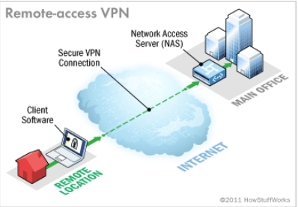

Site to site VPNs
A site-to-site VPN allows interconnection of different networks just as they are in the same building for instance. That allows the different networks or locations to work together in a safe and secured environment. It’s a safe way to share or process sensitive data that cannot be exposed over the internet.
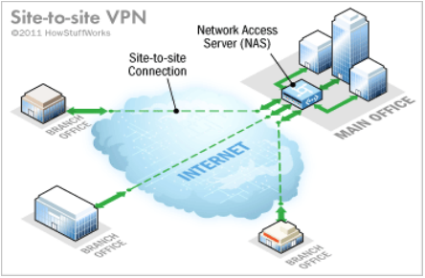

Requirements
The requirements to setup a VPN depend mostly on the protocol chosen. As I detailed above some of the protocols can’t get beyond the firewalls and while in the 90’s or even 2000’s the threats and attacks were low on intensity, todays these are something normal hence the necessity of having a firewall in place. So the VPN has to be able to communicate with the network/resource beyond the firewall which sits in front of it either by allowing in firewall a certain port (e.g. 1723 for PPTP or UDP 500 for L2TP) but must be research if that can
lead to a potential opportunity for an attacker to exploit that. Also, the VPN protocol and software must be cross platform compatible to ensure all or most of the devices can access it such as PCs: Windows, Linux, MacOS or mobile devices: iOS & Android.

Conclusion
VPNs enable users and companies to communicate over the public network to remote servers, offices or the business while doing that in a secure way. Most of the VPNs are highly secure, versatile, inexpensive communication tools. VPN technology certainly belongs to the category of secure remote communication with one's own office, which guarantees data confidentiality, data integrity and secure user authentication.

Bibliography

[1] | V. MUJOVIĆ, "THE HISTORY OF VPN," 17 August 2018. [Online]. Available: https://www.le-vpn.com/history-of-vpn/.
[2] | M. Marlinspike, "Divide and Conquer: Cracking MS-CHAPv2 with a 100% success rate," 29 July 2012. [Online]. Available: https://web.archive.org/web/20160316174007/https://www.cloudcracker.com/blog/2012/07/29/cracking-ms-chap-v2/.
[3] | ExpressVPN, "What is L2TP/IPsec?," ExpressVPN, [Online]. Available: https://www.expressvpn.com/what-is-vpn/protocols/l2tp.
[4] | R. Privacy, "WireGuard vs OpenVPN in 2022," 2022. [Online]. Available: https://restoreprivacy.com/vpn/wireguard-vs-openvpn/.
[5] | J. A. Donenfeld, "WireGuard: Next Generation Kernel Network Tunnel," Wireguard.
[6] | J. Carmouche, IPsec Virtual Prive Network Fundamentals, Cisco Press, 2007.

