
Applied Leadership and Management
Module Assignment Submission
Student Name: | Harley Scott
Student Number: | 2225835
Module No: | BMSK4010/C
Module Title: | Contemporary Challenges: Making a Difference

Statement of Confirmation of Authenticity
By the act of making this submission, the student declares that this is the work of the student named above. The work has not, in whole or in part, been knowingly presented elsewhere for assessment, or where assessment has been built on a previous assessment, this has been identified. Where materials have been used from other sources it has been properly acknowledged. If this statement is untrue, the student acknowledges that an assessment offence has been committed.
Attention is drawn to the plagiarism and unfair practice policies of both the University and of ILM.

Introduction
This summary will be looking at what a global team is and what it takes to lead a global team. It will cover how a global team is affected by diversity, culture, inclusion, responsible stewardship and cognitive bias. It will also cover some of the advantages and challenges that come with leading a global team.
What is a global team and what does it take to lead a global team?
A global team is a group of employees working for the same company; however, they are based all around the world. An example of this is the food chain McDonald’s. McDonald’s is a worldwide food chain. It first started in Illinois, US, and now has over 38,000 stores in over 100 countries. A global team often includes team members who live in and telecommute from different countries. Overcoming language barriers and embracing the diversity of team members can enable the leader and team members to build meaningful relationships with colleagues in countries across the world.
A global team is made up of a diverse group of employees from different cultures, race, values and beliefs. When leading a global team, it is important to understand that different countries have different legislations. Depending on where you are in the world depends on what laws apply to the company. McDonalds in France will serve an alcoholic drink with a meal, however, in the UK you can only get a non-alcoholic drink.
A global team needs to have a global leader. Their role is to provide direction, coordination, guidance, accountability and effective decision-making across diverse cultures and locations.
‘The modern manager needs to work with greater creativity and flexibility in today’s diverse and digitally enhanced work environment. Rapid technological progress and access to new markets have driven multinational corporations to create more complex, fluid, and interdependent company structures, which Buckley (2009) conceptualises as global factories.’
With being a global team leader, comes great responsibility and skills. You must be able to work around and understand the different time zones, culture differences and be inclusive of the different diversity within the different countries. You must be able to respect people’s ethnicity and beliefs without judgement. You need to be able to set clear team goals, be able to delegate work and set deadlines. Provide training when needed. Have a good open communication with different cultures and be able to motivate your team. In today’s world, leading a global team requires more than just effective management skills. With increasing globalization and the digital revolution, teams are often composed of individuals from diverse background, cultures, and perspectives. This necessitates leaders to embrace and foster diversity and inclusiveness to unlock the full potential of their teams. Trust is essential for diversity and inclusion to thrive in a global team, it fosters open communication, collaboration and respect among members from different backgrounds. This will give them confidence to share diverse perspectives and to contribute to the team.
It is important as a leader to get to know everyone in their team. Actively listening to members of the team from different cultural backgrounds will help the leader to communicate better with employees with a greater understanding of their values and beliefs. It is important that everyone on the team is an equally valued member, and all get the chance to provide their expertise. To reduce the chance of conflict, the team leader must work on building trust within the community. Any sign of conflict must be dealt with immediately and in a professional manner. It is important to follow the company culture and to treat everyone equally and respectfully. Bringing together people from diverse cultural backgrounds will help bring different solutions to situations as everyone will have different experiences and points of views these can help solve issues which you may not have been able to alone. It increases creativity and therefore helps with problem solving.
A key role in a global team is responsible stewardship. This is the careful and ethical management of resources, responsibilities and relationships for the benefit of all involved. It is crucial as it ensures the proper utilization of resources, promotes transparency and trust with the team members. By practising responsible stewardship, teams can uphold sustainability, fairness, and accountability leading to effective teamwork, shared goals and long-term success.
As a leader it is important that accountability is taken when needed. Due to a global team being large, steps need to be taken to ensure things run as smooth as possible. These can be setting clear boundaries, instructions and to document everything. By assigning people to certain tasks, it is easier to find out who did what task and if it was followed out correctly. It is important to follow up with any tasks delegated and to give feedback. Provide consequences for poor performance and reward those who work hard and do well, this can encourage team members to try their best.
‘While diversity emerges from characteristics of individuals (cognitive diversity), inclusiveness stems from the ability of teams and organizations to utilize diverse individuals to achieve their specified mission (Ferdman et al., 2020).’
Working within a diverse team enables the leader to learn to overcome language barriers, educate themselves about different cultures and build relationships with colleagues across the world. Utilizing information from a diverse team can help a leader take a different perspective and often results in better decision making to complete the specified missions.
For a global team to work effectively, there needs to be equality across the whole team. This ensures that all members have equal rights, equal opportunities and are treated as fairly as each other. It is important that people feel accepted for their differences and to embrace themselves and their personalities. By having equality within the global team, it will lead to a happier workplace environment with everyone feeling included and a valued member of the team. By showing equality within the team, it rules out room for discrimination. It is important to recognise and understand that people’s cultures celebrate different holidays throughout the year. This should be respected, and members of the team should not be discriminated at or feel ashamed for their beliefs.
There are great advantages and disadvantages to working in a global team. Some advantages are that it is worldwide. You are not limited to certain areas of the world of who you can recruit. By recruiting people in areas that you want the business to expand, will give you greater understanding of the market as your employee will already have knowledge from living there. You can create a new insight of knowledge from having members of your team from different cultural backgrounds which will bring new ideas which you may not have otherwise. It is also a good way to value diverse cultures and creates a good way of understanding and communicating when it comes to interacting for the business. An example of this is Covid. Members of the health teams from all over the world come together to help create a vaccine to reduce the impact of covid. Working as part of a global team gives employees a chance to travel around the world and experiencing different cultures, ethics and to see how people work differently in their own environments compared to your own.
‘In a recent survey conducted by recruiting site Glassdoor, 76% of job seekers report that a diverse workforce is an important factor when evaluating potential employers and job offers, while a majority of current employees think their companies should be doing more to increase diversity.’
Although there are many advantages, there are some disadvantages and challenges to working within a global team. Being able to manage the communication issues. This is the main challenge as due to different time zones; it will be difficult to arrange a time that is convenient for everyone to attend meetings if online. There could be technical issues, getting into the meeting or if the internet drops out which could then lead to misunderstandings or receiving incorrect information. Due to cognitive bias in global teams, it can lead to cultural misunderstandings, there could be a language barrier which could then again lead to not understanding something or misinterpretation of information, stereotyping and favouritism. Due to being such a large team with a variety of personalities, there could be disagreements or conflict within the team which may lead to certain members not performing to their greatest ability. By working in a global team, decisions may take longer to be reached due to the type of communication and with it being worldwide there will be lots of input to discuss and agreements may become a challenge.
To work effectively in a global team there needs to be an understanding of everyone’s values and beliefs. There needs to be mutual respect for one and other. The teams’ values need to direct the team to work together to reach the same goal. You need to believe in yourself and your experience of expertise that you can bring helpful information to move forward within a global team and the goals of the company. If you don’t believe in your company, then your values will not align. Your lack of passion would be evident with how you act and behave within your team which could lead to conflict.
For a global team to work there must be mutual respect for everyone. It is important that everyone should have a voice and an input. They may have information that could help progress the company that no one else may have thought of. It is important to listen and give everyone a fair chance to give their point of view and ideas.
‘Focusing on compassion at work promotes healthy interpersonal relationships (Dutton & Ragins, 2007). It lets us acknowledge and appreciate others wholeheartedly and work for the organizational benefits, rather than personal gains. Compassion works by building trust, mutual connections, and reciprocation.’
As a member of a global team showing compassion can be extremely beneficial. Performing simple acts of kindness can help someone’s mood that day. It helps to build trust with each other and form friendships. This can build someone’s confidence which can result in them performing better at their job. By saying words of encouragement or praise may help a team member believe in themselves more and push them to work outside of their comfort zone.
In order to support teams to form and become high performing there is a need to take some time for team development at the outset. One of the models that can be used to identify the stages of team development is Tuckman.

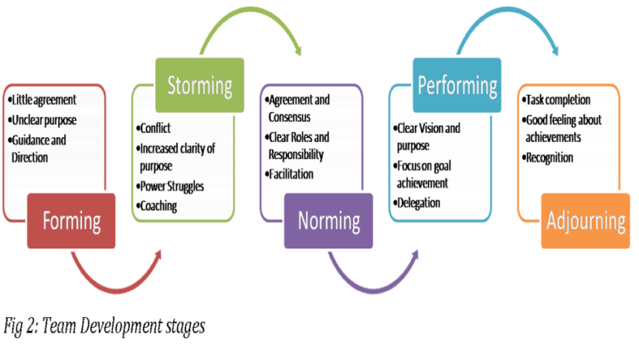
Okpalad, based on Tuckman and Jensen (1977)
This is Tuckman’s 4 stages of team building. This method can be used to help a global team because initially team members come together to form a team. Then there may be cultural differences and communication barriers which takes you to the storming if conflict was to arise. As the team work together, differences will be solved and there becomes and understanding which is the norming stage. This then leads to the performing stage, where trust and respect is built, and goals are achieved.
Conclusion
To conclude, working in a global team can be both challenging and rewarding. It offers a unique opportunity to work with individuals from diverse backgrounds, cultures, and perspectives. By bringing together a variety of skills and experiences, global teams can generate a difference of ideas and approaches to problem-solving. However, communication can be complex due to language barriers, time zone differences, and difference of cultures. Effective work in a global team requires you to be open-minded, flexible, and a willingness to adapt to different working styles. Despite the challenges, working in a global team can develop personal growth, cultural understanding, and the development of a global mindset. Through effective communication, mutual respect, and a shared vision, global teams can overcome obstacles and achieve remarkable results.

References
Dutton, J. E., & Ragins, B. R. (Eds.). (2007). Exploring positive relationships at work: Building a theoretical and research foundation. Mahwah, NJ: Lawrence Erlbaum.
Buckley, P. J. (2009). Internalisation thinking from the multinational enterprise to the global factory. International Business Review, 18(3), 224-235. https://doi.org/10.1016/j. ibusrev.2009.01.006
Ferdman BM, Prime J, Riggio RE (eds) (2020) Inclusive leadership: transforming diverse lives, workplaces, and societies. Routledge
Tutman and Jenson (1977) https://mspguide.org/2022/03/18/tuckman-forming-norming-storming-performing/
Glassdoor. "Diversity & Inclusion Workplace Survey.” Accessed Feb. 5, 2021.

