
LEarning In The DiGital ERA - ACCA4025
Certificate in Higher Education, Computing Skills for the Workplace

March 29, 2026
Gamze SErtkaya
2529589@student.uwtsd.ac.uk
Assessment 1

Table of Contents
E-Portfolio 2
1. Task 1 – Essential Academic And Employment Skills 3
2. Task 2 – Mind Map & Academic Poster 7
2.1. Mind Map 7
2.2. Academic Poster 8
3. Task 3 – Automatic Referencing Tool 9
3.1. Topic Summary Unit 3 New Norming 9
3.2. Usage Of RefWorks 10
4. Task 4 – E-Portfolio Creation And Review 15
4.1. Home Page 15
4.2. IEEE Referencing 16
4.3. Teamwork 17
4.3.1. Mind Map 18
4.3.2. Academic Poster 19
4.4. RefWorks 20
4.4.1. Usage of RefWorks 21
4.5. E-Portfolio 23
Task 1 References 24
Task 3 References 24

E-Portfolio

Here is my e-portfolio link -> Gamze Sertkaya's E-Portfolio

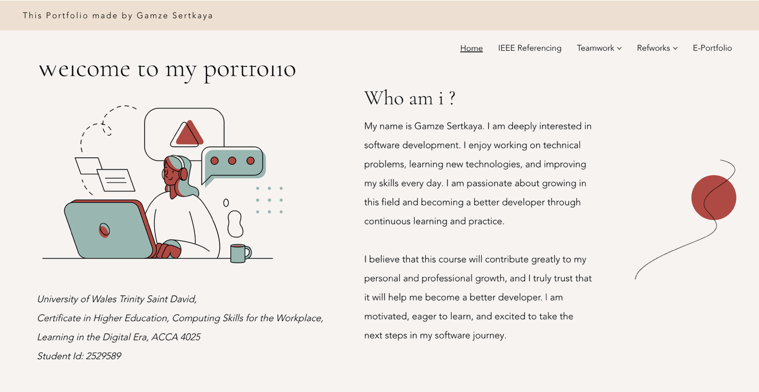

Task 1 – Essential Academic And Employment Skills

Academic And Employment Skills
Academic skills are the abilities and strategies that enable students to learn effectively, understand complex information, and succeed in an educational environment such as school, college, or university. These skills are essential for completing coursework, participating in discussions, conducting research, and performing well in exams.
Academic skills are not only about intelligence; they involve learning how to learn. They help students manage their studies independently and meet academic standards. Examples of Academic Skills:
- Reading and Comprehension Skills
- Writing Skills
- Critical Thinking
- Research Skills
- Time Management and Organization
- Note-Taking and Study Skills
- Presentation and Communication Skills
Employment skills (also called employability skills or workplace skills) are the abilities needed to get a job, perform well at work, and maintain employment.
Employment skills, often referred to as employability skills, include a wide range of abilities, personal qualities, and professional behaviours that enable individuals to succeed in today’s competitive and constantly changing job market. These skills go beyond technical knowledge; they reflect how effectively a person can apply their abilities in real workplace situations. [1]
Employment skills form the essential base for career development and long-term professional growth. They help individuals adapt to different roles, respond to workplace challenges, collaborate with others, and contribute productively to their organizations. Without these skills, even strong academic or technical knowledge may not be enough to achieve career success. [1]
Therefore, employment skills are not only about getting a job but also about maintaining performance, building professional relationships, and continuously improving in one’s chosen field. [1]. Examples of Employment Skills:
- Communication skills (speaking and listening clearly)
- Teamwork
- Problem-solving
- Adaptability
- Professionalism
- Leadership
- Work ethic
- Customer service skills
- Technical or job-specific skills

Academic Skills Required for Higher Education
Academic skills required for higher education refer to the abilities students need to succeed at university or college level. Higher education demands independent learning, critical analysis, and strong communication skills. Students are expected not only to understand information but also to evaluate, apply, and present knowledge effectively.
Academic reading and writing play a central role in higher education. They are not only essential for understanding course materials but also for expressing knowledge in a structured and analytical way. In university contexts, students are expected to engage with complex texts, evaluate arguments, and produce well-organized academic work. [2]
Academic literacy also involves foreign language learning, especially in contexts where instruction or research is conducted in a second language. Research has shown that a genre-based approach to teaching writing can effectively support literacy development. By explicitly teaching the features of different text types—such as their structure, grammar, vocabulary, and communicative purpose—students become better equipped to understand and produce various academic genres. [2]
Many young university students transition from primary and secondary education systems where learning often relied heavily on memorization and repetition. However, higher education shifts the focus from reproducing information to generating original ideas. At the university level, students are expected to demonstrate independent thinking, analytical ability, and critical evaluation. Rather than simply repeating knowledge, they must question assumptions, compare perspectives, and construct evidence-based arguments. [2]
Therefore, academic reading and writing in higher education require a transformation in learning approach: from passive absorption of information to active, critical, and reflective engagement with knowledge [2].

Employability Skills Required for Future Employment
One of the most important skills for future employment is adaptability. As technology, industries, and job roles continue to evolve, employees must be flexible and open to learning new skills. Lifelong learning will be essential to remain competitive in the job market.
Digital literacy is another critical skill. With the increasing use of artificial intelligence, automation, and digital platforms, workers must feel comfortable using technology, analysing digital information, and adapting to new software systems.
Critical thinking and problem-solving skills will also play a key role. Employers will value individuals who can analyse complex situations, think creatively, and make informed decisions rather than simply follow instructions.
In addition, communication skills will remain fundamental. The ability to express ideas clearly, collaborate with diverse teams, and communicate across cultures is essential in a globalized workforce. Strong interpersonal skills help build professional relationships and improve teamwork.
Emotional intelligence is increasingly recognized as a valuable employability skill. Understanding one’s own emotions and responding effectively to others helps create positive work environments and strong leadership potential.
Furthermore, entrepreneurial thinking will be highly beneficial in the future. Even within organizations, employees are expected to be innovative, proactive, and solution oriented. Taking initiative and identifying opportunities for improvement can significantly enhance career growth.

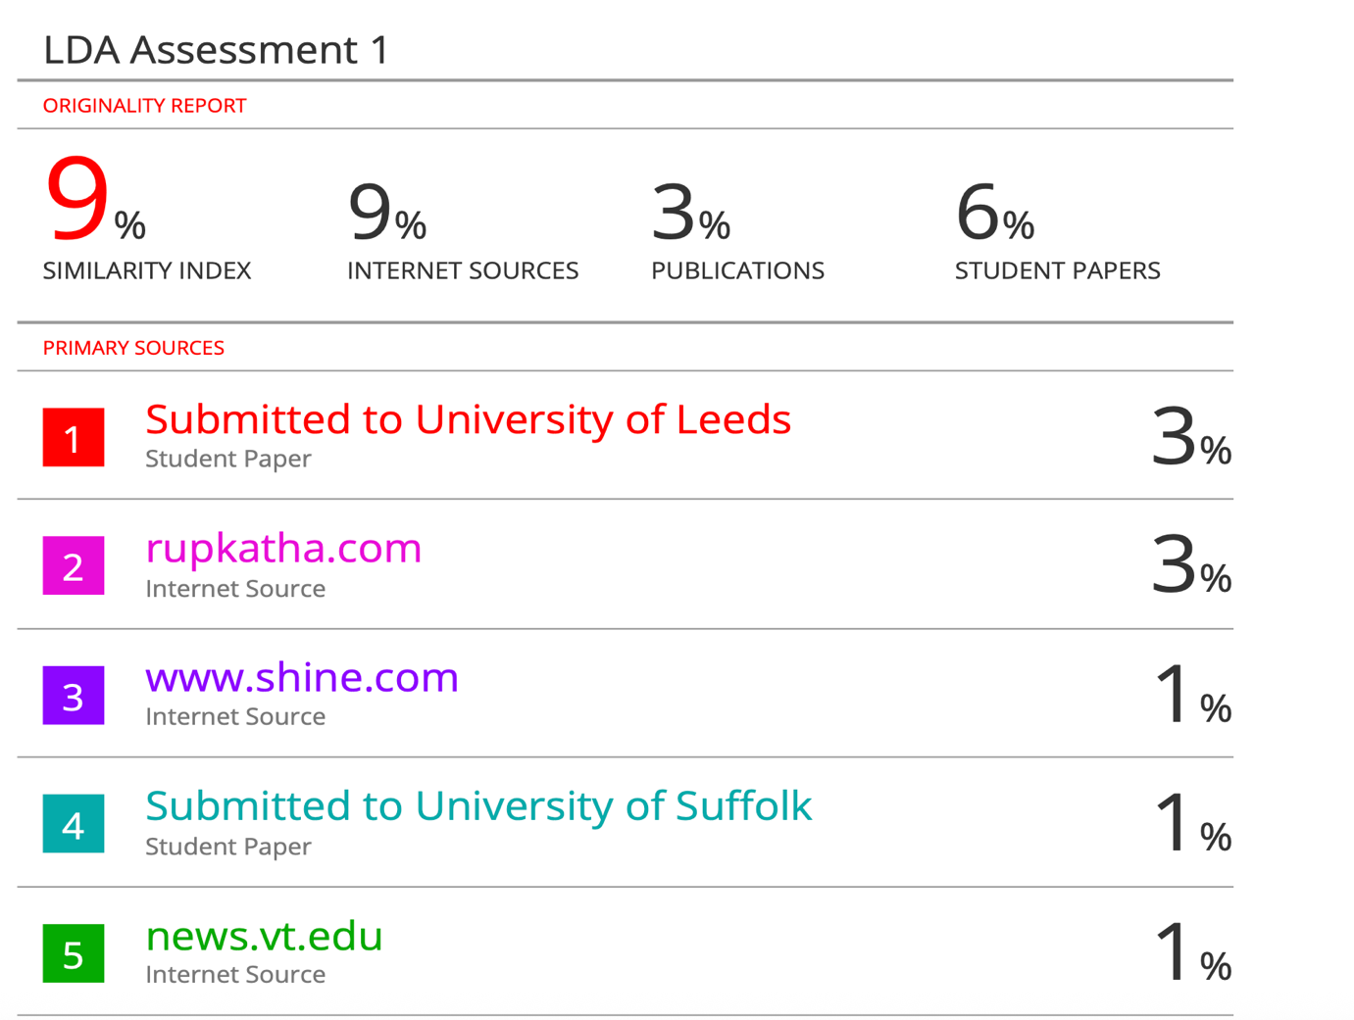

Task 2 – Mind Map & Academic Poster

Mind Map
Here is my mind map link via Mind Meister Mind Map
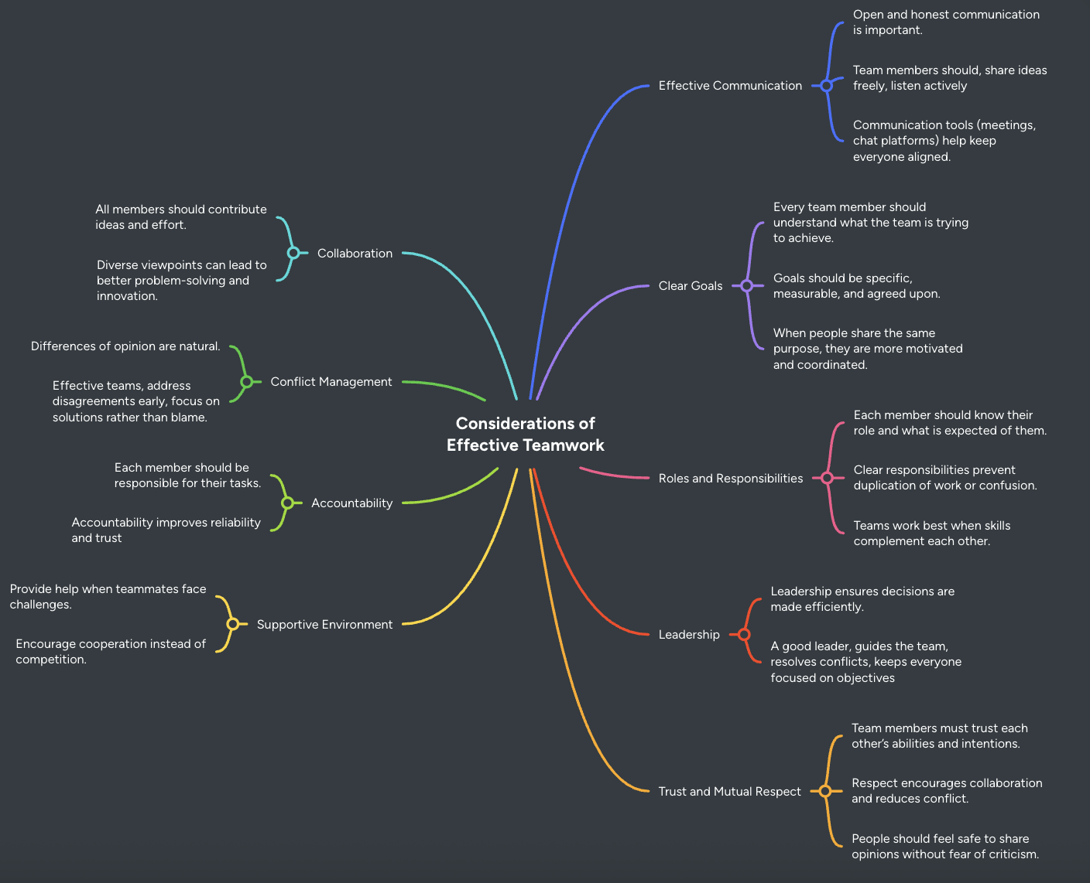

Academic Poster
A3 Academic Poster Link via OneDrive LDE-Assessment1-AcademicPoster.pptx
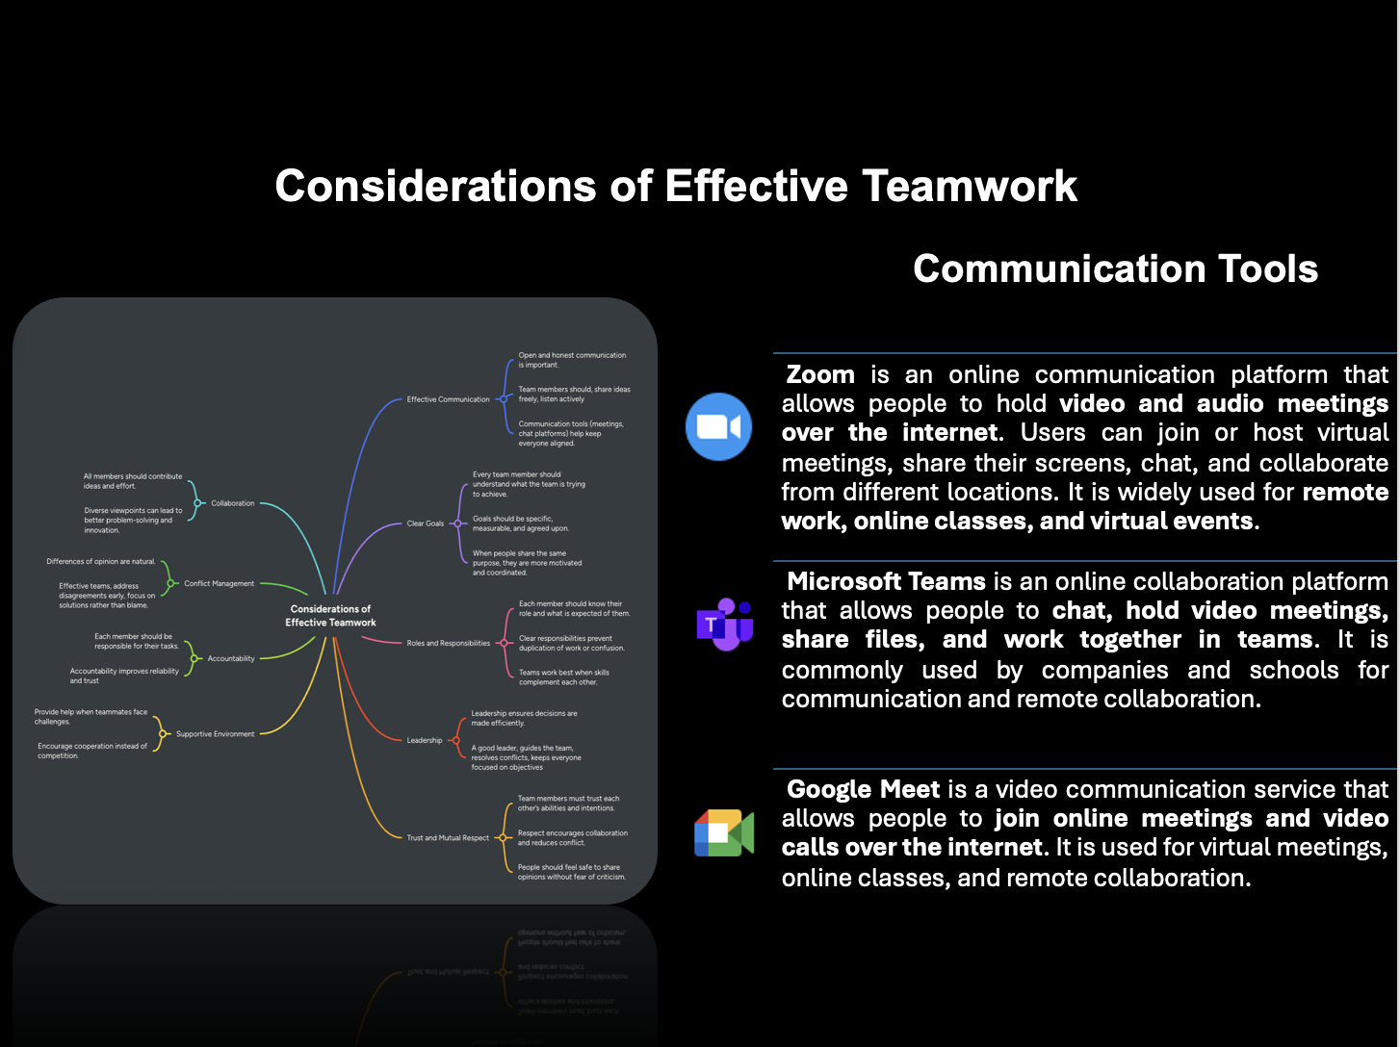

Task 3 – Automatic Referencing Tool

Topic Summary Unit 3 New Norming
This section focuses on understanding team dynamics, individual responsibility, and the emotional responses that arise during group development. It encourages individuals to reflect on how much they value their team, as well as their own level of commitment and accountability within it. These reflections are essential for building effective collaboration and maintaining a supportive team environment.

A key aspect of this topic is the emotional impact of changes in team composition, particularly when a valued member leaves and a new member is introduced. At this stage, teams are often beginning to build trust and develop stronger interpersonal relationships. According to Bruce W. Tuckman and Mary Ann C. Jensen, group development is a sequential process that includes stages such as forming, storming, and norming. During the storming stage, members may experience conflict, uncertainty, and emotional resistance, especially when there are disruptions to the group, such as changes in membership. These changes can challenge group cohesion and create mixed feelings among team members.[1]
As the group progresses into the norming stage, a stronger sense of unity begins to emerge. Team members start to appreciate each other’s strengths, perspectives, and experiences, leading to improved cooperation and mutual respect. This stage reflects increased cohesion and a shared sense of responsibility, allowing the team to function more effectively.

Overall, this section helps individuals become more aware of how feedback, commitment, and emotional understanding contribute to successful teamwork. By recognizing the challenges associated with group transitions and valuing each member’s contribution, teams can strengthen cohesion and improve their overall performance.

Usage Of RefWorks
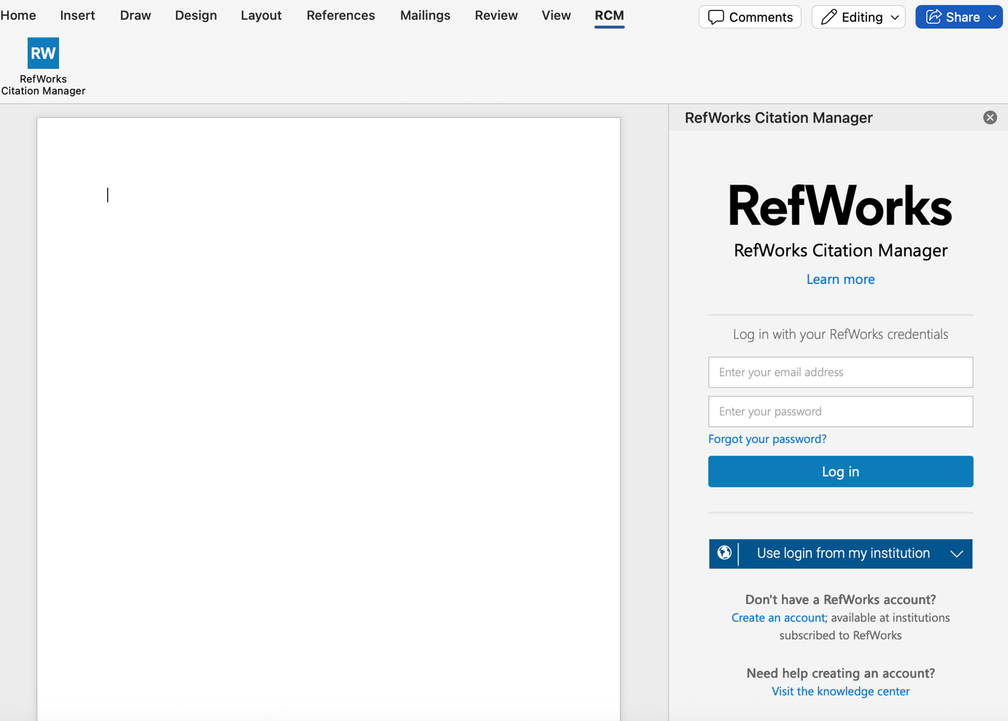

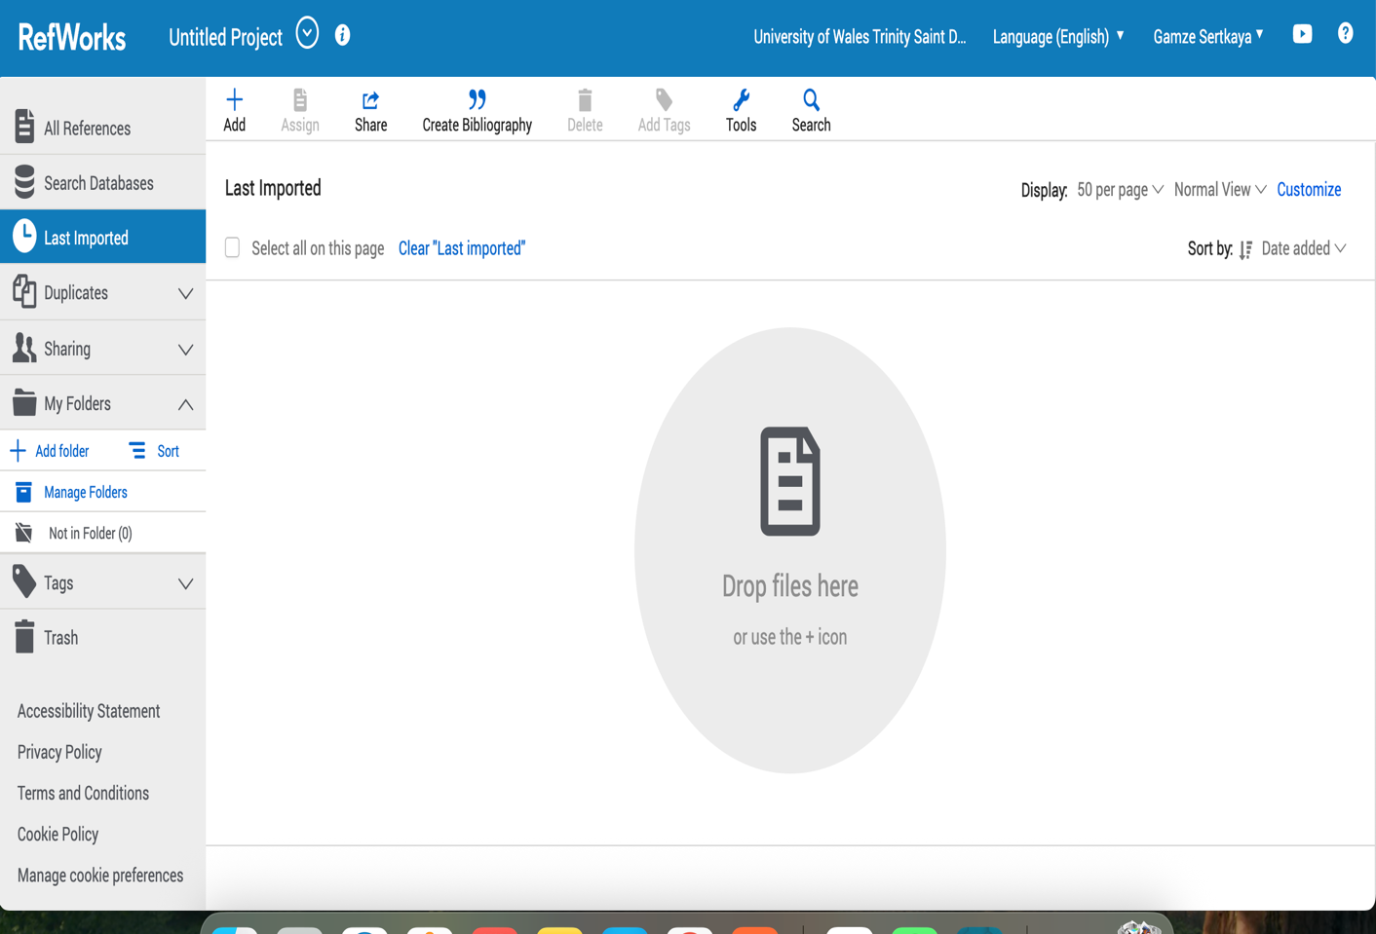
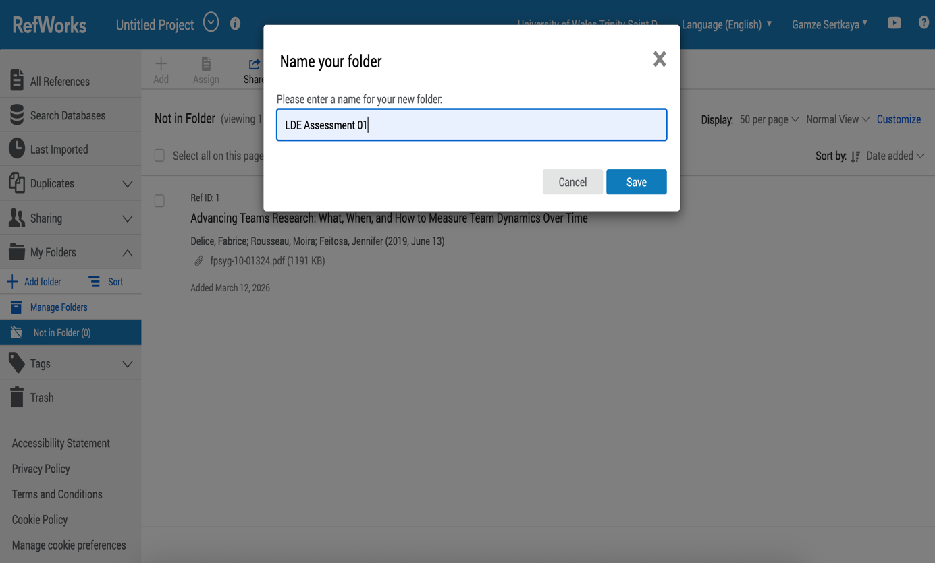

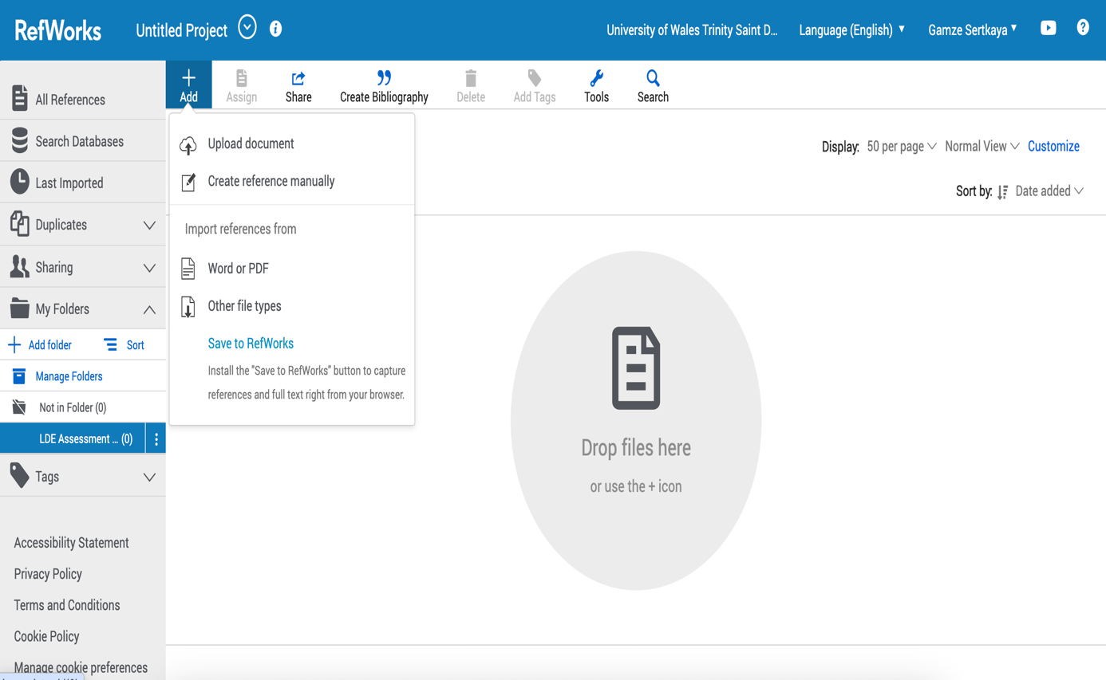

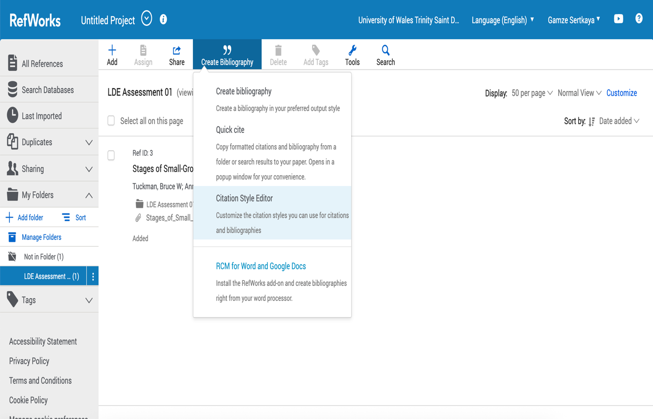

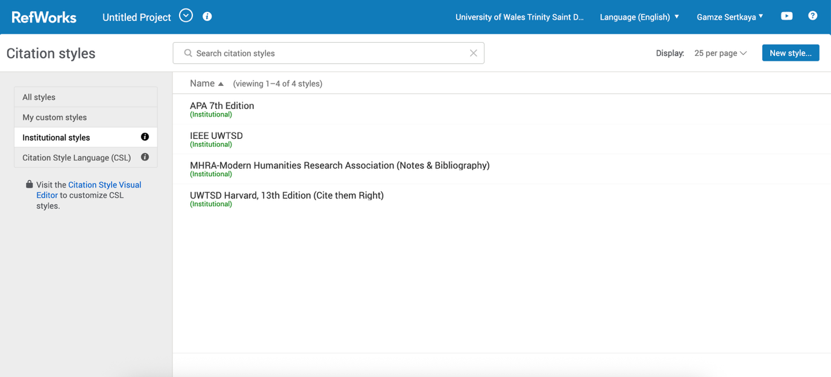

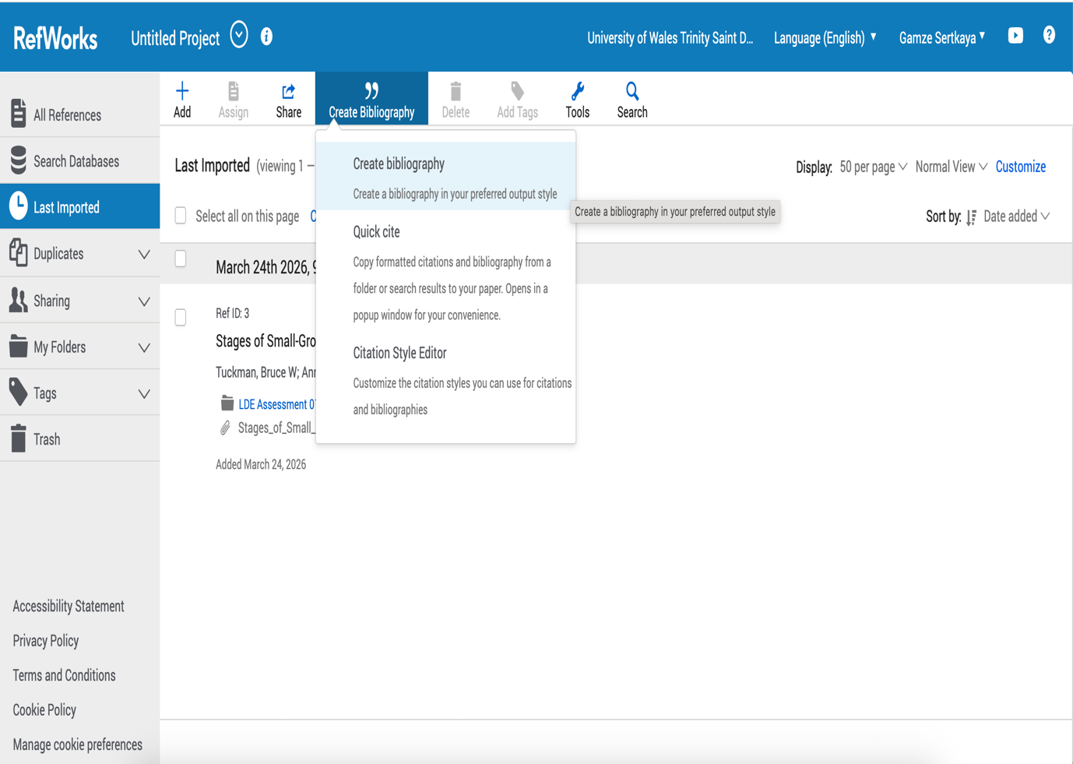

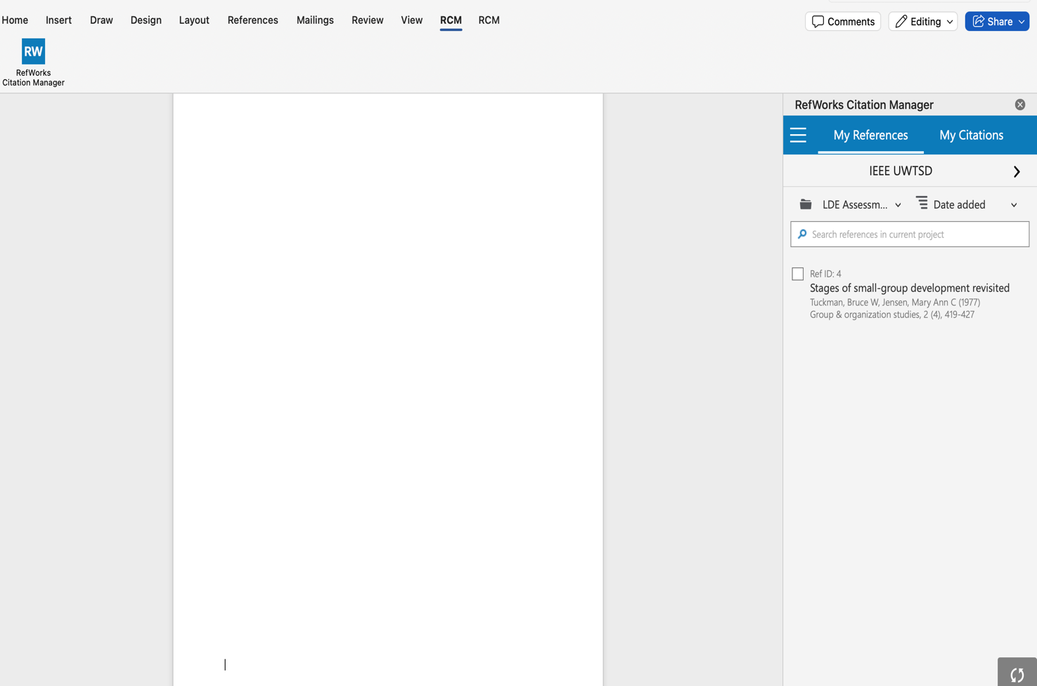
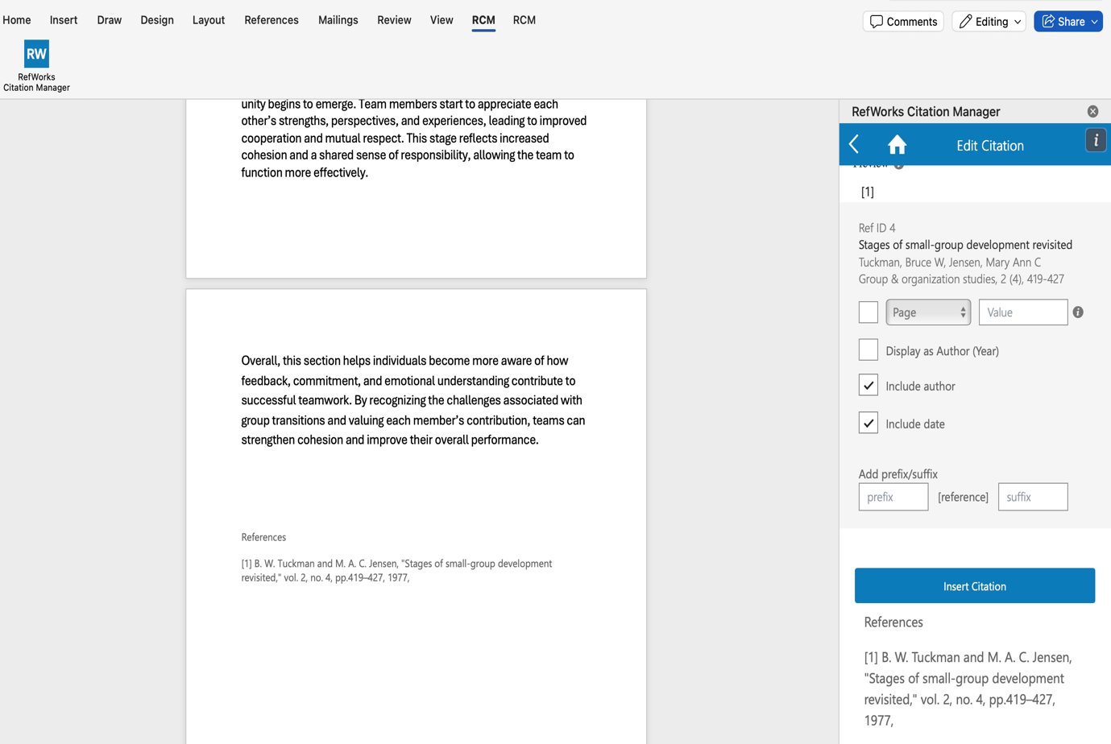

Task 4 – E-Portfolio Creation And Review

Home Page

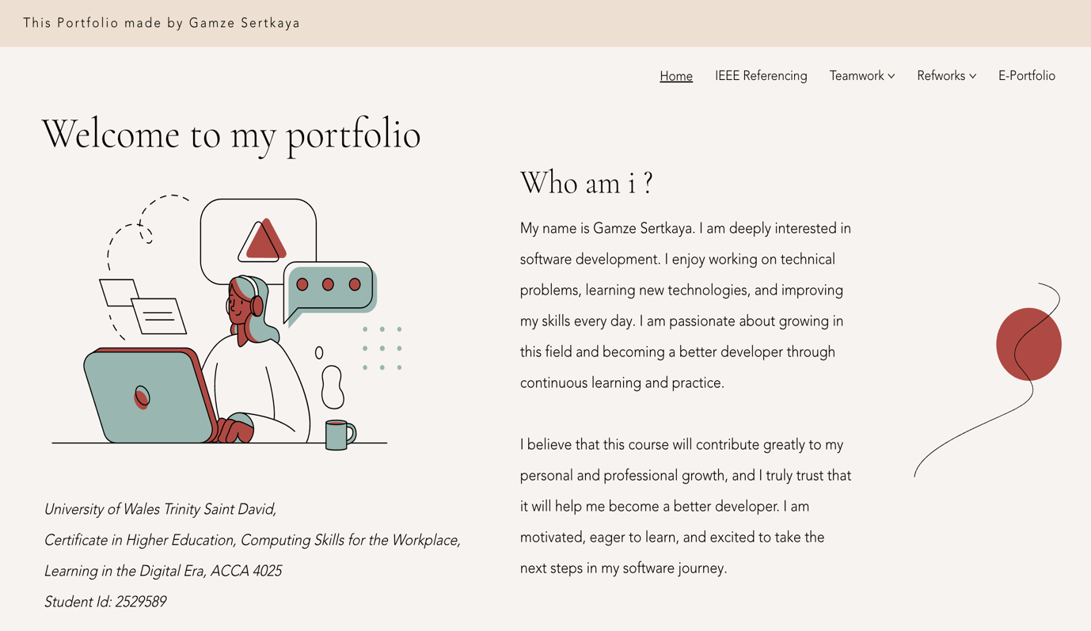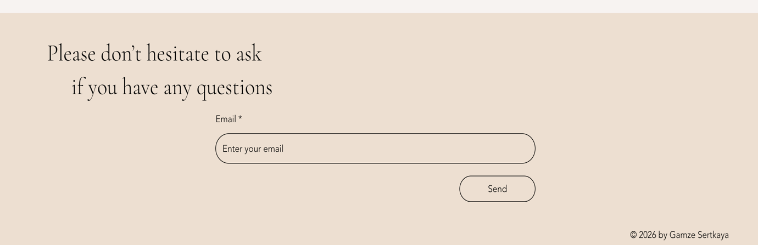

IEEE Referencing
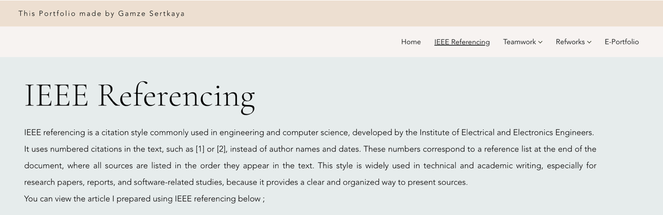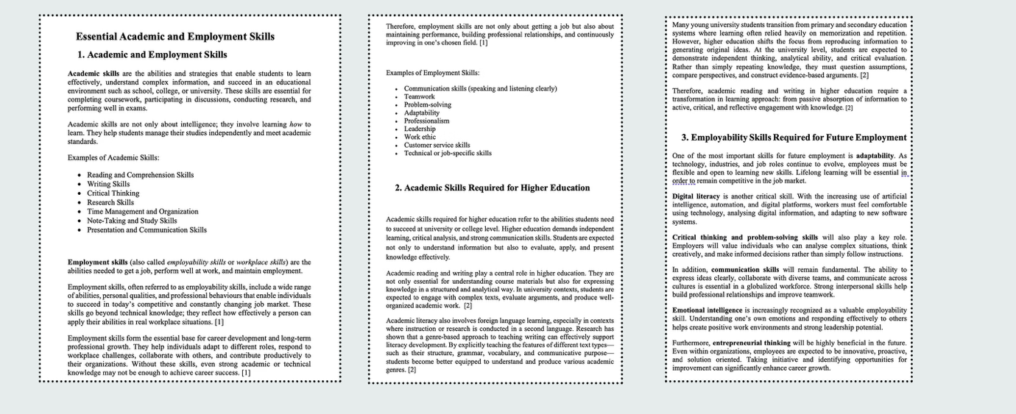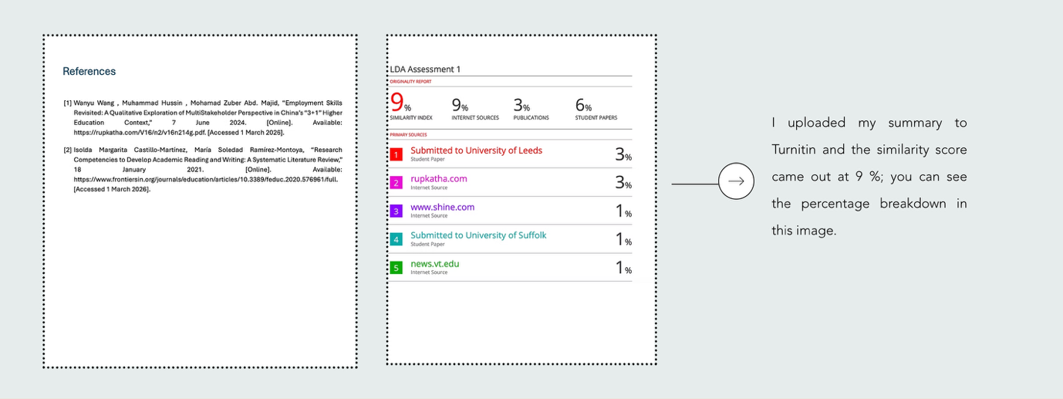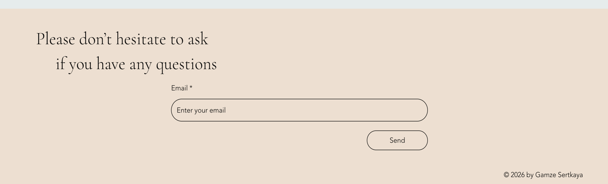

Teamwork

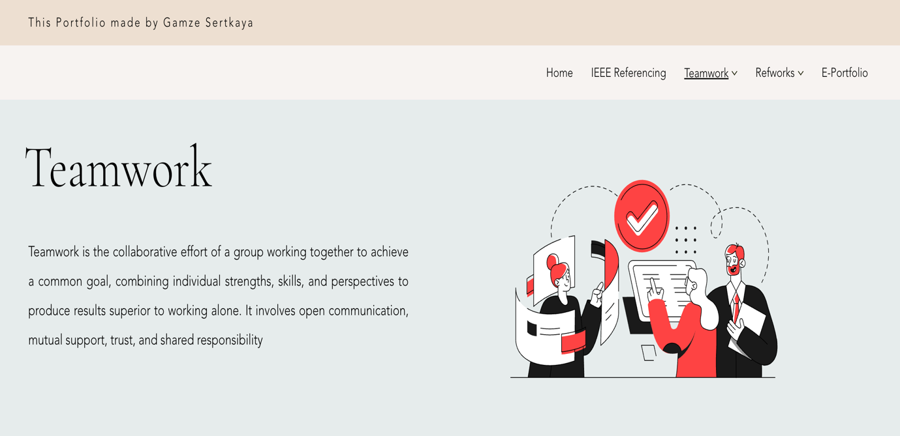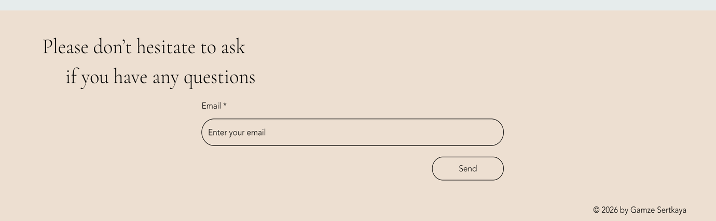

Mind Map

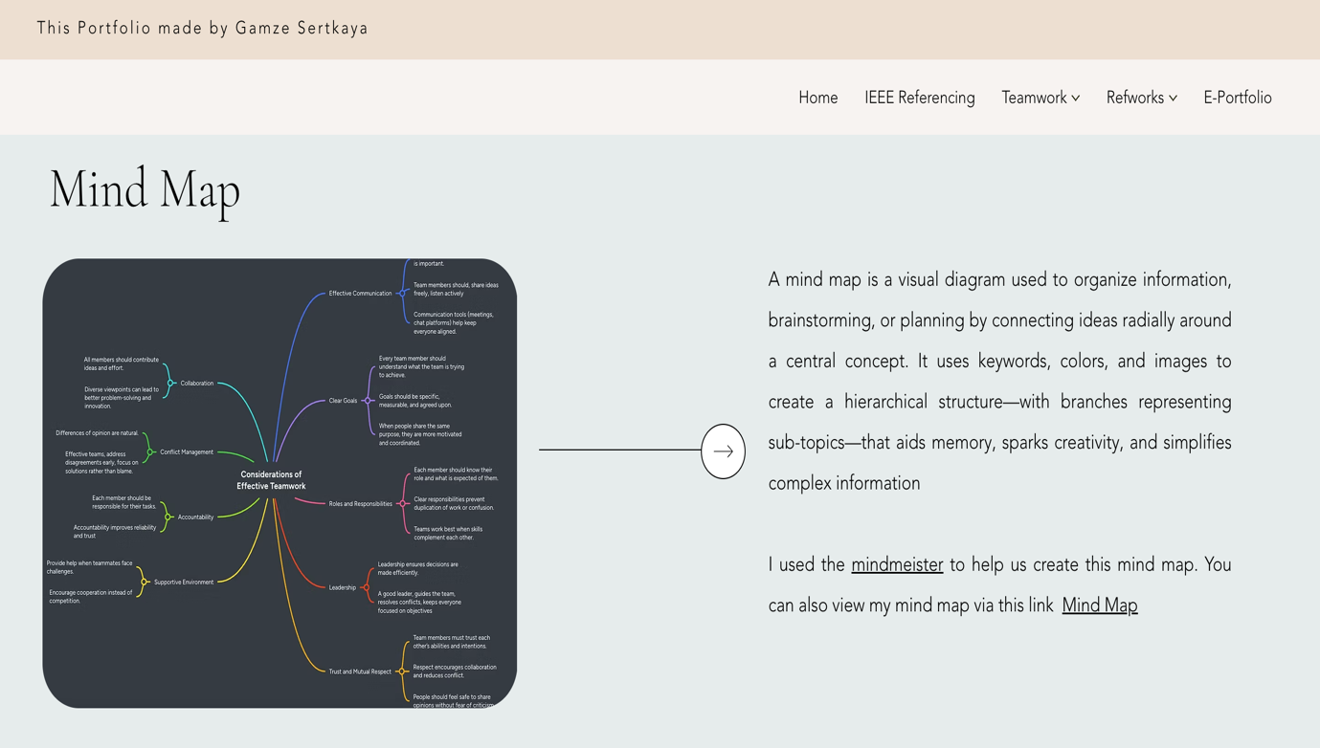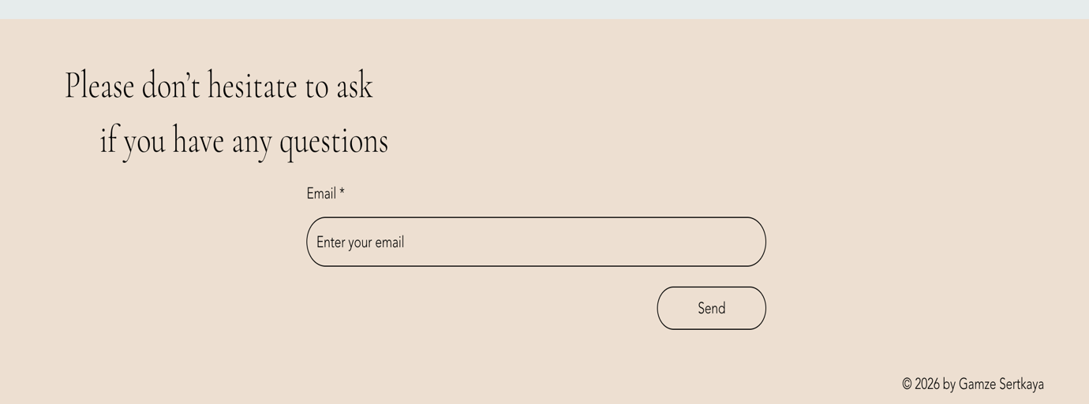

Academic Poster

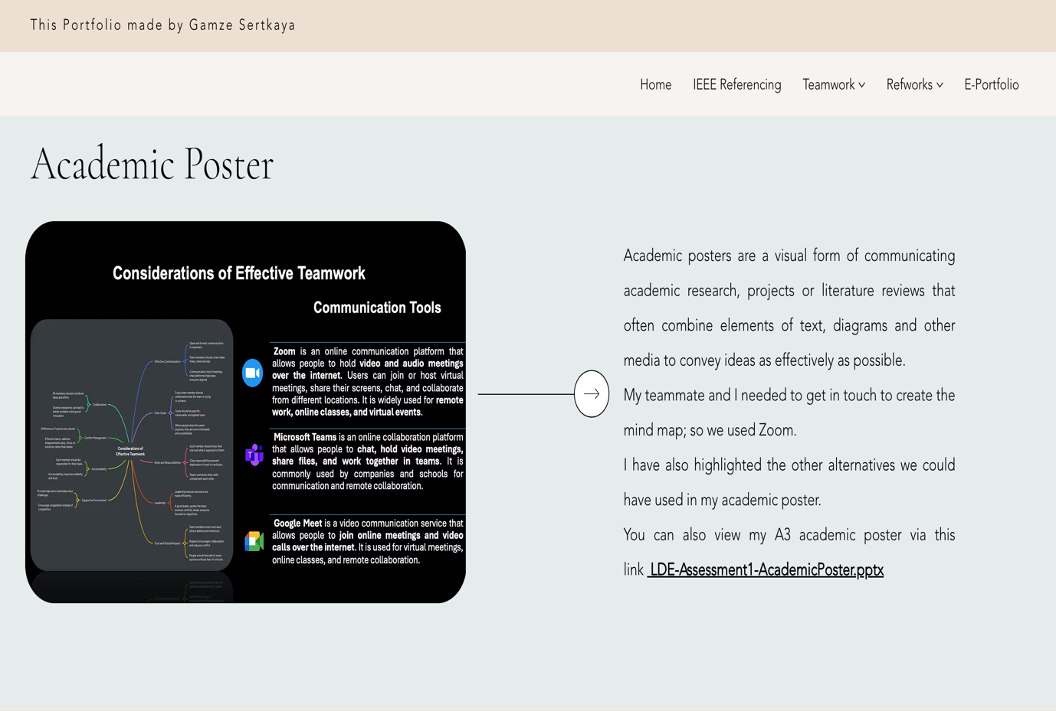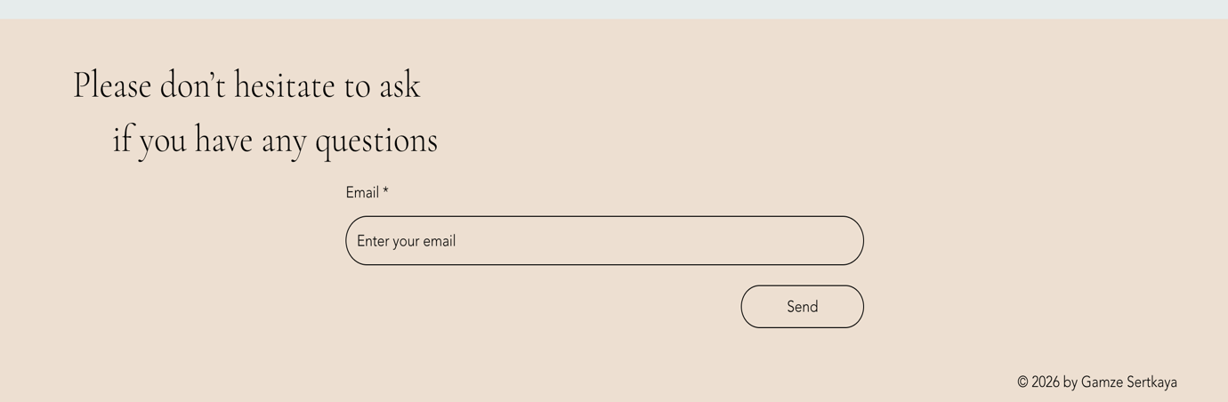

RefWorks

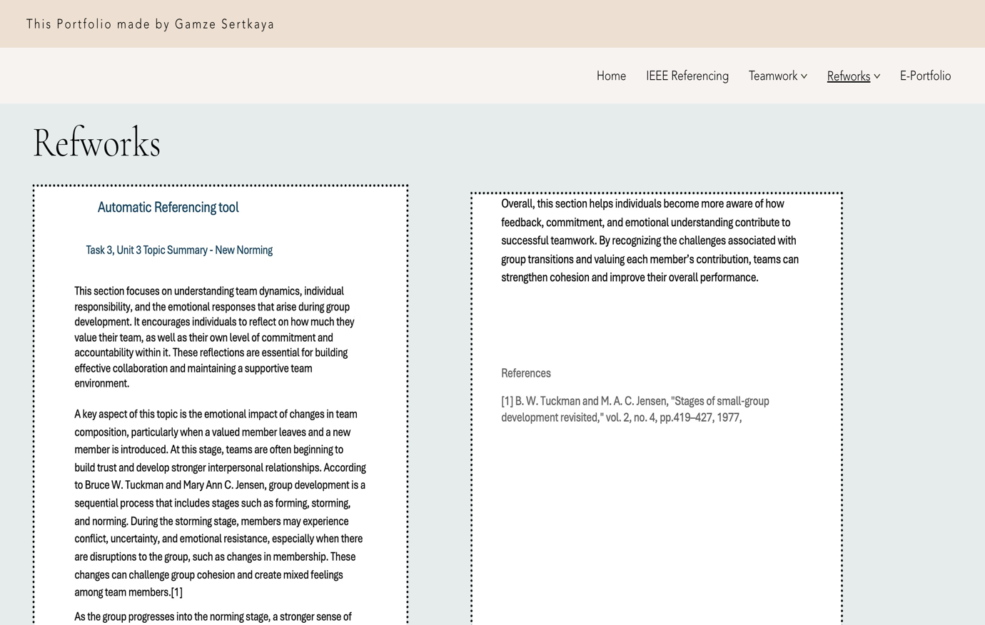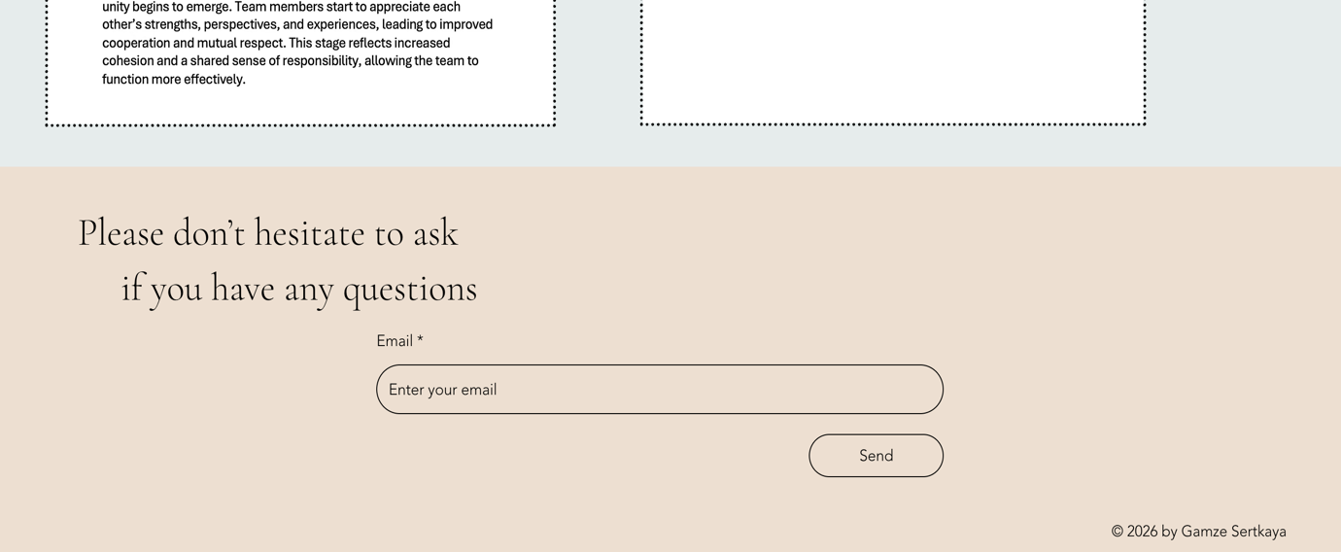

Usage of RefWorks

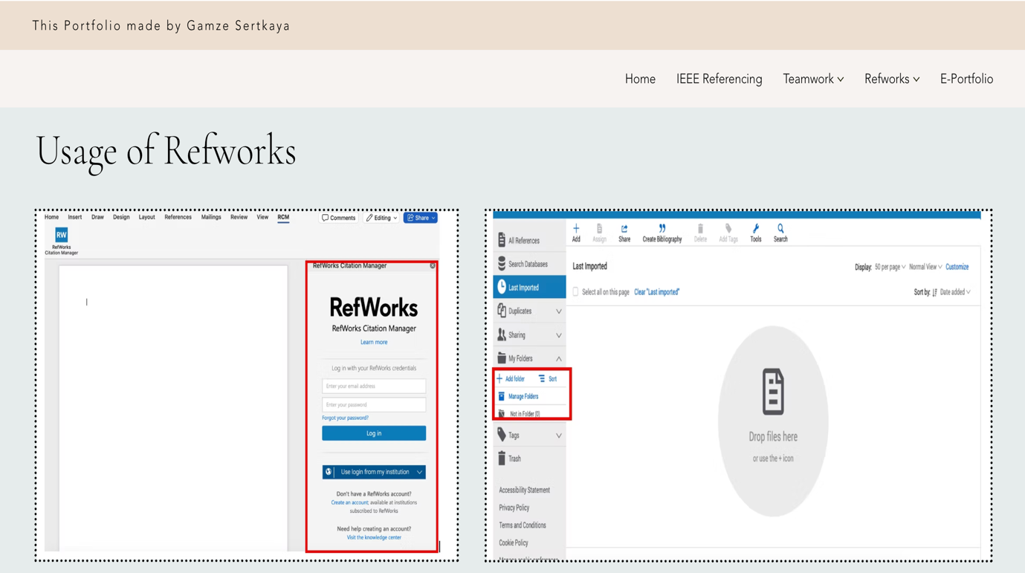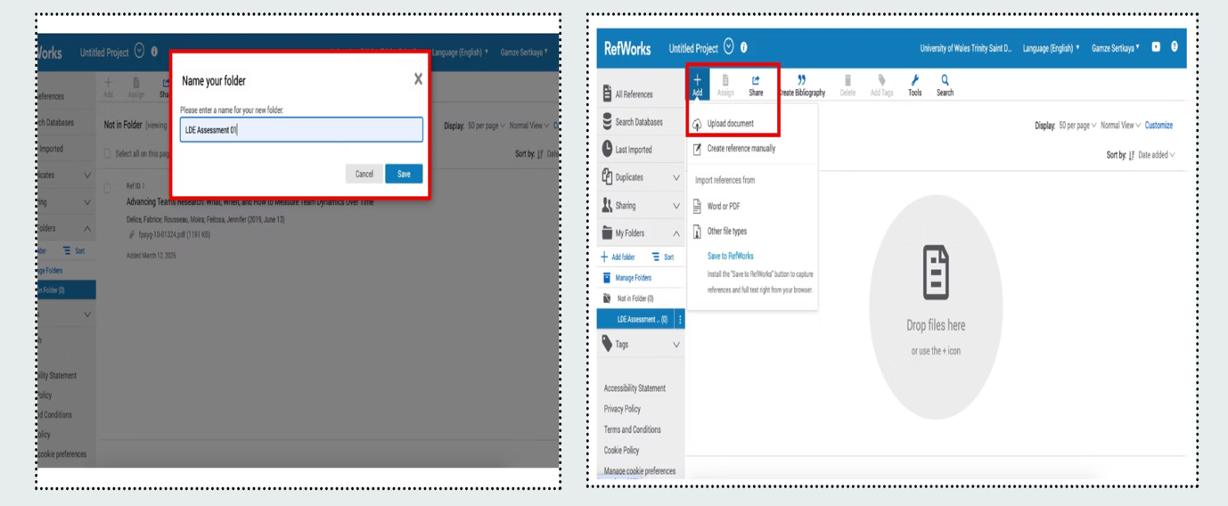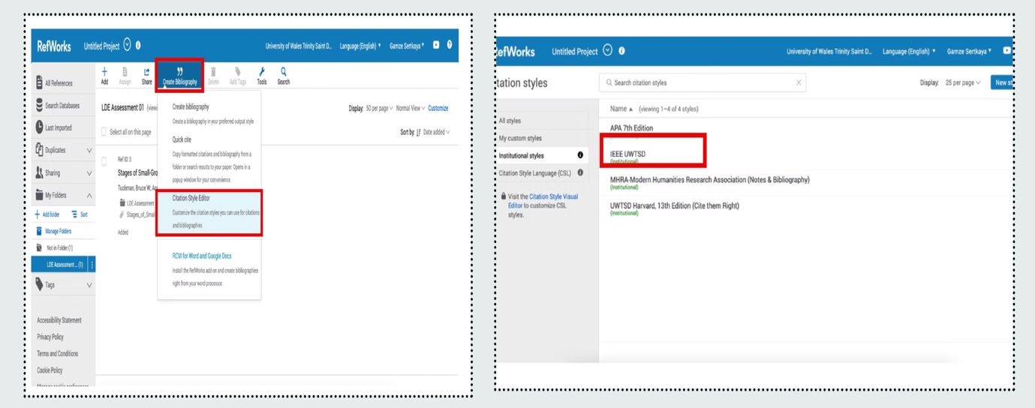
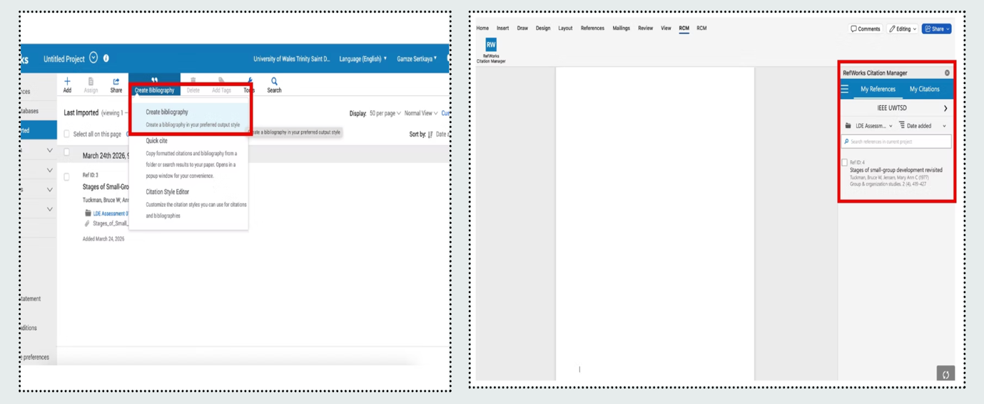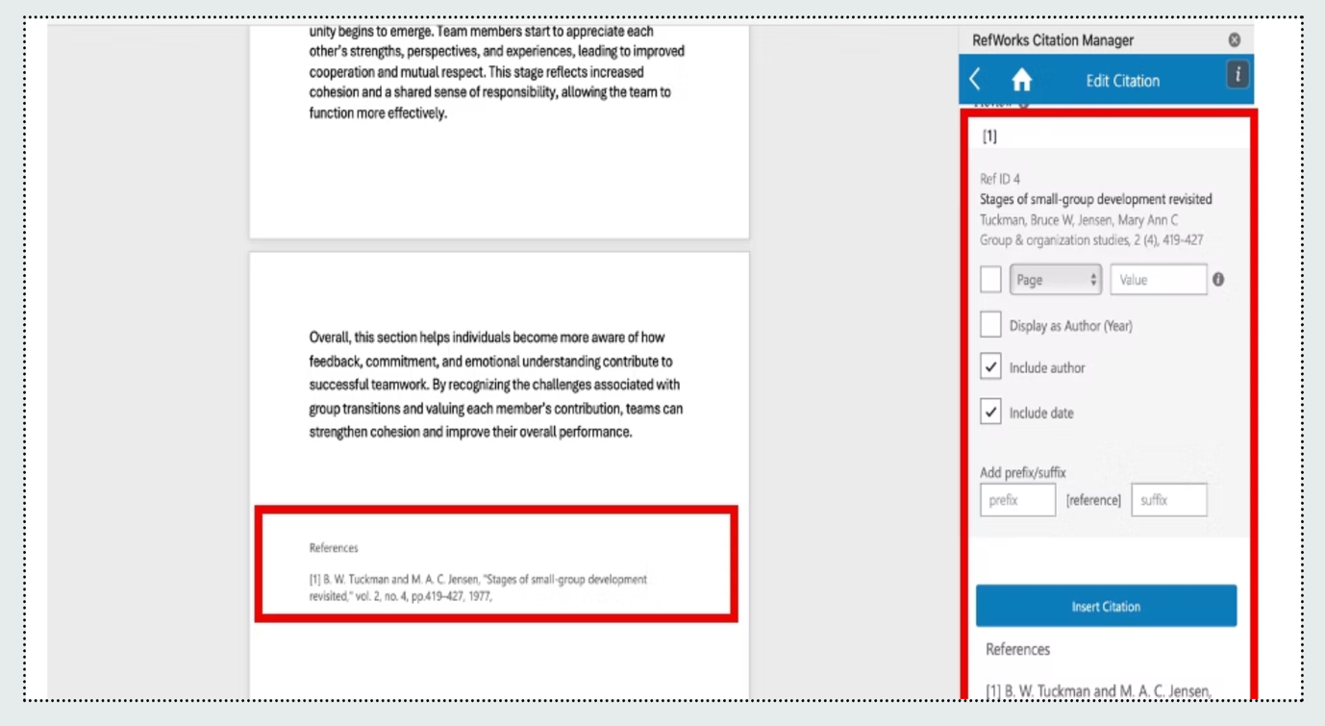

E-Portfolio

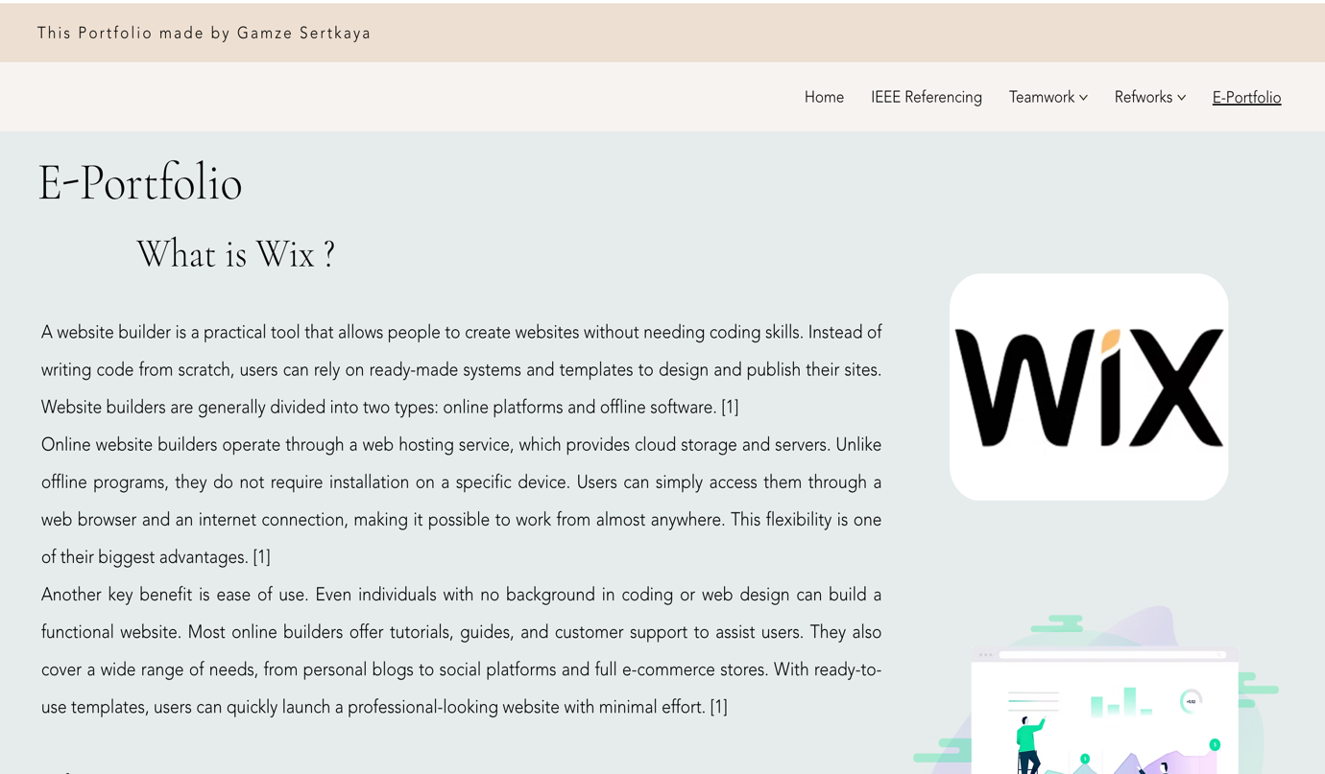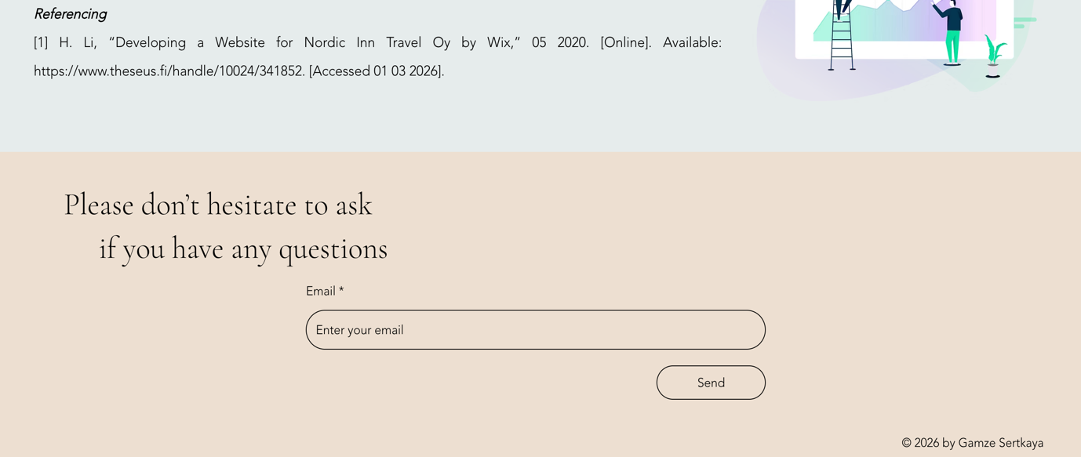

Task 1 References

[1] | Wanyu Wang , Muhammad Hussin , Mohamad Zuber Abd. Majid, “Employment Skills Revisited: A Qualitative Exploration of MultiStakeholder Perspective in China’s “3+1” Higher Education Context,” 7 June 2024. [Online]. Available: https://rupkatha.com/V16/n2/v16n214g.pdf. [Accessed 1 March 2026].
[2] | Isolda Margarita Castillo-Martínez, María Soledad Ramírez-Montoya, “Research Competencies to Develop Academic Reading and Writing: A Systematic Literature Review,” 18 January 2021. [Online]. Available: https://www.frontiersin.org/journals/education/articles/10.3389/feduc.2020.576961/full. [Accessed 1 March 2026].

Task 3 References

[1] B. W. Tuckman and M. A. C. Jensen, "Stages of small-group development revisited," vol. 2, no. 4, pp.419–427, 1977,

