
Project Planning and Management in Workplace
Identifying the needs of new refugees into the area


University of Wales Trinity Saint David

By BEN NSUKA
1816136

Executive Summary
The purpose of this report is to critically assess Project Management tools and techniques and analyse various tools to demonstrate the ability to plan and implement projects in the workplace. This will also include describing the organisation of the work, drawing upon a range of recognised tools and techniques.
The same applies to showing how the project plans will be communicated with appropriate stakeholders and demonstrate the implementation of the project plan.
At the end, a critical evaluation of own ability of managing projects is conducted alongside with future recommendation and self-development plan to improve own performance.
This report has been made possible thanks to different resources available on the University website library as well as a deep online research via journal articles, viable websites as well as lecturer’s guidance and supervision throughout.

Contents

Executive Summary 1

Introduction 3

Main Findings 4
What is Project Life Cycle? ...…………………………………………………………………4
Project Initiation Phase ……………………………………………………………………..…4
Project Planning …...………………………………………………………………………..…5
Project Execution Phase ..…………………………………………………………….……..…7
Project Closure Phase .……………………………………………………………….……..…7
SWOT Analysis .……………………………………………………………………..……..…8
PESTLE Analysis ..…………………………………………………………………..……..…8
Risk Analysis .………………………………………………………………………..……..…9
GANTT Chart ..……………………………………………………………………..……..…10
Project Evaluation …………………………………………………………………..……..…10

Conclusion 12

Recommendation 13

Bibliography 14

Introduction
A project is a team activity undertaken to create a unique product or service. It is done within a set timeframe with a fixed start and a closure, using restricted resources that involve change. A project is designed to accomplish a singular goal (Dolphin, 2017).
Project Management is the application of knowledge, skills, tools and techniques to project activities in order to meet stakeholders’ needs and expectation from the project (Chiu, 2010).
Our project had clear aims, goals and objectives and identified stakeholders, despite the risks that arose during its execution. We needed budget and staff to improve customer satisfaction, because good project managers must possess leadership qualities, time management skills, communication skills, team building skills, decision-making skills (Morgan, 2017).
In our case, the project was done within a set timeframe with a fixed start and closure of 3 months, and used needed resources to meet stakeholders’ needs and expectation.
For a successful result of the project, and based on the Project Life Cycle, we used different analysing and planning tools such as Quad Chart, Gantt Chart, WBS, Risk Analysis, Iron Triangle as well as Monitoring and Evaluation.
Our project required different types of management tools and techniques with a controlled achievement and a good involvement of the team.
Planning tools and techniques are very important, especially time. The success of our project is linked to the timeframe set as a resource. These resources needed to be used regularly and appropriately to help make effective use of the allocated resources. Applying the Iron Triangle helped our project to be fulfilled within the time, the cost and in respect of the product quality.

Main Findings

2.1 Project Life Cycle
According to Pinto and Slevin (1988), Project Life Cycle is a four-step process that goes through the project's completion phase.
Project Life Cycle is the sequence of stages that the project goes through from the Initiating to the Closure. The number and sequence of cycles are determined by management and various other factors, such as the needs of the organisations involved in the project, the nature of the project and its application areas (Jaafari, 2000).
It was important for the team to ensure the project life cycle used on the project was appropriate to the work being carried out and split into distinct and manageable phases. This was a tried and tested method for us to deliver the project on time, within budget and to the stakeholders’ satisfaction.
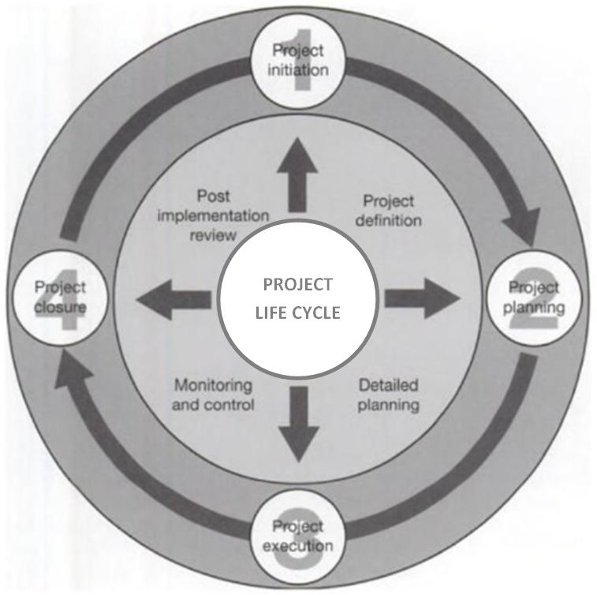

  - Project Initiation Phase
The project was looking at identifying the needs of new asylum seekers into the area. So, based on the judgment of Belbin team roles, the project team was brought together and contained 5 project managers whose roles are defined as Shaper, Resource Investigator, Implementer, Specialist, Coordinator and Completer.

Belbin team roles quiz is a test to assess how an individual operates in a team environment and their preference for any of the nine team roles identified (Indeed, 2021).
Two factors are always important: the knowledge that a person has in order to contribute to a group and the skills and abilities that they bring to a task (Morgan, P. (2017).
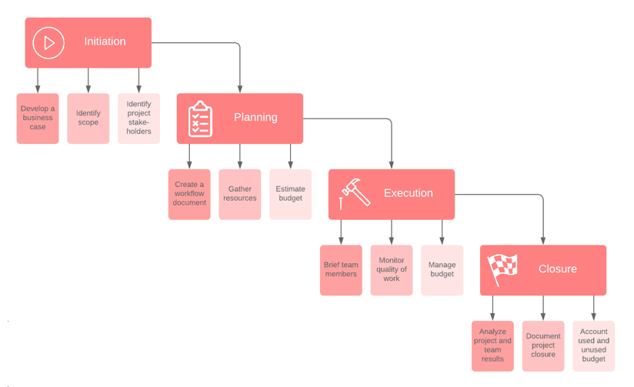

  - Project Planning
Project Planning is when we structured the work, describing what will be done, including aims, goals and objectives and what the measures of success will be. We assigned responsibilities, set the budget and set a-three month timeframe for the project. One of the major causes of project failures is poor planning. This step is when we designed our Quad Chart including the secondary benefits.
A Quad Chart is a one-page summary of a visual and descriptive project (Keenan, 2020). Using the Quad Chart as a tool, we divided the project into four quadrants and planned and communicated the success of the project as follows:
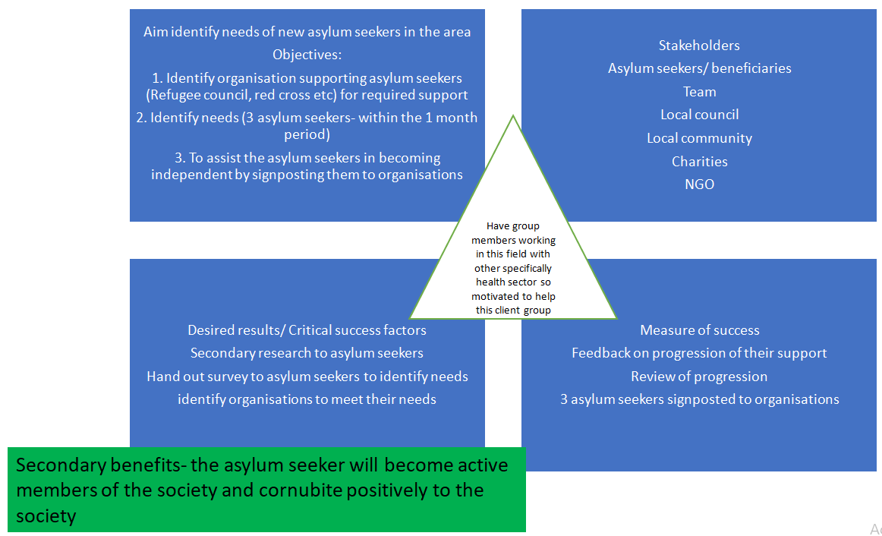
During this phase, we also conducted a Stakeholders Analysis to ensure who we will be dealing with and how we will conduct surveys and other actions.
References to Stakeholders and the use of stakeholder analysis as a tool have become increasingly popular in Management during the last decade (Mason and Mitroff, 1981).
As a team, we cared about the characteristics of stakeholders – individuals (team of drivers), observers, groups and organisations – influence decision-making process. We also underlined that the aim of our Stakeholder Analysis was to determine the customers’ relevance to the project.

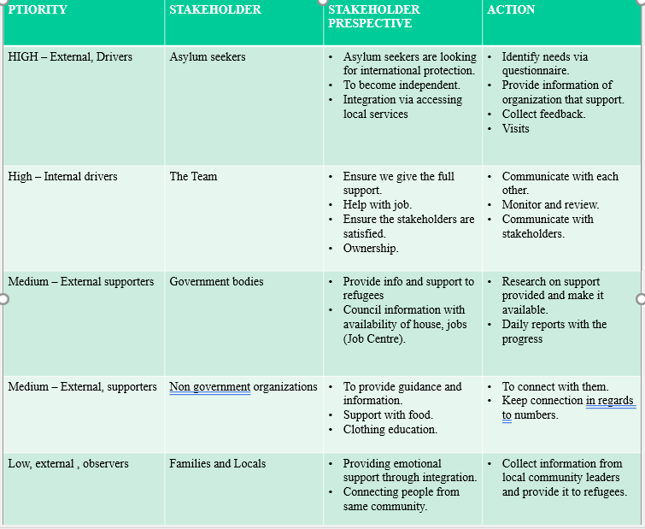
We orchestrated some limitations such as stakeholders not engaging in answering the questionnaire.
  - Project Execution Phase
This is when we implemented the project plan to make sure everything was done accordingly, despite the risks.
In this stage, we needed to create a Work Breakdown Structure (WBS), based on our Quad Chart, especially the 4th box. Work Breakdown Structure (WBS) is a visual, hierarchical, and result-oriented decomposition of a project. It is a useful chart for project managers because it allows to categorize the scope of the project and to visualise all the tasks needed to complete a project (Project Management, 2022).
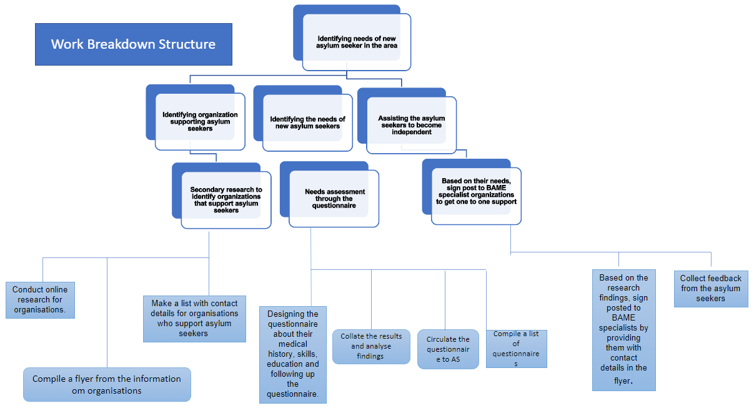
WBS was a very important tool that helped us to define and organise the work required, to facilitate the quick development of a schedule, and to identify potential scope risks. The approach taken was
According to the University of Waterloo, WBS can be used to identify communication points during the execution of a project.

  - Project Closure Phase
Project Closure Phase is the completion of the project within budget and on time. This means that the work identified on the project plan is complete, so the plan must be brought up-to-date and filed (Roberts, 2007).
A project may close for various reasons such as normal closure, premature closure, perpetual projects, failed projects and changed priority. In our case, our project closure was a normal one, as we achieved the defined aims and objectives as well as the goals. During this stage, we evaluated things to ensure what worked from the plan and what could be changed for the future. A final lessons-learned review was also done before we considered the project is complete. This led us to prepare a project closure report to be submitted to the project sponsors for sign-off. In our case, our sponsors were the local government and the community deputy.

SWOT ANALYSIS

SWOT Analysis as a tool has helped us build on our Strengths, mitigate, and overcome potential risks. As per Lindenberg and Crosby (1981), we carried out questionnaires about the stakeholders’ position, interests, influence and interrelations.
Our project was a success thanks to the team’s effective application of stakeholder analysis as a tool, alongside with the data we gathered from the stakeholder analysis.

PESTLE ANALYSIS

Using the PESTLE Analysis, the team focused on the Technological element. We therefore used technology to make our questionnaires available to everyone. For this sake, we created a marketing campaign to encourage candidates to participate via online digital platforms like Facebook, Instagram and Google with easy to access forms. We used the same tools to track our progress through Facebook, Instagram and Google analytics. This way, we could tell how many impressions our ads have received. This determined the number of people who have seen our ads in a particular demographic. Also, we can complete our questionnaires in a timely manner. This also made it easier for the candidates to participate.

On the other end, thanks to technology, we managed to launch a messaging platform to communicate the project plans with appropriate stakeholders.
Monitoring and Evaluation are two different things, but they go hand-in-hand to set the functions for things to be done according to the plan. This helped us evaluate the time, budget, and the features for our stakeholders’ satisfaction.

Risk Analysis
Risk analysis is a process that helps a team to identify and manage potential problems that could undermine a project (MindTools, 2016). In our case, a risk analysis was conducted based on internal and external risks which impact and likelihood is measured as High, Medium and Low.
From our risk analysis, internal risks were identified such as a lack of involvement of team members due to illness or absenteeism. This was recognised as a potential threat. Therefore, we used SWOT analysis as a tool to mitigate and overcome the impact of these risks by implementing knowledge sharing.
We were aware that risk is the uncertainty that could affect the outcome of the project. Therefore, the two main components of risk are the potential for risk and its implications. The uncertainty is measured by likelihood and the effect on the project is measured by the impact.
Risk mitigation involves implementing precautionary measures in project planning. Mitigation is a strategic risk response in which the project team takes proactive steps to mitigate the potential and impact of adverse risks to the project (Project Management, 2016).

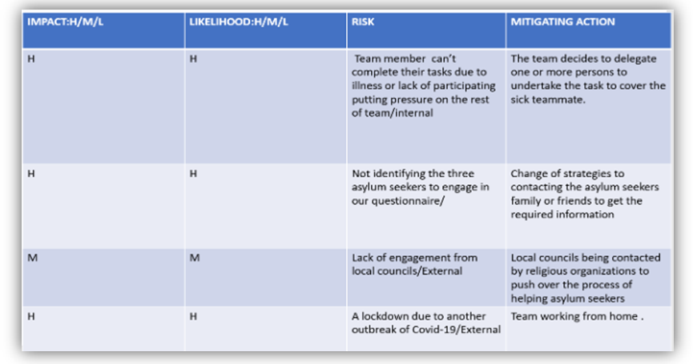

Gantt Chart
A Gantt Chart is one of the most common and convenient ways to view activity (tasks or events) over time. There is a list of activities on the left side of the chart and a suitable timescale at the top. Each activity is represented by a bar. The position and length of the bar reflects the start date, duration, and end date of the activity (Gantt.com).
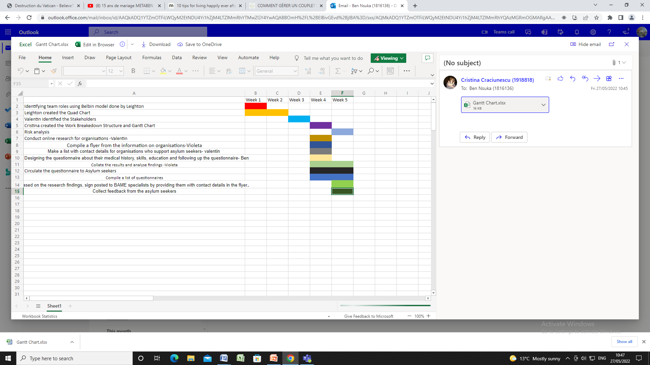

Project Evaluation
As one of the tools of the Project Life Cycle, Project Evaluation is the process of measuring the success of a project. It is also important to keep stakeholders up to date on the status of the project (Landau, 2022). The purpose is to confirm that the intended goals and objectives have been achieved. It was processed internally when the project is completed. This phase helped the team learn from their mistakes and celebrate their success.
Evaluation is an important tool for assessing how well our project has been performed in relation to its purpose. This is an important way to look back on the outcomes and shortcomings, and it is also useful for reassessing the goals that may have been set in different situations.
For our project, our unique aim was identifying the needs of asylum seekers in the area and our objectives were as follows:
- To identify organisations supporting asylum seekers (Refugee Council, Red Cross, etc.) for required support;
- To identify the needs of 3 asylum seekers within a-one month period;
- To assist the asylum seekers in becoming independent by signposting them to organisations.
By doing so, the 3 asylum seekers will become active members of the society and contribute positively to the society
By creating a Quad chart, we identified our main beneficiaries who are the asylum seekers. Further, our stakeholders were categorised as:
- Beneficiaries : asylum seekers
- Drivers : the internal and external team;
- Supporters : the governing bodies;
- Observers : the local communities.
As stated previously on the Quad Chart box 4, our measure of success was defined based on the feedback on the progression of their support, a review of progression and 3 asylum seekers being signposted to organisations. The project was completed within the expected timeline, and our desired results were successfully met, as shown on the table below.
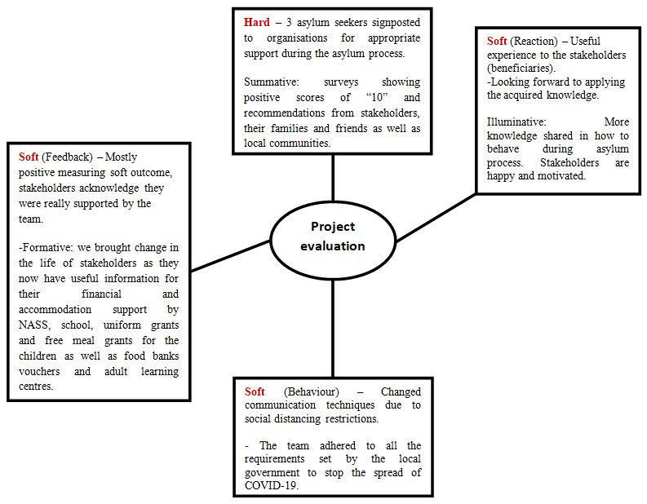
We also conducted a risk analysis to support our decision-making during the project (Aven, 2015).
The team strengths were:
- Punctuality
- Flexibility
- Involvement
That helped the team complete the tasks within the timeframe and in appropriate time.
The team weaknesses were:
- Lack of good communication skills.
- Lack of resilience.
Having a hard time to identify the three asylum seekers to answer the questionnaire, mitigation actions were put in place to reduce or eliminate long-term risks.
As a result, the team managed to overcome the weaknesses by adapting to change after training and resilience.
A self development plan is suggested on the table below.

Focus area | Actually | Will be | How known? | Activity | Resource | Timing | Reward
Creating plan | Much better | Regularly | Will achieve | Internet research | Local libraries | By August | Good management skills
Following | Nervous | Chasing up | Still following | Self confident | www.gov.uk | By September | Good Implementer
Reading | Uncertain | Certain | Share knowledge | Go to library | My team | By October | Fully skilled

Conclusion
In conclusion, Project Management is a powerful tool that can provide many benefits for projects of all sizes. It can increase chances to delivering excellent results to meet the stakeholders’ expectations. Effective use of Project Management tools and techniques helped our team to work successfully from its Initiation to its Closure.
As detailed in this report, running a project comes with different risks; so mitigating actions were to be taken carefully to ensure the smooth running of the project.
Our project required the use of different types of management tools and techniques to ensure proper use of resources such as time and finance, while closely monitoring the progress of the project. This process involved running a project with controlled performance and good team involvement.
To better manage a project, a project manager has to have good communication skills, strong leadership skills, good decision maker, and team-building skills, cool under pressure and resilient.

Recommendation
To avoid project failure in future, the team has to develop effective communication skills and resilience.

Bibliography
Aven, T. (2015). Risk Analysis. 2nd Edition
Bonghez, S. & Grigoroiu, A. (2013). Project Performance Management. Newtown Square, PA: Project Management Institute.
Boyette, D. (2017) A Guide to the Project Management Body of Knowledge. 6th Edition
Chiu, Y. C. (2010). An Introduction to the History of Project Management from the Earliest Times to A.D. 1900. Eburon Academic Publishers.
Dolphin, J. (2017). What They Don't Teach You in Project Management School. 1st Edition. Notion Press.
Gantt.com (2016). Online article available at: https://www.gantt.com/ [Accessed: 26 June 2022].

Indeed Editorial Team (2021). Online article available at: https://uk.indeed.com/career-advice/career-development/belbin-team-roles [Accessed: 28 June 2022].

Indeed Editorial Team (2021). Online article available at: https://www.indeed.com/career-advice/career-development/monitoring-a-project [Accessed 28 June 2022].
Jaafari, A. (2000). Life Cycle Project Management: a proposed theoretical model for development and implementation of capital projects. Project Management Journal, 31(1), 44–52.
Landau, P. (2022). Project Evaluation Process: Definition, Methods & Steps. Online article available at: https://www.projectmanager.com/blog/improving-project-evaluation-process [Accessed 28 June 2022].
Lindenberg, M. and Crosby, B. (1981). Managing Development: the political dimension. Hartford, CT: Kumarian Press.
Mason, R. and Mitroff, I. (1981). Challenging Strategic planning assumption. New York, NY: John Wiley & Sons.

Mauro Sotille (2016). Mitigation. Online article available at: https://www.projectmanagement.com/contentPages/ [Accessed: 30 June 2022].
Morgan, P. (2017). The Business Student’s Guide to Study and Employability, p.207, SAGE Publications Ltd, London

Morphy, T. (2008) What is a Project? The definitive guide with examples. Available on: https://www.stakeholdermap.com/project-management/what-is-a-project.html [Accessed: 28 June 2022].
Othieno, FAO (2019). The Roles of Monitoring and Evaluation in Projects. Project Management Scientific Journal. Volume 1.
Pinto, J. K. & Slevin, D. P. (1988). Critical Success Factors across the Project Life Cycle. Project Management Journal.
Roberts, P. (2007). Guide to Project Management. P.229, Wiley Publishers, London.

Teamwork Team (2021). Online article available at:
https://www.teamwork.com/project-management-guide/project-stakeholders/ [Accessed 19 June 2022].

Van Der Waldt, Andre (1998). Project Management for Strategic Change and Upliftment, International Thomson.

