

Student name: Marie Louise Audrey Sombo Niamie
Student ID:2335747
Module name: Changemakers
Module code: BMH5015
Lecturer name: Christopher Mafuva

Introduction
This assignment examines the learning acquired from the Changemaker: Building Your Personal Brand for Sustainable Employment module, with a particular focus on how the structured content has influenced personal and professional development. The module is designed to enhance employability by equipping learners with the knowledge, skills, and strategic awareness required to navigate contemporary career landscapes.
The programme is underpinned by four key thematic areas: personal branding, networking within a globalised environment, opportunity recognition, and the development of resilience and wellbeing. Each of these areas contributes to a broader understanding of how individuals can position themselves strategically within evolving professional contexts. Employability is no longer limited to technical competence but extends to adaptability, self-awareness, and continuous professional growth (Out,2025)
Furthermore, the assignment reflects on how these insights have influenced my approach to goal setting, decision-making, and long-term career planning. By integrating theoretical perspectives with personal reflection, the discussion highlights the importance of aligning individual capabilities with industry expectations.
Overall, this work demonstrates how structured learning can enhance employability by fostering critical thinking, self-reflection, and strategic career management. It positions personal development as a continuous, intentional process essential to achieving sustainable employment in complex, evolving professional environments.

Personal Branding, Self-Awareness, and Motivation.
The concept of personal branding extends beyond superficial self-presentation and involves the strategic articulation of one’s values, competencies, and experiences. It requires individuals to develop a coherent and authentic identity that aligns with professional expectations and organisational standards.
Personal branding is the deliberate process of establishing a unique professional image that communicates an individual’s value proposition (Montoya and Vandehey, 2002). Through engagement with this concept, I developed a more critical awareness of how I present myself in academic and professional settings. It became evident that personal branding is not static but evolves through continuous reflection and skill development. This aligns with contemporary career theory, which emphasises adaptability and self-management within boundaryless career structures.
Critically, I recognised that effective personal branding requires authenticity and evidence-based representation. In professional contexts where trust and credibility are essential, particularly in service-oriented sectors, individuals must demonstrate consistency between their stated values and actual behaviour. This realisation prompted a deeper reflection on how my academic work, communication style, and professional interactions contribute to my overall identity.
A key component underpinning personal branding is self-awareness. The unit emphasised the importance of understanding one’s strengths, limitations, and behavioural patterns. Self-awareness enables individuals to make informed decisions, regulate their behaviour, and engage effectively with others. The Johari Window model (Luft and Ingham, 1955) provides a useful framework for understanding self-awareness by illustrating the relationship between self-perception and external feedback.
Through reflective activities, I became more conscious of the areas within my “blind spot,” recognising the value of seeking feedback to enhance personal growth. This process reinforced the idea that self-awareness is not a one-time achievement but an ongoing developmental process. It requires openness, critical reflection, and a willingness to challenge personal assumptions.
Furthermore, self-awareness plays a significant role in communication and interpersonal effectiveness. By understanding emotional responses and behavioural tendencies, individuals can adapt their approach to different situations, thereby improving professional interactions. This is particularly relevant in collaborative environments where effective communication is essential for achieving shared objectives.
Houston (2019) highlights that goal setting provides direction and enhances focus, enabling individuals to achieve desired outcomes. However, the effectiveness of goal setting depends on the type of motivation underpinning it.
Pink’s (2009) theory of motivation, which emphasises autonomy, mastery, and purpose, provided valuable insight into the role of intrinsic motivation. I developed an understanding that sustainable career development is more likely to be achieved when individuals are internally motivated rather than driven solely by external rewards. Autonomy enhances engagement by allowing individuals to take ownership of their decisions, while mastery fosters competence through continuous skill development. Purpose provides meaning and aligns individual goals with broader aspirations.
This theoretical perspective influenced my approach to career planning by encouraging me to focus on long-term development rather than short-term achievements. It also highlighted the importance of aligning personal values with professional goals to maintain motivation and commitment.
Emotional intelligence refers to the ability to recognise, understand, and manage emotions in oneself and others (Salovey and Mayer, 1990). This competency is essential for effective communication, relationship building, and conflict management.

Through reflection, I recognised that emotional intelligence enhances empathy and supports collaborative working. It enables individuals to respond appropriately to different situations and maintain positive professional relationships. Developing emotional intelligence requires self-regulation, active listening, and an awareness of social dynamics.

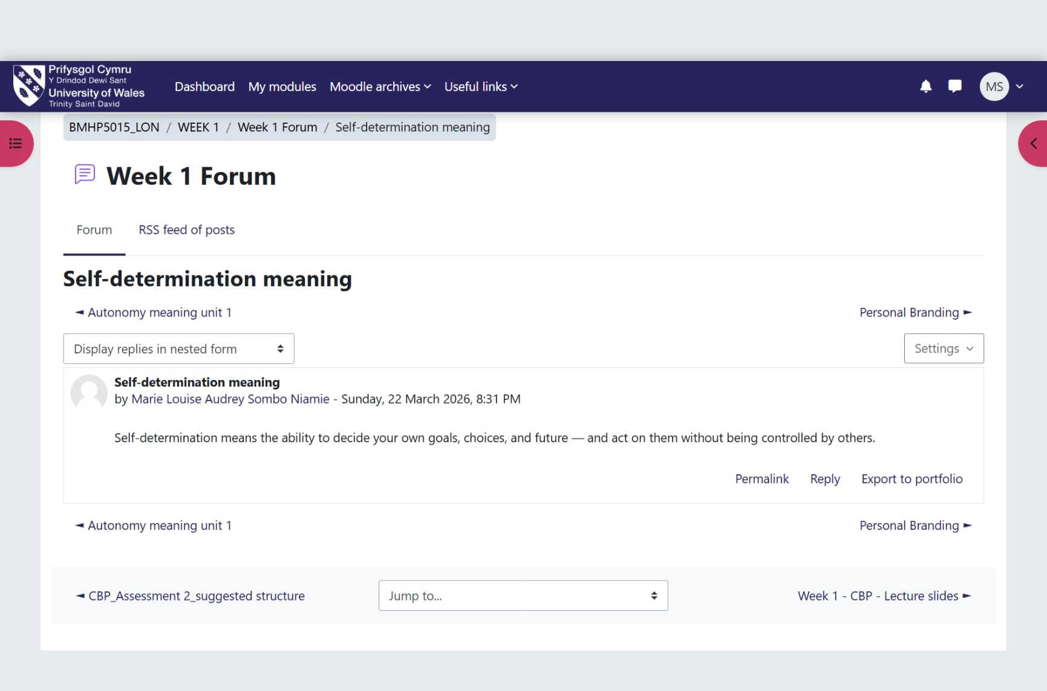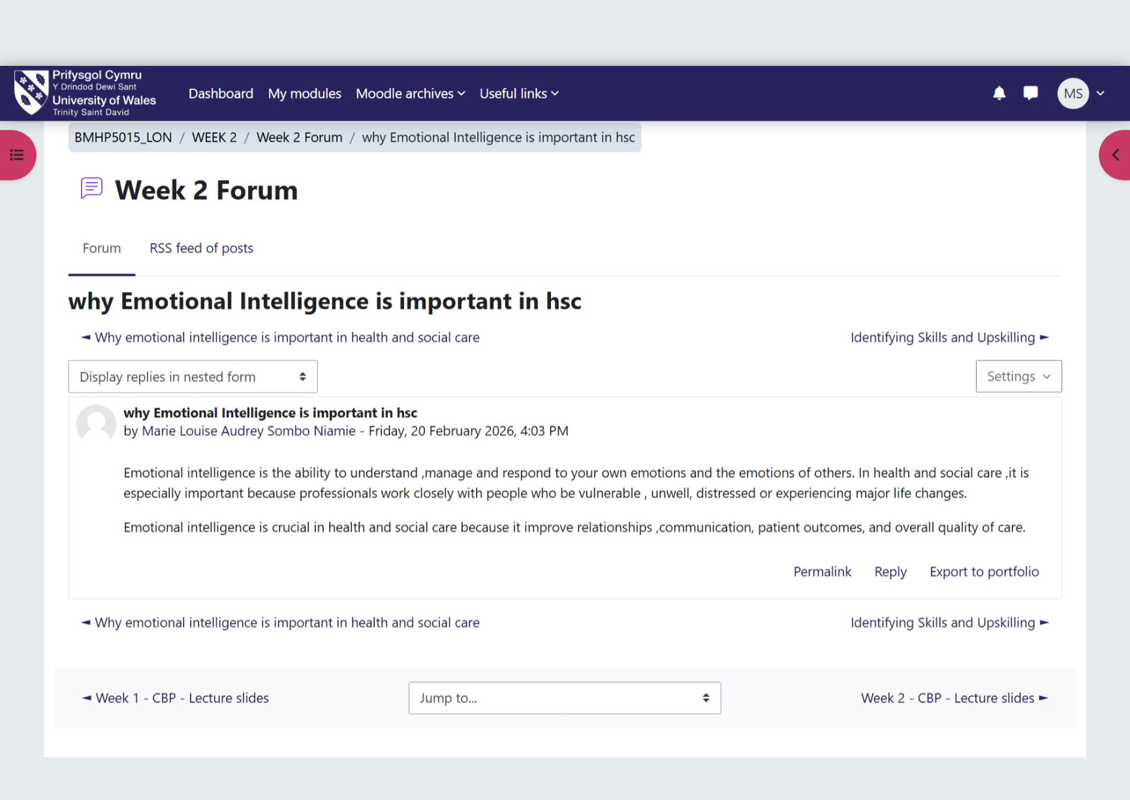

Networking, Diversity, and Global Contexts
It’s a Small World, focused on the role of networking within an interconnected and globalised environment. The unit highlighted how professional relationships, cultural awareness, and organisational structures influence collaboration and performance.
Networking was presented as a strategic process of building and maintaining relationships to exchange knowledge, resources, and opportunities (Gibson, Hardy and Buckley, 2014). This shifted my perception of networking from informal interaction to a structured and purposeful activity. It became clear that networking is not optional but a critical component of career development and organisational effectiveness.
Effective networking facilitates collaboration, enhances information sharing, and supports problem-solving. It enables individuals to access diverse perspectives and expertise, which is essential in complex professional environments. By engaging in networking activities, individuals can expand their knowledge base and identify new opportunities.
The unit also introduced the concept of evaluation in relation to networking and organisational practices. Evaluation involves assessing the effectiveness of activities and determining whether objectives have been achieved. The distinction between goal-based, process-based, and outcome-based evaluation provided a comprehensive framework for analysing performance.
Goal-based evaluation focuses on whether specific objectives have been met, while process-based evaluation examines how activities are implemented. Outcome-based evaluation assesses the overall impact of interventions. Understanding these approaches highlighted the importance of continuous assessment and improvement.
The discussion also emphasised the challenges associated with networking, including communication barriers, conflicting priorities, and a lack of shared objectives. These challenges can hinder collaboration and reduce effectiveness. The World Health Organisation (2010) highlights the importance of interprofessional collaboration in addressing complex global challenges, reinforcing the need for effective networking strategies.
Diversity emerged as a critical theme within the unit. Engaging with individuals from diverse backgrounds enhances creativity, innovation, and problem-solving. Cultural competence, defined as the ability to understand and respond effectively to cultural differences, is essential in diverse environments (Betancourt et al., 2003).
Hofstede’s Cultural Dimensions theory (Hofstede, 2001) provided a framework for understanding how cultural differences influence behaviour and communication. By applying this theory, I developed a deeper awareness of how factors such as power distance and individualism affect interactions. This understanding is crucial for effective collaboration in multicultural contexts.
Therefor explored organisational structures, including bureaucratic hierarchies and network societies. Traditional hierarchies provide clear roles and accountability, while network-based structures promote flexibility and collaboration. Castells (2010) argues that modern societies increasingly operate through networks, driven by technological advancements and global connectivity.
This perspective highlighted the need to balance structure and flexibility within organisations. While hierarchies ensure order and accountability, networks enable innovation and adaptability. Effective organisations integrate both approaches to achieve optimal performance.
Furthermore, the concept of making connections extended beyond professional relationships to include engagement with communities and stakeholders. This emphasised the importance of a holistic approach to collaboration, recognising that outcomes are influenced by a wide range of factors.
It enhanced my understanding of networking as a strategic and essential activity. It demonstrated that effective collaboration requires cultural awareness, continuous evaluation, and the ability to navigate complex organisational structures.
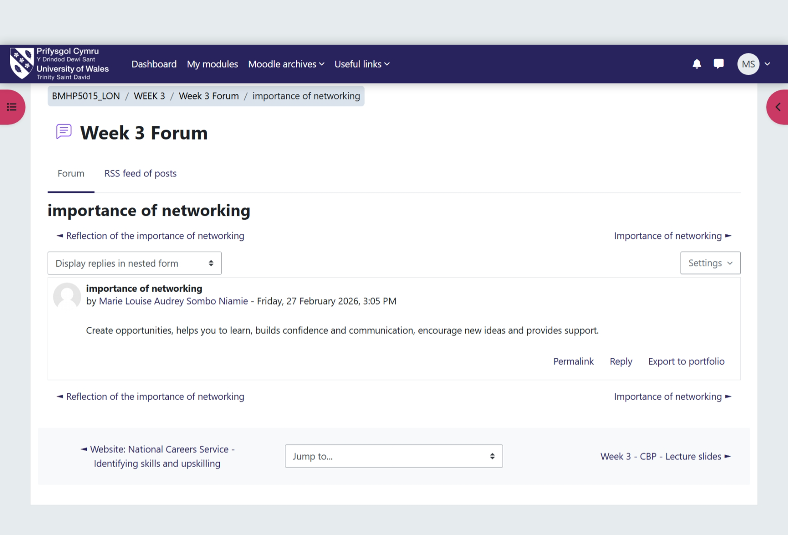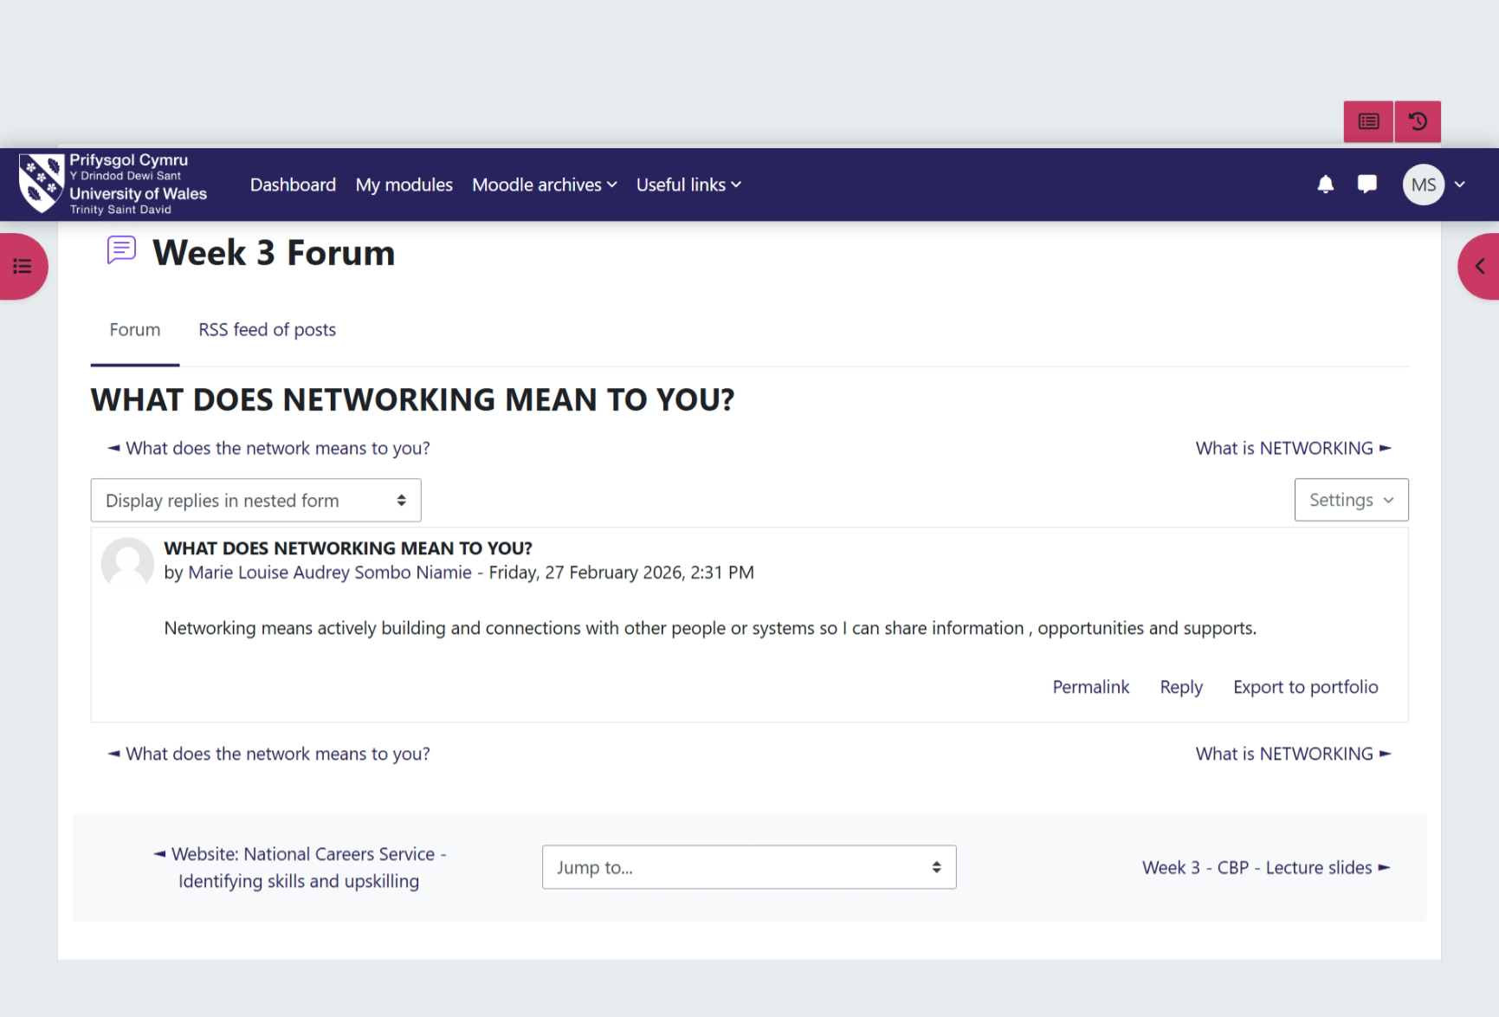

Opportunity Recognition and Career Strategy
Opportunity Knocks, focused on identifying and creating opportunities for career development. The unit emphasised the importance of perception, adaptability, and proactive engagement.
Perception plays a critical role in recognising opportunities. The ability to view situations from different perspectives enables individuals to identify possibilities that may not be immediately apparent. Bury (2013) highlights that changing perspectives is essential for addressing complex challenges and adapting to evolving environments.
Reflective practice, particularly through Gibbs’ Reflective Cycle (Gibbs, 1988), supports this process by encouraging individuals to analyse their experiences and learn from them. By applying reflective techniques, I became more aware of how my assumptions influence decision-making.
The concept of success and luck further expanded my understanding of career progression. While success is often attributed to external factors, the unit emphasised the role of individual behaviour in shaping outcomes. Skills such as communication, organisation, and networking contribute significantly to success.
Krumboltz’s Happenstance Learning Theory (Krumboltz, 2009) highlights the importance of being open to unplanned events. This perspective encouraged me to adopt a more flexible approach to career planning, recognising that opportunities may arise unexpectedly.
Stretch goals were introduced as a tool for promoting growth and innovation. Pina e Cunha et al. (2017) argue that challenging goals can enhance performance by encouraging individuals to exceed their perceived limitations. However, the effectiveness of stretch goals depends on their alignment with realistic planning.
The SMART framework (Doran, 1981) provides a structured approach to goal setting, ensuring that objectives are specific, measurable, achievable, relevant, and time bound. Combining stretch goals with SMART principles enables individuals to balance ambition with practicality.
The unit also explored recruitment methods, highlighting the shift towards digital platforms. Kaharuddin, Pangemanan and Rumokoy (2018) emphasise the growing importance of online recruitment in accessing diverse opportunities. This shift requires individuals to develop a strong online presence.
Digital platforms, such as professional networking sites, enable individuals to showcase their skills and engage with wider audiences (Aveyard and Sharp, 2017). Additionally, blogging and online engagement support knowledge sharing and professional development (Rains and Keating, 2011).
Overall, enhanced my ability to recognise opportunities and adopt a proactive approach to career development.
It emphasised the importance of adaptability, strategic planning, and continuous engagement.
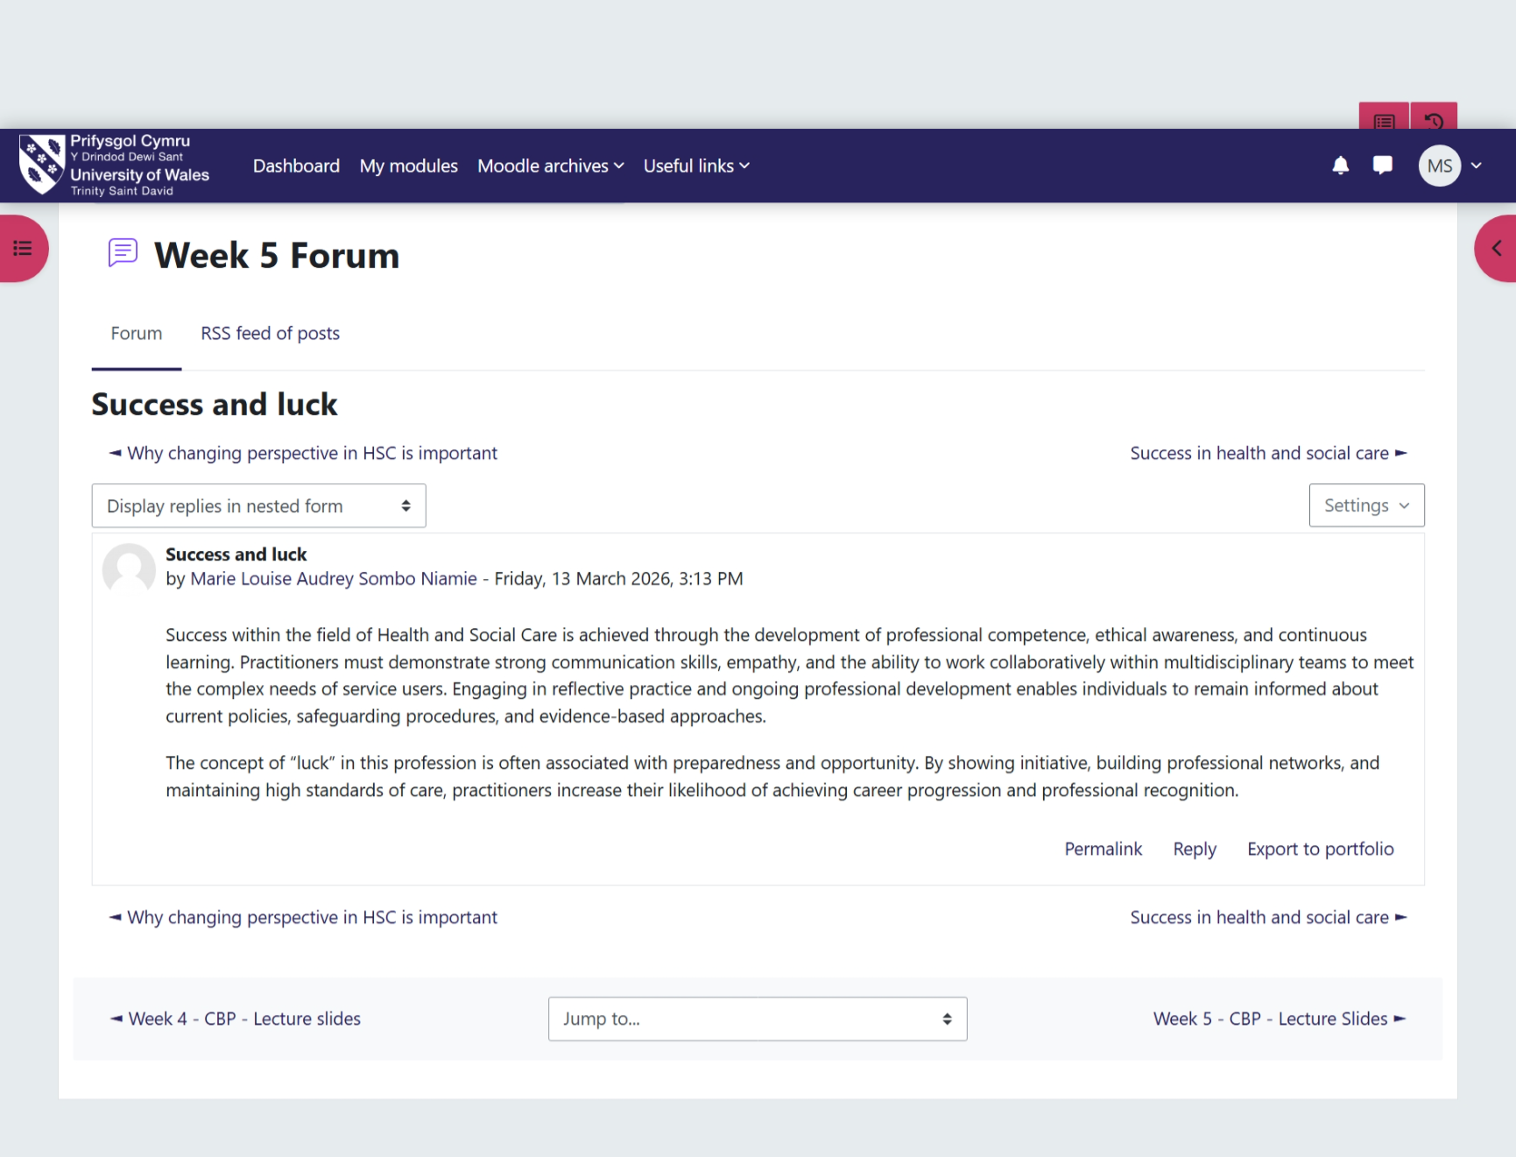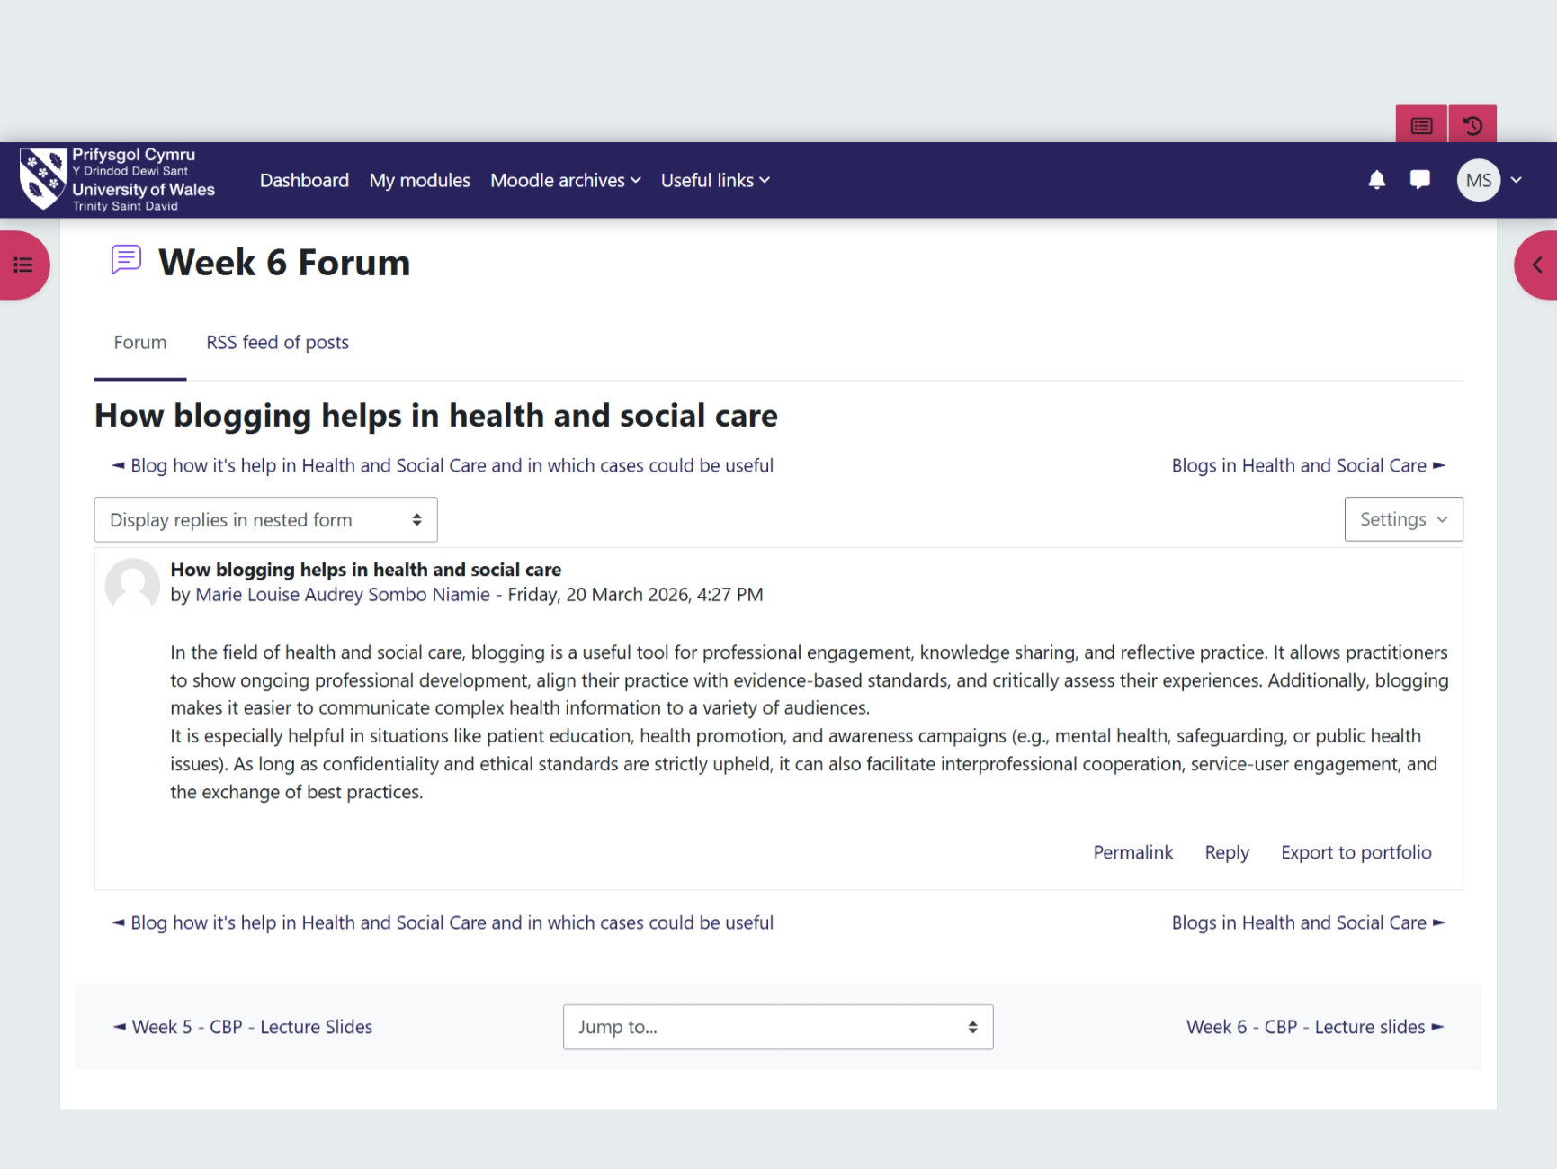

Wellbeing, Resilience, and Professional Sustainability
The Pursuit of Happiness, explored wellbeing, resilience, and work–life balance. These concepts are critical for maintaining performance and sustaining long-term career development.
The PERMA model (Seligman, 2011) provided a framework for understanding well-being. By focusing on positive emotion, engagement, relationships, meaning, and accomplishment, individuals can enhance their overall well-being. Applying this model enabled me to identify areas for improvement and implement strategies to maintain balance.
Resilience was identified as a dynamic process influenced by internal and external factors. Ullsperger, Nittono and Von Cramon (2007) highlight that constructive responses to failure enhance learning. By reframing challenges as opportunities, I developed a more positive and adaptive mindset.
The concept of limiting beliefs highlighted the impact of self-perception on performance. Meadows (2015) emphasises the importance of challenging negative beliefs to achieve personal growth. By addressing these beliefs, I increased my confidence and willingness to take risks.
Grit, defined as perseverance and passion for long-term goals (Duckworth et al., 2007), reinforced the importance of persistence. Maintaining focus despite challenges is essential for achieving success.
Work–life balance was also emphasised as a key factor in preventing burnout. Effective time management and prioritisation enable individuals to maintain well-being while achieving professional goals.

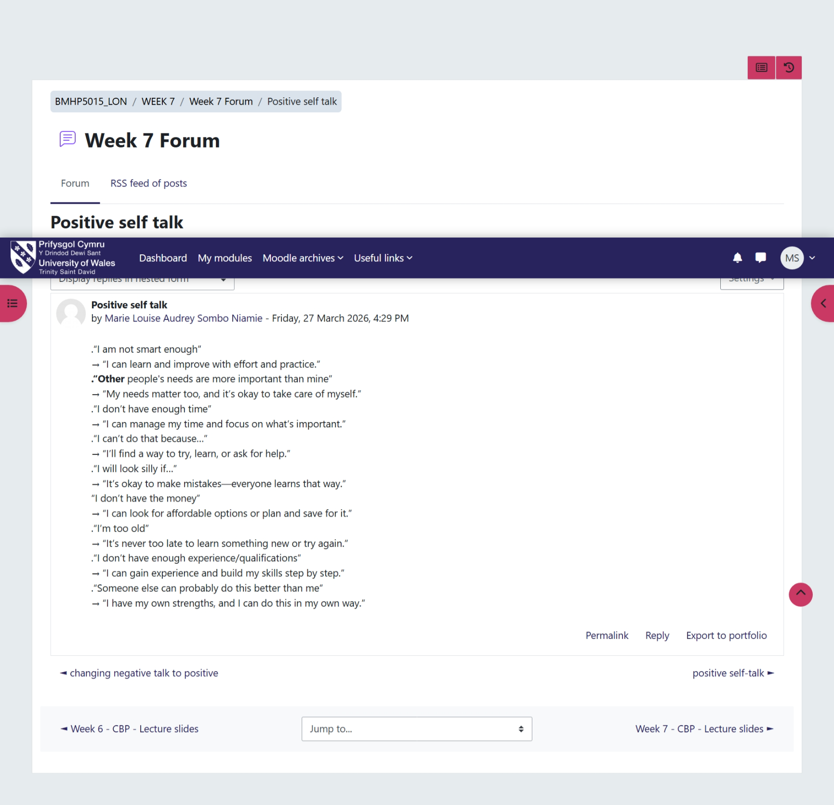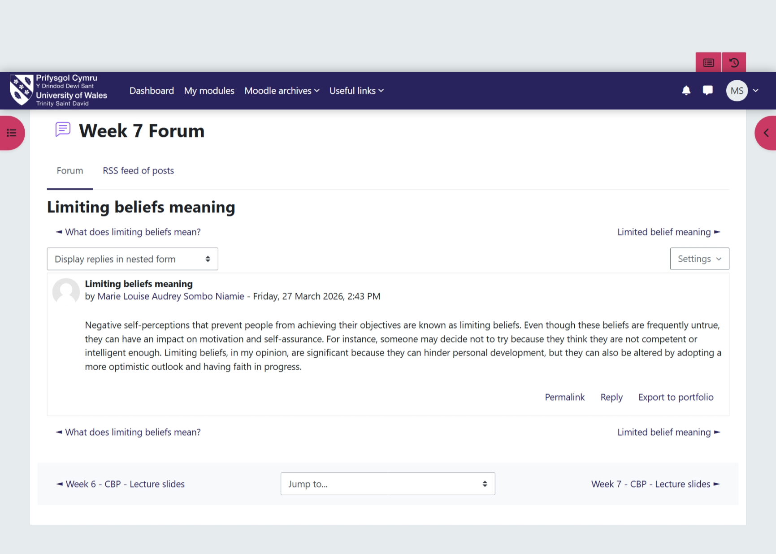

Conclusion
In conclusion, the Changemaker: Building Your Personal Brand for Sustainable Employment module has provided a comprehensive framework for personal and professional development. The integration of personal branding, networking, opportunity recognition, and well-being has enhanced my understanding of employability within modern professional contexts.
The module has demonstrated that sustainable career development requires a strategic and reflective approach. By developing self-awareness, emotional intelligence, and resilience, individuals can navigate complex environments and achieve long-term success.
Furthermore, the emphasis on networking and cultural awareness highlights the importance of collaboration in a globalised world. Recognising and utilising opportunities requires adaptability, proactive engagement, and continuous learning.
Overall, this learning experience has strengthened my ability to manage my career effectively and position myself within competitive environments. It has equipped me with the tools and knowledge required to build a strong professional identity and achieve sustainable employment.

References
Aveyard, H. and Sharp, P. (2017) A Beginner’s Guide to Evidence Based Practice in Health and Social Care. Open University Press.
Betancourt, J.R. et al. (2003) ‘Defining cultural competence in health care’, Public Health Reports, 118(4), pp. 293–302.
Bury, M. (2013) Health and Illness in a Changing Society. Routledge.
Castells, M. (2010) The Rise of the Network Society. 2nd edn. Oxford: Wiley-Blackwell.
Doran, G. T. (1981) There’s a S.M.A.R.T. way to write management’s goals and objectives. Management Review, 70(11), 35–36.
Duckworth, A.L., Peterson, C., Matthews, M.D. and Kelly, D.R. (2007) Grit: Perseverance and passion for long-term goals. Journal of Personality and Social Psychology, 92(6), pp.1087–1101.
Gibbs, G. (1988) Learning by Doing: A Guide to Teaching and Learning Methods. Oxford Polytechnic.
Gibson, C., Hardy, J.H. and Buckley, M.R. (2014) ‘Understanding the role of networking in organizations’, Career Development International, 19(2), pp. 146–161.
Hofstede, G. (2001) Culture’s Consequences: Comparing Values, Behaviors, Institutions and Organizations Across Nations. 2nd edn. Thousand Oaks: Sage.
Houston, E. (2019) What is goal setting and how to do it well? Available at: https://positivepsychology.com/goal-setting/
Kaharuddin, A., Pangemanan, S. and Rumokoy, F. (2018) The influence of digital recruitment. Journal of Management Research.
Krumboltz, J. D. (2009) The happenstance learning theory. Journal of Career Assessment, 17(2), 135–154.
Luft, J. and Ingham, H. (1955) The Johari Window: A graphic model of interpersonal awareness. Los Angeles: University of California.
Meadows, M. (2015) Confidence: How to overcome your limiting beliefs and achieve your goals. Meadows Publishing.
Montoya, P. and Vandehey, T. (2002) The personal branding phenomenon. New York: Peter Montoya Inc.
Otu, M.S. 2025). Exploration of career coaching programmes for employability skills acquisition. In Career Coaching and Employability Skills Acquisition (pp. 257-284). IGI Global Scientific Publishing.
Pina e Cunha, M., et al. (2017) Stretch goals and performance. Business Horizons, 60(3), 321–330.
Pink, D.H. (2009) Drive: The surprising truth about what motivates us. New York: Riverhead Books.
Rains, S. A. and Keating, D. M. (2011) The social dimension of blogging. Journal of Health Communication, 16(1), 87–103.
Salovey, P. and Mayer, J.D. (1990) ‘Emotional intelligence’, Imagination, Cognition and Personality, 9(3), pp. 185–211.
Seligman, M.E.P. (2011) Flourish: A visionary new understanding of happiness and well-being. Free Press.
Ullsperger, M., Nittono, H. and Von Cramon, D.Y. (2007) When goals are missed: Dealing with self-generated and externally induced failure. NeuroImage, 35(3), pp.1356–1364.
World Health Organization (2010) Framework for action on interprofessional education and collaborative practice. Geneva: WHO.

