Banking Financial Management and Financial Markets

NAME- PRITI CHHABDA
FILE NAME-BANKING FINANCIAL MANAGEMENT
MODULE CODE-LCMB7012
LECTURER- DAVID COKER
COURSE-MASTER’S BUSINESS ADMINISTRATION
STUDENT ID- 2208700

Table of Contents

Introduction 3
Identification of the laws 3
Laws that were determined by the UK 3
Laws that were determined by the EU 3
Laws that were determined by the US 3
Contribution of the Reforms in the Stability of the financial sector 4
Issues faced by banking management in the post 2008 crisis 10
Solutions 12
Impact of the crisis on the business operation of AIG 13
Conclusion 15
Reference List 17

Introduction
The financial crisis of 2008 destroyed the entire financial system is going to be explored in this report. Further, the description of the pricing of financial assets will be triggered so that the post scenario of the entire disaster can be encountered to draw out various aspects of the banking sectors. The bank performances will also be measured through various findings of the reforms induced for addressing the regulations and its impacts on the UK, US and EU. The finance theory will be mentioned for better understanding. Thus the various laws must be identified in the various countries to explore the norms individually to get a clear view in order to broaden the knowledge. In the following part a critical review of the reforms that were inclined to help financial stability will also be performed. Hence, the purpose of the research process aims to identify the importance of financial markets that collapsed due to the huge crisis in 2008. Further, the role of the financial assets will also be examined to verify the bank's performance. The various valuation methods will also be accounted for in the presentation. Later the different operations will be particularly analysed to provide the finance theory. These findings will later be attributed to account the various issues that were faced in the banking management and its effects will also be measured. This will provide a new insight that will attract the attention of the readers in order to generate curiosity regarding the past 2008 crisis more specifically.
Overview of Santander Bank UK
Santander Bank UK is a British Bank and is owned by the Spanish Santander Bank. The UK plc controls the affairs autonomously. The organisation also consists of a own build local management team. The bank has its own solely stability and responsibility to perform the best efforts. It was found on 11th January, 2010 (Bank, 2018). The headquarters of the bank is situated in London, United Kingdom. The bank has its division in Cahoot, Santander Corporate and Commercial Banking and Santander Private Bankings. The office is located at 2 Triton Square, Regent's Place. The bank has over 25, 000 employees working in the organisations. It has been the leading personal financial services and provides mortgages and savings to the United Kingdom.
Impacts of post 2008 Financial Crisis
The 2008 financial crisis had stopped in the year 2009 but the effects were long lasting which affected the global banking sectors which caused long term consequences. The first and foremost thing that was observed was excessive lending and risk-taking which was unsupported by the adequate liquidity and capital buffers (Senbeto and Hon, 2020). The other effects that were observed were the net migration rates among advanced economies that had declined drastically after the crisis.

Identification of the laws

Laws that were determined by the UK
DODD-FRANK Wall Street Reform and Consumer Act
The Economic Stimulus Act of 2008
The American Recovery and Reinvestment Act

Laws that were determined by the EU
European Commission proposed 30 sets of rules
Steps were taken for using a single currency system for better functioning.
EU governments and heads of state agreed to create a banking union
Financial system overview through European Securities and market authority (ESMA).
Agreement on the deposit guarantee scheme reform Directive.

Laws that were determined by the US
The massive bailout program launched by the state helped to control the crisis from further spiralling.
The Federal Reserve took swift action for economic growth.
The IMF took various actions for low-income countries by creating new lending instruments.
The US treasury also played an important role
All these laws were implemented to evaluate the various disruptions that took place via different methods that were legally implemented over the countries to get control over the losses. Valuation is a crucial integral activity performed in an organisation that helps to detect mispriced securities and also determine the existence of a project to judge its incitement. The specific reasons for valuation are purchasing and selling of a business. It helps the buyer and the seller both to get benefitted from the valuation so that the ultimate decision can proceed (Group, 2021). Strategic planning is also a vital factor as it helps organisations to invest in projects that can increase in present net worth. Capital financing is an objective for valuation as it can be useful in terms of negotiations with banks as the credibility of the organisation also gets enhanced for lenders and equity investors. the time of funding. Capital finance also documents a company's worth which can enrich its cash flow (Vaidya, 2022). Security investing is another crucial indicator that ensures the current market price of the security is not reflected in its intrinsic value. The fair market value of individual assets is calculated by the approached assets. Discounted cash flow is one of the processed analytic techniques that allow the analyst to forecast the floated free cash flow into the future and discount it back to the present at the firm’s weighted average cost of capital (WACC).

Contribution of the Reforms in the Stability of the financial sector
The Reform and the consumer act was passed to control the restoration of stability and strengthen the look over the financial systems so that repetition of such crises could be avoided. The lowering of the interest rates was introduced with the monetary policy by the BOE to stabilise the economy and enhance growth opportunities (Chen and Yeh, 2021). Further recovery acts were passed to resolve the issue of long-term unemployment so that the deepest UK recessions could be overcome.
Bank performances are the pillar of fulfilling the purposes of financial activities. The performances helped the global economy to measure the strength of return on assets and return on equity. In aspects of the financial analysis, the individual ratios elucidate the accounting value constructs on historical cost assumption because it leads to the quiescent in the measurement of performance differentiate from the market value. Scheduled for timeliness, a market index is a structured value for a firm's performance accountability that is important for investors who focus on market value instead of ROA, and ROE comes from the organisation's internal techniques (corporate finance institute, 2022). The 2008 global financial crisis has triggered both national and international economies’ realisation of the critical banking performance from its activities that require supervised vigilance. The existence of the CAMELS rating system signifies and categorises financial conditions of the entire banking measures in the banking financial performance sector. The Federal Financial System Examination Council (FFIEC) emanated the decision-making process to utilise the formal Financial Institutions Rating System, called CAMEL. It designated each financial institution into an amalgam ranking that consists of six crucial indicators of a financial condition and activities encapsulated into a composite “CAMELS '' rating. So, most banks use this model covering the spherule as a performance estimation procedure. The US faced a grave economic crisis in the past like between 1929 to 1933 which collapsed the banking system. The price of financial assets makes way for the investors to get access to the roots of assets to determine the future stream of cash flow.
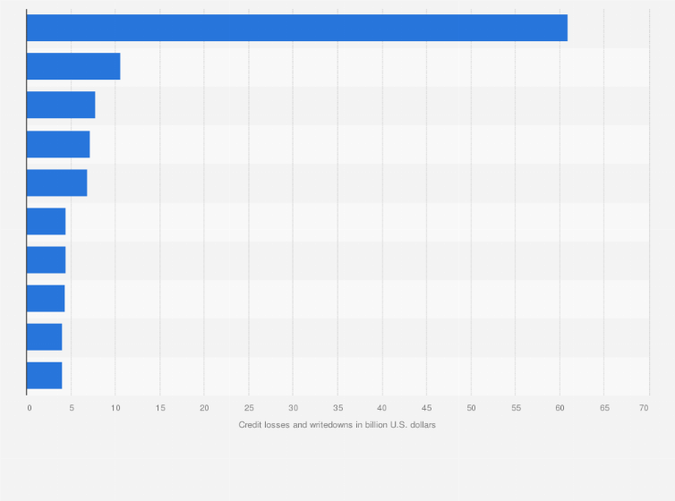
Figure 1: Credit losses and write downs during financial crisis
Source: (Rudden, 2008)
The lower the cost of the asset the return on investment will be high which will enhance the investor's interest more effectively. The asset pricing model is the ideal portrayal of the process of financial market price securities so that the expected return on investment can be determined (Al Ahbabi and Nobanee, 2019) The method in the pricing is used to quantify the risk to translate that risk into estimates of expected return on equity. The theory of price states that the price of a specific product or service is acquired from the relationship between its supply and demand. In this scenario, it is seen that if demand exceeds supply then the prices of the asset should rise automatically and on the other way if the rise in supply exceeds demand then the prices of the commodities fall gradually. The optimal market value is the point where the entire amount of items available can be consumed reasonably by potential customers. Supply of assets can be affected by the availability of raw materials whereas the demand fluctuates depending on the other competitors in the market. This microeconomic principle affects the pricing of a financial asset that is considered in the market which completely depends on the supply and demand factors (Ghorbel and Jeribi, 2021). In the free market, it is also observed that the producers are willing to charge far more for their goods and services. On the other hand, the consumer pays as little as they consume. Therefore, it is the market price that forces both the reduced and the consumer to meet in the middle of somewhere which helps them to meet at their will point purposely. However, the 2008 financial crisis started in the USA but it had a global impact which was felt across boundaries. The steps that the US authorities had to take should have been aligned with the global markets. The global financial crisis (GFC), also known as the great recession, was caused by the subprime mortgage crisis, which originated in the United States and spread to Europe and the rest of the world (DesJardine, Bansal and Yang, 2019). The November 2008 G20 summit declared several steps to create resiliency in the financial sector in the USA. Systematic risk-assessing measures were taken by the authorities for the detection of any kind of irregularities in the system. The financial stability forum (FSF) and also the IMF did a detailed study of the crisis and highlighted the lack of a proper regulatory environment in the financial market. The “Over-the-counter” derivatives market was reformed to make it safer from the risks by providing sufficient capital for the Non centrally cleared derivatives (Brem, Nylund and Viardot, 2020). In July 2010, the Dodd-Frank Act was passed which has the provision to safeguard investors' financial interests.
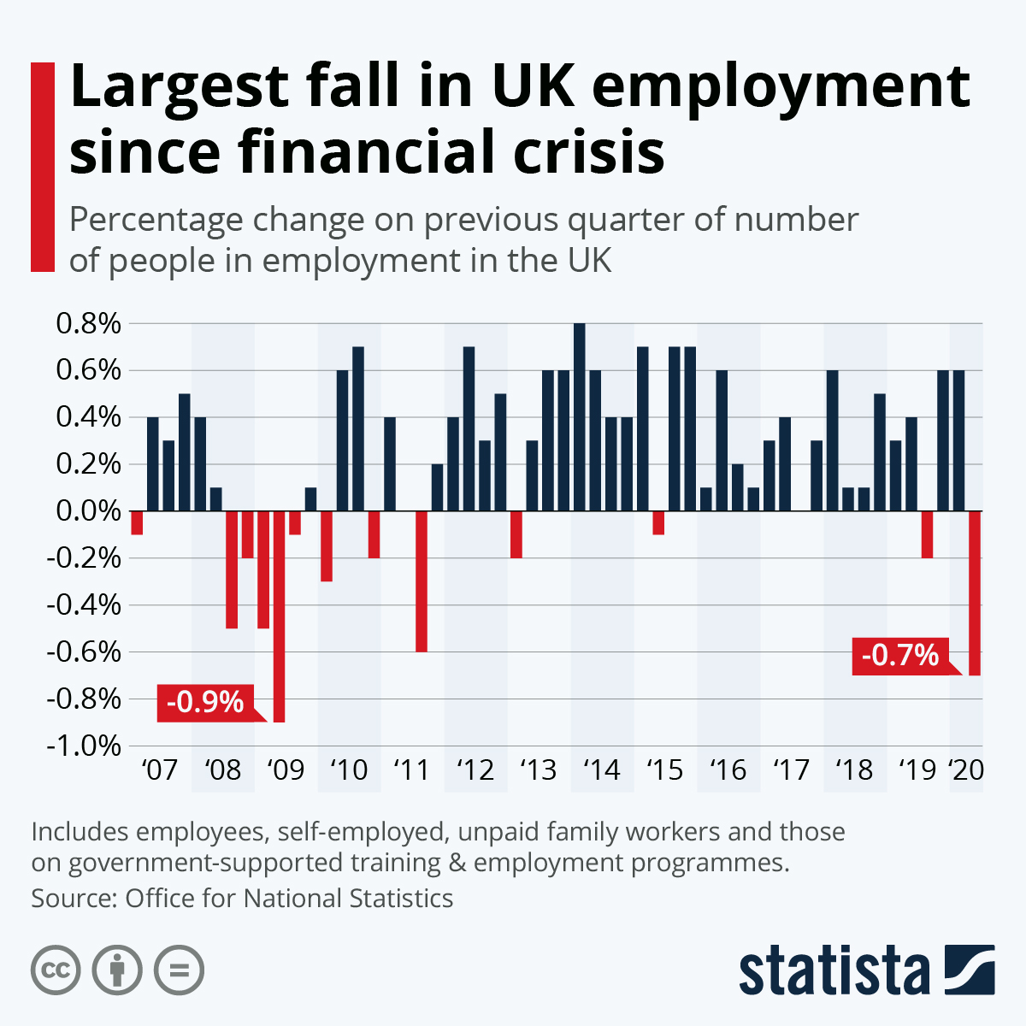
Figure 2: Largest fall in the UK employment during financial crisis
Source: (Armstrong, and Richter, 2020)
A proper bailout system without splurging the taxpayer's money was also introduced to avoid any kind of repeat of the 2008 financial crisis. Significant advancements towards a eurozone banking union and a solid economic framework for Europe were achieved after the 2008 financial crisis. The 30 rules proposed by the EU were made the basic framework of the 28 states (Chen and Yeh, 2021). Banks and sovereigns are caught in a vicious cycle which was focused on after the 2008 crisis. The framework that was adopted by the EU ensured that any kind of bailout program will not be done with the taxpayer's money which added stability to the market. The financial market plays a vital role in expediting the allocation of resources to create business and entrepreneurship liquidity for future developments. It is the market that alleviates the need for sellers and buyers to trade financial holdings. The financial markets generate security products to provide a return for those who have excess funds (Notteboom, T., Pallis, T. and Rodrigue, J.P., 2021). Financial markets are created by purchasing and selling different types of financial tools which include equities, currencies, bonds and derivatives. Financial markets depend highly on data transparency to affirm that the markets set prices that are structured and pertinent. The market prices of securities may not be denoting their congenital value for the reason that of macroeconomic forces like taxes. The financial markets are comprehensive in scale and scope. The amalgamation of the sellers and buyers is processed by the financial markets through the help of regulations and fundamental actions allowing the capital to flow fluently to make the global economy run smoothly (Probasco, 2022). The firm uses the bond and stock markets to raise capital from investors and uses derivatives to reduce risks in the financial markets. The market takes the benefit of utilising digitised tools and financial instruments that allows the creation of virtual documents legally to trigger new monetary value for better transactions.
The whole supervision system of the EU financial sectors was revamped after the crisis. The European Banking Authority (EBA) introduced the system to understand the need for the recapitalisation of the banks whenever needed (Notteboom, Pallis and Rodrigue, 2021). The European Securities and Market authorities supervised the various trade repositories and credit rating agencies. A single rulebook of the various legislative texts was introduced for all financial institutions. The European system of Financial Supervision that was established in the year of 2011 was instrumental in the creation of transparency and efficiency in the financial markets. The Omnibus II directive was further adopted in the same year to clarify the authorities of the supervisory councils, especially in the financial sectors. The financial assets are available at all class's important roles in the net worth. The identification of the financial asset is highly important so that the purpose of utilisation is determined which helps in systematic financial planning. Therefore financial assets are tangible and can be converted quickly into cash that is owned by people (Kliestik et al., 2020). The tangible assets can also be a piece of paper which can be traded for cash. Moreover, there are risks associated as well when the investment goes wrong like non-FDIC insured can put the invested money into high risks. In order to improve protections for customers and promote transparency in the financial sector, the Dodd-Frank Wall Street Reform and Consumer Protection Act was passed in the US in 2010 which stabilised the market to a great extent. The subsequent economic growth that is achieved after the measures also helped to stabilise the market to a great extent. The banks were pushed to hold more assets against the risks that they were taking in the market (Ansca et al., 2019). Proprietary trading activities were banned from the investment banks' activities and it focussed more on giving services to the trades of the clients. The reforms also led to the merger of several financially stressed banks and financial institutions with their stronger counterparts (Vlachos et al., 2019). Keynesian Fiscal stimulation was adopted by all the governments which boosted the economy through measures such as tax cuts and increased government spending. Macro and Micro prudential policies were also introduced by the authorities for assessing systematic risks which stabilised the market further. The economic recession of 2008 had adverse effects on different parts of the world, which is why an effective and powerful supervision team was created by the governments of different nations. An effective supervision team helped governments to analyse the various factors which are hindering economic stability and helped the governments to find a better way to deal with destabilised economical conditions (Benos, Payne and Vasios, 2020). The governments also decided to deploy an LEI system or Legal Entity Identifier which helped the nation to figure out various objectives which could help to stabilise the economic crisis situation.
The LEI system also helped the nations to assess macro-prudential and micro risks which can be resolved by the effective resolutions provided by the system. The LEI system also helped various firms to analyse their risk management plans and helped them to improve them by providing effective resolutions (Leledakis and Pyrgiotakis, 2022). The banking sectors took help from various reforms such as the Dodd-Frank Wall Street Act which enabled the federal reserve to closely watch large banks, insurance agencies and large financial institutions. It helped the banks to have a detailed observation of the daily activities happening in the financial institutions (Lund, 2018). The consumer protection Act was another important reform which helped to stabilise the banking sector since it also helped the banks to observe their daily procedures and make them accurate. The consumer protection act also helped to analyse the upcoming risks so that consumers can be protected by regulating their procedures properly. The emergency economic stabilisation act also played an important role in stabilising the banking sectors throughout the world since it helped the major banks to analyse weak points and provided resolutions to deal with them in an effective manner (obamawhitehouse, 2019). The emergency economic stabilisation act also helped the banks to deal with sudden crisis situations in a much more efficient way.
When the banking sectors took help from the various reforms which were implied to help the banking sector get stabilised, the Volcker rule played a huge role in its stabilisation. Speculative investments have the potential to draw a lot of unwanted risk upon a major banking institution, which is why the Volcker rule worked on limiting investments which required speculations, ultimately decreasing the risk factors (Merle, 2018). The Volcker rule also limited the proprietary trading by institutions that were depository by enacting a ban called de facto. The troubled asset relief program helped major banking institutions to restore their economic growth. TARP used to achieve its objectives by buying the endangered financial institution's stocks and assets backed by mortgages (Weinberg, 2023). The actual objective of TARP was to increase and bring liquidity into the mortgage markets which were secondary and money markets. The TARP program helped many major banking institutions to mitigate the risks by avoiding potential losses, it later on also allowed the governments to finance financial institutions' equities.

Issues faced by banking management in the post 2008 crisis
The value of the tangential financial asset can fluctuate according to the market value. In this case, it is seen that when the supply is high and the demand is low the prices of the asset reduce whereas when the demand is high compared to that of supply the prices of the asset decrease instantly. Financial assets can also be precious metals or things like property. Intangible assets on the other way can be trademarks which are valuable but can't be physically dealt with. The combination of tangible and intangible assets are both certified values of financial assets that are owned by people (Park and Kim, 2020). Some of the liquid assets can gain interest by increasing the net value of the asset which is a powerful benefit of owning financial assets. The governments of various nations also decided to decrease their reliance on credit ratings, so that the cliff effects can be avoided along with avoiding systemic disruption. These reforms helped the governments to improve their financial sector significantly. A shift in culture affects management due to changes in work style. The inducements of digitalised technology through AI needs innovation to compete with challenges affecting drastically to raise instability (Liu, 2021). Regulatory compliance has been a common challenge.
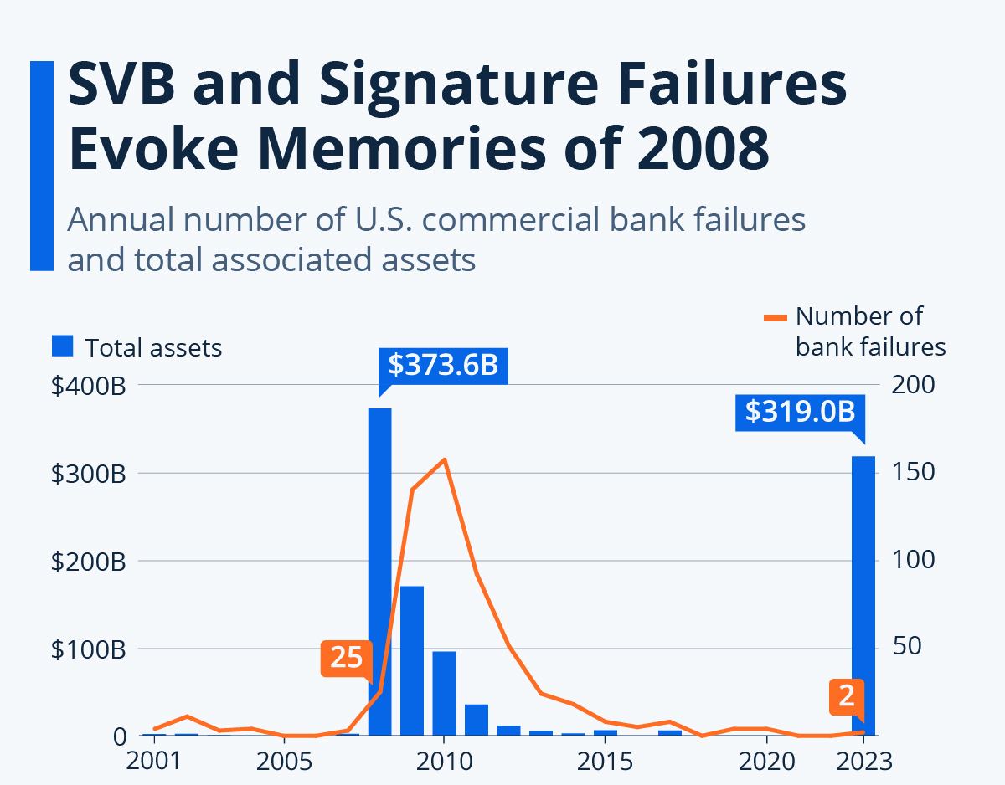
Figure 3: SVB and signature failures Evoke memories of 2008
Source: (Armstrong and Richter, 2023)
Changes in banking regulation have also been problematic for the business. Lack of proportional enhancement and risk mitigation. The changing business models are a result of costs associated with compliance management which are affecting the financial institutions to change their way of committing businesses resulting in decreased proprietary trading. Customers are mostly influenced by the recommended reviews which highlight the protruding online presence on various social media platforms. There are salient perspectives that influence consumer behaviour like building product awareness. Credit Ratings have a significant impact on the returns of equity. There are several financial problems identified as a result of credit ratings. It is observed that most business establishments are ravaged due to the credit ratings and it also affects the entire process of the business. In addition to this, the stability and the growth rate of the business establishments get ravished due to the credit ratings. Credit ratings refer to an income of the banking sector which is associated with the lenders for doing or initiating a business. It is important to note that if there is a change in the ratings of the credit, trade with the collaborative companies fails. Change in credit ratings impacts the high standards of the non-performing debts by the banking sector to the debtors. The relationship between credit ratings and statistical equity represents the ability of debtors to pay back the loan on time.

Solutions
When consumers face various issues the first step is to start researching for solutions. It is also observed that consumers are not confirmed regarding the option to choose a particular product among so many. Social evidence is also a powerful source for making buying decisions due to the tendency of the consumers to emulate the behaviour of others having their influence. Satisfied customers always tend to recommend good products and review the beneficial opportunities. This is mostly done by making the post more transparent through vlogs, life-changing videos and many more. This influences the customers to opt for the product under the influence of others. The banking organisation, therefore, takes the initiative to emphasise they are happy customers to share pictures, testimonials, videos and case studies which will help them to gather more trust and will also enhance the brand name. Accordingly, it is also derived that the power of social media evidence cannot be underestimated as these social platforms are collaboratively mixed among the crowd around the globe. Thus the buyers and the sellers are cooperatively using the essence of the social media evidence to enhance the productivity and stabilise the economic conditions of the banking sectors all over the world. Credit control and flow of cash are significant as without controlling the flow of cash businesses and banks are not able to pay the bills or make investments. Investments are required to bring new products and hire new employees. Moreover, it is also important to note that in credit returns it is significant to ensure by the lender that the debtors must be able to return the taken amount back. It is concerned with the process of controlling and doing management of the accounts of a company that is receivable. The invoices given by purchasers have yet not been paid. With the help of credit control, it is monitored very minutely and all the payments which are paid in delinquency help in improving the business. It is crucial for business establishments to adopt a clear process for controlling the credit system. Credit control and management are significant for business establishments as it helps establish an accurate timetable. This helps in ensuring the payments and its delays and to reduce the unnecessary delays. Establishing the promptness of the invoices of payment by reminding the shoppers helps in preparing a proper schedule when there is a fulfilment of orders. During financial crunches, it is important for the banks to send several invoices for the payments of the debts. It is significant to note that it is quite helpful for the banks to pass the debt on to an accurate and commercial debt gathering agency so that the debts can be taken back from the people who have taken the debts

Impact of the crisis on the business operation of AIG
AIG had the biggest fall after the crisis of 2008. Several restructuring initiatives were taken after the crisis. Stress was given to the asset quality of the mortgages before insuring a certain project. Better corporate governance was introduced in the business operations to control the restoration. AIG was one of the few USA-based financial organisations which were deemed too big to fail before the financial crisis. The US government had to take a stake in the company. The London sister concern of this company called AIG financial products was the centre of the source of the crisis. This division was responsible for selling insurance against investment losses including real estate. The rapid fall of real estate prices in the USA after the meltdown of the mortgage-backed securities in the US housing sector (Amadeo, 2020). The rising number of borrowers in the real estate market defaulted on their loans and created pressure on the business operations of AIG in a significant manner. AIG had an asset value of nearly $1 trillion before the crisis. It lost nearly $99 billion after the crisis. The crisis had put an end to the dealings with the securities of the banks which were backed by subprime Mortgages which was the main reason for the start of the 2008 financial crisis. The online marketplace has been growing rapidly for many years and the effect of this can be seen in the offline market. The effect of the online marketplace on the offline marketplace can be seen based on this research paper. The research paper has concluded the various pieces of evidence that were gained through the various types of research that were gained from the study and the interviews that were taken. The effect of the online business on the offline market is evident from the fact that the closure of many offline companies during the Covid time was due to the online medium of the business.
Small businesses in the banking sector have a big contribution to the local businesses which is the backbone of any economy. Small and medium enterprises are responsible for the various ways of job creation that affect the marketplace. Lots of people were not able to invest in their areas due to unstable factors which is the reason for the reduction of growth in the offline banks in the market. Small businesses got hampered due to the effect of the financial crisis in 2008. As found in this study, the main reason for this problem can be attributed to the fact that the various aspects of the mode that was available in the marketplace changed drastically due to the effect of the instability in the economic relations. Online shopping removes the middlemen from the supply chain in a suitable way that benefits every stakeholder. They can provide the items at a much cheaper price which may not be matched by the offline players. The hampering of the selling by the offline stores can be seen in the results of the financial markets offline which was evident in this research. There is no other option for the offline market player other than to offer the customers cheaper options to gain market share. The packages that they are generating can be sold at a cheaper rate due to the various factors of online marketplaces. The loyalty cards that are offered by online banks are giving them more consumers based on various factors. The extra benefits the customers are getting from the companies are allowing them to buy products at a cheaper rate than the consumers of the online marketplaces. If they are regular customers then they are getting the offers automatically due to the various tools the online market players are employing to attract the customers. The data mining tools that are employed by them are allowing them to get authentic customer data and they target the consumers with various kinds of offers that the customers might not resist. The local bank owners can challenge the system by providing them with their version of the loyalty or membership cards which can give them the same opportunity that the online marketplaces are getting to attract consumers. The Federal Reserve undertook several actions for the salvage of AIG after the crisis. The reckless gambling on the collateral debt obligations was stopped by the organisation after the crisis. This was the biggest takeaway on the operations of the AIG as this mindset of being indestructible was changed in a rapid manner. Its bankruptcy was hastened by its extensive diversification and overburdened management (sec202, 2020). Before the dismantlement, the subsidiary's operations were broken into four parts which are Life insurance and retirement, Non-Life Insurance, Asset Management services and financial services. Investors who purchased AIG shares between March 16, 2006, and September 16, 2008, got $960 million from AIG. The notional amount* financial by-products have decreased from two billion United States dollars to less than 1 billion USD (Amadeo, 2020), while its securities portfolio has decreased from 44 000 holdings to less than 16 000 after 2008. 56,400 people worked for AIG in 2016 compared to 116,000 in 2008. This step was for simplifying and selling assets to minimise expenses and return to profitability. The business model of AIG was restructured as per the reforms.
The subsidiary of AIG was divided and a particular sector was given. The investors were given importance according to the new business model. Steps like a decrease in the security portfolio were undertaken to explore the scenario. The workforce was trimmed to minimise expenses. The Federal Reserve undertook several actions for the salvage of AIG after the crisis. The reckless gambling on the collateral debt obligations was stopped by the organisation after the crisis. This was the biggest takeaway on the operations of the AIG as this mindset of being indestructible was changed in a rapid manner. Its bankruptcy was hastened by its extensive diversification and overburdened management (sec202, 2020). Before the dismantlement, the subsidiary's operations were broken into four parts which are Life insurance and retirement, Non-Life Insurance, Asset Management services and financial services. Investors who purchased AIG shares between March 16, 2006, and September 16, 2008, got $960 million from AIG. The notional amount of financial by-products have decreased from two billion United States dollars to less than 1 billion USD (Amadeo, 2020), while its securities portfolio has decreased from 44 000 holdings to less than 16 000 after 2008. 56,400 people worked for AIG in 2016 compared to 116,000 in 2008. This step was for simplifying and selling assets to minimise expenses and return to profitability. The AIG took several steps to be compliant with the rules post-2008.
The company took the route of bankruptcy in the bankruptcy code. It also follows the instruction of the National Association of Insurance Commission. Several internal structures were also done according to the rules. All kinds of risky securities are avoided by the organisation to prevent any crisis. Various regulations were introduced after the crisis which included better scrutiny of the financial sectors. The AIG took steps according to the suggestions of the various regulatory councils. The financial product segment of the concern filed for Chapter 11 bankruptcy code according to the regulations in the year 2022. The National Association of Insurance Commissioners (NAIC) had a set of regulations which were adopted by the AIG (fsb, 2022). NAIC had decided to gain more information from the insurers which was also complied with by the AIG. In order to better manage scale in dealing with vendors and property expenditures, the corporation is also looking to reduce costs. In regard to the pertinent capital restrictions of both the consolidated firm and insurance companies, AIG absolves the capital impact of prospective macroeconomic, financial and insurance stressors (iclg, 2023). AIG no longer engages in derivatives activities that significantly raised concerns during the financial crisis or functions as a market maker for contracts for derivatives.

Conclusion
The various observations seem to be related to financial activities. The impact of the financial crisis led to poor performance in the economy. The effect was on the major countries like the US, UK AND EU. The promotion of transparency was circulated regarding the compliance with regulations which seemed to be vital for the banking sector. It can be concluded from the above study that the reforms that were undertaken after the 2008 economic crisis had a far-reaching impact. The various reforms like the Dodd-Frank act for the financial stability act played a significant role in stabilising the world economy after the crisis. The necessary steps that are taken by the AIG were also discussed in the study.

Reference List
Amadeo, K. (2020) This bailout made Bernanke angrier than anything else in the recession, The Balance. Available at: https://www.thebalancemoney.com/aig-bailout-cost-timeline-bonuses-causes-effects-3305693 (Accessed: April 20, 2023).
sec202 (2020) American International Group, Inc., July 27, 2020 - SEC. Available at: https://www.sec.gov/divisions/corpfin/cf-noaction/2020/aig072720-rule405.pdf (Accessed: April 20, 2023).
Rudden, J. (2008) Financial crisis: Credit losses and writedowns of insurance 2008, Statista. Available at: https://www.statista.com/statistics/269594/credit-losses-and-writedowns-at-insurances-in-the-financial-crisis/ (Accessed: April 22, 2023).
Armstrong, M. and Richter, F. (2020) Infographic: Largest fall in UK employment since financial crisis, Statista Infographics. Available at: https://www.statista.com/chart/22523/uk-quarterly-change-in-employment-percent/ (Accessed: April 22, 2023).
Armstrong, M. and Richter, F. (2023) Infographic: SVB and signature failures evoke memories of 2008, Statista Infographics. Available at: https://www.statista.com/chart/29479/us-commercial-bank-failures-and-associated-assets/ (Accessed: April 22, 2023).
fsb (2022) Post-2008 financial crisis reforms, Financial Stability Board. Available at: https://www.fsb.org/work-of-the-fsb/market-and-institutional-resilience/post-2008-financial-crisis-reforms/ (Accessed: April 20, 2023).
iclg (2023) Insurance & Reinsurance Laws and Regulations Report 2023 USA, International Comparative Legal Guides International Business Reports. Global Legal Group. Available at: https://iclg.com/practice-areas/insurance-and-reinsurance-laws-and-regulations/usa (Accessed: April 20, 2023).
DesJardine, M., Bansal, P. and Yang, Y., 2019. Bouncing back: Building resilience through social and environmental practices in the context of the 2008 global financial crisis. Journal of Management, 45(4), pp.1434-1460. DOI: 10.1177/0149206317708854
Brem, A., Nylund, P. and Viardot, E., 2020. The impact of the 2008 financial crisis on innovation: A dominant design perspective. Journal of Business Research, 110, pp.360-369. DOI: https://doi.org/10.1016/j.jbusres.2020.01.048
Chen, H.C. and Yeh, C.W., 2021. Global financial crisis and COVID-19: Industrial reactions. Finance Research Letters, 42, p.101940. DOI: https://doi.org/10.1016%2Fj.frl.2021.101940
Notteboom, T., Pallis, T. and Rodrigue, J.P., 2021. Disruptions and resilience in global container shipping and ports: the COVID-19 pandemic versus the 2008–2009 financial crisis. Maritime Economics & Logistics, 23, pp.179-210. Available at: https://link.springer.com/article/10.1057/s41278-020-00180-5
Lentner, C. and Kolozsi, P.P., 2019. Innovative ways of thinking concerning economic governance after the global financial crisis. Problems and Perspectives in Management, 17(3), p.122. DOI: http://dx.doi.org/10.21511/ppm.17(3).2019.10
Elsayed, A.H., Nasreen, S. and Tiwari, A.K., 2020. Time-varying co-movements between energy market and global financial markets: Implication for portfolio diversification and hedging strategies. Energy Economics, 90, p.104847. DOI: https://doi.org/10.1016/j.eneco.2020.104847
Ansca, C.C., Suyapto, K.A., Pranoto, T. and Gunawan, V.P., 2019. The effect of capital structure and financial structure on firm performance (an empirical study of the financial crisis 2008 and 2009 in Indonesia). Jurnal Akuntansi dan Keuangan Indonesia, 16(2), p.5. DOI: 10.21002/jaki.2019.11
Vlachos, V.A., Mitrakos, P., Tsimpida, C., Tsitouras, A. and Bitzenis, A., 2019. Factors favoring Greece’s inward foreign direct investment in the aftermath of the global financial crisis: An exploratory survey. Journal of East-West Business, 25(3), pp.262-292. DOI: https://doi.org/10.1080/10669868.2019.1616647
Benos, E., Payne, R. and Vasios, M., 2020. Centralized trading, transparency, and interest rate swap market liquidity: Evidence from the implementation of the dodd–frank act. Journal of Financial and Quantitative Analysis, 55(1), pp.159-192. DOI: http://dx.doi.org/10.1017/S0022109018001527
Leledakis, G.N. and Pyrgiotakis, E.G., 2022. US bank M&As in the post-Dodd–Frank Act era: Do they create value?. Journal of Banking & Finance, 135, p.105576. Available at: https://mpra.ub.uni-muenchen.de/93207/1/MPRA_paper_93207.pdf
Lund, S. (2018) A decade after the global financial crisis: What has (and hasn't) changed?, McKinsey & Company. McKinsey & Company. Available at: https://www.mckinsey.com/industries/financial-services/our-insights/a-decade-after-the-global-financial-crisis-what-has-and-hasnt-changed (Accessed: April 20, 2023).
obamawhitehouse (2019) Wall street reform: The dodd-frank act, National Archives and Records Administration. National Archives and Records Administration. Available at: https://obamawhitehouse.archives.gov/economy/middle-class/dodd-frank-wall-street-reform (Accessed: April 20, 2023).
Merle, R. (2018) A guide to the financial crisis - 10 years later, The Washington Post. WP Company. Available at: https://www.washingtonpost.com/business/economy/a-guide-to-the-financial-crisis--10-years-later/2018/09/10/114b76ba-af10-11e8-a20b-5f4f84429666_story.html (Accessed: April 20, 2023).
Weinberg, J. (2023) The great recession and its aftermath, Federal Reserve History. Available at: https://www.federalreservehistory.org/essays/great-recession-and-its-aftermath (Accessed: April 20, 2023).
Al Ahbabi, A.R. and Nobanee, H., 2019. Conceptual building of sustainable financial management & sustainable financial growth. Available at SSRN 3472313. Available at: https://www.researchgate.net/profile/Haitham-Nobanee/publication/336913485_Conceptual_Building_of_Sustainable_Financial_Management_Sustainable_Financial_Growth/links/5f044777a6fdcc4ca452f953/Conceptual-Building-of-Sustainable-Financial-Management-Sustainable-Financial-Growth.pdf
Ghorbel, A. and Jeribi, A., 2021. Investigating the relationship between volatilities of cryptocurrencies and other financial assets. Decisions in Economics and Finance, 44, pp.817-843. DOI: https://doi.org/10.1007/s10203-020-00312-9
Kliestik, T., Valaskova, K., Lazaroiu, G., Kovacova, M. and Vrbka, J., 2020. Remaining financially healthy and competitive: The role of financial predictors. Journal of Competitiveness, 12(1), p.74. DOI: https://doi.org/10.7441/joc.2020.01.05
Park, H. and Kim, J.D., 2020. Transition towards green banking: role of financial regulators and financial institutions. Asian Journal of Sustainability and Social Responsibility, 5(1), pp.1-25. DOI: https://doi.org/10.1186/s41180-020-00034-3
Chen, X., Xie, H., Zou, D. and Hwang, G.J., 2020. Application and theory gaps during the rise of artificial intelligence in education. Computers and Education: Artificial Intelligence, 1, p.100002. DOI: https://doi.org/10.1016/j.caeai.2020.100002
Shafiei, A. and Maleksaeidi, H., 2020. Pro-environmental behavior of university students: Application of protection motivation theory. Global Ecology and Conservation, 22, p.e00908. DOI: https://doi.org/10.1016/j.gecco.2020.e00908
Notteboom, T., Pallis, T. and Rodrigue, J.P., 2021. Disruptions and resilience in global container shipping and ports: the COVID-19 pandemic versus the 2008–2009 financial crisis. Maritime Economics & Logistics, 23, pp.179-210. Available at: https://link.springer.com/article/10.1057/s41278-020-00180-5
Probasco, J. (2022) Keynesian economics: A Depression-era idea that's seen a resurgence in the 21st century, Business Insider. Business Insider. Available at: https://www.businessinsider.com/personal-finance/keynesian-economics?IR=T (Accessed: April 20, 2023).
corporatefinanceinstitute (2022) Camels rating system, Corporate Finance Institute. Available at: https://corporatefinanceinstitute.com/resources/wealth-management/camels-rating-system/ (Accessed: April 20, 2023).
Chen, Q., Goldstein, I., Huang, Z. and Vashishtha, R., 2022. Bank transparency and deposit flows. Journal of Financial Economics, 146(2), pp.475-501. Available at: https://fnce.wharton.upenn.edu/wp-content/uploads/2022/09/Paper4_Goldstein.pdf
de Moraes, C.O., Grapiuna, L.S. and Antunes, J.A.P., 2023. What do we know about the relationship between banks’ risk measures and social-environmental sustainability transparency?. Borsa Istanbul Review. DOI: https://doi.org/10.1016/j.bir.2023.01.013
Vaidya, D. (2022) Valuation methods, WallStreetMojo. Available at: https://www.wallstreetmojo.com/valuation-methods/ (Accessed: April 20, 2023).
Group, V. (2021) Valuation methods: A guide, Transfer Pricing & Valuation Specialists. Available at: https://www.valentiam.com/newsandinsights/valuation-methods#:~:text=Three%20main%20types%20of%20valuation,to%20which%20each%20is%20suited. (Accessed: April 20, 2023).
Liu, E. (2021) Stay competitive in the digital age: The future of banks1, imfsg. International Monetary Fund. Available at: https://www.elibrary.imf.org/view/journals/001/2021/046/article-A001-en.xml (Accessed: April 20, 2023).

Bank, S. (2018) Transfer to one of our fixed rate Isas and get a £50 e-voucher, Personal | Santander UK. Available at: https://www.santander.co.uk/ (Accessed: April 24, 2023).
Senbeto, D.L. and Hon, A.H., 2020. The impacts of social and economic crises on tourist behaviour and expenditure: an evolutionary approach. Current Issues in Tourism, 23(6), pp.740-755. DOI: https://doi.org/10.1080/13683500.2018.1546674

