
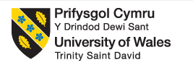
Employability report


Student Name: | Ilona Stailse
Student No: | 1922115
Module Name: | Academic and Employability Skills
Module No: | BMSW4001
Lecturer Name: | Peter Allen
Date: | August 2020

Table of content
1 Introduction. 2
2 Time management. 3
2.1 What is “Time management” 3
2.2 Effective time management 3
3 Transferable Skills 6
2.1 Transferable skills on a resume 6
2.2 What skills you bring to a table…... 7
4 How Skills Can Be Improved For Employability Whilst in Education. 8
4.1 Develop some work experience. 8
4.2 Volunteer to Develop Vital Employability Skill. 8
4.3 Clean Up Online Presence. 8
4.4 Join a Club or Society. 9
4.5 Speak to Your Careers Leader. 9
4.6 Focus on Your Studies. 9
5 What Are Employers Looking For 10
5.1 Few methods to develop your skills 10
5.2 Productive demonstration of your skills on the CV. 11
5.3 STAR Method. 11
5.4 Top skills employers look for in graduates 12
5.5 Hard skills 13
5.6 Soft Skills 13
6 My Employability Skills 14
7 Appendix 15
8 Conclusion 17
Reference list 18

1 Introduction.

This report is my summary of the article’s a brief discussion about my Employability skills.
In the very first part of my report is where you will find my interpretation of Time management. I have included extra information on how I believe Time management can be improved.
Also, you will find a summary of article about transferable skills and how to include them in your CV.
I have put together a section of discussion on how people can improve they skill set and strengthen their employability status while still studying at the same time.
This will be a very popular section of information for all students.
Finally, we will run through what employers are looking for in potential candidates for the future employment within their business infrastructure. What skills are valuable the most for them. And for better understanding I will explain types of skills and ways to develop them.
I included my own experience in this report and conclude all the sections I wrote.

2 Time management.

2.1 What is “Time management”????
The process of organizing and planning time and dividing it between
specific tasks or activities.

2.2 Effective time management only really comes down to:
When we understand what our distractions are, and how much time that is wasted on the things that are not important or non-priority.
It will then help us understand what areas need more attention or time, more time allocation planed for them

Task:
SMART Specific, Measurable, Attainable, Relevant, and Timely.
- Set goals correctly - Have a clear vision of your targets and requirement’s
Priority:
- Prioritize wisely - Know what your priorities are:
- Important and urgent: Do these tasks right away.
- Important but not urgent: Decide when to do these tasks.
- Urgent but not important: Delegate these tasks if possible.
- Not urgent and not important: Set these aside to do later.

It is important we remove or limit any time-wasting activities.

Plan:
  - Set a time limit to complete are tasks –
very imponent we know how long jobs really take.

CAPTURE REAL TIME DATA:

Only with correct and accurate time data, can we start to form a plan and even weekly job-time calendar.
This will help us to maximise are time in a much more productive and efficient way.
Achievement:
  - Take a break between finishing tasks –
When we do a lot of tasks without a break, we all find it harder to stay focused and keep motivated. So, we need to plan in some downtime between are tasks so we can keep heads clear and refresh ourselves. Things like short walks, or meditating are a couple of examples we could use. (Haughey, n.d.)

key management skills we will need to use to achieve effective time management
- Organization.
- Prioritization. ...
- Target ...
- Communication. ...
- Planning. ...
- Delegation. ...
- Stress- management.

We will understand what our distractions are, and how much time that is wasted on the things that are not important or priority. It will help us understand what areas need more attention and extra time allotted to them.
With all this correct and accurate data, we can start to form a weekly calendar. This will help us maximise are time in a much more productive and efficient way.
(Cottrell, 2019)

MANAGE = Issues and problems
FOCUS = On tasks and targets
AVOID = Distractions and interruptions
LIMIT = Loss of time.
Used well alongside key prioritising skills this is a very important tool in management. (Nahabedian, 2019)

3 Transferable Skills

Transferable skills, also known as “portable skills,”
Transferable skills are sets of skills abilities and qualities that can be applied and used in a wide variety of professions and industries.
Skills like:
Organization Communication Prioritization Integrity Management
Are just a few that employers, would for sure see a great value in.
Other strong transferable skills employers will try to source are:
Adaptability Teamwork Problem-solving Decision-making Collaboration
Transferred all of them key skills that will be very beneficial to their company and strengthening it within its industry.

Transferable skills on a resume

Business skill set relevant and transferable within employment:
Skills like these are normally picked up over time and can be moved with you from various employment. Adding new ideas and strengthening the skill you have even more.
Other jobs can help increase your skill set as can things such as charity or voluntary work even your hobbies, socializing or even just at home.
You can demonstrate your Transferable skills within a new job position.
A great way to start a working relationship to demonstrate your skill set to the new employer show him transferable skills that are incredibly valuable to his businesses.

2.2 What skills you bring to a table…...
Skill set:
Obtained from previous employment:

- Time management
- Leadership
- Prioritisation
- Delegation
- Listening
- Communication
- Research and analysis
Transferred into your business plan will bring great
improvements leading us to valuable results.

In every case when you are applying any required skills you have on to your CV, always remember it will require more information that complements the nature of that skill, and benefits’ it offers employers, and their businesses.
Giving them actual life experiences and true outcomes and achievements gained.
(Cheary, 2020)

4 How Skills Can Be Improved for Employability Whilst in Education.

4.1 Develop some work experience by getting a part time job, summertime job or a summer internship.
On the job training in a work environment, is key in helping us to gain so many of the vital skills we will need along the way, this in the industry we aim to work in would be ideal of course. Giving us understanding of the job and physical experiences will make us a much stronger candidate for employment.

4.2 Volunteer to Develop Vital Employability Skill.
Volunteering can give us benefits. That will help us gain a better understanding of what we would like to do in life. It can increase are problem solving and communication skills.

4.3 Clean Up Online Presence.
Make sure your online presence is sort out professionally because it can be checked by employer as soon as you apply for a new role. Employers would like to see you used your time and internet beneficially by creating a blog or become a freelancer. This will make a positive online presence and you can earn some money.

4.4 Join a Club or Society.
We can get a positive impact on are personal life and employability if we join a Club and we can learn teamwork and communication skills. This experience will look significant on your application and highlight if from the others. Fair at University is a best place to try to join Club or Society.

4.5 Speak to Your Careers Leader.
Plan your future! Speak to career adviser, he may guide you to your best alternatives. He can explain the options that you can choose or even provide with contacts that will suit you with your work experience.

4.6 Focus on Your Studies.
To develop your employability - concentrate on studies. Specially because fees been paid, do not waste your money. Employers focus will be on your results and level on knowledge about your given subject.
. (Hart, 2020)

5 What Are Employers Looking For

In some work positions every graduate will need certain amount of hard skills and soft skills that are transferable.
Even when a student is at entry-level but offers a solid foundation of skills that can be developed, it will still be of interest to an employer. It may be necessary to provide the employer with evidence of your ability to develop.
More so if your degree discipline was not based around this type of work.
Always read job description clearly and highlight what the requirements that the employer is looking for. And only after that edit your CV and input highlighted skills.
Even tho the skill set you have more than likely acquired will help you in achieving your dream job. Certain job roles will need potential employees to have a certain set of skills or qualifications for that industry. This could be things like knowledge of a certain software or experience of a practical skill.
Very commonly these specific qualifications will help to boost your work application to the top of the list.
There is multiple number of various methods that can help you to boost your skill set or to develop new skills, and this will not always take you as long as you expected.
5.1 Few methods to develop your skills:
- Take a course
- Volunteer
- Get some work experience
- Do an internship
- Make the most of your hobbies and interests

5.2 Productive demonstration of your skills on the CV.

Always input the exact skills that the employer is looking for from candidates.
Remember to provide only true skill related life examples.
Use the STAR method in the design layout of resume.

5.3 STAR Method.

Situation – Describe with examples your previous position held in employment include listing any of your developed skills.
Task –Give examples when your skills were of benefit in any certain situation of dealing with an issue or issues. Describe the relationship of this with the description that was listed on the application before employment
Activity – How did your achievement succeed in that situation? Was this achieved with guidance or completely from your own ability? Was this a win for the team or a win for yourself? This will highlight key skills within yourself. Also showing examples of working on your own initiative and examples of your ability to work within a team, with both resulting in achievement.
Result – How were the results achieved and how was it beneficial to the company? Was the workload better distributed due to this?
(Tonge, n.d.)

Always apply more detail rather than use clichés or buzzwords.
Provide the employer with facts about your ability and skills and how it will benefit their company.
When you input into your CV, specific skills always give accurate and true information and detailed examples.

5.4 Top skills employers look for in graduates
- Commercial awareness
- Interpersonal skill
- Time management
- Confidence
- Self-awareness
- Decision making skill
- Ability to work under pressure
- Initiative
- Leadership
- Emotional intelligence
- Creative problem solving
- Adaptability

The job you are applying for will require a certain set of skills and experiences.
A strong set of core skills will always be sort after in most industries and key skills that helps the employee to learn will always be wanted by employers as then they can grow with in their company.

5.5 Hard skills
Are specific and industrial skills for the exact job role that you can learn on the training, course, or university. Skills that you can demonstrate to the employer.
Examples:
- Programming
- Foreign language skill
- Bookkeeping
- Engineering

5.6 Soft Skills
Skills that you have developed at your place of work, home, or hobbies. They are valuable in lots of ways.
Examples:
- Communication
- Teamwork
- Problem solving
- Time management

(Rolfe, 2020)

6 My Employability Skills

When I first started on this course, I was very bad at time management. I just could not do all that was required from me in the allotted time. But after the lecture about a time management and reading a Cottrell article all about time management. I finally understood what I need to do to manage my time better.
I never realised how much time I wasted on non-important tasks.
This wasted time used better for the more important tasks that really need to be done. I was rushing myself around and wondering where the time gone. In the book I found strategies and approaches to help me manage my time.
So, with a better understanding.
I now plan my time and I feel I have more control.
Also, I realised how many skills I have. I had never really thought about it before. It felt like I do things naturally I never realised that skills like research, listening, communication you develop in your everyday life.
In next page you will be able to see appendix, there you will find my first Weekly Calendar and SWOT analysis.

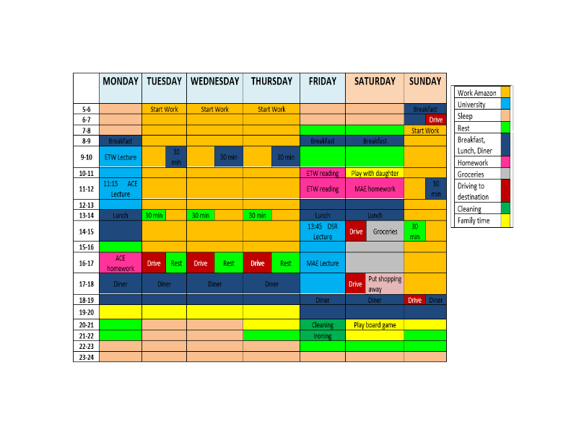

7 Appendix.
My weekly calendar:

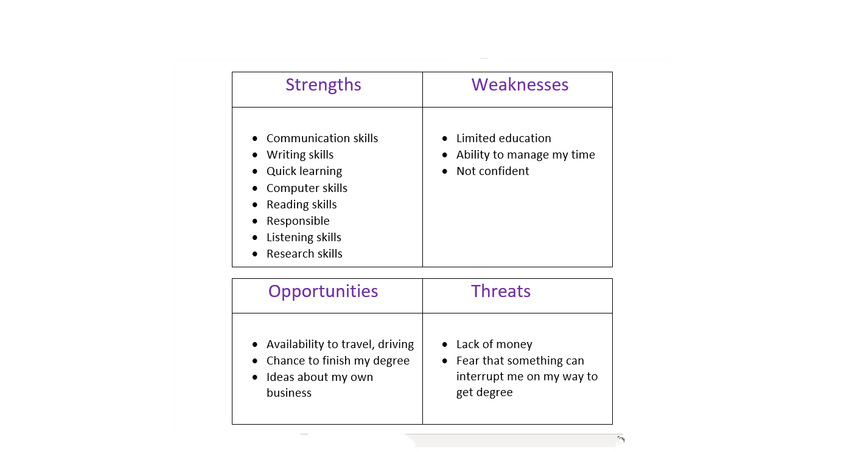
SWOT analysis:

8 Conclusion.

I conclude that in time management is important to set are goals. Plan and organize our time. Prioritize our tasks and stick to the time we allocated for certain task. Short brakes between tasks is necessary.
Another valuable conclusion is that we develop our transferable skills in everyday life, work experiences or hobbies. And they are valuable in all work positions. Also, if we include are portable skills in our work resume, we must reference them and conclude what we achieved.
Continuing we need to develop are employability by getting work experience, find a part time job or volunteer. Joining club or society also will help improve are employability. And we should remember to keep are online presence look professional.
I can conclude that resume wringing is a significative part. Where our responsibility is to Demonstrate are skills in the productive way. Giving an example of are true live situation where we used our skills and explain how we dealt with the situation. We may tell about the result and what the company gain by your result.

Reference list

Cheary, M.,(2020) What are transferable skills?. [Online]
Available at: https://www.reed.co.uk/career-advice/what-are-transferable-skills/
[Accessed 14 August 2020].
Cottrell, S.,(2019) Time menagment. In: The Study Skills Handbook. 5th ed. London: Red Globe Press, pp. 121-150.
Hart, R., (2020) Six Ways to Improve Your Employability While Studying. [Online]
Available at: https://blog.springpod.co.uk/improve-your-employability-while-studying/
[Accessed 17 August 2020].
Haughey, D., (n.d.) SMART Goals. [Online]
Available at: https://www.projectsmart.co.uk/smart-goals.php
[Accessed 20 August 2020].
Nahabedian, M., (2019) 10 Tips for Managing Time Effectively. [Online]
Available at: https://www.projectsmart.co.uk/10-tips-for-managing-time-effectively.ph
[Accessed 14 August 2020].
Rolfe, A., (2020) Graduate skills – what are employers looking for?. [Online]
Available at: https://www.reed.co.uk/career-advice/graduate-skills-what-are-employers-looking-for/
[Accessed 22 August 2020].
Tonge, L., (n.d.CV Preparation Using the STAR Method. [Online]
Available at: https://www.thecvstore.net/blog/cv-star-method/
[Accessed 21 August 2020].

