Exercises for Random Numbers

1. Guess my number

1a. Generate a random number and invite the user to guess what it is (use variable myGuess). Tell the user if they got it right or not.

Sample output:

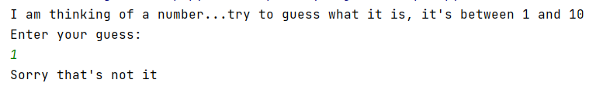

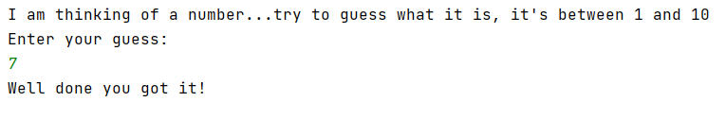

Solution:

import random
myrand = random.randint(1,10)
print("I am thinking of a number...try to guess what it is, it's between 1 and 10")
print("Enter your guess:")
myGuess = int(input())
if myGuess == myrand:
print("Well done you got it!")
else:
print("Sorry that's not it")

2. Jackpot game

2a. Write a program that generates a lucky number for the user (between 1 and 10). There is a prize associated with each number. 5 = Jackpot, 3,4,6,7 = consolation prize, everything else = no prize. Inform the user of their prize.

Sample output:

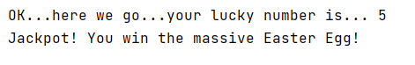.

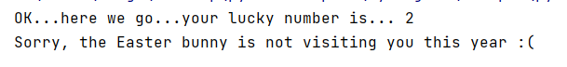

Solution:

import random
luckyNo = random.randint(1, 10)
print("OK...here we go...your lucky number is...", luckyNo)
if luckyNo == 5:
print('Jackpot! You win the massive Easter Egg!')
elif luckyNo >= 3 and luckyNo <= 7:
print("Not quite the jackpot, but you still win a packet of Cadbury's Mini Eggs!")
else:
print("Sorry, the Easter bunny is not visiting you this year :(")

2b. Extend your game to allow the user to choose whether they want to play or not.

Sample output:

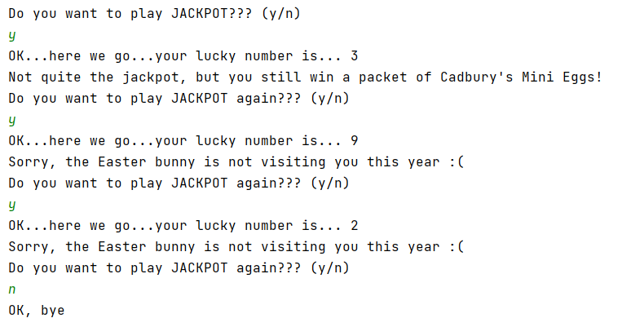

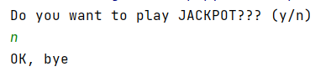

Solution:
import random
print("Do you want to play JACKPOT??? (y/n)")
choice = input()
while choice == 'y':
luckyNo = random.randint(1, 10)
print("OK...here we go...your lucky number is...", luckyNo)
if luckyNo == 5:
print('Jackpot! You win the massive Easter Egg!')
elif luckyNo >= 3 and luckyNo <= 7:
print("Not quite the jackpot, but you still win a packet of Cadbury's Mini Eggs!")
else:
print("Sorry, the Easter bunny is not visiting you this year :(")
print("Do you want to play JACKPOT again??? (y/n)")
choice = input()
print("OK, bye")

3. "Fruit" machine

3a) Generate 3 random numbers, each in the range 1 and 3.

Tell the user whether they have won (all numbers equal) or not.

Sample output:

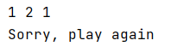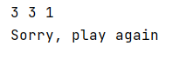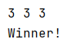

Solution:

import random
number1 = random.randint(1, 3)
number2 = random.randint(1, 3)
number3 = random.randint(1, 3)
print(number1, number2, number3)
if number1 == number2 and number2 == number3:
print("Winner!")
else:
print("Sorry, play again")

4. Lottery numbers

4a. Generate 6 lottery numbers (you could store these in individual variables, or in a list) Print your lottery numbers on the screen

Sample output:

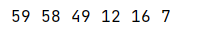

Note: Run the program a few times and you will see that there duplicates appear sometimes.

Solution:

import random
myLott = []
for counter in range(0, 6):
myLott.append(random.randint(1, 59))
for nextLott in myLott:
print(nextLott, end=" ")

4b Sort your lottery numbers into order. Providing you have used a list in 4a) above, this is quite easy by using the sorted() function.
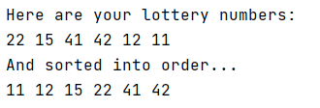

Solution:
import random
myLott = []
for counter in range(0, 6):
myLott.append(random.randint(1, 59))
print("Here are your lottery numbers:")
for nextLott in myLott:
print(nextLott, end=" ")
myLott = sorted(myLott)
print("And sorted into order...")
for nextLott in myLott:
print(nextLott, end=" ")

