EFFECTIVE TEAM WORKING AND COMMUNICATION
Academic Report

Assignment :1
Module Name: BMSW4002
Lecturer Name: Timothy Hopkins

Student Name: Svetla Markova 1908349
Group 1
Table of Contents

- Introduction …………………………………………………………………………3
- Effective Communication in Business Organization …….…….………………….3/4
- Relevant Theory ……………………………………………………………………4/5
  - Shannon and Weaver
  - Wilbur Schramm
  - David Berlo
- Importance of effective communication …………………………………………6
- How to improve the situation on my workplace …………………………….......6/7
- Methods of communication.……………………………………………………....7
  - Verbal communication
  - Written communication
  - Oral communication
  - Non-verbal communication
- How communication works between management and employee……………….7
- Conclusion……………………………………………………………………….8/9
- List of References……………………………………………………………......10
- Appendixes………………………………………………………………..11/12/13

Introduction
Communication is among the most pivotal tenets in the management of teams and organizations. As a discipline, it complements management and is an essential element in business success. According to Lunenburg (2010), communication is the process of transmitting information and general understanding from one person to another. The term is obtained from the Latin word communis, which means common. In other words, a common understanding is achieved through sharing and exchanging information. From a management standpoint, communication refers to the process through which people get acquainted and instructed towards achieving the best results (Bucata and Rizescu 2017). A manager employs effective communication practices to inform, guide, and coordinate business activities as well as in making and implementing decisions. The aspect of effective communication entails placing one’s thoughts in an ordered manner and presenting them in an accessible way as to capture the receiver’s attention. A review of the role played by communication in organizational management, with a particular focus on the relevant theories and methods, reveals that for effective communication, the choice of words, tone, appearance, and body language ought to match the message being conveyed.
Effective Communication in Business Organizations
Characteristically, effective communication is a two-way process. Therefore, the sender and receiver need to try and be appropriately skilled to interact with each other. An organization's management generally assumes either roles at certain points in the communication process. In a business organization, communication can be made more effective by first recognizing both environmental and personal barriers. The environmental obstacles can be overcome by attentively observing the message and devoting adequate time to listen to it. Furthermore, adapting and encouraging a free flow of conversation within an organization fosters effective communication. Reducing the hierarchical links between the sender and receiver neutralizes the chances of message distortion. In addition, restrictions caused by relative status or power, of the sender with respect to the receiver, can be minimized through conscious tailoring of words and symbols to make messages more understandable and by complementing one’s words with actions. Personal barriers that hinder effective communication can be addressed through concerted efforts of the sender and receiver to understand and adapt to the other party’s beliefs and ideals. Once these barriers are eliminated, effective communication is guaranteed between the two parties.
The sender and receiver have a major role to play in effective communication. Senders can enhance the effectiveness of their message through several efforts, including systematically analyzing the information to be delivered to ensure clarity before presenting it. Senders should also understand the purpose of each message. They ought to identify the goal of the communication and then customize their language, tone, and approach to serve the intended purpose. Additionally, senders should consider the overall human and physical setting in which they are communicating, including the circumstances, social climate, customs and practices, and expectations of their audiences to effectively adapt the message to the environment. A follow up is essential to know whether the information was received and understood as intended. Furthermore, high-ranked senders such as team leaders should match their words with corresponding actions. A contradiction in actions and attitude may distort a receiver’s understanding of the message. It is also important to note that the ability to send is as equally important as the ability to receive messages. Thus, effective listening skills can significantly enhance the communication process. Receivers should cease talking, show interest in listening, eliminate distractions, have patience, hold their temper, and ask questions when in doubt (Adu-Oppong and Agyin-Birikorang 2014). These practices not only help in understanding the message but also in achieving effective communication.
Relevant Communication Theories
Shannon and Weaver model of communication. Claude Shannon and Warren Weaver of Bell Laboratories were among the first innovators of a major communication model. Their prototype provided a foundation upon which other researchers developed and advanced new communication patterns. The Shannon and Weaver Model of Communication is characterized by linearity (a linear process), simplicity, semantic — easily identifiable content but difficult to solve, a dominant source that is impactful in decision-making, and noise as a disturbing factor. It outlines the flow of information through a medium and can be applied to the systems it maps. The transmission commences at the transmitter that sends a message to a receiver through a medium. The model is based on the theory that communication within a medium is direct and unidirectional. In comparison, however, communication in real-world media is hardly unidirectional and is often indirect (Amudavalli 2011). Notably, the Shannon and Weaver communication theory also considers the way information increases or decreases the entropy — the degree of uncertainty within a given system. As an extension of this view, the theory defines information as a reduction of uncertainty. Essential concern is on the level of uncertainty or noise that can be withstood in any transmission before regarding the message to be sent as inaccurate.
Wilbur Schramm – the circular model of communication. This model was developed and advanced by Wilbur Schramm and Osgood in 1954 to correct the linear communication models of the time. Notably, each party acts as both the sender and receiver. Communication, including encoding, interpreting, and decoding, coincides. According to Schramm, communication is an endless process that does not start and end at a given point (Amudavalli 2011). The sender and receiver reciprocate in similar roles throughout the communication process with noises being barriers to comprehension. Understanding, as a process varies, widely from one individual to another due to the differences in the degree of semantics noise such as beliefs and cultural differences, values, education, background, and socioeconomics, among other factors (Amudavalli 2011). The model offers several advantages for efficacious communication. Firstly, it is dynamic and caters for redundancy. Secondly, the sender and receiver are the same persons, and feedback is integrated into the process. Essentially, the model recognizes communication as circular in nature. However, a major setback is that the model does not consider semantic noise but assumes it during encoding and decoding.
David Berlo model of communication. Berlo’s model, developed in 1960, is among the most famous communication principles. Berlo emphasizes the relationship between the sender and the receiver, whereby both need to be well equipped with communication skills so that the message can be properly encoded and decoded. The model insists that optimum communication can be achieved only when the two parties are skilled. The sender and receiver have to be on the same level. For instance, in case the sender or source has excellent communication skills, the receiver should also have equally good listening skills, or the message may not be communicated correctly (Berlo’s SMCR Model of Communication n.d.). This model of communication consists of four main components: source, message, channel, and receiver- each with its sub-elements. The prototype, however, faces several criticisms because of several drawbacks. Firstly, it lacks feedback to account for barriers to communication such as noise. Secondly, Berlo’s model is overly complex for efficient communication. Another issue is that the model being linear, the sender and the receiver are required to be on the same level, which might be impractical in real-life. Lastly, it also omits of usage of the sixth sense, which is an important asset to people’s thinking, understanding, and analyzing for effective communication.
Importance of Effective Communication
Effective communication in the workplace is a critical element for business success. Firstly, effective communication, coupled with honesty, can greatly strengthen team bonds. Secondly, consultation and providing feedback among team members fosters a collaborative workspace. Additionally, communication ensures the involvement of all team members, thus making them feel included and useful. Thirdly, great communication increases innovation due to an open line of dialogue between the management and their subordinates at a company. Specifically, this open interaction encourages team members to be more innovative and offer newer and more creative ideas. Overall, effective communication builds and enhances relationships internally within the company and with external parties such as clients, and boosts employee engagement, thus improving the overall effectiveness of a team or unit.
How to Improve the Situation at my Workplace
Currently, I am privileged to work as a waitress at a large hotel in a team of three, with more casual workers joining during peak seasons. My primary tasks include handling meetings and conferences, particularly preparing breakfast, lunch, and coffee breaks. The hotel’s department manager provides a daily plan comprising of the day's tasks for different rooms. Unfortunately, there have been several occasions where the event manager in charge of a function provides wrong information on the plan sheets, including timing, number of people, and other essential details. Therefore, problems arise with the organizers and customers who issue complaints about the planning. As such, miscommunication, especially wrong information, is a significant hindrance to my performing a better job and an instigator of unhappy customers at my workplace.
Personal experiences and observations of various workplaces reveal elements of excellent communication that bears success or gaps in the interaction that leads to failure. Business organizations can improve communication and teamwork through various approaches. In this context, the situation at my workplace can be improved through consultation between the event manager and the meetings and conference department. Since we comprise the staff implementing the planned tasks at the clients’ end, our feedback, coupled with proper confirmation of event details, is critical to effective execution.
Additionally, inclusion is a key determinant in communication, and all team members need to be equally involved in the process. Secondly, offering a listening ear and showing empathy is essential. Since communication is a two-way process, listening and encouraging dialogue show respect and provide a chance to solve unfamiliar challenges. Furthermore, defining goals and expectations provides a clear and accessible path for individuals and teams to follow through. Importantly, the message should be sent clearly and through an accessible medium.
Methods of Communication
Verbal communication. It is the most common method of communication. It involves exchanging ideas and information through words. This exchange can be face-to-face, in group, meetings, or over the phone, where the message is transmitted through oral means. An example of verbal communication is a simple talk between two or more people. The one-on-one form of verbal communication offers the advantage of obtaining immediate feedback and evaluating the response through observation of body language. Major types of verbal communication include written and oral conversation.
Written communication. Written communication has been the formal means of interaction within businesses for centuries. Generally, it comprises of conventional paper and pen, emails, reports, electronic documents, and other forms that can be relayed through written symbols such as language. This method of communication is mostly used in preparing formal business reports, handbooks, contacts, and memos. Its effectiveness is dependent on the clarity of writing, grammar, and the choice of vocabulary.
Oral communication. This method involves the spoken word. It can take place through phone, one-on-one, videoconferencing, or any other medium. It is applied in both formal communication scenarios such as lectures and informal ones like gossiping. Volume, pitch, voice variations, the speed of speaking, and clarity influences its effectiveness.
Non-Verbal communication. It involves sending and receiving messages through body language cues such as eye contact, body posture, tone, touch, facial expressions, and other movements. All these gestures convey a particular message to the recipient. Facial expressions are the most common forms of non-verbal communication, where, for example, a smile or a frown can indicate emotions which are difficult to convey through verbal communication.
The effectiveness of non-verbal communication significantly depends on the way the message is delivered. The speaking style, emotion, tone, intonation, and voice quality — essentially, paralanguage can either portray approval, interest, or lack thereof. Other forms of non-verbal communication include aesthetic communication (dancing or painting), appearance (grooming and dressing), space language, and symbols.
How Communication Works Between Management and Employees and to What Purpose? Tone /Choice of Language/Level of Formality
The management, particularly managers and supervisors, conduct administrative functions, including organization, control, staffing, planning, and leading. These activities need constant interaction with employees. Moreover, effective communication leads to more efficiency, productivity, and help establish a conducive work environment. Therefore, the management and employees should communicate regularly through less tedious approaches, such as meetings, once in a while, and more online or email correspondence should be encouraged. The administration can adopt employees' preferred communications forms to establish a reliable conversation routine. Additionally, the management should make efforts to remove formality barriers through friendly ways of soliciting feedback. This fosters two-way communication and shows employees that their ideas are valued while giving the management new insights. It also provides a platform for employees to air their suggestions and complaints. Both parties, the company management and the employees, should listen keenly. Listening is as important a communication skill as speaking and writing to facilitate effective communication. A listening management makes employees more comfortable to open up and communicate, thus improving the workspace. Moreover, the managers ought to be mindful of the communication styles they use, including non-verbal communication cues and tone because the choice of style indicates their interest, openness, and willingness to communicate.
Conclusion
Communication is a core element for the success of a business organization. It is the exchange of ideas and information either verbally, non-verbally, or both. More importantly, effective communication is critical for optimum performance and efficiency. The most common and relevant communication models include Shannon and Weaver Model, David Berlo Model, and Wilbur Schramm’s Circular Model. Notably, while the former models lack feedback, the latter third model has feedback. Overall, to achieve effective communication, it is paramount for one to match the tone, appearance, and body language with the message. Therefore, companies should strive to educate their workforce, especially the higher management, on proper communication techniques to improve productivity and eliminate instances of miscommunication.

List of References
Adu-Oppong, AA & Agyin-Birikorang, E 2014, ‘Communication in the workplace: Guidelines for improving effectiveness’, Global Journal of Commerce & Management Perspective, vol. 3(5), pp. 208-213.
Amudavalli, A 2011, ‘Theories & models of communication’, Department of Library & Information Science: University of Madras. Available from: <epgp.inflibnet.ac.in/epgpdata/uploads/epgp_content/library_and_information_science/knowledge_society/05._theories_and_models_of_communication/et/4305_et_et.pdf.> [01 December 2019].
Berlo’s SMCR Model of Communication, Communication Theory. Available from: <www.communicationtheory.org/berlos-smcr-model-of-communication/> [01 December 2019].
Bucata, G & Rizescu, AM 2017, ‘The role of communication in enhancing work effectiveness of an organization’, Land Forces Academy Review, vol. 22 (1), pp. 49-57.
Lunenburg, FC 2010, ‘Communication: The process, barriers, and improving effectiveness’, Schooling, vol. 1(1), pp.1-11.

Appendixes
Exercise1
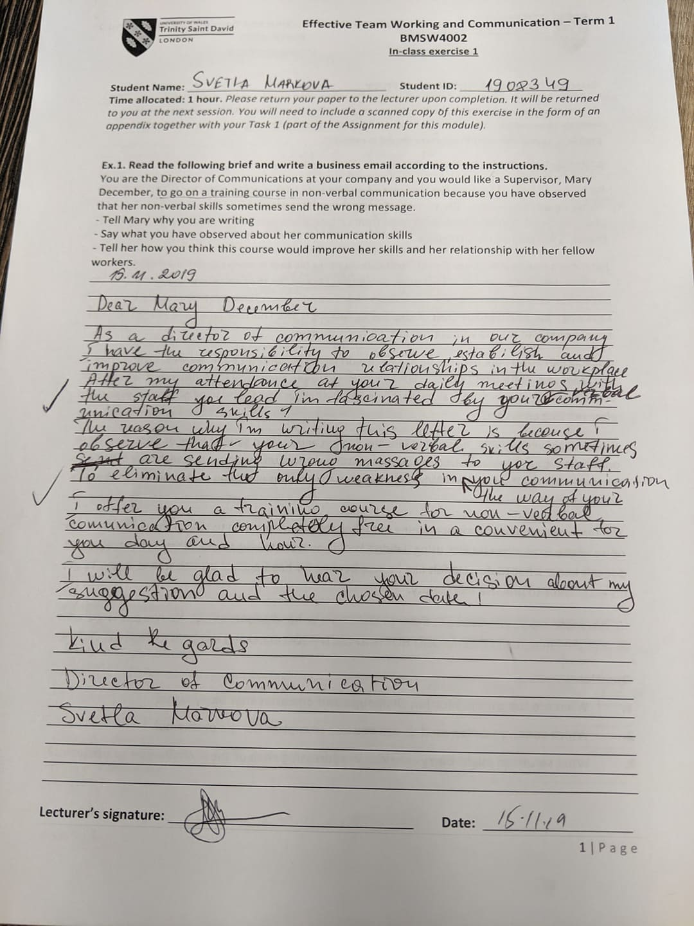
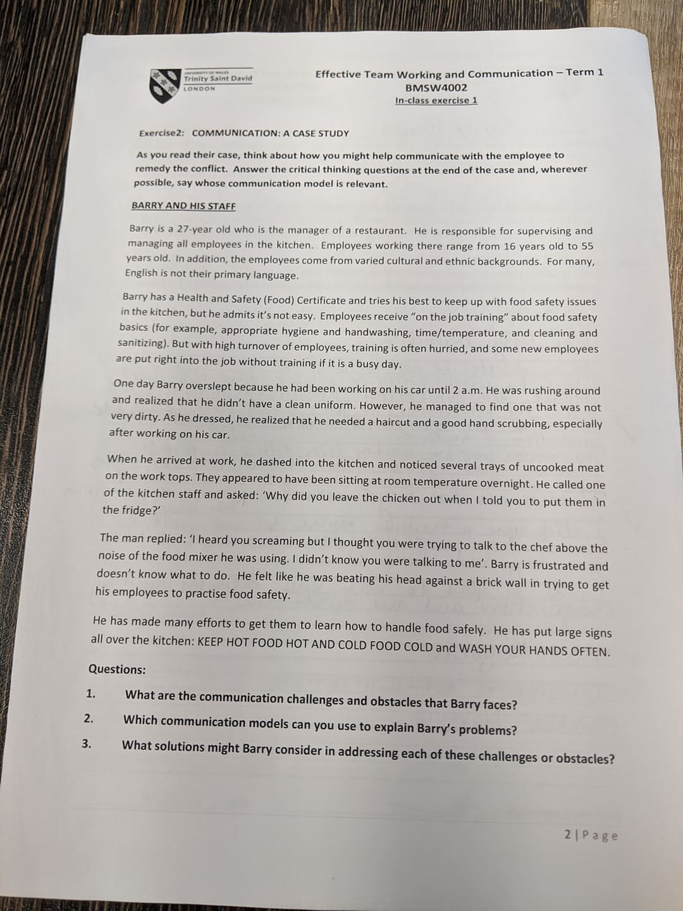
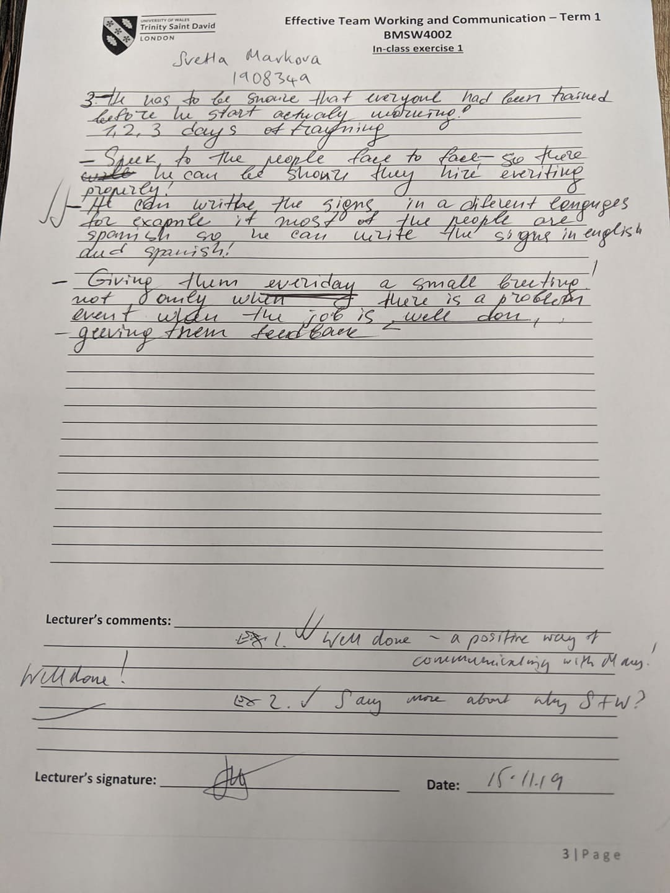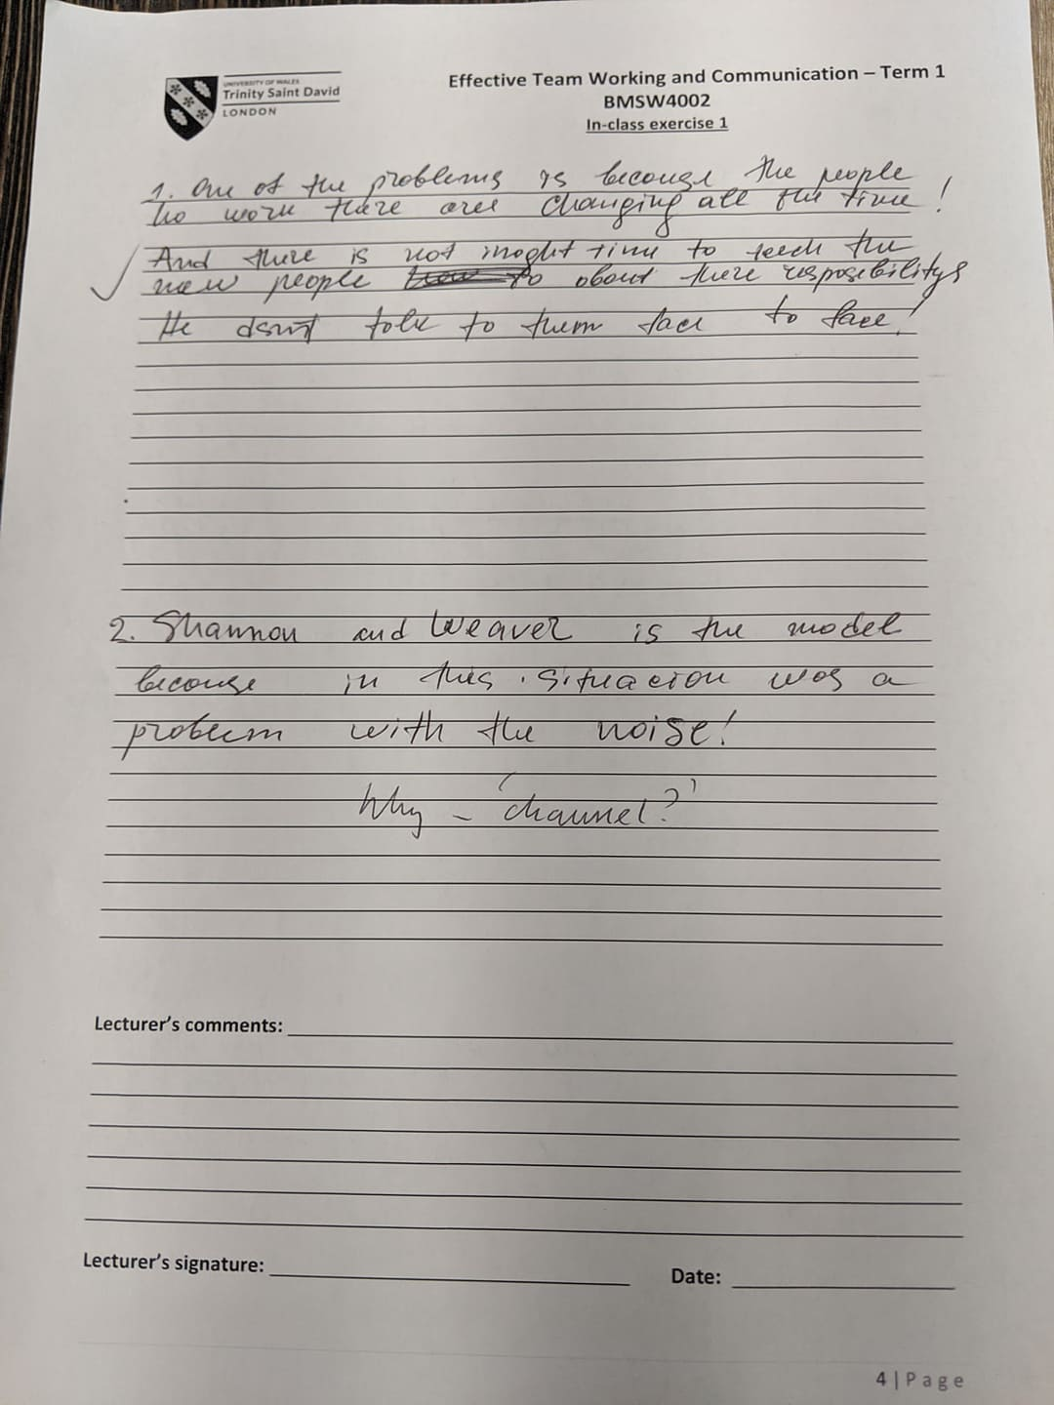
Exercise2


