introduction
This academic paper is discussing childhood. There will be an analysis of what childhood is and what s the word Children means. The analysis will be presented and supported by an overview of the historical construction of childhood and the changes that childhood meaning has a social construction in the past time in the United Kingdom. By analysing the past, the factors will be evaluated and discussed with the aim to highlight the improvement made till the current time. When the current time is described, theories and models of intervention will examine the background of the social construction.
Childhood
Childhood is influenced by different conceptions of what means to be a child. Various definitions and perspectives can be seen: according to the United Nations Convention on the Rights of the Child (uncrc) a child is someone under 18 years of age. To the Child support Act 1991 section 55, a child is “a young person between the ages of 0 and 16 or under the age of 19 and enrolled in a full-time educational program” (Kheily, 2013). Any human being that hasn’t reached the adult stage is referred to as a child. Childhood and children are subjected to the effect of social, biological, cultural, and legal factors during the present and past times. There is no universally agreed definition of childhood as there are different conditions that apply to the terms. “Socio-political constructs” is what Steve Wagg refers to when he describes childhood as social construction: “Circumstances that shape lives are socially built.” (Wagg, 1992). Wagg declares that childhood is constructed by a certain culture, specific period, and locations and by specific legislation dictate by the origins of beliefs of the populations. Because childhood is not just influenced by a biological factor, there is no universal terminology applicable to every human. According to Mcdowall-Clark, children are seen as the social and psychological issues by the family needs, bonding, and material deprivation. Family is the nuclear situation where childhood gets constructed, but the factor that influences childhood are various politics, socio-economical, culture and based on lifestyle. Is quite common to evidence the difference between childhoods by looking, for example, at the different ages of children's marriage or the children's work duties: in the Uk work is allowed just for over 16. While in a country like Bolivia, children can start their job career at the age of 10. The same is happening with children's marriage: in Yemen is believed that the children are ready to be married by the age of 9, but according to Human Rights Watch (HRW) the minimum age should be 15.

key elements of family life
According to Mondal family “is an intimate domestic group made up of people related to one another by bonds of blood, sexual mating, or legal ties. It is the smallest and most basic social unit, which is also the most important primary group found in any society.” (Mondal,2021)
the purpose of the family Is to maintain the well-being of the individuals and is the primary step of socialisation for children. The family also functions as cultural transmission. The concept of family has always existed but has changed during the era.
The first conception of the family was based on a biological factor: a father and a mother and their respective biological children. The social-economic factors and the lifestyle change have affected the social construction of the family: women start to work, divorce becomes legal, adoption and fostering become a reality. Now there are different types of settings that are considered family, such as a single-parent family, blended family, extended family, the chosen family, just to mention some.
The family normally has key elements that have universal characteristics such as mutual respect, offering emotional support, providing basic needs and cooperation in a unique entity.
History of childhood
Before 1970 there was not much written about childhood, and the primary discussions were more related to the right to be called children and their universal definition seek. (Aries, 2013).
Since the ancient roman children were used as a workforce the child was considered an adult from age 12 for women and 14 for men. Gordian III, that governs from 238 to 244, became a king at the age of 13.
During the medieval ages, children were employed in the family business or were recommended to relatives or friends with the aim to help the household economy. According to Hedegaard, “the interconnection of employment, residences, home labour demands, subsidies comprise the family economics” (Hedergaard, 2020)
By looking at the UK, is necessary to mention the industrial revolution era. Great Britain became industrialised in 1760. child labour become a political and social issue because of the high demand of industrial bodies, and it officially becomes the first country to highlight childhood as a social construction problem (Adekundle,2022). Children's inactivity was considered an issue, but their exploitation wasn’t. The textile industry employed a considerable number of the youngster, according to Cruikshank (Cruikshank, 0000). The industrial revolution was one of the factors in children's inequality improvement: because Uk had a high improvement in living standards, children started to receive home education with the mother supervising the house while the husband was in the factory (Sterns, 2020).
In the Victorian era, Queen Victoria was the one who reign Uk. The era is characterised by population growth and continuous industrial sector development. Children were working as coal miners, chimney sweeps or on farms (Dickens, 2022). Also, many of them were railway workers, despite the heavy-duty involvement.
If we think about the childlike in a Locke perspective, like a “tabula rasa” (children learn by surrounding as they are born with no knowledge), it can be said that the social construction is easily malleable, and childhood is influenced negatively by the surrounding environment.
According to Rousseau, children are born innocent (as opposite where Hobbe’s belief that children were born with an evil nature) (Russeau, 2017). Rousseau also thought that if individuals are allowed to grow organically, without the restrain put out by society, they would develop their most educational and moral potential.
Policy and Legislation
In the industrial period, child labour becomes a concern due to the lack of regulations on working conditions. Many children were armed, and the government was persuaded by the economic growth rather than enhance the children's protection. It was common practice to put children in mines for 12 to 18 hours a day with little air or space (Walker, 2013). This automatically causes a rise in catastrophes and deaths. An organisation was created with the aim of children's protection in 1875 in the USA (Antoniu et al, 2012). The protection was then reinforced with the introduction of mandatory education in 1880(Education Act) and the restriction of child labour.
In UK, NHS improve the lifestyle of children by the increase of free services and decrease drastically the mortality rate. The protection against children from cruelty law arrived in UK in 1880. The first children Act was recorded in 1948, and the care and protection of vulnerable children were one of the key points of the legislation. The first time that neglect has recognised as a crime was in 1973 with the revised Children act 1975 (NSCPP, 2021), after the death of a 7-year-old girl, killed by her stepfather.
The children act has been revised and tailored in 1975, 1989 and 2004, introducing every time more strict and appropriate rules for children's safety.
One of the biggest steps toward the recognition of the children was the “convention on the right of the child” (UNCR), where the children have gained a voice in society with a new concept of the “right of the child”. All children differ in ability, religion, colour, culture, social, political, economic, and civil, but every one of them have to gain the protection of the government in aim to satisfy their necessities and their basic needs. (Goldfield and Hayes,2012) They have the right to life, survival, and growth. They need support to gain their full potential and be safeguarded from abuse, violence, exploitation, and neglect. In 2000 the convention also banned children in the military (considered now a war crime) and the illegality of children prostitution (Morrison et al. 2016).
The laws are made to protect the childhood period from the arm. It should be mentioned that welfare and stability at an early age have consequently a better future and a more productive development. According to numerous studies conducted by the neuroscientist, early-stage traumas and problems are affecting the children's development and their experience.” By 3 years of age, a baby’s brain has reached almost 90 per cent of its adult size. The growth in each region of the brain largely depends on receiving stimulation, which spurs activity in that region. This stimulation provides the foundation for learning.” (Child Welfare, 2015). The child in the early stage will acknowledge and experience situations that could affect his well-being dramatically.
Because of all these factors, modern society invests in children considerably: government funds are invested in educational and sociological growth, the Nhs and the Department of Health are protecting them on the health and safety sides, and the parent are seeking constantly new methods and approaches to develop the children potential.
Bronfenbrenner s ecological model
The theorist creates an idea of the socio-cultural development model to analyse the background of childhood. “Children are defined as growing and dynamic entities that move within the environment and change the environment”. (Fullerton et al., 2017).In 1979 he create the “ecological model of infancy: “This theory explains human development as the result of nested relationships between the individual and family, friends, schools, neighbourhoods, society, and the period in which the individual lived”(Fullerton et al., 2017). According to Bronfenbrenner ecology is the study of an individual’s environment, that get influenced by another environmental system, like the socioeconomic and cultural (Bronfenbrenner, 2017).
According to the professor, childhood is structured in 4 systems:
The microsystems are the child household and close influences are where the main child influences are taking place.
The mesosystem is the system where two microsystems are meeting and interacting: for example, a teacher meets the child's parents. According to him, is critical to have an exceptional connection between systems.
The exosystem is the part that influences the child indirectly, as the child doesn’t take part but take the impact of it: for example, the parent-child job place, the health practices, and the local communities. The child will get an indirect influence.
The macrosystem is defined as the nation's condition, such as laws, culture and economic factors that can impact childhood. The macrosystem contributes to developing the values and vision of the child.
The chronosystem, at last, deal with the socio-historical circumstances: how the social aspect is expressed in that particular era. For example, is considered a norm now having children’s longer hours in childcare settings: this is because the social role of the woman and the economical factor has changed in this epoch. (Perron, 2017)
Maslow theory
Maslow ideate a theory that is based on satisfaction requirement to drive people’s behaviour. The theorist believes in a pyramid scheme: at the base of the pyramid, there is the basic need of every human being, while at the top there is the most complicated demand for a person to achieve. The ultimate aim is self-actualization, where individuals become the best version of themselves.
The pyramid describes the different stages of achievement:
The first stage is the physiological need: air, water, food, sleep and all the basic need that an individual needs to survive.
Once the physiological need is achieved, the individuals can achieve their safety level: the primary essential aspect of well-being and safety. Getting a job, obtaining a house, saving money is all factor that can contribute to achieving safety and stability.
The third level is considered the love and acceptance level: human conduct is driven by an emotional connection of necessity with others. Romantic bonds, families, social groups, community and friendship are the things that meet the achievement and the realisation on this level (Mata-Mcmahon et al., 2018).
The fourth level is described as self-esteem, they want recognition. At this level, the human being has achieved the stability necessary to focus on their personal development as the individual will not be worried about lacking further necessities. Self- actualisation, as Maslow define it, is “the full application and exploitation of skills, capacities and potentialities”. (Maslow,1943)
Current Interventions and approaches to help children and different families
The intervention of the governments and other organisations is vital to protect the human being and to assure them of the basic needs they need to reach their full potential.
In Uk, the safety and promotion of the nation’s health and well-being resulted in the creation of Public Health England. The approaches are in the application of science, research, multi-agencies services to deliver the best solution possible and tailored for every human (Annan, 2018).
The social aspect in Uk is covered by the Department of Health and social care, which actively work with the NHS (National Health System) and other authorities.
NHS is the whole entity created to give health and well-being practical support.
All this organisation works together or alongside to prevent and safeguard all the factor of the vulnerability of the children. Their intervention varies, but they all work intending to avoid children's trauma
The interventions are divided into 3 lines of intervention: the universal, the targeted and the specialists.
The universal interventions are “services which all families can access without needing any extra support or resources. Universal services are provided by a range of different agencies, including health and education. Health visitors, GPs and school nurses are all examples of universal services as are leisure centres and parks in the community.” ( London Borough of Bromley, 2022). examples of the work to reduce the socio-economic gap are universal free health services and free education from the age of 3.
The targeted interventions are present when “concerns are emerging and who may require additional support usually provided by professionals already involved with them as a single agency response, they may also require multi-agency support to meet their additional needs. This may relate to their health, development, social skills or education (Gloucestershire County council, 2022). Examples of specific intervention can be seen in a school counselling setting or the free school meals offered up to year 1.
Specialistic intervention is necessary when the needs are multiple or more serious.
Specialistic interventions are divided into tiers (lower lever 3, upper level 3 and tier 4) and based on the level of the factor of the vulnerability of the child. In this level multiagency, referral and strategic plans, like the Common Assessment Framework (CAF), are vital.

Conclusion
It can be said that Children and young people that get early intervention have a better chance of acquiring the stability and the skills to achieve success, well-being and fulfilling lives. Parenting intervention and support now are a reality and they give the opportunity to better understand children's needs. For example, when a child has a disability or is been through an adoption process, the parental specific intervention could be very beneficial. Is believed that a community-based approach to prevention emphasizes the importance of building situations where the necessary conditions are in place to help children develop and create self-esteem in future adulthood.
Poverty and social neglect, in my opinion, should be one of the main targets for an intervention with the aim to ensure a better lifestyle and a social-integrated fit with the environment. Recognition of every child's right is essential, and the government should keep guaranteeing accessibility to this right to every child.

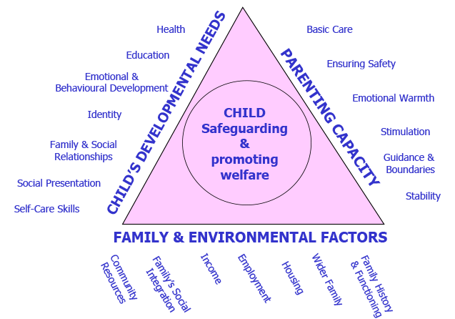

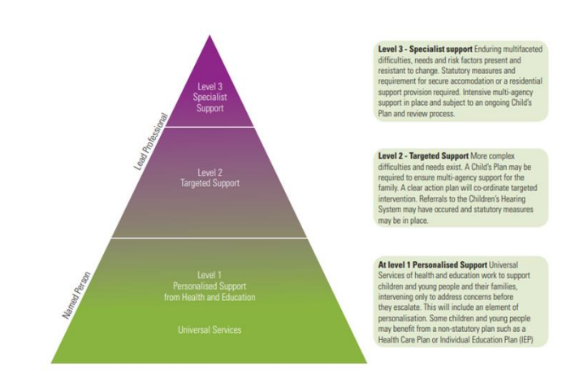
Aberdeen

https://www.yourarticlelibrary.com/speech/family-meaning-characteristics-function-and-types/34966

https://citeseerx.ist.psu.edu/viewdoc/download?doi=10.1.1.474.5887&rep=rep1&type=pdf#page=163
https://learning.nspcc.org.uk/child-protection-system/history-of-child-protection-in-the-uk
https://www.childwelfare.gov/pubpdfs/brain_development.pdf
https://books.google.co.uk/books?id=CuIeWIjfTkUC&printsec=frontcover&hl=it&source=gbs_ge_summary_r&cad=0#v=onepage&q&f=false
https://www.assessmentpsychologyboard.org/edp/pdf/Urie_Bronfenbrenner.pdf
https://www.childandfamilytraining.org.uk/98/Introduction-to-the-Hope-for-Children-and-Family-Intervention-Resources
https://gloucestershirechildcare.proceduresonline.com/images/windscreen_need.png

https://www.bromley.gov.uk/info/10122/children_and_young_adults_with_disabilities_and_learning_needs/1260/short_breaks_for_disabled_children_and_young_people_and_their_carers/3
https://search.informit.org/doi/pdf/10.3316/informit.627943485395629

