

Subject: Strategic Management
Subject Code: LCMB7003

Student name: Sachin Ashokbhai Japi
Student ID: 2430819

Term-2

Lecturer: Dr. Andry Rakotovololona

Strategic Expansion of Mahindra & Mahindra’s Electric Vehicle Business into the United States Market: An Integrated Strategic Management Analysis

Table of Content
1. Introduction 3
2. Organisation and Target Market Choice. 4
2.1 Mahindra and Mahindra Company Overview. 4
2.2 Target Market Choice: United States. 5
2.3 Strategic Justification of Market Selection. 6
3. General Strategic Analysis. 6
3.1 PESTLE Analysis of the United States Electric Vehicle (EV) Market 6
3.2: Porter’s Five Forces – US Electric Vehicle (EV) Industry 8
3.3: VRIO Analysis of Mahindra & Mahindra 8
Table 3.4: Porter’s Diamond Model – US EV Market Conditions 9
3.5 Critical Analysis of Strategic Tools 10
4. Strategy Development and Formulation. 11
4.1 Matrix of the Ansoff Growth Direction in expanding to the US. 11
Table 4.1: Ansoff’s Matrix Application for Mahindra’s EV Strategy 12
4.2 Generic Competitive Strategy of Porter. 12
Table 4.2: Porter’s Generic Strategy for Mahindra EVs 13
4.3 Market Entry Strategy 13
Table 4.3: Evaluation of Market Entry Modes 14
4.4 BCG Matrix – Strategic Positioning of Mahindra’s EV Portfolio 14
Table 4.4: BCG Matrix Classification of Mahindra’s EV Business 15
4.5 CSR and Sustainability Strategy 15
4.6 Risk Analysis 16
5. Performance Evaluation Framework 17
5.1 Balanced Scorecard Framework. 17
5.1.1 Financial Perspective 17
5.1.2 Customer Perspective 18
5.1.3 Internal Business Processes Perspective. 19
5.1.4 Learning and Growth Perspective. 19
5.2 Triple Bottom Line (TBL) Integration. 20
5.3 KPI Measurement and Financial Reporting. 20
6. Discussion and Strategic Integration 21
7. Conclusion 22

1. Introduction
In case of international expansion, firms are able to access new markets, enjoy economies of scale, diversify risks and position themselves better. Nevertheless, the trade protectionism, tariff changes, and economic instability is increasingly becoming a factor in global business operations, especially in such major economies as the United States and the European Union (VanGrasstek, 2021; Contractor, 2025). These difficulties were heightened by the COVID-19 pandemic that disrupted supply chains all over the world and increased the pace of digital and technological transformation in industries (Free and Hecimovic, 2021).
Financial markets too have undergone structural changes, and equity markets have been growing very well, as a result of technological development, and investor belief in new sectors (Morhachov et al., 2022). The concept of sustainability, environmental responsibility, and climate adaptation has become an inseparable part of strategic decision-making, especially in industries that are characterized by a high ratio of manufacturing (Chu et al., 2022; Karner, 2021).
The Electric Vehicle (EV) business has become a major force of industry change in the global arena, with strong environmental demands, government policy subsidies, and accelerated technological advancement (Hsu, 2023; Ajeigbe and Holt, 2025). The general embrace of electric and autonomous vehicles has also been growing, which further bolsters the business potential of the industry (Alqahtani, 2025). The EV industry is a strategically important industry that is highly competitive due to these forces.
Mahindra and Mahindra (M & M) is among the major multinationals in India in the automotive sector that features intensely in the manufacturing, invention and green mobility. Its electric mobility department is an indicator of the long-term strategic interest of the firm in clean transportation and vehicle design that is low-cost (Sikder, 2021; Potharla, 2025).

2. Organisation and Target Market Choice.

2.1 Mahindra and Mahindra Company Overview.
Mahindra and Mahindra (M&M) is among the largest multinational auto and manufacturing conglomerates in India, with diversified deals in the areas of passenger cars, commercial cars, farm machinery, electric mobility, financial services and information technology (Mahindra & Mahindra Ltd, 2024). The company has built a powerful brand name in terms of cost-effective engineering, mobility solutions innovation and strong manufacturing capacities in both developing and developed markets. Its automotive sector is part of the international strategy of the organisation and generates a significant share of the total earnings and brand image (Sikder, 2021).
In recent years, Mahindra has been putting a growing emphasis on its corporate strategy on sustainability and clean mobility, especially in the electric vehicle (EV) business unit. The initial investment in EV technology demonstrates a perspective strategy of the company in reaction to the climate change threat by being proactive and involving consuming trends towards eco-friendly transport (Karner, 2021; Hsu, 2023). The portfolio of Vehicles under the electric mobility has three categories: electric passenger vehicles, three-wheelers and commercial EVs, which puts Mahindra in a strategic position to serve the low-priced and utility-oriented EV segment.
Financially and strategically, Mahindra has a high level of operational resilience with its diversified sources of revenue, a market leadership and strategic investment in innovation in the domestic market. Financial analysis of Mahindra vs. Mahindra and the primary Indian rivals (e.g. Maruti Suzuki) shows that Mahindra has competitive profitability and cost positioning, especially on utility cars and new EV platforms (Sikder, 2021). Moreover, the corporate finance-driven analysis reveals that the capital efficiency of Mahindra has been improved, and it has a better orientation towards strategic investments in the process of EV transition (Potharla, 2025). These aspects render Mahindra & Mahindra an organisation that is strategically appropriate to be analysed in terms of international expansion.

2.2 Target Market Choice: United States.
The United States is chosen as the target foreign market in the expansion of Mahindra & Mahindra EV as it is a technologically advanced country, has a large market, an EV shift via policies and consumer demand towards sustainable mobility. The US is one of the biggest and competitive markets of the automotive industry in the world, and the use of electric and autonomous vehicles is quickly gaining momentum. Electric cars and full autopilot transport systems have been increasingly accepted by the society, which enhances long-term business sustainability (Alqahtani, 2025).
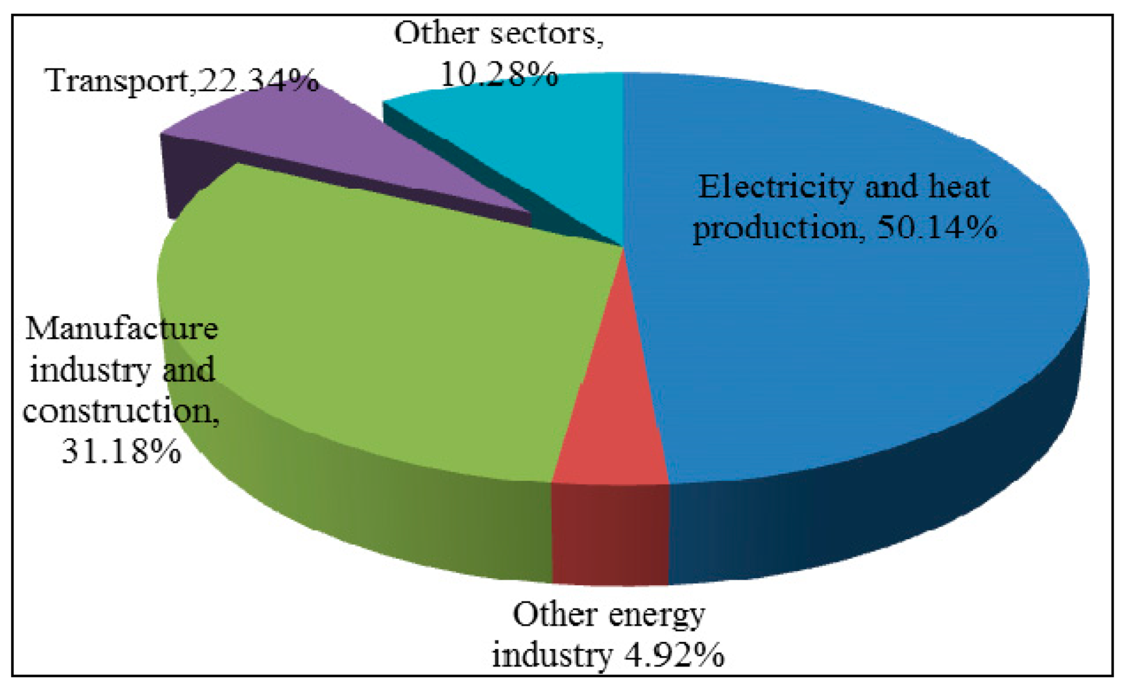
Figure 1: The United States has established a wide range of federal and state incentives
Source: (Ajeigbe and Holt, 2025)
Policymaking On a policy level, the United States has established a wide range of federal and state incentives to promote EV production, deployment of infrastructure, and purchase by consumers. International EV producers have been provided with favourable market entry conditions by the government policies, subsidies, tax credits and green industrial policies that directly target the production of EVs (Ajeigbe and Holt, 2025). Also, climate policies and environmental regulations are still pressuring the automotive manufacturers to begin electrification and emission cutoffs (Hsu, 2023).
The US offers a deep capital market, venture capital financing and innovation ecosystems that sustain high-growth sectors like electric mobility and autonomous vehicle technology, economically. The successful growth of the US stock market has been well-associated with technological breakthrough and investor trust in areas of the future such as clean energy and EVs (Morhachov et al., 2022). This economic climate is favourable to foreign companies in the need of strategic alliances, investment and expansion finance.
In terms of technology, the US is on the forefront in the world in terms of innovation in EVs, including battery, autonomous driving systems, digitization and smart mobility infrastructure. Close cooperation among automotive industries, technologies, and research centers improves the innovation environment. Investment into the automotive technologies facilitated by venture capital also increases the strategic appeal of the US market (Hurry et al., 2022). Furthermore, the development of off-door EVs and autonomous robotic platforms also present an opportunity in the specialised vehicle segment, and Mahindra has product alignment potentials (Ghobadpour et al., 2022).

2.3 Strategic Justification of Market Selection.
A combination of political, economic, technological and environment factors forms the strategic reason of why the United States has been chosen as the expansion market of Mahindra and Mahindra. Trade and political-wise, despite the periodic protectionist actions of the US and the trade policy that relies on tariffs, multinational companies still readjust their worldwide strategies to reduce the effects of tariffs by localising, forming alliances and restructuring their supply chains (VanGrasstek, 2021; Contractor, 2025). These adaptation measures enable companies like Mahindra to deal with tariff exposure as well as achieve a long-term presence to the market.
Sustainability on the environment is a powerful strategic force. EV industry has a high correlation with the goal of climate mitigation and the compulsory need to substitute internal combustion engines (Chu et al., 2022; Karner, 2021). The sustainability core of EV at Mahindra can be supportive of the US climate adaptation targets and clean mobility frameworks.
Moreover, the redesigning of global supply chains following COVID-19 has promoted diversification, nearshoring and supply chain resilience, and localised manufacturing in the US and strategic alliances are becoming more appealing (Free and Hecimovic, 2021). Mahindra has been successful in producing at a low cost and has a flexible supply chain that has placed it in a good position to adjust to these new global manufacturing realities (MAHINDRA & MAHINDRA LTD, 2023).
Together, America provides Mahindra and Mahindra with the best mix of market size, technological expertise, regulatory encouragement and financial breadth. The choice of Mahindra and Mahindra as the organisation of interest and the United States as the target foreign market to expand its EVs in this strategic management analysis justifies these strategic conditions.

3. General Strategic Analysis.

3.1 PESTLE Analysis of the United States Electric Vehicle (EV) Market
The US government has taken a two-pronged strategy of protectionism and industrial promotion. Although the cost of entry in foreign markets increases with tariff based trade policies, there is a rising trend of multinational companies adapting to the effects of tariffs using localisation and restructuring (VanGrasstek, 2021; Contractor, 2025). Meanwhile, there are powerful federal and state-funded incentives, subsidies and tax credits that encourage the manufacturing of domestic EVs and clean energy transitions (Ajeigbe and Holt, 2025). This opens up possibilities to the foreign firms that are ready to invest locally.
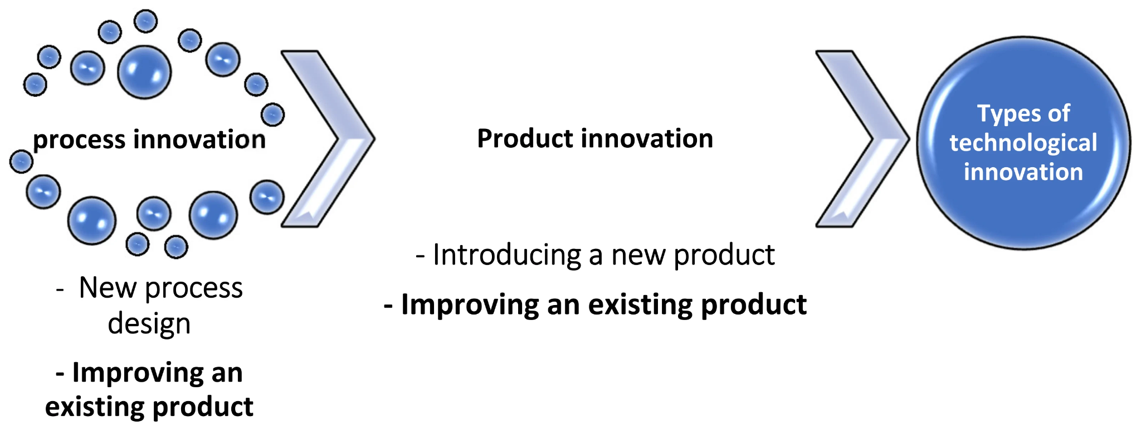
Figure 2: Causality between Technological Innovation and Economic Growth
Source: (Free and Hecimovic, 2021)
The US has economic conditions that are highly in favour of technology-driven sectors. The current rise of the US stock market demonstrates the high confidence of investors in the future of the industry in the field of innovation, including clean energy, EVs and high-tech production (Morhachov et al., 2022). But the pressures of inflation, fluctuations in interest rates and the post covid supply chain remains (Free and Hecimovic, 2021) affect the cost of production and consumer buying behaviour.
Research shows that there is a growing confidence among people towards EV and autonomous technologies, especially among city consumers (Alqahtani, 2025). The changing consumption habits of consumers and sustainable lifestyles, which are environmentally aware, enhance clean mobility demand (Chu et al., 2022). Nonetheless, high expectation as regards to safety, performance and technology are pertinent purchase drivers.
The US is on the forefront of EV innovation around the world with robust R&D ecosystems, venture capital investment and inter-industry partnership (Hurry et al., 2022). Also, the off-road EVs and autonomous agricultural robots innovation opens new segments with the utility vehicle capabilities of Mahindra (Ghobadpour et al., 2022).
The US emission regulations, vehicle safety standards, and environmental regulations are considerably more expensive to enter but at the same time they facilitate the adoption of cleaner vehicles (Hsu, 2023; Karner, 2021). Import costs and localisation strategies are also affected by trade regulations and the changing industrial policy (Contractor, 2025).
The shift in internal combustion engines to electric mobility is picking up due to climate change mitigation, carbon neutrality goals and decarbonisation pledges (Chu et al., 2022; Karner, 2021).

3.2: Porter’s Five Forces – US Electric Vehicle (EV) Industry
Force | Industry Condition | Strategic Implication for Mahindra & Mahindra
Competitive Rivalry | Very high due to strong players such as Tesla, Ford, GM, Rivian and continuous technological innovation and price competition (Fedotov, 2022; Pangarkar and Prabhudesai, 2024). | M&M must adopt strong differentiation or cost leadership to survive intense rivalry.
Threat of New Entrants | Moderate due to high capital requirements, strict regulations and technological complexity, but partially reduced by venture capital funding and start-ups (Hurry et al., 2022; Hsu, 2023). | Entry requires strong financial backing, partnerships and localisation strategies.
Bargaining Power of Suppliers | High due to dependency on lithium, semiconductors and battery materials with global supply risks (Free and Hecimovic, 2021). | Long-term supplier contracts and vertical integration are necessary.
Bargaining Power of Buyers | High as consumers are price-sensitive and have many EV brand choices (Fedotov, 2022). | Competitive pricing, strong after-sales service and brand trust are essential.
Threat of Substitutes | Moderate due to hybrid vehicles, hydrogen fuel vehicles and efficient ICE vehicles (Fedotov, 2022). | Continuous innovation and sustainability positioning are needed to maintain demand.

3.3: VRIO Analysis of Mahindra & Mahindra
Resource / Capability | Valuable | Rare | Inimitable | Organised to Exploit | Competitive Implication
Frugal Engineering & Cost-Efficient Manufacturing (Sikder, 2021; Potharla, 2025) | ✅ | ✅ | ❌ | ✅ | Temporary Competitive Advantage
EV R&D Capability and Battery Technology (Hsu, 2023) | ✅ | ❌ | ❌ | ✅ | Competitive Parity
Brand Strength in Utility & Off-road Vehicles (Sikder, 2021) | ✅ | ✅ | ❌ | ✅ | Temporary Competitive Advantage
Sustainability-Oriented EV Strategy (Karner, 2021) | ✅ | ❌ | ❌ | ✅ | Competitive Parity
Managerial Coordination & Strategic Alignment (Potharla, 2025) | ✅ | ❌ | ✅ | ✅ | Potential Sustained Advantage

Table 3.4: Porter’s Diamond Model – US EV Market Conditions

Diamond Factor | US Market Condition | Implication for Mahindra & Mahindra
Factor Conditions | Advanced infrastructure, skilled workforce and deep capital markets (Morhachov et al., 2022). | Strong foundation for high-quality EV manufacturing and R&D partnerships.
Demand Conditions | High consumer demand for sustainable, high-tech, low-emission vehicles (Alqahtani, 2025). | Supports premium and mid-range EV market entry.
Related & Supporting Industries | Strong ecosystems in batteries, AI, charging infrastructure and robotics (Hurry et al., 2022; Ghobadpour et al., 2022). | Enables innovation collaboration and supply chain efficiency.
Firm Strategy, Structure & Rivalry | Intense competition with rapid technological shifts and aggressive price rivalry (Pangarkar and Prabhudesai, 2024). | Requires strong strategic agility and continuous innovation.

3.5 Critical Analysis of Strategic Tools
PESTEL analysis is useful in determining macro-environmental forces (such as trade policy, EV incentives, sustainability regulation and climate policy) that significantly influence the development of the US EV industry (VanGrasstek, 2021; Ajeigbe and Holt, 2025; Karner, 2021). Its greatest weakness is however its fixed nature. It records the environmental conditions at a given time but it fails to consider the rapid change in policy, disruptive technology, unexpected geopolitical issues, which are prevalent in the international EV markets (Contractor, 2025). This limits its forecasting capability in dynamic international situations.
The Five Forces can provide powerful information about the competitiveness in the industry, and it is noteworthy that the competition is brutal, suppliers have power, and buyers are price-sensitive in the US EV industry (Fedotov, 2022; Pangarkar and Prabhudesai, 2024). However, the model presupposes fairly constant industry boundaries and underestimates the impact of digital platforms, acceleration of innovation, and competition through ecosystems, which is becoming more and more central in the world of EV and autonomous mobility (Hurry et al., 2022).
The VRIO model is very useful in assessing the internal capabilities of M & M, especially its low-cost production and lean engineering capabilities (Sikder, 2021; Potharla, 2025). Nevertheless, dynamic capability construction or learning rate are not sufficiently reflected in VRIO, yet in technologically intensive industries like EVs, competitive advantage is usually not lasting but fleeting (Hsu, 2023).
The Diamond Model by Porter is applicable to examining the national competitiveness through the demand conditions, clusters of innovation and supporting industry in the US market (Morhachov et al., 2022; Ghobadpour et al., 2022). However, it is less useful in the explanation of the strategic placement of the foreign multinational firms that exist in a variety of institutional settings.

4. Strategy Development and Formulation.
This section develops an international expansion strategy of Mahindra and Mahindra (M&M) countries EV in the United States through four fundamental strategic tools: the Matrix of Ansoff, the Generic Strategies of Porter, the Market Entry Strategy and the BCG Matrix. These models combined guarantee consistency between growth direction, competitive positioning, entry mode and portfolio balance.

4.1 Matrix of the Ansoff Growth Direction in expanding to the US.
Mahindra already has developed EV platforms, low-cost engineering and production competencies worked out in India, and in some global markets. Entering the US will give the company a chance to utilize these current strengths and an opportunity to enter a high growth, innovation-driven consumer base. Nevertheless, the external risks associated with market development are especially connected with regulatory compliance, safety requirements, charging infrastructure and customer demands in the US (Hsu, 2023; Karner, 2021). Moreover, the entry risk is affected by world trade volatility, tariffs restructuring and post-COVID disruption of supply chains too (VanGrasstek, 2021; Contractor, 2025; Free and Hecimovic, 2021). Such risks explain the necessity of localisation and strategic partnerships.

Table 4.1: Ansoff’s Matrix Application for Mahindra’s EV Strategy
Strategy Option | Definition | Relevance to Mahindra EV
Market Penetration | Existing products in existing markets | Already pursued in India
Product Development | New products in existing markets | Ongoing EV R&D
Market Development | Existing products in new markets | Selected strategy for US expansion
Diversification | New products in new markets | High risk, not suitable currently

4.2 Generic Competitive Strategy of Porter.
According to the Porters Generic Strategies model, the three fundamental positioning strategies are the cost leadership, differentiation and focus. According to the internal capabilities of Mahindra and the competitive landscape of the US EV market, hybrid cost leadership/focused differentiation strategy is the most appropriate.
Mahindra has always been strong in terms of cost-efficient production and economical engineering and has the ability to produce powerful cars at reasonable prices (Sikder, 2021; Potharla, 2025). This leaves the company at a strong point of leading in cost in utility EV, off-road EV, and light commercial EV, in which Tesla and premium EV brands do not pose direct competition.
Nevertheless, high battery performance, battery life, and intelligent functionality are the minimum safety standards, as well as digital compatibility, which the US consumers expect (Hurry et al., 2022; Ghobadpour et al., 2022). Thus, moderate differentiation in terms of better battery management solutions, connected vehicle technologies and driver-assistance features should also be implemented by Mahindra.
Pure cost approach would put Mahindra in the price wars whereas pure differentiation approach would place it in a direct competition with mainstream premium EV brands. The hybrid strategy will enable Mahindra to be affordable and at the same time have technological legitimacy

Table 4.2: Porter’s Generic Strategy for Mahindra EVs
Strategy Type | Applicability | Strategic Outcome
Cost Leadership | Strong manufacturing efficiency (Sikder, 2021) | Competitive pricing
Differentiation | Required for safety and digital features (Hurry et al., 2022) | Brand credibility
Hybrid Strategy | Adopted approach | Cost-efficient but tech-enabled EVs

4.3 Market Entry Strategy

The choice of market entry mode is a risky strategic choice dependent on trade policy, capital requirements and complexity of regulatory procedures. The most commonly used modes of entry into the Indian market by Mahindra are exporting, licensing, joint venture, strategic alliances and wholly owned subsidiary.
Export entry cannot be used because it has high logistics prices, tariff and rigid US safety policies (Contractor, 2025). Wholesomely owned greenfield investment despite the ability to exert complete control, is highly capital and regulatory risky in an advanced and competitive market.
The best entry mode is a strategic alliance with the US based manufacturing and technology companies.
This allows Mahindra to:
- Local production tax incentives and subsidies on access to EVs (Ajeigbe and Holt, 2025)
- Co-operate on battery systems, software and AV technologies (Hurry et al., 2022)
- Less tariff and trade exposure by sourcing locally (VanGrasstek, 2021; Contractor, 2025)
- Break the cultural barriers of brand recognition.

Table 4.3: Evaluation of Market Entry Modes
Entry Mode | Risk Level | Suitability for Mahindra
Exporting | High | Poor – tariff and compliance risk
Licensing | Medium | Low control over brand & quality
Wholly Owned Subsidiary | Very High | Capital intensive
Strategic Alliance | Moderate | Most suitable entry option

4.4 BCG Matrix – Strategic Positioning of Mahindra’s EV Portfolio
The BCG Matrix rates the business units in terms of market growth and market share. EV is a fast-developing sector in the world due to sustainability regulation and innovation (Chu et al., 2022; Hsu, 2023). The level of market share held by Mahindra within the US market is, however, negligible.
Hence, the EV business of Mahindra in the US falls under the category of a Question Mark- high growth in the market but low market share.
To become a future Star, Mahindra needs to:
- Invest in brand positioning
- Scale local production
- Enhance battery and software.
- Develop charging and service networks.
The off-road EVs, agricultural EVs and utility vehicles are niche segments that are less competitive and have high product-market fit thanks to the strengths of Mahindra in the past (Ghobadpour et al., 2022; Sikder, 2021).

Table 4.4: BCG Matrix Classification of Mahindra’s EV Business
BCG Category | Market Growth | Market Share (US) | Mahindra EV Position
Stars | High | High | None currently
Question Marks | High | Low | Mahindra US EV Entry
Cash Cows | Low | High | Traditional ICE vehicles
Dogs | Low | Low | Obsolete EV models

4.5 CSR and Sustainability Strategy
The long-term expansion strategy of Mahindra and Mahindra (M&M) in the United States in terms of EV expansion revolves around Corporate Social Responsibility (CSR) and sustainability because of emerging strains on the environment and other stakeholders. One of the pillars of this strategy is green manufacturing, which entails cutting carbon emission by utilization of renewable energy, adopting energy efficient production systems, and cleaner logistics networks. The manufacturing regulatory climate of the US auto sector heavily supports manufactured low-emission vehicles, which adds to the importance of strategic need to have green production systems (Karner, 2021; Hsu, 2023).
It is also important to embrace a circular economy model. This involves battery recycling, retrieving of rare metals and lifecycle product design to reduce waste and environmental effects. The policy of urban development and sustainability that are climate-oriented demand manufacturers to go beyond the linear model of production (Chu et al., 2022). Circular practices also lower regulatory exposure and long-term costs of raw materials.
Another important CSR priority is ethical sourcing of batteries. There is environmental degradation and human rights issues related to lithium, cobalt and nickel sourcing. Therefore, to keep in line with the global expectations of ESG, Mahindra has to implement responsible supplier codes, transparent sourcing audit and supplier diversification (Karner, 2021). Ethical sourcing is also commendable in boosting brand legitimacy among US consumers who have sustainability concerns.
Lastly, the adaptive measures related to climate change should be integrated in the operation planning of Mahindra. Climate change poses risks in terms of extreme weather, disruption of supply chain and energy volatility. The key elements of the future stability in operations are therefore sustainable infrastructure development, responsive logistics and climate-resistant production planning (Chu et al., 2022). All these CSR initiatives enhance regulatory compliance, brand trust and long-term environmental performance.

4.6 Risk Analysis
Mahindra & Mahindra EV venture in the US is vulnerable to a number of strategic and operational risks that it should actively address. Though companies strive to overcome the pressure of tariffs by implementing the strategies of localisation, the cost structures and pricing competitiveness can be affected by the presence of import duties and regulatory tariffs (VanGrasstek, 2021; Contractor, 2025). Strategic alliances and local production thus become the risk-reduction measures.
International supply chains have been vulnerable due to global semiconductor shortages, battery materials and logistics bottlenecks (Free and Hecimovic, 2021). Mahindra should implement the use of multiple suppliers, nearshoring and inventory cushions to strengthen its supply resilience.
The threat of consumer adoption is that the product is price sensitive, has range anxiety, is limited by charging infrastructure and brand recognition in the US market. Regardless of the growing acceptability of EVs and autonomous vehicles among the general population, the factors of trust, safety, and technological reliability are still in the purchase decision-making process (Alqahtani, 2025). In absence of a good brand positioning and service infrastructure, Mahindra can be experiencing slow customer uptake as part of early market entry.
Lastly, capital intensity is very high, and it poses a significant risk in terms of financial matters. EV production demands significant investment in research and development, battery technology, and charging system and governmental requirements (Hsu, 2023).

5. Performance Evaluation Framework
To determine the strategic successfulness, financial viability, and long-term competitiveness of Mahindra and Mahindra (M&M) EV entering the United States, an efficient performance evaluation framework is highly needed. Considering the capital-intensive scale of the EV investments and the presence of the great amount of competitive and regulatory pressure, combined system of non-financial and financial performance measurement is needed. In this part, the Balanced Scorecard (BSC) framework has been applied, the Triple Bottom Line (TBL) strategy has been incorporated and the importance of KPI-based performance systems and financial reporting in the strategy have been analyzed.

5.1 Balanced Scorecard Framework.
Balanced Scorecard offers a multidimensional method of performance measurement since financial performance is merged with customer value and internal operation efficiency and organisational learning (Teichgraben et al., 2021).

5.1.1 Financial Perspective
Due to the expensive initial price of the EV production and battery system, the ROI has to be monitored thoroughly to make sure that the returns on investment will be covering the financial risk (Hsu, 2023; Potharla, 2025).
The revenue development will be used as a metric of the commercial success of the EV business in the US market, by measuring vehicle sales, service revenues and platform based digital services. Since the EVs market is still at the high growth stage, the consistent growth of revenues means that the brand is accepted and penetrates the market successfully (Morhachov et al., 2022).
The cost efficiency indicates the capacity of M&M to manage the production, logistics, and procurement costs, and maintain high quality in terms of the strict standards of regulation. Controlling costs has been placed as a strategic agenda due to post-COVID supply chain disruption and inflation of raw materials (Free and Hecimovic, 2021). Frugality engineering and scale economies must thus be implemented to sustain competitive prices to the established EV brands.

5.1.2 Customer Perspective
The customer perspective is the market acceptance, brand strength, and value creation based on the consumer perspective.
EV adoption rate is used to determine the percentage of customers who opt to buy Mahindra EVs against other brands. This KPI assesses the efficiency with which products are positioned, the pricing and incentive use to cause a rise in sales (Ajeigbe and Holt, 2025).
After sales services, charges, product and software performance are captured in customer satisfaction. Trust and reliability of technology are still the determining factors in the purchase of EVs, particularly among first-time users of EVs (Alqahtani, 2025). The level of satisfaction leads to repeat purchase behaviour and good brand image.

5.1.3 Internal Business Processes Perspective.
The factors that are measured under production efficiency include output/unit of input, reduction of downtime and defect rates. To ensure the competitive prices and meet the US safety and environmental standards, effective production is necessary (Karner, 2021; Hsu, 2023).
Supply chains are still vulnerable to disruption after the pandemic, geopolitics and bottlenecks in logistics (Free and Hecimovic, 2021). The reliability is enhanced through long-term supplier relationships and diversified sourcing.

5.1.4 Learning and Growth Perspective.
Unrelenting investment in battery performance, digitalization and autonomous technology, improves product differentiation and technological superiority (Hurry et al., 2022; Ghobadpour et al., 2022). Battery engineering, power electronics, software systems and mechatronics training programmes are used to facilitate productivity, safety and innovation.

5.2 Triple Bottom Line (TBL) Integration.
As the strategic implementation is gauged in the Balanced Scorecard, the Triple Bottom Line (TBL) framework is used to make sure that performance is gauged at the economic, social and environmental levels to attain sustainable growth.
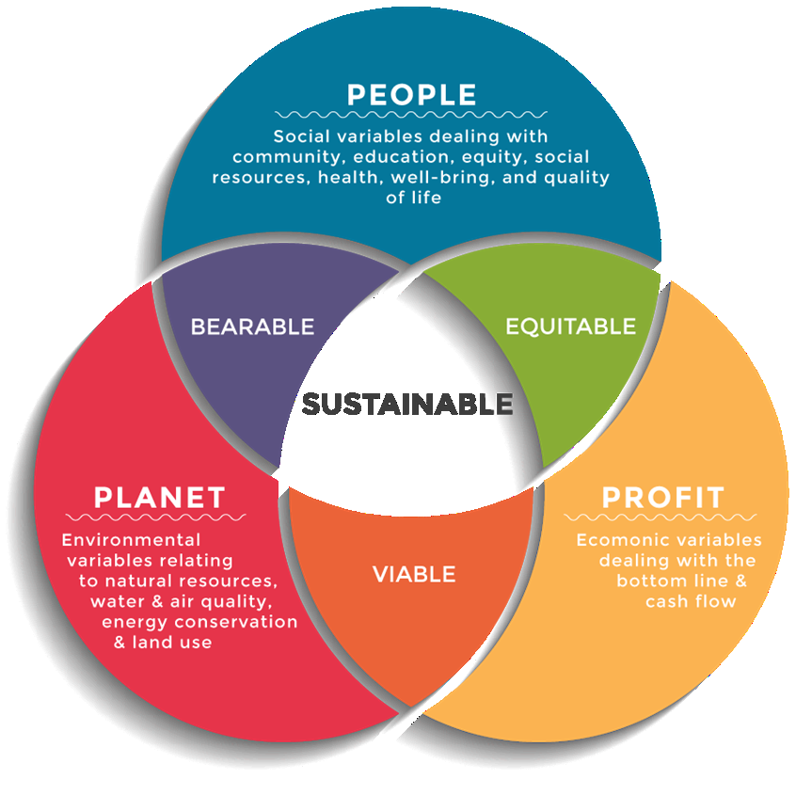
Figure 3: Triple Bottom Line (TBL)
Source: (Chu et al., 2022)
People (Social Performance) is concerned with the creation of employment, diversity of work forces and occupational safety. The entry of US companies gives Mahindra an opportunity to create new jobs locally and follow the high labour standards and safety requirements. High-voltage EV system training is also beneficial to the welfare of employees and to the prevention of accidents.
Planet (Environmental Performance) deals with reduction of emission, uptake of renewable energy and clean production. The policies of decarbonisation and climate that are developed by the US are biased in favor of EV manufacturers with low-carbon production and clean energy supply sources (Chu et al., 2022; Karner, 2021).
Profit (Economic Sustainability) makes the EV strategy of Mahindra profitable in the long-term. Sustainable profitability describes the combination of cost efficiency, increase in revenues and creation of shareholder values (Bontempi, 2024). The Profit aspect also has a direct relationship with investor confidence and availability of long-term capital.

5.3 KPI Measurement and Financial Reporting.
The financial KPIs of ROI, gross margin, operating cash flow and return on capital employed allow the management to monitor the profitability and efficiency of capital (Bontempi, 2024; Rahiminezhad Galankashi and Mokhatab Rafiei, 2022).
Mahindra can optimise working capital and identify operational inefficiencies using supply chain financial performance measures like inventory turnover, supplier payment cycles and logistics cost ratios. Financial metrics in the supply chain are especially relevant to EVs manufacturing because the prices of battery parts and semiconductors are currently high (Free and Hecimovic, 2021).
EVs are a capital-intensive and innovative industry, so it is particularly important that investor reporting relevance. Clear KPI-driven financial reporting enhances the confidence of investors, aids valuation of the equity and opens long-term capital markets (Bontempi, 2024). Regular performance reporting is also good to increase the regulatory compliance and corporate governance standards.

6. Discussion and Strategic Integration
PESTLE and Porters Five Forces analyses reveal that the US EV market is both rich in opportunities and competitive as it is characterised by good regulatory support, fast technological development, and intense competition on the market (Fedotov, 2022; Ajeigbe and Holt, 2025). These reasons determine the use of a market development strategy with the help of a hybrid cost leadership and differentiation strategy.
The entry strategy of Mahindra is characterised by the volatility of tariffs, industrial incentives and restructuring of supply chains following the COVID-19 (VanGrasstek, 2021; Contractor, 2025; Free and Hecimovic, 2021). Meanwhile, the increase in consumer tolerance to EVs and autonomous technologies empowers the demand-side to believe in the viability of the market in the long run (Alqahtani, 2025).
Regarding the internal analysis, the VRIO analysis verifies the fact that vehicles expertise makes a good basis of competitive positioning, especially in off-road and light commercial EV segments (Sikder, 2021; Potharla, 2025; Ghobadpour et al., 2022). These internal assets work well with the niche opportunities in Porters Diamond Model namely in technologically facilitated mobility ecosystems anchored by developed infrastructure and clusters of innovations (Hurry et al., 2022; Morhachov et al., 2022).
Moreover, the combination of the Balanced Scorecard and Triple Bottom Line models make sure that the strategic performance is measured not only based on financial results but also based on the customer value creation, operational efficiency, employee capability development and sustainability performance (Teichgräber et al., 2021; Chu et al., 2022; Bontempi, 2024). Such a holistic fusion enhances strategic consistency and value creation in the long term.

7. Conclusion
This report has critically discussed the strategic feasibility of the Mahindra and Mahindra (M&M) extension of its business to the United States market of Electric Vehicle (EV). Using the major strategic management frameworks, the analysis reveals that the US EV market is characterized by significant growth prospects due to the high level of environmental regulation, governmental incentives, technological advancement and growing adoption of clean mobility by consumers (Ajeigbe and Holt, 2025; Alqahtani, 2025; Chu et al., 2022). It is also, however, known by aggressive rivalry, significant accumulation of capital and a complicated system of regulations (Fedotov, 2022; Hsu, 2023).
The internal analysis proves that Mahindra has a good base on which to develop in the international market, especially in niche utility and off-road EV segments due to their cost-efficient production, economical engineering and expanding expertise in EVs (Sikder, 2021; Potharla, 2025; Ghobadpour et al., 2022). The market development strategy proposed, which relied on a hybrid cost leadership-differentiation strategy and strategic alliances, will guarantee the consistency between the internal strengths and demands of the external market.

References
- Ramachandran, N.V. and Saravanan, S., 2021. A Study on Business Prospects for Builders at Mahindra World City, Chengelpet. Quing: International Journal of Commerce and Management, 1(1), pp.07-13. https://scholar.archive.org/work/djkimqp6yncarma4xezrxsh6yu/access/wayback/https://quingpublications.com/qijcm/2021/1/1/cm201111006.pdf
- Chu, E., Brown, A., Michael, K., Du, J. and Mahendra, A., 2022. “Unlocking the Potential for Transformative Climate Adaptation in Cities”: from the Global Commission on Adaptation (2021). In The Sustainable Urban Development Reader (pp. 86-90). Routledge. https://pure.eur.nl/files/120662306/Unlocking_the_potentia.pdf
- Jahan, T., 2022. Challenges and prospects of assessment development center. https://dspace.bracu.ac.bd:8443/xmlui/bitstream/handle/10361/17962/18304028_BBA.pdf?sequence=1&isAllowed=y
- Morhachov, I., Chorna, O., Oleksandr, O., Martynov, A., Ovcharenko, I., Khandii, O. and Ivchenko, Y., 2022. The Reasons for the Growth of the US Stock Market. European Journal of Sustainable Development, 11(1), pp.124-124. http://ojs.ecsdev.org/index.php/ejsd/article/download/1295/1276
- Hurry, D., Miller, A.T. and Bowman, E.H., 2022. Calls on high-technology: Japanese exploration of venture capital investments in the United States. In Venture Capital (pp. 83-99). Routledge. https://www.academia.edu/download/49581555/smj.425013020220161013-6667-1jgw9r9.pdf
- Ghobadpour, A., Monsalve, G., Cardenas, A. and Mousazadeh, H., 2022. Off-road electric vehicles and autonomous robots in agricultural sector: trends, challenges, and opportunities. Vehicles, 4(3), pp.843-864.https://www.mdpi.com/2624-8921/4/3/47
- VanGrasstek, C., 2021. The trade policy of the United States under the Trump administration. Trade Policy in the 21st Century: Back to the Past. https://papers.ssrn.com/sol3/Delivery.cfm?abstractid=3330577
- Contractor, F.J., 2025. Assessing the economic impact of tariffs: adaptations by multinationals and traders to mitigate tariffs. Review of international business and strategy, 35(2/3), pp.190-213. https://dspace.uii.ac.id/bitstream/handle/123456789/45208/Undergraduate%20Thesis_18323052_revisi.pdf?sequence=1
- Bown, C.P., 2024. Trade policy, industrial policy, and the economic security of the European Union. Peterson Institute for International Economics Working Paper, pp.24-2. https://papers.ssrn.com/sol3/Delivery.cfm?abstractid=4834530
- Ajeigbe, K. and Holt, W., 2025. Government Policies and Incentives for EV Manufacturing. https://www.researchgate.net/profile/Kolade-Ajeigbe-2/publication/390329268_Government_Policies_and_Incentives_for_EV_Manufacturing/links/67ea6d919b1c6c487768ab10/Government-Policies-and-Incentives-for-EV-Manufacturing.pdf
- Hsu, S.L., 2023. On Electric Vehicles and Environmental Policies for Innovation. UC Law Science and Technology Journal, 14(2), p.231. https://repository.uclawsf.edu/cgi/viewcontent.cgi?article=1126&context=hastings_science_technology_law_journal
- Alqahtani, T., 2025. Recent Trends in the Public Acceptance of Autonomous Vehicles: A Review. Vehicles, 7(2), p.45. https://www.mdpi.com/2624-8921/7/2/45
- Karner, A., 2021. THE ENVIRONMENTAL ISSUE FACED BY THE AUTOMOTIVE INDUSTRY: FROM A REGULATORY-PULL PERSPECTIVE TO A BUSINESS-PUSH IMPLEMENTATION. https://unitesi.unive.it/bitstream/20.500.14247/7097/1/847678-1242108.pdf
- Pangarkar, N. and Prabhudesai, R., 2024. Using Porter's Five Forces analysis to drive strategy. Global Business and Organizational Excellence, 43(5), pp.24-34. https://onlinelibrary.wiley.com/doi/pdf/10.1002/joe.22250
- Fedotov, P., 2022. Critical Analysis of the Electric Vehicle Industry: Five forces and strategic action fields. Exchanges: The Interdisciplinary Research Journal, 10(1), pp.43-56. https://exchanges.warwick.ac.uk/index.php/exchanges/article/download/362/954
- Ghobadpour, A., Monsalve, G., Cardenas, A. and Mousazadeh, H., 2022. Off-road electric vehicles and autonomous robots in agricultural sector: trends, challenges, and opportunities. Vehicles, 4(3), pp.843-864. https://www.mdpi.com/2624-8921/4/3/47
- Free, C. and Hecimovic, A., 2021. Global supply chains after COVID-19: the end of the road for neoliberal globalisation?. Accounting, Auditing & Accountability Journal, 34(1), pp.58-84. https://www.researchgate.net/profile/Clinton-Free/publication/344733657_Global_supply_chains_after_COVID-19_the_end_of_the_road_for_neoliberal_globalisation/links/5f94ea2fa6fdccfd7b7d6155/Global-supply-chains-after-COVID-19-the-end-of-the-road-for-neoliberal-globalisation.pdf
- Teichgräber, U., Sibbel, R., Heinrich, A. and Güttler, F., 2021. Development of a balanced scorecard as a strategic performance measurement system for clinical radiology as a cost center. Insights into Imaging, 12(1), p.69. https://link.springer.com/content/pdf/10.1186/s13244-021-01009-2.pdf
- BONTEMPI, F., 2024. FINANCIAL REPORTING AS A DECISION-MAKING TOOL: AN ANALYTICAL STUDY ON KPI-DRIVEN VALUE ASSESSMENT IN CORPORATE STRATEGY. https://tesi.univpm.it/bitstream/20.500.12075/22366/1/TESI%20BONTEMPI%20-%20Completa%20%28Rev%20GP%29.pdf
- Rahiminezhad Galankashi, M. and Mokhatab Rafiei, F., 2022. Financial performance measurement of supply chains: a review. International journal of productivity and performance management, 71(5), pp.1674-1707. https://www.academia.edu/download/65737768/10_1108_IJPPM_11_2019_0533.pdf
- Jahan, T., 2022. Challenges and prospects of assessment development center. https://dspace.bracu.ac.bd:8443/xmlui/bitstream/handle/10361/17962/18304028_BBA.pdf?sequence=1&isAllowed=y
- Potharla, S., 2025. Financial and Strategic Analysis of Tata Motors: Insights from Corporate Finance Perspectives. Available at SSRN 5294575. https://papers.ssrn.com/sol3/Delivery.cfm?abstractid=5294575
- SIKDER, S., 2021. A COMPARATIVE STUDY ON FINANCIAL PERFORMANCE OF MAHINDRA & MAHINDRA LIMITED AND MARUTI SUZUKI INDIA LIMITED. https://bsssbhopal.edu.in/uploads/naac/criteria_1/students_projects/274%20Sneha%20Sikder.pdf
- Pandey, N., 2021. Digital marketing strategies for firms in post covid-19 era: insights and future directions. The new normal challenges of managerial business, social and ecological systems in the post covid-19 era. https://www.researchgate.net/profile/Neeraj-Pandey-2/publication/348417568_Digital_Marketing_Strategies_for_Firms_in_Post_COVID-19_Era_Insights_and_Future_Directions/links/602559aa299bf1cc26bcb34e/Digital-Marketing-Strategies-for-Firms-in-Post-COVID-19-Era-Insights-and-Future-Directions.pdf
- Morhachov, I., Chorna, O., Oleksandr, O., Martynov, A., Ovcharenko, I., Khandii, O. and Ivchenko, Y., 2022. The Reasons for the Growth of the US Stock Market. European Journal of Sustainable Development, 11(1), pp.124-124. http://ojs.ecsdev.org/index.php/ejsd/article/download/1295/1276
- Mahindra & Mahindra Ltd., 2024. Mahindra & Mahindra Ltd. | Integrated Annual Report 2024-25. [online] Mahindra.com. Available at: https://www.mahindra.com/annual-report-FY2025/10/index.html#zoom=true [Accessed 2 Dec. 2025].
- MAHINDRA & MAHINDRA LTD., 2023. MAHINDRA & MAHINDRA LTD. | Integrated Annual Report 2023-24. [online] Mahindra.com. Available at: https://www.mahindra.com/annual-report-FY2024/6/index.html. [Accessed 2 Dec. 2025].

