shannon W
1901768
Network labs

Contents
Packet Tracer Labs- 3
Lab 1 3
Lab 2 3
Lab 3- 4
Lab 4 5
LAB 5 6
LAB 6 7
Lab 7 9
LAB 8 9
Virtual Machine – Labs 11
Lab 1- 11
LAB 2 12
Lab 3 12
Lab 4 14
Lab 5 – not done 15
Lab 6 15
Lab 7 16
LAB 8- 16

Packet Tracer Labs-

Lab 1
Why would a user be able to browse to an IP address but not a FQDN?
The IP address is accessible while a HTML link isn’t when not connected or configured properly.
Why does the Email service require both SMTP and POP3 to be activated?
They are emailing services. There are protocols for emailing and it needs to be activated/configued to allow emails to get to the correct location.

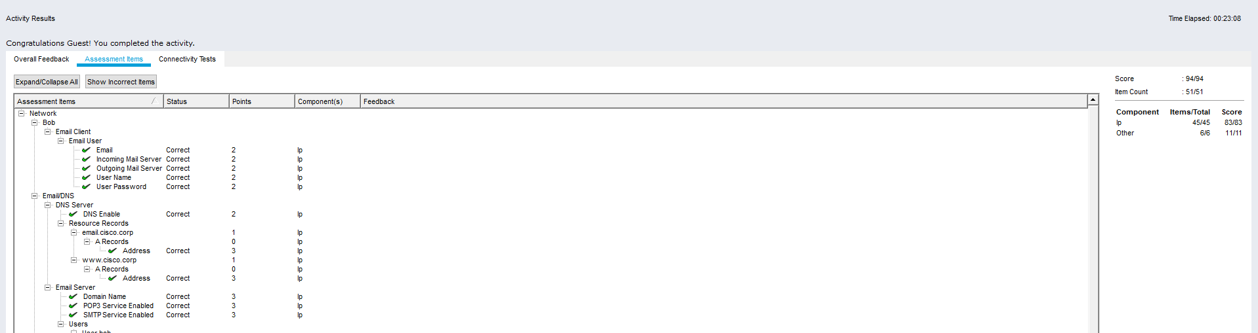

Lab 2
What protocol was used to retrieve the email from the email server?
POP3
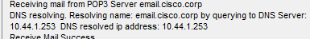
Why is FTP considered an insecure protocol for moving files?
It stands for File Tranfer Protocol and it Is used mostly. It does not use encryption

What information is displayed in clear text from the FTP header?
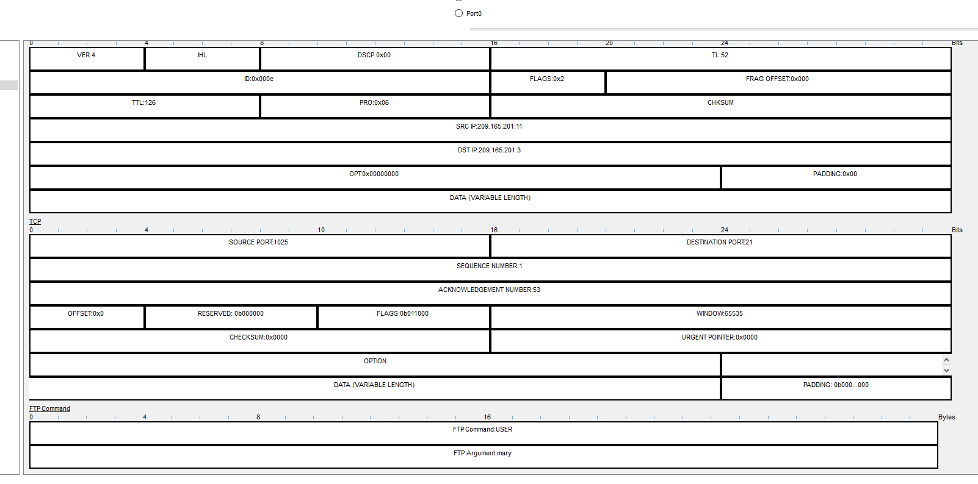
- On the left, click the 2nd FTP packet available to select it. Then scroll down to the bottom of the window displayed on the right. Do this again for the 3rd FTP packet.
- Besides the username, what other sensitive information is displayed in clear text from the FTP header?
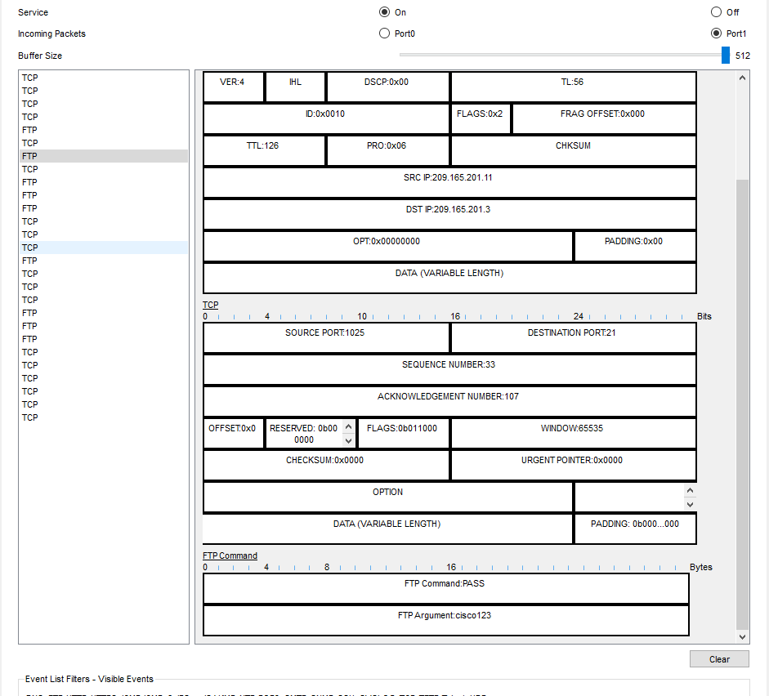
Why is Telnet considered an insecure protocol for remotely managing a device?
Anyone can type
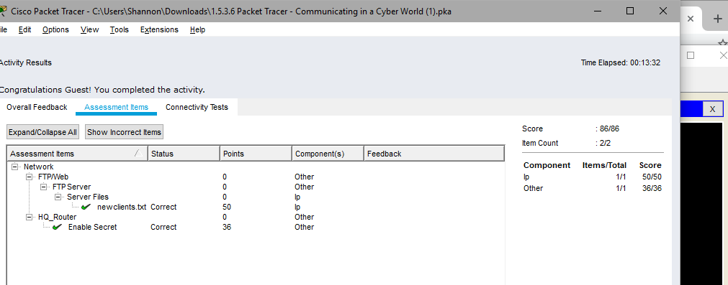

Lab 3-
What is the IP address for the default gateway?
    - / 10.44.3.100
WEP and the key 0123456789 are not secure. Why is WEP not recommended for use in securing wireless networks?

When considering a large organization, why is WPA2 RADIUS more beneficial than WPA2 PSK?
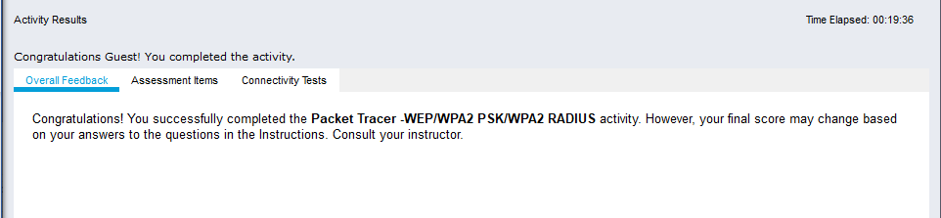

Lab 4
What information is displayed in clear text?
User cisco
Pass public key
What is the Client IP for the client-to-site VPN connection?
10.44.2.200
What extra IP address is now shown that was not shown before in Part 1 Step 2c?
Tunnel interface ip address
Are there any FTP messages displaying the password of internal or the file upload of PrivateInfo.txt? Explain.

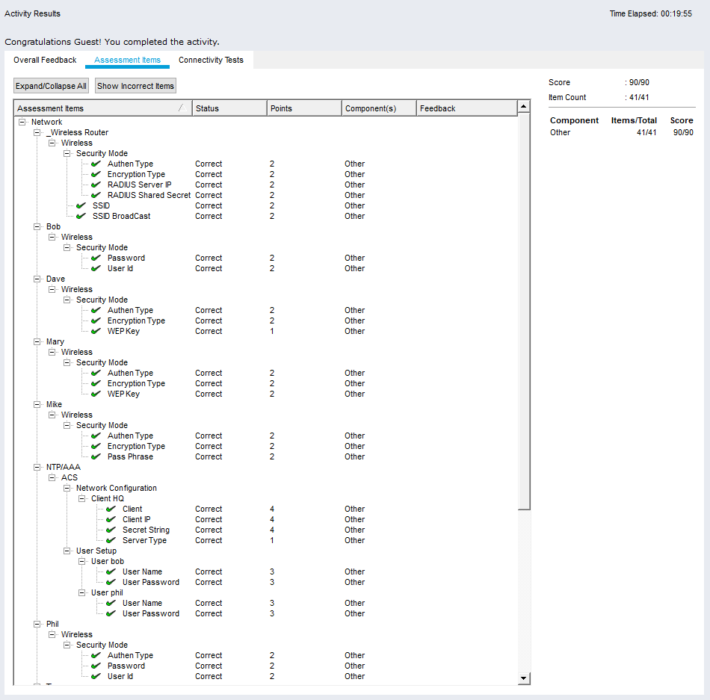

LAB 5
Click the FTP messages displayed on the sniffer and scroll to the bottom of each one. What information is displayed in clear text?
The username and password in the two FTPS.
Are there any FTP messages sourced from the IP of Sally’s computer? Explain.

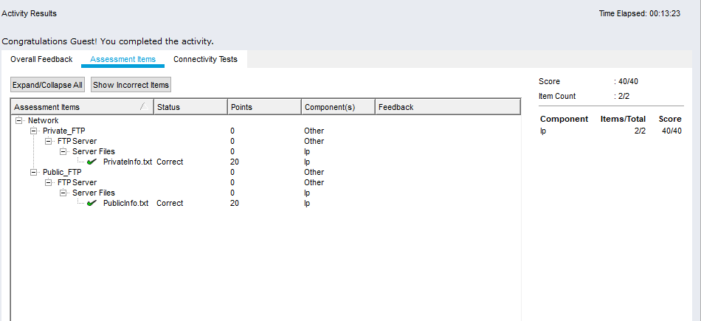

LAB 6
What are the IP addresses of the devices that the traffic from Phil’s laptop is crossing to reach the External Web server?

Comparing the output of the tracert command to the Addressing Table at the beginning of this lab, which router is operating as the current default gateway?
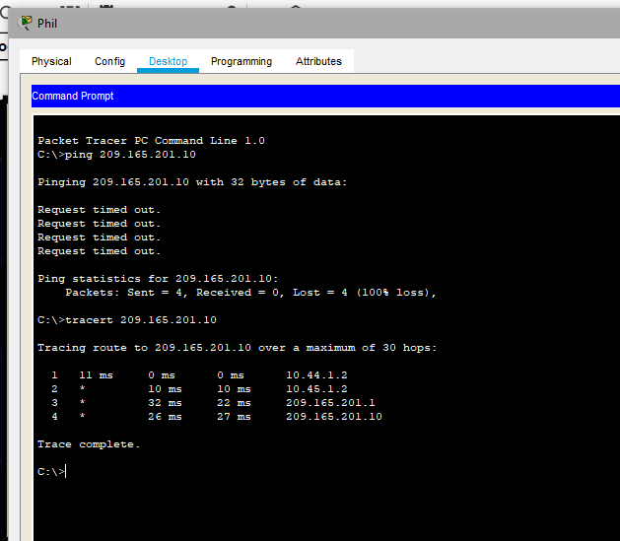

What are the IP addresses of the devices that the traffic from Phil’s laptop is crossing to reach the external web server?
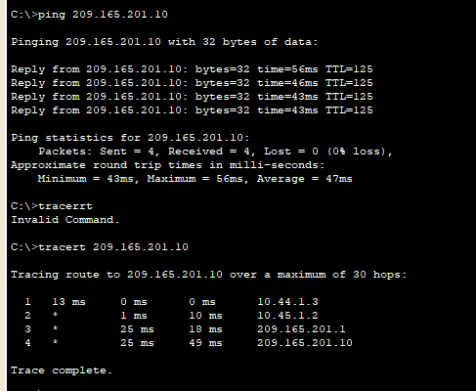
      - The first address of the tracert output is the default gateway (exit point) of the network.
Which router is now operating as the current default gateway?

Which cable was the data crossing during the successful ping replies before the “Request timed out” messaged occurred?
____________________________________________________________________________________
Which cable was the data crossing during the successful ping replies after the “Request timed out” messaged occurred?
____________________________________________________________________________________
What does this scenario prove about switch failover redundancy when a Gigabit Ethernet port is shutdown all of a sudden?

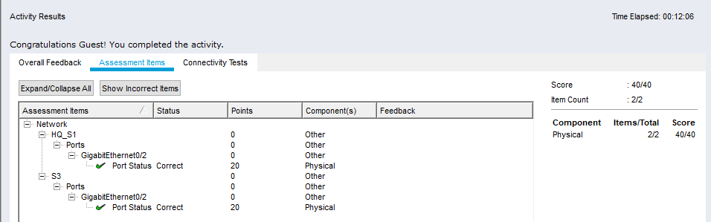

Lab 7
      - Were you prompted with any warning message preventing unauthorized users from accessing the HQ_Router?
No it did not

Were you prompted with any additional text/information when you connected successfully to the HQ_Router? What is shown?
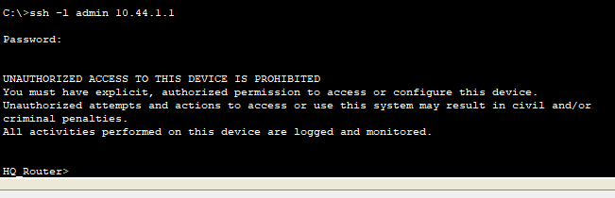
What is the name of the current .bin file in flash?
C2900-UNIVERSALK9-MZ.SPA.151-4.M4.BIN
Are there any IOS.bin file listed? No

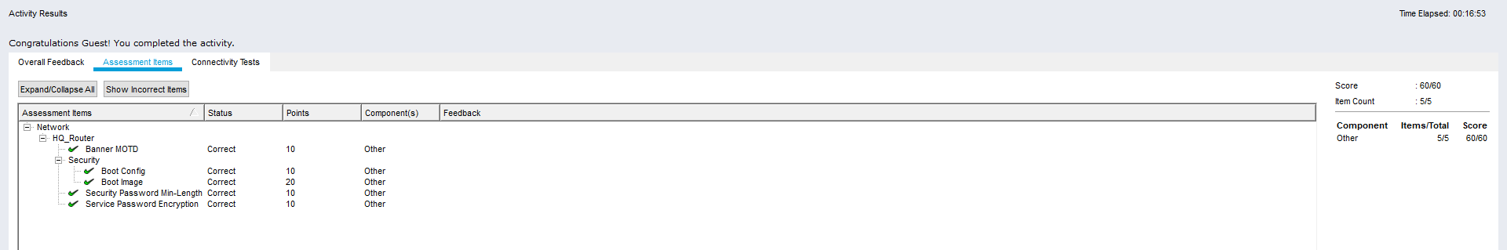

LAB 8
Why would a user be concerned when submitting information using this website?
The password is visible, and so is security identifier
Why would a user be less concerned when submitting information using this website?
Is Sally’s computer able to access the HQ Internet Web Server using HTTP?
Is Sally’s computer able to access the HQ Internet Web Server using HTTPs?
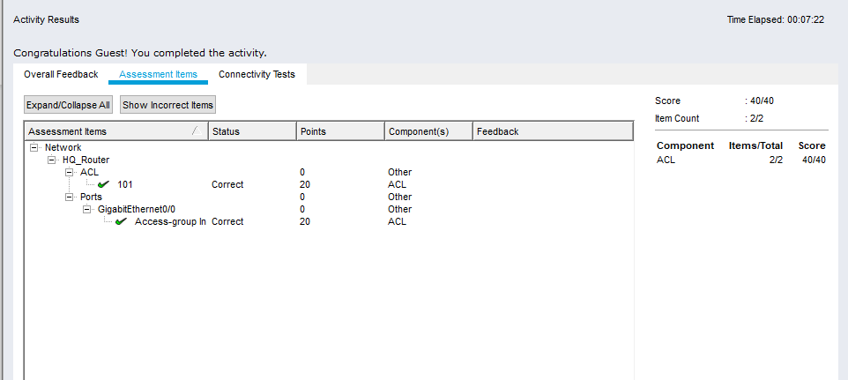

Virtual Machine – Labs

Lab 1-
Open the terminal application. Type the command ip address at the prompt to determine the IP address of your virtual machine.
What are the IP addresses assigned to your virtual machine?
127.0.0.1/8
10.0.2.15/24
Locate and launch the web browser application. Can you navigate to your favorite search engine? Yes, I can access using firefox to access google
Press the right ctrl key to release the cursor from the virtual machine. Now go to the menu at the top of the virtual machine window and choose File > Close to close the virtual machine. What options are available?
It brings up a information box – telling you. The options that are available are
- Start the machine state
- Send the shutdown signal
- Power off machine
Reflection
What are the advantages and disadvantages of using a virtual machine?
Advantages
- Does not affect the main PC if VM crashes
- Using another OS
- Experiment
Disadvantages
- Depends of the host PC

LAB 2
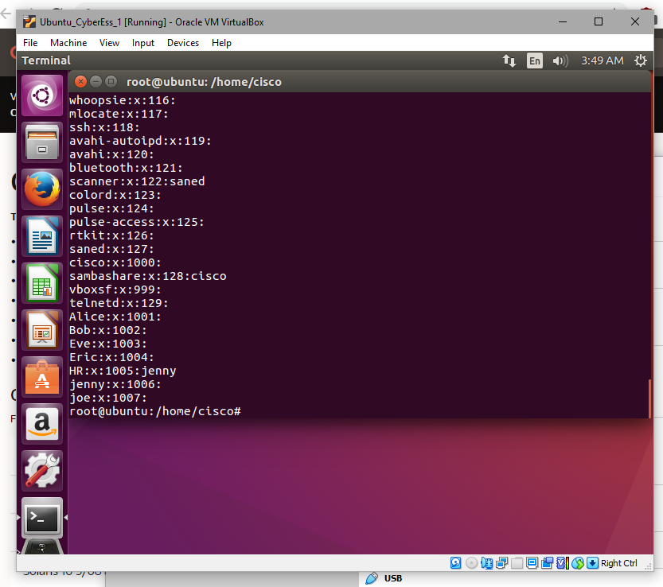

Lab 3

What TCP ports are open?
22/tcp open ssh
23/tcp open telnet
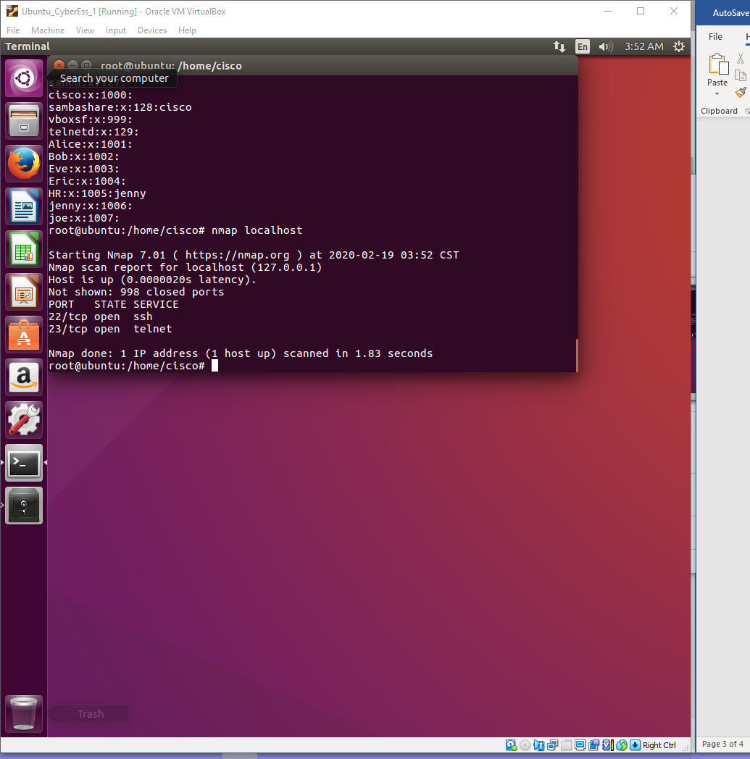

What UDP ports are open?
68/UDP DHCPC
631/UDP IPP
5353/UDP ZEROCONF

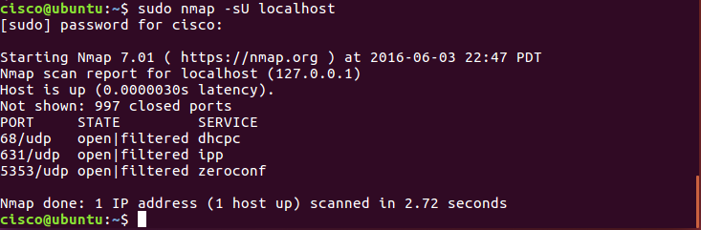

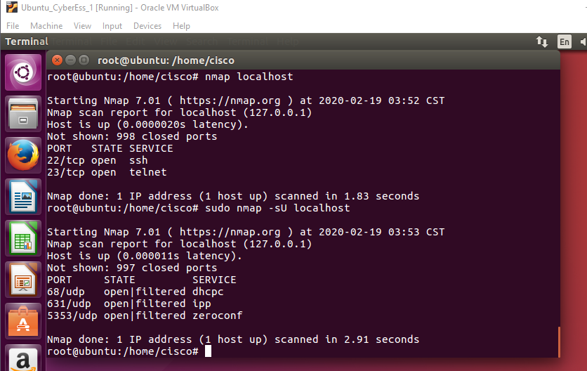

Lab 4
What is the message in the secret.odt?
The secret document
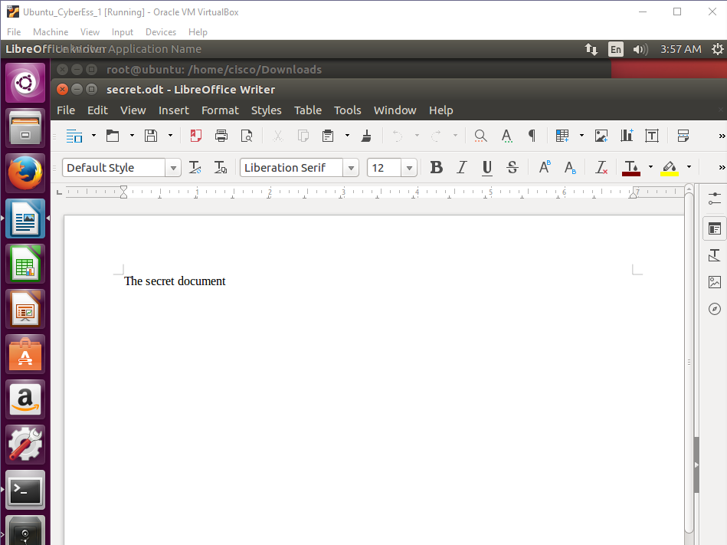
Open the files, secret.odt and keyboard.jpg. Did these files change? No
You have extracted the file. Open the extracted secret.odt file with LibreOffice.
Could you open the file? Is the secret message the same as before?
Yes exactly the same

Lab 5 – not done

Lab 6
How many passwords were cracked?
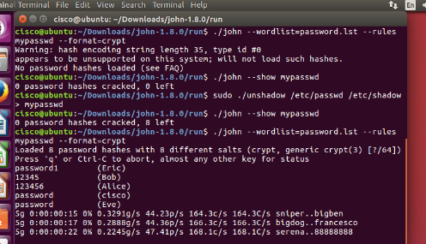
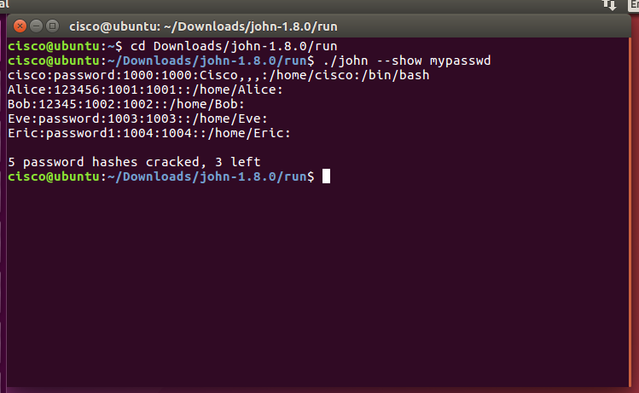

Lab 7
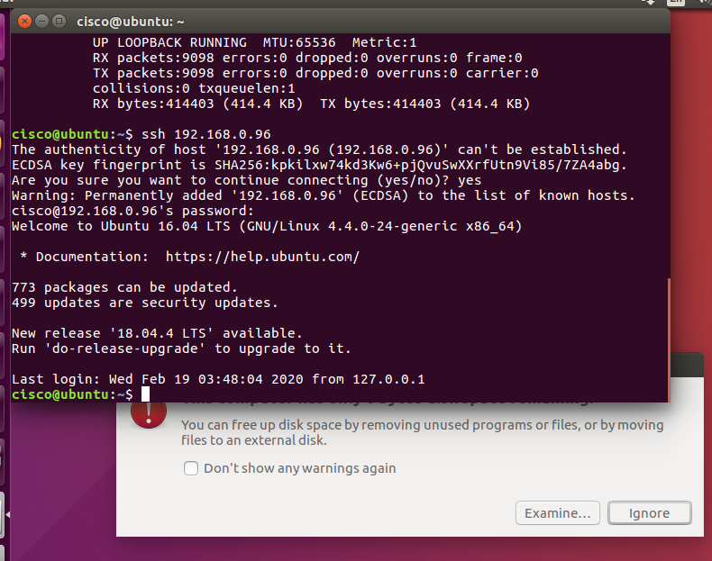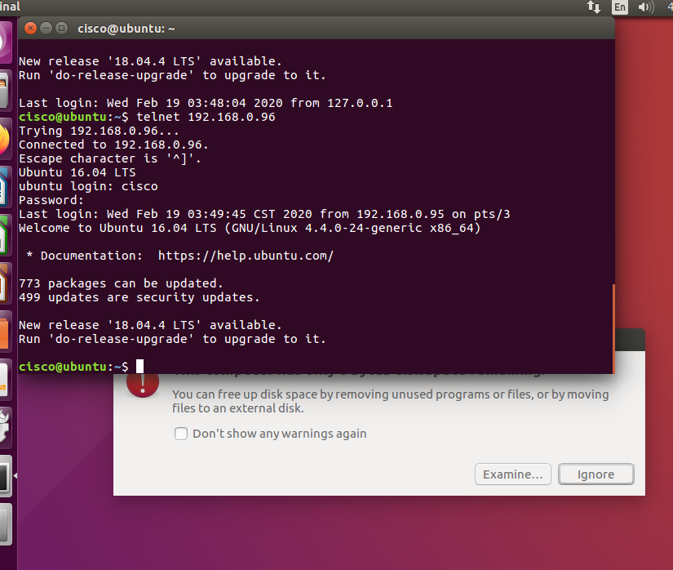

LAB 8-
How many Warnings did you receive? 5
How many Suggestions did you receive? 6
    - Scroll through the suggestions and select one. You will research a suggestion that you can implement to address the issue.
Which suggestion are you addressing?
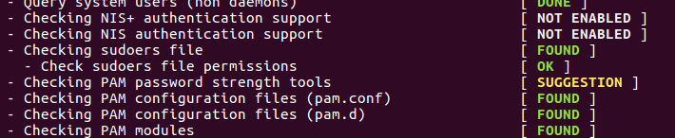

What is your suggested solution?

