University of Wales Trinity Saint David School of Engineering

Analysis of Student Grades using Statistical Methods in Matlab

Engineering Applications and Study Skills ACMA4007



Julian Edwards

2315607
Contents
1 Introduction i
1.1 Objective i
1.2 Dataset i
2 Data Import and Summary Statistics ii
2.1 Data Import ii
2.2 Summary Statistics ii
3 Correlation Analysis iv
4 Data Grouping & Hypothesis Testing vi
4.1 Hypothesis Testing vi
4.2 Frequency Plots vi
5 Discussion and Conclusion ix
5.1 Summary ix
5.2 Strengths and Limitations of Statistical Methods ix
6 References xi
7 Appendix xii
7.1 Matlab Code xii

Introduction

Objective
The objective of this report is to analyse student grades using statistical methods inside of MATLAB. The first aim of this is to produce a functional MATLAB script which will import the data provided and use several statistical methods to analyse the data and support this report.. The second aim is to identify particularly influential data using methods such as summary statistics and correlation analysis. If possible, patterns will be identified in the data which will help to provide can good understanding of what affects student grades. By the end of this report, influential variables will have been identified as well as the strengths and weaknesses of the statistical methods that will have been used.

Dataset
The dataset that was provided for this report included several numerical variables as well as string variable, ‘gender’ and ‘studentID’ of which the ‘studentID’ is unique to each student and should be discarded from the dataset. Statistical methods, such as the ones discussed above will be carried out on the data to identify patterns and influential variables.

Data Import and Summary Statistics

Data Import
The first step in analysing student grades is to import the initial data from the CSV file that was provided. There are several functions in MATLAB to import data from a file, such as ‘readmatrix()’ or ‘readtable()’, each of these functions has its advantages. For example, ‘readmatrix() makes it easy to specify the output type of the data’ (Sizemore & Mueller, 2021), alternatively, ‘readtable()’ reads all of the data and returns a table whilst including possible heading inside of the source file as it’s ‘designed more for work with database output’(Sizemore & Mueller, 2021). Due to the data source containing a header as well as two different data types, in this case, strings and integers, the ‘readtable()’ function was used. After the data was imported, a large table was produced in the MATLAB environment containing all of the student data previously stored in the CSV file, this then allows for the data to be altered without affecting the initial data source. A new column is then generated for the overall exam result, which was easily calculated as the average of ‘Exam_1’ and ‘Exam_2’ for each row within the table. After this step, the data was complete, and now the numerical data needed to be removed from the string data so that it could be processed separately. This process is relatively simple, a new table which consists of ‘age’, ’attendancePercentage’, ‘Exam_1’, ‘Exam_2’, and ’Overall’ which are all of the numerical variables within the data source, is then converted into a matrix using the ‘table2array()’ function which ‘converts the table or timetable, T, to a homogenous array’ (MathWorks, no date). This allows the data to be easier to work with, being limited to a single data type, as well as being easier to apply functions to.

Summary Statistics
From the numerical data matrix that was generated during the data import stage the functions, ‘mean’, ‘median’, ‘mode’, ‘min’, ‘max’, and ‘std’ were applied and combined into a single table to produce the following summary statistics table below (see Table 1).
Table 1 - Summary Statistics (Adapted from MATLAB Output)
Variable | Mean | Median | Mode | Range | Standard Deviation
Age | 36.65 | 37.5 | 48 | 19 – 53 | 9.7643
Attendance | 60.58 | 57 | 27 | 20 – 100 | 24.249
1st Exam Score | 58.27 | 58 | 59 | 7 – 98 | 21.673
2nd Exam Score | 55.08 | 53.5 | 51 | 4 – 98 | 22.428
Overall Score | 56.675 | 54.5 | 25.5 | 9.5 – 95 | 21.452

A table of summary statistics, such as the one above, can be useful, for example, it shows a general overview of the data and can help to highlight some of the possible similarities and differences between the different variables. However, there are some limitations as to what can be interpreted, for example (NIST, No Date) states that ‘A summary analysis is simply a numeric reduction of a historical data set’ which means that it is not reliable for finding patterns and doesn’t focus on a particular area of interest where data may be more consistent or more anomalous. The data can also be easily influenced by anomalies or errors which could skew the data to be completely incorrect and useless. A third example is that when the data has been summarised it is they can quickly become outdated, the summary statistics would need to be recalculated as often as the data is altered which could yield vastly different figures compared to the current data. For these reasons, the data usually goes under further analysis to prove their validity and can provide further evidence of relationships between variables.

Correlation Analysis
The next step in analysing the student grades is a correlation analysis, which ‘is used to determine the strength of a relationship between two item sets’ (Kumar & Chong, 2018). This can easily be achieved in MATLAB by making use of the ‘corr()’ function which, given the numerical data, produces the data in the following table (see Table 2).
Table 2 - Correlation Matrix of Variables (Adapted from MATLAB Output)
 | Age | Attendance | Exam1 | Exam2 | Overall
Age | 1.0000 | -0.0362 | -0.0364 | -0.0506 | -0.0448
Attendance | -0.0362 | 1.0000 | 0.8912 | 0.8297 | 0.8839
Exam1 | -0.0364 | 0.8912 | 1.0000 | 0.8929 | 0.9719
Exam2 | -0.0506 | 0.8297 | 0.8929 | 1.0000 | 0.9738
Overall | -0.0448 | 0.8839 | 0.9719 | 0.9738 | 1.0000

This data clearly shows the correlation between each variable, which clearly shows that there is a very small negative coefficient between ‘Age’ and all of the other variables, showing that age has very little influence over student exam scores. It is also clear to see that ‘Exam1’, ‘Exam2’, and ‘Overall’ have extremely high positive correlation coefficients, which is to be expected as the ‘Overall’ value is average of ‘Exam1’ and ‘Exam2’. The only remaining variable is ‘Attendance’, while its correlation coefficient between the exam result variables is lower than the coefficients of the exam scores previously stated, it still has a high positive correlation coefficient. This suggests that a student’s attendance has a positive impact on their grades, so in general, a student with a higher attendance should achieve a higher exam score. However, the data displayed in the table faces a similar issue to the summary table (Table 1) which is that the data distribution cannot be seen, this means it is nearly impossible to understand how these figures were achieved and even if they are accurate. This is why a more graphical view was generated using the ‘corrplot()’ function to produce the figure below (see Figure 1).
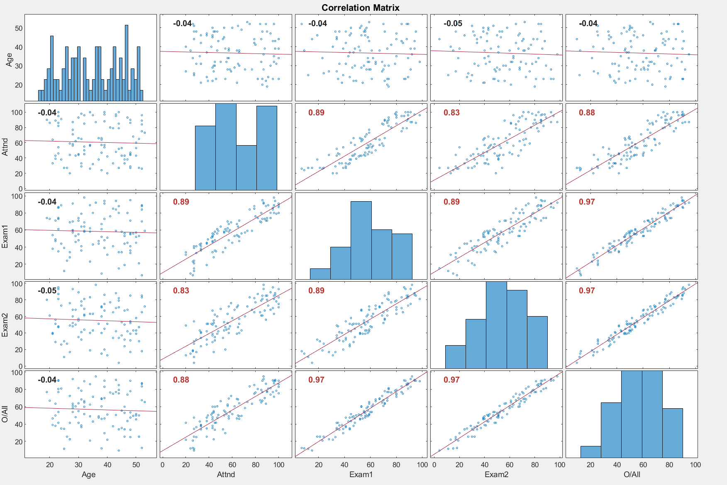
Figure 1 - Plotted Correlation Matrix
With a more graphical figure the actual distribution is seen, for example, ‘Age’ has a very large distribution when compared to other variables, meaning there is little to no correlation between age and any other variable. It is also clear that the correlation between both exams and overall scores is high and is located very tightly in the line of best fit. It is also possible to see that there is some variance in the relationship between ‘Exam1’ and ‘Exam2’ which suggests that those who perform better on the first exam are likely to perform better on the 2nd, but there are few cases where the opposite occurs in very minor cases. This can also be seen with attendance about the exam scores, but in general, the higher attendance that a student has, the higher the score that they should achieve on each exam.

Data Grouping & Hypothesis Testing
‘Grouping data is a core component of data management and analysis’ (Batra, et al., 2021), it allows for data to be separated into categories and allows them to be more easily analysed individually or directly with other variables. There are several advantages to data grouping such as the previously mentioned separation of data and individual analysis, as well as improving ‘the accuracy/efficiency of estimation’ (Vedantu, 2024) by removing irrelevant or anomalous data.

Hypothesis Testing
First, a new table was created which consisted of ‘gender’ and overall exam score, this was then grouped individually by gender, this is so that gender which is a string-based value can be compared to exam score which is a numerical value, so they cannot be compared using most analysis techniques. The method that was used in this analysis was Hypothesis Testing which allows us to compare the means of both male students and female students to determine if there is some correlation between gender and exam score. ‘Hypothesis testing is used to assess the plausibility of a hypothesis by using sample data’(Majaski, 2024), which makes it ideal for comparing male and female students, and can be carried out in MATLAB using the ‘ttest2()’ function for two sample testing which is ideal in this case. To conduct the hypothesis test there are two hypotheses, the first is a null hypothesis or ‘H0’, in this case, H0 is that the means are approximately equal to each other. The alternative hypothesis or ‘H1’ would be that the means are not equal to each other and prove that gender can influence the exam score. The alpha for this was set at MATLAB’s default of 0.05 (5%) which means that the p value would have to be less than the alpha. The result of ‘ttest2()’ returned a p-value of 0.437006 which is greater than the alpha of 0.05, which means that there is not enough information to reject H0, which further suggests that gender has no visible influence over the overall exam scores.

Frequency Plots
Secondly, several variables were created using the ‘histcounts()’ function to calculate the edges of each ‘bin’ with a width of 10 as well as the count of items in each of these ‘bins’, this then groups the data by both exam and ‘bin’. The count that was produced in the previous step can be considered the frequency of the bin, and the edges can be used to display this data in a histogram such as the one below (see Figure 2) which was produced using the ‘histogram()’ function.
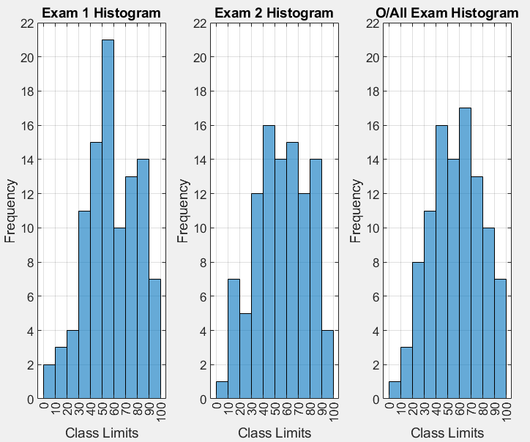
Figure 2 - Histogram Distribution of Exam Scores
From this figure, it is clear that in Exam 1, the most common exam score was between 50 and 60, it is also clear to see that the average score would be closer to 100 than 0 when compared to Exam 2 which has a more even distribution of scores. Then the distribution of overall scores is between that of Exam1 and Exam2, distributed fairly centrally but skewed more to the right due to the influence of the Exam1 scores. This distribution can be further examined in an Ogive Plot (see Figure 3).
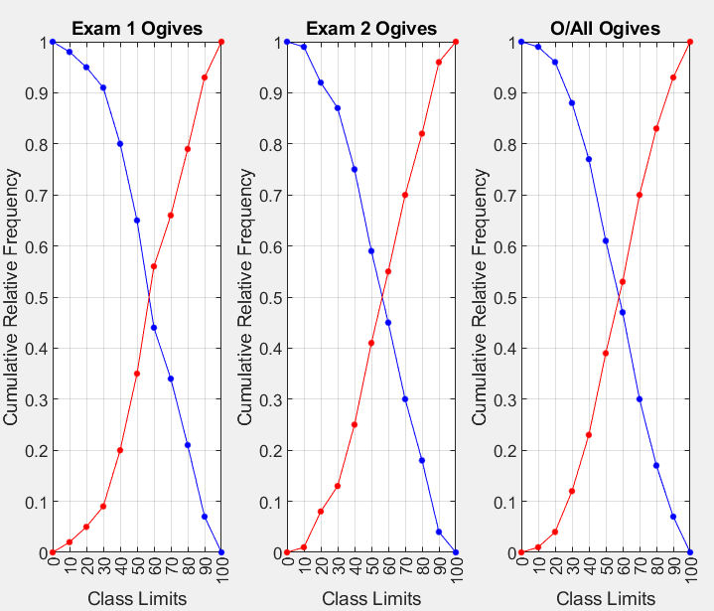
Figure 3 - Ogive Plot of Cumulative Exam Scores
The above figure was generated by calculating the cumulative frequency of each edge using the ‘cumsum()’ function as well as adding an additional 0 to the array because the frequency must start or end at 0. On each of the plots, there are two lines, the less than Ogive (red), which shows what percentage of the exam scores were below a specific value. The second is the greater than Ogive (blue), which is the opposite of the less than Ogive, and shows what percentage of the exam scores were above a specific value. It is useful for showing the distribution of exam scores without being too generalised.

Discussion and Conclusion

Summary
To summarise the analysis that was carried out in this report, a table of summary statistics was generated which gives a general overview of the data and allows for the relationship between Exam 1, Exam 2, and Overall score to be seen easily but was limited to simple figures.
A correlation analysis was then carried out to help display the relationship between variables and identify strongly correlated variables. It was determined that Age had a negligible negative correlation between each of the variables. The remaining variables had a much larger correlation with each other, this included the overall, exam 1 and exam 2 scores which are to be expected considering the overall score is calculated using both variables. The other variable, attendance, also had a large correlation coefficient with these variables, clearly showing that it is likely a very contributing factor to exam scores.
There was also another variable, gender, which could not be evaluated directly using the same numerical methods. Therefore, a hypothesis test was carried out by grouping the overall exam score by gender and testing if the means greatly differ using the current data set. This resulted in an h-value of 0, supporting the null hypothesis of similar means, which suggests that gender does not influence exam scores.

Strengths and Limitations of Statistical Methods
The first statistical method used was a table of summary statistics, which allows for a general overview of the numerical data and can show similarities and differences between variables over the whole data. However, it is limited to showing the whole data source and can be easily influenced by anomalies which can then skew the data. It also must be frequently updated to reflect accurate data.
The second method was a correlation analysis which helps to easily identify related and unrelated variables, and while it can be influenced by anomalies, it typically is only a minor influence and can be seen when plotted such as in Figure 1. However, even when a value has a high correlation coefficient, it is not completely certain that the variable is related and can be a coincidence within the data.
The third was a hypothesis, which is good for comparing means between variables, in this case, male and female overall test scores. Also due to the data being grouped, it does not include other variables which may influence the data. However, a hypothesis test is very much limited by its sample size, which is reduced when grouping by variables such as gender. It also only provides a yes or no answer, which can ignore the significance of the actual result.
The fourth and fifth methods used were histograms and Ogive frequency plots, these allow for patterns to more easily be identified and identify how the data can vary and where it is similar. However, the bins become a larger issue due to the simplification of the data which may not properly reflect the data, the bins are too small, patterns are harder to identify and the data becomes over-complicated. But if the bins are too large the data becomes oversimplified and loses details and results are more generalised.

References
Batra, N. et al., 2021. The Epidemiologist R Handbook. [Online]
Available at: https://epirhandbook.com/en/
[Accessed 27 May 2024].
Kumar, S. & Chong, I., 2018. Correlation Analysis to Identify the Effective Data in Machine Learning: Prediction of Depressive Disorder and Emotion States. In, 15(12), pp. 2907-.
Majaski, C., 2024. Hypothesis Testing: 4 Steps and Example. [Online]
Available at: https://www.investopedia.com/terms/h/hypothesistesting.asp#:~:text=Key%20Takeaways,of%20the%20population%20being%20analyzed.
[Accessed 27 May 2024].
MathWorks, no date. table2array. [Online]
Available at: https://uk.mathworks.com/help/matlab/ref/table2array.html
[Accessed 27 May 2024].
NIST, No Date. Engineering Statistics Handbook. [Online]
Available at: https://www.itl.nist.gov/div898/handbook/
[Accessed 27 May 2024].
Sizemore, J. & Mueller, J. P., 2021. MATLAB For Dummies. 2nd ed. Hoboken(New Jersey): John Wiley & Sons.
Vedantu, 2024. Grouping of Data. [Online]
Available at: https://www.vedantu.com/maths/grouping-of-data
[Accessed 27 May 2024].

Appendix

Matlab Code
clc % Resets all the variables in the workspace
clear % Clears the command window
close all % Closes all the open figures

% TASK 1 - Data import and summary statistics
% -------------------------------------------

% A - Import the data into Matlab

student_Data = readtable("student_grades.csv"); % Load the grades from the CSV file
% Calculate the overall (average) score and add it to the student data
student_Data.("Overall") = (student_Data.("Exam_1") + student_Data.("Exam_2")) / 2;

gender_Data = student_Data(:, "gender"); % Create a separate table for student genders (to be used later)
% Seperates useful numerical date and converts it into an array/matrix
numerical_Data = table2array(student_Data(:, ["age","attendancePercentage", "Exam_1", "Exam_2","Overall"]));
% Manually grabbed by name rather than index to minimise error

% B - Compute summary statistics for numerical variables

mean_Array = mean(numerical_Data)'; % Calculate the means for each of the numerical variables
median_Array = median(numerical_Data)'; % Calculate the medians for each of the numerical variables
mode_Array = mode(numerical_Data)'; % Calculate the modes for each of the numerical variables
min_Array = min(numerical_Data)'; % Calculate the mins for each of the numerical variables
max_Array = max(numerical_Data)'; % Calculate the maxes for each of the numerical variables
range_Array = [min_Array, max_Array]; % Calculate the ranges for each of the numerical variables
std_Array = std(numerical_Data)'; % Calculate the standard deviation for each of the numerical variables

% C - Use table to display the summary statistics

% Create a cell of strings to be used as the left-most column to label variables
Names_Cell = {'Age'; 'Attendance'; '1st Exam Score'; '2nd Exam Score'; 'O/All Score'};
% Another cell of strings but this time used as headings for each column
col_Headings = {'Variable'; 'Mean'; 'Median'; 'Mode'; 'Range'; 'Std'};
% Combines previous summary statistics into a single table, using the previous strings as headings and label
summary_Table = table(Names_Cell, mean_Array, median_Array, mode_Array, range_Array, std_Array, VariableNames=col_Headings);
disp(summary_Table) % Displayed on a separate line to remove 'var = xyz'

% TASK 2 - Correlation Analysis
% -------------------------------------------

% A - Return a matrix of the pairwise linear correlation coefficients between variables

% Use the Corr function on the previous data, using pairwise rows
disp(corr(numerical_Data(:,:), "rows","pairwise")) % Use of disp to remove 'var = xyz'

% B - Use corrplot to visualise the matrix's results

figure Name 'Correlation Coefficient' % Create a figure window for the corrplot with appropriate name

Names_Cell = {'Age', 'Attnd', 'Exam1', 'Exam2', 'O/All'}; % Create a cell of strings used to identify variables

% Use the corrplot function to generate a visual correlation matrix, using testr on to help identify high correlation coefficients
corrCo_Plot = corrplot(numerical_Data(:,:), 'VarNames', Names_Cell, TestR = 'on');

% C - Examine the relationship between Gender and overall using a hypothesis test

% Organise the data, in this case gender and overall exam score in 1 table
gender_Score = table(student_Data{:, "gender"}, student_Data{:, "Overall"}, VariableNames={'Gender', 'Overall'});

% Group the data by gender

% Get only the male scores by filtering the previous table by gender
male_Score = gender_Score(gender_Data{:,1} == "Male", "Overall"); % Return the overall value when Gender = 'Male'
female_Score = gender_Score(gender_Data{:,1} == "Female", "Overall"); % Return the overall value when Gender = 'Female'

% Convert Table to matrix - Done on seperate line to make the code less cluttered
male_Score = table2array(male_Score); % Converts the previous tables to array / matrix for ease of use
female_Score = table2array(female_Score);

% Use ttest2 to conduct a hypothesis test against male and female scores, h0 suggesting same/similar means
[h,p] = ttest2(male_Score, female_Score);

% If h=0 promote the null hypothesis
if h == 0
hVal_Str = "approximately equal given the samples";
% Else Suggest an alternative hypothesis
else
hVal_Str = "not equal given the samples";
end

% If p is greater than 0.05 (default alpha values), state it is more likely that the means are equal
if p > 0.05
pVal_Str = "greater than an alpha of 0.05, so there is not enough information to reject h0";
% Else suggest the opposite
else
pVal_Str = "less than an alpha of 0.05, so it is likely h0 can be disproven";
end

% Display the results
% fprintf responses based on the hypothesis test result
fprintf("The hypothesis test returned a value of h = %i which suggest suggests that the means are %s\n", h, hVal_Str)
fprintf("The hypothesis test also returned a value of p = %f which is %s\n", p, pVal_Str)

% D - Identify strongly related variables to exam results

% Using the generated correlation matrix as suggested 'TestR' which
% highlights values in red, exam scores are likely to be strongly related
% (which is expected) as well as the attendance of the student with a
% correlation coefficient 0.89 to exam1, 0.83 to exam2, and 0.88 to the
% overall exam score.
% Also as shown by the hypothesis test, it is unlikely that gender is
% related.

% E - Discuss the implications of the results

% The implications of this would be that in general, a higher attendance
% would suggest that a student would achieve a higher exam score, with
% little no interference by any other variable that has been identified
% within the given data

% TASK 3 - Visualise grouped data for exam1, exam2, and overall score
% -------------------------------------------

% A - Use histcounts to determine frequency

% Use histcounts on the numerical data, with a bin width of 10, to return the count of each bar as well as the edges for exam 1
[Exam1_Count, Exam1_Edges] = histcounts(numerical_Data(:, 3), "BinWidth", 10);
[Exam2_Count, Exam2_Edges] = histcounts(numerical_Data(:, 4), "BinWidth", 10); % Same as above but for Exam 2
[Overall_Count, Overall_Edges] = histcounts(numerical_Data(:, 5), "BinWidth", 10); % Same as above but for the Overall score

% Calculate Edges for all exams just so everything is accounted for

% B - Use histogram to plot histograms in a single figure

figure Name 'Histograms' % Generate a figure window ready for the histograms with an appropriate name

subplot(1, 3, 1) % Use subplot to place items in the figure (1 row, 3 columns, 1st position)
% Use the histogram function to create a histogram using the previous values for Exam1 as the count and edges
histogram('BinCounts', Exam1_Count, 'BinEdges', Exam1_Edges)
title('Exam 1 Histogram') % Assign an appropriate title for the histogram
xlabel('Class Limits') % Assign an appropriate label for the x axis
ylabel('Frequency') % Assign an appropriate label for the y axis
ylim([0, 22]) % Set the ylimit appropriately to compare to the other histograms
xticks(Exam1_Edges) % Set tick spacing (Makes grid look nicer)
grid on % Turn gridlines on

subplot(1, 3, 2) % Use subplot to place items in the figure (1 row, 3 columns, 2nd position)
% Use the histogram function to create a histogram using the previous values for Exam2 as the count and edges
histogram('BinCounts', Exam2_Count, 'BinEdges', Exam2_Edges)
title('Exam 2 Histogram') % Assign an appropriate title for the histogram
xlabel('Class Limits') % Assign an appropriate label for the x axis
ylabel('Frequency') % Assign an appropriate label for the y axis
ylim([0, 22]) % Set the ylimit appropriately to compare to the other histograms
xticks(Exam2_Edges) % Set tick spacing (Makes grid look nicer)
grid on % Turn gridlines on

subplot(1, 3, 3) % Use subplot to place items in the figure (1 row, 3 columns, 3rd position)
% Use the histogram function to create a histogram using the previous values for the overall score as the count and edges
histogram('BinCounts', Overall_Count, 'BinEdges', Overall_Edges)
title('O/All Exam Histogram') % Assign an appropriate title for the histogram
xlabel('Class Limits') % Assign an appropriate label for the x axis
ylabel('Frequency') % Assign an appropriate label for the y axis
ylim([0, 22]) % Set the ylimit appropriately to compare to the other histograms
xticks(Overall_Edges) % Set tick spacing (Makes grid look nicer)
grid on % Turn gridlines on

% C Use plot to plot, in a single figure, more than and less than Ogives for exam1, exam2, and overall score

% Calculate the Exam 1 < & > Ogives
% Get the cumulative sum (cumsum) of the frequency/count (as a percentage) for the < Ogive
Exam1_LessThan = cumsum(Exam1_Count/sum(Exam1_Count));
Exam1_LessThan = [0, Exam1_LessThan]; % Add a zero to the beginning because 0 is minimum, nothing < 0
Exam1_MoreThan = 1 - Exam1_LessThan; % 1 - the matrix to calculate the > Ogive

% Calculate the Exam 2 < & > Ogives
% Get the cumulative sum (cumsum) of the frequency/count (as a percentage) for the < Ogive
Exam2_LessThan = cumsum(Exam2_Count/sum(Exam2_Count));
Exam2_LessThan = [0, Exam2_LessThan]; % Add a zero to the beginning because 0 is minimum, nothing < 0
Exam2_MoreThan = 1 - Exam2_LessThan; % 1 - the matrix to calculate the > Ogive

% Calculate the Overall Exam Score Ogives
% Get the cumulative sum (cumsum) of the frequency/count (as a percentage) for the < Ogive
Overall_LessThan = cumsum(Overall_Count/sum(Overall_Count));
Overall_LessThan = [0, Overall_LessThan]; % Add a zero to the beginning because 0 is minimum, nothing < 0
Overall_MoreThan = 1 - Overall_LessThan; % 1 - the matrix to calculate the > Ogive

figure Name 'Ogives' % Generate a figure window ready for the Ogives with an appropriate name

subplot(1, 3, 1) % Use subplot to place items in the figure (1 row, 3 columns, 1st position)
% Plot the more than and less than Ogives for exam2, using the previous Ogive data and the edges calculate from the histcount
Exam1_OgivePlot = plot(Exam1_Edges, Exam1_MoreThan, Exam1_Edges, Exam1_LessThan, Marker='.', MarkerSize=10);
Exam1_OgivePlot(1).Color = 'blue'; % Set the Exam1 > Ogive (first line) to blue
Exam1_OgivePlot(2).Color = 'red'; % Set the Exam1 < Ogive (second line) to red
title("Exam 1 Ogives"); % Give the plot an appropriate title
xlabel("Class Limits") % Assign an appropriate label for the x axis
ylabel("Cumulative Relative Frequency") % Assign an appropriate label for the y axis
xticks(Exam1_Edges) % Set tick spacing (Makes grid look nicer)
grid on % Turn gridlines on

subplot(1, 3, 2) % Use subplot to place items in the figure (1 row, 3 columns, 2nd position)
% Plot the more than and less than Ogives for exam2, using the previous Ogive data and the edges calculate from the histcount
Exam2_OgivePlot = plot(Exam2_Edges, Exam2_MoreThan, Exam2_Edges, Exam2_LessThan, Marker='.', MarkerSize=10);
Exam2_OgivePlot(1).Color = 'blue'; % Set the Exam2 > Ogive (first line) to blue
Exam2_OgivePlot(2).Color = 'red'; % Set the Exam2 < Ogive (second line) to red
title("Exam 2 Ogives"); % Give the plot an appropriate title
xlabel("Class Limits") % Assign an appropriate label for the x axis
ylabel("Cumulative Relative Frequency") % Assign an appropriate label for the y axis
xticks(Exam2_Edges) % Set tick spacing (Makes grid look nicer)
grid on % Turn gridlines on

subplot(1, 3, 3) % Use subplot to place items in the figure (1 row, 3 columns, 3rd position)
% Plot the more than and less than Ogives for the overall exam score, using the previous Ogive data and the edges calculate from the histcount
Overall_OgivePlot = plot(Overall_Edges, Overall_MoreThan, Overall_Edges, Overall_LessThan, Marker='.', MarkerSize=10);
Overall_OgivePlot(1).Color = 'blue'; % Set the overall score > Ogive (first line) to blue
Overall_OgivePlot(2).Color = 'red'; % Set the overall score < Ogive (second line) to red
title("O/All Ogives"); % Give the plot an appropriate title
xlabel("Class Limits") % Assign an appropriate label for the x axis
ylabel("Cumulative Relative Frequency") % Assign an appropriate label for the y axis
xticks(Overall_Edges) % Set tick spacing (Makes grid look nicer)
grid on % Turn gridlines on

