Specialised Care: Working with Dementia
Samantha Whitter-Jones

Contents
Contents 1
Abstract 2
Introduction 3
Support in the community (Social Model) 4
Medical model 5
Conclusion 6
Appendices 7
References 11

Abstract

Learning the struggles within the medical approach of care within the dementia such as the use of antipsychotic medication to control challenging behaviours that may be presented to care staff, friends and family (Dr Barrett,E. Burns, A, 2014). The use of graphs to demonstrate the impact that learning difficulties have upon the onset of dementia and the likelihood of having dementia at different age ranges. Whilst the social model looks into the support offered not only to the person living with dementia but to friends and families that may be struggling with the changes in their loved ones. The effect of participating within different activities (Jopling,K, 2017) such as being physically active, singing songs from childhood as well as playing games offers, as well as the impact of staying at home rather than in a care environment (Quince, 2012).

Introduction
Dementia is what is called an umbrella term covering a wide variety of illnesses that link within the dementia subject. Alzheimer's being the most common within the general public affecting 6-10 people that have dementia. Vascular dementia being the second biggest effector within Wales, followed by dementia with lewy bodies and frontotemporal dementia to name but a few of the key dementia illnesses. Alzheimer's Research UK (2019) shows that 53% of the Welsh population have been diagnosed with some form of dementia compared to Northern Ireland at 73% of the population. Dementia therefore (as seen in appendix one) is on the increase due to the population ageing longer. The extension of lifespan of individuals has highlighted the health concerns that develop with age (The Older People’s Commissioner for Wales, 2018). Therefore, the demand for better services and information to battle stigma is vital, community based support the importance of it and who should be able to get information will be discussed as part of the social model as well as the importance of person-centred care. The medical model focuses upon treatment that is provided and how the use of ct scans have helped within the diagnosis process.

Support in the community (Social Model)
The Welsh Government (2017) set out a survey attached to a fact sheet about dementia and how to become ‘together for a dementia friendly Wales’. Within the Welsh Government document includes vital information to improve and adapt care within Wales to better ensure correct care is in place to those who desire the support as well as offering alternative support for friends and family of the person living with dementia. In partnership with Alzheimer Europe (2015) Glasgow Declaration, The Welsh Government (2017) signed to ensure all those living with dementia must by law have the right to be respected as a individual rather than a person with dementia, diagnosis is done within a timely fashion, the ability to access support past diagnosis ensuring person centred care, to name but a few legislations informed by the Welsh Government.

The Kings Fund (2013) states that by improving the care environment by creating and applying small but effective changes within the environment some as simple as sign posting being clear and visible to the start of person centred health care treatment (National Health Service Wales, 2015). Thus allowing for not only the patient/resident to be involved directly in the care process and adapted as best tailored to that individual. The key to having the individual involved in their own care plan is not only provide individually tailored care but to also get to know the individual with the use of ‘this is me’ (Alzheimer's Society, 2016) allowing for more information such as work history hobbies likes and dislikes, preferred name and much more. This in turn allows the caregiver to discuss in better detail and build a greater relationship with the person living with dementia ensuring the dementia is not who they are putting the emphasis on who the individual is without the dementia.

According to the Mental Health Foundation (2019) people are three times more likely to have dementia, if the person as an adult has some form of learning disability. Presented in appendix 1, dementia prevalence within learning disabilities shows that it is now more than ever seen before as to provide effective health care to those living with dementia and must be taken into consideration their abilities and disabilities to carry out certain tasks.

The Alzheimer's Society (2019), clearly shows in appendix 1, the age range and the outcome of dementia upon those with learning difficulties compared to those who are seen as ‘normal’. The results demonstrate that those who have a learning deficiency are almost twice as likely to live with dementia than the general public.

RTPI Practice Advice (2017), believe in creating a dementia friendly community. By encouraging people living with dementia to stay active and play a significant part within the community they live, whilst also promoting and acknowledging the best community that offer the strongest support system to those living with dementia of and kind (Poole, 2006) as seen in the tables in appendix 2 and 3. The amount of people using community services such as day centres with cognitive impairment is 14.6% whilst those who are both physical and cognitive impaired is 19.4%, which therefore show the more prevalent the impairment is the greater day service required. Focusing on services offered within Swansea City include dementia friendly Swansea, Forget me not, Dementia friends and Age Cymru Swansea bay (Uncil, 2017).
Forget Me Not (2019) offer day, not only support to the key person living with dementia by including them in social activities such as days out and game playing activities as well as offering the opportunity for the care staff to communicate and discuss their own challenges as well as their achievements confidentiality to those who may be in a position to offer support. Musical Memories Chore are in association with Dementia Friendly Swansea offering the experience of any persons living with dementia the opportunity to reminisce and sing choir songs. However, this choir are constantly mobile around the Swansea area therefore not situated within one location for those whom may not be able to travel can be seen as an inconvenience. While this is true, it can be considered on the other hand that it is reaching out to more of the community by traveling (Lewis, 2017) .

It is vital to ensure that those who offer care services are well looked after as well during their care of a person living with dementia be that, family, friends, neighbours who may not get financial support to those who have a career within the services available to support people living with dementia. Health Care Research Wales (2017) The support is due to the challenges faced as people living with dementia may depending on type of dementia affect their personality may forget who family are, may sometimes be aggressive or repetitive. Swansea Carers Centre (2014) offer support for the dedicated persons offering support to people with memory loss as is dementia. The services discussed are only touching the surface of opportunities within the community for those living with dementia.

Providing such services can be said to help insure care at home (Alzheimers Society, (2016) can be the focus, it is vital that the community has some form of understanding and the individual has a support network available as there is yet to be a significant way to stop the onset keeping the mind active can be said to be the greatest impact in delaying memory loss.

Medical model
The medical model of dementia specifically looks into the currently untreatable disease to try to understand scientifically. The key factors about dementia are the reasoning and how best to manage the disease. Current studies have shown that the use of computerized tomography (CT) scans can highlight to trained personnel the brain deterioration causing memory loss. When using the medical approach to dementia early diagnosis is best.

However, can come become more difficult to diagnose with the older adults as memory loss plays into age related health and illnesses. The use of the International Classification of Diseases (ICD) 10 (2019) is used be all medical professions as a key guideline to allow for a diagnosis, dementia comes under organic, including symptomatic, mental disorders, which is subdivided to a wide variety of different types of dementia.

Medical professions use antipsychotic drugs to treat challenging behaviour associated with dementia The National Health Service (NHS) Wales, 2014, describes that antipsychotic medication should be given as a last resort after showing clear signs of alternative methods such as therapies, including talking therapy as well as reassuring the person living with dementia (O’Brien et al; 2017).

Scott-Thomas supports NHS Wales in the concept that antipsychotic medication should be provided as a last resort to those living with dementia, whilst expanding on this by stating that the medication should not be given on a long term basis, the person with dementia should always be monitored to be able to adjust the medication given correctly and efficiently minimising the harm to both the person living with dementia and those who are around that individual be that care providers, friends or family just in case of challenging behaviour.

The area of concern within the medical model can be said to be challenging due to prescribing behaviour changing medication therefore whilst the challenging behaviour may become less of an issue (Hood, 2017), the person taking the medication will be open to the side effects, as well as due to the individual taking the medication may depending on their individual circumstance forget what the medication’s purpose is. Therefore, it should be clearly stated to the individual each time the medication is given Alzheimer’s Disease International, 2018). The medical professions could well see a backlash from this as the individual living with dementia may refuse the medication, which is within their right to do so, which may lead to challenging behaviour later on that day.

Due to the wide variety that dementia term has within this term care and hospital staff must be aware of day to day life of the individual Mental health can be a big factor in the medical model as the memory loss can cause upset for the individual and the support system surrounding them (National Health Service Wales, 2018) . The circumstances change day to day as people with dementia may not be able to perform tasks that once they found easy such as maintaining personal care, food shopping and so on there for their independence is taken away. People living with dementia should remain physically active however remaining within their physical and mental limitations.

Conclusion
The medical approach has many obstacles when dementia care is involved, as the right to consent such as receiving care packages or adapting their lifestyle to become more socially active within the community. Refusal of medication and challenging behaviour raises concern as there can be many alternatives that should be attempted on a number of occasions first that is why person centred care is vital within the field of care. The reassurance that the charities listed previous such as Forget Me Not are widely available and offer support and a great opportunity to become one in the community therefore without realising, while having an impact not only on themselves but on the stigma that comes with people living with dementia within the community or care settings.

Appendices

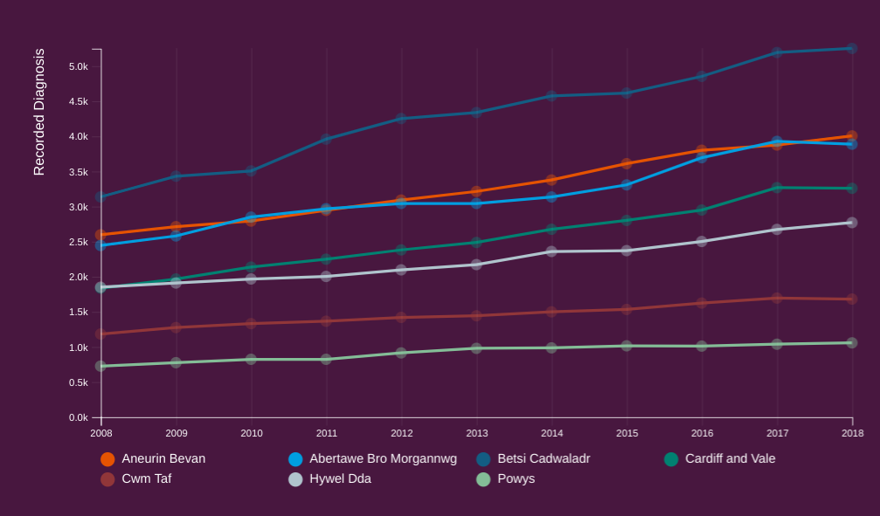

Alzheimer's research uk (2019)

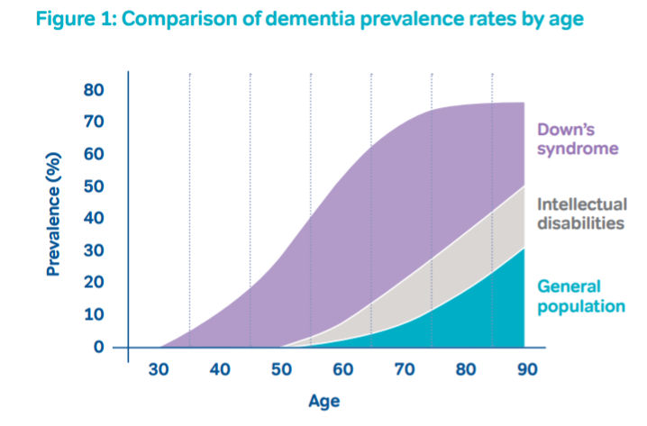
Mental Health Foundation. (2019).

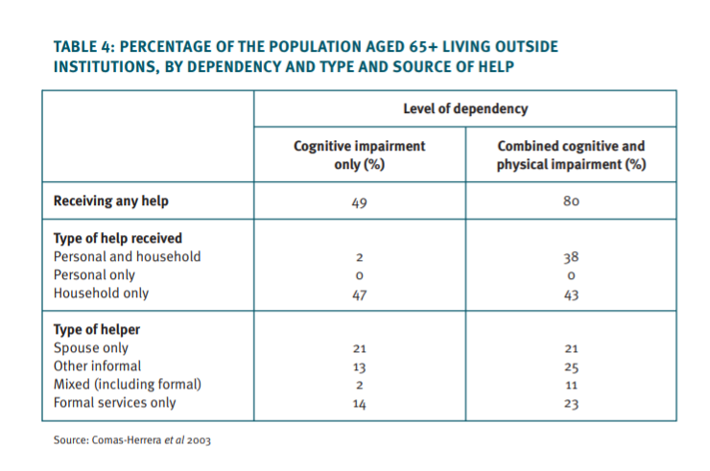
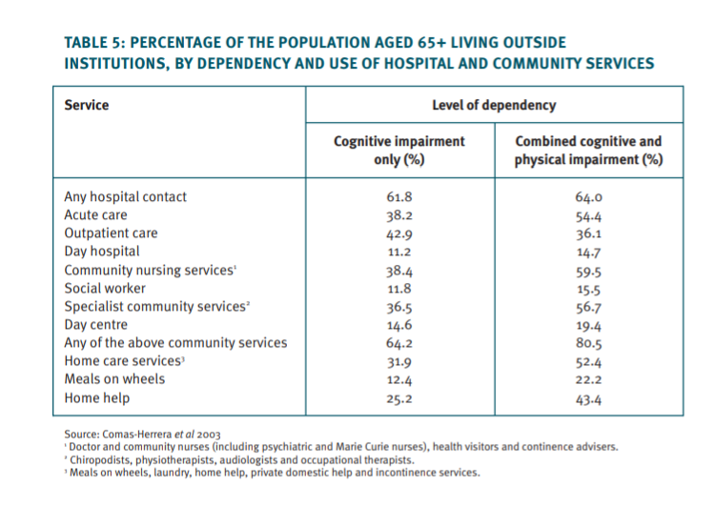

References
Alzheimer Europe. (2015). Glasgow Declaration. [online]. Available at : https://www.alz.co.uk/sites/default/files/pdfs/policy-alzheimer-europe.pdf. Accessed 24th April 2019.

Alzheimer’s Disease International. (2018). The state of the art of dementia research: New frontiers. London. [online]. Available at: https://www.alz.co.uk/research/WorldAlzheimerReport2018.pdf. Accessed 21st April 2019.

Alzheimers research UK. (2019). Dementia statistics hub. Diagnoses in the UK. [online] Available at:https://www.dementiastatistics.org/statistics/diagnoses-in-the-uk/. Accessed 20th April 2019.

Alzheimer's society. (2019). This is me. Alzheimer's society. London. [online]. Available at: https://www.alzheimers.org.uk/sites/default/files/2019-03/Alzheimers-Society_NEW_This-is-me-booklet_190318.pdf. Accessed 18th April 2019.

Alzheimers society. (2016). Keeping safe at home. London. [online]. Available at:https://www.alzheimers.org.uk/sites/default/files/pdf/living_with_dementia_-_keeping_safe_at_home.pdf. Accessed 26th April 2019.

Alzheimers society. (2016)Alzheimer’s Society briefing. (2017). Dementia Strategic Action Plan. Cardiff. 03 (17). [online]. Available at: http://senedd.assembly.wales/documents/s58459/Paper%201%20-%20Submission%20from%20Alzheimers%20Society.pdf. Accessed 23rd April 2019.

Dr Barrett,E. Burns,A. (2014). Department of Health. Dementia Revealed What Primary Care Needs to Know. Volume 2. England. [online]. Available at: https://www.england.nhs.uk/wp-content/uploads/2014/09/dementia-revealed-toolkit.pdf. Accessed 21st April 2019. Welsh Government. (2017). Together for a dementia friendly

Forget me not. (2019). Dementia day clubs. [online]. Available at: http://www.forgetmenotclubs.com/. Accessed 25th April 2019.

Health care research Wales. (2017). centre for ageing and dementia research. 2016-2017 Annual report. Swansea.

Hood, A. (2017). National Health Service. Changes in Dementia Incidence, Prevalence, Severity and Mortality. [online]. Available at: https://www.strategyunitwm.nhs.uk/sites/default/files/2017-09/Changes%20in%20Dementia%20Incidence%2C%20Prevalence%2C%20Severity%20and%20Mortality.pdf. Accessed 22nd April 2019.

International Classification of Diseases 10. (2019). World Health Organisation. Pg 23-25. [online]. Available at: https://www.who.int/classifications/icd/en/GRNBOOK.pdf. Accessed 20th April 2019.

Jopling,K. (2017).Age UK love later life. Promising approaches to living well with dementia. [online]. Available at:https://www.ageuk.org.uk/globalassets/age-uk/documents/reports-and-publications/reports-and-briefings/health--wellbeing/rb_feb2018_promising_approaches_to_living_well_with_dementia_report.pdf. Accessed 20th April 2019.

Lewis, S . (2017). RTPI Practice Advice. Dementia and town planning. Creating better environments for people living with dementia. London. [online]. Available at:https://www.rtpi.org.uk/media/2213533/dementia_and_town_planning_final.compressed.pdf. Accessed 19th April 2019.

Mental Health Foundation. (2019). Need2Know Hidden in Plain Sight – Dementia and Learning Disability. [online]. Accessed 21st April 2019.

National Health Service Wales. (2015). Dementia friendly health and social care environments. [online]. Available at: http://www.wales.nhs.uk/sites3/Documents/254/HBN%2008-02%20for%20Wales.pdf. Accessed 28th April 2019.

National Health Service Wales. (2018). Betsi Cadwaladr University Health Board. Dementia strategy 2018 - 2020. 1 (03). [online]. Available at: http://www.wales.nhs.uk/sitesplus/documents/861/BCUHB%20Dementia%20Strategy.pdf. Accessed 27th April 2019.

National Health Service Wales. (2014). The Use of Antipsychotics in Dementia – Information for Patients and their Carers. [online]. Available at: http://www.1000livesplus.wales.nhs.uk/sitesplus/documents/1011/%283%29antipsychotic%20leaflet.pdf. Accessed 20th April 2019.

O’Brien,T,J. Holmes,C. Jones,M. Jones,R. Livingston,G. McKeith,I. Mittler,P. Passmore,P. Ritchie,C. Robinson,L. Sampson,L,E. Taylor,P,J. Thomas,A. Burns,A. (2017). Clinical practice with anti-dementia drugs: A revised (third) consensus statement from the British Association for Psychopharmacology. Sage. [online]. Available at:https://www.bap.org.uk/pdfs/BAP_Guidelines-AntiDementia.pdf. Accessed 27th April 2019.

The Older People’s Commissioner for Wales. (2018).Rethinking Respite for People Affected by Dementia. Cardiff. [online]. Available at:https://lx.iriss.org.uk/sites/default/files/rethinking_respite_for_people_affected_by_dementia.pdf. Accessed 25th April 2019.

Poole,T. (2006). The Kings Fund. Dementia Care. London. [online]. Available at: https://www.kingsfund.org.uk/sites/default/files/dementia-care-wanless-background-paper-teresa-poole2006.pdf. Accessed 23rd April 2019.

Quince,C. (2012). Home truths: Housing services and support for people with dementia.Alzheimer’s Society. [online]. Available at: https://www.alzheimers.org.uk/sites/default/files/migrate/downloads/alzheimers_society_home_truths_report.pdf. Accessed 24th April 2019.

Swansea Council. (2017). Dementia support and advice. [online]. Available at: https://www.swansea.gov.uk/article/6579/Dementia-support-and-advice. Accessed 18th April 2019.

Social Care Wales. (2019). Service improvement / People with dementia / Dementia resource for care professionals. What is Dementia. [online]. Available at: https://socialcare.wales/service-improvement/what-is-dementia-an-introduction. Accessed 23rd April 2019.

Swansea Carers Centre. (2014). Making a positive difference to the lives of carers. [online]. Available at: http://www.swanseacarerscentre.org.uk/. Accessed 21st April 2019.

The British Psychological Society & The Royal College of Psychiatrists. (2007). NICE Clinical Guidelines, No. 42.Dementia: A NICE-SCIE Guideline on Supporting People With Dementia and Their Carers in Health and Social Care. [online]. Available at :https://www.ncbi.nlm.nih.gov/books/NBK55480/. Accessed 24th April 2019.

The Kings Fund. (2013). Developing Supportive Design for People with Dementia. London. [online]. Available at :https://www.kingsfund.org.uk/sites/default/files/field/field_publication_file/developing-supportive-design-for-people-with-dementia-kingsfund-jan13.pdf. Accessed 20th April 2019.

Thomas-Scott,S. (2018). Dementia Action Plan for Wales looks at antipsychotic use. Royal Pharmaceutical Society. [online]. Available at:https://www.pharmaceutical-journal.com/your-rps/dementia-action-plan-for-wales-looks-at-antipsychotic-use/20204471.article. Accessed 21st April 2019.

Wales 2017-22. WG30441. Cardiff. Available at: https://gov.wales/sites/default/files/consultations/2018-01/170109dementia-consultation-en.pdf. [online]. Accessed 21st April 2019.

Wilcox, J. (2018). Signpost. Journal of Dementia and Mental Health Care of Older People. 23 (2). Cardiff. [online]. Available at: http://dsdc.bangor.ac.uk/documents/Volume23Number2Autumn2018.pdf. Accessed 26th April 2019.

