Module: Research Methods II

Module Code: ECPS5002

Title: Can levels of emotional intelligence have an effect on a person’s recall of emotion-induced stimuli?

Abstract
The main purpose of this report is to explore whether there is any significance with high emotional intelligence or low emotional intelligence can have an effect on a person’s recall of emotional induced words such as negative, neutral and positive words. This was investigated by a study that was conducted by level 5 students.

Introduction
This report looks at how a person’s high emotional intelligence or low emotional intelligence can have an effect on their memory recall. In order to be able to understand this a study had been conducted by level 5 university students. The study conducted by the university students had looked at how the participant’s high emotional intelligence or low emotional intelligence can affect the participant’s memory recall by being introduced to an emotional induced stimuli. The emotion induced stimuli that was used within the study that was conducted by the level 5 university students were positive words, neutral words and negative words. According to (Mavrou, 2021) it is believed that people who have a higher emotional intelligence are more able to recall and regulate their experiences that could be an emotional part within their lives, therefore allowing the person with a higher emotional intelligence to be able to have a higher memory recall for the positive words, neutral words and negative words. They had also found that people who have a lower emotional intelligence and have also been diagnosed with language or cognitive impairments are more likely to have a lower memory recall for the positive words, neutral words and negative words (Mavrou, 2021). According to (Mavrou, 2021) they believe that a person who has a higher emotional intelligence are more able to regulate as well as recall emotional induced words such as positive, neutral and negative words more than a person who has a lower emotional intelligence (Mavrou, 2021). According to a study which was conducted by (Ciarrochi et al., 2000) they had also believed that people with a higher emotional intelligence would have a greater memory recall of emotional induced stimuli. However within their hypothesis they had also believed that their participants who were female who have a high emotional intelligence would also have an even higher memory recall of the emotional induced stimuli then the male participants who had taken part within their study who would have a high emotional intelligence (Ciarrochi et al., 2000).
Method
Participants
During the study conducted by the level 5 university students there were 30 participants who had voluntarily taken part within this study. The participants were all university students who were taking undergraduate courses within the University of Wales Trinity Saint David. The number of females who in which had taken part within this study were 22 and the number of male who in which had taken part within this study were 8. The age range for all of the participants who had taken part were 18 to 51 (M= 31.66; SD= 11.152). In order for the participants to be able to take part within the researchers study they were required to sign up to the study voluntarily via a link within the universities psychology department’s Experimental Management system (EMS).
Design
The first independent variable within this study is emotional intelligence. This variable has a between subject factor. This is a between subject factor because it has two levels which are high and low. The second independent variable within this study is an emotion included stimuli. This has a within subject factor. This factor has three levels which are negative, neutral and positive words. This study also has dependent variable which is the number of positive, neutral and negative words were correctly recorded by the participant. The analysis that will occur once the participant has taken part within the study is a mixed ANOVA analysis.
Materials
In order to conduct this study, the students had to design the study and apply ethical approval. This was done by an application form in which the level 5 student were required to fill out and then send to the ethical panel for approval (See appendix A). In order for the study to be conducted by the level 5 students had be designed through the Qualtrics computer programme. This was used in order to be able to present the participant with the questionnaire created by the level 5 students before they would take part within the main part of the study. The Qualtrics computer programme also allows the researchers to put in the consent form before the questionnaire in order for the participant to be presented with any important information that they should know about before they take part within the questionnaire. (see appendix A)
After the participant has been presented with as well as has completed the questionnaire they are then shown a debrief form with information on the questionnaire and will also be presented with the researchers contact information should they wish to contact the researchers (see appendix B).The main part of the study was run through a computer software called superlabs. This allowed the positive, neutral and negative words to be presented to the participant in order for the researchers to gather their data (see appendix C).
Procedure
During the study the participants were greeted within a waiting room by the
Researcher and then taken to a room where they were talked through what the tasks they were required to do within the study. The researcher would tell the participant that they must complete a questionnaire which is presented to them on a laptop. They are then told that once they have completed the questionnaire that was resented on the laptop they are then to move to the computer and take part within the main section of the study. Once the researcher has left the room the participant can then begin the study.
Firstly, the participant would be presented with a consent form which would have information of how long the study will take. It also informs the participants that if they wish to withdraw from the study at any point during the study they were able to as well as that the data collected from the study is confidential. After this the participant will then be required to complete a questionnaire. Once the participants had finished the questionnaire they are then presented with a debrief form which provided the participant with information on what the aim of the questionnaire was about and also provides the researchers information if the participants wishes to contact them about the study after they have completed the study.
After the participant has been presented with the debrief form they are then instructed to move to the computer next to them and take part within the main part of the study. During the study the participant is presented with 20 positive words which would come on the screen one at a time and then presented with a positive recall question. This had occurred twice more with negative and neutral words with a neutral or negative recall question in between the words.
Results
In order to explore the effect of emotional intelligence has on their recall of emotional included stimulate words a three way mixed ANOVA analysis was conducted on the data which was collected from the study. From this data analysis it showed that there was a significant score of the participants recalling negative words. During the data analysis it was found that the three-way interaction which is between genders, the emotional induced stimuli and emotional intelligence was not significant. F (2, 52) = .62, p = .54, np2 = .02. It was also found that the two-way interactions which were between the emotional induced stimulated words and genders (F (2, 52) = .17, p = .84, np2 = .007), as well as the emotional induced stimulated words and emotional intelligence (F (2, 52) = 1.09, p = .34, np2 = .04), and emotional intelligence and genders (F (1, 26) = 2.7, p = .12, np2 = .093) had also shown no significance within the results. The data analysis of the results of this study had also shown that the main effect of the gender of the participant F (1, 26) = .48, p = 0.5, np2 = .18 was not significant. The main effect of emotional intelligence of the participant F (1, 26) = 2.5, p =.12, np2 = .89 was also not significant as well as the main effect of the emotional induced stimulated words F (2, 52) = 3.73, p = .30, np2 = .13. However, after looking at the Pairwise comparisons table there was a result of a significant score between the participant’s recall of negative words (M = 10.33, SD = 4.10) and their recall of positive (M = 9.37, SD = 3.98) or neutral words (M = 7.93, SD = 3.23). (See appendix D)
Discussion
The study that was conducted by the level 5 students was conducted with the aim of being able study how the participant’s emotional intelligence can have an effect on their memory recall of emotional induced words such as positive words, neutral words and negative words. The results data collected from the level 5 university students conducting the study had found that there was a significant score of negative words that had been recalled by the participants. The data that was collected had also found that there was also a significant score between the participants who have a lower emotional intelligence and their memory recall of the negative words that were presented to them during the study. These finding can suggest that the people who have a lower emotional intelligence can have a greater memory recall of negative emotional induced words more than positive words or neutral words. However, this does not support the hypothesis by (Mavrou, 2021) as they believed that a person who has a higher emotional intelligence would be able to recall the emotional induced words more than a person who has a lower emotional intelligence. The results did however support (Ciarrochi et al., 2000) claims as the data analysis had shown that the female participants who had taken part within the level 5 university students study had shown a higher memory recall of the negative words. However this was also consistent within females who had either a high emotional intelligence or a lower emotional intelligence.

Reference
Mavrou, I. (2021). Emotional intelligence, working memory, and emotional vocabulary in L1 and L2: Interactions and dissociations. Lingua, 257, 103083. https://doi.org/10.1016/j.lingua.2021.103083
Ciarrochi, J. V., Chan, A. Y. C., & Caputi, P. (2000). A critical evaluation of the emotional intelligence construct. Personality and Individual Differences, 28(3), 539–561. https://doi.org/10.1016/s0191-8869(99)00119-1

‌
‌

Appendices
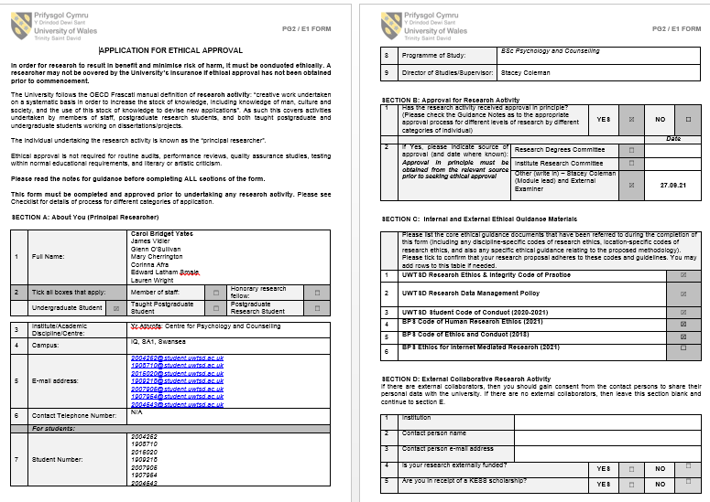
Appendix A

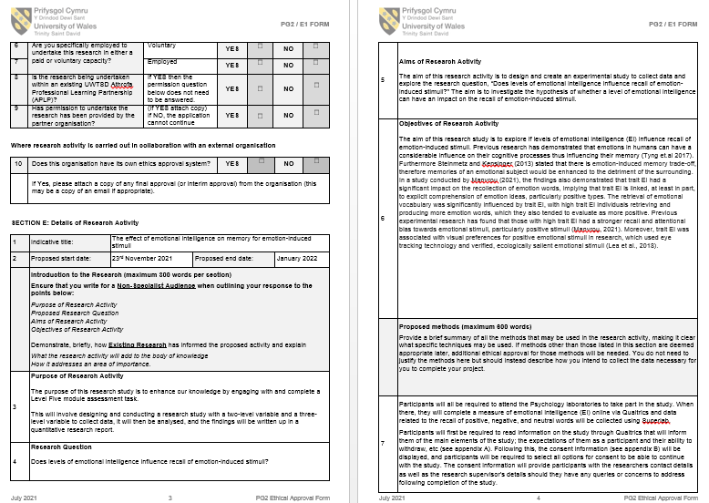

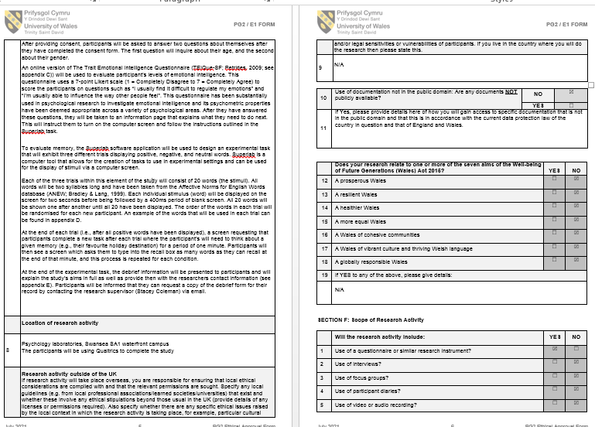

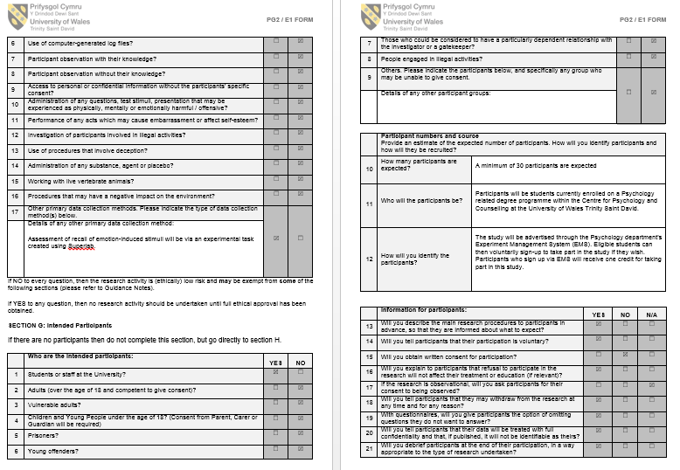

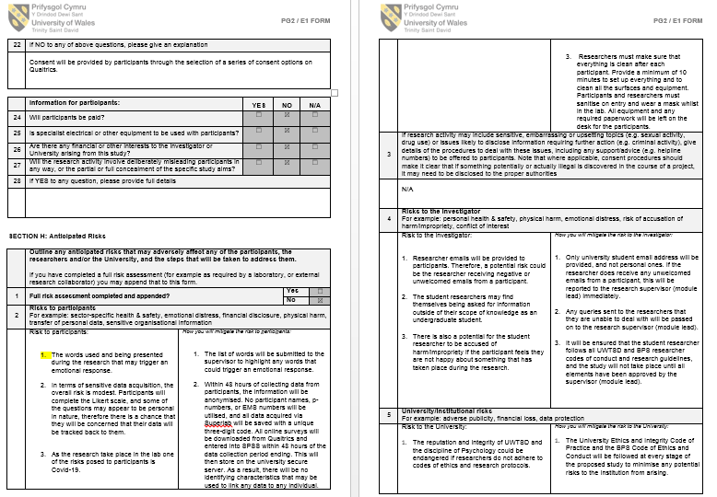

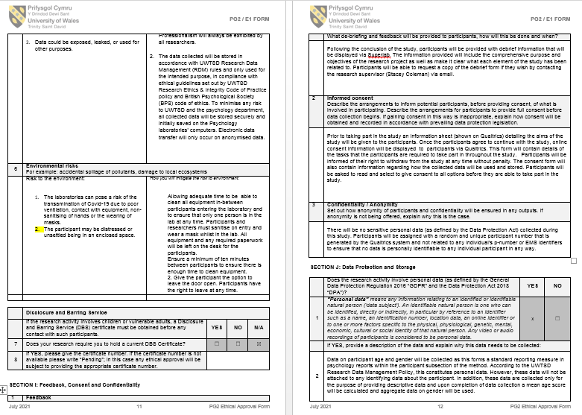

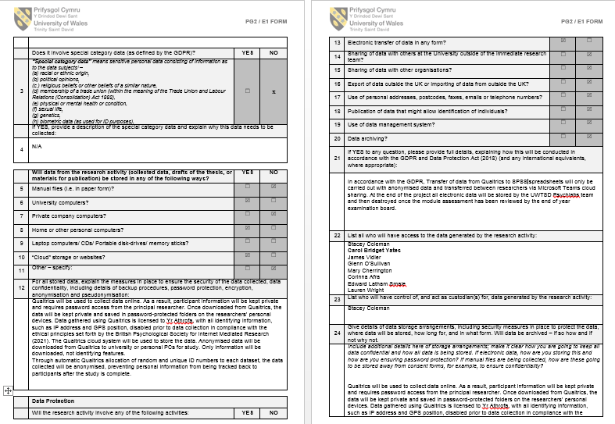

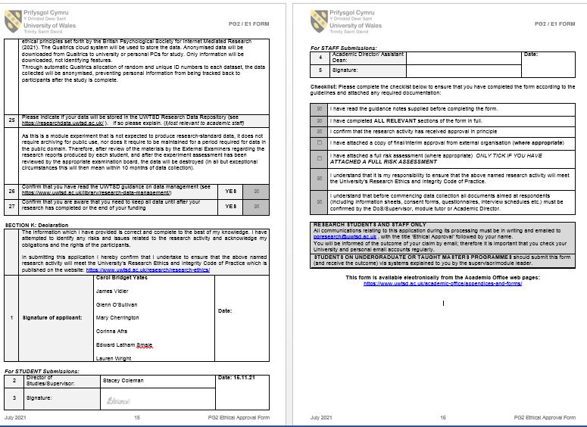

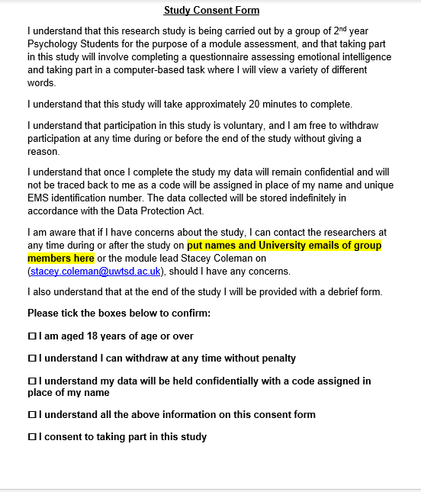
Appendix B

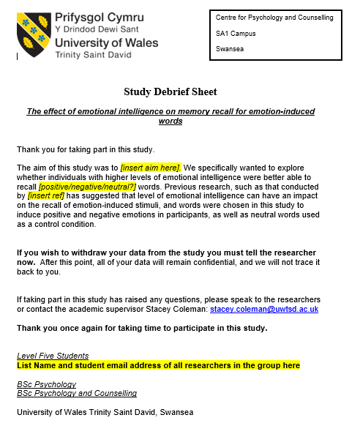
Appendix C

Appendix E
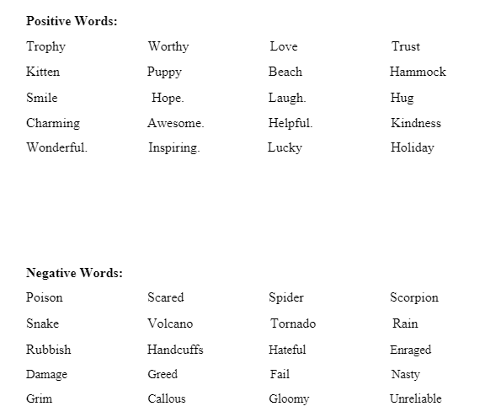

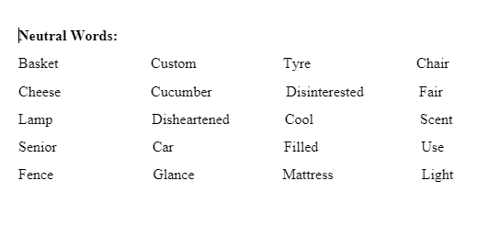

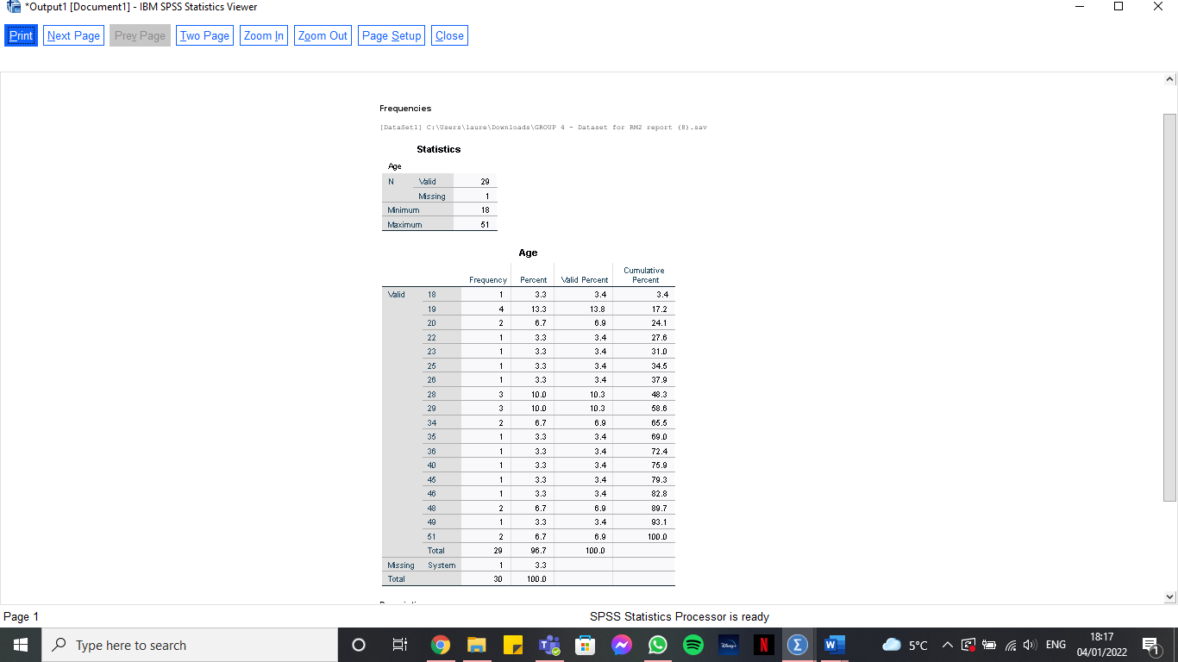
Appendix D:



