Games for positive impact

Table of Contents
Life is Strange 1
Night in the Woods 2
Bibliography 3

Life is Strange

Life is Strange [1] is a linear story game about the story of Max Caulfield [2] and her relationship with her friends as she explores her new ability to rewind time. As Max [2] explores these new powers, she is able to uncover and prevent major travesties in her hometown, Arcadia Bay [3]. The main thesis of the game is to show the consequences of your actions along with the butterfly effect [4] and chaos theory [5] in action. The game is rated a PEGI 16 [6], as there are heavy topics such as drug use, violence, strong language, suicide and trafficking.
The game shows multiple examples of childhood trauma, varying from the loss of a parent at a young age to manipulation from parents and high standards to be perfect. Nathan Prescott [7] and Victoria Chase [8] are both examples of childhood trauma from their parents that have a high status. Their parents are both very rich, Nathan’s parents own his and Max’s school, Blackwell Academy [9] and Victoria’s [8] parents own an art gallery. Their parents both have very high expectations for them and force them to strive to be perfect like them to not damage their family’s reputation. This manipulation lead both of them to grow up as bullies, they both attend parties and Nathan [8] supplies drugs to the attendants. Victoria [8] makes sarcastic comments towards students to assert dominance and specifically picks on Kate Marsh [10] due to an inappropriate video of her being released after she was drugged by Nathan at a party.
Throughout the game, Max [2] starts to care about Victoria’s [8] safety after discovering Nathan likes to drug girls and take pictures of them. Even though Victoria [8] has picked on Max [2], she still cares about Victoria’s [8] safety.
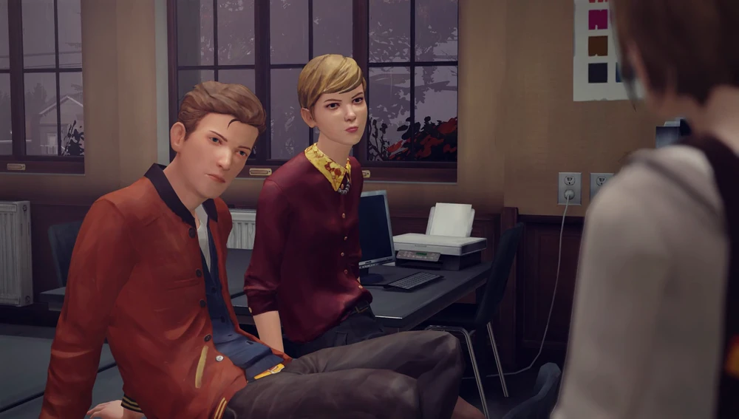
Max’s childhood friend, Chloe Price’s [11] father [12] died when she was 14 years old due to a car accident, leading Chloe’s [11] attitude towards life to drastically change. She also develops anger and abandonment issues due to the passing of her best friend, Rachel Amber [13] and her father.
Nathan Prescott [7] and Victoria Chase [8]
Her mother, Joyce, [14] remarries another man, David Madsen [15], and David [15] and Chloe [11] do not get along at all. David [15] is very strict and hot-headed, and suspicious of almost every student in Blackwell, he is the head of security in Blackwell [9]. As Chloe [11] deliberately rebels against her parents, she is seen to smoke weed in her room and she knows how to use a gun.
Max [2] gains the ability to travel far back in time after interacting with an old picture of her and Chloe [11]. She is able to stop Chloe’s dad, William [12], from leaving to pick up Chloe’s mother [14] which prevents him from getting in the car crash. However, after this happens a whole new reality happens instead. Chloe [11] gets into a car crash and is paralysed from the neck down, leaving her family in debt due to the expensive equipment needed for Chloe [11]. Chloe [11] asks Max [2] to euthanise her, to free her from her suffering and to help her parents from their debt.
The game represents Chloe’s [11] personality as an angsty teenager well, showing that she struggles with mental health and her poor life choices but doesn’t romanticise her drug and alcohol addictions to make it look sexy. Her being a moody teenager isn’t the butt of any joke either, it shows her quarrels with her mother and stepfather which makes their relationship appear more realistic. It is implied that Chloe was in love with Rachel Amber [13] and later falls in love with Max [2]. As Max [2] and Chloe [11] reconnect with each other, Chloe [11] starts to gain stronger feelings for Max [2].
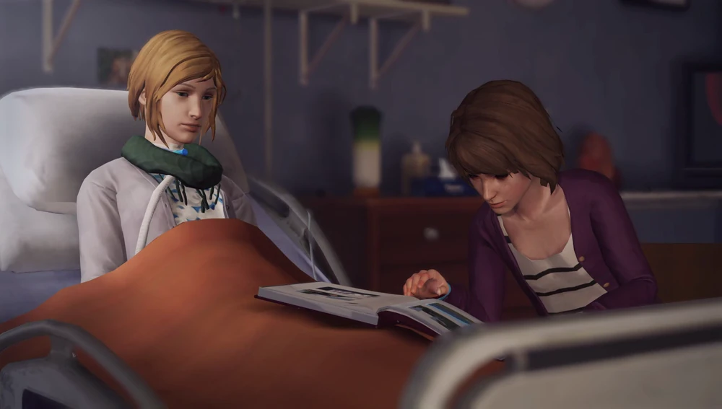
Chloe [11] and Max [2] in an alternative reality

Max [2] doesn’t treat Chloe [11] any different when she is paralysed, Max [2] is more shocked than anything about the fact that she created this new reality and put Chloe [11] in this situation when she was only trying to help. Chloe [11] still has her rebellious personality, even when she is unable to move.
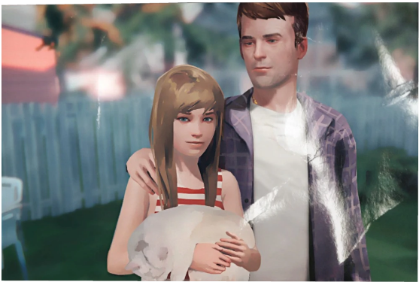
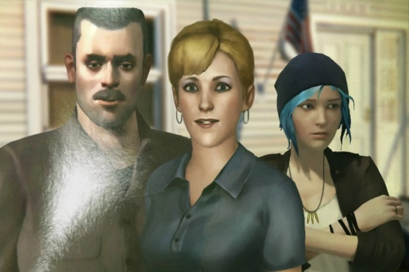
One of Max’s [2] friend, Kate Marsh [10], gets bullied at school due to an inappropriate video of her that got released by Nathan Prescott [7] after she was drugged at a party. Kate’s [10] family are heavily religious, when they find out about Kate’s [10] video, they are very disappointed with her, leading Kate [10] to become very depressed as she believes no one cares about her. Due to the bullying, Kate [10] becomes suicidal and jumps off the roof of one of the buildings in Blackwell [9], there is an option to prevent this by simply spending time with her, this makes Kate [10] feel slightly better as she realises someone cares about her.
Chloe [11] before and after her father's [12] passing
The game shows struggle that both men and women of different ages experience, Max [2] being a girl isn’t the main part of the story or her character, the story shows how different life is compared to the people around her.
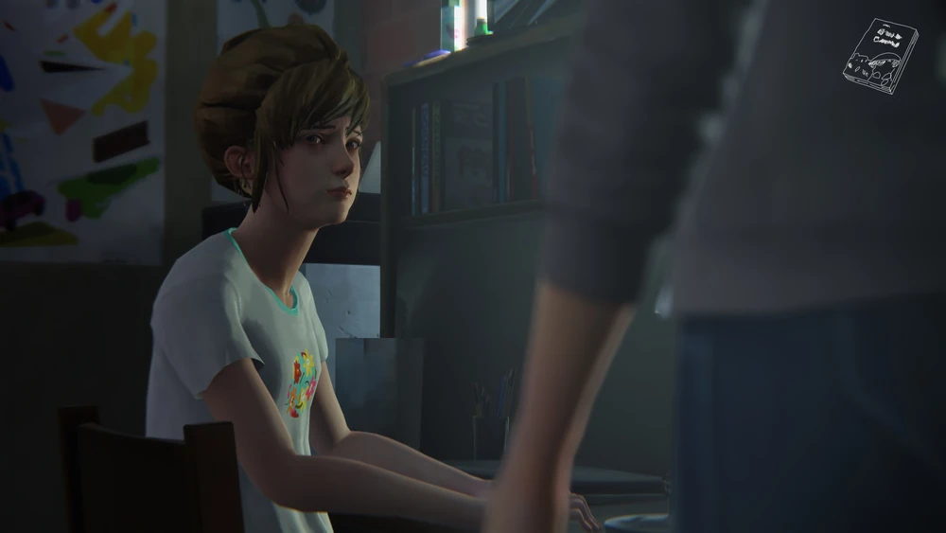
Kate [10] crying whilst talking to Max [2] about the video of her
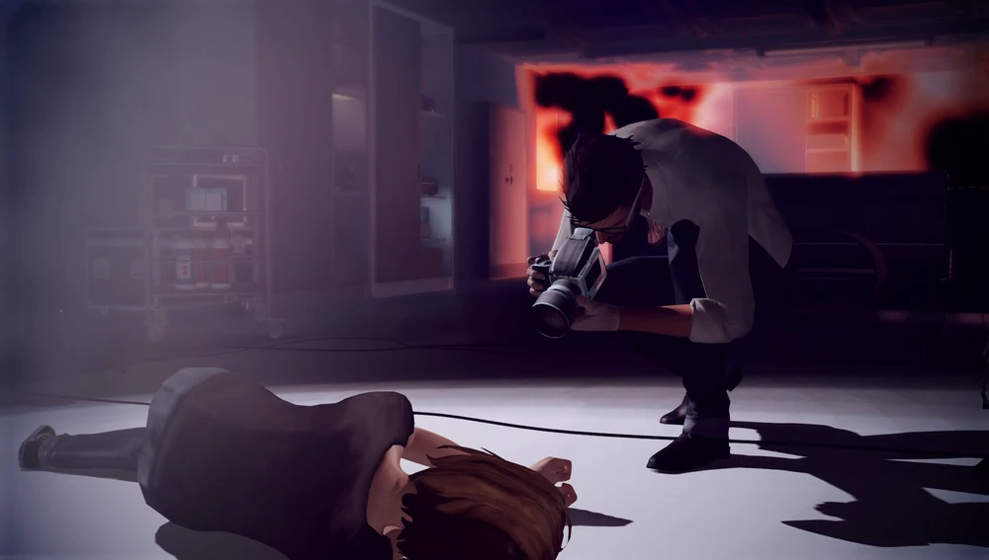
During the early stages of the game, Nathan Prescott [7] is shown as the main protagonist, but as the game progresses, Mark Jefferson [16], Max’s [2] photography teacher is then revealed as the main antagonist. It is revealed that he was behind the missing and death of Rachel Amber [14] and has been trafficking girls in Blackwell Academy [9] by drugging them and taking pictures of them in a venerable state. He used his high status and admiration of fans to get away with his trafficking, along with manipulating Nathan [7] to help him which made Nathan [7] a suspect.
Mark Jefferson [16] taking a photo of Max [2] tied up and drugged

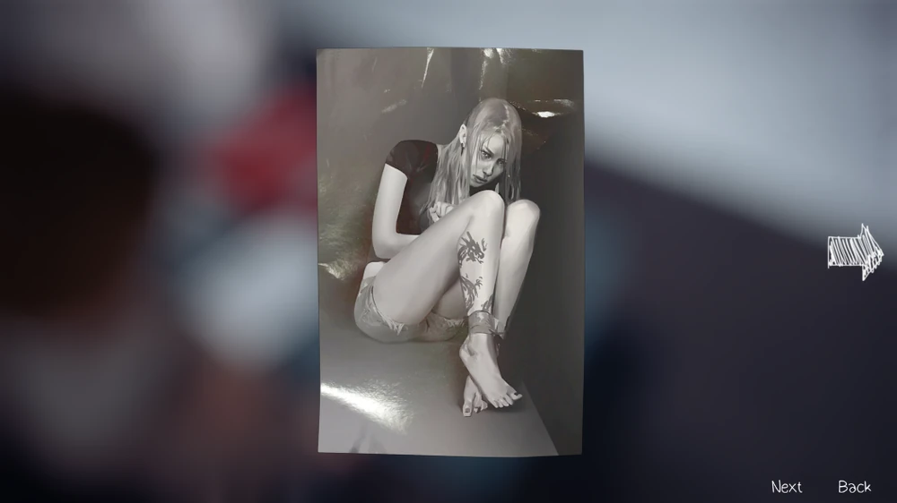
Max [2] finds the truth about Nathan [7] by snooping in his dormitory to find clues on his drugging and trafficking. She finds notes and letters from Nathan’s [7] father saying to not contact him in public and reminders to take his medication. Due to his trauma, Nathan [7] has severe anger issues and often lashes out at people. His father wants him to keep a good reputation for his family and sends him letters to remind him to avoid lashing out at him in public to maintain their reputation.
A photo of Rachel Amber [13] tied up and drugged, taken by Mark Jefferson [16]

In another reality Max [2] enters, she saves herself, Chloe [11] and Victoria [8] from being trafficked and killed by Mr Jefferson and prevents Kate [10] from committing suicide. However, although Mr Jefferson [16] is arrested and Max wins a trip to an art exhibition in San Fransico, she receives a call from Chloe who is back in Arcadia Bay and tells her that a storm is coming to wipe out everything and everyone in Arcadia Bay. No matter the reality, something bad happens, nothing in life is perfect.
The start of the game shows Max [2] walking towards a lighthouse while a storm occurs, the storm becomes as crucial part of the story throughout the game and has a scientific link towards Max’s [2] powers. As Max continues to use her powers, it creates a weather anomaly [17] that forms a hurricane that makes its way to Arcadia Bay [3]. This scientific link adds a slight sense of realism to the story.

Night in the Woods
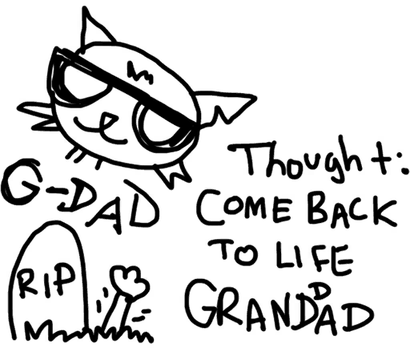
Night in the Woods [18] is a 2D platformer story-based game about the story of the main character, Mae Borowski [19], an adventurous and troublesome cat and the mysteries in her hometown, Possum Springs [20]. Mae [19] struggles with dissociation [21] and depression [22], which is why she dropped out of college. Although she doesn’t outright say it, she talks about an episode she had 6 years prior to the game where she started beating someone with a baseball bat in front of the whole school without realising. After this incident, Mae [19] was told to keep a journal [23] by her doctor [24] which she uses throughout the game to make small drawings of her experiences.
One of Mae's [19] drawings in her journal [23]
There are 3 members in Mae’s [19] friend group: Bea [25], Angus [26] and Gregg [27]. As Mae [19] reconnects with her old friends, each one of them has a different route where the player can spend time with them for multiple days. After spending a couple of days with each character, they eventually start opening up to Mae [19] about their past and what’s troubling them. The story of Night in the Woods [18] highlights realistic teenage friend groups, it shows the awkward moments as Mae [19] and her friends open up to each other and shows the mistakes Mae [20] makes and how she learns from them. Night in the Woods [18] shows realistic friendships with (late) teenagers, they aren’t afraid to be honest with each other when someone has done something wrong but also comfort each other when they are upset.

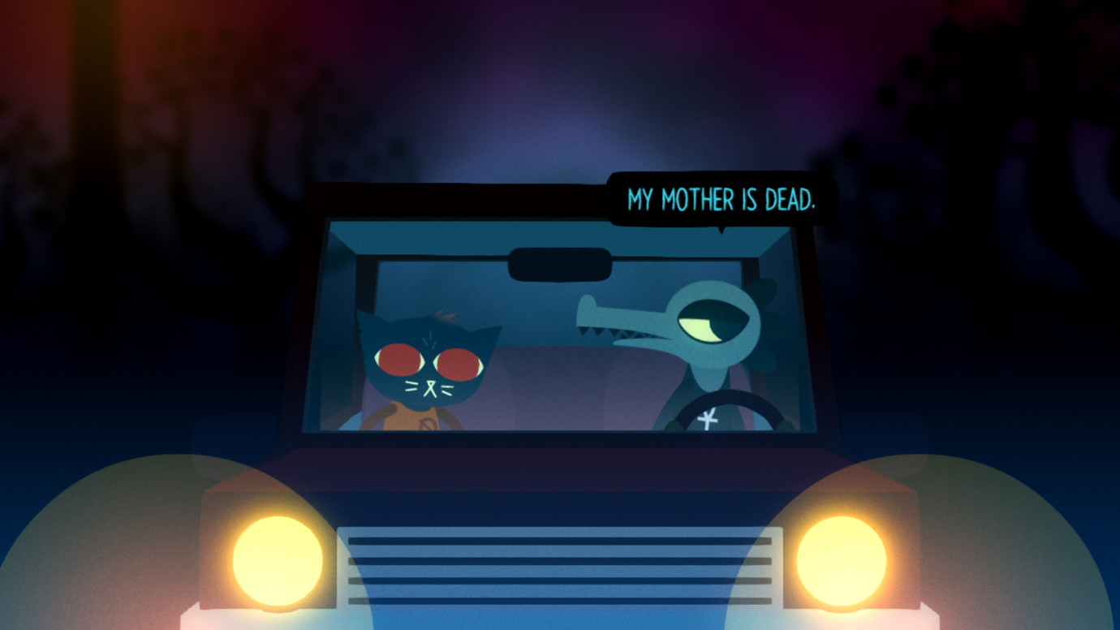
Bea [25] has experienced losing her mother, which leads the cost of her mother’s medical bills and funeral to cause Bea’s [25] dad to sell their house and move to an apartment. Leaving Bea [25] to get a job to help her dad as he didn’t take the passing well. Bea [25] has always wanted to go to college, but due to her mother passing she wasn’t able to afford it. When Mae [19] and Bea [25] spend time together, Bea [25] tells Mae [19] she doesn’t realise how lucky she is to even be able to go to college, let alone drop out.
Bea [25] telling Mae [19] her mother is dead

Gregg [27] is a misfit; he enjoys breaking things and committing “crimes”. Gregg [27] gets overly excited, and he worries it might affect his relationship with Angus. Gregg [27] and Angus [26] have a healthy relationship, but they are both very different people. He worries about losing Angus [26] and believes he wouldn’t have a future without him.
Gregg [27] opening up to Mae [19]
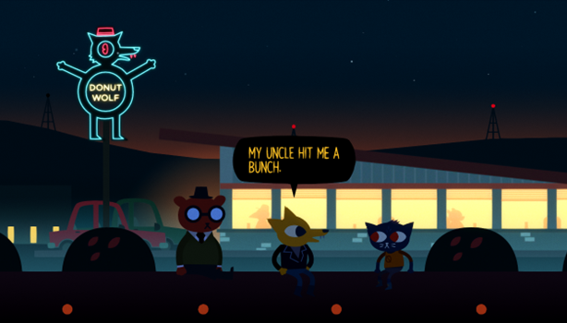
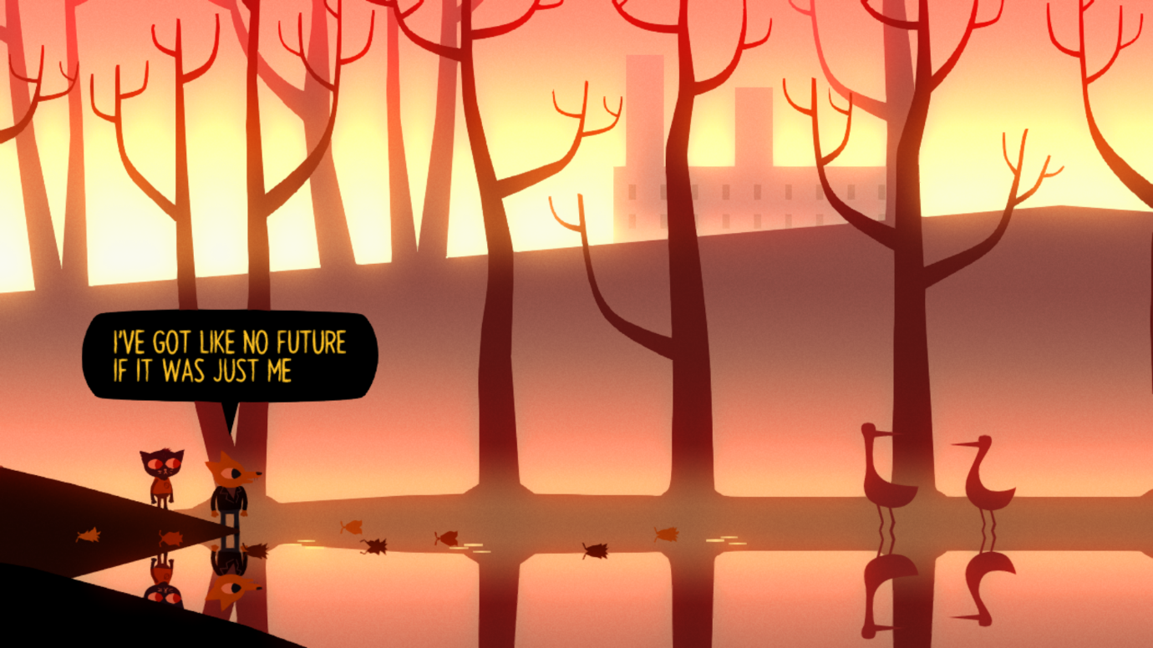
Gregg [27] has also talked about his past with his family. Due to his high energy, his parents couldn’t handle him and dropped him at his uncle’s house for a weekend. There, Gregg’s [27] uncle told him to look after a flock of sheep, which lead Gregg [27] to letting them loose and one got hit by a car, and Gregg’s [27] uncle hit him.
Gregg [27] talking to Mae [19] with Angus [26]
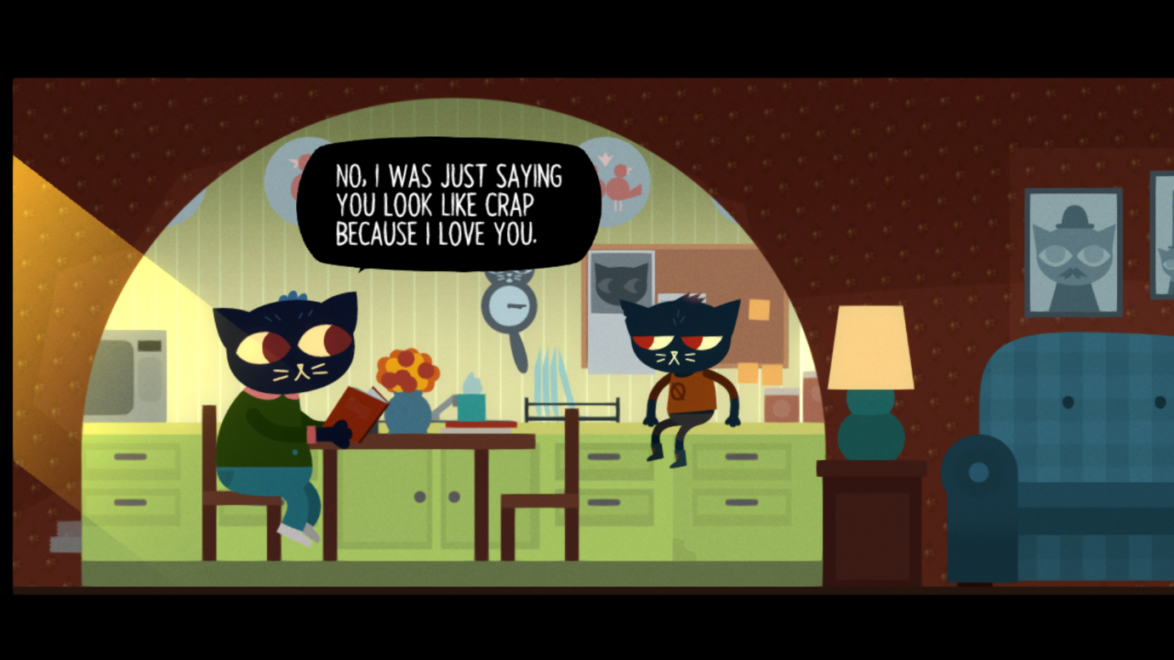
Angus [26] and Mae [19] don’t spend a lot of time together, they are mainly friends because of Gregg [27] and through the band. Angus [26] has a route where he opens up to Mae [19] about his extremely abusive parents. His father would often beat him, and his mother would starve him and lock him in their pantry.
Many people that have played Night in the Woods [18] have come out to say that they feel seen due to the representation of LGBT couples and mental health issues, along with family trauma. These are represented subtly throughout the game and treated as an everyday occurrence and not made a big deal about it which further adds to realism. Mae’s [19] design can also be seen as androgynous; some players first thought Mae [19] was a boy, due to the art style in the game. It’s not obvious at first what gender some characters are, and because the dialogue isn’t voiced.
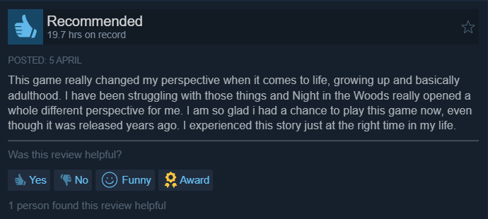
Positive Steam review of Night in the Woods [28]
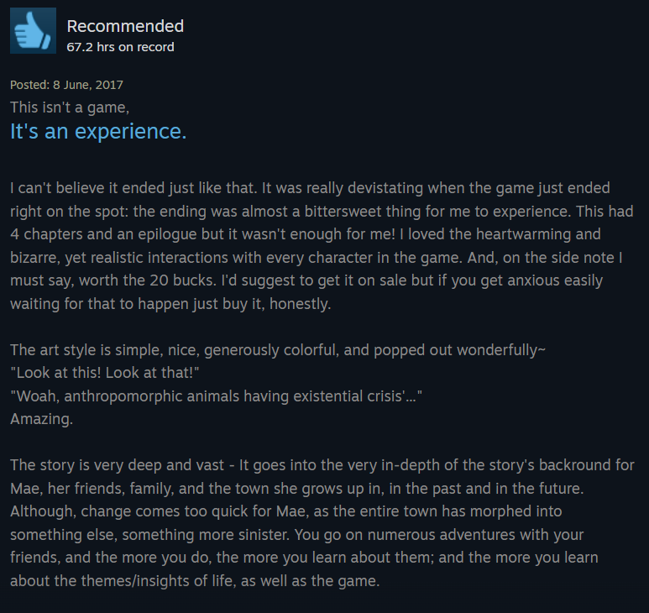
Positive Steam review of Night in the Woods [29]
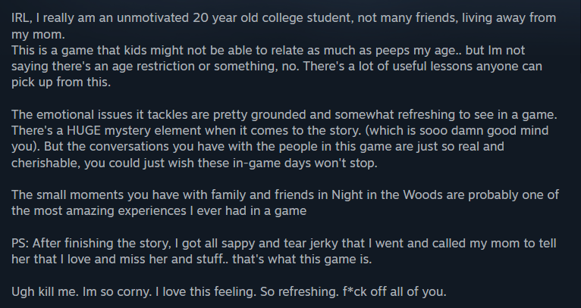
Positive Steam review of Night in the Woods [30]

Night in the Woods [18] has been described to be more of an experience than a game, due to the minimal gameplay in the game. There is more focus on the story than gameplay. To further feel like the player is a part of the game, there are mini games played through Mae’s [19] perspective to complete certain tasks and when she spends time with her friends.
There is no specific target audience for the game, but the majority of the characters that are involved with Mae [19] are very clearly alternative teenagers and people in their early twenties. Bea [25] is a goth and Gregg [27] is a punk. Other characters that are friends of Mae [19], Bea [25] and Gregg [27] wear alternative fashion styles, similar to Bea [25] and Gregg [27].
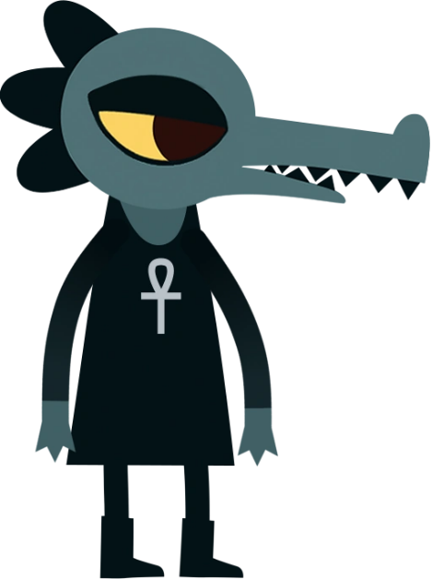
Bea's [25] full body design
Bea [25] wears an ankh [31] symbol around her neck, the Ankh [31] is an ancient Egyptian hieroglyphic symbol that represents immortality, life and the afterlife. Many gothic people wear this symbol and have adapted it in ways to match their style, but also wear it for its meaning.
Mae's [19] mother, Candy [32], has said that Mae is a miracle baby [33] and said she had been through multiple miscarriages before Mae [19] was born. Candy [33] believes in God and works in the local church, she believes that Mae [19] was a blessing from God. She doesn’t force Mae [19] to be religious, but she does offer that she tries it eventually. This shows that Candy [32] respects Mae’s [19] decisions and won’t force her to do anything she doesn’t feel comfortable with.
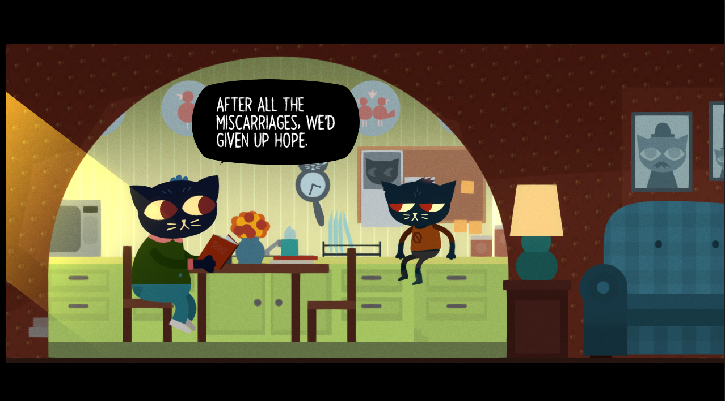
Candy [32] talking to Mae [19] about her miscarriage
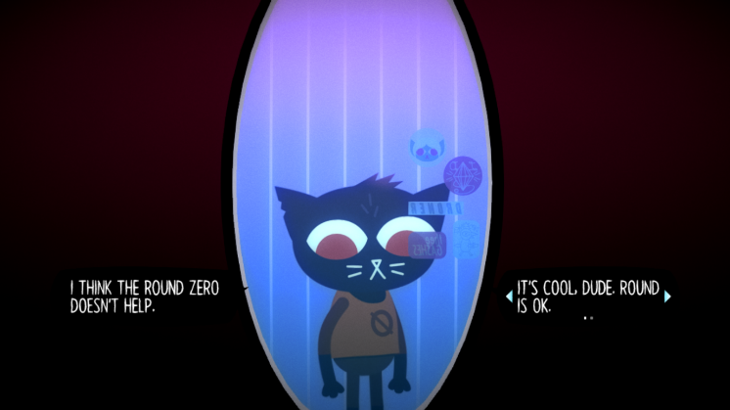
Mae [19] also has self-image issues, she has a chubby body and has been called “sturdy” by her grandfather [34]. This isn’t the main focus of the game and just a one-time thing that appears. There are two options the player can choose for Mae [19] to think when she talks about her body in the mirror, but neither effect the gameplay, Mae [19] just brushes it off and carries on with her day. None of the other characters bring up Mae [19] being chubby or use it to make fun of her.
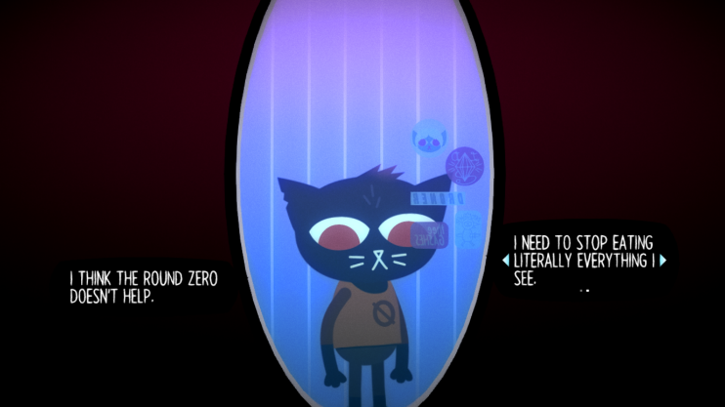
Mae's [19] thoughts about her body

Bibliography

[1] Official website for Square Enix (Apr, 1. 2003) Life is Strange [Online]
Available: https://lifeisstrange.square-enix-games.com/en-gb/games/life-is-strange-remastered-collection

[2] Life is Strange Fandom Wikipedia (18, Oct, 2004) Life is Strange Wiki [Online]
Available: Maxine Caulfield | Life is Strange Wiki | Fandom

[3] Life is Strange Fandom Wikipedia (18, Oct, 2004) Life is Strange Wiki [Online]
Available: https://life-is-strange.fandom.com/wiki/Arcadia_Bay

[4] D.Pilat and Dr. S.Krastev (Date Unknown) The Butterfly Effect [Online]
Available: https://thedecisionlab.com/reference-guide/economics/the-butterfly-effect

[5] S.E. Jorgensen (Aug, 6. 2008) Chaos [Online]
Available: https://www.sciencedirect.com/science/chapter/referencework/abs/pii/B9780080454054001488

[6] Official website for PEGI (Apr, 9. 2003) Life is Strange [Online]
Available: https://pegi.info/search-pegi?q=Life%20Is%20Strange&op=Search&age%5B0%5D=&descriptor%5B0%5D=&publisher=&platform%5B0%5D=&release_year%5B0%5D=&page=3&form_build_id=form-T4guuonK5gIrqc3Moa5jBa9ihLVcyQcc0k-BgPdRPxA&form_id=pegi_search_form

[7] Life is Strange Fandom Wikipedia (18, Oct, 2004) Life is Strange Wiki [Online]
Available: https://life-is-strange.fandom.com/wiki/Nathan_Prescott

[8] Life is Strange Fandom Wikipedia (18, Oct, 2004) Life is Strange Wiki [Online]
Available: https://life-is-strange.fandom.com/wiki/Victoria_Chase

[9] Life is Strange Fandom Wikipedia (18, Oct, 2004) Life is Strange Wiki [Online]
Available: https://life-is-strange.fandom.com/wiki/Blackwell_Academy

[10] Life is Strange Fandom Wikipedia (18, Oct, 2004) Life is Strange Wiki [Online]
Available: https://life-is-strange.fandom.com/wiki/Kate_Marsh

[11] Life is Strange Fandom Wikipedia (18, Oct, 2004) Life is Strange Wiki [Online]
Available: Chloe Price | Life is Strange Wiki | Fandom

[12] Life is Strange Fandom Wikipedia (18, Oct, 2004) Life is Strange Wiki [Online]
Available: William Price | Life is Strange Wiki | Fandom

[13] Life is Strange Fandom Wikipedia (18, Oct, 2004) Life is Strange Wiki [Online]
Available: Rachel Amber | Life is Strange Wiki | Fandom

[14] Life is Strange Fandom Wikipedia (18, Oct, 2004) Life is Strange Wiki [Online]
Available: Joyce Price | Life is Strange Wiki | Fandom

[15] Life is Strange Fandom Wikipedia (18, Oct, 2004) Life is Strange Wiki [Online]
Available: David Madsen | Life is Strange Wiki | Fandom

[16] Life is Strange Fandom Wikipedia (18, Oct, 2004) Life is Strange Wiki [Online]
Available: Mark Jefferson | Life is Strange Wiki | Fandom

[17] T.Allsworth (Nov, 2. 2024) Weather Anomaly: Departure from Long-Term Average Value [Online]
Available: https://timsweather.au/weather-anomaly

[18] Official website for Night in the Woods (21 Feb, 2017) Night in the Woods [Online]
Available: http://www.nightinthewoods.com/

[19] Night in the Woods Fandom Wikipedia (18 Oct, 2004) Night in the Woods Wiki [Online]
Available: Mae Borowski | Night in the Woods Wiki | Fandom

[20] Night in the Woods Fandom Wikipedia (18, Oct, 2004) Night in the Woods Wiki [Online]
Available: https://nightinthewoods.fandom.com/wiki/Possum_Springs

[21] Official NHS website for dissociative disorders (14, Aug, 2023) Dissociative disorders [Online]
Available: Dissociative disorders - NHS

[22] Official NHS website for depression (16, May, 2023) Depression in children and young people [Online]
Available: https://www.nhs.uk/mental-health/children-and-young-adults/advice-for-parents/children-depressed-signs/

[23] Night in the Woods Fandom Wikipedia (18, Oct, 2004) Night in the Woods Wiki [Online]
Available: Mae Borowski/Journal | Night in the Woods Wiki | Fandom

[24] Night in the Woods Fandom Wikipedia (18, Oct, 2004) Night in the Woods Wiki [Online]
Available: Dr. Hank | Night in the Woods Wiki | Fandom

[25] Night in the Woods Fandom Wikipedia (18, Oct, 2004) Night in the Woods Wiki [Online]
Available: Bea Santello | Night in the Woods Wiki | Fandom

[26] Night in the Woods Fandom Wikipedia (18, Oct, 2004) Night in the Woods Wiki [Online]
Available: Angus Delaney | Night in the Woods Wiki | Fandom

[27] Night in the Woods Fandom Wikipedia (18, Oct, 2004) Night in the Woods Wiki [Online]
Available: Gregg Lee | Night in the Woods Wiki | Fandom

[28] zuzu ִֶָ۶ৎ˖ִ ˚[zuzu ִֶָ۶ৎ˖ִ ˚] “This game really changed my perspective when it comes to life”, Steam, (5, Apr)
Available: https://steamcommunity.com/profiles/76561198156488981/
[29] protein shake gaming [autistlcshawty] “This isn’t a game, it’s an experience.”, Steam, (8, Jun, 2017)
Available: https://steamcommunity.com/id/autistlcshawty

[30] qawal [quotabee] “IRL, I really am a unmotivated 20 year old college student”, Steam (20, Oct, 2017)
Available: https://steamcommunity.com/id/quotabee

[31] The College of Psychic Studies (12, Apr, 2024) The ultimate meaning of the Ancient Egyptian Ankh [Online]
Available : https://www.collegeofpsychicstudies.co.uk/enlighten/the-ultimate-meaning-of-the-ancient-egyptian-ankh

[32] Night in the Woods Fandom Wikipedia (18, Oct, 2004) Night in the Woods Wiki [Online]
Available: https://nightinthewoods.fandom.com/wiki/Candy_Borowski

[33] O.Kessler, (2, Jul, 2025) Miracle Baby Meaning: What It Is & 7 Things to Know [Online]
Available: https://www.marriage.com/advice/pregnancy/miracle-baby-meaning/

[34] Night in the Woods Fandom Wikipedia (18, Oct, 2004) Night in the Woods Wiki [Online]
Available: https://nightinthewoods.fandom.com/wiki/Mae%27s_Grandfather

