PROGRAMME: MASTER OF BUSINESS ADMINISTRATION
MODULE: INTERNATIONAL BUSINESS CONCEPTS
MODULE CODE: LCMB7034
LECTURER: AKSHAY NARAYANAN TAONGA KAONGA SOBERE SNITHERS
ASSIGNMENT TITLE: REPORT
STUDENT NAME:
STUDENT ID NUMBER:

Table of Contents
Section 1: Globalized Business Environment 5
1. Organisational Classification and Global Strategy 5
1.1 Strategic Categorisation Using Bartlett and Ghoshal 5
1.2 Global Configuration and Geographic Footprint 6
2. Macro-Environmental Appraisal and Market Attractiveness 9
2.1 Political Environment 9
2.1.1 Political Stability and Government Effectiveness 9
2.1.2 Government Policies and Foreign Investment 10
2.1.3 Trade, Taxation and Import-Related Considerations 11
2.1.4 Political Risks and Strategic Implications 12
2.2 Economic Environment 12
2.2.1 Economic Growth and Market Potential 12
2.2.2 Inflation and Purchasing Power 12
2.2.3 Exchange Rates and Financial Risk 13
2.2.4 Consumer Market and Coffee-Shop Demand 14
2.2.5 Economic Opportunities and Constraints 15
2.3 Legal and Regulatory Environment 15
2.3.1 Foreign Business and Investment Regulations 16
2.3.2 Taxation and Business Compliance 17
2.3.3 Employment and Labour Regulations 17
2.3.4 Food Safety, Consumer Protection and Licensing 17
2.3.5 Legal Risks for Starbucks 17
2.4 Cultural Environment 18
2.4.1 Consumer Culture and Coffee Consumption 18
2.4.2 Religious and Cultural Considerations 19
2.4.3 Local Consumer Preferences 19
2.4.4 Cultural Adaptation versus Global Brand Consistency 20
2.5 Integrated Market Attractiveness Assessment 21
2.6 OLI / Eclectic Paradigm Analysis 21
2.7 Market Entry Decision: Integrated Strategic Judgement 22
3. Entry Mode Strategy and Strategic Synthesis 24
3.1 Historical Pattern Recognition 24
3.2 Strategic Fit & Justification 26
3.3 Conclusion & Recommendations 29
3.3.1 Conclusion 29
3.3.2 Recommendations 29
Section 2: Reflection 30
References 34

List of Figures
Figure 1: Bartlett and Ghoshal’s Model 5
Figure 2: Q2 International Segment Results 6
Figure 3: Starbucks Report’s Q2 2026 Fiscal Year 8
Figure 4: Total population in Pakistan 9
Figure 5: Pakistan Foreign Direct Investment: % of GDP 10
Figure 6: Decoding the National Tariff Policy 2025-2030 11
Figure 7: Trend in Consumer Price Inflation 13
Figure 8: Pakistani Rupee vs US Dollar Trend 14
Figure 9: Tea and Coffee Consumption by Income Quintile in Pakistan 15
Figure 10: Pakistan GII Ranking (2020-2025) 16
Figure 11: Pakistan Household Income and Inflation Impact 18
Figure 12: Global Population Trends and Data Quality 19
Figure 13: Pakistan Live Population Clock 21
Figure 14: OLI framework 21
Figure 15: How many Starbucks stores will it have worldwide in 2026? It plans to open 650 new stores this year. 24
Figure 16: Starbucks’ Turnaround Strategy Drowned Out Strike Noise As U.S. Sales Rose 4% 25
Figure 17: Pakistan opens digital accounts for foreign investors as Mideast tensions raise remittance concerns 26
Figure 18: Pakistan wary of militant attacks after Afghanistan air strikes 27
Figure 19: Pakistan eases market closure restrictions imposed during Iran war 28

Section 1: Globalized Business Environment

1. Organisational Classification and Global Strategy
Starbucks is a worldwide multinational coffee company that sells its products in company-owned and licensed stores in global markets. As of March 2026, it was running 41,129 stores in total, reaching out to the international market as well in a significant manner, which is relatable to the question of expansion in Pakistan (Starbucks, 2026).

1.1 Strategic Categorisation Using Bartlett and Ghoshal
Bartlett and Ghoshal have proposed 4 international strategies, namely: international, multidomestic, global and transnational (Uddin et al., 2026). They vary based on the level of pressures for integration and pressures for responsiveness to local markets. Starbucks can be described as taking a transnational approach to combining brand, product and operational consistency and efficiency with adaptation to each market's consumers' preferences.
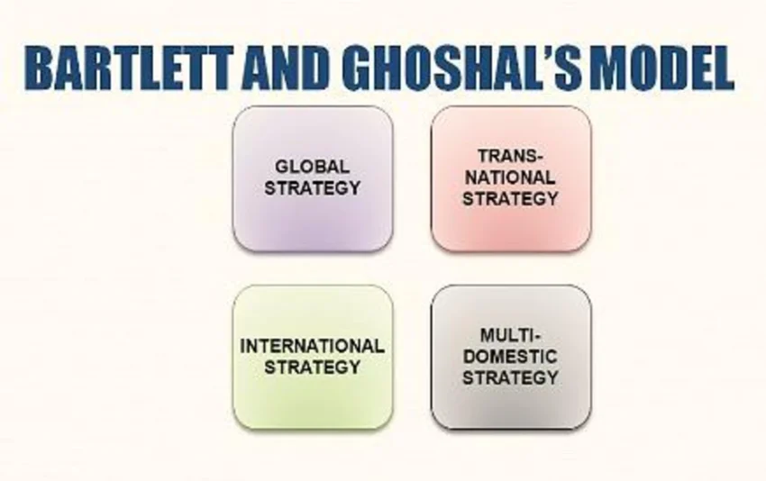

Figure 1: Bartlett and Ghoshal’s Model
(Source: Ali, 2023)
Starbucks exemplifies a transnational strategy in which it takes on a top-brand, yet local approach. It offers global consistency in the core of its coffeehouse, the brand and coffeehouse standards, and allows for flexibility in product offerings and customer engagement in local markets. This is because in this situation, Starbucks can import knowledge, abilities and brand value while adapting to cultural variations. Its international model also has a mix of company-owned and franchised locations, allowing flexibility and market reach. Starbucks had 22,744 stores and net revenues of $2,051.1 million in its international business across the regions it operates in in Q2 2026 (Starbucks, 2026). In this way, Starbucks combines worldwide efficiency and individualised local solutions, a measure that can be strategically difficult, regardless of the many different markets.
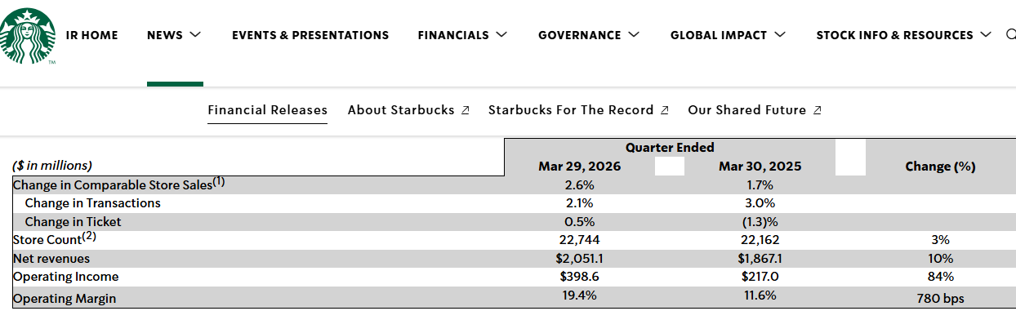

Figure 2: Q2 International Segment Results
(Source: Starbucks, 2026)
The global branding and local responsiveness of Starbucks' transnational strategy enhance competitive advantage, and adaptation can lead to greater operational complexity and costs. In Pakistan, localisation may even be necessary to keep the brand of Starbucks alive while keeping in mind the cultural requirements. International comparable-store sales grew 2.6% in Q2 FY2026, reflecting robust demand in the international market with varied results across markets (Starbucks, 2026).

1.2 Global Configuration and Geographic Footprint
Starbucks has geographically diversified its international footprint, including both developed and emerging markets such as North America, China, etc. In 2026, it had 22,744 stores across the world, showcasing its significant geographic expansion and market diversity (Starbucks, 2026). This scale also enhances brand recognition, economies of scale, knowledge transfer and supply-chain capabilities, and provides for a fairly uniform customer experience. Value is also generated by international activities that include expansion and diversification of revenues, market learning and licensing agreements. Starbucks also shows excellent performance in its international operations, where its operating margin in Q2 FY2026 was 19.4%. This indicates the profitability of the company's global network (Starbucks, 2026). But geographic diversification comes with the challenge of diverse consumer preferences, as well as regulations and operating conditions; hence, the need to strike a balance between geographic efficiency and geographic responsiveness for Starbucks. This arrangement can then offer features that could play towards clever adjustments to enter Pakistan.
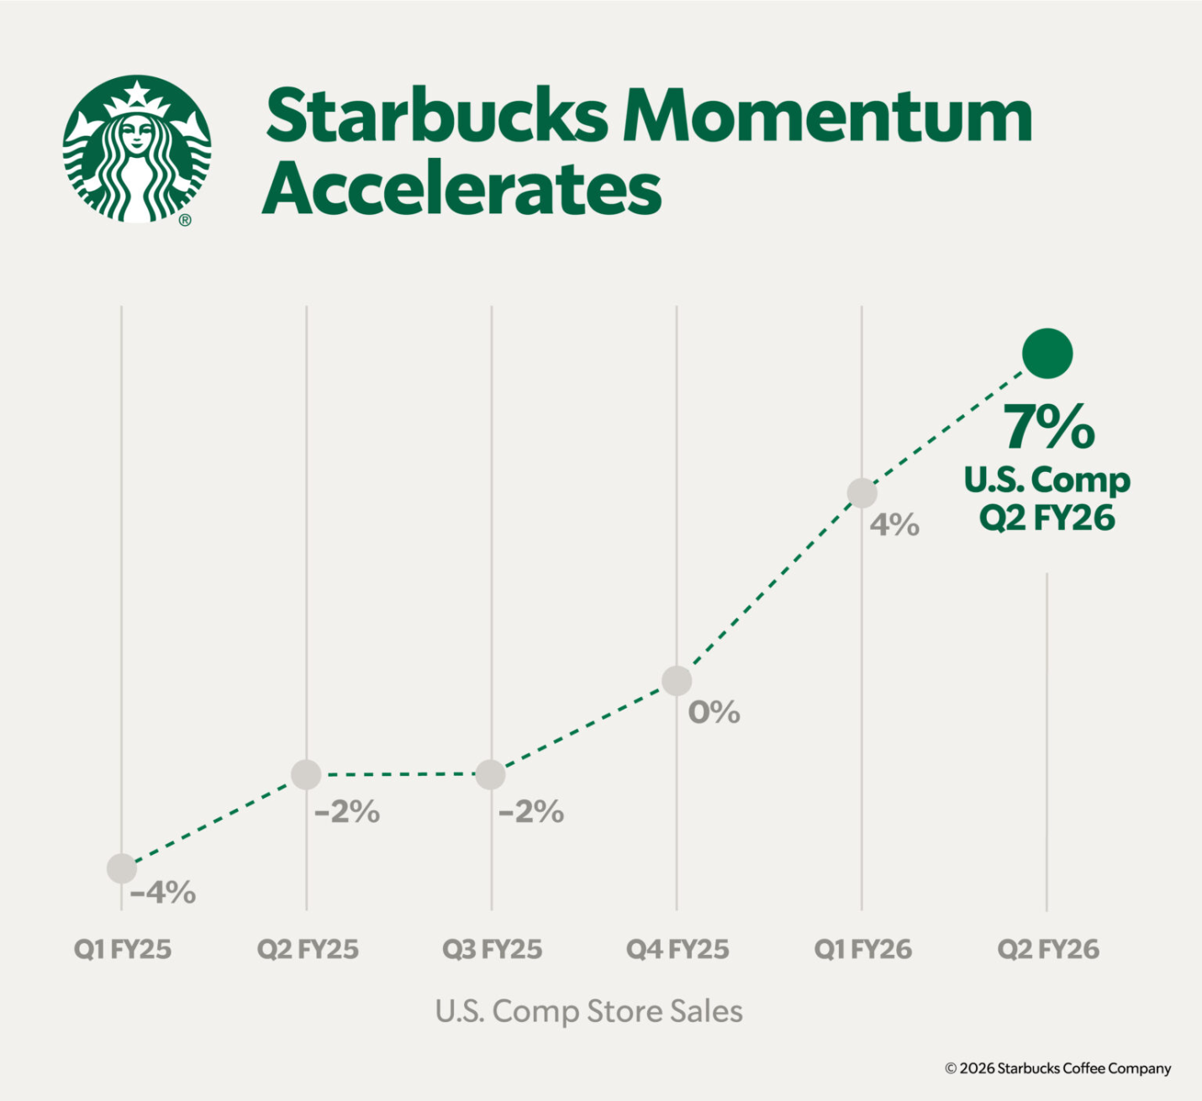

Figure 3: Starbucks Report’s Q2 2026 Fiscal Year
(Source: Starbucks, 2026)
Starbucks' transnational approach could ensure that its launch in Pakistan is a blend of global and local adaptation. Its international competences bring operational and brand advantages, but to be successful, a balance between standardisation and localisation is necessary. Thus, it is imperative to subject Pakistan's political, economic, legal and cultural landscape to scrutiny prior to entering.

2. Macro-Environmental Appraisal and Market Attractiveness
The large consumer base and the nascent urban café market present a potentially important emerging-market opportunity for Starbucks in Pakistan. According to the World Bank, the population of Pakistan is projected to reach 255.2 million in 2026, which will further boost its long-term market potential (GeoFactbook, 2026). This assessment thus determines the political, economic, legal and cultural environment that can facilitate or hinder Starbucks in being successful in its market entry.
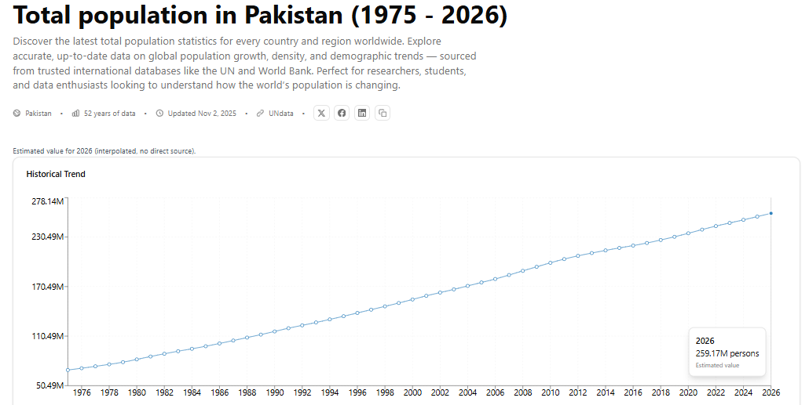

Figure 4: Total population in Pakistan
(Source: GeoFactbook, 2026)

2.1 Political Environment

2.1.1 Political Stability and Government Effectiveness
Starbucks in Pakistan faces the crossroads of growth and challenges, as political stability and uncertainty persist. According to the latest information from the IMF, Pakistan had reported disbursement of US$4.8 billion against its EFF and RSF programmes till May 2026, which shows good progress in policy implementation and maintaining macroeconomic stability (ABC Live, 2026). Still, the World Bank points to chronic inadequacies in these institutions and policies that erode investor confidence. LTP uncertainty regarding policy implementation and taxation/business regulations may add risks to Starbucks' LTP store investment and supply-chain plans. Thus, Starbucks would require a series of investments, effective local partnerships, and ongoing policy oversight to minimise risk and evaluate the market dynamics in Pakistan.

2.1.2 Government Policies and Foreign Investment
Pakistan has a relatively flexible FDI regime, with the Board of Investment facilitating FDI and allowing up to 100% foreign equity in services, depending on the sector(s) (Norton Rose Fulbright, 2026). The Investment Policy 2023 also provided for reforms to strengthen investor facilitation, the most prominent being the Special Investment Facilitation Council (UNCTAD, 2026). These policies might lessen the obstacle and promote more strategic control for Starbucks. But market entry and establishment expenses can be raised and establishment time may be further delayed by administrative approvals, taxation, and coordination with licensing and regulation.
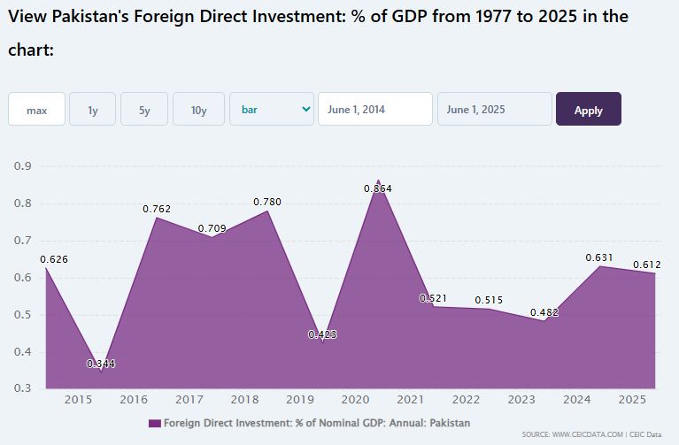

Figure 5: Pakistan Foreign Direct Investment: % of GDP
(Source: CEIC Data, 2026)

2.1.3 Trade, Taxation and Import-Related Considerations
Starbucks would have to import coffee beans and buy some special equipment and other inputs. Additionally, the Customs Tariff for FY2025-26 in Pakistan imposes a customs duty of 10% on coffee imports (HS0901), making it more expensive for Starbucks to import its premium offerings, which could impact the company's premium pricing model (Trade Information Portal of Pakistan, 2026). The tax on imports is also generally sales tax, and customs value may also include transport, insurance and handling. Such efforts may increase operating expenses and make foreseeing supply chain difficult. Starbucks would therefore be able to reduce its exposure by establishing local sourcing and supplier partnerships to leverage local ability to develop quality standards as needed, and importing only unique inputs that are key to ensuring product consistency across the world.
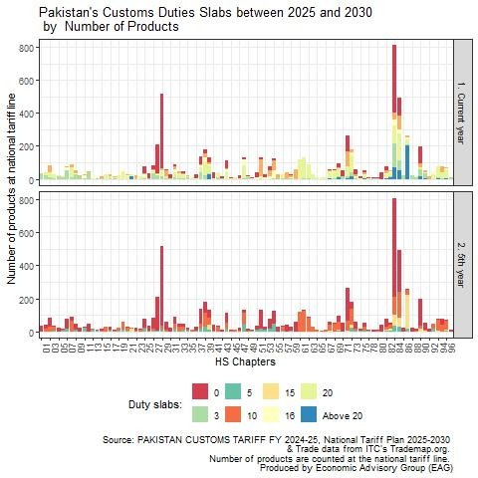

Figure 6: Decoding the National Tariff Policy 2025-2030
(Source: Economists Association of Pakistan, 2025)

2.1.4 Political Risks and Strategic Implications
Politically, Starbucks sees moderate risk compared to Pakistan, but not a market constraint at all. Having experienced shocks from the Middle East conflict, the IMF estimates in 2026 that a 0.6 percentage point decrease is anticipated in Pakistan's growth in FY2027 as a result of external geopolitical uncertainties (IMF, 2026). Such volatility can raise operational expenses, hamper imports, and have an impact on long-term store and supply-chain planning. Even if policy reforms improve investor confidence, caution is needed as a result of security conditions and policy changes. Starbucks would then benefit from a phased approach to investing, flexibly sourcing, and effective risk monitoring in its expansion that would keep politics and operational shocks at bay.

2.2 Economic Environment

2.2.1 Economic Growth and Market Potential
Starbucks has huge potential in Pakistan's market as a place where a nascent market of consumers is developing, albeit a low market with low buying power. IMF forecasts real GDP growth to be 3.2% in FY2026, continuing to expand but at relatively slow economic growth (IMF, 2026). In larger urban areas, increasing urbanisation can contribute to the demand for cafes, but Starbucks' high-end positioning can impact affordability. Economic conditions give long-term market potential, but premium coffee consumption will, to a great extent, hinge upon income growth and consumer confidence.

2.2.2 Inflation and Purchasing Power
Pakistan saw a reduction in the country's inflation, but high inflation remains a worry for Starbucks' premium pricing. The IMF also anticipates a consumer price inflation of 7.3% for FY2026, which may have a negative impact on disposable income and lead to greater price sensitivity among consumers (IMF, 2026). Therefore, Starbucks could run into some difficulties when it comes to its premium drinks, as consumers could be budget-conscious. Stabilisation of inflation, however, could gradually boost purchasing confidence. Starbucks, thus, ought to apply localised pricing, smaller, inexpensive offerings and marketing tactics, maintaining its discrete brand position and margins.
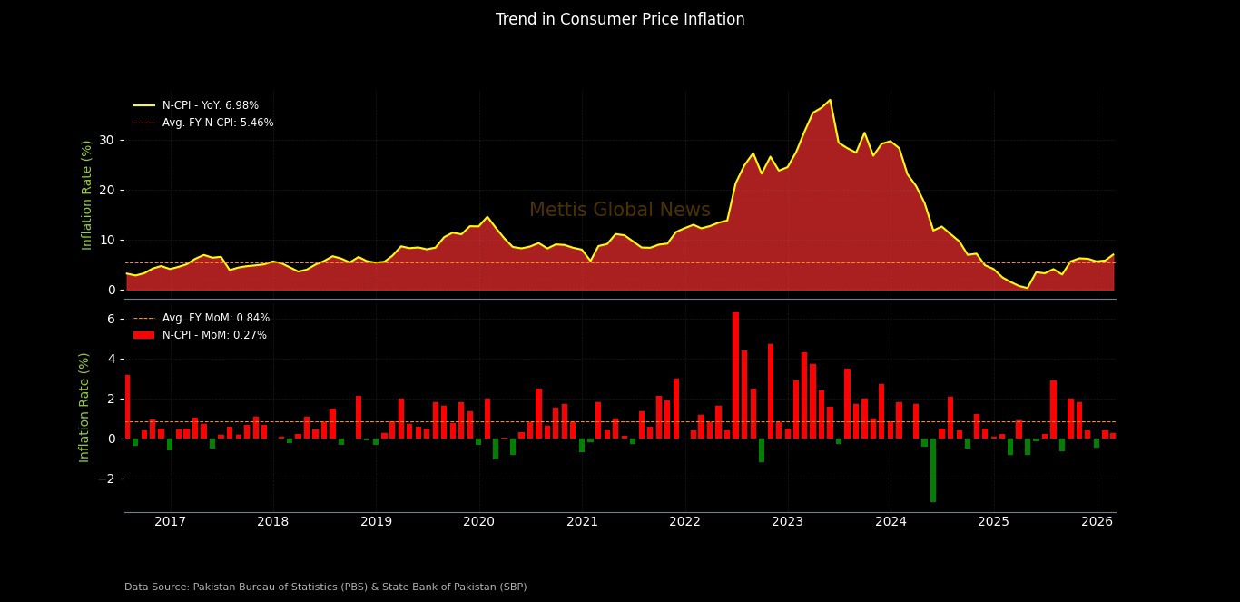

Figure 7: Trend in Consumer Price Inflation
(Source: Mettis Global, 2026)

2.2.3 Exchange Rates and Financial Risk
The exchange rate risk would have a material impact on the financial condition and performance of Starbucks since the cost of imports of coffee and equipment would increase if the value of the rupee drops. On 30 June 2026, the exchange rate of USD/PKR was 278.16, which reveals the currency exposure of foreign investors (Mettis Global, 2026). Stock and currency fluctuations may thus squeeze margins, raise operating expenses and decrease the number of profits that may be repatriated in dollars. More local sources should be employed, and implementing currency-risk management, along with selective pricing, can ensure that Starbucks' profitability is not harmed and that their products remain affordable.
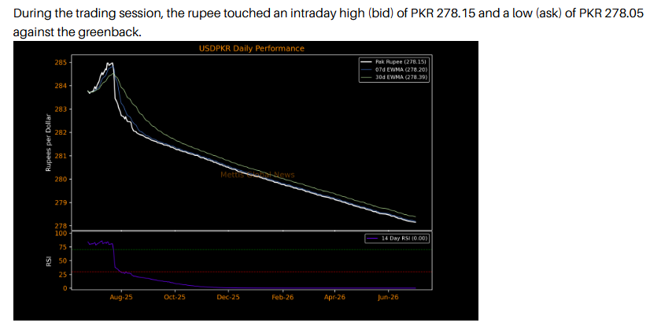

Figure 8: Pakistani Rupee vs US Dollar Trend
(Source: Mettis Global, 2026)

2.2.4 Consumer Market and Coffee-Shop Demand
The urban and younger consumers in Pakistan are looking for places to socialise or enjoy fine dining, and Pakistan's café culture is growing towards that. This is still a relatively niche item though, as 6% of the households in the top income quintile had bought coffee in 2025 (Gallup Pakistan, 2026). This shows us that there is plenty of opportunity for expansion, but there is also a lot of sensitivity when it comes to price and from existing local cafes. Different experiences, localised products and digital engagement might be key for Starbucks if aiming to target the rich, urban customer.
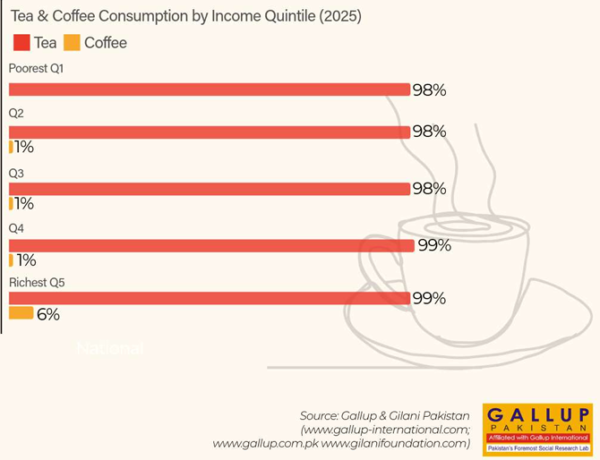

Figure 9: Tea and Coffee Consumption by Income Quintile in Pakistan
(Source: Gallup Pakistan, 2026)

2.2.5 Economic Opportunities and Constraints
On the other hand, Starbucks has a potential to grow in Pakistan with its vast consumer base as the urban markets would be increasing soon, while on the other hand, the café culture is also growing in Pakistan. But restricted buying power, currency fluctuations and inflation could have an impact on demand for premium beverages. According to World Bank projections, Pakistan's economy will expand by 3.0 per cent in FY 2026, suggesting a moderate pace of growth and not a fast growth in the consumer market (World Bank, 2025). The economic situation is moderately attractive, but Starbucks must make a phased investment and go through a process of rationed pricing.

2.3 Legal and Regulatory Environment

2.3.1 Foreign Business and Investment Regulations
In general, Pakistan allows foreign investment in the formation of one hundred per cent Foreign Direct Investment (FDI) companies; registration and licensing conditions may apply depending on the sector. According to the Global Business Complexity Index 2026, Pakistan was ranked as the 99th out of 139 economies, with a relatively higher level of business administrative procedures' complexity (WIPO, 2025). Ownership flexibility is a plus for the Starbucks brand, but at the same time, the regulatory landscape can create greater establishment times, compliance costs, and management needs.
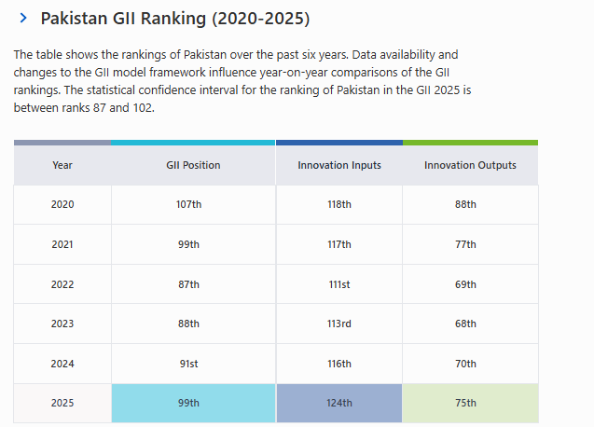

Figure 10: Pakistan GII Ranking (2020-2025)
(Source: WIPO, 2025)

2.3.2 Taxation and Business Compliance
Pakistan's tax system can drive up Starbucks' operating and compliance costs. According to the Federal Board of Revenue, the effective tax rate (ETR) benchmark for the year 2026 is 24.5% for non-banking companies, which is the tax burden of corporate taxpayers (Hayat, 2026). Also, taxable supplies and imports are subject to sales tax and will require registration and reporting. This would require robust tax-management systems on Starbucks' end, to manage compliance risks and safeguard margins.

2.3.3 Employment and Labour Regulations
Pakistan's labour system entails employers observing the provisions of minimum wages, employee rights, health and safety and collective bargaining. According to the WageIndicator Foundation (2026), in Khyber Pakhtunkhwa, the minimum wage for unskilled workers was set at PKR 40,000 per month in 2026, which represents a high level of labour cost for this category. Starbucks, as an organisation of coffeehouses, must comply to muster a lot of frontline employees.

2.3.4 Food Safety, Consumer Protection and Licensing
Starbucks would have to observe the provincial food-safety legislation, “café” licensing rules and consumer protection legislation and standards in Pakistan. Food handlers were trained in food safety. The Punjab Food Authority has trained 120 food handlers in Lahore in 2026 under active food safety supervision (Punjab Food Authority, 2026). Starbucks would then have to adhere to the licensing rules, hygiene and product-compliance requirements – this imposes additional administration but could safeguard product quality, consumer trust and brand reputation with good compliance control.

2.3.5 Legal Risks for Starbucks
Regulatory complexity may slow down Starbucks’ entry, increase compliance costs and decrease the flexibility of management throughout licensing and operational needs. Pakistan is currently implementing measures to streamline the country's regulations, including the passing of the Asaan Karobar Act in November 2025 and the expected release of additional regulatory-streamlining packages in 2026 (IMF, 2026). Looking toward compliance, Starbucks can expect changes in the near term, but it will be keeping an eye on the progress of reform.

2.4 Cultural Environment

2.4.1 Consumer Culture and Coffee Consumption
Beverage culture has been difficult for Starbucks in Pakistan as the people in the country have come to be used to drinking tea as a daily habit, and as for coffee, it is only limited to the well-to-do Pakistanis. An analysis of 2026 data by Gallup Pakistan indicates that in 2025, only 6% of households in the upper 20% income quintile were able to purchase coffee (Gallup Pakistan, 2026). Starbucks will therefore need to highlight cafés as a prime social space for the "affluent in urban areas" and to tweak its beverages and experiences to resonate with local preferences, and not simply become a direct competitor to tea drinking.
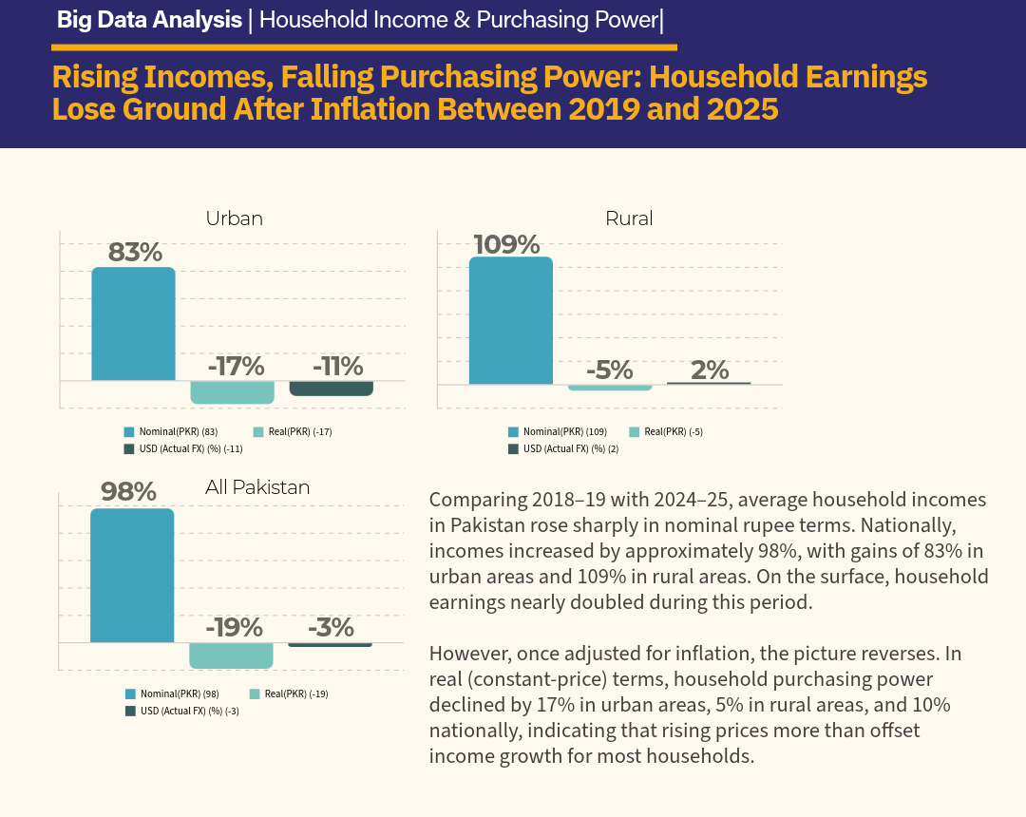

Figure 11: Pakistan Household Income and Inflation Impact
(Source: Gallup Pakistan, 2026)

2.4.2 Religious and Cultural Considerations
In the Islamic cultural context of Pakistan, Starbucks needs to be culturally appropriate, market the product and be transparent about ingredients, as well as be halal compliant. As per World Economics (2025), Pakistan's population will reach around 254.5 million in 2026, which will continue to strengthen the predominantly Muslim consumer market. There is a need to have halal-friendly ingredients in Starbucks' products and to avoid promotions that is culturally inappropriate, and to tailor the wording as per local practices. These can initiate the strengthening of trust, but at the same time enable the global brand identity to be consistent.
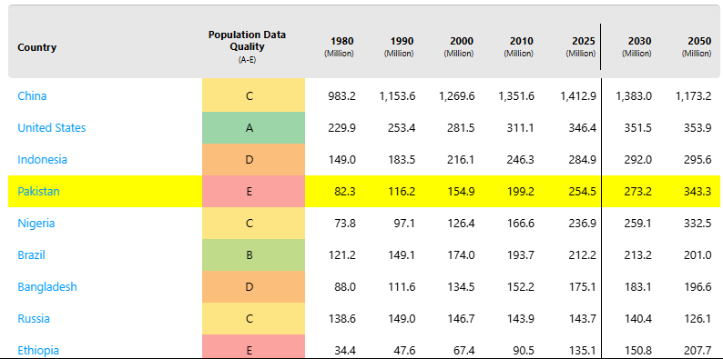

Figure 12: Global Population Trends and Data Quality
(Source: World Economics, 2025)

2.4.3 Local Consumer Preferences
Pakistani consumers could find more familiar brands and pairings to indulge in, seeking cheaper options, which are also cafés with seating areas and a social environment. According to SDPI (2026), Pakistan's e-commerce market will create $5.9 billion in revenue in 2026, showing the increasing level of digital consumers' engagement. Starbucks therefore has the ability to fuse localised drinks and food offerings, affordable pricing, online app ordering and unique store experience. This helps to aid its transnational strategy – it provides for brand consistency around the world, continuously tweaking products and interactions to suit Pakistani tastes.

2.4.4 Cultural Adaptation versus Global Brand Consistency
Starbucks must strike a balance to be consistent worldwide and adapt to the Pakistani culture. Too standardised to the local market might lack acceptance due to the neglect of local tastes as well as the local price sensitivity and consumption patterns, while too adapted might become heterogeneous from Starbucks' unique experience and corporate image. The estimated population in Pakistan is 259.3 million in 2026, which is significant in terms of the richness of culture and size of the market (World Population Clock, 2026). Hence, selective localisation with core global standards provides for the optimal strategic mix.
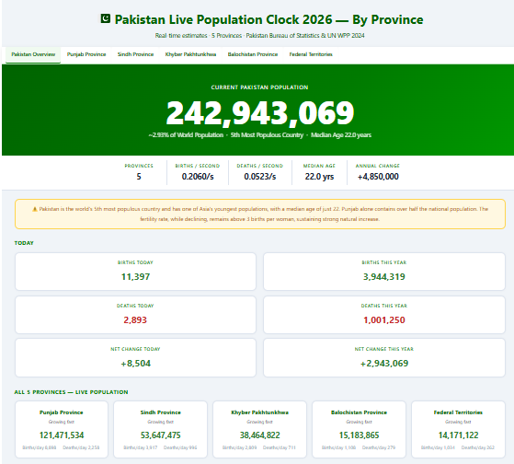

Figure 13: Pakistan Live Population Clock
(Source: World Population Clock, 2026)

2.5 Integrated Market Attractiveness Assessment
The attractiveness of the Pakistani market can be described as in the moderate category, as there are substantial number of consumers as well as operating risks for Starbucks. Investment complexity can rise, as can the pressures of inflation, currency exposure, and limited buying power, potentially putting Starbucks' premium positioning at risk, in the face of political and regulatory uncertainty. However, this will give room for long-term growth as urbanisation, a café culture and opportunities to offer localised products emerge. To be sure, the World Bank FY2026 outlook calls for the economic growth of the Pakistani real GDP around 3.0% (World Bank, 2025), which is considerably slower than the past three years, but still represents a fairly moderate level of growth.

2.6 OLI / Eclectic Paradigm Analysis
Dunning's OLI framework analyses the internalisation, location and ownership advantages Starbucks has when evaluating its capabilities (Rahman et al., 2026). The market conditions and retained control over the market are both favourable for successful market entry in Pakistan.
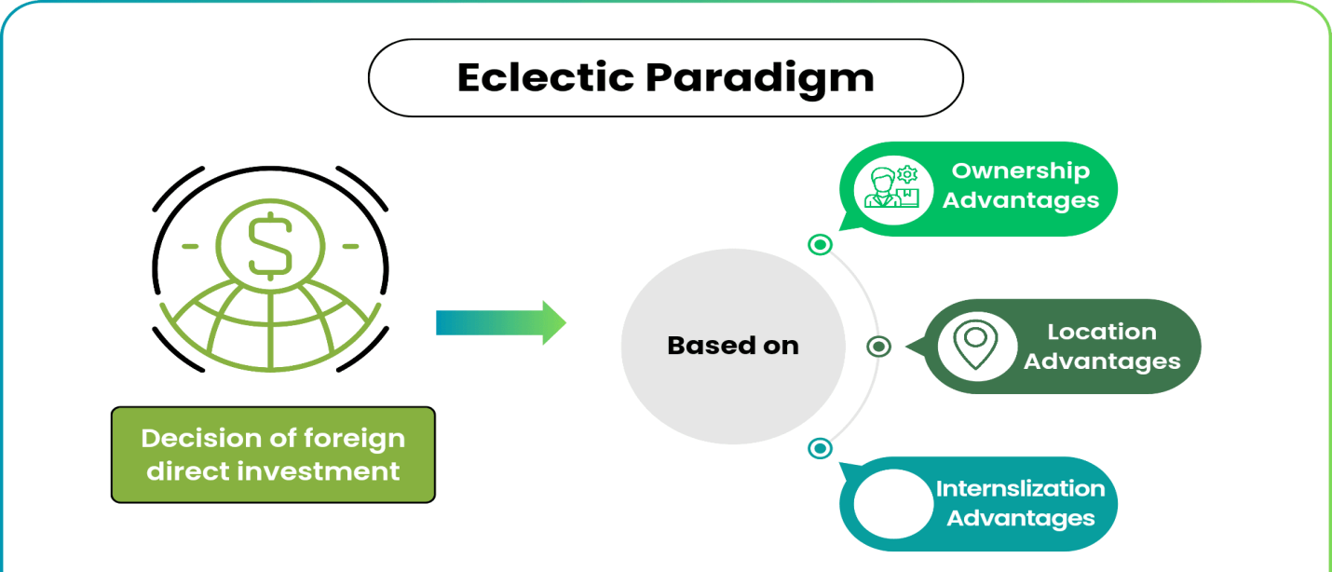

Figure 14: OLI framework
(Source: WallStreetMojo, 2026)
Ownership Advantages (O)
Starbucks has solid ownership advantages in the form of the brand, expertise in coffeehouses, technology or digital strengthening, management and knowledge of how to run a coffeehouse, as well as supply chain systems. Starbucks Rewards garnered a total of 35.5 million users in 90 days as customers, illustrating the strength of its customer-engagement ecosystem in 2026 (Starbucks, 2026). The strengths can help to set Starbucks apart from its local rivals, backed by the quality consistency, digital convenience and unique Customer Experience they can offer, making them premium in value among the competitors.
Location Advantages (L)
Starbucks benefits from the location advantages in Pakistan, owing to its population and main cities, and the growth of the café culture, as well as the availability of labour. On the basis of the Degree of Urbanisation methodology and satellite imagery, Pakistan's real urbanisation level is near 88 per cent, suggesting a significant consumer base in urban areas (Dawn 2025). But the political uncertainty, regulatory complexity, reduced purchasing power, and economic instability pose disadvantages.
Internalisation Advantages (I)
The advantages to Starbucks are that they maintain control over the brand standards, product quality, customer experience, and control the IP and operational knowledge, thereby mitigating the risk of inconsistent execution by their partners. This shows that Starbucks is a successful system in terms of the number of stores that they have worldwide, with 41,000 stores already in place for 2026 (Starbucks, 2026). Internal control, however, needs more capital and management resources, along with being prone to all the risks related to the regulatory framework of Pakistan (Ashraf and Qureshi, 2026). Starbucks should therefore try to minimise the commitment of resources by striking some selective deals with partners operating locally.
Overall, OLI gives a boost to Starbucks entering Pakistan as its ownership strengths will make use of the advantages that Pakistan has to offer due to its location, internalisation secures a smooth conduction of knowledge and quality.

2.7 Market Entry Decision: Integrated Strategic Judgement
Pakistan offers moderate attractiveness for Starbucks due to its substantial and urban market share on the one hand, and political, economic, legal and cultural barriers on the other hand. Based on the OLI analysis, certain advantages of the Starbucks company, along with the advantages of the location of Pakistan, can support Starbucks' entry, and internalisation can maintain the brand consistency of its products. But these advantages don't offset market risks.

3. Entry Mode Strategy and Strategic Synthesis

3.1 Historical Pattern Recognition
In the past, Starbucks operated its stores, licensed stores, franchised stores, as well as joint ventures, stores it acquired, and partnerships in markets around the world. Licensing was the dominant mode of operation internationally for Starbucks, which involved lower capital expenditures and leveraging the work of partners. Starbucks' global presence expanded to 41,129 stores, with 52% of them having been built by the company itself (Islas, 2026). The leading current markets for the company remain the United States and China, with about 61% of the total. In particular, Starbucks has over 16,900 locations in the United States and almost 8,000 locations in China, making both regions of great strategic importance.
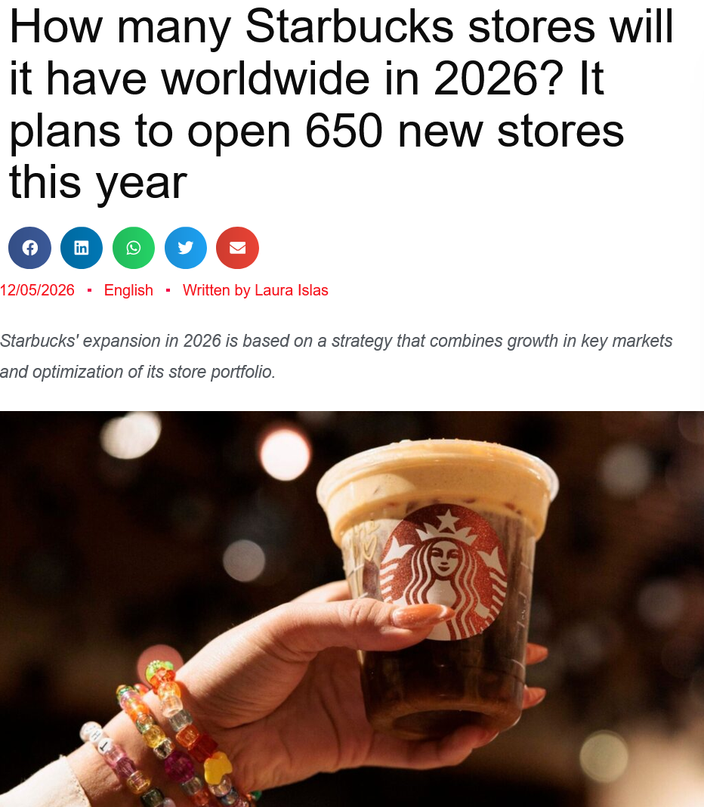

Figure 15: How many Starbucks stores will it have worldwide in 2026? It plans to open 650 new stores this year.
(Source: Islas, 2026)
It's been years since the situation began to boil at some of Starbucks' baristas in Buffalo elected to unionise, but the discontent keeps simmering. To this, more stores joined, creating the Starbucks Workers United, whose membership is estimated to be about 600 stores or 5% of the 11,000 North American stores (Danziger, 2026). On one of the busiest days of the year, Starbucks releases its drink specials menu on Starbucks Red Cup Day (November 13th), with free collectable cups being awarded to the union's supporters; its call for a nationwide strike has the potential to deliver a maximum effect.
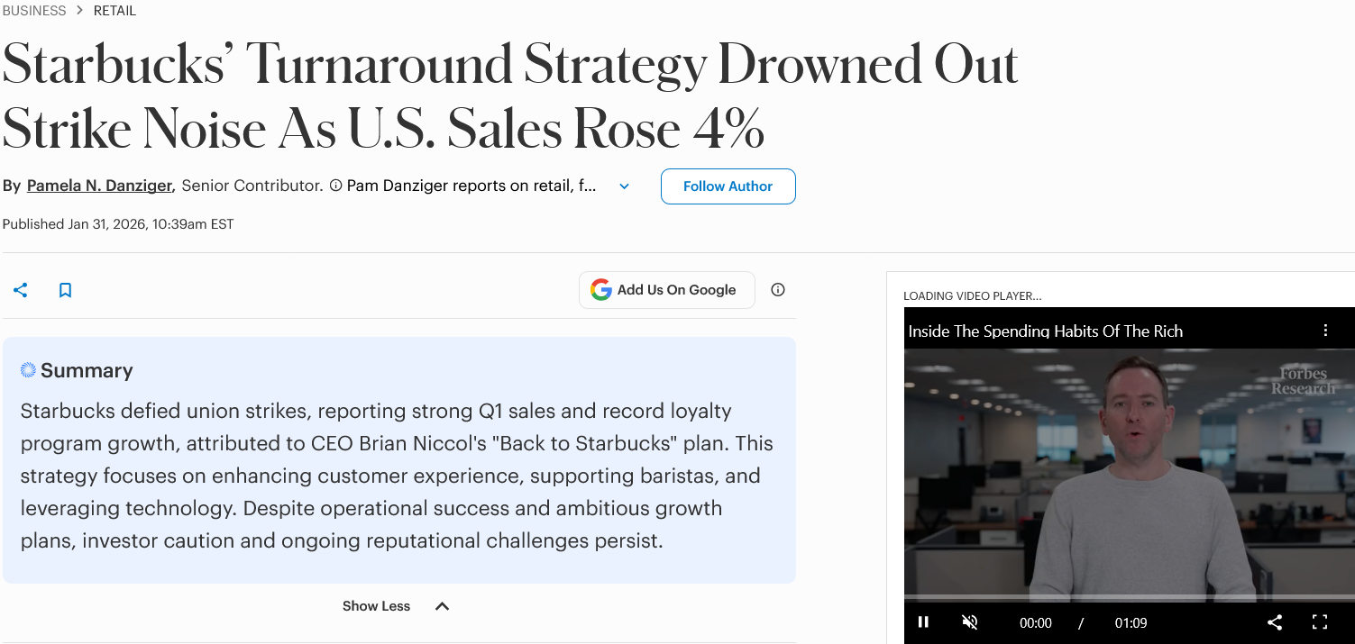

Figure 16: Starbucks’ Turnaround Strategy Drowned Out Strike Noise As U.S. Sales Rose 4%
(Source: Danziger, 2026)
As part of the deal, a portion of Boyu Capital's money will be used to acquire 60% of Starbucks China retail company. By contrast, Starbucks maintains a 40% stake and remains owner and licenser of the brand and IP to the joint venture company called Starbucks (Starbucks, 2026). This joint venture manages some 8,000 company-run coffeehouses, which convert to a licensed business model, and has a shared long-term goal of growing those numbers to as many as 20,000 outlets in the future. This is one of the most exciting business opportunities Starbucks has and is able to solve with this deal finally closing in China.

3.2 Strategic Fit & Justification
Starbucks' licensing model worked well for Pakistan because it allowed for less exposure as well as increased knowledge of the local market. It has been decided by Pakistan to open Roshan Digital Account (RDA) for foreign nationals, companies and institutional investors in addition to its existing policy for retail investors. By February, Pakistan's Roshan Digital Accounts stood in excess of 900,000, with inflows of over $12 billion (Khan, 2026). The scheme expansion enabled foreign nationals, companies and institutional investors to avail these investment avenues.
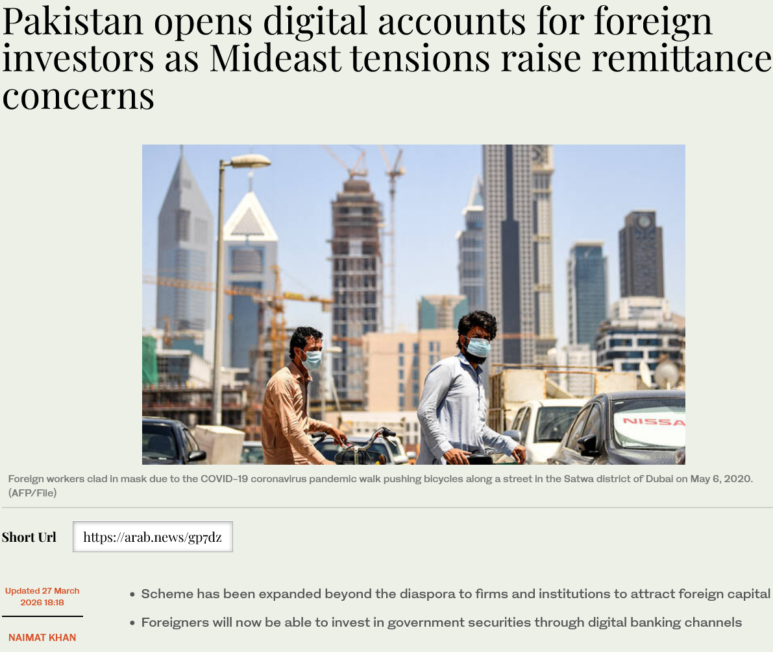

Figure 17: Pakistan opens digital accounts for foreign investors as Mideast tensions raise remittance concerns
(Source: Khan, 2026)
This evidence was in favour of partnership structures but would require contractual controls for protection of brand and standards for Starbucks. Despite growing militant threats, Pakistan hiked up its security operations, and there was political risk. Tensions and fears of possible attacks across the border prompted increased security measures. According to data from ACLED, the number of attacks in Pakistan increased by almost 4 times from 658 in 2022 to 2,425 in 2025, while TTP attacks also grew by more than seven times from 118 to 838 during the same period (Shahzad and Bukhari, 2026). Thus, local partners might better sustain security knowledge and operations coordination than a Starbucks-owned store could.
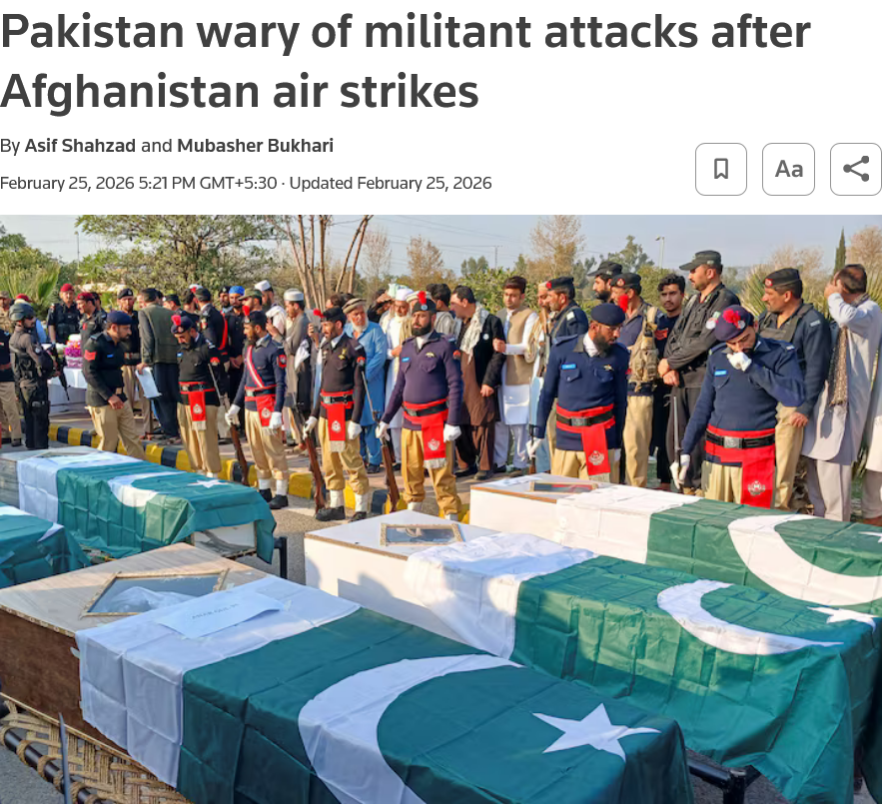

Figure 18: Pakistan wary of militant attacks after Afghanistan air strikes
(Source: Shahzad and Bukhari, 2026)
Financial risk also continued to be high due to the 11.1% consumer inflation (English, 2026). This may lower discretionary expenditure, make the cost of inputs more expensive, and diminish profitability in Pakistan. Lahore's growing café culture, however, has seen a rise in social demand for coffee-related spaces by younger consumers. Lahore's Gen Z found their cafés as meeting, studying, working and leisure hubs. This demand facilitated entry, but it is logical to expect that Starbucks will need to adjust their prices, products and experiences to local conditions. Operational risk was the concern, as there was a change in restaurant and café operating hours due to government restrictions.
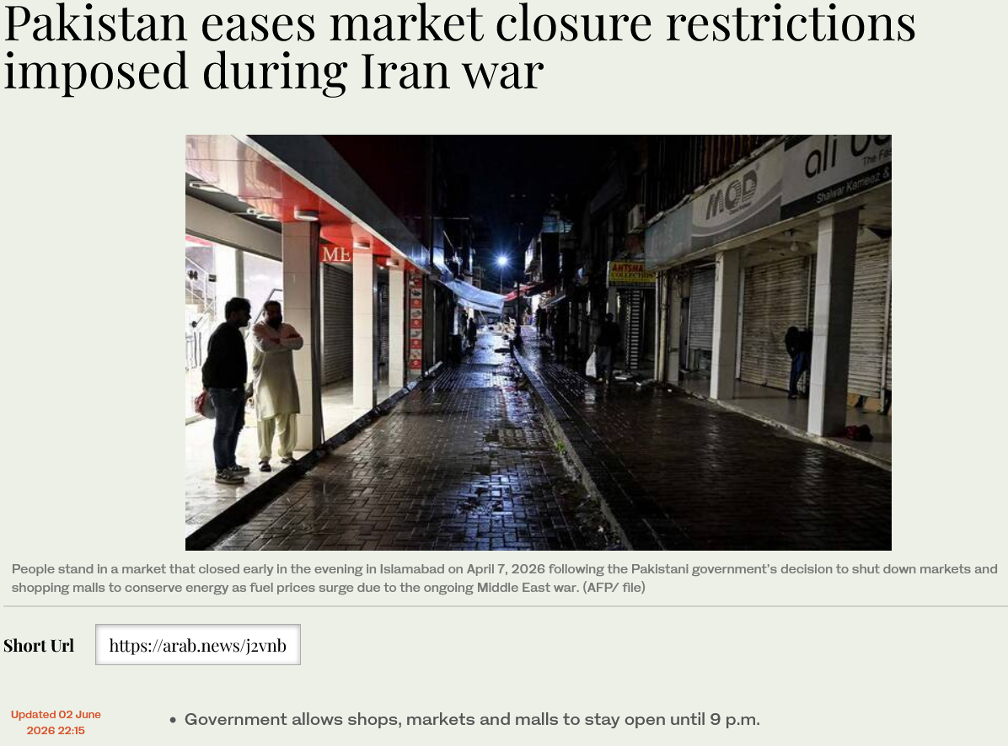

Figure 19: Pakistan eases market closure restrictions imposed during Iran war
(Source: Arab News, 2026)
Especially, restaurants and cafés were allowed to remain open until 11 pm, indicating ongoing uncertainty in the rules (Arab News, 2026). Moreover, 12,861 big merchants are hooked on Pakistan's mandatory e-sales-monitoring tracking system as of March 2026 (Tribune, 2026). Hence, coupons might maintain flexibility, and compliance could be taken care of via partners, staffing, property, sourcing, and regulatory concerns. However, Starbucks would be better off making a series of investments instead of going all in, and monitoring performance with licensing stage controls. This was an effective solution that took a balance of local knowledge, reduced resource investment, flexibility of operation, brand control, and strategic fit.

3.3 Conclusion & Recommendations

3.3.1 Conclusion
Flexibility, knowledge, investment and control seemed to be an ideal match for Starbucks and Pakistan. But the political situation of uncertainty, inflation pressure and operational constraints introduced risks that demanded robust local risk management. It was therefore inferred that licensing should be kept in place until the market is developed enough to avoid excessive capital exposure. Starbucks had a balanced approach for controlled and sustainable expansion in the Pakistani market through its partnership approach.

3.3.2 Recommendations
Starbucks should choose a licensee in the area that has sound financial strength and proven regulatory, security and operational skills. Brand requirements, audit rights, goals, contingency planning and terminations must be explicitly outlined in contracts (Camilleri, 2025). Starbucks ought to adopt a phased investment, local procurement, and contingency planning approach, as well as compliance reviews, to reduce exposure. These would ensure a lower level of financial, political and operational risks and keep flexibility during the development of Pakistan.

Section 2: Reflection
I chose Gibbs’ cycle since it gave the opportunity to look at research, learning, decision making, and improvements in stages. I was able to draw connections more systematically between experiences, feelings, evaluation, analysis, conclusions, and future actions, with its sequence. It encouraged me to reflect on it more than just giving descriptions when I did the assessment process clearly.
(i) Description
In the beginning, I read the brief carefully and determined the analysis of Starbucks' expansion needed for Pakistan. Week 1 gave me an understanding of the importance of country-specific analysis of Pakistan because of the international business context. Reviewed Starbucks' past growth and contrasted licensed, joint ventures, acquisitions, and wholly owned operations. I used Bartlett and Ghoshal's model to gain insight into integration, local responsiveness and transnational attributes of Starbucks. In addition, I also discussed the ownership advantages for Starbucks, the location advantage for Pakistan and the issues faced by internalisation. Starbucks presents opening market strategies in the Starbucks case, such as a joint venture in Japan. Country Risk Analysis developed my systematic approach towards conducting country risk analysis in Pakistan from Week 4 onwards. The international expansion analysis should include elements of evidence of the market, strategic theory, resources, and condition of the country (Roh et al., 2026). To enhance my research process in foreign-market entry, I studied foreign-market entry research. Created my evidence around the following headings before coming up with my recommendation: political, economic, legal, cultural and strategic.
(ii) Feelings
At the beginning, I was a little bit confused because there were theories, evidence, numerical data and critical judgement needed for the assessment. I was concerned that gathering the sources would result in a description of the situation, rather than a strategic argument. The VUCA analysis in Week 2 highlighted the skill of identifying uncertainty in assessing Pakistan's evolving business environment. I utilised entry-mode theory since it promoted comparisons of commitment, control, flexibility, risk and knowledge. The Starbucks case helped to clarify the situation as Starbucks was seen making adaptations to entry strategies in international markets. An international business management program focuses on key business topics in an international context (Santangelo et al., 2025). I had already experienced a degree of confidence when reading EPRG's that other countries' practices may differ depending on their local circumstances. I became confident as I progressed to research structured comparison and critical evaluation.
(iii) Evaluation
The positive thing was being told at the outset that the assessment was going to be brief and would define the analytical direction needed. During Week 3, I did my cross-cultural analysis, which helped me to understand how to make the Starbucks practices viable in the Pakistani context. The Starbucks case furnished examples on the issues of joint venture, local adaptation, training, and international expansion. The foreign-market-entry study made this more apparent, clearly highlighting systematic market selection and network capability. The theory of trade has developed my understanding of national advantage and possibilities of Pakistan for doing trade with the world from Week 5 onwards. Selecting sources was difficult because of the variations in quality, reliability, dates and definitions in the information retrieved. I narrowed down the analysis to evidence with strategic implications by eliminating weaker evidence when it was found.
(iv) Analysis
There are multiple factors involved with an international market entry decision and not just one strategic factor that can impact outcomes. The lectures demonstrated to me that the attractiveness of the country relies on balance benefits, costs and various risks. There could be more exposure due to political instability, and costs and purchasing power due to inflation and currency changes. Legal considerations might drive increased compliance needs, while cultural factors might affect products, employees, and experience. The Starbucks case gave me the realisation that entry modes can vary based on the local situation. A firm imports its ideas and values from the parent company to another subsidiary in a different country because it is important for the organisation (Pilz, 2016). Starting from Week 8, international strategy helped me in balancing the standards of Starbucks with sensitivity towards the Pakistani market. A company with regular procedures, routines, and evaluation systems shows shared knowledge which can be easily shared throughout the company (Martín et al., 2022). These readings provided me with an understanding of why Starbucks could have both standards and practices adjusted for Pakistan. The foreign-market-entry study demonstrated that knowledge can be useful as a component in a systematic approach to market selection and evaluation in foreign markets. Hence, I decided to analyse the political, economic, legal, cultural, and OLI aspects of Pakistan before choosing licensing.
(v) Conclusion
I have learned how to conduct international business research in a well-structured way and compare the various issues and findings at hand, using reliable evidence and then synthesising it into something new. Businesses leverage globalisation to ensure that their products and services are appealing to and relevant for the local customers in new areas, thereby boosting their ability to thrive in new regions (Stepanov, 2025). The class content helped me enhance my knowledge of entry modes, country risks, international strategy and control flexibility trade-offs. In Week 9, I began to improve my skills of marketing analysis by incorporating an ability to analyse Pakistani consumers based on adequate and selective evidence. These concepts connected very well to me through the Starbucks case involving a realistic situation involving a multinational extension to the market. I could have refined this process by making an outline of evidence categories and reviewing definitions before writing.
(vi) Action Plan
Goals | Actions | Resources needed | Weeks
Communication | Practise presenting ideas clearly during group discussions | Group communication, presentation videos | 2
Leadership | Lead small group activities and share responsibilities | Group projects, leadership videos | 3
Decision-making | Compare alternatives before making strategic decisions | Case studies, internet sources | 4
Analytical skills | Evaluate evidence and identify meaningful patterns | Internet sources, academic videos | 5
Problem-solving | Practise solving complex business problems systematically | Business cases, online learning videos | 6
Table 1: Action Plan
(Source: Self-made)

References
ABC Live (2026) Pakistan: Shehbaz-Munir Governance Model and its Impact. [online] Available at: https://abclive.in/2026/08/02/pakistan-shehbaz-munir-governance-model
Ali, W. (2023) A Report Global Strategy Assessment of Wendy's United States of America (USA). [online] Ulster University: ResearchGate. Available at: https://www.researchgate.net/publication/379954525_A_Report_Global_Strategy_Assessment_of_Wendy's_United_States_of_America_USA
Arab News (2026) Pakistan eases market closure restrictions imposed during Iran war. Available at: https://www.arabnews.com/node/2645811/pakistan
Ashraf, M. and Qureshi, M.W. (2026) ‘Impact of Internal Control System Effectiveness on Firm's Financial Performance: Evidence from Non-Financial Firm's Listed on Pakistan Stock Exchange’, Competitive Research Journal Archive, 4(01), pp. 390-403. Available at: https://thecrja.com/index.php/Journal/article/view/249
Camilleri, M. A. (2025) Sustainability accounting and disclosures of responsible restaurant practices in environmental, social and governance (ESG) reports. International Journal of Hospitality Management, 126, 104051. https://www.sciencedirect.com/science/article/pii/S0278431924003633
CEIC Data (2026). Pakistan Foreign Direct Investment: % of Nominal GDP. [online] Available at: https://www.ceicdata.com/en/indicator/pakistan/foreign-direct-investment--of-nominal-gdp
Danziger. N.P. (2026) Starbucks’ Turnaround Strategy Drowned Out Strike Noise As U.S. Sales Rose 4%. Available at: https://www.forbes.com/sites/pamdanziger/2026/01/31/starbucks-turnaround-strategy-drowned-out-strike-noise-as-us-sales-rose-4/
Dawn (2025) LCCI for low-cost energy to boost industry’, 11 August. Available at: https://www.dawn.com/news/1953204
Economists Association of Pakistan (EAG) (2025) Decoding the National Tariff Policy 2025-2030: Transforming the Trading Landscape in Pakistan. [online] Available at: https://eag.org.pk/decoding-the-national-tariff-policy-2025-2030-transforming-the-trading-landscape-in-pakistan/
English (2026) Pakistan's inflation eases to 11.1 pct in June. Available at: https://english.news.cn/20260702/0aea65e29d0f4e3aacbd56817c2146a3/c.html
Gallup Pakistan (2026) ‘[Title of the article/post]’. Gallup Pakistan. Available at: https://gallup.com.pk/post/39550
Gallup Pakistan (2026) English Press Release - 09 February 2026. Available at: https://gallup.com.pk/wp/wp-content/uploads/2026/02/English-09-February-2026.pdf
Gallup Pakistan (2026) English Press Release - 09 February 2026. Available at: https://gallup.com.pk/wp/wp-content/uploads/2026/02/English-09-February-2026.pdf
GeoFactbook (2026) Pakistan: Total Population. [online] Available at: https://geofactbook.com/countries/pakistan/total-population
International Monetary Fund (2026) Pakistan: Staff Report for the 2026 Article IV Consultation. [online] IMF Country Reports. Available at: https://www.imf.org/-/media/files/publications/cr/2026/english/1pakea2026001.pdf
International Monetary Fund (IMF) (2026) Pakistan: Staff Report for the 2026 Article IV Consultation. Available at: https://www.imf.org/-/media/files/publications/cr/2026/english/1pakea2026001.pdf
International Monetary Fund (IMF) (2026) Pakistan: Staff Report for the 2026 Article IV Consultation. IMF Country Report No. 26/101. Available at: https://www.elibrary.imf.org/view/journals/002/2026/101/article-A001-en.xml
International Monetary Fund (IMF) (2026) Pakistan: Staff Report for the 2026 Article IV Consultation. IMF Country Report No. 26/101. Available at: https://www.elibrary.imf.org/view/journals/002/2026/101/article-A001-en.xml
Islas, L. (2026) How many Starbucks stores will it have worldwide in 2026? It plans to open 650 new stores this year. Available at: https://www.merca20.com/how-many-starbucks-stores-will-it-have-worldwide-in-2026-it-plans-to-open-650-new-stores-this-year/
Khan, N. (2026) Pakistan opens digital accounts for foreign investors as Mideast tensions raise remittance concerns. Available at: https://www.arabnews.com/node/2637878/pakistan
Martín, O. M., Chetty, S., and Bai, W. (2022) ‘Foreign market entry knowledge and international performance: The mediating role of international market selection and network capability,’ Journal of World Business, 57(2), 101266. https://www.sciencedirect.com/science/article/pii/S1090951621000778
Mettis Global (2026) ‘PKR closes slightly higher vs USD’. Available at: https://mettisglobal.news/PKR-closes-slightly-higher-vs-USD-61689
Mettis Global (2026) February inflation rises/falls’. Available at: https://mettisglobal.news/February-inflation-risesfall-by-58760
Norton Rose Fulbright (2024) Cross-border private M&A in Pakistan. [online] Available at: https://www.nortonrosefulbright.com/en/knowledge/publications/91c131a4/cross-border-private-manda-in-pakistan
Pilz, M. (2016) ‘Training patterns of German companies in India, China, Japan and the USA: What really works?,’ International Journal for Research in Vocational Education and Training (IJRVET), 3(2), 66-87. https://www.econstor.eu/bitstream/10419/146393/1/867438770.pdf
Punjab Food Authority (PFA) (2026) Punjab Food Authority Training School Lahore conducted a training session on food safety and hygiene practices at bus terminals of Lahore. Available at: https://pfa.gop.pk/punjab-food-authority-training-school-lahore-conducted-a-training-session-on-food-safety-and-hygiene-practices-at-bus-terminals-of-lahore/
Rahman, A., Rowlinson, S., Xia, B., Mahmood, M.N. and Hubbard, B. (2026) ‘Testing the multinational contracting OLI framework: Australia as a host market’, Engineering, Construction and Architectural Management, 33(8), pp. 6464-6488. Available at: https://www.emerald.com/ecam/article/doi/10.1108/ECAM-12-2024-1651/1265204
Roh, T., Xiao, S., Park, B. I., and Samiee, S. (2026) ‘Exploring disruptive and social innovation in MNE affiliates in emerging markets.’ European Journal of Marketing, 1-37. https://www.researchgate.net/profile/Taewoo-Roh/publication/400386091_Exploring_disruptive_and_social_innovation_in_MNE_affiliates_in_emerging_markets/links/6983292342f94d1212a6c1e8/Exploring-disruptive-and-social-innovation-in-MNE-affiliates-in-emerging-markets.pdf
Santangelo, G., Phene, A., Coviello, N., Tung, R. L., and Felin, T. (2025) ‘Microfoundations as a toolkit for international business research,’ Journal of International Business Studies, 56(6), 681-690. https://link.springer.com/content/pdf/10.1057/s41267-024-00753-z.pdf
Shahzad, A. and Bukhari, M. (2026) Pakistan wary of militant attacks after Afghanistan air strikes. Available at: https://www.reuters.com/world/asia-pacific/pakistan-wary-militant-attacks-after-afghanistan-air-strikes-2026-02-25/
Starbucks (2026) Investors. Available at: https://investor.starbucks.com/ir-home/default.aspx
Starbucks (2026) Starbucks and Boyu Capital Finalise Joint Venture to Accelerate Long-Term Growth in China. Available at: https://investor.starbucks.com/news/financial-releases/news-details/2026/Starbucks-and-Boyu-Capital-Finalize-Joint-Venture-to-Accelerate-Long-Term-Growth-in-China/default.aspx
Starbucks (2026) Starbucks Reports Q2 Fiscal Year 2026 Results. [online] Available at: https://investor.starbucks.com/news/financial-releases/news-details/2026/Starbucks-Reports-Q2-Fiscal-Year-2026-Results/default.aspx
Stepanov, M. (2025) ‘Diversification and adaptation of small enterprises to the dynamic changes in international demand in the context of globalisation,’ Professional Bulletin: Economics and Management, (3), 26-31. https://cyberleninka.ru/article/n/diversification-and-adaptation-of-small-enterprises-to-the-dynamic-changes-in-international-demand-in-the-context-of-globalization
Sustainable Development Policy Institute (SDPI) (2026) Pathway for a Digital Pakistan. Available at: https://sdpi.org/pathway-for-a-digital-pakistan-/news_detail
Trade Information Portal of Pakistan (2026). Trade Information. [online] Available at: https://www.tipp.gov.pk/index.php?r=tradeInfo/view&id=15601
Tribune (2026) FBR links 13k major retailers to POS. Available at: https://tribune.com.pk/story/2599130/fbr-links-13k-major-retailers-to-pos
Uddin, I., Suleman, U. and Zahid, M. (2026) ‘From Entry to Embeddedness: A Case Study of Haier’s Strategic Localization and Cross-Cultural Management in Pakistan,’ Journal of Management Science Research Review, [online] 5(2), pp.988–1002. Available at: https://jmsrr.com/index.php/Journal/article/view/576
UNCTAD (2026) Investment Policy Hub: Pakistan. [online] Available at: https://investmentpolicy.unctad.org/country-navigator/163/pakistan
WageIndicator Foundation (2026) Minimum Wage - Khyber Pakhtunkhwa. Available at: https://wageindicator.org/en-pk/work-in-pakistan/minimum-wage/166-khyber-pakhtunkhwa/
WallStreetMojo (2026) Eclectic Paradigm. Available at: https://www.wallstreetmojo.com/eclectic-paradigm/
World Bank (2025) ‘Pakistan: Sustained reforms needed for inclusive growth, economic stability and flood recovery’. Available at: https://www.worldbank.org/en/news/press-release/2025/10/27/pakistan-sustained-reforms-needed-for-inclusive-growth-economic-stability-and-flood-recovery
World Bank (2025) Pakistan: Sustained reforms needed for inclusive growth, economic stability and flood recovery. Available at: https://www.worldbank.org/en/news/press-release/2025/10/27/pakistan-sustained-reforms-needed-for-inclusive-growth-economic-stability-and-flood-recovery
World Economics (2025) Pakistan Population Size. Available at: https://www.worldeconomics.com/Processors/Demographics-Countries-PopulationSize.aspx?Country=Pakistan
World Intellectual Property Organization (WIPO) (2025) Global Innovation Index 2024: Pakistan. Available at: https://www.wipo.int/gii-ranking/en/pakistan
World Population Clock (2026) Pakistan population. Available at: https://worldpopulationclock.net/pakistan-population/

