
APPENDIX GA36d

LEVEL 7 ASSESSMENT SPECIFICATION

Student name: | Alexander Daniel Joseph Saunders | Student ID number: | 1806042
Programme: | Secondary PGCE
Module: | Curriculum Development and Enhancement
Module code: | ECSP7002 | Contribution to Overall Module Assessment (%): | 100%
Lecturer: | Helen Denny | Internal Verifier:
Assignment Title: | Research Study including Ethics Form | Word count (or equivalent): | 8452 words in total excluding an Ethics form (to be given in on January 11th 2019)
Submission deadline: | July 27th 2019 | Return date of provisional marks & written feedback: | August
Submission method: | All written assessments, where practical and possible, must be submitted via Turnitin unless otherwise instructed by the Lecturer. (Please DO NOT put this assessment specification into Turnitin or it will match many similarities with other students’ submissions.)  Alternative submission method (if applicable):  Late submission of the assessment will result in a late penalty mark. Penalties for late submission: Up to one week late, maximum mark of 50%. Over one week late, 0%. Only the Extenuating Circumstances Panel may approve a change to submission dates.
Academic honesty / referencing: | Academic honesty is required. In the main body of your submission you must give credit to authors on whose research and ideas your work is based. Append to your submission a reference list that indicates the books, articles, etc. that you have used, cited or quoted in order to complete this assessment.

Introduction
Twenty years ago, the Assessment Reform Group (ARG), a group of researchers formed at the behest of the British Educational Research Association (BERA), made the following declaration - ‘Assessment which is specifically designed to promote learning is the single most powerful tool we have for both raising standards and empowering lifelong learners.’ (Assessment Reform Group, 1999, p.2). This declaration alone encapsulated the need to shift the focus from a summative approach towards a formative one. This formative assessment was coined as ‘assessment for learning’ (AFL) a year prior by Black and William, two of the most prominent members of the ARG (Black and William, 1998). They defined it as ‘all those activities undertaken by teachers, and/or their students to modify teaching and learning activities in which they [the students] are engaged’ (Ibid., 1998). In spite of the educational reforms that have occurred in the past twenty years, the research produced by the ARG has continued to crescendo in the education sector and AFL has maintained its dominance in the classroom. With this being said, how does one put this into practice? It is easy to promote the importance of AFL but only a facta non verba approach facilitates learning. There are many different strategies that fall within AFL with each having their own advantages and disadvantages. These range from questioning to self and peer-assessment but this research paper will only focus on one – success criteria. The main aim of this paper, therefore, is to review the current research on success criteria and then put this AFL strategy into practice myself. I will then be able to evaluate the effectiveness of using a success criteria and see how my experiences correlate to those of prior research.

The primary research question I have decided to explore is whether success criteria hinders creativity or not. My reason for this is that much of the feedback I have been given within my placement schools is to be more consistent in the use of success criteria. In wanting to develop my understanding, the literature, or lack thereof, made me question its purpose and whether it simply acts as a funnel to ensure that pupils are all achieving the same thing. If this was the case, my main concern was that pupils are being stripped of developing their creative talents and instead being treated like robots where they must all conform. In the new Welsh curriculum, one of the four core purposes includes pupils who are ‘enterprising, creative contributors’ (Donaldson, 2015). My initial presupposition is that, in light of using success criteria as an AFL strategy, the impetus to implement this core purpose is greater now more than ever since success criteria curtails creative thought. The research that I will carry out will determine whether there is any merit to this statement and aim to give a fair and balanced argument of the outcomes. In addition to my primary research question, there are multiple secondary questions that arise out of this that also need to be taken into consideration. These include whether modelling also acts as a hindrance to creativity when used alongside success criteria and whether there is any correlation between quality and creativity. Although these are not as essential, they will help underpin the conclusion.

The school I undertook the research in will be referred to as School A. School A is an English medium, 3-16, mixed gender school in the local authority of Neath Port Talbot (My Local School, 2019). The school was an amalgamation of a primary and a secondary school and they moved into their new building at the beginning of the 2018/19 academic year. Consequently, there is no data available on the school and they are yet to have an Estyn inspection. The following section will evaluate the current literature available with respect to assessment in general and success criteria. This will help identify key issues and concerns and evidence the areas where my teaching and learning decisions have emerged from.

Literature Review
As mentioned above, assessment in both the formative and summative forms can be an extremely powerful tool. In more traditional times, assessment and instruction were conceived as completely separate in both time and purpose (Graue, 1993). The traditional method of teaching pupils then testing them may be what you think of when you hear the term assessment, a term which is historically associated with exams. This was a typical way of working in education systems until relatively recently and is often referred to as ‘summative assessment’ (Fautley and Savage, 2008). The other form of assessment ‘formative assessment’ “… is usually informal, embedded in all aspects of teaching and learning, and conducted by different teachers as part of their own diverse and individual teaching styles.” (Black et al., 2003, p.2). Formative assessment differs from teacher to teacher and may change depending on the content being taught and the class in front of them.

Assessment requires preparation and incorporates many different aspects and stages. The ‘assessment event’ includes preparation for the assessment, feedback, analysis and reflection and subsequent learning and teaching behaviours (Jones and Tanner, 2006). This essay is mainly focusing on the preparation for the assessment and how this affects pupil attainment and creativity. Ample preparation for the assessment is imperative and the pupils need to know the purpose of the task and the expected outcomes. Heritage (2018, p. 52) states that “The practice of AFL involves establishing clear learning goals and performance criteria (success criteria), eliciting and interpreting evidence of learning, taking immediate or near-immediate pedagogical action based on evidence, and promoting students’ active involvement in the assessment process”. Therefore, it is clear that planning AFL and within that the learning objectives and success criteria is exceedingly important. Sadler (1989) notes the importance of students holding a concept of quality which is roughly similar to that held by the teacher. This is usually communicated to pupils using both learning outcomes and assessment/success criteria which are of great importance (Fautley and Savage, 2008). In sharing a success criteria with pupils, they become aware of the expectations and this can be used to mark the work.

Griffith and Burns (2012) assert that flow (an essential aspect of engagement) rarely occurs without all of the six foundations being in place. The fourth of these foundations is that ‘Goals are clear and worthwhile’ (Ibid., 2012). This involves students showing a clear understanding of the success criteria and understanding how it fits in with the bigger picture of their improvement in the subject (Ibid., 2012). Bentley-Davies (2010) also says that teachers should make criteria clear to pupils and phrase them in easy to use language. These should be written on the board when starting the task, kept there for pupils to use to check their own and their partner’s work and referred to at the end of the lesson (Ibid., 2010). It is clear success criteria are an imperative tool for assessment as they improve engagement for pupils and act as a guide for them to ensure they progress.

The Welsh Government (2010) suggest using Think-pair-share when devising success criteria as learners usually produce better quality success criteria when working collaboratively. The Skills framework for 3 to 19-year-olds in Wales (Welsh Government, 2008) includes ways to develop thinking skills and in the planning phase it includes pupils determining and justifying success criteria. In the reflection phase pupils should link outcomes to the success criteria, evaluate outcomes against success criteria and refine success criteria in light of experience for future occasions (Ibid., 2008). As well as being used in the planning and reflection phases, it is also referred to throughout the lesson in order to ensure pupils are achieving the correct outcomes. Therefore, the use of success criteria not only develops skills and thinking but it also plays a vital role in all the different elements of the lesson.

It is worth mentioning that although we are focusing on the preparation for assessment, two essential forms of formative assessment are peer and self-assessment. In order for these to be successful, the pupils must understand the learning objectives and the success criteria. The Welsh Government (2010) states that success criteria is used most effectively by learners when they have been involved in constructing it. This ensures that the peer and self-assessment are both meaningful activities because they have criteria to guide them. Although I am not focusing on how pupils peer and self-assess their work, it is clear that the criteria is essential in planning and conducting the work. Whether the work will be self-assessed, peer-assessed or marked by the teacher, success criteria being used throughout the whole process is inherently important.

The effective use of success criteria does not come naturally to pupils. An excellent way to teach pupils to use success criteria is to get them to develop them themselves (Petty, 2009). Petty (2009) suggests that pupils should first work in groups to develop criteria then the teacher should question pupils in order to develop the criteria. Pupils should engage more with the task as they feel they have contributed towards the planning. It also gives pupils some ownership of their learning and as mentioned above increases the effectiveness of the use of the success criteria. For these reasons, I have included pupils in the creating of the success criteria in my research.

Success criteria and modelling go hand in hand as both are methods of communicating expectations to pupils, therefore, I will also be considering the effectiveness of modelling. Allison and Tharby (2015, p. 91) emphasise the importance of modelling: “To learn how to do something, students need to watch and listen to experts as they guide them through the process, step by step, before they make an attempt themselves.” It is clear within theory and practice that modelling is an essential part of teaching. Allison and Tharby go on to discuss the effect modelling has on creativity and independence. They state that although modelling is fundamental in stimulating and inspiring creativity, it also has a ‘dark side’ (Ibid., 2015). If not implemented carefully and correctly it can restrict and narrow thinking rather than inspire it. (Ibid., 2016). This clearly links in with my research question of whether success criteria hinder creativity.

There are two types of success criteria that are used within schools – product and process. Although both are forms of assessment, they have very different intentions. Product success criteria focuses on what pupils will have achieved by the end of the task (Clarke, 2003) whereas process success criteria focuses on what pupils will do during the task (Clarke, 2005); essentially, it is a completion vs. instruction distinction. The two can be equated to the following:

Product success criteria – ? + ? + ? = D.
Process success criteria – A + B + C = ?.

In terms of utility, process success criteria has much more value as corroborated by the Gillingham study (Clarke, 2003). Although product success criteria is useful for knowing whether a task has been achieved or not, it is rendered useless without proper guidance on how to complete the task and what to include. Thus, as quality assurance, process success criteria ensures that pupils have all the necessary components to complete the task correctly. Furthermore, the instructions to the task naturally lead to the end product so the equation of process success criteria can be consequently altered to A + B + C = D. However, if we were to consider the potential end outcomes algorithmically, the results can vary greatly depending on the number of success criteria pupils actually use. The following examples use only three and four success criteria but reflects seven and fifteen possible outcomes respectively (permutations are not necessary here).
1) A + B + C + D = A 9) A + B + C + D = BD
2) A + B + C + D = B 10) A + B + C + D = CD
3) A + B + C + D = C 11) A + B + C + D = ABC
4) A + B + C + D = D 12) A + B + C + D = ABD
5) A + B + C + D = AB 13) A + B + C + D = ACD
6) A + B + C + D = AC 14) A + B + C + D = BCD
7) A + B + C + D = AD 15) A + B + C + D = ABCD
8) A + B + C + D = BC

1) A + B + C = A
2) A + B + C = B
3) A + B + C = C
4) A + B + C = AB
5) A + B + C = AC
6) A + B + C = BC
7) A + B + C = ABC

Using this method, we can calculate further data for increasing numbers of total success criteria which is represented in the following table and graph. The purpose of this is to not only show the exponentially increasing outcomes that are viable but also where the maximal creative potential lies. This is important for, what I would call, selective success criteria. Selective success criteria is when you give pupils the freedom to choose their own success criteria from a list. For example, if there were eight success criteria in total, pupils may be tasked with choosing any four. Looking at the graph, we can see that there are 70 possible outcomes for this and the highest value within that series. Choosing four out of eight success criteria would, therefore, be the best choice as this is where the maximal creative potential lies; choosing more or less gives less opportunity for creative and unique work. This still falls within the paradigm of process success criteria since they are still forms of guidance towards the end goal, they just allow for the end goal to be met in different ways.
The benefits of giving pupils the choice are numerous – it gives them ownership of their learning (Petty, 2009) and pupils are able to go off in multiple directions as seen above. This is also useful for differentiating work. Whilst Clarke (2003) has noted that there is a lot of apprehension about differentiation and success criteria, particularly in reference to creating separate lists, this circumvents that concept completely. A variety of success criteria can be included in a single list that stretches across all ability ranges. Pupils can then tailor success criteria to meet their needs and to challenge themselves. The good thing about this is that pupils do not know what success criteria are considered high or low levels so that does not influence the pupils’ choice.

 |  | Total number of success criteria
 |  | 3 | 4 | 5 | 6 | 7 | 8
Number of success criteria used | 1 | 3 | 4 | 5 | 6 | 7 | 8
Number of success criteria used | 2 | 3 | 6 | 10 | 15 | 21 | 28
Number of success criteria used | 3 | 1 | 4 | 10 | 20 | 35 | 56
Number of success criteria used | 4 |  | 1 | 5 | 15 | 35 | 70
Number of success criteria used | 5 |  |  | 1 | 6 | 21 | 56
Number of success criteria used | 6 |  |  |  | 1 | 7 | 28
Number of success criteria used | 7 |  |  |  |  | 1 | 8
Number of success criteria used | 8 |  |  |  |  |  | 1
Total number of outcomes |  | 7 | 15 | 31 | 63 | 127 | 255

Fig. 1 – A table showing the number of outcomes between the total number of success criteria and the number of success criteria used.

Fig. 2 A graph showing a visual representation of the data in the table above.
Another type of success criteria is something I would call levelled success criteria. Unlike selective success criteria, the success criteria here are pre-determined by levels; pupils only choose the level they wish to work at and then follow the success criteria in that division (Clarke, 2003). Whilst this is useful for pupils knowing what success criteria best suits their ability, it does not necessarily push pupils to challenge themselves. The biggest pitfall is that pupils will choose an easier level than their actual ability to avoid doing as much work which does not allow them to progress. Another issue is that pupils may find themselves between two levels – one is too easy and one is too hard. If given the choice of individual success criteria like before, this problem is avoided because pupils are not pinned to one list. More examples of uses of success criteria are given by Clarke (2003, 2005), but these already indicate just how Brobdingnagian the applications of success criteria are.

One final key issue that needs to be highlighted is creativity itself. There are many questions that are beyond the scope of this essay but it is important to show an awareness of these. The three biggest questions that wrangle the minds of academics are, according to Kara (2017):
1) How should creativity be defined?
2) How can creativity be measured?
3) Does everyone have the capacity for creativity?
Understandably, there are no definite answers for these hence the amount of literature on them but I have, at least for the first two questions, attempted to tackle these within some capacity for the purpose of my research. This will be explored in the section on results below. What is more interesting is the third question since it calls into question the fallibility of the whole research. According to Child (2007), creativity is an attribute that someone either has or does not have. Thus, if pupils are not innately creative, am I unfairly testing them for something they do not possess? If this is the case, then regardless of how I use success criteria or modelling, creativity will not be accurately reflected in the results. Of course, there is no way for me to determine, particularly with the limited time I have spent teaching them, if the pupils I am doing research with possess creativity so I will not worry about this variable. However, it is something that deserves closer attention going forward so that I can get an even better understanding of creativity and how it is affected within the classroom.

School Policy and Practice
In spite of school A still being in its transitional period, it has ensured that its policies have remained up-to-date and reflect current pedagogical principles. As far as success criteria is concerned, there is limited mention of such an assessment technique but its purpose is reflected in its policies regularly.
Within their assessment policy (School A, 2018a), school A states that ‘effective practice is seen when the teachers use suitable forms of assessment, based on expectations which are clear, realistic and understood by pupils’. It then goes on further to talk about formative, summative and ipsative assessments and how these can be applied within the classroom. As a formative assessment, success criteria, whilst not explicitly mentioned, clearly falls within the ‘effective practice’ framework laid out in the policy. Using the aforementioned excerpt, the expectations of a task are most certainly seen when laid out as a success criteria as these help to complete the task and allows for pupils to both peer and self-assess their work. This subsequently forms part of their feedback and marking policy which states, ‘Feedback must be specifically linked to a clear success criteria of which all students have an understanding’ (School A, 2018b).

As part of an inset day, staff had specific training on success criteria led by J. Hopkins (School A, 2017). In it, he echoed Petty (2009) by stressing the importance of success criteria being used for pupils to take ownership of their learning. He then continued by listing what a success criteria should be using the acronym SEC – specific, extensive and challenging (School A, 2017). With this, he gave examples of success criteria being used to support specific tasks using the levelled success criteria model. His final sentiments were given to the benefits of using success criteria to support peer and self-assessment, highlighting the same sentiments given by the Welsh government (2010). Given that there was training devoted to this assessment alone not only underlines its importance in the classroom but also ensures a consistent understanding of what it is and how it can be implemented throughout all the departments. The only issue which has been a concurrent theme in this research is the many applications of success criteria. Whilst being able to example levelled success criteria, the training did not talk about other ways success criteria could be utilised which could call into question the actual effectiveness of it.

Methodology
Sampling is the way in which participants are selected to become part of a research study (Fallon and Massey, 2008). Participants were selected for my research study by selecting two classes that I was already timetabled to teach. This is called a convenience or opportunity sample which involves choosing a sample from those to whom the researcher has easy access (Cohen et. al, 2007). The use of a convenience sample has its limitations because it cannot be generalised to a wider population (Winterbottom, 2013). However, when I considered other sampling methods it was apparent with a lack of budget and time, convenience sampling was the best fit. I undertook my research with two different year 8 classes, one with 31 pupils and the other with 28. Both classes are mixed ability and will be referred to as class X and Y respectively. Because of the nature of my research, I needed two similar classes as one would be used for the pre-test and the other for the post-test. From the classes that I had timetabled, these were the only two that were in the same year and being taught religious studies by me hence my choosing them.

There are many different ways in which educational research can be undertaken. Cohen et al. (2007 pp. 272-296) describe the many different ways in which pre and post-testing is used in educational research. As I could not repeat the same task with the same class with and with different levels of success criteria, I chose to use two different classes for the pre and post-tests. The pre-test consisted of pupils in class X creating a success criteria for a religious testimony then using this success criteria to write the testimony. Pupils were told they had to write the testimony from the perspective of a criminal who had turned to Christianity. The post-test was then with class Y and it included both modelling and success criteria. Pupils watched a clip of a testimony of a convicted criminal, used this to create the success criteria and then wrote the testimony from the criminal’s perspective. With both classes, I did an extra post-test where pupils had to create a scene that shows an act of agape with no success criteria. The aim was to look at the levels of success criteria with different levels of success criteria and modelling.

Due to the nature of the extra post-test, the method I used to collect data was observation. I decided to use unstructured observation rather than structured observation because it is more natural and observes events as they naturally unfold (Punch, 2009). However, this comes with its limitations, the main one being that despite attempts to remain impartial we are influenced by our basic (pragmatic) assumptions about the research (Taber, 2007). Furthermore, due to being the teacher and the researcher, I was in charge of the lesson so was not fully able to focus on observation. This was the best method as it was more true to life than having an extra observer in the lesson which may have caused pupils to act differently. However, in hindsight, one way to combat this could have been to ask the usual class teacher to write some observation notes. I did, however, ask each pupil to reflect on their own scene and write about what happened, how it showed agape and why they chose this example of agape. Therefore, I could use this and my own observations when looking at how the lack of success criteria impacted creativity.

Ethics
When undertaking a study on children it is important to consider all of the implications before carrying out the research. Hopkins (2014, p.71) states that “It is paramount that classroom research teachers, as part of the wider research community, are fastidious in taking into consideration and meeting ethical standards posed by such communities.” For this reason, I completed an ethics form outlining the risks and how I would reduce these which was approved by the University Ethics Committee. Furthermore, the study followed the ethical guidelines set out by the British Educational Research Association (2011). The ethical repercussions were, therefore, limited as much as possible.

With this study, one risk was that the participants would feel obliged to take part in order to please the researcher. I minimised these risks by explaining the informed consent process to the participants. Informed consent “involves telling the participants the nature of the study, the fact that participation is voluntary, and that they may withdraw from the study at any time” (Fallon and Massey, 2007, p.119). Furthermore, partnership schools were provided with a letter asking them to inform parents and guardians of the research and their right to withdraw. I explained that if anyone wished to withdraw from the research, they could by letting the researcher know. Consequently, their data would not be included when the research was written up. However, no pupils withdrew from the study. A further risk is that there could be a conflict of interest as the researcher is also the class teacher and may show bias of results from “favoured” students leaving the research skewed and inaccurate. In all of my lessons, I also tried to remain impartial and to gather a spread of data from a vast range of students. I also explained to pupils that there would be no impact on their progress or attainment whether they took part in the research or not.

A further risk is that of anonymity and privacy of the participants. Burton and Bartlett (2009, p.33) state that, “Usually confidentiality relating to any information given and the privacy of the respondents is guaranteed by the researcher through a promise of anonymity”. Therefore, I informed all participants that their data would be treated with confidentiality and would be anonymous when written up. To keep confidentiality throughout, I have used pseudonyms such as ‘school A’ and ‘class X’ thereby making the participants anonymous in the write up of the research. I also stored data securely and protected if with a password in accordance with the data protection act and the university data management guidelines.

Evaluation
Task 1 – The scheme of work that led to the first task used for the research focused on growing up ceremonies – three lessons on believer’s baptism, two on confirmation and three on bar mitzvah. These were followed by one lesson to consolidate all the knowledge learned prior to an end of module assessment. I chose to do the research within the believer’s baptism topic as this was the only good opportunity that allowed me to use success criteria. In hindsight, the only thing I would have done differently is teaching about believer’s baptism last rather than first since pupils’ knowledge of growing up ceremonies would have been more secure and possibly given them more creative insight for the task. Nevertheless, the first lesson for believer’s baptism ensured a secure foundation. Pupils first recalled what they had previously learned about infant baptism and then compared it against believer’s baptism, analysing how the two are similar and dissimilar. Pupils gathered the information needed for this from a video that gave a basic understanding of what believer’s baptism is and how it is conducted. The final task of this lesson introduced key words, many of which were used within the video, and pupils had to match them with their definitions by way of a tarsia task (see figures below for reference). This was done in order to prepare pupils for the upcoming lessons which would have these keywords embedded in them.
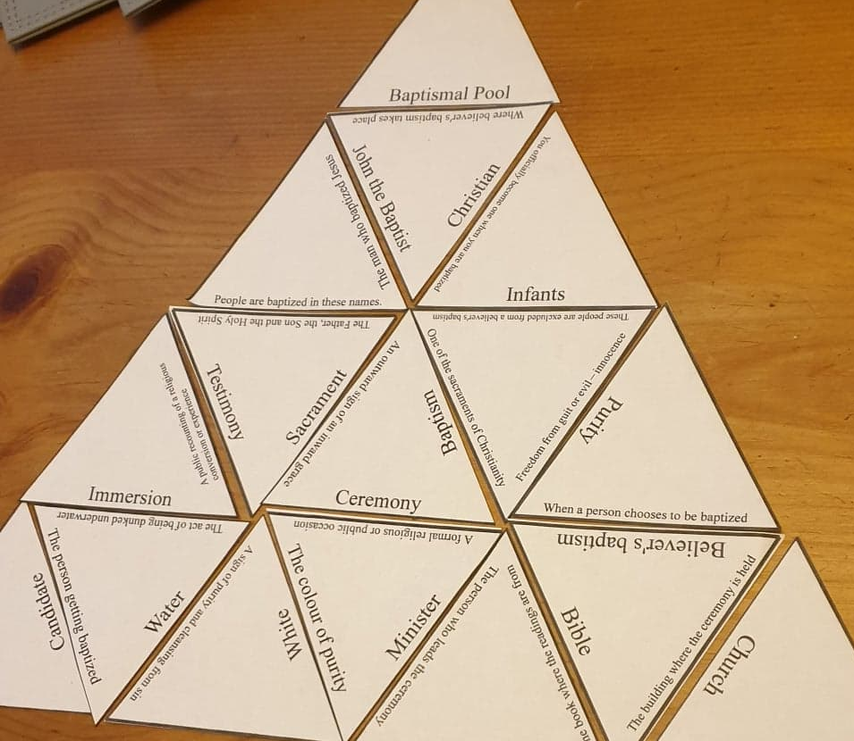
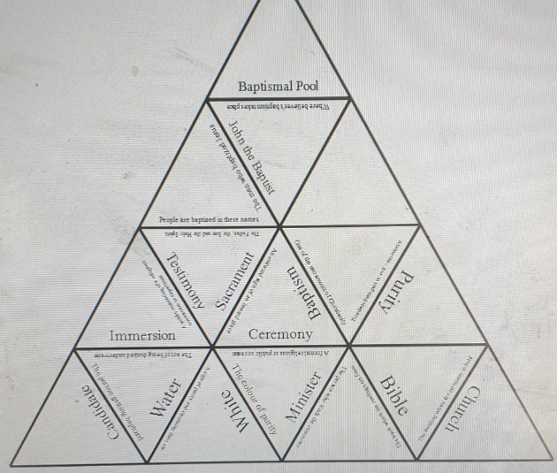
Fig. 1 This is the tarsia puzzle in its Fig.2 The triangles are cut out and
creation process. shuffled; pupils then have to
re-assemble them as seen above.

The following lesson’s primary focus was on testimony and contained my first research task, a written testimony. To ensure that this was done successfully, the tasks leading to this were of the utmost importance. I began with an introductory quiz to test pupils on the knowledge learned in the prior lesson, paying close attention to the key words. My main reason for this was not just for the retention of knowledge but to push pupils to actively use these key words in their answers. After this, I focused on looking at why people choose to get baptised, perhaps the most important aspect of this lesson since this forms the crux of a testimony. Once pupils had devised a spider diagram that showed this, pupils were tasked with writing a testimony as a way to further develop their understanding of why people choose to get baptised. This is where the lesson diverged between the two classes as I used class X for the pre-test and class Y for the post-test. To note, the third and final lesson of believer’s baptism was identical for both classes as they learned about the steps of the ceremony and the symbolism throughout; the written testimony had no influence on this lesson.

Pre-test
For class X, pupils were given the task to imagine they were a criminal turned Christian and write a testimony about how their life has changed and why they are now getting baptised. Initially, I had opted for pupils to only write in the first person because they could create their own experiences and reasons why they were getting baptised. However, the option for pupils to write in the third person had to be given, as instructed by my mentor, in order for pupils to not seemingly be espousing religious beliefs, a grievance that had arisen from parents in the past. However, making the testimonies impersonal proved useful as pupils, particularly those of lower ability, could draw on the experiences of fictional characters to help support them; for them it was easier to talk from someone else’s perspective rather than their own. Whilst no pupils wrote their testimonies in the first person, many did write from the perspective of a fictional character. Therefore, if I were to repeat this task, I would give pupils the choice to write in either first or third person but particularly emphasise the use of fictional characters.
Pupils devised their own success criteria as a class which primarily consisted of what needed to be included and the structure. Apart from this and lesson brief, they had the freedom to go in any direction they wanted and spent the remainder of the lesson writing the testimony.

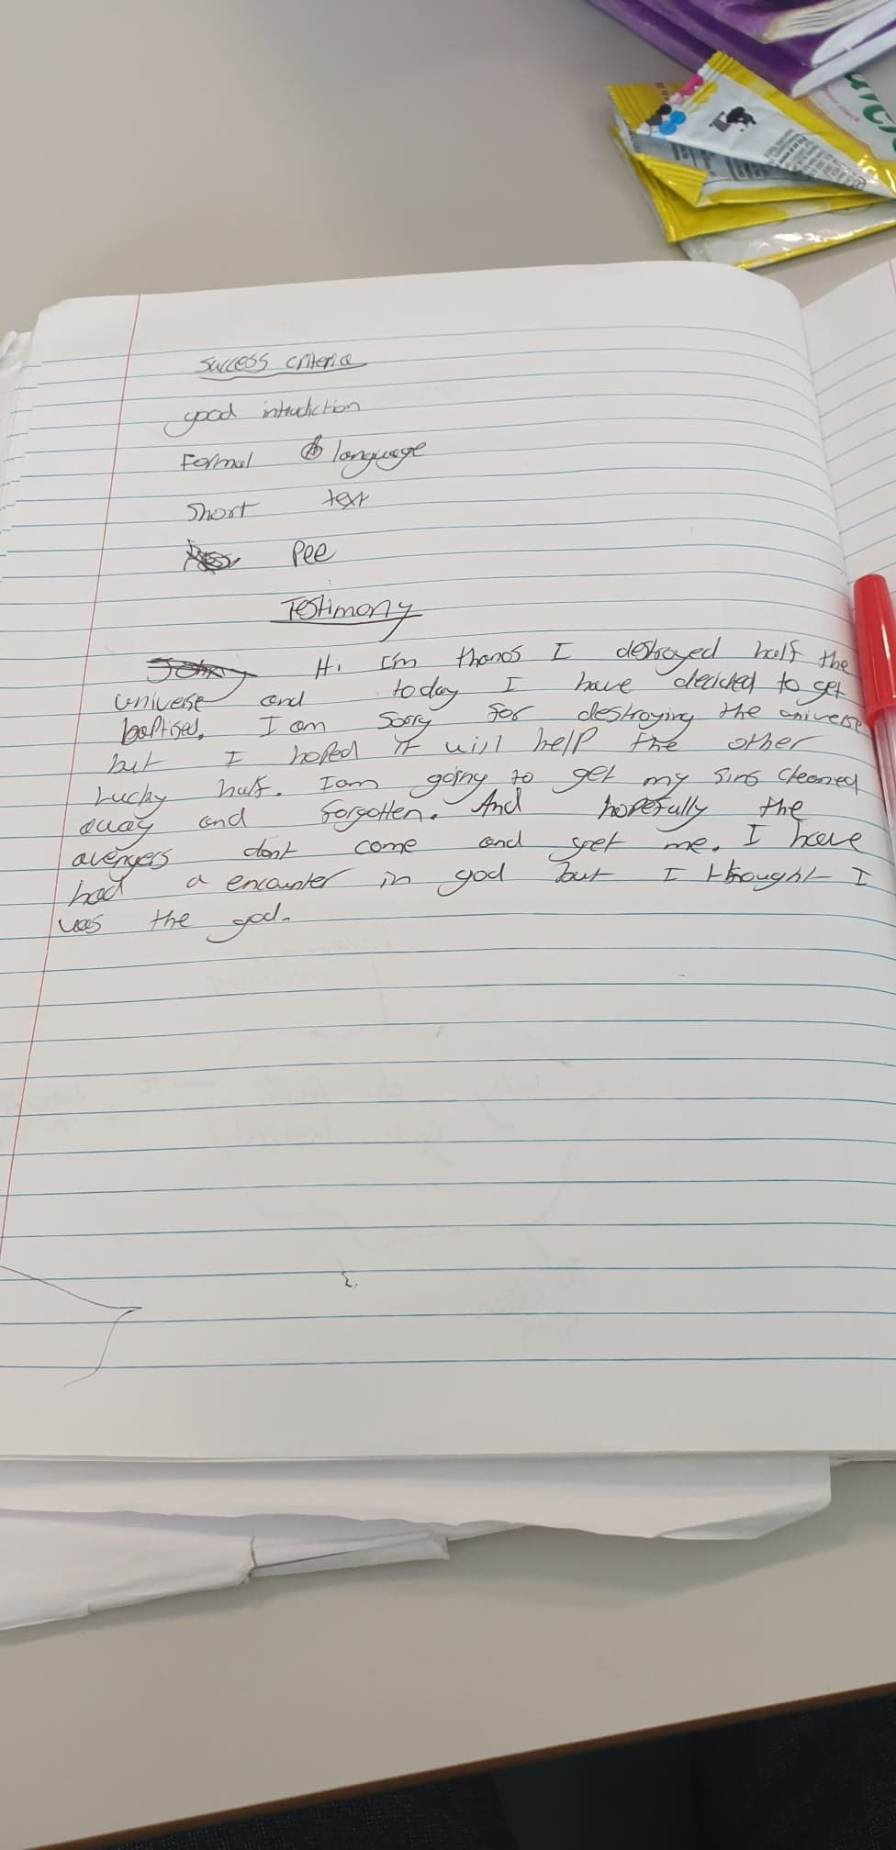
Fig. 1 An example of a written testimony from the perspective of a fictional character.

Post-test
For class Y, pupils were given the same task with one major difference – they had to write a testimony from the perspective of a selected criminal turned Christian; thus they were not creating their own experiences but all writing about the experience of one man. To achieve this, pupils first watched a video on said criminal where he talked about his past and how he became a Christian. Pupils then devised their own success criteria as a class which similar to before primarily consisted of structure but also contained more specific details of what needed to be included taken from the criminal’s life. Once done, pupils had the remainder of the lesson to write his testimony.

Results
In order to try and quantify creativity, I have chosen an approach that compares the pupils’ written work to test their originality. This is done by the following equation –

$$Originality= \frac{No. of unique words}{No. of total words} ×100$$

Thus, pupils’ work had to be first totalled into the number of words they had written. Then by comparing the pupils’ work with each other, I can take the number of unique words found in each. Of course, this is not fully accurate since some words are homonyms and other times, the same words can be used in two different contexts. Furthermore, many words are synonyms and so whilst being different do not make for a different sentence. Therefore, I have taken whole sentence into consideration so I can determine the context of the words and whether to class it as unique or not.

Consider the following:
- Today, I have decided to get baptised because…
- I have chosen to get baptised today because…

Other than the order of the words, the only difference here are the words ‘decided’ and ‘chosen’. However, I would not consider either unique because in this context they mean the same thing and do not alter the meaning of the sentences.

Consider the following:
- Today, I have decided to get baptised because I have been chosen by God.
- I have chosen to get baptised today because I want my sins washed away.

In sentence 1, the word ‘chosen’ is used passively so whilst it has the same meaning as that in sentence 2, I would consider it unique because of how it is used. Thus, I would give sentence 1 a total of four unique words – ‘been chosen by God’ and sentence 2 five unique words – ‘want my sins washed away’. Whether these remain unique is dependent on the rest of the testimony but this is intended to give an indicator of the method I have used to determine what is unique and what is not.

Because of how long it would have taken if I compared every pupils’ work, I only took six samples from each class to calculate an average. For a more accurate class representation, two were from pupils working at a level 3/4, two from pupils at level 5 and two from pupils at level 6/7. The results do not show, however, which pupils are working at which levels.

Pre-test results
Pupil | Number of words | Number of unique words | Originality
A | 40 | 20 | 50
B | 62 | 34 | 55
C | 50 | 41 | 82
D | 162 | 93 | 57
E | 223 | 149 | 67
F | 92 | 58 | 63
Average originality |  |  | 62

Post-test results
Pupil | Number of words | Number of unique words | Originality
A | 78 | 24 | 31
B | 90 | 20 | 22
C | 129 | 38 | 29
D | 119 | 80 | 67
E | 192 | 102 | 53
F | 58 | 12 | 21
Average originality |  |  | 37

Task 2 – The scheme of work that led to the next task focused on love, particularly what it is and the types of loves – agape, philia, storge and eros. This followed on directly after the aforementioned module assessment. Because of the remaining lessons I had left in my placement, I was only able to teach up to and including agape so I ensured that the research would be done here. The first lesson was a ‘Philosophy for Children’ (P4C) lesson where pupils watched a stimulus video and then had to devise a philosophical question in small groups. Once they had all come up with a question, there was a class vote on which one should be the centre of discussion. In both classes, the question ‘What is love?’ came out on top. The remainder of the lesson was then spent with pupils discussing and philosophising on this question as one big group with little interference from me. Both classes raised the ideas of different types of love including that of unconditional love which set up the next lesson on agape perfectly.
The next lesson focused on building pupils’ knowledge of agape and exactly what this term entails. This was done by first having pupils come up with their own definition of agape using images of the parable of ‘the Good Samaritan’ and a woman giving money to a homeless man as a stimulus. As a class, we then decided on a single definition that best suited the majority of pupils’ input. Pupils then watched a video which explained agape – its origin, meaning and use – completing a quiz throughout to ensure engagement with the video. The answers to these questions were checked after and we returned to our class definition. Now that pupils had a deeper understanding of agape, they had the opportunity to adjust the definition to reflect the knowledge they had just learned. As a precursor to the final task, pupils watched a final video of a television advert entitled ‘Ripple’. Its purpose was to show an act of agape being used in a real-life situation and to get pupils thinking about other acts of agape. After watching the video, pupils were tasked with creating and delivering a scene that showed an act of agape in groups of two to five. The only stipulation besides showing at least one act of agape was that the scene had to be at least 1 minute. As previously stated, this task was not altered between the two classes as I am testing both classes using no success criteria against the previous task. Pupils spent the remainder of the lesson and the first 15 minutes of the next preparing their scenes. Each group took it in turns to deliver their scenes. Whilst doing this, the other pupils observed carefully and then wrote short paragraphs on each group’s scene saying what happened and how agape was shown. Once every group had delivered their scene, pupils had to write about their own scenes, stating what they did, how they showed agape and, most importantly, why they chose their scene. This was important not only for pupils to reflect on their own work but also because it allowed me to see from the pupils’ perspective how their creativity came to fruition – was their scene influenced by something they have seen, from society or was it a work of pure imagination?
Reflecting on the delivery and content of these lessons, in particular the research task, there is nothing that I would change. The scaffolding of the lesson to build upon pupils’ knowledge of agape was paced well and the final task allowed pupils to consolidate and apply that knowledge in a sophisticated manner.

Results
Because this was not a written task, there was no way to quantify the data like in the previous task. Therefore, I have simply summarized the scene that each pupil performed as these can then be compared against each other.

Class X results
Group | No. of pupils | Description of scene presented
1 | 4 | A woman takes her elderly father who is confined to a wheelchair to the chemist. There they ask for medicine but they do not have the money to afford it so they leave stating that without it he will die. A customer overhears the conversation, buys the medicine and catches up to the daughter and father. He gives them the medicine and they are overjoyed and profusely thank the customer.
2 | 5 | Three friends are walking through the street and spot someone they dislike named Rhys. They walk over to him and start beating him up. Another man spots the foray and intervenes, defending the innocent man. Rhys thanks the man for stepping in and departs. The time jumps forward three years. The same three friends are walking along and spot the man who intervened years ago. They approach him and start beating him up. This time Rhys notices that man getting beat up and proceeds to defend him. After knocking out the three friends, he helps him up and the man thanks Rhys. In elation, they jump and high-five each other shouting, “Agape!”
3 | 3 | A man and a woman go shopping and buy new clothes for themselves. After they leave, they notice a homeless man on the street in the rain. He has no coat and is soaking wet. The man keeps walking past him whilst the woman stops and gives him the coat she had just bought. The homeless man puts it on and thanks the woman.

Class Y results
Group | No. of pupils | Description of scene presented
1 | 3 | Two men pass a homeless man in the street. One passes him in disgust whilst the other gives him money.
2 | 3 | One pupil raps the chorus of ‘Where is the love?’ by the Black Eyed Peas. During this, the other two pupils act out the chorus with scenes of violence but by the end there is reconciliation and love.
3 | 3 | One man is at an airport wanting to buy a one-way ticket to leave the country. He is short by £100 and pleads for the person working at the ticket office to make an exception but this is in vain. Just as he is about to leave a man comes running to his aid and pays for the remainder of his ticket. He thanks the man and asks how he can repay him but the man does not want anything in return.
4 | 2 | The scene starts with one man beating up another and then cuts forward a number of years. The man who got beaten up passes the man who beat him up years ago but he is now homeless. The homeless man is invited to his house and here, he helps to feed him, clothe him and gets him a job.
5 | 5 | There are two homeless women begging on the street. Two women pass the two in disgust and walk on. Another woman walks past and gives both some money. A final woman walks past but is unable to help as she has no money. She is scoffed at by one homeless woman but the other gives her some of the money she had just been given. The woman thanks the homeless woman before walking on.
6 | 5 | Three men approach a homeless man who is a Sikh and start throwing racial slurs at him before proceeding to assault him. A passer-by steps in to help the Sikh stranger by throwing the others off him. The Sikh thanks the passer-by before they go their separate ways.

Conclusions
Task 1 – The first conclusion that can be drawn is that strict modelling impedes creativity. Unlike class X who had an average originality value of 62, class Y only had a value of 37. Having to use the same model to write their testimony about made class Y’s work more formulaic and unoriginal, something that William (2018) had warned about. However, whilst not reflected in the results, the quality of work was very good and pupils, especially those of lower ability, were able to write a lot more because the information had been given to them to use. That there was a difference between the two classes was not surprising but I had expected class X’s originality to be higher in spite of the use of success criteria. Interestingly, the success criteria played a minimal role on the originality of their work. Whilst the success criteria did push pupils to again write in a formulaic manner and include a generic list of points in their work, it was the lack of modelling in this instance that appeared to be the main problem. Thus, the second conclusion that can be drawn is that no modelling also impedes creativity. Without giving pupils some sort of stimulus to focus on and then apply their imagination to, pupils resorted to discussing ideas with each other which led them to write similar things. Furthermore, pupils struggled to get going which forced me give sentence starters. Although sentence starters do not include the main content of the work, it still brings down the originality according to the way I have measured it and guides pupils in a very similar direction. Whilst 62 is still a considerably good score for creativity, it is evident that pupils are still being held back from using their full potential of creativity. The quality, however, was not as good as class Y’s which suggests that there is a correlation between quality and creativity but the cause of it being because of the modelling and not the success criteria as originally thought. Therefore, between the two classes and the results of this task alone, it would seem that what is required to get the best creativity out of pupils is a fine balance between no modelling and strict modelling with success criteria to guide structure. However, task 2’s results must also be considered and compared to get a better picture of this.

Task 2 – After comparing the scenes of the classes, the conclusions that have arisen are telling, the main one being that using no success criteria has allowed creativity to flourish. In spite of having no quantifiable data, comparing the results of this task against those of the first generally and against class to class specifically, it is clear that this task has bred the best creativity. This is not to say that all the scenes are entirely original since three of them in class Y were about giving homeless people something. However, these were not influenced by any success criteria but likely by either society, since homelessness is a prevalent issue, or by the picture of the woman giving the homeless man charity at the start of the lesson, thereby subconsciously making them conjure up this idea. Nevertheless, those that were different went off in very unique directions This may have been helped with the modelling of the advertisement which indicates that when modelling is done right, it is not a hindrance. A big difficulty with these results is that it was group work so lower ability pupils working on this individually may well have struggled without a success criteria to guide them.

Ultimately, it does appear that success criteria is a hindrance for creativity but only to a limited extent. As long as it does not force specific details onto pupils, the biggest issue actually lies with modelling and whether it is effectively used. More research would definitely need to go into this for a more thorough conclusion but at least my initial presuppositions appear to be supported.

Limitations and future development
Although I had tried to limit the research question into a more focused area surrounding creativity, success criteria was a much larger area than I had initially given credit for. Consequently, because of the many applications that are possible with success criteria, the biggest limitation has been the inability to analyse each application and evaluate how they affect creativity. This has skewed my research since it only gives a glimpse into the effectiveness of success criteria rather than a fuller picture. In hindsight, with the limited time and resources including the size of the research project itself, this was always going to be unavoidable. Nevertheless, I do believe that the research gives a fairly accurate representation of the effect success criteria can have on creativity and should the research have been done on a larger scale, I would expect those outcomes to support these results further.

Another major limitation which was inevitable was the reliability of the results through the samples of the classes chosen. The initial problem was that the same task could not be used for the same class twice, once to test with success criteria and again without, hence the reason the pre-test and post-test had to be conducted across two classes. Whilst I had tried to mitigate these circumstances by using two very similar classes with regards to age and ability, no two classes can ever be fully identical. Consequently, the results for the first task cannot be reliably compared between the two classes, at least not as a one-off. What would have made this more reliable is the inclusion of more tasks since this would lessen the margins of error and give a more conclusive result over a longer length of time.

Furthermore, pre and post-tests could have also been done within the same class thereby getting more reliable results. For example, with class X I could have done a written task such as a testimony with very brief success criteria then in the next lesson I could have done a different written task such as a blog post with ample modelling and pupils creating their own success criteria. This could have then been repeated with class Y. Both classes could then have the opportunity to rate the usefulness of the success criteria and how creative they felt when writing. This would have given me written work to analyse, my personal observations of pupils’ engagement with the work and pupil voice about the tasks.

In terms of the creative task, I could set a task such as acting out a scene with no success criteria, time them to practice and present the scenes. I would then ask pupils to rate how creative they felt when making their scene. Then we could reflect on the scenes as a class and use them to create a success criteria for a good scene. The success criteria would also include extra elements that groups have not done so each group has the opportunity to improve. The class would then use this success criteria to re-create their scenes. After they have presented their second scenes, I would ask pupils to again rate how creative they felt. This would enable me to directly compare whether the added success criteria impacted their creativity. This would require an explanation of the definition of ‘creativity’ so that all pupils understand what they are rating.

Although my study has its limitations, it is extremely useful in outlining areas for future research to be undertaken. It will also inform my future pedagogy as I will continue to use different levels of success criteria and to engage with pupil voice and their work to determine the most effective methods. I will continue to read professional literature and future research studies around creativity and success criteria and use this to inform my professional development.

Reference List
Allison, S. and Tharby, A., (2015). Making Every Lesson Count, six principles to support great teaching and learning. Carmarthen: Crown House Publishing LTD.
Assessment Reform Group (1999). Assessment for Learning: Beyond the Black Box, University of Cambridge School of Education.
Bentley-Davies, C. (2010). How to be an amazing teacher. Bancyfelin: Crown House.
British Educational Research Association (BERA) (2011). Ethical Guidelines for Educational Research. <https://www.bera.ac.uk/wp-content/uploads/2014/02/BERA-Ethical-Guidelines-2011.pdf?noredirect=1> (Accessed 14/07/2019)
Black, P., Harrison, C., Lee, C., Marshall, B. and William, D. (2003). Assessment For Learning Putting it into practice. England: Open University Press.
Burton, D. and Bartlett, S. (2009). Key Issues for Education Researchers. London: Sage Publications Ltd.
Child, D. (2007). Psychology and the teacher. 6th ed. New York, NY: Continuum.
Clarke, S. (2003). Enriching feedback in the primary classroom. London: Hodder Murray.
---. (2005). Formative assessment in action weaving the elements together. London: Hodder Murray.
Cohen, L., Manion, L. and Morrison, K. (2007). Research Methods in Education. 6th ed. London: Routledge.
Donaldson, G., (2015). Successful Future: Independent review of curriculum and assessment arrangement in Wales <https://gweddill.gov.wales/docs/dcells/
publications/150225-successful-futures-en.pdf> (Accessed 19/07/2019).
Fallon, M. and Massey, D. (2008). ‘Strategies for Dealing with Other Research Issues’ in C. Lassonde and S. Israel eds., 2008. Teachers Taking Action A Comprehensive Guide to Teacher Research. Newark: International Reading Association.
Fautley, M. and Savage, J., (2008). Assessment for Learning and Teaching in Secondary Schools. Exeter: Learning Matters Ltd.
Graue, M. (1993). Integrating theory and practice through instructional assessment. Educational Assessment. 1: 283-309.
Griffith, A. and Burns, M., (2012). Engaging Learners. Carmarthen: Crown House Publishing.
Heritage, M. (2018). Assessment for Learning as Support for Student Self-Regulation. In: Australian Educational Researcher. 2018. Vol. 45, Iss. 1: 51-63< http://dx.doi.org/10.1007/s13384-018-0261-3> (Accessed 19/07/2019).
Hopkins, D. (2014). A teacher’s guide to classroom research. 5th ed. Berkshire: Open University Press.
Kara, H. (2017). Creative research methods in the social sciences. Bristol: Policy Press.
Jones, S. and Tanner, H., (2006). Assessment: A Practical Guide for Secondary Teachers. London: Continuum.
My Local School (2019). < http://mylocalschool.gov.wales/?lang=en> (Accessed 19/07/2019).
Petty, G. (2009). Teaching Today, A Practical Guide. 4th ed. Cheltenham: Nelson Thornes.
Punch, K. (2009). Introduction to Research Methods in Education. London: Sage Publications Ltd.
Sadler, D. (1989). Formative assessment and the design of instructional systems. Instructional Science, 18, 119-44.
School A, (2018a). Assessment Policy.
---, (2018b). Feedback and Marking Policy.
---, (2017). Success Criteria: Inset Day Training.
Welsh Assembly Government (2010). How to develop thinking and assessment for learning in the classroom. [pdf] Wales: Crown Copyright <https://s3-eu-west-1.amazonaws.com/hwb-live storage/0b/7e/2a/dc/dc1f4a3dbf14716ec0041020/ how-to-develop-thinking-and-assessment-for-learning-in-the-classroom.pdf> (Accessed: 24/07/2019).
---, (2008). Skills Framework for 3 to 19-year-olds in Wales. [pdf] Wales: Crown Copyright<https://dera.ioe.ac.uk/11297/1/SKILLS_FRAMEWORK_2007_Engli1.pdf%3flang=en> (Accessed 24/07/2019).
William, D. (2018). Embedded formative assessment. 2nd ed. Bloomington, IN: Solution Tree Press.
Winterbottom, M. (2013). Taking a Quantitative approach. In: E. Wilson, ed. 2013. School-Based Research, A guide for education students. 2nd ed. London: Sage Publications Ltd. Ch. 11.

From my readings, there appears to be no research that has calculated success criteria and its variants algorithmically which is why there are a lack of references within the following paragraphs. It is understandable that qualitative research is the core focus since being able to quantify creativity and quality respectively is objectionable. Nevertheless, I thought it was still important to include this within the ‘literature review’ since it highlights a research gap which needs to be addressed.
Realistically, similar tasks could have been achieved within confirmation and bar mitzvah but the familiarity pupils had with baptism having previously studied infant baptism best informed my decision since this would have given them some pre-conceived ideas they could utilise for the task.
There are significantly less results here than class Y because the majority of pupils were attending a class trip.

