Alternative Powertrain Assignment 2 – Hybrid Conversion

University of Wales Trinity Saint David
School of Engineering
Motorsport engineering
Oliver gordon
P150782
15/3/20
Alternative powertrain
Mark Sandford

Table of Contents
1 Introduction 4
2 Research 5
3 The maths 8
4 Conclusion 10
5 References 11

Table of figures
Figure 1 - hybrid diagram - https://en.wikipedia.org/wiki/File:Hybridpeak.png 5
Figure 2 - VW 1.0 litre TSI 90 HP up! Beats tech specs - (CARS-Data, 2016). 7
Figure 3 - Chain Efficiency losses - (Ride Far, 2016) 8
Figure 4 - YASA P400R motor specification information used - (YASA , 2018) 9
Figure 5 - combined motor and controller efficiency graph - (YASA , 2018). 9
Figure 6 - Nissan Leaf lithium ion battery - (Electric Vehicle Wiki, 2018) 9
Figure 7 - integrated motor generator 3 made by Bosch - (Bosch, 2020). 10
Figure 8 - efficiency table - Oliver Gordon excel document. (gordon, 2019). 10

Introduction
This assignment is about switching the buggy from a normal petrol buggy to a series hybrid, going through parts that are required, doing this by backwards engineering the power and the efficiency losses. Building a series hybrid system, including the motor and controller, then the battery, charger and then generator and a new smaller engine. The efficiencies that were used are from the chain drive, motor and controller, discharge and charge efficiencies and then finally the generator. In the excel, changes have been made so the table is now in seconds for the original buggy and the new hybrid changes including weight differences.

Research
The motor chosen for his assignment is the YASA P400 RS. As seen in the maths section further in the essay, the max power required for a lap of the track in kw is 22Kw, so with that information know the motor chosen was because the power output is 160kw, and a continuous power of 0-60 Kw, this is to guarantee it can produce the required power for the lap. (YASA , 2018). The motor controller chosen is the 800v controller @450Arms P400 RS which is the controller that comes with the YASA motor chosen. (YASA , 2018). The combined efficiency of 94% being the figure used for the maths/ excel.

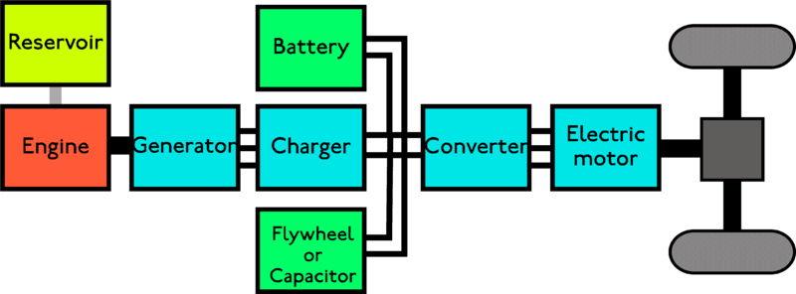
Figure 1 - hybrid diagram - https://en.wikipedia.org/wiki/File:Hybridpeak.png
When researching about dc to dc converters the following quotes were found, “The different configurations of EV power supply show that at least one DC/DC converter is necessary to interface the FC, the Battery or the Super capacitors module to the DC-link.” (InTech, 2011). Then went on to state that “In electric engineering, a DC to DC converter is a category of power converters and it is an electric circuit which converts a source of direct current (DC) from one voltage level to another, by storing the input energy temporarily and then releasing that energy to the output at a different voltage. The storage may be in either magnetic field storage components (inductors, transformers) or electric field storage components (capacitors).” (InTech, 2011). Efficiency losses are calculated using many formulas and some estimations for the dc to dc converter.
In the research for batteries, information being hard to come by and looking of multiple websites and papers, the efficiency of battery charge of 99% being the best that was found. “The battery is highly efficient. Li-ion has 99 percent charge efficiency, and the discharge loss is small.” (Battery University, 2011). So an assumption of discharge losses has been made, this being 4% efficiency loss from battery discharge.
The built in charger that the Nissan leaf has, also known as the EVSE (Electric Vehicle Supply Equipment), is used to take in alternating current and switch it too to direct current. “This charger can accept alternating current from 100 to 130 volts (level 1) and also from 200 to 250 volts (level 2). It sends direct current to the battery at a variable voltage in the neighbourhood of 400 volts. It communicates with the Li-Ion Battery controller, which specifies current levels that vary during the charging. The charger meets those levels by dynamically adjusting its output voltage.” (Electric Vehicle Wiki, 2018).
For plug in charging it is recommended that the vehicle is only 80% charged, this is to prolong the life of the battery. “The long life mode is set by changing the % Charge to 80% Charge (Improves Battery Longevity)” (Electric Vehicle Wiki, 2018).
The generator chosen is the Bosch IMG gen 3, “The integrated motor-generator (IMG Gen3) provides electric propulsion to the vehicle in its function as a motor, while in its capacity as a generator it converts mechanical braking energy into electrical energy. The third-generation IMG's high torque and power density provide electric propulsion for plug-in hybrid vehicles. Since 2016, it has been in use in production vehicles.” (Bosch, 2020). This generator produces the sufficient power and has low efficiency losses at just 5%, as seen later in the essay.
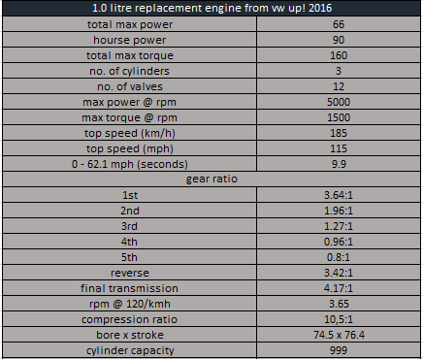
The engine chosen is the 1.0 litre TSI from a 2016 VW Up! All information taken from Car-Data, (CARS-Data, 2016). This supplies plenty of power for the car hybrid system, this also has more power than the original engine whilst being a smaller and more compact engine.
Figure 2 - VW 1.0 litre TSI 90 HP up! Beats tech specs - (CARS-Data, 2016).

2016 1.0 litre TSI engine from a VW Up! Sells for around, £600-£700, “2019 Volkswagen Polo UP engine 1.0 TSI Petrol HCZA Code fits 2016 – 2019, £650.00” (365 Engines, 2019).
The price of the Bosch IMG gen 3 is subject to an enquiry, which hasn’t been replied. This is the same reason that there isn’t a stated price for the YASA motor and controller “Please contact us to discuss your application requirements. We can then supply detailed information on the YASA products and options that may be suitable for you” (YASA , 2018).

The maths
Chain efficiency: “The main source of resistance in the drivetrain is the chain. Even a new, well-oiled chain will lose about 3% of the power that is put into the pedals.” (Ride Far, 2016).
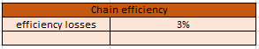
Figure 3 - Chain Efficiency losses - (Ride Far, 2016)

The specs below including the efficiency as previously stated are a combined number with the motor and controller, this being because they are supplied by the same company.
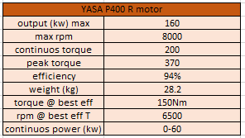

Figure 4 - YASA P400R motor specification information used - (YASA , 2018)
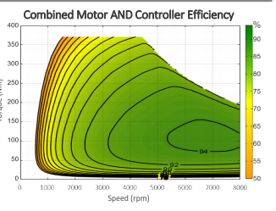
Figure 5 - combined motor and controller efficiency graph - (YASA , 2018).
On the right is the combined motor and controller efficiency graph, using this was how the 94% efficiency was chosen.

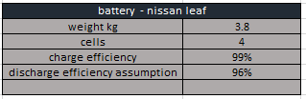
The battery used is a lithium ion battery used in a Nissan Leaf, below is the required information used in the excel document. From electric vehicle wiki, (Electric Vehicle Wiki, 2018).

Figure 6 - Nissan Leaf lithium ion battery - (Electric Vehicle Wiki, 2018)
The generator information below, this add another efficiency step to working out how much power was required from the engine which is in above in the research section of this essay.
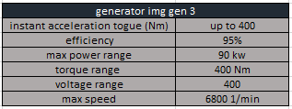
Figure 7 - integrated motor generator 3 made by Bosch - (Bosch, 2020).

Below is the efficiency table made by myself in excel to help determine the amount of power that’s needed to be generated by the previous component in the cycle and at the bottom of the table is 26.12Kw which is the power required for the engine to produce to be able to complete a lap of the track designed from the first assignment. Which as seen previously in the report the engine produces more than enough power, which shows the engine could be downsized further but as this is for a corporate event that would eliminate some of the fun factor.
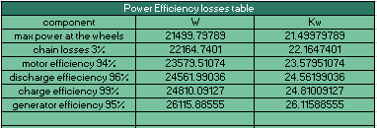
Figure 8 - efficiency table - Oliver Gordon excel document. (gordon, 2019).

The equation used to work out the power before the efficiencies, the old power divided by the percentage, for example =(old power/0.99) 0.99 being 99%.

Conclusion
To conclude this assignment, a high level of knowledge has been shown on swapping the original 450cc Subaru engine from the renegade Dx30 to a series hybrid system including the YASA P400R motor and controller, Battery from a Nissan leaf, the Bosch IMG gen 3 generator and the 1.0 litre TSI 95 engine from a 2016 VW Up!. With the efficiency losses being miniscule with the most being 5% at the generator. The prices of the components being a majority of enquiry basis.

References
365 Engines, 2019. [Online]
Available at: https://www.365engines.com/products/2019-volkswagen-polo-up-engine-1-0-tsi-petrol-chza-code-fits-2016-2019?utm_medium=cpc&utm_source=google&utm_campaign=Google%20Shopping&gclid=Cj0KCQjwpLfzBRCRARIsAHuj6qVz-SctQ0ET1ubkbFvQ5O-UZ6cr3RJBjiizzh4BpOxwjeyp2O7-OX
ABB Motors and Generators, 2019. M2BAX 200 MLA. [Online]
Available at: https://www.motors-online.co.uk/3gba202410-add.html
Battery University, 2011. BU-104a: Comparing the Battery with Other Power Sources. [Online]
Available at: https://batteryuniversity.com/learn/article/comparing_the_battery_with_other_power_sources
Bosch, 2020. Integrated motor-generator. [Online]
Available at: https://www.bosch-mobility-solutions.com/en/products-and-services/passenger-cars-and-light-commercial-vehicles/powertrain-systems/electric-drive/48v-battery/integrated-motor-generator/
CARS-Data, 2016. Volkswagen Up! 1.0 TSI 90hp up! beats tech specs. [Online]
Available at: https://www.cars-data.com/en/volkswagen-up-1.0-tsi-90hp-up-beats-specs/79853/tech
Electric Vehicle Wiki, 2018. Battery Specs. [Online]
Available at: http://www.electricvehiclewiki.com/wiki/battery-specs/
Electric Vehicle Wiki, 2018. Charging System. [Online]
Available at: http://www.electricvehiclewiki.com/wiki/charging-system/
gordon, O., 2019. assignment one excel document dirt buggy corporate event, s.l.: s.n.
InTech, 2011. DC/DC Converters for Electric Vehicles, s.l.: intech open.
Ride Far, 2016. Mechanical Resistance on Bikes: Drivetrain Efficiency & Hub Bearings. [Online]
Available at: https://ridefar.info/bike/cycling-speed/mechanical-resistance/
Toshiba, 2019. TC78B027FTG, s.l.: Toshiba Electronic Devices & Storage Corporation.
YASA , 2018. YASA P400 R E-Motors series, s.l.: s.n.

