

Information Engineering

University of Wales
Trinity Saint David

Student Name: Asen Genov
Student ID: 1906814
Date 30/04/2021
Course Title:
Information Engineering

BSc Clous Computing

Table of Contents
Introduction 3
Entity Relationship Diagram (ERD) 4
Documentation 6
3NF 8
ERD Implementation Assumptions 10
Creating Tables 10
Forms 15
Reports 20
Relationships 23
Using SQL Queries to Create Relationships 23
Using SQL to Add Records to Tables 27
Working of Main Menu and Form Navigation 29
User Documentation 30
Conclusion 31
References 32

Introduction
Data and information storage has evolved over the years. In the early civilizations, data storage was not adequate and reliable. Forms of data storage in early days included scrolls, stone tablets, carvings and rock painting. During the industrial revolution, data storage evolved from ink and paper to file management systems. The file management systems seemed to be reliable and easy to store and retrieve the information. With the file systems, data could be manipulated. This came along with the concept of Database Management Systems (DBMS). DBMS makes it possible for data to be stored, recorded, manipulated and retrieved using the available DBMS tools. Tools such as MySQL, SQL and Microsoft Access facilitate easy data management practices.
The report will address the issue of development and implementation of a Database Management System for Universal Sports using MS Access and other tools. The system will enable the institution to upgrade from traditional data storage forms to the digital data management systems. This way will enable Universal Sports to record, store, manipulate and retrieve required information from the database.

Entity Relationship Diagram (ERD)
DBMS acts as the data container/storage platform. DBMS requires precise skills and knowledge during their designing and development stages. To achieve this objective, ERDs are the perfect tool used in the initial planning, design and modeling of a database system. An ERD is comprised of entities, attributes and relationship or flow diagrams. All these components form a clear high visualization and analysis of data. Verification of data stored in the database is mainly made possible by data normalization and entities tools. Database modeling goals are achieved when ERDs and flow diagrams are put into use when planning and designing the system.
Database system is comprised of several tables some of which can be related depending on the type of attributes they contain as illustrated by the figure below.
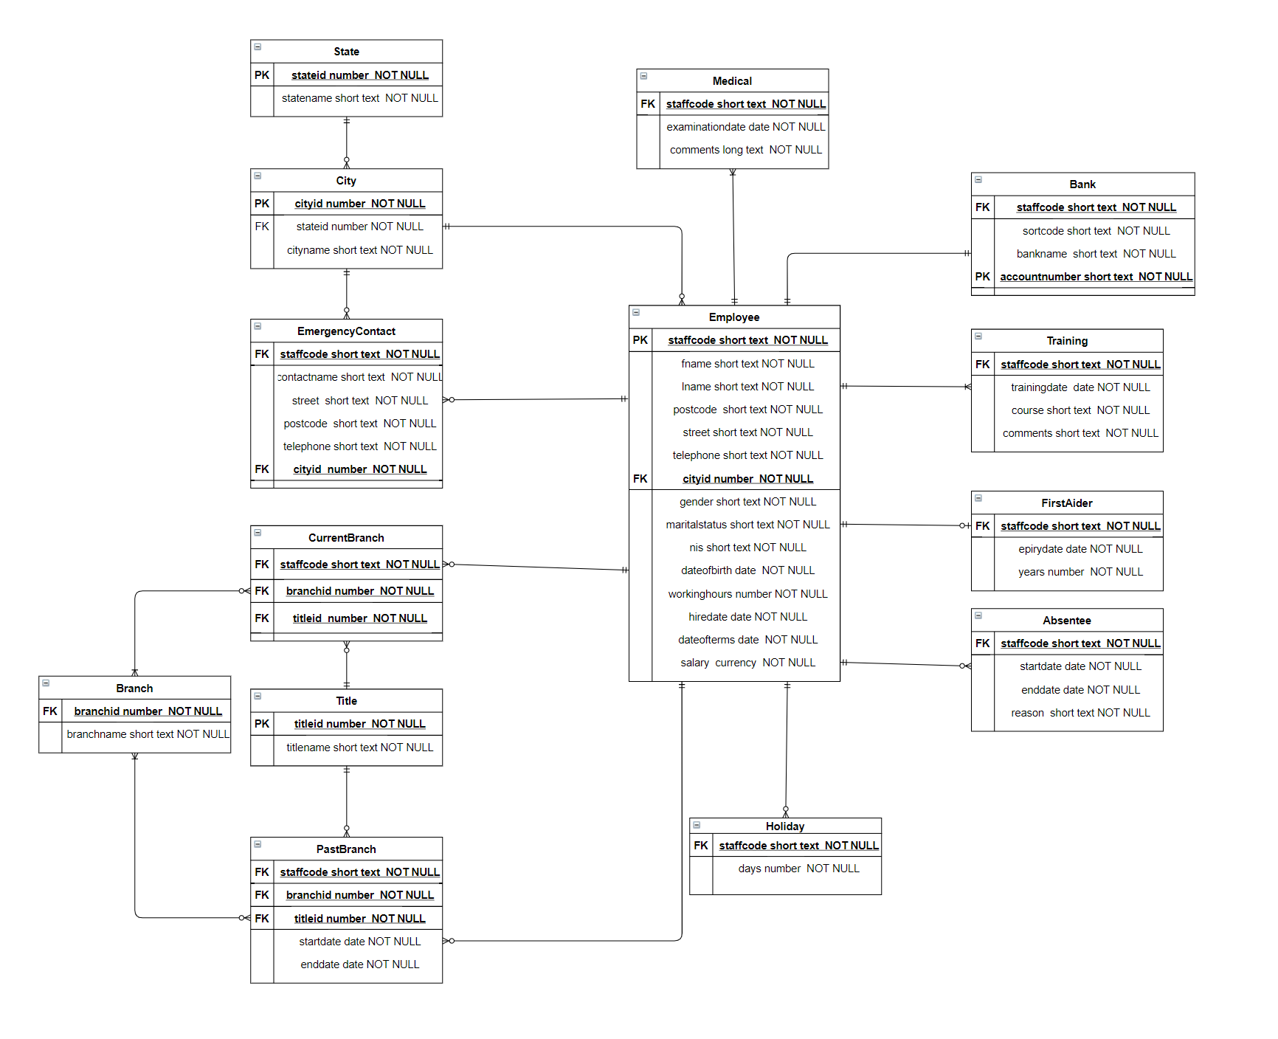
Relationships Using Crow Foot Annotations

Entity Relation with Member Class
This type of relation illustrates how different tables of the same member are related to each other in terms of the type of data they hold. For instance, each staff has a staff ID that applies all across the tables related to the staff member as shown below.
Degree of Relation with Annotations
This type of database entity relationship shows how different entities are related to each other in a logical manner. It is more of a descriptive way of showing the relationships.

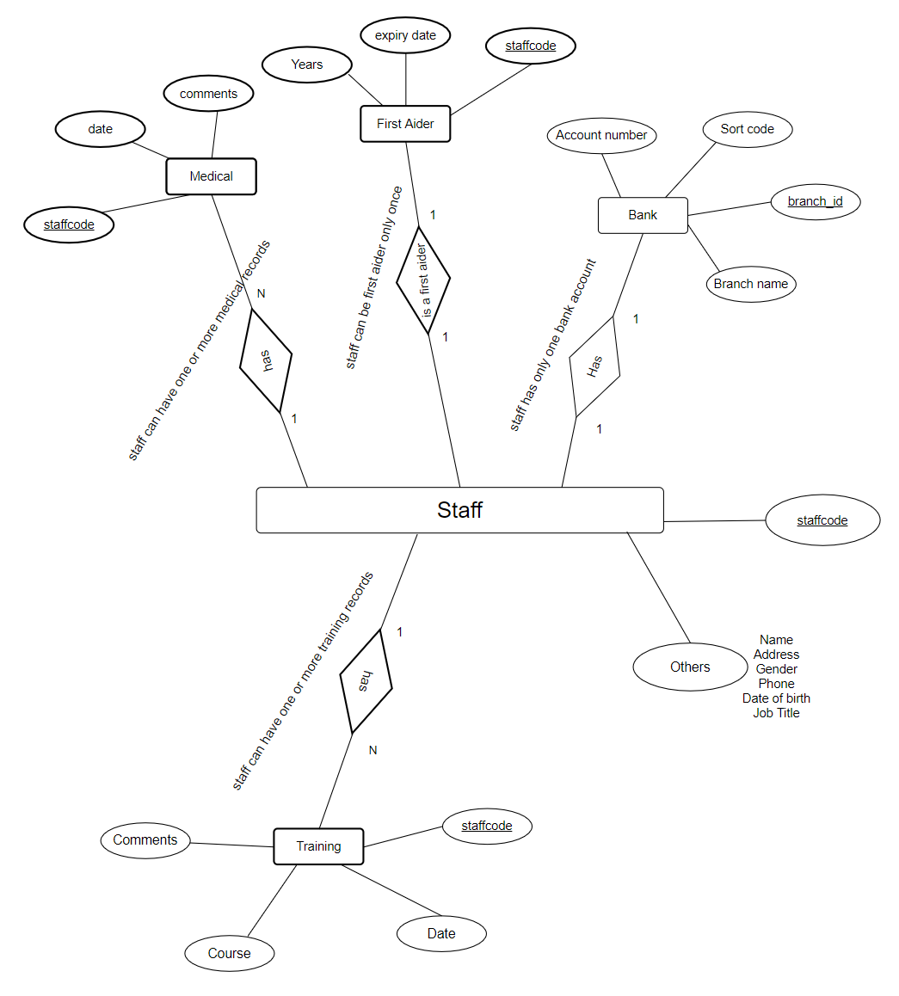

Documentation
Employee Table Data
Table Name | Employee
User requirements | It contains the personal information of employees
Fields | Staff_code, firstName, lastName, postcode, streetName, telephone, current_salary, sex, marital_status, NIS, date_of_birth, working_hours, hire_data and date_of_terms.
Foreign Keys | postcode
Relationships | It is a parent table of other tables including Absenteeism, Medical, FirstAiders, Training, BankDetails, HolidayEntitlement, EmergencyContacts, Postcode and Job Titles.  The table has one to many relationships with Absenteeism, Medical, Training, EmergencyContacts, HolidayEntitlement and PreviousBranches sub-tablees.

Absenteeism Table Data
Table | Absenteeism
Fields | Staff_code, start_date, end_date, reason and ID
Foreign Keys | Staff code
Relationships | Absenteeism table is a child table of parent table Employees and has a one to many relationships with the latter.
User requirements | It holds the information of absenteeism of the Employees

Medical Table Data
Table | Medical
Fields | staff_code, data, comments an ID
Foreign Keys | staff_code
Relationships | It is a child class of Employees table with a one to many relationship
User requirements | It holds the medical information of the Employees

First Aiders Table Data
Table | FirstAiders
Fields | ID, staff_code, expiry data and years
Foreign Keys | saff_code
Relationships | It is a subtable of the Employees table having a one to many relationship with the Employee table.
User requirements | It contains information of all employees who have been trained and holds certificate on first aid and can carry out first aid

Training Table Data
Table | Training
Fields | staff_code, data, course, comments and ID
Foreign Keys | staff_code
Relationships | It has a one to many relationship with the Employees table
User requirements | It holds information on the training of all club members

Bank Details Table Data
Table | BankDetails
Fields | staff_code, bank_name, sort_code and account_number
Foreign Keys | staff_code
Relationships | It has one to many relationship with Employee table
User requirements | It holds the bank details of employees

Holidays Table Data
Table | HolidayEntitlement
Fields | staff_code, days and day_id
Foreign Keys | Staff_code
Relationships | It is a child class of Employees class and has a one to many relationship with the parent table.
User requirements | It contains the information of holidays each employee is entitled to.
Holidays table Data
Table | HolidayEntitlement
Fields | staff_code, days and day_id
Foreign Keys | Staff_code
Relationships | It has one to many relationship with employee table
User requirements | It contains information of all holidays gone by employees
Previous Branch Table Data
Table | PreviousBranches
Fields | Staff_code, branch_code, title_id, start_date and end_date
Foreign Keys | staff_code, branch_code and title_id
Relationships | It has one to many relationshop with the Employees table. It is a linking table between the Employees table and the Titles table as well as the branches table
User requirements | It holds information on employees’ duration of staying in various branches
Branches Table Data
Table | Braches
Fields | branch_code and branch_name
Foreign Keys
Relationships | It has one to many relationships with the PreviousBranches and Job Titles. It is a linking table between the PreviousBranches and the JobTitles tables.
User requirements | It holds all names of the club branches
Titles Table Data
Table | Titles
Fields | title_id and title_name
Foreign Keys
Relationships | It has one to many relationships with the JobTitles table and PreviousBranches
User requirements | It holds names of titles at the club
Job Title Table Data
Table | JobTitles
Fields | Staff_code, current_branch and title_id
Foreign Keys | Staff_code, current_branch and title_id
Relationships | It has one to many relationships with employees table and branches table
User requirements | Holds titles of all employees in the club and their current branches
Postcode Table Data
Table | Postcode
Fields | postcodeID, postcode and city_id
Foreign Keys | city_id
Relationships | It has one to many relationships with the Employees table, city and EmergencyContacts
User requirements | It contains information of postcodes and the cities
City Table Data
Table | City
Fields | City_id, state_id, city_name
Foreign Keys | State_id
Relationships | it has one to many relationship with state and postcode tables
User requirements | It holds information of all cities and their countries
State Table Data
Table | State
Fields | State_id and state_name
Foreign Keys
Relationships | It has one to many relationship with city table
User requirements | It holds names of all states

3NF
Different tables in the database sometimes may contain fields which are already in other tables. To avoid unnecessary fields which can be derived from other tables, 3NF method is used. The main purpose of 3NF is to get rid of fields that are already available in other tables as shown in the below table.
UNF | 1NF | 2NF | 3NF | ENTITY
Employee Information | Staff number (PK) | Staff number (PK) | Staff number (PK)
 | First name | First name | First name
 | Last name | Last name | Last name
 | postcode | Phone number | Phone number
 | Street name | postcode | postcode | EMPLOYEE
 | city | Street name | Street name
 | state | City id (FK) | City id (FK)
 | salary | Current salary | Current salary
 | sex | sex | sex
 | status | status | status
 | National Insurance Number | National Insurance Number | National Insurance Number
 | Birth date
 | Hire date
 | Hours of work
 | Terms and conditions date
Emergency contact Information | Staff number (FK) | Staff number (FK) | Staff number (FK)
 | Contact name | Contact name | Contact name | Emergency contact
 | Street name | Street name | Street name
 | Postcode | Postcode | Postcode
 | City | City ID | City ID
 | State | Telephone | Telephone
 | Telephone
First aider Information |  | Staff number (FK) | Staff number (FK) | First aider
 |  | Expiry date | Expiry date
 |  | Number of Years | Number of Years
Past Branch Information |  | Staff number (FK) | Staff number (FK) | Past Branch
 |  | Branch id (FK) | Branch id (FK)
 |  | title id (FK) | title id (FK)
 |  | Start date | Start date
 |  | End date | End date
Current branch |  | Staff number (FK) | Staff number (FK) | Current branch
 |  | Branch id (FK) | Branch id (FK)
 |  | title id (FK) | title id (FK)
 |  | Staff number (FK) | Staff number (FK)
Absence |  | Start date | Start date | Absentee
 |  | End date | End date
 |  | Reason for absence | Reason for absence
 |  | Number of Days | Number of Days
Training |  | Staff number (FK) | Staff number (FK)
 |  | Training date | Training date | Training
 |  | Course | course
 |  | comments | comments
City |  | City id (PK) | City id (PK)
 |  | State id (FK) | State id (FK) | City
 |  | City name | City Name
Bank |  | Staff number (FK) | Staff number (FK)
 |  | Sort code | Sort code | Bank
 |  | Bank name | Bank name
 |  | Account no (PK) | Account no (PK)
Title |  | Title id (PK) | Title id (PK) | Title
 |  | Title Name | Title Name
State |  | State id (PK) | State id (PK) | State
 |  | State Name | State Name
Branch |  | Branch id (PK) | Branch id (PK) | Branch
 |  | Branch name | Branch name
Medical |  | Staff number (FK) | Staff number (FK)
 |  | Examination date | Examination date | Medical
 |  | Comments | Comments
Holiday |  | Staff number (FK) | Staff number (FK) | Holiday
 |  | Number of Days | Number of Days

ERD Implementation Assumptions
During the planning, design and implementation of the Universal Sports database ERD, assumptions have to be made to foresee the possible challenges that may arise and plan for how to handle them. Some of the assumptions that will be made in this report are as follows;

- Every employee has one and only one bank account with its details included hence there will be only one record in bank details table that matches in staff code in employees’ table
- Employees can have at more one training course.
- Each employee can have more than one medical record.

Creating Tables
Tables will be the containers of the data stored in the Universal Sports Database system. To be able to create tables in the database, usually the CREATE TABLE SQL statement is used. The tables created should be designed in such a way that the data they hold is consistent and error-free. This will ensure data accountability, integrity and consistency throughout the database system. When then CREATE TABLE statement is issued to the DBMS, the following figure shows all the tables that will be created.
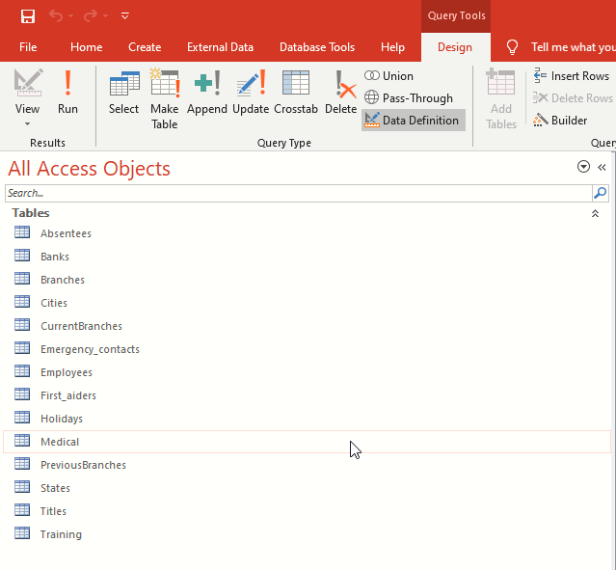Since all tables are linked with foreign keys as show in the diagram proofs that also in relation database tables will still.
After creating all the required tables to be used in the Universal Sports DBMS, the next step will be to discuss each table independently as follows;
Create Employees Table
To create the employees table, the CREATE TABLE Employees [Query is issued to the DBMS as shown below
. 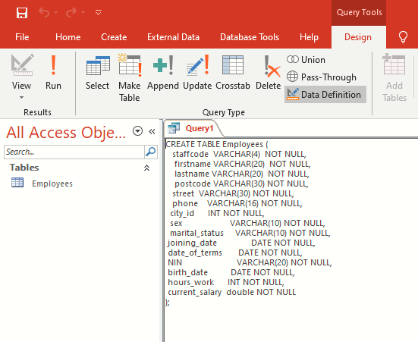

The following employee table will be created.
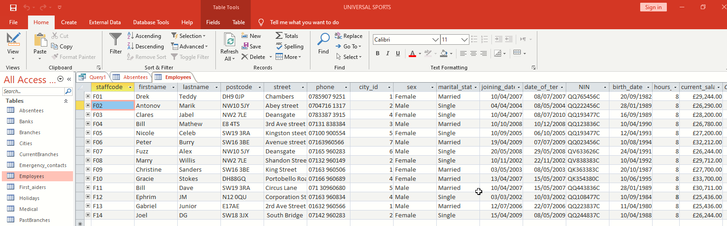

Create Absenteeism Table
To create the Absenteeism table the CREATE TABLE Absenteeism[ Query is issued to the DBMS as shown below.
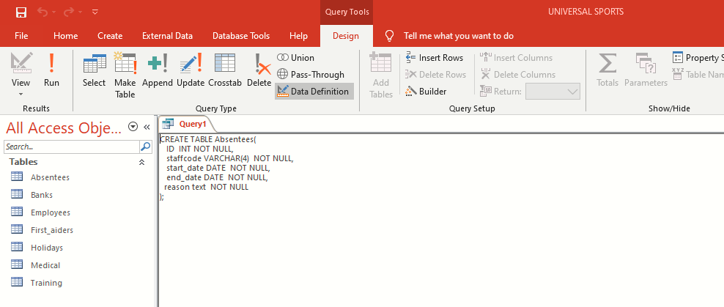

Create Medical Table
To create the Medical Table the CREATE TABLE Medical[ Quuery is issued to the DBMS as shown in the figure below
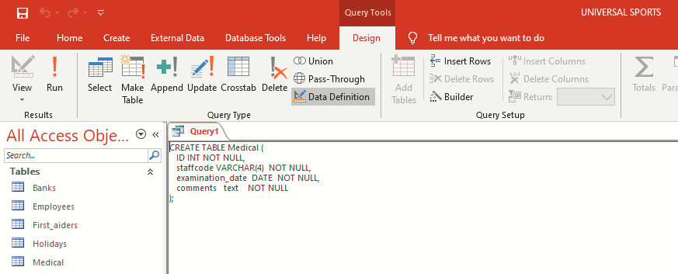

Create Training Table
To create Training Table the CREATE TABLE Training[ Query is issued to the DBMS as shown in the figure below.
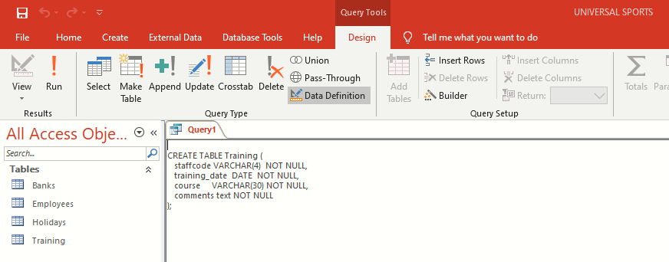

Create Bank Information Table
To create Bank Details Table the CREATE TABLE Bank Query is issued to the DBMS as shown in the figure below.
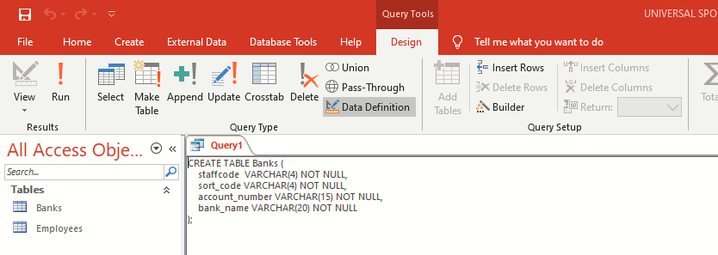

Create Holidays Table
To create the Holidays Table the CREATE TABLE Holidays[ Query is issued to the DBMS as shown in the figure below.
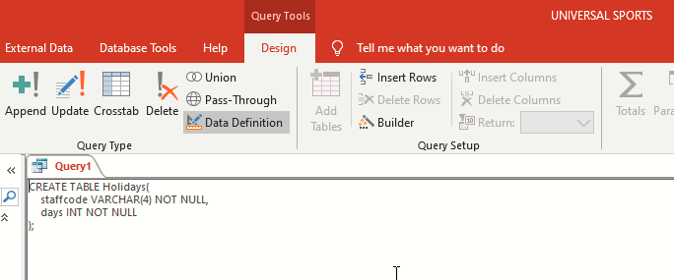

Create First Aiders Table
To create the First Aiders table the CREATE TABLE First_aiders Query is issued to the DBMS as shown below.
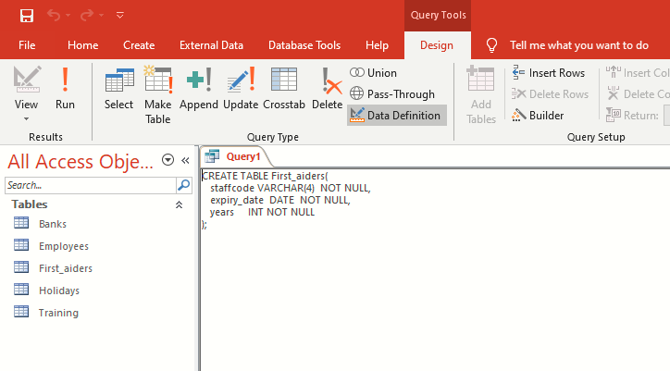

Forms
Database Management Systems should have a GUI for the users. Forms are powerful tool for providing a graphical view of the underlying database structure. They enable the user to interact with the DBMS in a friendly manner. Forms are used to view data, capture/record data, navigate and modifying data in the database system. Forms are made up of properties such as textboxes, labels, buttons and text fields. These properties help in the process of inputting and outputting data in the database systems.
For instance, forms can be used by the Universal Sports DBMS to input and output staff details in the database system as shown below.
Staff Bio Data Form
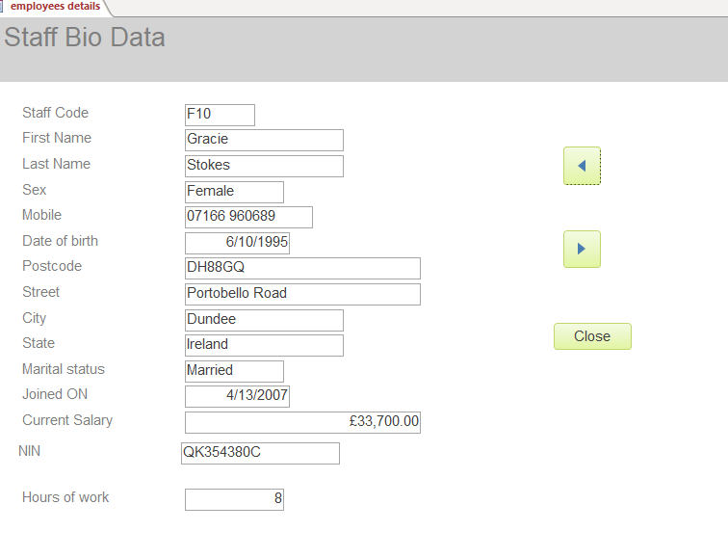
This form will be used in input/output and manipulation of staff details within the Universal Sports Club.
Absence Form
The form will be used to manage details of the staff who will be absent from their duties within Universal Sports Club. The form is as shown in the figure below.
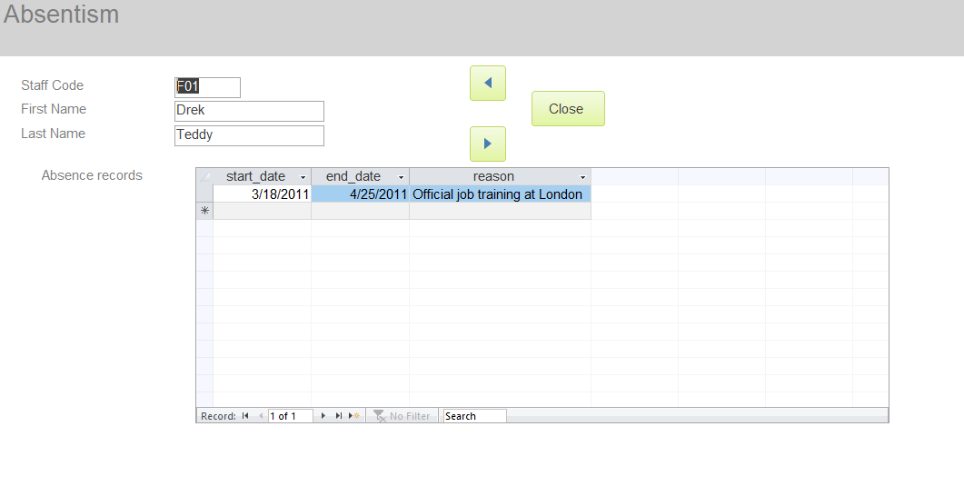

Training Form
This form will be used to manage training session details of staff within the club. The below figure shows the GUI of the form.
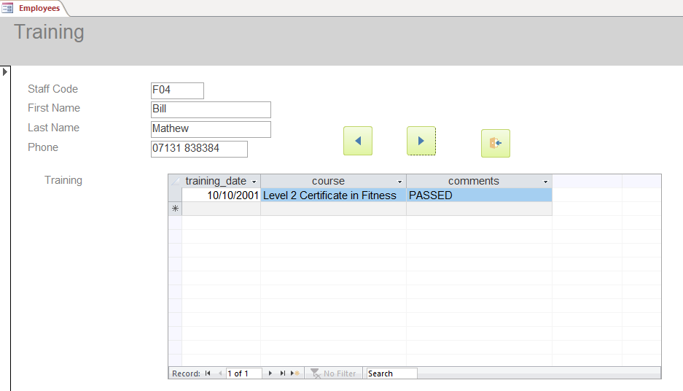

Past Branches Worked Form
This form will be used to show the details of the previous branches where each staff has worked before. It is as shown below.
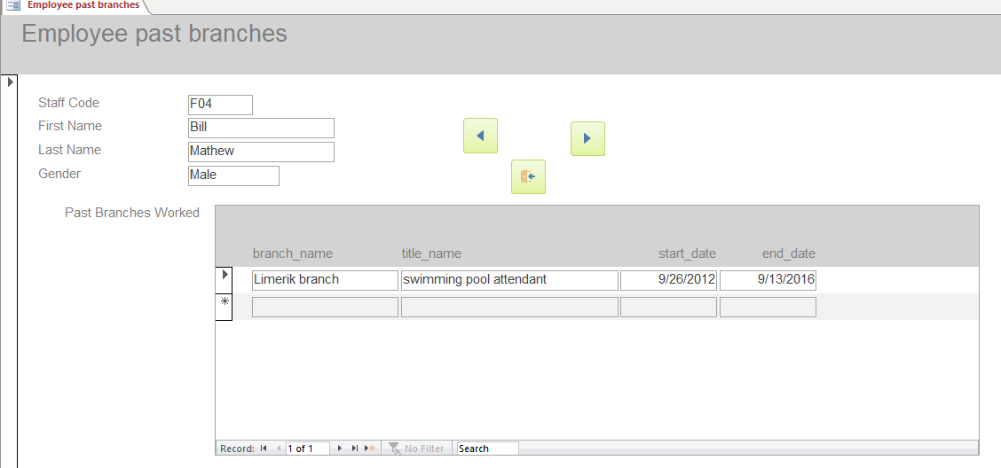

Current Branch and Salary Form
The form will be used to display the current branch where each staff is stationed. In addition they will be used to show salary details of each staff at Universal Sport. The figure below displays the form GUI.
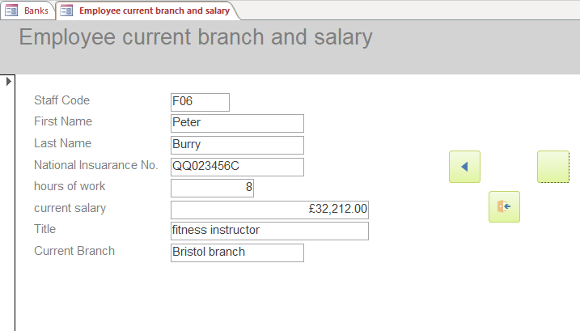

Holiday Form
The Holiday form will be used to manage vacation/leave details of each staff entitled to annual leave at the club. It will be as shown below.
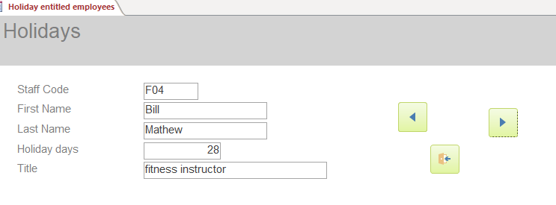

Bank Details Form
The Bank Details Form will be used to manage the banks details of all the salaried staff within the Universal Sports Club. It is as shown below.
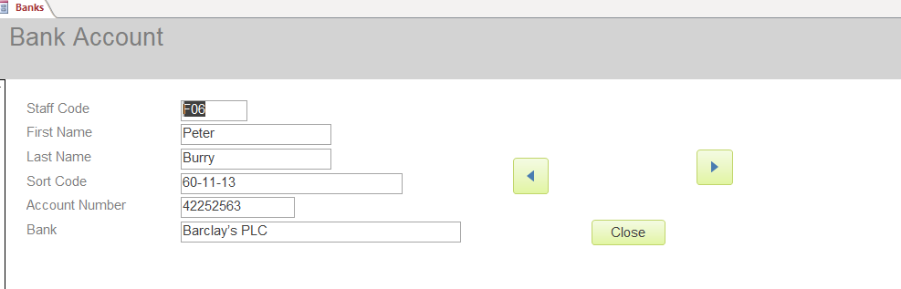

Reports
The data stored in the Universal Sports DBMS will have to be shared, formatted or printed depending on their intended purposes. The information will have to be put in summery format for easy understanding and interpretation by intended users. This will only be made possible through the use of Reports. Reports are used to output information stored in the database system of the club. Some of the information that will use reports within the Universal Sports DBMS is as discussed below.
Employee Bio Data Reports
The report will give a summary of the personal details of each staff for instance, gender, phone number, residence and cities as shown below.
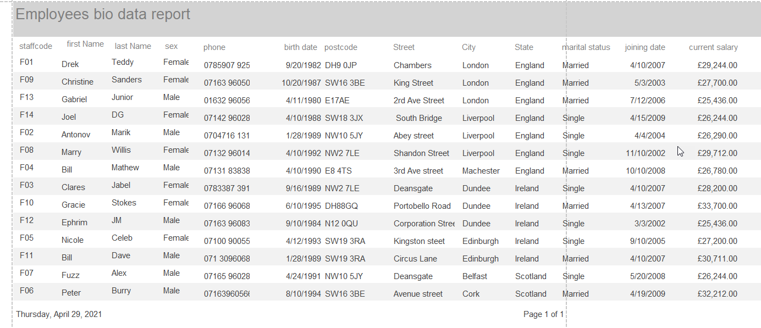
First Aiders Reports
The report will be used to give a detailed summary of the first aider profiles. It will show information such as their staff codes, names, years of experience, expiry dates of their certificates and gender. It will be displayed as follows.
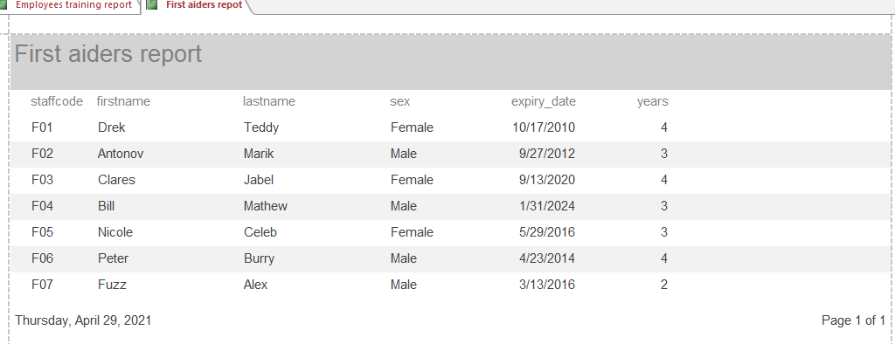
Holiday Reports
The report will provide information such as names, tittles, leave days and staff code of staff entitled to holidays. It will be as follows.
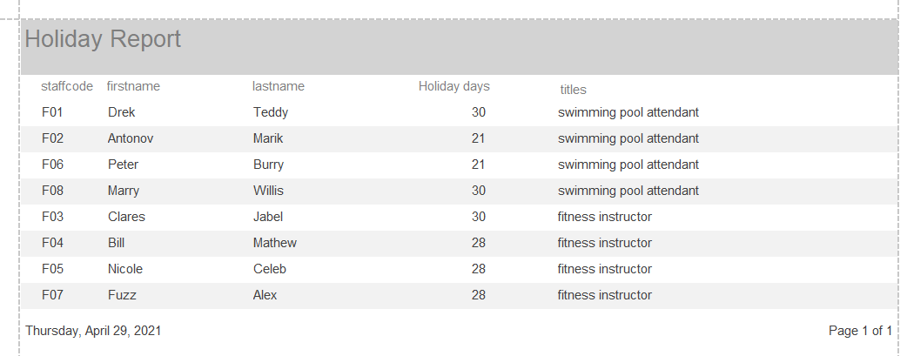
Medical Reports
The medical report will have each staff’s information about when they were examined, doctor’s comments, names and their staff IDs as shown in the figure below.
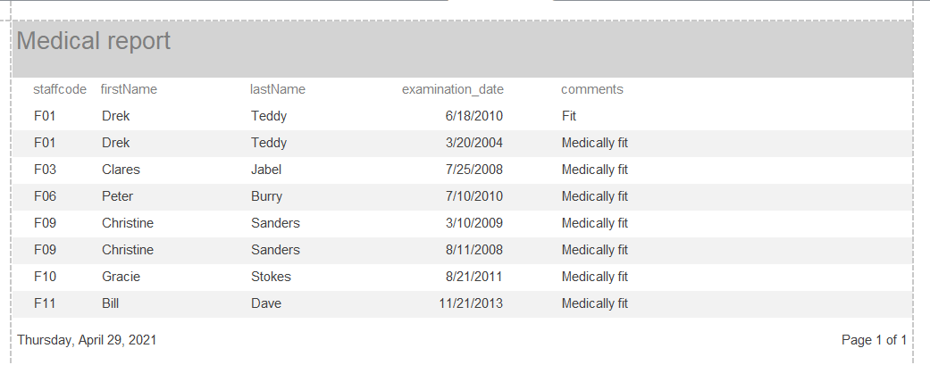
Past Branches Report
The report will provide information on the past employment history of all the current staff at the Universal Sports Club. It will provide information such as past branch name, previous tittle and duration served. The following figure illustrates how it will appear.
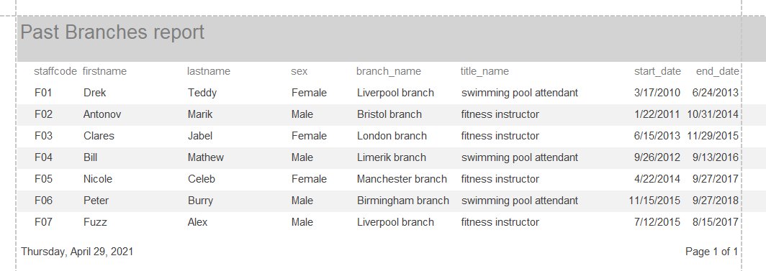

Training Report
The Training Report will provide information on the training progress of each staff. It show the training periods, performance, names and staff IDs as well.
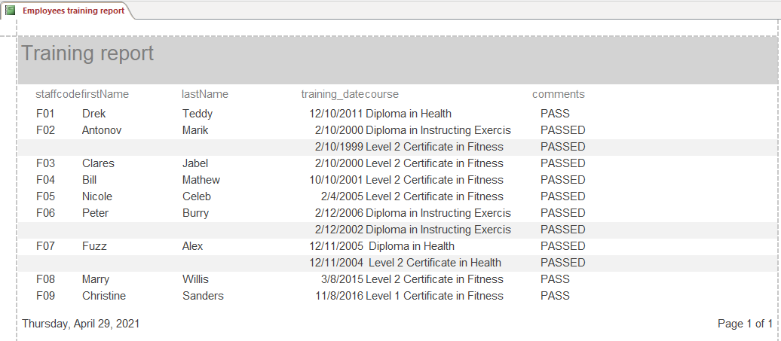

Relationships
A DBMS contains tables which hold various data for various entities. Some of the tables or data may be related in different ways. Database systems provides for all related tables or data to be linked through the provision of relationships functionality.

Using SQL Queries to Create Relationships
SQL Queries can be used in Access to create relationships between different entities or tables. In creating these relations, public or private keys are used depending on the type of relation to create. Some of the examples demonstrating this are discussed below.
Adding Relation Key to Employees
To add a relation key on Employee member class in MS Access, the following query is used.
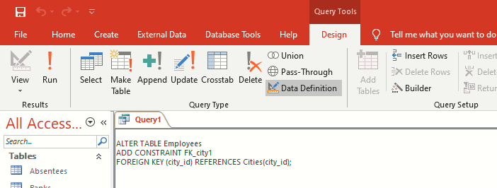
Adding Primary Key to Employees Table
The diagram below demonstrates on how to add a primary key to the employees table using MS Access.
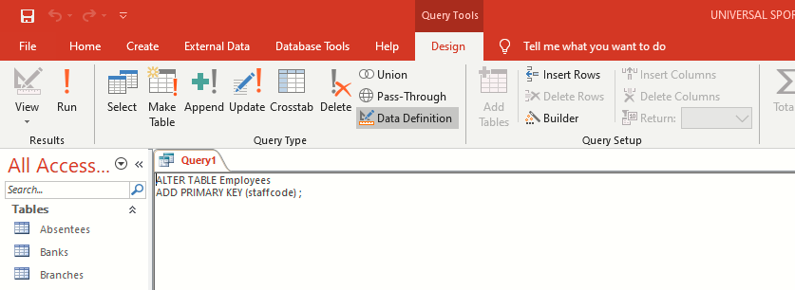
Adding Primary Key to First Aiders
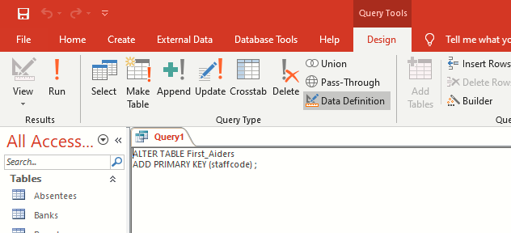
Adding Primary Key to Medical
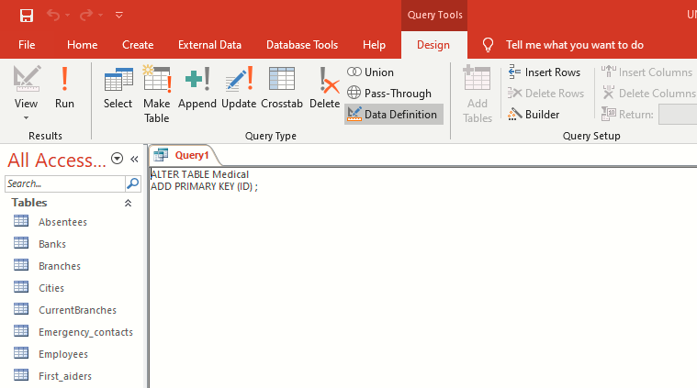
Adding Foreign Keys to Tables Using SQL
Foreign Keys are used to show the relationship of different tables of different member class in the database. Using MS Access, it is possible to add foreign keys to tables belonging to different member classes in the database as follows.
Adding Foreign Key to Absentee Table
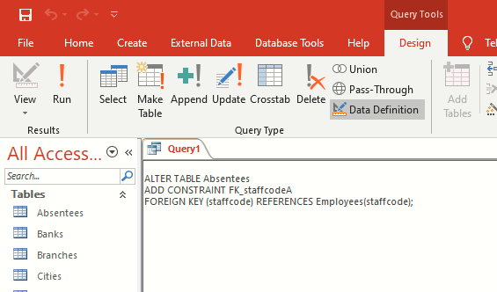
Adding Foreign Key to Bank Details Table
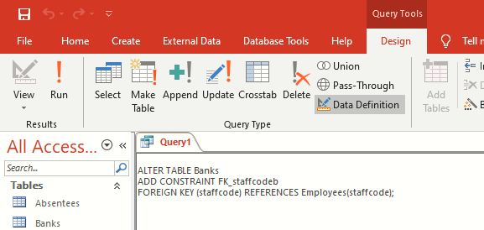

Adding Foreign Key to First Aiders Table
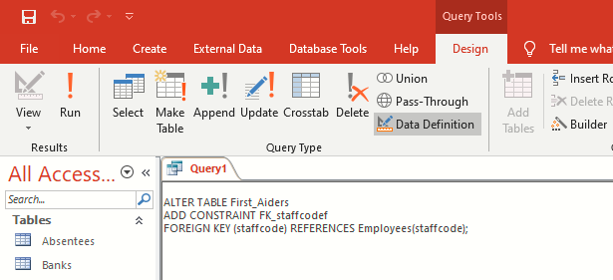
Adding Foreign Key to Holidays Table
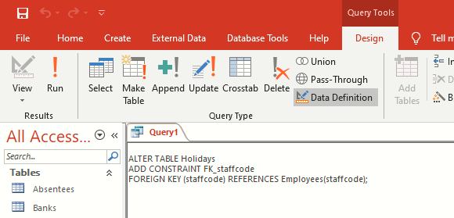
Adding Foreign Key to Medical Table
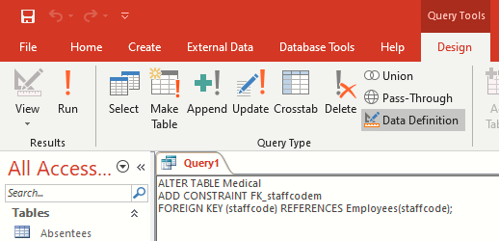

Adding Foreign Key to Training Table
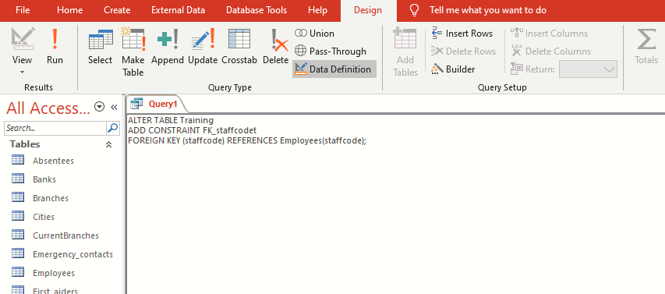

Using SQL to Add Records to Tables
SQL is a powerful tool used in DBMS to add, delete or update database records. In MS Access SQL Queries can be used to accomplish these data manipulation operations as shown below.
Insert Data into Employees Table
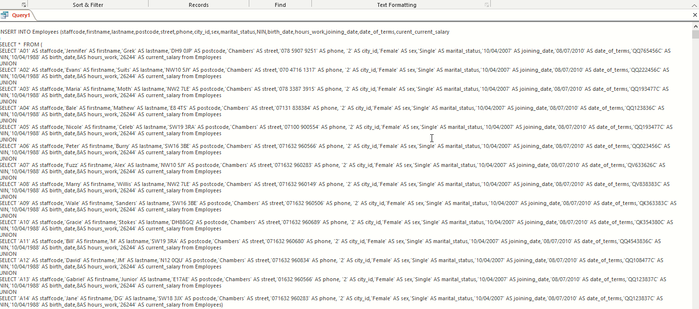

Insert Data into Holidays Table
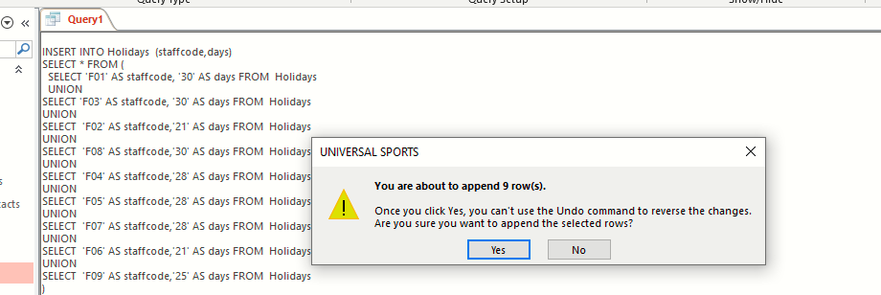
Insert Data into Medical Table

Insert Data into Training Table
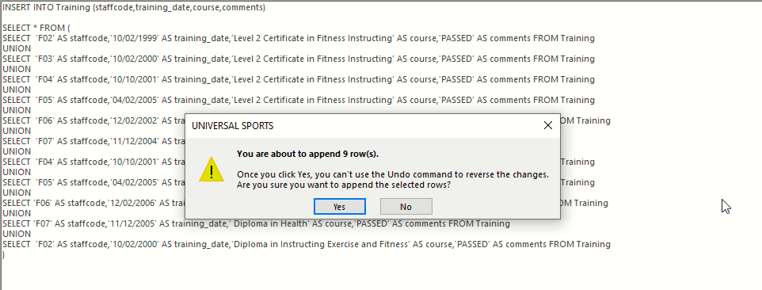

Insert Data into Bank Table
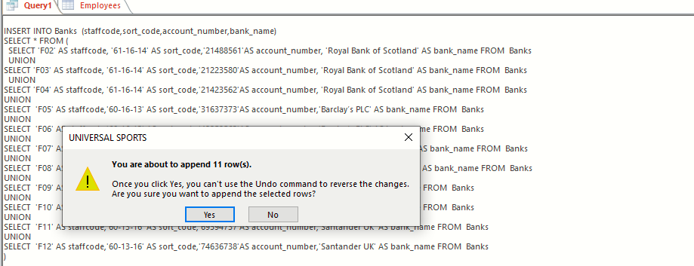
Insert Data into Branch Table
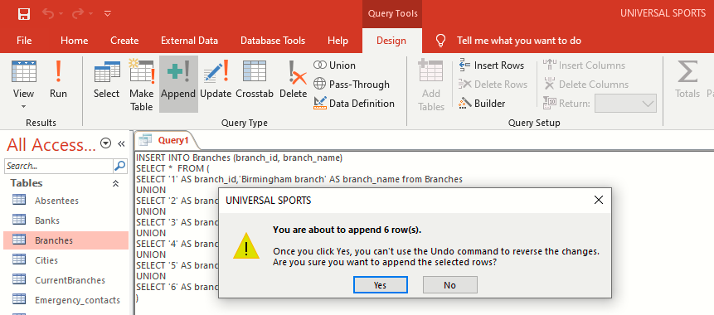

Working of Main Menu and Form Navigation
In MS Access SQL queries can be used to generate forms and navigate at the same time as briefly demonstrated below.
Main Menu Navigation Form

Report Sub-Menu Form
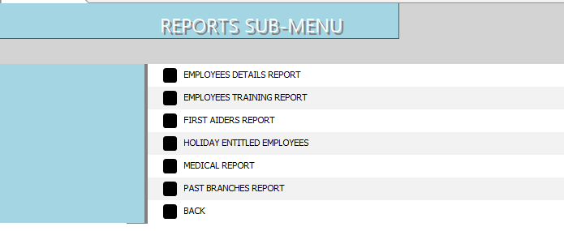
Form Sub-Menu
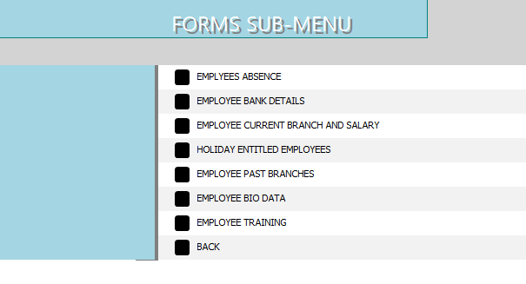
Menu Displayed when Database Opens
The menu shown below will be the default Main Menu that will open immediately the user initiates the opening of the Database

User Documentation
Upon user opening the database, the main menu will be displayed. It contains other sub-menu items from which the user can select from for updating the database. On the other hand, when user wants view, format of print information from the database, reports will be used. On the forms interface, the user can use navigation options to move back and forth.
Forms Sub-Menu
Reports Sub Menu

Conclusion
Data capturing, recording, storing and retrieving has been made easy and reliable through the use of database systems. DBMS tools such as the MS Access, SQL and MySQL have simplified the way data can be managed in the database systems. Information sharing, viewing and formatting has been made efficient through the use of reports in DBMS.

References
Alexander, M. and Kusleika, D. (2019). Access 2019 Bible. Indianapolis, IN: John Wiley & Sons, Inc.
Bhattacharya, J. (2014). Rudiments of Computer Science. Kolkata: Academic Publishers.
Davis, W. and Yen, D. C. (2019). The Information System Consultant's Handbook: Systems Analysis and Design. Boca Raton, FL: CRC Press.
Eckstein, J. and Schultz, B. R. (2018). Introductory Relational Database Design for Business, with Microsoft Access. Hoboken, NJ: John Wiley & Sons Ltd.

Appendix

