Name: NITHISH KUMAR REDDY POSHAM
Student id: 2224271
Email: 2224271@student.uwtsd.ac.uk
HUMAN RESOURCE MANAGEMENT

Executive Summary:

BMW has been chosen for this study because it has a clear HRM procedure for managing its staff. In addition, BMW's Employee wellbeing has been given priority in this study to address the organisation's benefits & current shortcomings. One of the most prestigious premium car companies in the world is BMW. Through the provision of guidelines and the inclusion of the organisation's profit-generating component, BMW has included value-oriented HR practises. However, there are issues such as wrong termination and racial discrimination in the organisation. For this reason, this manufacturing sector must establish health and wellness policies that adhere to HR rules. Workplace work-family conflict is a significant element that has an impact on employee wellbeing and organisational performance. Thus, work-life balance of employees can motivate them to work proficiently which would further help in developing brand image and value of the organisation.

Table of Contents
1.0 Introduction 3
2.0 Organisational overview 3
3.0 Main discussion 4
3.1 Priority area that needs to be improved in BMW 4
3.2 Current weaknesses of BMW with employee wellbeing 5
3.3 Impact of wellbeing on the performance and effectiveness of organisation 6
3.4 Benefits of improving the priority area 8
4.0 Conclusions 9
5.0 Recommendations 9
References…………………………………………………………………………………………..11

Appendices 14
Appendix 1: Data driven model of HR 14
Appendix 2: Harvard framework of HRM 15

Introduction:

The implementation of HRM in international organisations is important in managing a strategic approach to provide a positive working environment to the employees (Van Rossenberg et al. 2020). This also involves recruitment, training and development, leave management, benefits and wellbeing of the employees in organisations. In this report, BMW has been selected for understanding its HRM process to manage its workforce. Moreover, employee wellbeing of BMW has been prioritised in this report to improve the current shortfalls of this organisation. The impact of the Employee wellbeing on the performance of this organisation has been provided. Furthermore, the benefits of HRM with managing proper employee wellbeing have been determined in this study.
BMW provides a variety of financial services, including leasing and financing alternatives for its cars, in addition to its line of automotive products. The corporation sells its goods in more than 140 countries and has production sites in Europe, North America, and Asia (Bekker,2023).
BMW is renowned for its commitment to sustainability and environmental responsibility, as well as its reputation for innovation and quality. The corporation continues to be a market leader in luxury automobiles despite winning countless accolades and awards for its goods and services.

2.0 Organisational overview:

Bayerische Motoren Werke AG commonly known BMW is one of largest and leading premium automobile manufacturing organisations across the globe (BMW 2023). The company is a German-based multinational luxury vehicle manufacturing organisation headquartered in Munich. Apart from specialising in cars and motorcycles, the company also manufactures aircraft engines. The goal of BMW is to dominate the market as the premier supplier of upscale goods and upscale services for personal transportation (BMW 2023). Moreover, in the organisation there are about 149,475 employees working across the globe (Statista, 2023). With this workforce, BMW has managed diverse operations such as in the automobile segment, financial segment and motorcycle segment. This workforce demographic has helped in maintaining the business operations across the world.
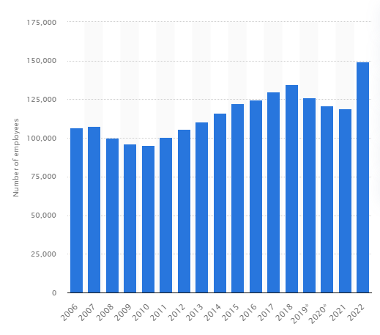
Figure 1: Employees in BMW across world
(Source: Statista, 2023)
It has been seen that 91.7% of the employees are in the automotive segment, 2.5% in motorcycles and the rest are in the financial segment (BMW, 2023). The HRM function in this organisation has focused on managing the future, which has helped in meeting the demographic challenges in the organisation (BMW Group, 2023). BMW includes hierarchical organisational structure where different leaders of the organisation have their own team in different places across the world. Ilka Horstmeier is the head of Labour Relations in the organisation (BMW, 2023). BMW, to manage their employees has focused on their skill set development and value-oriented human resource (HR) policy for which there is a requirement of improvement in managing the wellbeing of the employees in the organisation.

3.0 Main discussion:

3.1 Priority area that needs to be improved in BMW

BMW has involved value-oriented HR policies by providing guidelines with the involvement of the profit-generating factor to the organisation. In the guideline, it has not provided about the wellbeing of the employees in the organisation (BMW Group, 2023). The guidelines are mostly based on the culture remunerations, performance and human rights. It has included equal opportunities to the employees that appreciate culture in the work environment. The diversity management of the employees in this organisation is outstanding (BMW Group, 2023). However, as this is a manufacturing industry, there is a requirement for this organisation to provide health and wellbeing policies in the guidelines of HR (José Martínez‐Jurado, 2013).
In manufacturing, industry, health related safety rules are required to be implemented so that employees can sustain for a long duration of time. As per the sustainable development goals (SDGs) of the UN, the third goal is for good health and wellbeing, which is an important element in manufacturing organisations (Blaustein et al. 2021). For example, in the US, 79% of organisations are focusing on the wellness of the employees to retain them for long-term (Elflein, 2023). Therefore, from this it can be addressed that BMW needs to focus on the UN SDG 3 for managing the wellbeing of the employees.
Moreover, it is essential to maintain a code of conduct, which is a set of guidelines established for the employees of a company. The employment of the employees of an organisation may suffer if the regulation is broken. Similar to that, this also covers the organisation's policies about its employees so that any employees who encounter unethical actions can use those policies against the corporation (Schwepker et al. 2021). Therefore, there is a requirement for the employees to maintain their wellbeing with proper ethical means. In maintaining the international operations in BMW, the labour can feel problems with their health as they are going to new places. Therefore, proper reallocation facilities with health benefits are required to be involved for this organisation to manage employee wellbeing.

3.2 Current weaknesses of BMW with employee wellbeing

Various factual facts can be considered in order to illustrate BMW's existing deficiencies in maintaining employee welfare. The most serious worry in this case is that a BMW employee was wrongfully terminated. Ryan Parkinson, a temporary employee of BMW, was fired unfairly for going to Burger King for his lunch break during an overtime shift (Singh, 2022). The employee was accused of violating company regulations by failing to notify management about a lunch break. In this case, a disciplinary hearing was held in May 2019, after which the employee was fired. However, the conclusion of this dismissal resulted in a court claim being filed against BMW by Ryan Parkinson (Singh, 2022). This data suggested the presence of a bureaucratic management approach within BMW's working environment, raising concerns about the effectiveness of their employee well-being initiatives. Aside from that, BMW management and leadership were unaware of the need to consider a direct interaction with the accused employee before proceeding with wrongful termination. However, the resolution of the court case resulted in a financial penalty for BMW, with roughly £16000 paid as compensation (Singh, 2022). Along with this, Parkinson included a claim of racial harassment and prejudice in his case, which was utterly denied. This overall evidence has highlighted a lack of proper focus as well as attention on the part of BMW management in terms of ensuring transparency and justice in making important personnel choices on behalf of the company.
BMW, on the other hand, has been linked to racial discrimination claims. The primary cause for this claim was the existence of criminal conviction record guidelines within the organization. The complaint filed against BMW said that African-American logistics workers were fired at a disproportionate rate for failing to follow BMW's criminal conviction standards. This data eventually revealed the ramifications of racial prejudice within the organization. As a result, almost 80% of the company's existing workers were banned from employment (EEOC, 2023). However, a new court claim was brought against BMW for this purpose, alleging that black employees are disproportionately disqualified and terminated from their jobs at BMW due to following criminal conviction record requirements. The corporation eventually focused on this gap within their employee welfare policy, which was entirely and freely rectified once the concept of this legal complaint was developed.

3.3 Impact of wellbeing on the performance and effectiveness of organisation

BMW offers a pension plan to its employees as well as a health plan that includes an annual health checkup (BMW Group, 2023). However, there are no such services for employees to manage their immediate health and well-being. Accidents on the job might undermine an employee's belief in the organization in the manufacturing industry. As a result, involvement in the organization is essential to ensure the employees' well-being. Obrenovic et al. (2020), on the other hand, state that work-family conflict in the workplace is a significant issue that influences employee well-being and organisational performance. This puts a strain on an organization's employees' psychological development. As a result, work-family management is a key factor in ensuring that employees retain the efficacy of the workplace. Furthermore, Ho and Kuvaas (2020) assert that psychological well-being is an important aspect in job performance management. This contributes to the creation of a positive workplace environment by including human resource management (HRM) procedures that benefit both employees and employers. Thus, implementing a proper HRM system aids in the management of an organization's effectiveness.
In the case of BMW, there is a lack of unjust treatment of employees in the organization, which is one of the reasons why employee well-being is being disrupted (BMW, 2023). This had a bad impact on the employees' psychology. However, the impact of employee well-being has generated issues for the organization and is dependent on the use of an HRM system in the firm. The HR-driven model can help with this by ensuring that employees have a proper relationship with the organization (Peccei and Van De Voorde, 2019) (Refer to Appendix 1). This model describes the requirements of employees in the organization to ensure their proper well-being. This aids in the reinforcement of HRM processes and the involvement of employees in business activities. Thus, it has been discovered that the relationship between HRM and employee performance on wellbeing is curvilinear and has a moderate effect on the organization (Ho and Kuvaas, 2020). This aids in ensuring employee performance so that organizations may properly manage their personnel.
It has been found that there is excellent diversity management in BMW, which has helped in securing strength for the organisation to manage cross-cultural dimensions. However, the lack of employee wellbeing has created challenges, as there are discriminations, which are affecting the HRM system of this organisation. Hence, as per the views of Sarwar et al. (2020) employee wellbeing in the international market is an important element. Moreover, maintaining ethical culture in an organisation can help in developing the wellbeing of the employees through which human capital in business is increased. This has created a positive influence on the performances of the organisation. However, He et al. (2021) have suggested that there is a negative impact on the wellbeing of employees in the organisation as employees feel more confident and do not have any fear in working. This creates discrepancies in the businesses due to inappropriate documentation of the employee’s health and wellness. Therefore, implementing the proper HRM system in BMW helps in maintaining positive influence of employee wellbeing on the performance of the organisation.

3.4 Benefits of improving the priority area

While considering the improvement of this priority area concerning the maintenance of efficient employee wellbeing, several benefits can be taken into concern. Taking the perspective of BMW, the company can obtain subsequent advantages with improved brand image and awareness in the market as an effective employer by overcoming the shortfalls of racial discrimination in the workplace (Ahmed et al. 2020). Moreover, the overall brand value of BMW can also be improved through this aspect where strong commitment could be provided by BMW management and leadership with an intention to deliver a supportive and focused working environment for the employees. As per the reports of 2022, BMW was operating with a brand value of around USD 27.6 billion (Faria, 2023). It can further increase based on their increasing commitment towards the prevention of discrimination in the workplace. Moreover, BMW will also be able to ensure adequate employee engagement with their business, which can also be supportive to import their financial growth opportunities in the competitive market.
While taking the perspective of employees, greater benefits can also be certified with regards to the improvement of existing employee motivation levels within the organisation (de Tormes Eby and Allen, 2012). The reason behind this statement highlights the provision of a supportive working environment and atmosphere for the employees with the avoidance of harassment and discrimination. Currently, BMW is observed to operate in the market with a major employee satisfaction rate. This aspect can further emerge in terms of improving the selected priority area of employee wellbeing. Apart from that, BMW is also seen to operate with a rating of 4.5 for their culture and values (Comparably, 2023). This aspect can be increased to a wider extent by depending on subsequent development of employee wellbeing policies and strategies.
Referring to the case of respective stakeholders of BMW, adequate attention can be provided on the achievement of improved return on investment from BMW shareholders. The reason behind this statement enlightens the improvement of BMW productivity and performance with the achievement of increasing employee motivation and engagement level (Sackmann, 2011). Moreover, improvement of brand image as well as value would also be supportive and beneficial for BMW to ensure substantial performance development based on which future business expansion opportunities would also be achieved by them.

4.0 Conclusion
The overall report has presented a clear and comprehensive understanding regarding the consequences of employee wellbeing referring to the case evidence of BMW. Several toxic evidences like the existence of discrimination, wrongful termination of employment and others are observed in the case of BMW, which has questioned the efficiency of their policy for employee wellness. However, the impact of these aspects has been creating psychological pressure on the BMW employees, which may negatively impact their job performances. With a focus on substantial improvement of this priority area, BMW would be greatly benefited with the achievement of extended performance development and business growth opportunities.

5.0 Recommendations
A set of recommendations can be provided for BMW regarding further improvement of their HR function concerning the area of employee wellbeing.

Modification of existing policies

BMW management is strongly recommended to modify their existing strategic interventions and policy guidelines associated with employee management. This aspect would be highly supported for them to prevent challenging circumstances of occurring racial discrimination and others in the working environment. The Harvard framework of HRM can be signified in this concern (Refer to appendix 2). The theoretical understanding highlights the combination of both situational sectors and stakeholder’s interest as an integral part of outlining supportive HRM policies (Li et al. 2019). It results in substantial HRM outcomes with extended employee competence and commitment level, which may ensure long-term consequences of individual wellbeing in the organisation. This may include the disadvantage as well as risk factor of not communicating this policy change within the workforce, which may lead towards massacre and conflicts. No subsequent costs would be associated with this action.

Appointment of independent ombudsman

BMW management will have to look for appointing an independent ombudsman by providing him the responsibility of reporting issues and challenges linked with employee wellbeing in the working atmosphere. The management can have timely reports of the issues as a result of taking this initiative, which would also be helpful for them to take actions on an immediate basis for preventing those issues. Respective employees can also contact the ombudsman in order to indicate their priority as well as concerns regarding additional benefits like parental leaves and others to the ombudsman, which would be directly communicated to the management.
Along with this, BMW is also recommended to consider a 360degree feedback process by involving respective departmental heads in order to identify issues and gaps in employee wellbeing.

References:
Ahmed, M., Zehou, S., Raza, S.A., Qureshi, M.A. and Yousufi, S.Q., (2020). Impact of CSR and environmental triggers on employee green behavior: The mediating effect of employee well‐being. Corporate Social Responsibility and Environmental Management, 27(5), pp.2225-2239.
Bekker, H. (2023). 2022 (Full Year) Global: BMW and Mini Brand Worldwide Sales by Country. [online] Car Sales Statistics. Available at: https://www.best-selling-cars.com/brands/2022-full-year-global-bmw-and-mini-brand-worldwide-sales-by-country/
Blaustein, J., Chodor, T. and Pino, N.W., (2021). Development as a historical component of the United Nations’ crime policy agenda: From social defence to the Millennium Development Goals. Criminology & Criminal Justice, 21(4), pp.435-454
BMW (2023). BMW GROUP KEY FIGURES.. Available at: https://www.bmwgroup.com/en/company.html#:~:text=The%20BMW%20Group%20company%20profile.&text=Today%2C%20the%20BMW%20Group%2C%20with,premium%20financial%20and%20mobility%20services [Accessed on: 5 July 2023]
BMW Group, (2023). BMW Group HR Policy: thinking of tomorrow today / Package of measures to meet demographic challenges. Available at: https://www.press.bmwgroup.com/middle-east/article/detail/T0045736EN/bmw-group-hr-policy:-thinking-of-tomorrow-today-/-package-of-measures-to-meet-demographic-challenges?language=en [Accessed on: 6 July 2023]
BMW Group, (2023). RECOGNISING WHAT YOU DO – AND SHOWING OUR APPRECIATION. Available at: https://www.bmwgroup.jobs/in/en/benefits.html [Accessed on: 5 July 2023]
BMW Group, (2023). Value-oriented Human Resources Policy. Available at: https://www.bmwgroup.com/content/dam/grpw/websites/bmwgroup_com/responsibility/downloads/en/2003/BMWGroup_Personnel_Policy_Guidelines.pdf [Accessed on: 5 July 2023]
BMW, (2023). BMW GROUP PROFILE.. Available at: https://www.bmwgroup.com/en/company/leadership-and-governance.html [Accessed on: 5 July 2023]
Carlier, M. (2022). Global number of employees of BMW Group 2018. [online] Statista. Available at: https://www.statista.com/statistics/264343/global-number-of-employees-of-bmw-group/ (Accessed on 6 July 2023)
Comparably, (2023). Working at BMW Group. [Online]. Available at: https://www.comparably.com/companies/bmw [Accessed on 5 July 2023]
de Tormes Eby, L.T. and Allen, T.D. eds., (2012). Personal relationships: The effect on employee attitude s, behavior, and well-being. Routledge.
EEOC, (2023). BMW to Pay $1.6 Million and Offer Jobs to Settle Federal Race Discrimination Lawsuit. [Online]. Available at: https://www.eeoc.gov/newsroom/bmw-pay-16-million-and-offer-jobs-settle-federal-race-discrimination-lawsuit [Accessed on 5 July 2023]
Elflein, (2023). Workplace health and wellness in the U.S. - Statistics & Facts. Available at: https://www.statista.com/topics/3275/workplace-health-and-wellness-in-the-us/#topicOverview [Accessed on: 6 July 2023]
Faria, J., (2023). BMW's global brand value from 2010 to 2022. [Online]. Available at: https://www.statista.com/statistics/536927/bwm-brand-value/#:~:text=In%202022%2C%20in%20a%20ranking,prior%20year%20by%2011%20percent [Accessed on 6 July 2023]
He, J., Mao, Y., Morrison, A.M. and Coca-Stefaniak, J.A., (2021). On being warm and friendly: the effect of socially responsible human resource management on employee fears of the threats of COVID-19. International Journal of Contemporary Hospitality Management, 33(1), pp.346-366.
Ho, H. and Kuvaas, B., (2020). Human resource management systems, employee well‐being, and firm performance from the mutual gains and critical perspectives: The well‐being paradox. Human Resource Management, 59(3), pp.235-253.
José Martínez‐Jurado, P., Moyano‐Fuentes, J. and Jerez Gómez, P., 2013. HR management during lean production adoption. Management decision, 51(4), pp.742-760.
Li, S., Rees, C.J. and Branine, M., (2019). Employees’ perceptions of human resource management practices and employee outcomes: Empirical evidence from small and medium-sized enterprises in China. Employee Relations: The International Journal, 41(6), pp.1419-1433.
Obrenovic, B., Jianguo, D., Khudaykulov, A. and Khan, M.A.S., (2020). Work-family conflict impact on psychological safety and psychological well-being: A job performance model. Frontiers in psychology, 11, p.475.
Peccei, R. and Van De Voorde, K., (2019). Human resource management–well‐being–performance research revisited: Past, present, and future. Human resource management journal, 29(4), pp.539-563.
Sarwar, H., Ishaq, M.I., Amin, A. and Ahmed, R., (2020). Ethical leadership, work engagement, employees’ well-being, and performance: a cross-cultural comparison. Journal of Sustainable Tourism, 28(12), pp.2008-2026.
Sackmann, S.A. (2011). Success Factor: Corporate Culture: Developing a Corporate Culture for High Performance and Long-term Competitiveness, Six Best Practices. [online] Google Books. Verlag Bertelsmann Stiftung. Available at: https://books.google.co.uk/books?hl=en&lr=&id=PrP1DwAAQBAJ&oi=fnd&pg=PA13&dq=BMW+productivity+and+performance+with+the+achievement+of+increasing+employee+motivation+and+engagement+level&ots=WZL1QdNpHE&sig=s1Q7xgVo2fQzpq0DuG3_B5s-ULc#v=onepage&q&f=false [Accessed 10 Jul. 2023].
Schwepker, C.H., Valentine, S.R., Giacalone, R.A. and Promislo, M., (2021). Good barrels yield healthy apples: organizational ethics as a mechanism for mitigating work-related stress and promoting employee well-being. Journal of Business Ethics, 174, pp.143-159.
Singh, S., (2022). BMW employee sacked for taking lunch break at Burger King, wins £16,000 payout. [Online]. Available at: https://www.businesstoday.in/latest/trends/story/bmw-employee-sacked-for-taking-lunch-break-at-burger-king-wins-ps16000-payout-358439-2022-12-31 [Accessed on 6 July 2023]
Statista, (2023). Global number of employees of BMW Group 2006-2022. Available at: https://www.statista.com/statistics/264343/global-number-of-employees-of-bmw-group [Accessed on: 5 July 2023]

Appendices

Appendix 1: Data driven model of HR

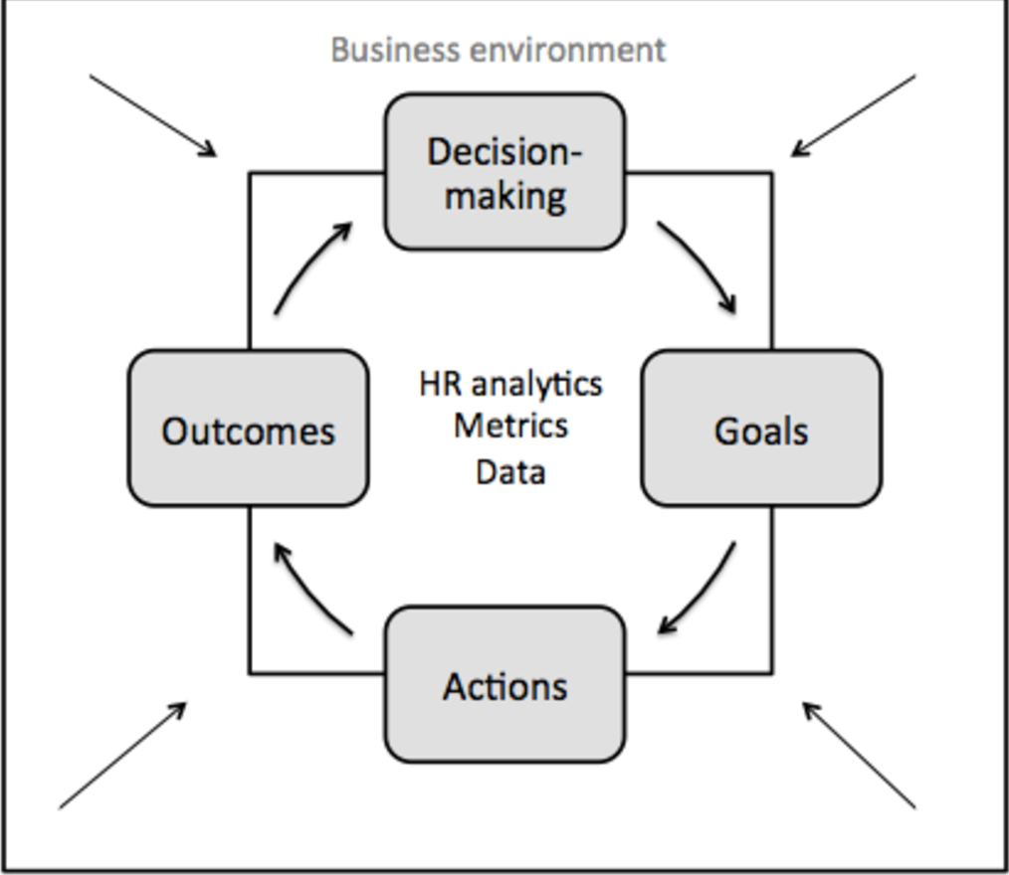

(Source: Peccei and Van De Voorde, 2019)

Appendix 2: Harvard framework of HRM
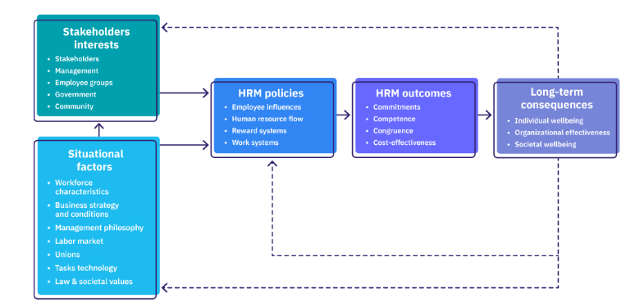
(Source: Li et al. 2019)

